|  |
| --- |

# Contents

Contents 2

1 Introduction 4

1.1 Problem Formulation 4

1.2 Research Contributions 5

1.3 Delimitations 5

2 Literature Review 6

2.1 Industrial Robot Condition Monitoring 6

2.2 Data-driven Anomaly Detection 6

3 Methodology 9

3.1 Combined Anomaly and Trend Detection Model 9

3.2 Model Design 10

3.3 Feature Engineering 10

3.3.1 Data Scaling 11

3.3.2 Cross-correlation 11

3.3.3 Feature Selection 11

3.4 Anomaly Scoring methods 12

3.4.1 Centroid-based Clustering 13

3.4.2 Local Outlier Factor 13

3.4.3 One-class SVM 14

3.4.4 Autoencoder 15

3.5 Anomaly Threshold 16

3.6 Trend Detection 16

3.7 Evaluation 17

Abbreviations

α Alpha

Ω Omega

# Introduction

Robots are increasingly being used in diverse applications, from industrial automation to healthcare and beyond. The reliable operation of robots relies heavily on the proper functioning of mechanical components, including gearboxes that enable precise motion control. However, wear and degradation of gearboxes over time can impact the performance and lifespan of robots, resulting in costly repairs, downtime, and safety risks.

To address this challenge, condition monitoring (CM) system of gearboxes offers the potential to proactively detect wear and resolve the issue before failures occur (Nentwich & Reinhart, 2021). CM involves the monitoring of an asset's health using sensor data, where the health state represents the wear reserve before a failure occurs, and it is quantified with some health indicators (HI). Significant changes in this health indicator can be used as decision-making aids in planning maintenance actions.

Traditional fault detection methods based on model-based approaches often face challenges such as the need for handcrafted mathematical models and the presence of useless information in sensor data, which can affect the stability and accuracy of fault detection (Wild, 1994). To overcome these issues, data-driven methods, such as anomaly detection, have gained significant attention in the field of condition monitoring and fault detection due to their ability to automate and optimize the monitoring and detection process using sensor data.

This thesis aims to explore robust anomaly detection methods in the context of CM for gearbox wear in robots. This involves the use of sensors, data analysis, and machine learning techniques to monitor the health of gearboxes and detects abnormal wear-related patterns.

## Problem Formulation

As mechanical components wear, the friction between their moving parts typically increases, resulting in greater resistance to movement and increased demand for motor torque to achieve the same level of movement. Monitoring torque over time makes it possible to detect wear patterns that may indicate abnormal joint wear or impending failures. However, direct application of anomaly detection techniques to wear level data of robot joints can result in high false alarm rates and reduced robustness of the conditioning system due to noise and fluctuations being identified as failures. Therefore, the combination of anomaly detection and trend analysis is a more robust approach that focuses on identifying consistent patterns in data that align with normal behaviour, making it less sensitive to isolated fluctuations. Trend detection methods are designed to adapt to changes in data over time, allowing them to account for normal changes without considering them as anomalies. Additionally, trend detection methods often produce interpretable results, aiding in understanding and explaining the detected trends. However, the imbalanced nature of wear level data in robot joints should be considered, as wear data may not follow a normal distribution or have similar characteristics across all joints, making traditional statistical analysis challenging. Despite this, anomaly detection techniques can still be feasible in this scenario. Therefore, in this thesis, anomaly detection and trend detection techniques will be utilized to identify wear patterns that are uncommon or unexpected, which may indicate abnormal joint wear or impending failures.

## Research Contributions

The main research contribution of this thesis is the development of a robust condition monitoring system for detecting anomalies of gearboxes on robot joints using data-driven methods, specifically machine learning techniques. Feature engineering methods are employed to extract descriptive features from the data, such as in the time, frequency, or time-frequency domain. Various machine learning models, including Support Vector Machines (SVM) and Local Outlier Factor (LOF), are implemented to obtain an appropriate conditioning indicator. Two trend detection methods are evaluated based on the generated indicators, and comparisons are made between different models to determine their effectiveness.

## Delimitations

One delimitation of this thesis is that the entire system will be limited to classifying only two patterns: normal and abnormal. The final output of this system is binary based on trend analysis, with the abnormal status triggered when the indicator value exceeds a predetermined threshold. This approach was chosen for the purpose of simplifying the development and evaluation of each model, as well as to maintain consistency with the available data. By focusing on these two distinct patterns, the study aims to provide a clear and concise analysis of anomaly detection performance, which can be applied to a wide range of real-world scenarios.

# Literature Review

## Industrial Robot Condition Monitoring

Condition monitoring (CM) was initially proposed in the 1960s for the American nuclear industry and then has been applied to a range of industrial systems (Wild, 1994). CM can be carried out online, concurrently with normal system operation, or offline, requiring the system to be run in a particular manner. It involves monitoring an operational asset and analysing the obtained data to detect signs of degradation, diagnose faults, and predict remaining useful life (Beebe, 2004). CM typically involves acquiring data through sensors, processing and analysing the data, and generating alerts or recommendations based on the results. With the rise of Industry 4.0 and the Internet of Things, CM has become increasingly important for ensuring the reliable and efficient operation of complex industrial systems.

In recent years, researchers have made great contributions to industrial robot condition monitoring. For example, Vallachira et al. (2019) proposed four pre-processing techniques to improve the detection performance of machine learning approaches for detecting gearbox failures in industrial robots. They used data differencing, local variation inclusion, training data augmentation with estimated measurements, and principal component selection to curate data prior to building a classification model. Nentwich and Reinhart (2021) proposed a method for calculating health indicators for industrial robot gears using sensor data. They suggested a new health indicator based on STFT spectrograms and Z-scores that can cope with specific needs arising from typical industrial robot applications. Additionally, the algorithm proposed by Bouzenad et al. (2021) uses the Kullback-Leibler (KL) divergence as a measure of dissimilarity between probability distributions to detect faults in large-scale industrial systems. The paper discusses how the use of a PCA filter before KL implementation and the development of an optimal threshold for this measure can improve fault detection accuracy.

## Data-driven Anomaly Detection

In terms of Condition monitoring, anomaly detection can be classified into two categories, model-based approach, and data-driven approach. The model-based fault detection approach is a widely used technique that involves developing a mathematical model of the system under observation and comparing its outputs with the actual system outputs to detect faults. This approach assumes that a fault in the system will lead to deterministic changes in the model parameters, which can be used to generate a residual signal and extract relevant information (Ding, 2008). While the model-based approach has been successful in many applications, it requires accurate modelling of the system and may not be suitable for systems with complex or uncertain dynamics.

Recently data-driven approaches have gained popularity for fault detection in industrial systems. Data-driven approaches use machine learning algorithms to analyse sensor data and identify patterns or anomalies that may indicate a fault. These approaches outweigh model-driven approaches for several reasons. Firstly, they do not rely on a priori knowledge of the system dynamics and can adapt to changes in the system’s behaviour over time. Secondly, they can handle large volumes of data and are less sensitive to modelling errors than model-based approaches (Gao et al., 2015). Additionally, data-driven methods can generalize, meaning that the same algorithm can be used to detect anomalies in different types of robots (Khalastchi and Kalech (2018). These advantages make data-driven approaches a promising option for developing fault detection systems, as they can save time and resources during system development.

Anomaly detection in condition monitoring can be accomplished through supervised or unsupervised machine learning methods. In supervised learning, the algorithm learns from labelled datasets that contain both normal and abnormal data points, enabling it to detect anomalies in new data. This approach is particularly useful for detecting various types of anomalies in balanced training datasets (Mao et al., 2021). However, various challenges have degraded the performance of supervised learning methods, including difficulties in recognizing all possible anomalies in historical data (Vallachira et al., 2020), insufficient data for training accurate models (Cheng et al., 2019), and potential inaccuracies in labeled data due to human experts (Cheng et al., 2019). Therefore, recent research in the field has focused on the use of semi-supervised or unsupervised methods, which are more practical for real-world scenarios where only limited labelled data may be available for training.

These methods can be categorized as distance-based, domain-based, and reconstruction-based algorithms. Bouzenad et al. (2019) proposed a modified version of the k-means clustering method that can be used for real-time monitoring and structural health monitoring (SHM) applications. The proposed method involves instant clustering of signals and detects defects by identifying new classes of signals. Nentwich and Reinhart (2021) conducted experiments on data obtained from an industrial robot gear condition monitoring system and found that both LOF and LSTM performed well in detecting anomalies, with LSTM slightly outperforming LOF. Zhang et al. (2007) method provides a promising solution for detecting network anomalies based on the one-class support vector machine (OCSVM) algorithm and has been demonstrated to be effective in detecting various types of anomalies in communication networks.

These methods can be particularly useful when dealing with large and complex datasets generated from gearbox wear tests of different types of robots. By leveraging data-driven approaches, it may be possible to develop more accurate and efficient fault detection systems that can detect and prevent faults before they cause significant damage or downtime.

# Methodology

## Combined Anomaly and Trend Detection Model

The Combined Anomaly and Trend Detection Model is a novel approach to condition monitoring for robots that uses anomaly detection methods to generate anomaly scores for incoming data (Principi et al., 2019). Anomaly detection is based on unsupervised machine learning methods, such as K-means clustering and One-class SVM, which can identify anomalies in real time after capturing the normal behaviour of the robots.

This system uses anomaly scores to detect faults because it can provide a more flexible and interpretable approach to anomaly detection (Li, et.al, 2020). First, the normal behaviours are learned from the training measurements. Then, for each test measurement, the anomaly score is calculated based on the trained model introduced in section 3.4. A classifier may be biased toward the majority class and may not be able to accurately predict rare anomalies. Anomaly scores, on the other hand, are based on the degree of deviation from the norm and can be more robust to imbalanced data.

To avoid false positives caused by isolated fluctuations, the model also incorporates trend detection methods to analyse the overall behaviour of the anomaly scores over time. The trend detection algorithms are based on statistical methods, such as the moving average (MA), which can detect long-term trends and changes in the robot’s health state.

The approach used in this research differs from classical methods as it adopts a semi-supervised approach for detecting anomalies. Classical methods typically rely on supervised algorithms that require labelled data to train the model on normal and abnormal data. Recent research on anomaly detection in the industrial field has paid more attention to unsupervised or semi-supervised learning (Chandola, Banerjee, & Kumar, 2009). This is because it is challenging to capture and label all possible failures in recorded data and acquire enough training data to train an accurate model (Khalastchi, 2018). Furthermore, the accuracy of data labels can be influenced by the knowledge and expertise of a human expert. Therefore, it is preferred to develop a real-time monitoring system that trains the model with recorded normal datasets and tests the model with the coming data points.

## Model Design

The proposed method shown in Figure 3.1 involves a two-stage process: model training on historically healthy data and real-time anomaly detection.

Figure 3‑1

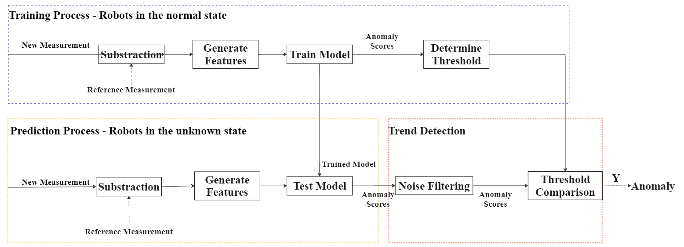

The model training stage involves learning the normal behaviour of the robot joints by training the features extracted from recorded healthy measurements. It is assumed that the robots are in a healthy state at the beginning of the diagnostic routine and the measurements for training are taken during the initial test cycles. The first measurement serves as a reference measurement, which is used as a baseline for comparison. Each subsequent measurement is subtracted from the reference measurement to generate a difference signal, and feature engineering techniques are applied to generate relevant features. These features are used to train different models, generating anomaly scores to determine the threshold.

During the real-time anomaly detection process, the new measurements are processed one at a time. The new measurement is still subtracted from the reference measurement and the same features are extracted from the measurement. Then the features are used in the trained model to generate anomaly scores.

In the trend detection step, a filtering method such as Moving Average essentially acts as a filter that smooths out high-frequency noise in the scores and retains the low-frequency signal or trend. The anomaly scores are compared with the threshold determined by the training process. If the anomaly score exceeds the threshold, the system flags an anomaly.

## Feature Engineering

In this section, Feature engineering techniques are implemented to select and transform raw data into features that are suitable for machine learning algorithms.

### Data Scaling

Raw data can come in many different formats and ranges, which can impact a model's interpretation of the data and affect its performance. Therefore, it is necessary to pre-process the data before feeding it into the models. Standardization is shown in Equation 3.1 where xˆ is the raw torque data before standardization, µ and $δ$ are the mean and standard deviation of the reference measurement. It is a commonly used method for scaling features, allowing for fair comparison and more efficient model training. Standardization also helps to prevent features with larger ranges from dominating the learning process compared to those with smaller ranges. By standardizing the features, the model can more accurately identify patterns and relationships in the data, leading to better predictive performance.

|  |  |  |
| --- | --- | --- |
|  | $$x = \frac{xˆ- µ}{δ}$$ | ( 3.1) |

### Cross-correlation

Simply extracting features directly from the collected measurements may not capture the subtle differences between normal and abnormal behaviours. Instead, the system is subtracting each new measurement from a reference measurement on the same axis to generate a difference signal (Večeř, Kreidl, and Šmíd, 2005), which highlights the differences between two measurements. However, there might be a slight phase difference between the reference measurement and the new measurement as the start positions of axes cannot be identical in each test cycle. This may add more noise to the difference signal and increase false positives or false negatives when detecting abnormal behaviours. By using cross-correlation to align the signals before subtraction, the system can more accurately detect abnormal behaviours in the robot joints and improve the overall performance of the system.

Firstly, the measurements are normalized by subtracting the mean and dividing by the standard deviation to eliminate any scaling differences. Cross-correlation is then performed by calculating the product of the two measurements shifted by a time lag, resulting in a new signal showing similarity at each time lag (Oppenheim, 1999). The time lag corresponding to the maximum cross-correlation value is determined to represent the necessary shift to synchronize the signals. Finally, one of the signals is shifted by the calculated lag amount to align the signals.

### Feature Selection

In this thesis, Root mean square (RMS), Standard Deviation (Std), and Area Under Signal (AUS) are the features used as indicators of the gearbox's health.

The RMS feature is a measure of the signal's amplitude. For instance, an increase in the RMS value may indicate that the machine is encountering an obstacle or a large load, which can cause the machine to operate outside its normal range. The definition of RMS is given by Equation 3.2,

|  |  |  |
| --- | --- | --- |
|  | $$∆τ_{rms}= \sqrt{\frac{1}{N}\sum_{i=1}^{N}{{\left({∆τ}_{i}\right)}^{2}}}$$ | ( 3.2) |

where ${∆τ}_{i}$ is the i-th member of the ddifferenttorque signal $∆τ$, N is the number of points in $∆τ$. RMS is hardly affected by isolated peaks and thus isn’t sensitive to noise (Večeř, Kreidl and Šmíd, 2005). By monitoring the RMS value, it is possible to record the overall condition of the robot’s gearboxes.

The standard deviation feature is defined in Equation 3.3, measuring the variability of the torque signal around the mean, which can be used to detect changes in the machine's operating conditions (Nentwich & Reinhart, 2021). If the wear level of the gearbox increases, the robot may produce a torque signal with a higher standard deviation than the normal torque signal. Similar to RMS, STD can detect the change in the condition of the gearbox.

|  |  |  |
| --- | --- | --- |
|  | $$∆τ_{STD}= \sqrt{\frac{1}{N}\sum_{i=1}^{N}{{\left({∆τ}_{i}-\overline{∆τ}\right)}^{2}}}$$ | ( 3.3) |

Additionally, according to the internal study material provided by ABB Research Insinuate, another feature called Area Under Signal is also suitable for monitoring the health state of the gearbox. The trapezoidal rule shown in Equation 3.4 is used to estimate the area under a signal curve as the torque signal is discrete. The difference between the area under the signal is given by Equation 3.4, where $k$ is the k-th number of torque measurement and r represents the reference measurement. This feature can be useful for detecting anomalies that result in a change in the overall energy or effort required by the robot.

|  |  |  |
| --- | --- | --- |
|  | $$τ_{AUS}= \frac{τ_{1}+τ_{N}}{2}+\sum_{I=2}^{i=N-1}{τ_{i}}$$ | ( 3.4) |
|  | $${∆τ}_{AUS}= τ_{AUS}^{k}-τ_{AUS}^{r}$$ | ( 3.5) |

## Anomaly Scoring Methods

Anomaly scoring methods are used to quantify the degree of abnormality of a data point in comparison to the normal data points. In this thesis, four different anomaly scoring methods were used: Centroid-based Clustering, Local Outlier Factor, One-class SVM, and Autoencoder. The anomaly scores obtained from these methods were then used to detect anomalies using the trend detection methods described in section 3.5.

### Centroid-based Clustering

K-means or Centroid-based clustering is an unsupervised algorithm grouping similar data into one cluster. The algorithm works by first randomly selecting K initial cluster centroids (where K is the number of desired clusters), and then iteratively assigning each data point to the nearest centroid and recalculating the centroid of each cluster based on the mean of the data points assigned to it. The process is repeated until convergence, i.e., when the centroids no longer move.

A modified version of K-means clustering proposed by Bouzenad et al (2019) give insights into the anomaly detection in this thesis. After extracted from the healthy signals, the features are considered as a reference cluster, and its centroid is used as a fixed reference point. During the prediction process, the anomaly score for the label-unknown feature vectors is the distance between the data point and its cluster centroid. If a data point is farther away from its centroid than a predefined threshold, it can be considered an anomaly. This approach can be useful for detecting outliers or anomalous data points that deviate significantly from the reference cluster.

### Local Outlier Factor

The local Outlier Factor (LOF) method was applied to identify any abnormal or unexpected behaviour in the feature vectors. LOF calculates the local density of a data point and compares it to the densities of its k-neighbors (Kotu & Deshpande, 2019). Data points that are located in regions of lower density compared to their neighbors are considered to have a higher LOF score, indicating that they are more likely to be outliers or anomalies. The definition of the relative density of data point X is given by the following equation:

|  |  |
| --- | --- |
| $$Relative Density of X= \frac{Density of X}{Average Density of its k-nearest neighbours}$$ | ( 3.6) |

An example of the LOF technique is shown in Figure 3.2, where the radius of the red circle represents the LOF score and the data points far from clusters have a larger LOF score. In this thesis, novelty detection with LOF in Scikit Learn is employed to identify unseen data points that vary from the normal dataset. The model is trained with data points that are known to be normal. For prediction purposes, the LOF score is calculated for each data point in the test dataset.

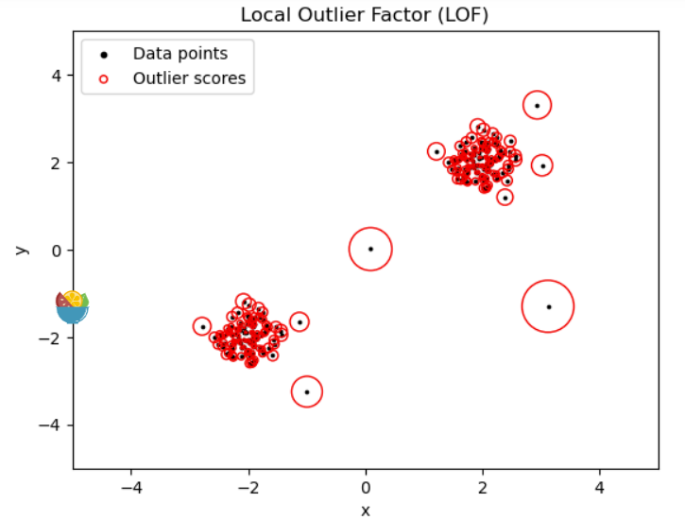This LOF score is used as an indicator reflecting the health state of the gearbox and the anomaly score for the following trend detection.

Figure 3‑2

### One-class SVM

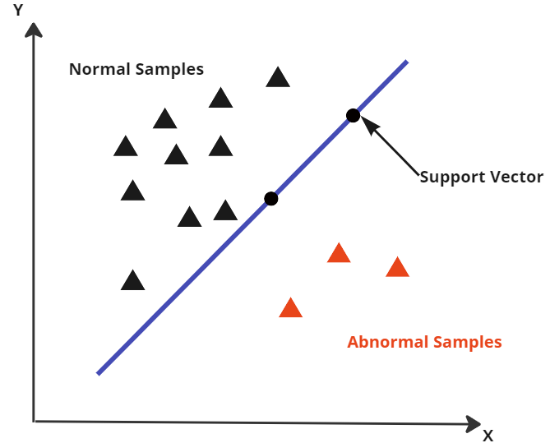Another algorithm applied in this thesis is the One Class Support Vector Machine (OCSVM), which is a variant of the Support Vector Machine (SVM). OCSVM generates a hyperplane around the training data and uses it to determine whether the test data points are closer to the normal class or an anomaly (McKinnon et al., 2020). In Figure 3.3, the boundary is determined by support vectors which are data points that are located near the boundary of the dataset. Since OCSVM is a boundary-based method, the performance of the anomaly detection model can be degraded if outliers are included in the training data (Guo et al., 2018). Therefore, the training data only consists of feature vectors in a normal state.

Figure 3‑3

To generate the anomaly scores for feature vectors, the distance of each data point to the hypersphere is calculated. This distance metric is a measure of the degree of similarity or likelihood of the data point belonging to the known data distribution. Data points with a small distance are close to the known dataset and are assigned low scores, while data points with a large distance are assigned high scores are more likely to be anomalies.

### Autoencoder

Autoencoders are a class of neural networks that consist of an encoder and a decoder. The encoder takes an input data vector and compresses it into a lower-dimensional latent representation, while the decoder maps this latent representation back to the original input space (Mortensen, 2020). During training, the encoder and decoder are jointly optimized to minimize the reconstruction error between the original input and its reconstructed output. This is typically done by using a loss function such as mean squared error or binary cross-entropy to measure the difference between the input and the output. The lower-dimensional representation learned by the autoencoder can be used as a feature vector for anomaly detection by comparing the reconstruction error of new data points to a predefined threshold. The architecture of the Autoencoder is shown in Figure 3-4 on a conceptual level.

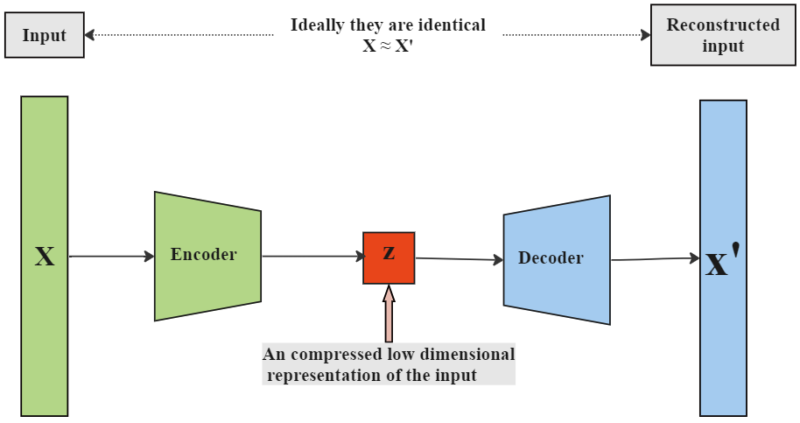Figure 3‑4

In this thesis, the autoencoder is trained on the dataset of normal data. For new data points, the reconstruction error is calculated and regarded as an indicator to detect anomalies.

## Anomaly Threshold

The anomaly threshold is a crucial parameter in anomaly detection, as it strongly affects the model's performance to detect the trends of failure in the gearbox, as well as avoid high false alarm rates. One method for setting the threshold is to use the 3-sigma rule, which is shown in Equation 3.7,

|  |  |
| --- | --- |
| $$P\left(μ-3σ≤v≤μ+3σ\right)≈0.997$$ | ( 3.7) |

where $μ$ and $σ$ are the mean and standard deviation of the distribution. The 3-sigma rule is a statistical hypothesis that suggests that in a normal distribution, 99.7% of all data points will fall within three standard deviations plus the mean (Chandola et al., 2009). This threshold needs to be high enough to capture most healthy data points but also allow for some tolerance for outliers.

In this thesis, two methods are used for trend detection: Moving Average and Linear Regression. The threshold for Moving Average is determined by calculating the upper bound of the 3-sigma rule based on the mean and standard deviation of the anomaly scores from healthy data points. Linear Regression uses the average slope of the linear regression model fitted with the anomaly scores of the training data from the gearboxes of six different joints.

The 3-sigma rule is a robust and statistically sound method that ensures that the anomaly detector can effectively detect anomalies while minimizing the number of false positives. With this approach, the proposed system can achieve high accuracy in detecting faults and provide reliable results.

## Trend Detection

In anomaly detection, trend detection is a crucial step for identifying whether a data point is an anomaly or not. This step involves smoothing out high-frequency noise in the anomaly scores and retaining the low-frequency trend. Two common methods for trend detection, Moving Average and Linear Regression are implemented in the thesis. After filtering, the anomaly scores are compared to a threshold determined by the training process to determine whether a data point is anomalous.

The Moving Average method involves calculating a rolling average of the anomaly scores within a sliding window of a specified size. The window is moved forward one data point at a time, and if the moving average scores exceed the threshold, an anomaly is detected (Nentwich & Reinhart, 2021).

Another approach is to use linear regression to fit the anomaly scores within a sliding window, finding the line of best fit through the data points (Nentwich & Reinhart, 2021). The slope of the line represents the rate of change or trend in the data. If the slope exceeds a threshold, the anomaly is detected. The sliding window moves forward one anomaly score at a time.

## Evaluation

The data used in the experiments are measurements recorded in gearbox wear tests of different types of robots, which are referred to as failure cases. One failure case consists of torque measurements collected from gearboxes on 6 joints of a single robot type, with information on the failure period and failure axis. Chapter 4 provides a detailed introduction to the available 4 failure cases. The first 10 measurements in each failure case are used as the training dataset, while the remaining measurements are used for testing the anomaly detection process.

To evaluate the performance of various combinations of anomaly scoring and trend detection models, a performance indicator matrix is generated using classic indicators: True Positive Rate, False Positive Rate, Accuracy, and F1 score. The predicted values are based on the anomaly detection results, while the actual values are determined by the failure period recorded in the failure case summary. Models that have high TPR, low FPR and high F1 score are considered to be more robust and effective at detecting anomalies in the data.

# Experiment

This chapter elaborates how experiments were performed, including the data collection, data pre-processing, feature extraction, model training and settings of model parameters. The experiments were conducted on 4 failure cases as the datasets, and failure case 2 will be used as an example to show the experiment process.

## Data Collection

The datasets used in this study were collected from repeatability tests designed to reveal any structural weaknesses in robot joints. During the wear test the robot is running constantly under high load and maintenance is performed when a breakdown occurs. The unique diagnostic routine involved repeatedly moving each joint by ±5°, while collecting system signals such as torque, feed-forward torque, and velocity in a sample period of T = 4.032ms.

The available datasets consist of 4 failure cases recorded in gearbox wear tests, each representing a different robot type. For example, failure case 1 recorded the data of a 6-axis robot from the ABB IRB 6700 family. This wear test was performed once a day over a period of one year, yielding a dataset where N is the total number test cycles.

|  |  |
| --- | --- |
| $$D_{FC1}=\left\{X_{1},X_{2},X_{3},…X_{N}\right\}$$ |  |

Given that the robot began in a healthy state, it was assumed that the first 10 measurements collected during the gearbox operation represented a normal state and were therefore used as a trained dataset. The remaining measurements were used as the test dataset for anomaly detection purposes.

|  |  |  |  |
| --- | --- | --- | --- |
| **Failure case** | **Robot type** | $$D_{Train}$$ | $$D_{Test}$$ |
| 1 | IRB 6700 | 60 |  |
| 2 | IRB 6600 | 60 | 4542 |
| 6 | IRB 6640 | 60 |  |
| 10 | IRB 6700 | 60 | 2952 |

Table 4‑1: failure case summary

## Pre-processing

In order to accurately detect abnormal behaviours, it may not be enough to simply extract features directly from collected measurements. To address this issue, the proposed system subtracts each new measurement from a reference measurement collected from the same axis, thereby generating a difference signal that highlights the subtle differences between the two measurements. By using the cross-correlation method in Section 3.1 to synchronize the signals before subtraction, the system can more accurately detect abnormal behaviours without signal noise. Figure 4.1 displays the difference signals obtained by subtracting the measurements from two different test cycles from the reference measurement. The blue line corresponds to the difference signal collected during the early stage of the wear test, while the red line corresponds to the difference signal was collected when the test already had conducted from a long time.

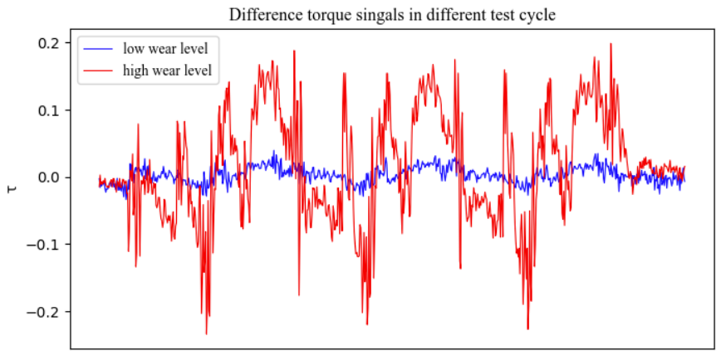

Figure 4‑1: Standardized torque $τ$ collected from different test cycles of failure case 10.

## Feature Extraction

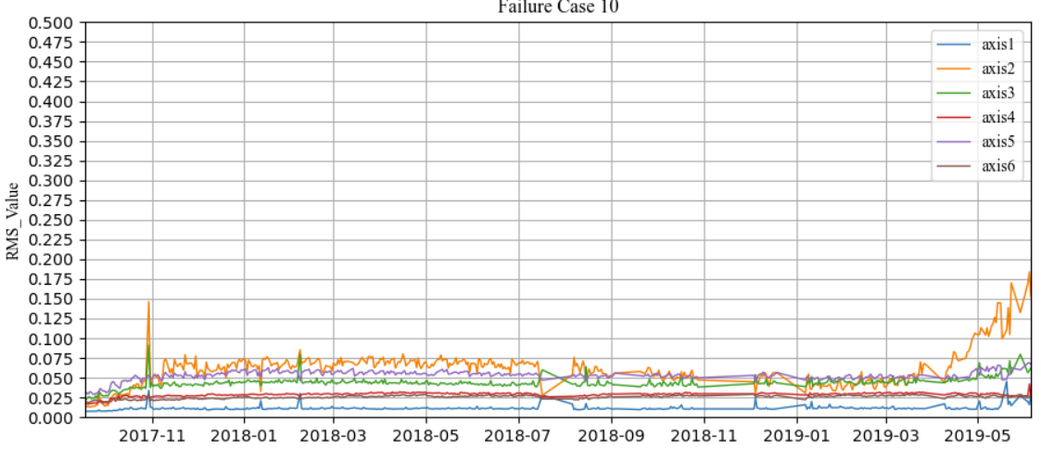

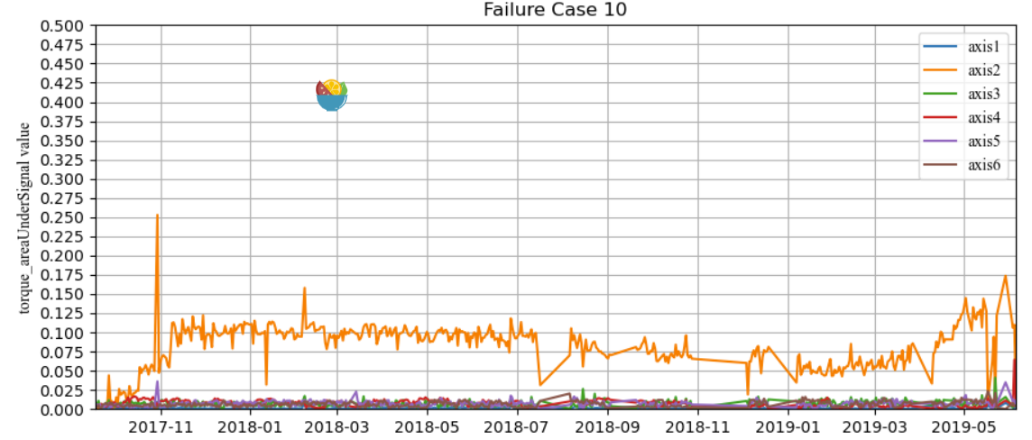

## Model Training

## Anomaly Detection