Dummy Title Page

Uppsala University Thesis Template for Word

For information please visit https://ub.uu.se/publish/thesis-support/

Dummy abstract page

Please register your abstract and publication details in DiVA:  
 https://uu.diva-portal.org/dream/info.jsf

| *Dedication* |
| --- |

List of Papers

This thesis is based on the following papers, which are referred to in the text by their Roman numerals.

1. Familyname, A., Familyname, B. (2008) Paper main title. Paper subtitle. *Name of journal in italics*, 1(2):3–4

Reprints were made with permission from the respective publishers.

Contents

Introduction 9

Abbreviations

α Alpha

Ω Omega

# Introduction

Robots are increasingly being used in diverse applications, from industrial automation to healthcare and beyond. The reliable operation of robots relies heavily on the proper functioning of mechanical components, including gearboxes that enable precise motion control. However, wear and degradation of gearboxes over time can impact the performance and lifespan of robots, resulting in costly repairs, downtime, and safety risks.

To address this challenge, condition monitoring (CM) system of gearboxes offers the potential to proactively detect wear and resolve the issue before failures occur. CM involves the monitoring of an asset's health using sensor data, where the health state represents the wear reserve before a failure occurs, and it is quantified with some health indicators (HI). Significant changes in this health indicator can be used as decision-making aids in planning maintenance actions.

Traditional fault detection methods based on model-based approaches often face challenges such as the need for handcrafted mathematical models and the presence of useless information in sensor data, which can affect the stability and accuracy of fault detection. To overcome these issues, data-driven methods, such as anomaly detection, have gained significant attention in the field of condition monitoring and fault detection due to their ability to automate and optimize the monitoring and detection process using sensor data.

The goal of this thesis is to explore the methods of anomaly detection in the context of CM for gearbox wear in robots. This involves the use of sensors, data analysis, and machine learning techniques to monitor the health of gearboxes and detect abnormal wear-related patterns.

### 1.1 Problem Formulation

As a joint wears, the friction between its moving parts usually increases. This results in a higher resistance to movement, which requires the motor driving the joint to work harder to produce the same level of movement. The additional effort required to overcome the increased friction corresponds to an increase in motor torque. Therefore, by monitoring the torque over time, it is possible to identify any changes or trends that may indicate wear in the joint.

Anomaly detection, also known as outlier detection, involves the identification of data observations that deviate significantly from the expected behaviour of the data. In this thesis, anomaly detection techniques can be utilized to identify wear patterns that are uncommon or unexpected, which may indicate abnormal joint wear or impending failures.

Anomaly detection techniques, when directly applied to the wear level data of robot joints, may result in high false alarm rates and reduced robustness of the conditioning system due to noise and abrupt changes being recognized as failures. To address this, trend detection is preferred as a more robust approach. Firstly, trend detection focuses on identifying consistent patterns in data that align with normal behavior, making it less sensitive to isolated fluctuations. Secondly, trend detection methods are designed to adapt to changes in data over time, allowing them to account for normal changes without considering them as anomalies. Thirdly, trend detection may rely less on training data and subjective threshold setting, making it more robust in situations where data is limited or subjective anomaly definitions are challenging. Additionally, trend detection methods often produce interpretable results, aiding in understanding and explaining the detected trends.

The imbalanced nature of wear level data in robot joints should be taken into consideration. For example, some joints may show anomalies for only a few days before the gearboxes are changed and return to a normal state. This imbalance can make traditional statistical analysis challenging, as wear data may not follow a normal distribution or have similar characteristics across all joints. However, anomaly detection techniques can still be feasible in this scenario.

### 1.2 Research Contributions

The main research contribution of this thesis is the development of a robust condition monitoring system for measuring the wear level of gearboxes in robots using data-driven methods, specifically machine learning techniques. Feature engineering methods are employed to extract descriptive features from the data, such as in the time, frequency, or time-frequency domain. Various machine learning models, including Support Vector Machines (SVM) and Local Outlier Factor (LOF), are implemented to obtain an appropriate conditioning indicator. Two trend detection methods are evaluated based on the generated indicators, and comparisons are made between different models to determine their effectiveness.

### 1.3 Thesis Outline

# Literature Review

## 2.1 Industrial Robot Condition Monitoring

Condition monitoring (CM) was initially developed in the 1960s for the American nuclear industry and then has been applied to a range of industrial systems (Wild, 1994). CM can be carried out online, concurrently with normal system operation, or offline, requiring the system to be run in a particular manner. It involves monitoring an operational asset and analysing the obtained data to detect signs of degradation, diagnose faults, and predict remaining useful life (Beebe, 2004). As shown in Figure 1.3, CM typically involves acquiring data through sensors, processing and analysing the data, and generating alerts or recommendations based on the results. With the rise of Industry 4.0 and the Internet of Things, CM has become increasingly important for ensuring reliable and efficient operation of complex industrial systems.

In terms of Condition monitoring, anomaly detection can be classified into two categories, model-based approach and data-driven approach. The model-based fault detection approach is a widely used technique that involves developing a mathematical model of the system under observation and comparing its outputs with the actual system outputs to detect faults. This approach assumes that a fault in the system will lead to deterministic changes in the model parameters, which can be used to generate a residual signal and extract relevant information (Ding, 2008). While the model-based approach has been successful in many applications, it requires accurate modelling of the system and may not be suitable for systems with complex or uncertain dynamics.

In recent years, data-driven approaches have gained popularity for fault detection in industrial systems. Data-driven approaches use machine learning algorithms to analyse sensor data and identify patterns or anomalies that may indicate a fault. These approaches do not rely on a priori knowledge of the system dynamics and can adapt to changes in the system behaviour over time. Additionally, they can handle large volumes of data and are less sensitive to modelling errors than model-based approaches (Gao et al., 2015).

## 2.2 Data-driven Anomaly Detection

# Methodology

## 3.1 Combined Anomaly and Trend Detection Model

The Combined Anomaly and Trend Detection Model is a novel approach to condition monitoring for robots that uses anomaly detection methods to generate anomaly scores for incoming data. Anomaly detection is based on unsupervised machine learning methods, such as K-means clustering and One-class SVM, which can identify anomalies in real-time after capturing the normal behaviour of the robots.

This system uses anomaly scores to detect faults because it can provide a more flexible and interpretable approach to anomaly detection (Li, et.al, 2020). First, the normal behaviours are learned from the training measurements. Then, for each test measurement, the anomaly score is calculated based on the trained model introduced in section 3.X. A classifier may be biased towards the majority class and may not be able to accurately predict the rare anomalies. Anomaly scores, on the other hand, are based on the degree of deviation from the norm and can be more robust to imbalanced data.

To avoid false positives caused by isolated fluctuations, the model also incorporates trend detection methods to analyse the overall behaviour of the anomaly scores over time. The trend detection algorithms are based on statistical methods, such as the moving average (MA), which can detect long-term trends and changes in the robot’s health state.

The approach used in this research differs from classical methods as it adopts a semi-supervised approach for detecting anomalies. Classical methods typically rely on supervised algorithms that require labelled data to train the model on normal and abnormal data. Recent research on anomaly detection in the industrial field has paid more attention to unsupervised or semi-supervised learning (Chandola, Banerjee, & Kumar, 2009). This is because it is challenging to capture and label all possible failures in recorded data and acquire enough training data to train an accurate model (Khalastchi, 2018). Furthermore, the accuracy of data labels can be influenced by the knowledge and expertise of a human expert. Therefore, it is preferred to develop a real-time monitoring system which trains the model with recorded normal datasets and test the model for the coming data points.

## 3.2 Model Design

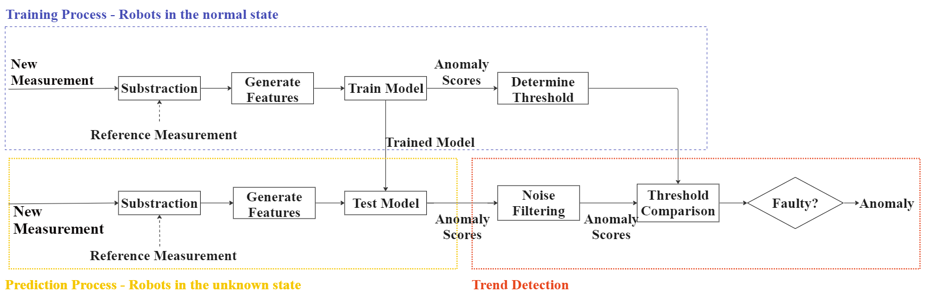The proposed method shown in figure 3.1 involves a two-stage process: model training on historical healthy data and real-time anomaly detection.

The model training stage involves learning the normal behaviour of the robot joints by training the features extracted from recorded healthy measurements. It is assumed that the robots are in a healthy state at the beginning of the diagnostic routine and the measurements for training are taken during the initial test cycles. The first measurement serves as a reference measurement, which is used as a baseline for comparison. Each subsequent measurement is subtracted from the reference measurement to generate a difference signal, and feature engineering techniques are applied to generate relevant features. These features are used to train different models, generating anomaly scores to determine the threshold.

During the real-time anomaly detection process, the new measurements are processed one at a time. The new measurement is still subtracted by the reference measurement and the same features are extracted from the measurement. Then the features are used in the trained model to generate anomaly scores.

In the trend detection step, filtering method such as Moving Average essentially acts as a filter that smooths out high-frequency noise in the scores and retains the low-frequency signal or trend. The anomaly scores are compared with the threshold determined by the training process. If the anomaly score exceeds the threshold, the system flags an anomaly.

## 3.3 Feature Engineering

### 3.3.1 Data Scaling

Raw data can come in many different formats and ranges, which can impact a model's interpretation of the data and affect its performance. Therefore, it is necessary to pre-process the data before feeding it into the models. Standardization is shown in Equation 3.1 where xˆ is the raw torque data before standardization, µ and $δ$ are the mean and standard deviation of the reference measurement. is a commonly used method for scaling features, allowing for fair comparison and more efficient model training. Standardization also helps to prevent features with larger ranges from dominating the learning process compared to those with smaller ranges. By standardizing the features, the model can more accurately identify patterns and relationships in the data, leading to better predictive performance.

$$x = \frac{xˆ- µ}{δ}$$

### 3.3.2 Cross-correlation

Simply extracting features directly from the collected measurements may not capture the subtle differences between normal and abnormal behaviours. Instead, the system is subtracting each new measurement from a reference measurement to generate a difference signal (Večeř, Kreidl and Šmíd, 2005), which highlights the differences between two measurements. However, there might be slight phase difference between the reference measurement and new measurement as the start positions of axes cannot be identical in each test cycle. This may add more noise to the difference signal and increase false positives or false negatives when detecting abnormal behaviours. By using cross-correlation to align the signals before subtraction, the system can more accurately detect ab-normal behaviours in the robot joints and improve the overall performance of the system.

Firstly, the measurements are normalized by subtracting the mean and dividing by the standard deviation to eliminate any scaling differences. Cross-correlation is then performed by calculating the product of the two measurements shifted by a time lag, resulting in a new signal showing similarity at each time lag (Oppenheim, 1999). The time lag corresponding to the maximum cross-correlation value is determined to represent the necessary shift to synchronize the signals. Finally, one of the signals is shifted by the calculated lag amount to align the signals.

### 3.3.3 Feature Selection

In this thesis, Root mean square (RMS), Standard Deviation (Std), and Area Under Signal are the features used as indicators of the gearbox's health.

The RMS feature is a measure of the signal's amplitude. For example, an increase in the RMS value may indicate that the machine is encountering an obstacle or a large load, which can cause the machine to operate outside its normal range. According to Equation 3.2, RMS is hardly affected by isolated peaks and thus isn’t sensitive to noise (Večeř, Kreidl and Šmíd, 2005). By monitoring the RMS value, it is possible to record the overall condition of robot’s gearboxes.

The standard deviation feature measures the variability of the torque signal around the mean, which can be used to detect changes in the machine's operating conditions (Nentwich and Reinhart, 2021). If the wear level of the gearbox increases, the robot may produce a torque signal with a higher standard deviation than the normal torque signal. Similar to RMS, STD can detect the change of the condition of gearbox.

Area under signal: The area under the signal feature measures the total energy in the torque signal. This feature can be useful for detecting anomalies that result in a change in the overall energy or effort required by the robot. For example, if a robot's motor becomes less efficient or experiences friction, it may require more energy to produce the same torque signal, resulting in a higher area under the signal value.

## 3.4 Indicator generation methods

### 3.4.1 Centroid-based Clustering

Briefly explain classical K-means clustering, an unsupervised algorithm.

A modified version of K-means clustering where you only have one reference cluster, and its centroid is used as a fixed reference point. This approach can be useful for detecting outliers or anomalous data points that deviate significantly from the reference cluster.

Keep in mind that the effectiveness of this method depends on the choice of the reference cluster and the distance metric used to measure the deviation of new data points from the centroid.

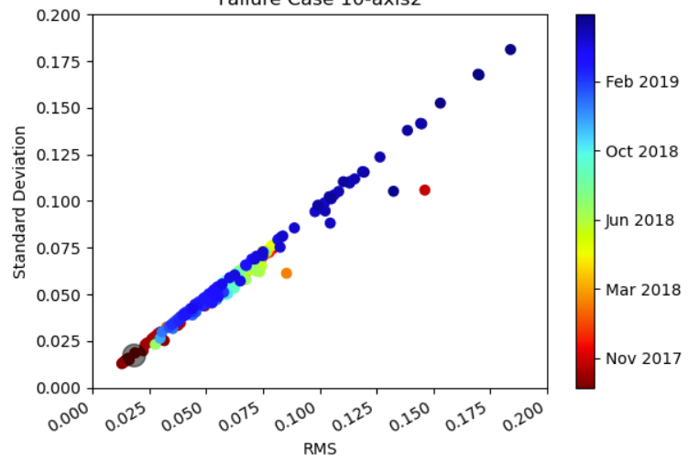

### 3.3.3 Local Outlier Factor

To monitor the condition of the robot joints, the Classic Local Outlier Factor (LOF) method was applied to identify any abnormal or unexpected behaviour in the joint movements. Time-series data of joint movements were collected over a period of time and the LOF scores were calculated for each joint movement data point based on the densities of its local neighbourhoods. A joint movement data point with a high LOF score was considered an outlier, indicating that the movement was significantly different from the normal patterns of joint movements, suggesting that there may be an issue with the joint or the robot.

By monitoring the LOF scores of joint movement data points over time, potential changes or trends in the joint behavior that could be indicative of developing issues or abnormalities were detected. This analysis allowed for the identification of potential problems with the joint or the robot before they become more serious, thereby improving the reliability and safety of the robot.

### 3.3.4 One-class SVM

One-Class Support Vector Machines (SVM) is a machine learning technique that can be used for anomaly detection in data. In the context of condition monitoring of robot joints, one-class SVM with novelty detection can be used to identify novel or unexpected behavior in the joint movements.

To apply one-class SVM with novelty detection to the condition monitoring of robot joints, the model is trained on a set of joint movement data points that are considered normal or healthy. The model then uses this normal data to define a decision boundary that separates the normal data points from potential novel data points.

### To calculate scores for new data points, the algorithm measures the distance of each data point to the center of the hypersphere. This distance can be interpreted as the degree of similarity or likelihood of the data point belonging to the known data distribution. Data points with a small distance are considered to be similar to the known data and are assigned low scores, while data points with a large distance are considered to be dissimilar and are assigned high scores.

### 3.3.5 Autoencoder

Autoencoders are a type of neural network that can be used for unsupervised learning tasks such as anomaly detection. The basic idea behind using autoencoders for anomaly detection is to train the autoencoder on a dataset of "normal" data, and then use it to reconstruct new data samples. When an anomaly is present in the data, the autoencoder will be less able to reconstruct the sample, indicating that it is an outlier or anomaly.

The methodology for using an autoencoder for anomaly detection can be divided into several steps:

1. Data preparation: The first step is to prepare a dataset of "normal" data samples. This dataset should be representative of the typical behavior of the system or process being monitored. In addition, a separate dataset of anomalous data samples should be prepared for testing the autoencoder's ability to detect anomalies.
2. Autoencoder training: Once the datasets are prepared, an autoencoder can be trained on the normal data using an unsupervised learning algorithm such as backpropagation. The autoencoder consists of an encoder network that compresses the input data into a lower-dimensional representation, and a decoder network that reconstructs the input data from the compressed representation. During training, the autoencoder is optimized to minimize the difference between the input data and its reconstruction.
3. Anomaly detection: After the autoencoder is trained, it can be used to detect anomalies in new data samples. When a new sample is input into the autoencoder, the reconstructed output is compared to the input. If the difference between the input and the reconstruction exceeds a certain threshold, the sample is flagged as an anomaly.
4. Evaluation: Finally, the performance of the autoencoder in detecting anomalies can be evaluated using the separate dataset of anomalous data samples. Metrics such as precision, recall, and F1 score can be used to assess the accuracy of the autoencoder in detecting anomalies.

### 3.4 Trend Detection

### 3.4.1 Moving Average

In moving average, a rolling average of a specified number of data points is calculated and plotted on a chart. The rolling average is calculated by taking the average of the data points within a sliding window of the specified size, and then moving the window forward one data point at a time. This process creates a smoothed line that follows the general trend of the data, while filtering out the noise and short-term fluctuations.

### 3.4.2 Linear regression

In linear regression, a line of best fit is drawn through a set of data points. The slope of this line represents the rate of change or trend in the data. A positive slope indicates an upward trend, while a negative slope indicates a downward trend.

# Evaluation

# Experiment

## 4.1 Data Pre-processing

In this study, the datasets used were collected from repeatability tests for robots. The measurements were obtained during unique diagnostic routines, which were specifically designed to reveal any structural weaknesses of the robot joints. The robot has 6 joints with each joint moving repeatedly by ±5°, while system signals such as torque, feed-forward torque, and velocity were collected in a sample period of T = 4.032ms.

Simply extracting features directly from the collected measurements may not capture the subtle differences between normal and abnormal behaviours. Instead, the system is subtracting each new measurement from a reference measurement to generate a difference signal, which highlights the differences between the two measurements. There might be slight phase difference between two consecutive measurements as the start positions of axes cannot be identical in each test cycle. This may add more noise to the difference signal and increase false positives or false negatives when detecting abnormal behaviours. By using cross-correlation to align the signals before subtraction, the system can more accurately detect abnormal behaviours in the robot joints and improve the overall performance of the system.

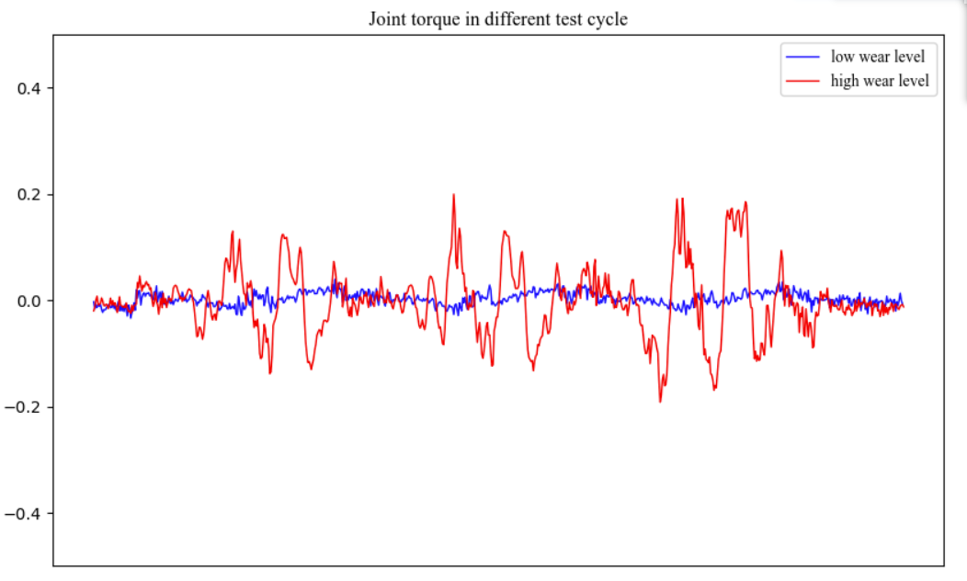

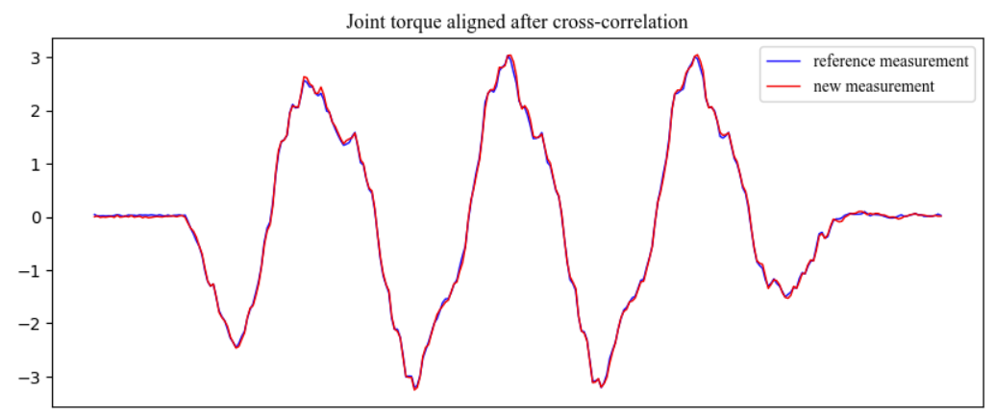

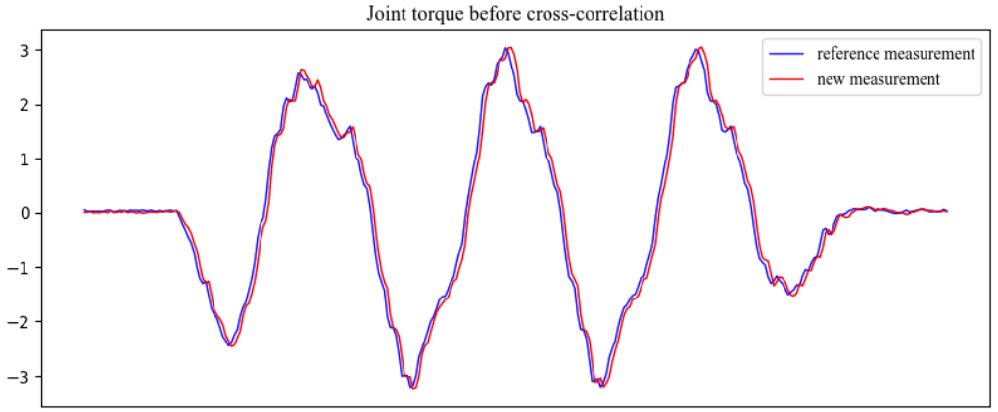

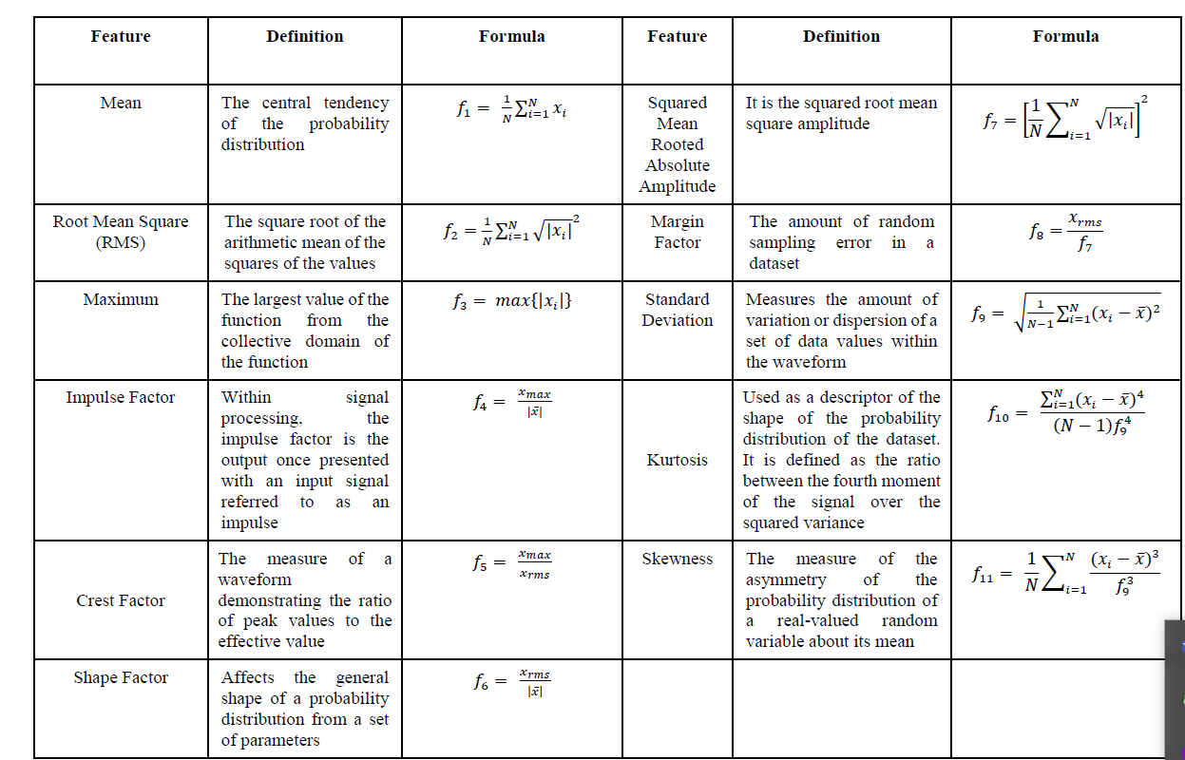

## 4.2 Feature Selection

RMS:

Standard deviation:

Area under signal:

## 4.3 Model Evaluation

