[Project Title]

Corban Hirawani

|  |  |
| --- | --- |
| Project team | [add team members here] |
|  |
|  |
|  |
| 22/08/2017 |
| Date last revised | [add date last time document changed] |

Table of Contents

Table of Contents 2

Executive Summary 3

Project Team 4

Project Objectives 5

Scope 6

Deliverables 9

Major Tasks and Milestones 10

Resource Requirements 11

Software Requirements: 11

References 12

Project Proposal Approval 13

# Executive Summary

The scope for this project is to create an Endless Vertical Scrolling 2D bomber game in the Unity Game engine a high score system, a pause menu and GUI.

* Player is a fighter plane from the top down view that is facing forward.
* Enemies shoot at player: Planes, ships, and turrets.
* Player will pick up power ups that increase the amount of bullets projected.
* Scrolling Endless environment/background
* The player can move up, down, left and right with the WASD keys, and up and down tiers with the R and F keys.
* The player can shoot with the spacebar
* Enemies will drop power ups when they die at random.
* When enemies die the player gains points towards their score.
* When the player dies their score will be saved into the high scores rankings if it is within the range of top 10.
* **Main menu**, Options include: Start game, view high scores, and exit.
* **Pause menu**, Options: Resume game, Restart, Exit to main menu, exit to desktop
* **Two layer System**, Top layer can shoot forward at planes, and bomb lower at ships/turrets, Slower movement and bigger target, Bottom layer can only shoot forward but has faster movement and smaller target.

The Game assets (Player, enemies and environment) will be created in Photoshop,

And then animated in the Unity engine.

Skills needed include: Knowledge of the Unity engine and C# scripting, and Photoshop Skills.

I will also need to research procedural generation techniques for the endless level environment, and AI techniques for the enemies that spawn.

# Project Team

|  |  |  |  |
| --- | --- | --- | --- |
| Team members | Name | Email | Telephone |
| Corban Hirawani | Cmh193@edu.waiariki.ac.nz | 0272672267 |
|  |  |  |
|  |  |  |
|  |  |  |

# Project Objectives

|  |  |
| --- | --- |
| [Objective] | [Description of the objective…] |
| 1. Sprites created 2. Scrolling Endless environment/background created 3. Player movement script 4. Player shooting script 5. Enemy AI 6. Collectable Gun or Power-ups 7. Particle effects 8. Scoring System in place 9. High scores system 10. Menu/UI | 1. Player and player health bar, Enemies, Bullets, etc. Drawn in Photoshop and then composed in Unity 2. Background moves towards user to create the illusion that the player is moving forward. 3. Player can move up/down/left/right (WASD Keys), It is independent of the background, can also move up and down (R, F) to one of the 2 layers (ground, air). 4. Bullets are visible, changes depending on power-up, The ship can shoot forward depending on what level they are on (ground or air), and can bomb downwards to a lower level. 5. Player loses 25% of life bar when shot by enemy, The longer the player lasts, the more enemies spawn 6. Increase the player weapons range and power 7. For when the gun shoots and bullets hit 8. The player collects score when they shoot an enemy 9. When the player dies their high score will be saved to the leader board if it is higher than the top 10 saved 10. The game will have an opening menu with an option to start game, view high scores, or exit. The in-game pause screen will have a Reset button, an exit to menu button, a resume button, and an exit to desktop button |

# Scope

The scope for this project is to create an Endless Vertical Scrolling 2D bomber game in the Unity Game engine a high score system, a pause menu and GUI.

* **Player sprite**; a fighter plane from the top down view that is facing forward.

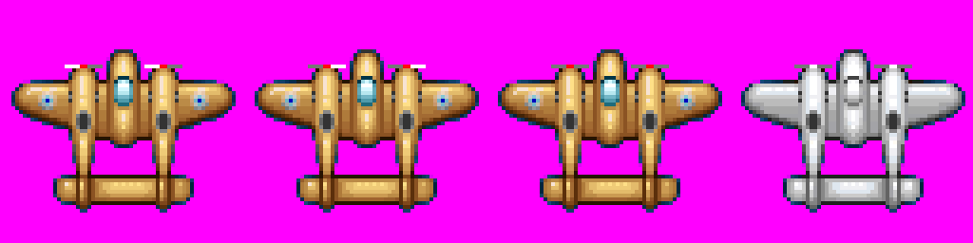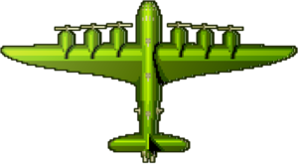

* **Player health bar**, player will lose a percentage of their health bar depending on what enemy hit them, a plane bullet will take away 25% and a turret shot will take away 50%, crashing into a plane or turret head on is instant death (100%).
* **Enemy sprite(s)**, Similar to player sprite but they will be flying towards the player, turrets that are mounted on boats or bunkers will also be included on a less frequent basis than the aeroplanes

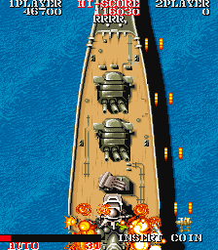

* **Bullet sprite**, player will pick up power ups that increase the amount of bullets projected.

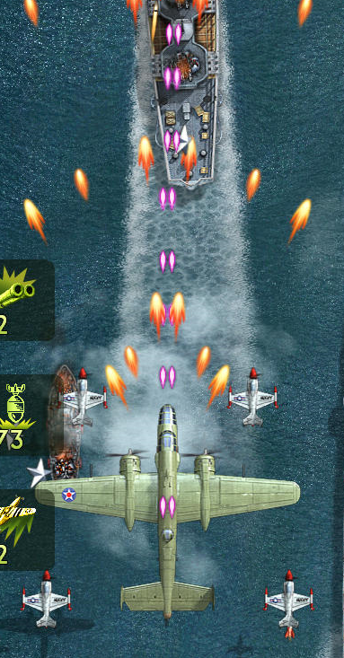

* **Scrolling Endless environment/background**, the purpose of this game is to survive as long as possible to get the highest score, so a procedural approach to generating content would be ideal because it can be infinite.
* **Player movement script**, The player can move up, down, left and right with the WASD keys, and up and down tiers with the R and F keys.
* **Player shooting script**, The player can shoot with the spacebar
* **Enemy AI Script**, The enemies will come from the top of the screen and shoot downwards, player can dodge these bullets by moving if they are fast enough.
* **Collectable Gun or Power-up sprite and scripts**, Enemies will drop power ups when they die at random, at least three different power up should exist. For example: Double bullets instead of one, an extra missile launched from the centre of plane and increased fire rate.
* **Particle effects for when the gun shoots and bullets hit**

**\\MokStu\Users\2008\2008003000\2008003866\My Documents\Desktop\xp.png**

* **Scoring System in place**, When enemies die the player gains points towards their score.
* **High scores in menu**, When the player dies their score will be saved into the high scores rankings if it is within the range of top 10.
* **Main menu**, Options include: Start game, view high scores, and exit.
* **Pause menu**, Options: Resume game, Restart, Exit to main menu, exit to desktop
* **Two layer System**, Top layer can shoot forward at planes, and bomb lower at ships/turrets, Slower movement and bigger target, Bottom layer can only shoot forward but has faster movement and smaller target.

**Discussion/notes with Bruce and Paul:**

Game Mechanic Idea

•         Research ‘Layer’ system.

•         Allow player to traverse to higher or lower layers

•         If you are on high layer, enemy attacks are slower and scale of sprite is larger, but gets smaller if on lower layer.

**Bottom Layer**

•         Setting Player Boundaries (as screen is constantly moving down)

•         Randomly generated and placed tile sets

•         Player movement does not control background movement

•         Look into background movement layer  speeding up over time

•         Random Island tiles with colliders

•         Animate islands (volcanos), turrets

•         Turrets to face and attack player

•         Randomly generate turrets on island

•         Player ship health bar

•         Player ship weapon system, shooting and bombing (dynamics of bullets, bombs and missile)

•         Player ship defences (shields)

•         What happens on collisions? Destroy animation?

•         Destroy all turrets on islands or sideways battleship to be able to move past.

# Deliverables

|  |  |
| --- | --- |
| [Deliverable] | [Description of the deliverable…] |
| 1. Sprites created 2. Scrolling Endless environment/background created 3. Player movement script 4. Player shooting script 5. Enemy AI, They shoot at players 6. Collectable Gun or Power-ups 7. Particle effects. 8. Scoring System in place 9. High scores system 10. Menu/UI | 1. Player and player health bar, Enemies, Bullets, Boats, turrets. 2. Background moves towards user to create the illusion that the player is moving forward. 3. Player can move up/down/left/right (WASD Keys), It is independent of the background, can also move up and down (R, F) to one of the 2 layers (ground, air). 4. Bullets are visible, changes depending on power-up, The ship can shoot forward depending on what level they are on (ground or air), and can bomb downwards to a lower level. 5. Player loses 25% of life bar when shot by enemy, The longer the player lasts, the more enemies spawn 6. Increase the player weapons range and power 7. For when the gun shoots and bullets hit 8. The player collects score when they shoot an enemy 9. When the player dies their high score will be saved to the leader board if it is higher than the top 10 saved 10. Opening menu with an option to start game, view high scores, or exit. The in-game pause screen will have a Reset button, an exit to menu button, a resume button, and an exit to desktop button |

# Major Tasks and Milestones

1. Proposal document
2. Player Sprite and player health bar created
3. Player Movement Script
4. Player Shoot script
5. Enemy Sprite Created
6. Enemy Movement script
7. Enemy shoot script
8. Power up sprite
9. Power up script
10. Particle effects for gunshots and bombs
11. Main Menu Image Created
12. Start Game Button Working
13. Exit Button working
14. Pause Menu Image created
15. Game pause when esc pressed
16. Restart button working
17. Exit to menu button working
18. Exit to desktop button working
19. Scoring system
20. High Scores

# Resource Requirements

# Software Requirements:

1. Photoshop for art assets

2. Unity game engine

I need to learn:

1. C# scripting

2. Environment Procedural generation techniques

3. GUI creation

# References

C# Scripting Tutorials: <https://unity3d.com/learn/tutorials/s/scripting>

Sprite editing software: <http://pyxeledit.com/about.php>

Unity Engine: [https://unity3d.com/](https://unity3d.com/learn/tutorials/s/scripting)

# Project Proposal Approval

I agree that the scope, objectives, resource estimates and plans given in this project proposal describe my general requirements for the project. I understand that this is a student project and that Toi Ohomai and the students will endeavour to provide the solution described but for whatever reason may not be able to do so.

|  |  |  |  |
| --- | --- | --- | --- |
| Supervisor Name |  | | |
| Supervisor Signature |  | **Date** |  |
|  |  | | |
| Project Team Name |  | | |
| Project Team Signature |  | **Date** |  |