**LEDA ATOMICA**

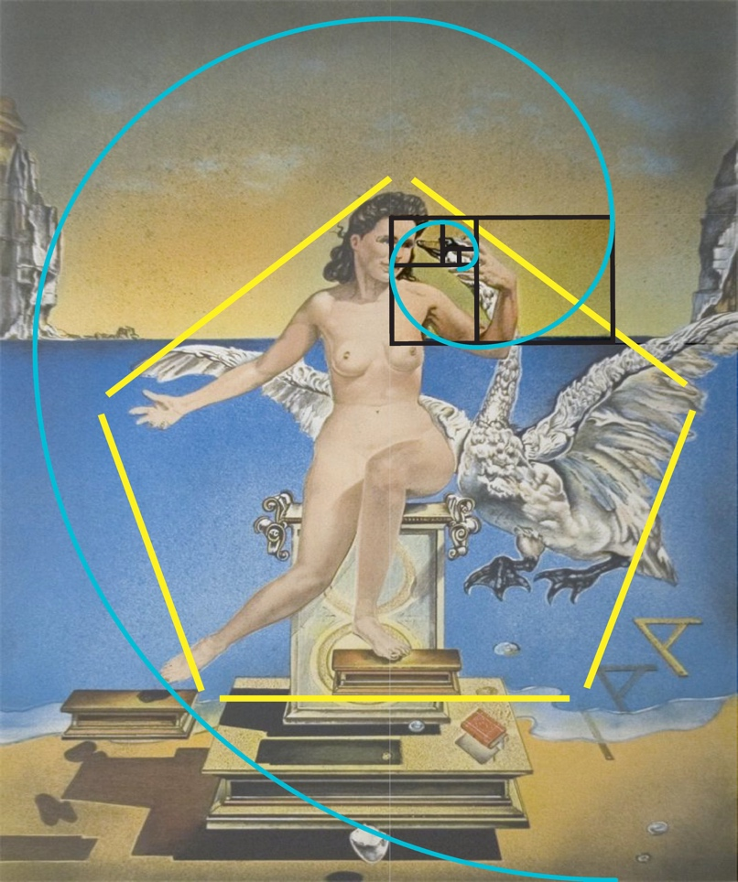

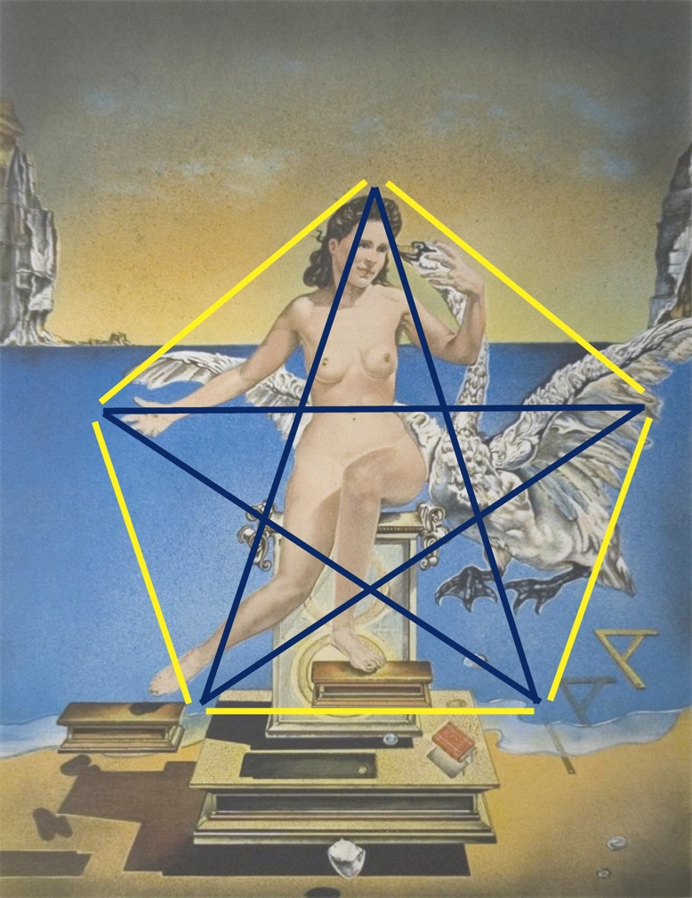

1. Leda (the main muse of this painting) and the swan sit inside a pentagon. On connecting the vertices of the pentagon, we get a star.
2. The five points of the star or the five vertices of the pentagon symbolise the origins of perfection: truth, willpower, order, love, and action.
3. It is another piece of art based on the concept of golden ratio, which means that (areas of) regions of the painting, are in the ratio (1+**√5)/2 which is roughly equal to 1.618.**

About(swipe up info)

Leda Atomica is a painting by Salvador Dali made in 1949. The picture depicts Leda, the mythological queen of Sparta, with a swan.

Leda was admired by Zeus who seduced her in the guise of a swan on her wedding night when she slept with her husband Tyndareus(the king of Sparta). This double consummation of her marriage resulted in two eggs, each of them hatching twins.

**Mona Lisa**

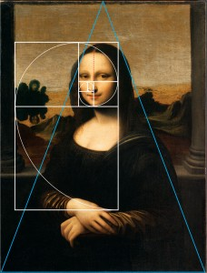

1. If a rectangle is drawn around the face of the ‘Mona Lisa’, the ratio of the height to width of that rectangle is equal to the ‘Golden Ratio’.
2. The legs of the (blue) triangle are shown correctly placed in the lower corners, and the peak bisects the width of the painting at the top. Now, that ‘Golden Ratio’ diagram is applied. It nestles against the edge of the left column, and, coming across the top of her head, exactly meets the leg of the triangle.
3. At the same time, the spiral beautifully frames her face, with the rounded side on the right, and the vertical side on the left. Also, the spiral winds from the tip of her nose, grazing the bottom of her chin, and all the way around to her right arm, from elbow to thumb.

About(swipe info)

The Mona Lisa  bears a strong resemblance to many renaissance depictions of the Virgin Mary, who was at that time seen as an ideal for womanhood. The woman sits markedly upright in a "pozzetto" armchair with her arms folded, a sign of her reserved posture. Her gaze is fixed on the observer. The woman appears alive to an unusual extent, which Leonardo achieved by his method of not drawing outlines.