**Assessment 2 Work – Corbin.**

Project Description:

Our team, Code Name Bricks, is planning to create a 2D game in Java. We aim to create a side-scrolling, platformer that is based on a scrap yard wherein the scrap has come to life and must fight for its dominance against the other metallic creatures of the yard. The Player will control one of these said creatures and must collect other pieces of scrap as it moves throughout the levels to fight against its opponents and keep itself alive. The pieces of scrap that it finds will be used as its ammunition, and as the main contribution to its health, meaning that the Player must manage its scrap levels to not only defend itself but also to keep itself alive. We also intend to create a feature that causes the Player to slow down and become an easier target with the more scrap that it has on-hand, so managing scrap levels and never holding too much is the key to survival. This means the Player may never stock-pile ammunition or health, a potential issue with this style of game that may lead to “broken” game mechanics.

The fundamental features of this game are:

* That the player may move and gain or lose health.
* Enemies move and pursue the player to attack them.
* That the levels are in the format of side-scroller/platformer.
* The attack is a projectile.
* Pixelated graphics made by us.

If time permits, we would also like to include a few ancillary features that are not fundamental to the gameplay but would bolster and polish the overall experience. These include:

* The players speed alters as their level of scrap increases/decreases. This creates a sense of needing to manage the characters scrap level to never hoard while also never allowing their health to become too low.
* Altering affects caused by picking up certain pieces of scrap. For example: scrap that makes the Player faster, slower, jump higher, lose health-over-time, or improve the effectiveness of its attacks.
* A soundtrack that will play in the background that hopefully changes as the Player moves through parts of the levels and sounds that respond to player input and actions that are performed in-game.
* A HUD that is always displayed during gameplay that shows the characters scrap level with a dynamic animation, and a pause menu that can be accessed at any point during the game.

But more on these features further in our report.

Though our experience levels writing in Java differ dramatically, some much more advanced than others, it is something that we all have programmed in and feel we can gain something from. Some of us will be responsible for basic programming, possibly focusing on only a few classes, and others have the responsibility of overall game mechanics and planning the class structure of the program. Some of us will even focus on creating parts of the game that are not necessarily associated with the performance of the program itself i.e., graphics sprites, the soundtrack, project planning etc. This means that we all have something to gain from this project and can collectively improve our technical, and IT industry proficiency.

**Listing Technologies.**

Collaborative Workspaces.

**Microsoft Teams.**

This is our primary method of communication. We hold all of our weekly group meetings and mentor meetings in this workspace, use it regularly for communication, and collaboratively work on documents required for our project.

Company: Microsoft.

Latest version: No version information available.

Cost: $0.

Link: <<https://www.microsoft.com/en-AU/microsoft-teams/group-chat-software>>

**GitHub.**

Our team performs regular uploads of our program code to GitHub to collaboratively work on our program. It allows us to dynamically accept and merge work done by our team mates, update others work to our local files, and revert to previous versions should we experience issues with any changes made to our build.

Company: GitHub.

Latest version: No version information available.

Cost: $0.

Link: <<https://github.com/>>

Project Repository: <<https://github.com/RossRRMIT/BITS_SP1_Group10_2DGame>>

**Eclipse IDE.**

We have chosen to use Eclipse IDE as the workspace that we will use to program our game in. We have chosen it becuase of our shared fimiliarity with its features, and because it is a proficient tool for what we require it for. It allows us to break our program into smaller classes that we can work on independently, then load them into GitHub to provide collaboratibility.

Company: Eclipse Foundation.

Latest version: 2021-03.

Cost: $0.

Link: <<https://www.eclipse.org/>>

**Trello.**

Trello is a task allocation and tracking collaboration tool that our team uses quite significantly. We use it to separate the tasks into our own personal areas, collaboratively track how each other is going, and upload assets and documents so they can be accessed and viewed by one another.

Company: Atlassian.

Latest version: No version information available.

Cost: $0.

Link: <[https://trello.com](https://trello.com/)>

Software.

**Java SE 16**.

We are using the latest Java release as the language to write our program in. It is a powerful, highly flexible language that allows us to create a game within our shared ability levels that is still complex and inidicative of our projects goals.

Company: Oracle.

Latest version: 8.

Cost: $0.

Link: <[https://www.java.com/en/](https://www.java.com/en/%22%20/t%20%22_blank)>

**LWJGL (Light-Weight Java Gaming Library).**

We are using the highly complex and powerful LWJGL to assist us in creating our project. It is a library that contains multiple API’s geared towards producing high-fidelity 3D games. Though we are not creating a 3D game, many of the features are still useful to us in order to create a functionally polished game.

Company: LWJGL.

Latest version: 3.2.3.

Cost: $0.

Link: <[https://www.lwjgl.org/](https://www.lwjgl.org/%22%20/t%20%22_blank)>

The main features we have chosen to use include:

* [OpenAL](http://openal.org/):

An audio library originally created for C/C++ that has been translated for use with Java. It handles loading audio data from file, storing the data, playing sounds dynamically in a 3D space, and managing memory.  

* [OpenGL](http://opengl.org/):

OpenGL is a popular library with a lean API that exposes functions allowing programmers to buffer data to the GPU for rendering, commonly this information will be in the form of “vectors”, populated with “floating-points” as GPU’s excel at floating-point computation. OpenGL supports a lot of modern day graphic technologies such as shaders and numerous other advancements. OpenGL supports both 2D and 3D vector graphics.  

* [NanoVG](https://github.com/memononen/nanovg):

A vectorized rasterization library for 2D graphics. This library is built around OpenGL and exposes an API for programmers to utilize, allowing them to easily create basic geometry shapes such as rectangles, circles, and triangles. This library rasterizes these shapes into vectors which OpenGL will interpret and buffer for the GPU to render.  

* [NanoSVG](http://nanosvg/):

A library that will parse a supplied SVG coordinate list and rasterize into geometry shapes that are supported by the SVG standard, much like NanoVG this library exposes an easy API for programmers, this library however does not depend on any external libraries such as OpenGL, instead this library simply parses supplied data, rasterizes and vectorizes it, and returns it as an array that a programmer can iterate over and implement in any way they see fit.  

SVG is a popular file format that describes “points” and “shapes” which forms “icons” or “images”, commonly SVG is used in the web space by front-end developers and provides theoretically infinite scalability, ideal to suit the technological push towards higher resolution displays and increased pixels-per-inch (PPI) or dots-per-inch (DPI).  

* [STBVorbis](http://stbvorbis/):

STB Vorbis is a small library created by Sean Barrett, also known as “nothings”, it is originally a single-header library for the programming language C and Vorbis is designed to parse the .ogg file format and extract relevant information from the sound file format, examples being the number of channels, the format the audio is encoded in, frequency, length, and other numerous things. LWJGL has converted this single-header C library into Java and gives us the choice to include it in our configuration.

Tools.

**Lucid App (Lucid Chart).**

We have chosen Lucid Chart as our diagram production tool. All of the diagrams you see in this report are created in Lucid. It is a highly flexible diagram production tool with a wide array of features allowing us to create in-depth, explanatory visualtizations of our program structure. Our team has chosen UML as our diagram standard.

Company: Lucid Software Inc.

Latest version: No version information available.

Cost: $0 - $11/month.

Link: <<https://lucid.co/>>

**Figma.**

Figma is a design tool that is directed at creating wireframes and visual prototypes of digital applications. It has allowed us to create highly descriptive visual representations of actions within our games and share our ideas with one another. This helps us to maintain a clear vision of the requirements of our project and to not waste time on unnecessary activities.

Company: Figma.

Latest version: No version information available.

Cost: $0.

Link: <<https://www.figma.com/>>

**ShareX.**

ShareX is a screen capture tool that primarily allows for screen capture, be it screenshots or recordings, though is has many other functions including but not limited to image and video alteration, uploading to external repositories, debugging, gif creations and conversion, FFMPEG, and many other capabilities.

Company: ShareX Team.

Latest version: 13.4.0.

Cost: $0.

Link: <<https://getsharex.com/>>

**Photoshop.**

Photoshop is used as a digital editing software, using various tools, Pixel art can easily be made, by using grids, small canvas’ a frame of pixel art can then br created and made into an animation, that you can then edit the anime frame by frame, in addition to using photoshop, i came upon some script that i could run from within photoshop that takes the frames on an animation made, and then generates a Sprite Sheet upon those frames and placing them within a predetermined buffer that is decided upon creation

Company:  Adobe.

Latest version: No version information available.

Cost: $21.49/month.

Link <<https://www.photoshop.com/en>>

**Ableton Lite.**

Ableton produces a light version of their audio recording, mixing and mastering software – Ableton Lite. This will be the tool that we use to produce all of the sounds for the game. It is extremely powerful, even as a light version, and will enable us to create complex, specific audio relevant to the actions in game.

Company:  Adobe.

Latest version: 10.

Cost: $0.

Link <<https://www.ableton.com/en/products/live-lite/>>

Resources.

**Oracle documentation.**

The official Oracle Java documentation website. This provides our team with the information necessary to research and learn about Java functions not currently known to us, or a well explained version of concepts we are trying to convey to one another. It is also an absolute must when utilizing unusual imports and methods as often the parameters cannot be assumed and require some form of explanation.

Link: <<https://docs.oracle.com/en/java/javase/11/docs/api/index.html>>

**LWJGL documentation.**

The LWJGL documentation is listed on the Java API documentation website. As most of us are new to LWJGL, it has been a very commonly accessed website by us as we learn many new methods in an entirely unknown library to us.

Link: <<https://javadoc.lwjgl.org/overview-summary.html>>

**YouTube.**

YouTube has provided us with a wellspring of information as many of us learn new ways to produce our project. This isn’t entirely limited to LWJGL (which is convenient as there are very few current tutorials on LWJGL), but covers all of the tools and technologies covered by our project including but not limited to: LWJGL, OpenAL, OpenGL, NanoVG, NanoSVG, PhotoShop, Ableton Lite, Eclipse, Java, and all other aspects of our technical library.

Link: <<https://www.youtube.com/>>

**GitHub.**

Not only is GitHub an incredibly useful file version sharing tool, it also contains a massive range of documentation and demonstrations. We have used it mostly for information on LWJGL related API’s, but there are many other pages with swathes of useful information.

Link: <<https://github.com/>>

LWJGL: <<https://github.com/LWJGL/lwjgl3/tree/master/modules/samples/src/test/java/org/lwjgl/demo>>

**Audio EVF.**

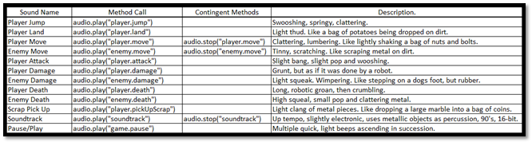

This is a table of all the sounds that will be developed and used in our game, the methods required to call those sounds, their contigent methods mostly relevant to whether the sound is looping or not, and a non-detailed description of how the sounds should turn out when created. The expectation of this table is to provide a clear understanding of the sounds that will be required, and to not waste time creating incorrect sounds that don’t fit the intended action. It also indicates the methods required to call the sounds, with appropriate wording, and alludes to whether they are looping, or play a single time. When beginning the process of creating the sounds in Ableton Lite, the planning process is already complete, and we will only need to fit the sounds as close as possible to the specifications in this table.

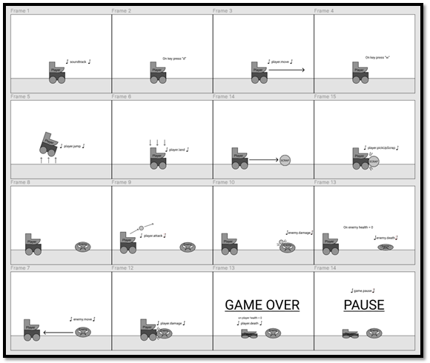

This interaction map is an example of how each sound will interact with actions performed in the game. It gives everyone involved in the planning process a graphical method of visualising the actions related to sound generation, when those sounds are generated, what causes them, which characters, and the input or condition that triggers them. This avoids any confusion as to what time and on what action to place which sounds. This diagram also offers clarity on when finalising sounds, or parralel actions are needed, for example: Whenever the player.jump sound is used, player.land must be played in conjunctor, and when the Player dies, the player.death sound needs to be played as well as the “game over” screen displayed, and the player death process ran.

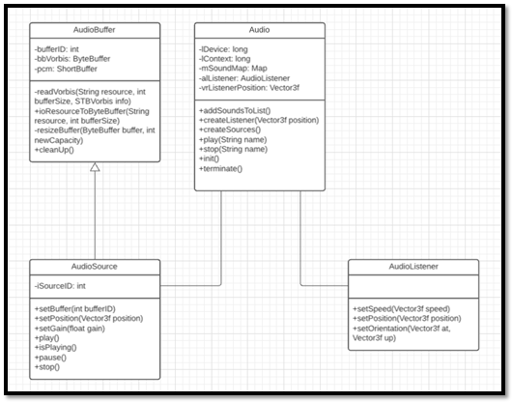

This is a class diagram of the Audio related classes, and how they work together. As you can see, the process starts in the AudioBuffer class where the audio files are decoded and loaded into a buffer. The AudioSource class extends AudioBuffer to maintain accuracy in the bufferID and sourceID parameters. Its purpose is to recieve the buffer data and store them for use later and to handle the position of the sound being played in the 3D game space (though we are not using the 3rd dimension in our project), the gain (volume) of the sounds, and the methods required to play, pause and stop the audio sources. These sources are fed into the Audio class, the main class that is the controller for all audio related interactions, AudioBuffer and AudioSource variables are created and loaded with sound data from external files, then stored in a HashMap to be easily retrieved and played when required in game. The AudioListener class is necessary to control the input or “position of the listener” in the 3D gamespace. It can be placed anywhere in the 3D space to provide a sense of depth and immersion to the sounds playing in game. For example: as the Enemy approaches the Player, the sound of it moving can be made to increase in volume as it gets closer.

Extended Feature 3 Validation Testing:

|  |  |
| --- | --- |
| **Validation** | **Failure** |
| Sound plays when related action occurs. | * Sound plays “out of synch” - at incorrect time. * Incorrect sound plays – incorrect source. * Sound does not play. * Sound loops when it is supposed to play once. * Sound plays once when it is supposed to loop. |
| Sound is clearly audible. | * Sound is crackly, due to incorrect file input. * Sound plays abruptly, due to not maintaining the thread. |
| Sound plays at an appropriate volume. | * Sound is too loud, quiet or inaudible. |
| Sounds are of a high quality, and in line with group expectations. | * Sounds appear low quality and not made with consideration. |
| Sound data loads into correct buffers and sources from file. | * Incorrect sounds play when calling. * Errors occur when compiling program. |