**Assessment 1 – Software Engineering Fundamentals**

**By Corbin Peever – s3855159**

**Submission Date - 30/03/2021**

**Task 1.**

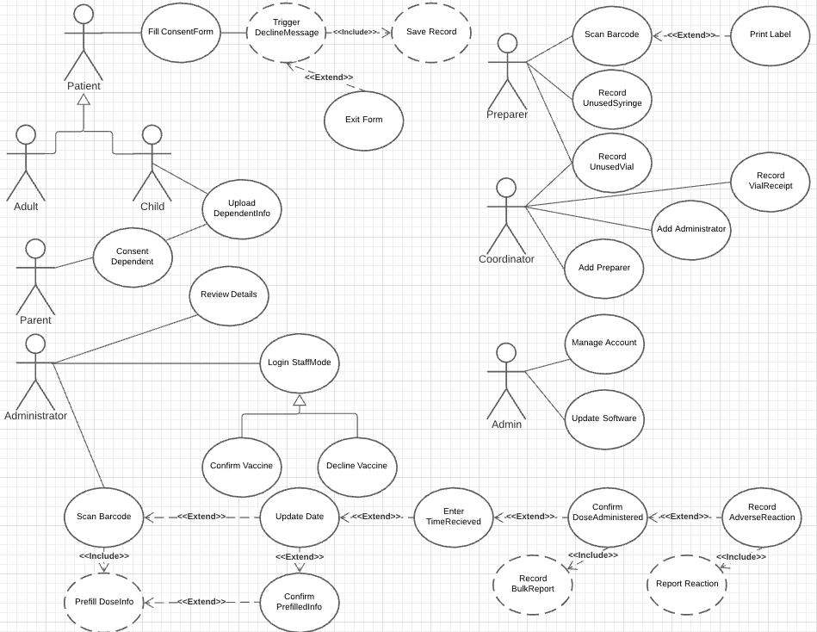

*Figure 1 –* [*Use Case Diagram*](https://lucid.app/lucidchart/invitations/accept/9ec5637c-447e-47c9-b7d4-9abf28ce7e0f?viewport_loc=-1281%2C-191%2C3510%2C1580%2C0_0)

**Task 2.**

1. **Under 18 patient** fills a consent form:

|  |  |
| --- | --- |
| **Name** | Fill ConsentForm. |
| **Version** | Only version present in diagram. |
| **Goal** | Fill out an online consent form for a COVID vaccine dosage administration. |
| **Summary** | The under-18-year-old patient, logs onto the online consent form and fills in their details. There are multiple pages each with a combination of check boxes and text boxes where they may fill in their information. If they do not complete the form, it will still be saved in the Queensland Health records. |
| **Actors** | Primary: Under-18 patient.  Secondary: None. |
| **Pre-Conditions** | Under-18-year-old consent form is filled out by parents, patients’ details are given by parents. |
| **Triggers** | The patient is given a tablet by the vaccine administrator and opens the consent form. |
| **Basic Course of Events** | 1. Patient opens consent form. 2. Patient fills out pages 2 and 3. Possible trigger that their vaccine will not proceed. 3. Patient may change their input or exit the form. 4. Patient confirms details. |
| **Alternative Paths** | 1. Patient may not be viable for test while filling out consent form, so they are unable to continue. |
| **Post-Conditions** | 1. Consent form is submitted. 2. Record is saved in Queensland Health database. 3. Administrator may review details. 4. Administrator may proceed with vaccine. |
| **Business Rules** | 1. Must not have received a vaccine within the last 21 days. 2. Must be approved by a parent or guardian. |
| **Notes** | Consent form must use language easily understood by an under-18-year-old patient. |

**Task 3.**

With COVID being such a contagious virus, it is of imperative importance that vaccinations are done as quickly as possible, and the process is efficient enough to allow as many patients to be administered their dose as possible, each day.

**Shakira**, it occurs to me that the process of administering vaccines to patients can be streamlined by making a few changes to the consent procedure. It appears that a major bottleneck for the process is that patients are required to fill out the form at the pharmacy and may not be approved though they have spent time filling out the form. The major cause of disapproval is that patients have not waited long enough since their last vaccination, attempting to receive their second dose without waiting the required 21 days. **Would you consider allowing patients to access an online portal and complete the consent form from home?** This would give them preapproval, and they would just need to provide their proof of identity when their vaccination is due. **George**, **do you consider it possible to create a function that would allow patients to set up an auto prompt, maybe an email, text message, or notification from the online portal, that would notify them when their 21 days is up?** Possibly even a week before the date?

**Corey**, what is the current time required to wait for the labels to be printed before it can be ascribed to the allocated syringes? **Is it possible to keep this time under a minute?** This printing time is another possible slow point as patients must wait between the moment they have given their consent and when their dose is ready before their vaccination can proceed. Though most of the people in our waiting rooms are there to receive a COVID vaccination, there may be others there that are not, for example: partners, children, friends etc. This poses a risk that COVID may spread in the waiting rooms, to the opposite affect of the purpose of the vaccination centers.

**George, Corey**, have you considered accessibility features for the patients with special needs? I understand that this is a healthcare institution with the needs of its patients at the forefront of its considerations, but I see no mention of large text/tick boxes, and alternative views for differing patient requirements**. Have you considered increased text size and user input areas?** It may even be prudent to provide a “colorblind” mode.

**Functional Requirements.**

1. Fill consent form online, in advance.
   1. The system should allow patients to log in to the consent form online.
   2. Patients should be able to enter their identity details to quickly identify themselves when they attend their vaccination.
   3. Patients should be shown available times to book their vaccination.
2. Enable auto prompt reminder when 21 days has passed.
   1. The prompt can be via email, text message, or notification.
   2. Ideally, the prompt will notify the patient 7 days beforehand, suggesting free times to book their vaccination.
      1. The notification should give them a method to directly access the booking site/page.

**Non-Functional Requirements.**

1. Maintain syringe label printing times to a minimum.
   1. Printing times should be under a minute, from beginning the process, to the end.
   2. Prebooked patients’ labels should be printed in advance.
      1. Labels can be allocated to syringes in advance, so that the preparer need only fill the syringe with the vaccine.
2. The requirements of special needs patients should be considered.
   1. Text should be large enough to read by patients with mild visual impairments.
      1. Text on default screen should not be too large as it may make the process feel “bloated” and more difficult for non-special needs patients.
   2. Text entry fields should be large enough so it can be selected by patients with mobility issues.
      1. Signature field should be large enough to allow patients with mobility issues to easily sign their name.
      2. Text fields should be expandable as solely large fields may slow down the process for non-special needs patients.
      3. Multiple styluses: traditional “pen-sized” and larger with rubber grips.

**Task 4 – Develop a Class Diagram**

*Figure 2 –* [*Class Diagram*](https://lucid.app/lucidchart/invitations/accept/0b48fd2f-43c5-4e6f-82f8-6532d57d21da?viewport_loc=-492%2C1%2C4962%2C2233%2C0_0)

**Task 5 – Develop an Object Diagram**

*Figure 3 –* [*Object Diagram*](https://lucid.app/lucidchart/invitations/accept/703453b7-4a22-4c3d-924a-5af86365a49f?viewport_loc=-4115%2C-1344%2C6157%2C2770%2C0_0)