Encounters intermediated by lectures
Corban Cristian, Coțoc Sebastian, Dascălu Raluca,
Păduraru Teodor, Teșu Cristina

Project’s short description – project’s goal (max 50 words):
Find my Reader is a web application that lets you connect with fellow readers. You can search for the book you have read and using our map, see what other readers with the same interests you have around you.

Architecture (schema):
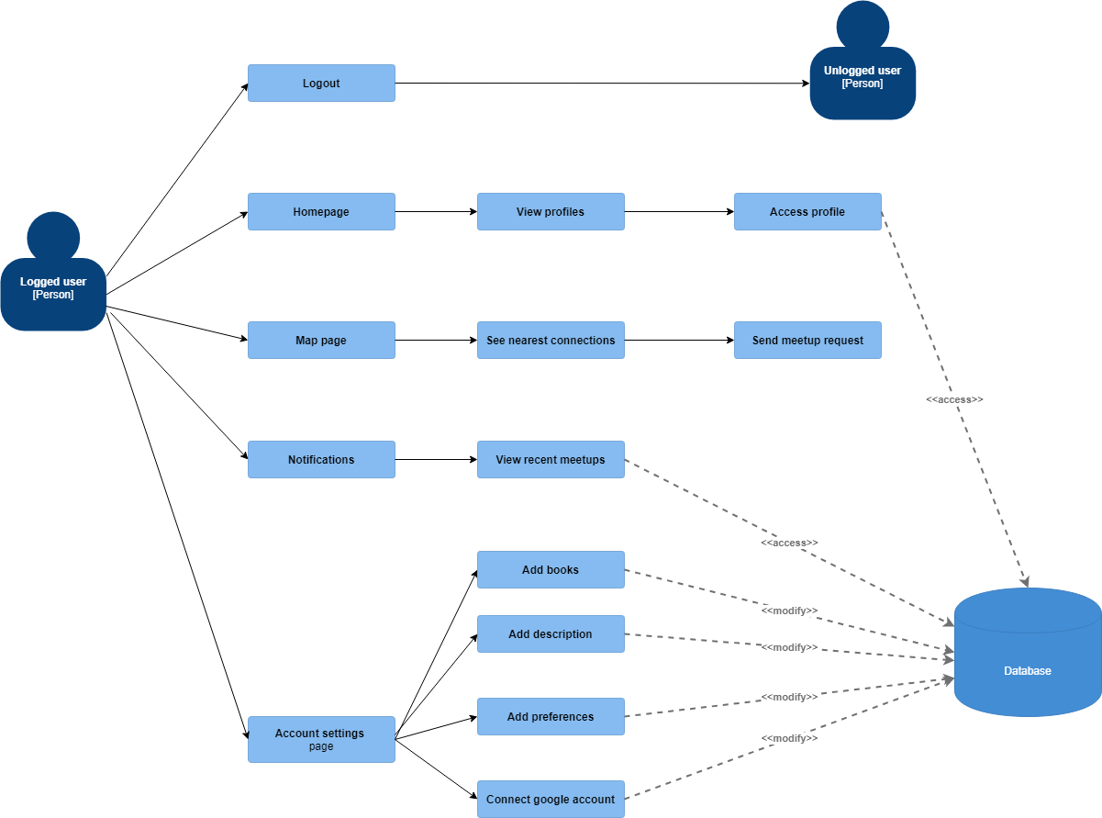
Figure 1 Logged in user usecase

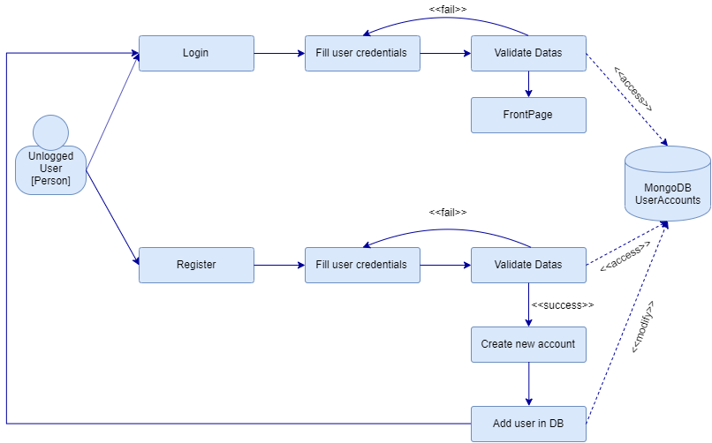
Figure 2 User not logged in usecase
Project’s details (max 1000 words), including:
- Motivation:
Find my Reader is an app for people of all ages who love reading and want to meet fellow readers. Create an account to add books that you read, select your favourite genres, get book recommendations based on what you like and meet new interesting people.
- Challenges:
Deliver a user-friendly interface, perfect for people of all ages and facilitate meetings between users
- State of the art:
We were inspired by other apps that allow you to meet people based on the same interests (i.e. Tinder) but we focused more on making our app a cosy place for readers.
- Objectives:
Deliver a polished, usable product.

- Short description of each module in the architecture, including methods to be used, programming language, additional resources (if any), input/output formats, etc.
Main language: PHP
Database: MYSQL
Interface: HTML5, CSS and Javascript
For the Map module we use Google Geolocation and Google Maps API combined with Javascript.
For the home page and settings page we use Google Books API to search for books and genres.
- Description of the integration of different modules: problems foreseen, if any (incompatibility of programming languages, input/output format changes, etc.).
Difficulties regarding variable transmission between the main language and Javascript used for APIS
Project management (no imposed max. words no.):
- Assignment of team members for each different module (one team member per module)
Achieved until Week 9:
Final database + integration– Coțoc Sebastian
Login + register – Cristian Corban
Map page (location of current user) + Web Design – Teșu Cristina
To be achieved:
Settings page (add books and favourite genres + personalisation for user) – Coțoc Sebastian
Map page (show location of surrounding users) + Visual and language fixes – Teșu Cristina
Home page (book recommendations based on liked genres using Google Books API requests) – Păduraru Teodor
Profile page (show liked books, profile picture(*), description, disliked books) - Dascălu Raluca

- Will the project have a team leader? If yes, who is it? What are its main duties?
Team leader - Cristina Teșu
Main duties - Distribute tasks, write documentation, make final fixes
- Detailed deadlines and milestones. Deadlines need to be settled for each subtask of each module. There will also be deadlines for the inclusion of all modules in the final system. Deadlines are actual dates (e.g. 22nd April 2020). Milestones are physical deliverables at specific deadlines. Your project needs to have at least 3 milestones, representing 3 different stages in the evolution of the project, and one final deliverable. The final deliverable will include the project itself and its description – in form of an 8 page article.

Web design – 2nd April 2020
Login + register - 16th April 2020
Map page + localization - 23rd April 2020
Settings page - 29th April 2020
Home Page – 7th May 2020

- Qualitative measures for the evaluation of the project (e.g. no. of annotations, no. of sentences processed, parsing accuracy/recall/precision, etc.). These measures will be used to assess the projects.
We don’t use annotations, parsing, etc.

You can add here more information.

