Encounters intermediated by lectures
Corban Cristian, Coțoc Sebastian, Dascălu Raluca,
Păduraru Teodor, Teșu Cristina

Project’s short description – project’s goal (max 50 words):
Find my Reader is a web application that lets you connect with fellow readers. You can search for the book you have read and using our map, see what other readers with the same interests you have around you.

Architecture (schema):
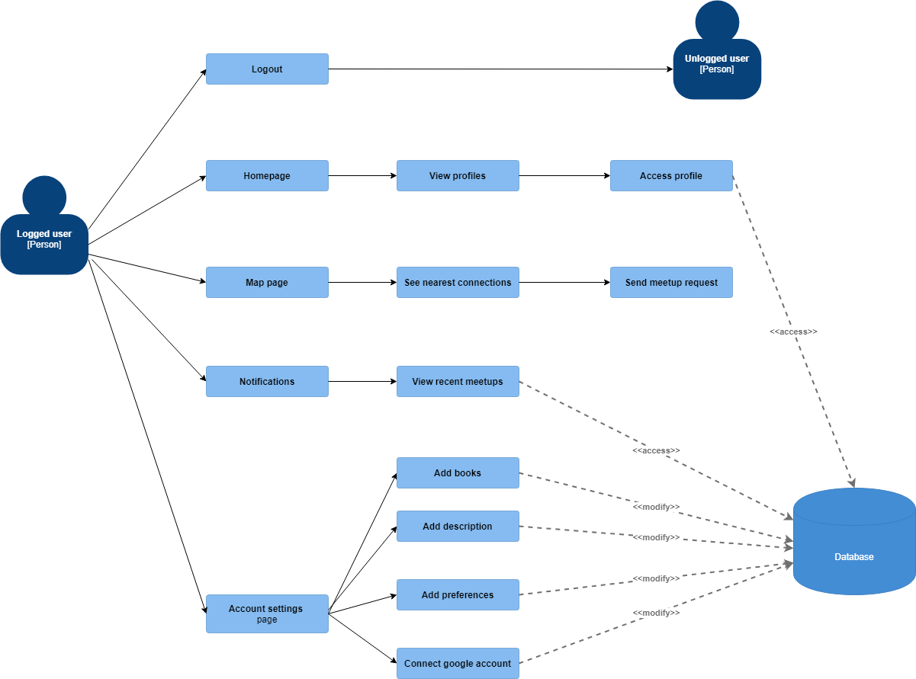
Figure 1 Logged in user usecase

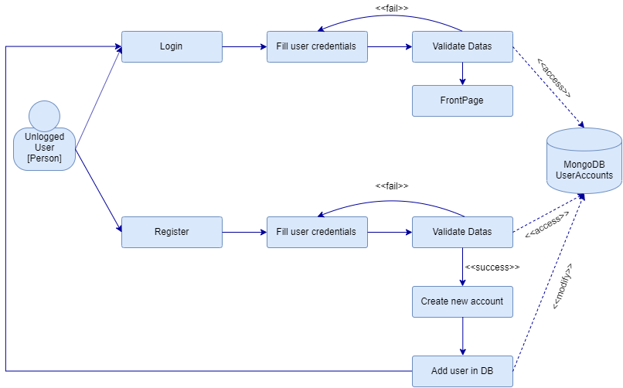
Figure 2 User not logged in usecase
Project’s details (max 1000 words), including:
- Motivation:
Find my Reader is an app for people of all ages who love reading and want to meet fellow readers. Create an account to add books that you read, select your favourite genres, get book recommendations based on what you like and meet new interesting people.
- Challenges:
Deliver a user-friendly interface, perfect for people of all ages and facilitate meetings between users
- State of the art:
We were inspired by other apps that allow you to meet people based on the same interests (i.e. Tinder) but we focused more on making our app a cosy place for readers.
- Objectives:
Deliver a polished, usable product.

- Short description of each module in the architecture, including methods to be used, programming language, additional resources (if any), input/output formats, etc.
Main language: PHP
Database: MYSQL
Interface: HTML5, CSS and Javascript
For the Map module we use Google Geolocation and Google Maps API combined with Javascript.
For the home page and the settings page we use Google Books API to search for books and genres.
- Description of the integration of different modules: problems foreseen, if any (incompatibility of programming languages, input/output format changes, etc.).
Difficulties regarding variable transmission between the main language and Javascript used for APIS
Project management (no imposed max. words no.):
- Assignment of team members for each different module (one team member per module)
Achieved until Week 9:
Final database + integration– Cotoc Sebastian
Login + register – Cristian Corban
Map page (location of current user) + Web Design – Teșu Cristina
To be achieved:
Settings page (add books and favourite genres + personalisation for user) – Coțoc Sebastian
Map page (show location of surrounding users) + Visual and language fixes – Teșu Cristina
Home page (book recommendations based on liked genres using Google Books API requests) – Păduraru Teodor
Profile page (show liked books, profile picture(*), description, disliked books) - Dascălu Raluca

- Will the project have a team leader? If yes, who is it? What are its main duties?
Team leader - Cristina Teșu
Main duties - Distribute tasks, write documentation, make final fixes
- Detailed deadlines and milestones. Deadlines need to be settled for each subtask of each module. There will also be deadlines for the inclusion of all modules in the final system. Deadlines are actual dates (e.g. 22nd April 2020). Milestones are physical deliverables at specific deadlines. Your project needs to have at least 3 milestones, representing 3 different stages in the evolution of the project, and one final deliverable. The final deliverable will include the project itself and its description – in form of an 8 page article.

Web design – 2nd April 2020
Login + register - 16th April 2020
Map page + localization - 23rd April 2020
Settings page - 29th April 2020
Home Page – 7th May 2020

- Qualitative measures for the evaluation of the project (e.g. no. of annotations, no. of sentences processed, parsing accuracy/recall/precision, etc.). These measures will be used to assess the projects.
We don’t use annotations, parsing, etc.
For the final version of the project, we had the following distribution of modules:
Corban Cristian – login, register, settings, fixes, testing
Cotoc Sebastian – database, project structure in PHP, settings, profile (show name, age, description, profile picture, favourite genres), a lot of fixes, testing
Dascalu Raluca - notifications
Tesu Cristina - home page, map page, show books on profile page and adding books from settings page (basically all the parts involving Google APIs), app design and visual fixes, documentation
After testing the final app, we made the following fixes:
- add book title just once
- for the delete genres dropdown menu show only genres for the current user
- send a meeting request to a user only once before he responds to it
- show a default book cover in case the google books API doesn’t return one because otherwise it didn’t show the book at all on our page
- block meeting request to yourself
For the map testing we added multiple accounts with coordinates near ours and some that were in other parts of town. Then we added some books for each account, some that had the same books as our personal account and some that didn’t have any common books. This way we were able to test if we can see only the people that are near us and that have the same read books as us. The ones that didn’t have at least one book in common or the ones that were too far away didn’t have a marker on the map. Also, in the early development of the page, the biggest problem was sending variables (latitude and longitude of the user) to our backend. After some research, we decided to put the coordinates in the link and then take the values in PHP. For that, we had to redirect the initial page and had some trouble with that because the first solution included a method that constantly refreshed the page. After that, we found a method that worked but, if we wanted to send the data and get the markers, the user had to hard refresh the page. In the end, we found another method that sends the data directly.
We ended up refreshing the map every 10 minutes, so in case the user stays on the page longer, he gets more accurate data regarding the people he can meet. This refreshing process isn’t necessary on the other pages because the map loads, gets the current users’ coordinates and loads the markers every time the user accesses the page.
On the profile page, that can be accessed after clicking on a marker from the map page, we wanted to show the name, age, description, favourite genres and the books read by the user. After testing, we chose to hide the description or the favourite genres if the user didn’t have any because of how the layout turned out in case those were not set yet.
On the home page, the process was pretty straightforward because we only call the database and see which favourite genres the user has and show 2 random genres recommendations every time he accesses the page. After testing, we decided to have 2 default genres, in case the user didn’t chose any genres yet and show a message at the top of the page telling him that if he wants personalised recommendations he has to go to the settings page and add some.
Considering the fact that we constantly tested our application whenever we added new functionalities, the final testing was just to make sure that everything works properly and that we also let the user know whenever something goes wrong.
Everybody thoroughly tested their module before uploading the final version to git.

Future development
- mobile version
- search for books and be able to read them
- add audio books
- add chat
- add author pages so new authors can share their work and grow
- reviews from users
- add events notifications about book launches or author meetings

