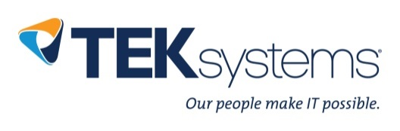

|  |  |  |
| --- | --- | --- |
| 9600 SW Barnes Road St. 350  Portland, Oregon 97225 | 503.205.3500  503.205.3510 | T  F |

Daniel Chrzan

# PROFESSIONAL SUMMARY

Ten years of customer service experience, five years of sales, and many more solving technical issues both in my spare time and as a Desktop Support Technician for Portland State. Seeking an opportunity to grow and bring my passion for service to a team environment where I can help improve the experience of the customer, business, team, and myself.

# SKILL PROFICIENCIES

* Proficient with Microsoft Windows, Office, Multi-platform email applications, Google Apps
* Expert in user support, including troubleshooting in person or via remote applications, by phone or email, and through online research or creation of technical documents via Confluence
* Experienced in enterprise accounting software troubleshooting and support
* Experienced in communicating with business professionals across various industries, and with accounting practices utilized by support software platforms

# WORK EXPERIENCE

Portland State University 2014 – Present

*Student Coordinator and Desktop Support Technician*

* Trained and assisted with acclimation of new hires to the team
* Facilitated and repaired communication between teams across departments
* Catalogued and tracked issues via a ticketing and escalation system and maintaining a knowledge database of known issues and resolutions via documentation software.
* Worked in an environment that is a split between Mac and PC users.
* Participated in large migration projects for both MAC and PC platforms
* familiarity with operating system installations ranging from Windows XP to Windows 10, and Mac OSX 10.7 to 10.13
* Along the lines of MDM, I have some experience in iPad management and imaging for an enterprise environment and for phone management on iPhone 6 to 7 models.
* I have thorough knowledge and experience working with JAMF and managing ac computers in a large enterprise environment.
* I worked within user management and monitored hardware and software through the JAMF platform
* I have worked in the Adobe suite and consistently troubleshooting adobe, 4, 5, and 6.

Convergys Stream Global Services 2011 – 2014

*Phone Support Specialist and SME* for Intuit Quickbooks

* Provided support and bookkeeping services for small businesses across multiple industries
* Assisted with general ledger maintenance, tracking balance sheet and income statement discrepancies, tax calculations, and set up of depreciation/amortization tables
* Assisted with bank reconciliation, assisted with collection of financial reports, assisted with set up of inventory systems

# EDUCATION

Portland State University 2014 – 2019

❖ Dual Bachelors of Science in Human Resource Management and Leadership