Joseph Chorak Home 702-736-1104 / Cell 702-885-5915 choj0@cox.net

Summary Sales Professional with a demonstrated track record of consistently combining sales with sound business practices to position employers for long term growth and profitability. Reputation for producing results with strong communication, persuasive presentation, negotiation and sales closing skills. Proven abilities in customer relationship retention, quickly achieving sales quotas, and utilizing a proactive approach to problem solving.

Accomplishments /Account Development: Selected to the Generals Club for sales achievements for 9 consecutive quarters. Selected to mentor new hires to prepare them for their position with NCC

Mainstreet Host 01/2019 to Present Account Manager Essential Duties and Responsibilities:

**To convert potential leads into sales. Selling all web services including Websites, SEO, Social Media and explaining all features and benefits to the client. Setting expectations to avoid any cancelations and follow up a on a regular basis to insure their degree of happiness, and proactive approach to any issues that may come up.**

Azuga 3/2018 – 6/2018 Account manager Essential Duties and Responsibilities:

Contacting Fleet managers, Operation Manager or appropriate Decision Makers that oversees the Fleet Management System and Telematics. Present product by an online Demonstration of all of the reports, dashboard, unique features and benefits to the potential client. Work current data base and managing pipeline through a CRM (Sales Force )to properly insure they are manage to a proper conclusion.

SNH / NCC Direct 8/2014 – 8/2017 Senior Account Executive Essential Duties and Responsibilities:

Selling Credit Reduction services to Automotive Dealerships Nationwide. Territory included 5 to 7 States from East coast to West coast. Pass all mandated FCRA compliance testing for the industry, and followed up with client to insure they processed paperwork required. Exceeded for 3 consecutive years , 1st year did it in 4 months. Promoted to SAE (Senior account executive) and in charge of mentoring new hires.

Identifix 2/14 – 7/31/2014 Account Executive Essential Duties and Responsibilities: Responsible for making outbound sales calls to independent automotive repair shops to sell automotive diagnostic web based system using consultative sales techniques. Best Practices,  
Better Business Bureaus and other resource for possible new clients.  
Maintained monthly contact with existing clients to assure the system is in fact working properly and increasing revenue and to gain referral business

Ameriprise Financial – 3/2012 -5/2012 Financial Advisor in Training Studied for License as Mandated by the SEC only, Series 7, Series 66, and State Insurance License

YellowPages.com 8/2005 -2/2010 Senior Account Executive Essential Duties and Responsibilities:

Initiate telephone calls for the purpose of selling internet advertising. Responsible for meeting aggressive sales quotas and objectives; posting daily results. Responsible for developing sales strategies prior to contacting designated market using a variety of visual and other sales aids.

Employment Guide, Las Vegas. 9/00 – 8/05 Nevada Senior Account Executive Essential Duties and Responsibilities:

Sold display advertising space to HR Directors, Ad Agencies, and Media Buyers. Developed territory by maintaining business relationships with approximately 200 existing and prospective customers. Designed ads for existing customers and created speculative ads for prospective and existing customers. Researched previous customers advertising and recruiting efforts to determine viable ways to identify their needs and to maximize their recruiting efforts to enable them to reach their quotas

Assisted clients in developing an appropriate marketing campaign or program based on their individual needs. Consistently achieved and maintained sales quotas. And produced 58% of all revenue for LV office and 62% of display advertising space in paper

Additional Skills / Training SST sales training, RE license (AZ) Inter-Action Management Seminars, Tax Seminars Exceeded all goals 50 out of 52 weeks, Member of Generals Club for sales 2 1/2 years, Canadian Club salesman of the year 1992,

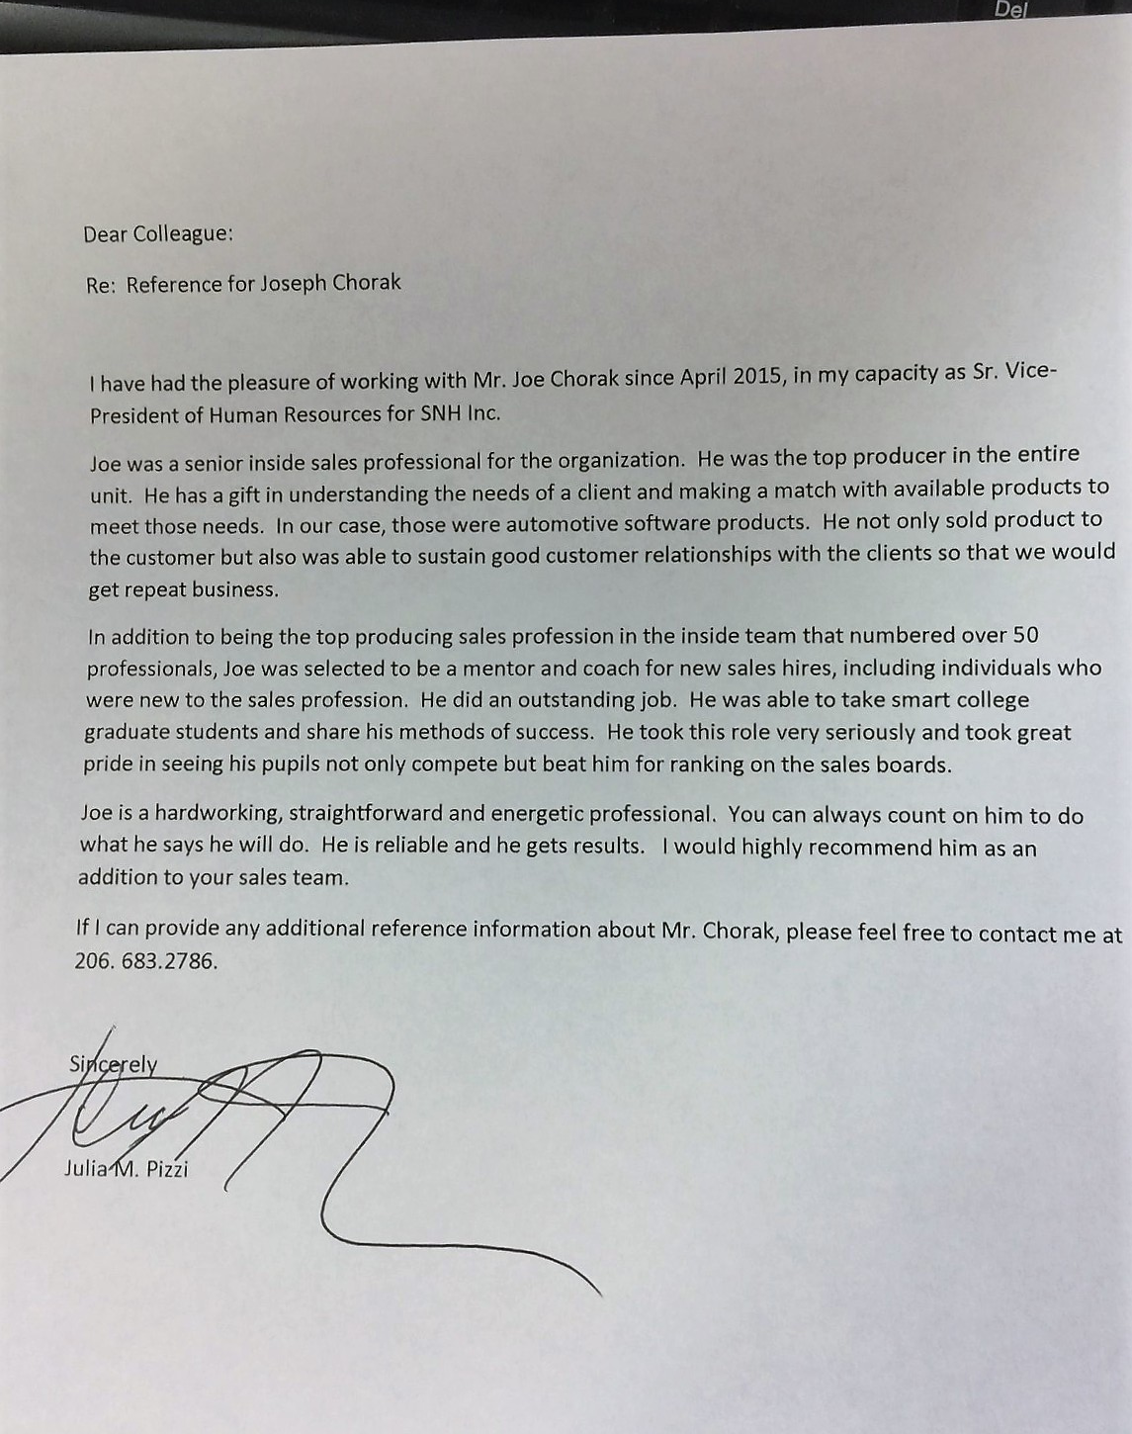

To Whom It May Concern:

It is with great pleasure that I recommend Joseph Chorak for a sales position with any company. I worked with Joe directly at National Credit Center for over 3 years and was continually impressed with his ability to reach if not exceed his monthly and annual sales quotas, and his ability to build long-term relationships with our very important clients.

Joe was also instrumental in helping my marketing team prepare for success at multiple tradeshows we attended as exhibitors. He did this by being the top performing sales team member at scheduling advance appointments at our tradeshow booth – a huge key to our success and in no small part helped us in achieving a positive ROI at these events; not easy considering their expense. He was also very assertive about prospecting on the tradeshow floor resulting demos and sales we otherwise would not have had.

I am happy to make myself available to speak directly about Joe and can be reached at 650.387.4171 with any questions.

Thank you kindly,

Charlene Christman