**Objective**

Well-organized and skilled Bellingham Technical College graduate eager to join an IT department to help build and maintain high-quality network performance while building skills as an IT professional.

**Education**

*Bellingham Technical College* – Bellingham, WA – Associate of Applied Science: Computer Networking   
August 2020 – 3.9 GPA – Dean’s List

*Fayetteville High School* – Fayetteville, AL – Advanced High School Diploma – 2006

**Certifications**

* Computer Network Support Certification
* Cloud Computing Certification   
  **Skills**

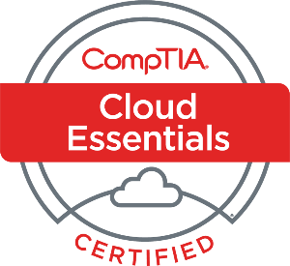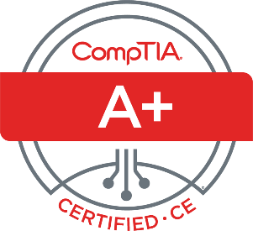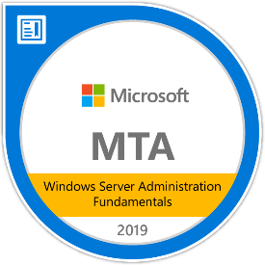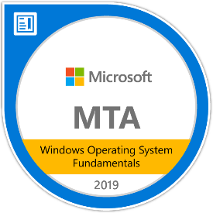

* *Hardware* – Cabling, Servers, Hardware Troubleshooting, Networking, A/V Setup
* *Software* – Web Development, HTML, CSS, .NET, Agile Development, Python, Microsoft Office Suite, Adobe Photoshop, Scripting for Powershell and Bash.
* *Spreadsheets & Databases* – Data Analytics, Excel Macros, VLOOKUP Statistics, Relational Databases, Pivot Tables.
* *Operating Systems* – Windows 95 through Windows 10, Windows Server 2012, 2016, and 2019, basic use of MacOS, Linux Distros: Ubuntu, Ubuntu Server, Debian, Fedora, openSUSE, and Kali.
* *IT Support* – Client Server Management, Troubleshooting, Tech Diagnostics, Network Support, Systems Administration, Password Resets.

**Experience**

*PNW Atlas (Non-profit) July 2020 – Present Board Member/Web Designer/Cloud Architect*

Duties include creation and maintenance of AWS development and production webservers, Mariadb servers, load-balancer, and Wiki server. Maintain IAM roles, security groups, virtual private cloud, Cloud9 CLI, Github documentation depository, S3 buckets, and Wordpress website. Managed a group of three interns remotely, assigned tasks, performed daily check-ins, while completing my own assignments.

*10+ years of general work experience*

**Community Activities**

* Room Captain – Linuxfest 2018
* Video Team Lead – Linuxfest 2019
* Vice President – Bellingham Technical College Gaming Club 2019 – 2020