Cory Michael Tobin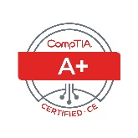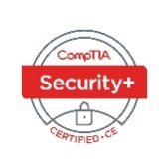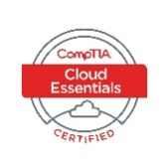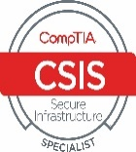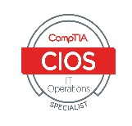

14112B 99th Ave NE, Arlington, WA 98223 | 425-422-4705 | cory.m.tobin@gmail.com

# Objective

Work in an technical environment where I can learn, grown and build my skills as an expert in the computer science industry.

# Education

## High School diploma | 2006 | cascade high school

## Current Student at Western governers university, bachelors in cloud systems

# Skills & Abilities

## IT knowledge

. COMPTIA A+, Network +, Cloud+, Security+ certified, ITIL certified, knowledge in cloud systems and advanced networking. Experience in SQL, Powershell and Kali Linux OS. Minor hands on with HTML and CSS.

## Communication

* I speak to hundreds of people a month and carry a 97% satisfaction rate based off of customer surveys over a 3 month rolling period. I have several awards from Comcast for my excellent customer experiences and have a solid knowledge base in large scale and small scale networking.

## Leadership

* I act as a role model for other agents and employees. My goal is to help everyone get better at what we do so that we can all benefit. I can drive growth within a company and provide a positive attitude to help everyone’s morale. I have hosted several training events and run group huddles.

# Experience

## Technical and account support | comcast | april 2016 - current

* I manage several hundred accounts per month. I provide excellent customer service and help customers with support and troubleshooting with advanced product knowledge. I promote growth within the company. I have been awarded several times for my statistics in sales, customer satisfaction and multiple other metrics.

## correctional officer level 2| washington state d.o.c. | june 2015 – april 2016

* After graduating academy I had been given a post in the Special Offenders Unit. I managed and looked out for hundreds of mentally ill inmates on a daily basis and had been given excellent reviews by my commanding Sergeant. My basic job duties were being responsible for the safety and security of others.

## Sales Expert | frontier communications | may 2012 – may 2015

* I helped clients by educating them on available products and built their accounts. I managed multiple client accounts and secured information. I ran several classrooms providing employees the chance to learn sales techniques in order to help others grow within the company.