MYKAILA WILLIAMS

 mykaila_w@yahoo.com                        (916)690-9060             1862 GARINGTON LN LINCOLN, CA, 95648

**Career Objective**

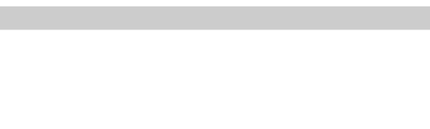

Experienced customer service professional seeking to work in a challenging environment for a position that provides an opportunity to develop skills and a career in Information Technology. Looking to achieve professional growth while being resourceful, innovative, and flexible in order to add valuable assets to your esteemed organization as an active team member.

**Experience**



Barista

Starbucks, Rocklin, CA / Aug 2018 - Jul 2021

* Learned every menu preparation and numerous off-label drinks to meet all customer needs.
* Pleasantly interacted with customers during hectic periods to promote a fun, positive environment.
* Maintained espresso equipment and performed minor repairs to keep coffee machines functioning properly.
* Recommended products based on solid understanding of individual customer needs and preferences.
* Developed and implemented updating training programs for multiple employees.
* Elevated customer loyalty by using strong communication skills and situational management abilities to resolve customer problems.
* Cultivated ability to recall customers' names and address each by name.

Courtesy Clerk | Florist | Fresh Cut Clerk

Safeway, Lincoln, CA / May 2017 - Jun 2018

* Addressed customer needs, including price checks and merchandise retrieval from upper shelves or stockroom.
* Handled multiple daily credit and cash transactions for customers with accuracy and speed.
* Processed monetary transactions by giving and receiving cash, processing coupons and refunds and applying discounts.
* Bagged customer items efficiently using proper techniques to protect delicate items and separate different groups of merchandise.
* Restocked, arranged and organized merchandise in front lanes to drive product sales.
* Monitored safety and security concerns and reported to leadership for resolution.
* Achieved and consistently exceeded revenue quota through product and service promotion during routine calls.
* Entered customer interaction details in the system to track requests, document problems and record solutions offered.

**Education**



|  |  |  |
| --- | --- | --- |
| **Arizona State University**  **Tempe, AZ**  Completed coursework towards Bachelor of Science Information Technology (Present) |  | **American River College**  **Sacramento**  Associate in Science (A.S.) Social Science (Jan 2021) |
| **American River College**  **Sacramento**  Associate in Science (A.S.) Physical Math and Science (Jan 2021) |  | **Lincoln High School**  **Lincoln, CA**  High School Diploma (Jan 2006) |

**Additional Skills**



|  |  |  |  |  |  |  |  |
| --- | --- | --- | --- | --- | --- | --- | --- |
| Exceptional Customer Service |  | Product and Service Sales |  | Hardware Assembly/Maintenance/Repairs/Troubleshooting |  | Software Installation/Configuration/Troubleshooting |  |
| Experienced with Windows/MacOS/Linux |  | Experienced with Microsoft products (Word, Excel, PowerPoint, Outlook, etc.) |  | Networking (Configuration, TCP/IP Protocols, Routers, Windows Server, troubleshooting, etc.) |  | Programming (C++, C, Python, Java, HTML) |
| Security (Virus Protection, System Updates, Maintenance, Backup Management, Disaster Recovery, etc.) |  | Strong communication skills |  | Conflict Resolution |  | Customer Relations |
| Reliable |  | Multitasking |  | Money Handling |

**Certifications**



|  |  |  |
| --- | --- | --- |
| COMPTIA A+ 1001 |  | COMPTIA A+ 1002 (In progress) |

**References**

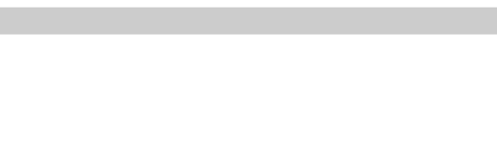

|  |  |  |
| --- | --- | --- |
| **London Harper Store Manager, Starbucks**  19167499223 - london_harper@gmail.com - Former Store Manager |  |  |