**Biruk Seboka**

**Las Vegas, NV 89103**

[**Booku.05@gmail.com**](mailto:Booku.05@gmail.com)

**702.820.8649**

**Date:-**

**Position:-**

**Lasvegas , NV**

**Dear:**

I graduated from Asher College with Computer Specialist and Networking Technology associate degree program and I have worked in PC clinic as desktop Technician, CDW as IT Configuration Technician, Treasure Island and COX as Desktop support engineering for more than two year.

**I’m seeking an opportunity to apply my knowledge and experience to the IT position in your company. Surely, I offer you the qualifications listed on your website, please contact me.**

**As my resume indicates, I possess the technical knowledge and training to effectively:**

* **Comptia A+**
* **Comptia Network +**
* **Comptia Security +**
* **Microsoft Windows 10 Configuration**
* **CISCO CCENT**

**My resume is attached for your review, Thanks for your consideration.**

**Kindest regards,**

**Biruk Seboka**

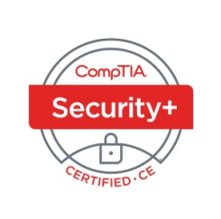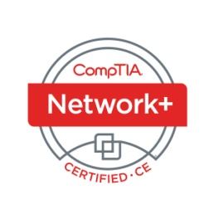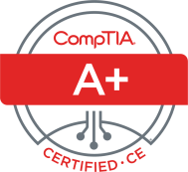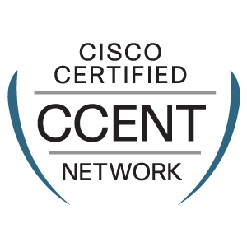**Biruk Seboka**

**Las Vegas, NV 89103**

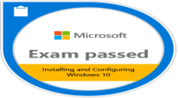**image010Booku.05@gmail.com**

**702-820-8649**

**Professional Summary**

**Certified IT specialist** with a reputation for being ambitious, energetic and highly dedicated.

An organized, detail-oriented, and conscientious self-starter, able to strategize and prioritize

effectively to accomplish multiple tasks and stay calm under pressure.

**Certifications:-**

* **Comptia A+ - CISCO CCENT**
* **Comptia Net + - Microsoft Windows 10 Configuration**
* **Comptia Security + - Employee Commendation certificate from TI**

**Other:-**

* **Nevada Gaming License**

**Technical Skills/Qualifications**

* Building new computer and installing operating system
* Maintaining Hardware and software problems for desktop and laptops
* Installing and maintaining LAN and Wireless network
* Cleaning virus, spyware, malwares and firewall configuration
* Applying different backup methods and configuration
* Using of diagnostic procedures and troubleshooting techniques for networks using various tools such as, ipconfig, ping, tracert, nslookup and interpret the output
* Applying protocols, TCP/IP, DHCP, DNS in relation to a network
* Understand the OSI layer and the network components that operate within that such as Hubs, switches, routers
* Knowledge of LAN/WAN applications
* Applying security configuration for LAN and Wireless Network
* Perfectly using Microsoft Office 365 (MS-Word, MS-Excel and MS-Access)

**Education**

**Asher College Las Vegas, NV**

Computer Specialist and Network Technology Associate Degree Program -2019 **( 3.8 GPA)**

**Work Experience**

**PC clinic- Desktop Technician LV NV, 05/2017- 06/2019**

* Installing /Troubleshooting computer hardware
* Building new computer and installing operating system
* Maintaining Hardware and software problems for desktop and laptops
* Installing and maintaining LAN and Wireless network
* Cleaning virus, spyware, malwares and firewall configuration
* Applying different backup methods and configuration
* Using of diagnostic procedures and troubleshooting techniques for networks using various tools such as, ipconfig, ping, tracert, nslookup and interpret the output

**CDW- IT Configuration Technician LV NV, 07/2019- 10/03/2020**

* Building new computer and installing operating system
* Advance Imaging and Bios configuration
* Installing/configuring operating system and application software’s
* Installing /Troubleshooting computer hardware and wireless devices
* Installing network hardware’s and basic configuration
* Using basic Windows command to diagnostic issues(ipconfig, ping, tracert, nslookup and etc)
* Configure customers systems to their required specifications.
* Test systems to ensure 100% quality.
* Maintain minimum monthly productivity goals.
* Troubleshoot problems with computer systems, including hardware, software and peripheral equipment.
* Ensure that customers receive the highest level of customer service.
* Communicate issues concerning customer orders to the area Help Desk or Team Leader.
* Adhere to safety procedures and guidelines at all times.

**Treasure Island- User Support Specialist LV NV, 05/27/21 -08/17/21**

* Using **CONNECT WISE** ticketing sytem
* Handle calls and support all end user device regarding hardware, software issue and general property emergencies related to IT
* Actively work trouble ticketing queue ensuring all issues are prioritized and resolved customer’s satisfaction
* Partner with other IT teams members and vendors to resolve problem tickets
* Installing and upgrading PC hardware and Software
* Applying different backup methods (like Cloud, local network drive and etc )
* Basic network installation ( Like jack activation, cross connecting , cable termination, closet punch downs, line toning and etc)
* Working on Active Directory and DNS
* Using basic Windows command to diagnostic issues(ipconfig, ping, tracert, nslookup and etc)
* Configuring and troubleshooting smart phones and tablets
* Installing, upgrading and repairing POS device, Credit card readers, Bar code readers and terminal printers
* Installing and configuring Microsoft office 365
* Working on Agilysys, LMS and Infogenesis

**COX/HCL- Desktop Support Engineer LV NV, 10/28/21 -12/30/21**

* Using SNOW ticketing system and Microsoft Team
* support all end user, Paying close attention to the user’s description of their computer problem and asking questions to identify the problem and determine how to solve it
* Training users on how the use of new hardware or software
* Testing and evaluating the organization’s computers and phones
* Troubleshooting network problems and individual user hardware or software problems
* Setting up or repairing computer hardware and other associated devices such as printers and scanners
* Setting up or repairing IP phone (AVAYA) and configuring VPN
* Working on Microsoft office 365
* Using FedEx to create labels for shipping items
* Using Excel to Track shipping items and inventory’s

**Biruk Seboka**

Las Vegas, NV 89103

**Booku.05@gmail.com**

702.820.8649

**Professional References**

**Name:**- Amir Badiee

Title:- **IT Instructor**

Company:-Asher College

Relationship:- N/A

Phone Number:- 702.836.9900 x119

**Email:-abadiee@asher.edu**

**Name** :- Kelly Brown

Title:- **Engagement Manager**

Company:-Randstad Technologies/ CDW

Relationship:- N/A

Phone Number:- 851-914-8567

**Email:-** **kelly.brown@randstadusa.com**

**Name** :- Jayson

Title:- **Supervisor**

Company:- CDW North Las Vegas, NV

Relationship: N/A

Phone Number:- +18008004239

**Email:-jaystom@cdw.com**

**Name:**- Nakano, Ashley

Title:- **IT manager**

Company:-TI

Relationship:- N/A

Phone Number:- 702-812-3015

**Email:-anakano@treasureisland.com**

**Name:- Albert Sanchez**

**Title:- IT Manager**

**Company:- COX/HCL**

**Relationship:- N/A**

**Phone no:- 702-545-3862**

**Email:- Albert.Sanchez3@cox.com**