**Matt Stafford**

**San Diego to Las Vegas**

******Phone: Available through email request**

**Email:** [**matstaf@gmail.com**](mailto:matstaf@gmail.com)

**Website:** [**sometechdude.com**](http://sometechdude.com)

***Objective:*** To obtain a position that utilizes my current skill level while challenging me to expand my knowledge base.

**Technical Skills**

**Network/ Operating Systems**

Linux- various distributions, Microsoft Windows 3.1 to 10 (PowerShell including scripting), Microsoft Servers 03 – 16

Strong and proven ability to figure out new and unknown operating systems when encountering new types of equipment for example Michael Weinig, Inc industrial milling equipment.

**Virtualization**

Azure Fundamentals Certified

**Proprietary Software**

Microsoft Office, Service Desk, Open Office, Seibel Database, GHOST, Clonezilla, eRepair, CRM, Rio, SystemX, Salesforce

**Program Languages**

HTML 5, CSS3, JavaScript

**Anti-Virus**

Norton, Trend, McAfee, Bitdefender

**Miscellaneous**

Front End Web Development

Routers: Cisco, Linksys, Soho, Net Gear, AT&T, Microtik, Microsoft firewall

Wireless: Cisco Aeronet, Soho, Net Gear, AT&T, Microtik

Telecom: POTS, Cellphone set up (any type or OS), Cell Phone Network Configuration, Black Berry Server Installation

**Education Certifications and Licenses**

Azure Fundamentals AZ900

CompTIA Network+

CompTIA A+ Certified Technician

Associates Degree ECPI University

CPR Certified

**Professional Experience**

Oct 2017- Present

**Sole Proprietor-Dr. Electronic Inc.**

**Freelance Cable Tech, Network Tech, Computer/Phone Tech**

**Denver, Co/ Las Vegas, NV/ San Diego, Ca**

* As a freelance computer technician I have performed installation of point of sale systems and automation of billing systems for a variety of small businesses and web based entities.
* In San Diego, I switched a small business over to Microsoft Office 365 including customizing their sales proposals with Word and Excel
* I also worked on setting up email accounts for work crew leaders, training on Google maps for vehicle tracking and creating a website to submit estimates out in the field, and app consulting
* I completed a several week contract with a major insurance carrier providing 2nd and 3rd tier support to end users located around the world. I provided a great deal of support for Microsoft Office and many applications and equipment unique to that industry. They used Go to Assist or Skype for Business to remote access into computers to perform a great variety of repairs and tasks. The ticketing software they used was Service Now and they were very ticket oriented. I also oversaw deployment of upgraded PC's and provided end user support as they moved from Office 2016 business and billing model to Office 365 and I was a global administrator during the change. They began downsizing their company by at least 1100 workers and I was also tasked with wiping the hard drives of those machines.
* I completed a few weeks contract providing help desk support for a hospital/ rehabilitation facility. This included providing support for desktop computers, laptops, tablets as well as all other types of electrical and electronics used at the facility. This included the surveillance camera system, the VOIP desktop phone system and the patient phone systems. I also supported and repaired devices specific to this industry such as a patient counting device and medicine distribution devices.
* I provided "smart hands" for SAP data centers throughout Colorado during various projects
* For a major Fortune 100 company, I was contracted to build 32 audio/video server racks for their new corporate headquarters. This included reading the schematics, and completing every phase of the build out, mostly alone, up to shrink wrapping the racks and attaching labels for shipping. For this project I had to solder wires and heat shrink connections for highly specialized audio/ video networking equipment. I was able to complete the project one week early.
* I assisted in the initial build out of two new data centers in Colorado Springs by running power cables and installing hardware in server racks
* At a brand new Hilton in Nevada I had to overhaul all networking cables and rerun them in a coherent manner as well as replace redundant power supplies in the server room
* I have installed and configured automatic doors and door locking mechanisms at the new VA Center in Denver, Co.
* I have performed repairs and maintenance for various computer and network break/fix and connectivity issues
* I routinely resolve email issues on Apple and Androids devices across various types of corporate email systems
* As a Cable Tech 2 for Outsource Inc. I have installed CAT5VP and up to 8 cellular repeaters per floor as temporary technician for Gigaspan Inc. at 1144 14th St. a new building in downtown Denver
* Also through Outsource Inc. I have run cabling and installed security systems in Colorado Mills Mall including glass break detectors, motion detectors, counters, keypads, panels, etc.
* I trained the employees at ABM Janitorial at various locations in the use of smartphones and various apps including Google Calendar, Google Translate and use of proprietary software to track hours
* I have resolved various computer and phone issues and provided training for a variety of people and businesses, mostly through a few websites for freelance techs

Apr. 2017 to Oct 2017

**Computer Controlled Machine Operator/ Technician**

**Austin Hardwoods of Denver**

**Denver, Co**

* I operated and assisted in maintaining the mechanical and electronic equipment including performing tier 1 troubleshooting on any equipment I used that was not functioning or malfunctioning including guide lasers, touchscreens, mechanical systems, pneumatic systems and various computer systems
* I assisted in the installation of new equipment such as Centak large industrial two-sided planers and Centak large straight line saw with a board distribution system.
* I processed different types wood from raw planks into more processed forms or sizes
* I operated forklifts to transport materials around the factory as needed
* I inspected, refilled or separated industrial propane tanks for equipment such as forklifts.

Feb. 2014 to Apr. 2017

***Freelance Computer/ Network/ Electronic Technician/***

***Front-End web programmer***

***Tech Logic of Virginia, Virginia Beach, VA***

***Field Technician Charlotte, NC***

***Contract Help Desk Technician, Greater Denver, CO Area***

* I have provided inbound 1st tier support and outbound next tier(s) support for AT&T/ DirecTV end user customers as well as internal clients. It was a performance based position where I was paid extra for every call I resolved depending on the level of service.
* I routinely dealt with a range of end users from an AT&T corporate contractor having onsite issues with a variety of internal programs to little old ladies who are unable to set up or retrieve voice mail on home phones.
* To follow up on certain trouble tickets in some of the systems if the ticket was unable to be resolved by another representative was also part of my duties effectively providing Tier 2 support. I was able to resolve most issues on the first phone call using AT&T/DirecTV’s proprietary software. A typical phone call required a minimum of three different programs to document and begin a resolution.
* As a freelance independent subcontractor for AT&T/DirecTV I documented on a finite level the type and level of support for a variety of different types of issues. I logged data using a variety of different systems depending on the origin of the call, the nature of the problem, the product or service not working and the steps that must be taken to resolve it, occasionally opening trouble tickets to send to internal AT&T IT Support if the issue is beyond my permissions level as an indirect employee.
* As a freelance computer technician I have performed installation of point of sale systems and automation of billing systems for a variety of small businesses and web based entities.
* To provide one stop computer services for small businesses I have created websites using a variety of WYSIWYG programs from FrontPage to Dreamweaver and coded utilizing HTML 3.5 to 5, CSS and Javascripting.
* THE go to guru for all the computing, internet and IT needs of a variety of small businesses including real estate offices, law offices, restaurants, landscaping/tree companies, salons, construction companies, and many more.
* I was one of very few contractors for TechLogic physically in the Charlotte, NC area.
* Contracted on a team responsible for maintaining and deploying desktop and network services from terminals, routers, firewalls, switches, and anti-virus solutions for a broad range of clients.
* Responsible for supporting a broad range of client types mostly using a great deal of legacy equipment.
* Provided field and remote support of users for VPN and onsite clients issues.
* Trained end users to ensure their needs are taken care of and to identify opportunities to improve user satisfaction.
* Provided personal training for installed and networked software
* Supported upper management points of contact in a timely manner and resolve their issues promptly acting almost as a technological concierge.
* Deployed imaged based installs of Microsoft clients using a variety of methods and performed many types installs of operating systems, programs, applications across a network using various technologies. For some ongoing clients, I was also responsible for User administration on Microsoft Active Directory, administration of Windows Updates, updates of drivers and general desktop/ network support and maintenance.
* Provide printer support for all kinds of printer issues.

Mar. 2011 to May 2015

***City Tavern, Charlotte, NC***

***Server, Shift Lead, Trainer***

* I managed all technology and equipment related issues within the restaurant. This included dealing with any and every type of technology issue a small restaurant chain could possibly run into, and on every level.
* Everything from set up new restaurants entirely to fixing simple printer issues and POS repairs while live during business.
* As a shift lead, it was also my job to monitor other wait staff performance and ensure side work and checkouts were done properly. I reported directly to the company owners who acted as the managers as well.
* As a fine dining waiter, I was responsible for presenting alternative menu options, Chef specials & drink specials as well as accurately taking customers' orders and inputting them in the company point of sale system. Once it was prepared I would serve food and drinks to the customers in a timely manner.
* I was responsible for acting as my own cash register until checking out with management at close. This means you carry your own cash and dispense it out as necessary.
* As a highly experienced and refined restaurant worker I would also train new hires to be able to perform these duties quickly and accurately.

May 2012 to June 2013

***Red Ventures, Charlotte, NC***

***Inside Sales Professional, Senior Sales Agent***

* I primarily received inbound sales calls on an automated dialer and with a call in queue. I sold a variety of different products including satellite television (DirecTV) and satellite internet (Wild Blue and HughesNet), tech support services (such as GeekSquad and AT&T Wireline) and WiMax internet service (Clear).
* I ensured a positive customer experience by educating customers on the features and benefits of the product, responding to questions and overcoming objections, and accurately updating our contact management system while live on the call with the customer.
* I excelled at my job there so for a time I was on a special permission based outbound calls team for various internet services. It was my job to make an outbound call to a customer we either could not close or could not previously offer service too.
* I consistently performed on a variety of dimensions including, exceeding sales goals and meeting quality assurance requirements for our venders and maintain call time averages.
* I increased customer profitability by utilizing cross-selling and upselling techniques such as preparing a customer for a warm transfer to a different sales team for a related product. (Transfer someone to DirecTV from Wild Blue or vice versa).
* I achieved Senior Sales Agent status by consistently performing in the top 25% of the call center for at least two full quarters. I was able to maintain every quarter as long as I worked there but had to wait the first two consecutive quarters to be eligible for the award.

Mar. 2008 to Feb. 2010

***WHO Cable Virginia Beach, VA***

***Network Cable Installation***

* Myself and a team deployed mostly CAT5, CAT6 network from patch panel to termination. I worked on a contract basis as the jobs became available.
* Occasionally I deployed fiber channel to begin setting up a SAN.
* Assisted the sales department while working with engineers to guide the cable install to better suit the customer’s long term needs instead of just what is projected for this year’s specific technology speeds. For instance, recommending an upgrade of cable to suite greater bandwidth for future network needs 5 to 10 years from install.

July 2009 to Feb. 2011

***TechniCredit.com, Virginia Beach, VA, Charlotte, NC***

***Sole Proprietor***

* I created this website myself using Dreamweaver and raw HTML and CSS code. The website and company dispensed free advice to the public about how they can repair their own credit and avoid unscrupulous and illegal debt collection tactics. The content of the site outlined the basics of my own 100% successful system to remove negative entries from credit reports as well as advice on how to increase your score.
* The site sold the actual letter templates that I used to repair credit and stop collection companies to the public so that anyone who can read, write and send letters can achieve these goals. I sold them for $10 with a decent amount of success.
* The site and copies of the templates were then successfully sold to a larger credit repair organization/ mortgage broker in February of 2011 (confidentiality required by buyer). They continued to operate the site unchanged at least until 2012.

**Awards and Achievements**

* ***1990*** Past Master Councilor, Order of DeMolay, the youngest in Lynnhaven chapter history
* ***1991*** Youngest Stand Manager in Company History Ogden Allied Services
* ***1995*** Youngest Licensed Agent at Independent Order of Foresters
* Jan. & Feb 1995 Highest producing salesman in Washington D.C area at Independent Order of Foresters
* **2000** Winner of Best of Local Websites for Greentree.cc from gohamptonroads.com the local search engine for Southeast Virginia
* ***2002*** At AT&T Wireless I was awarded the only customer retention award ever given out in the North East region as of 2003 when I left the company.
* ***2005*** I held the branch record for largest loan amount at the Tarrytown Office of Ameriquest.
* ***2000-2016*** I have won various production contests accounting for many prizes such as cash, dinner out, gift cards, travelers’ checks, stereos and a flat screen TV. At one time, every appliance in my home came from a sales contest of some kind. Unfortunately, I was unable to keep any of them throughout the years (marital troubles!) so I cannot accurately list them all and fortunately they were too numerous to do so anyway!

**Education**

* 1998-2000
* Associates Applied Science Electrical Engineering
* ECPI College of Technology, Virginia Beach, VA
* Relevant Courses: Analog & Digital Electronics, Computer Hardware, Computer Network Fundamentals
* Numerous self-study courses through Plural Sight, Professor Messor, InformIT, W3Cschools, etc.

**References**

**Available upon request**

**Recent 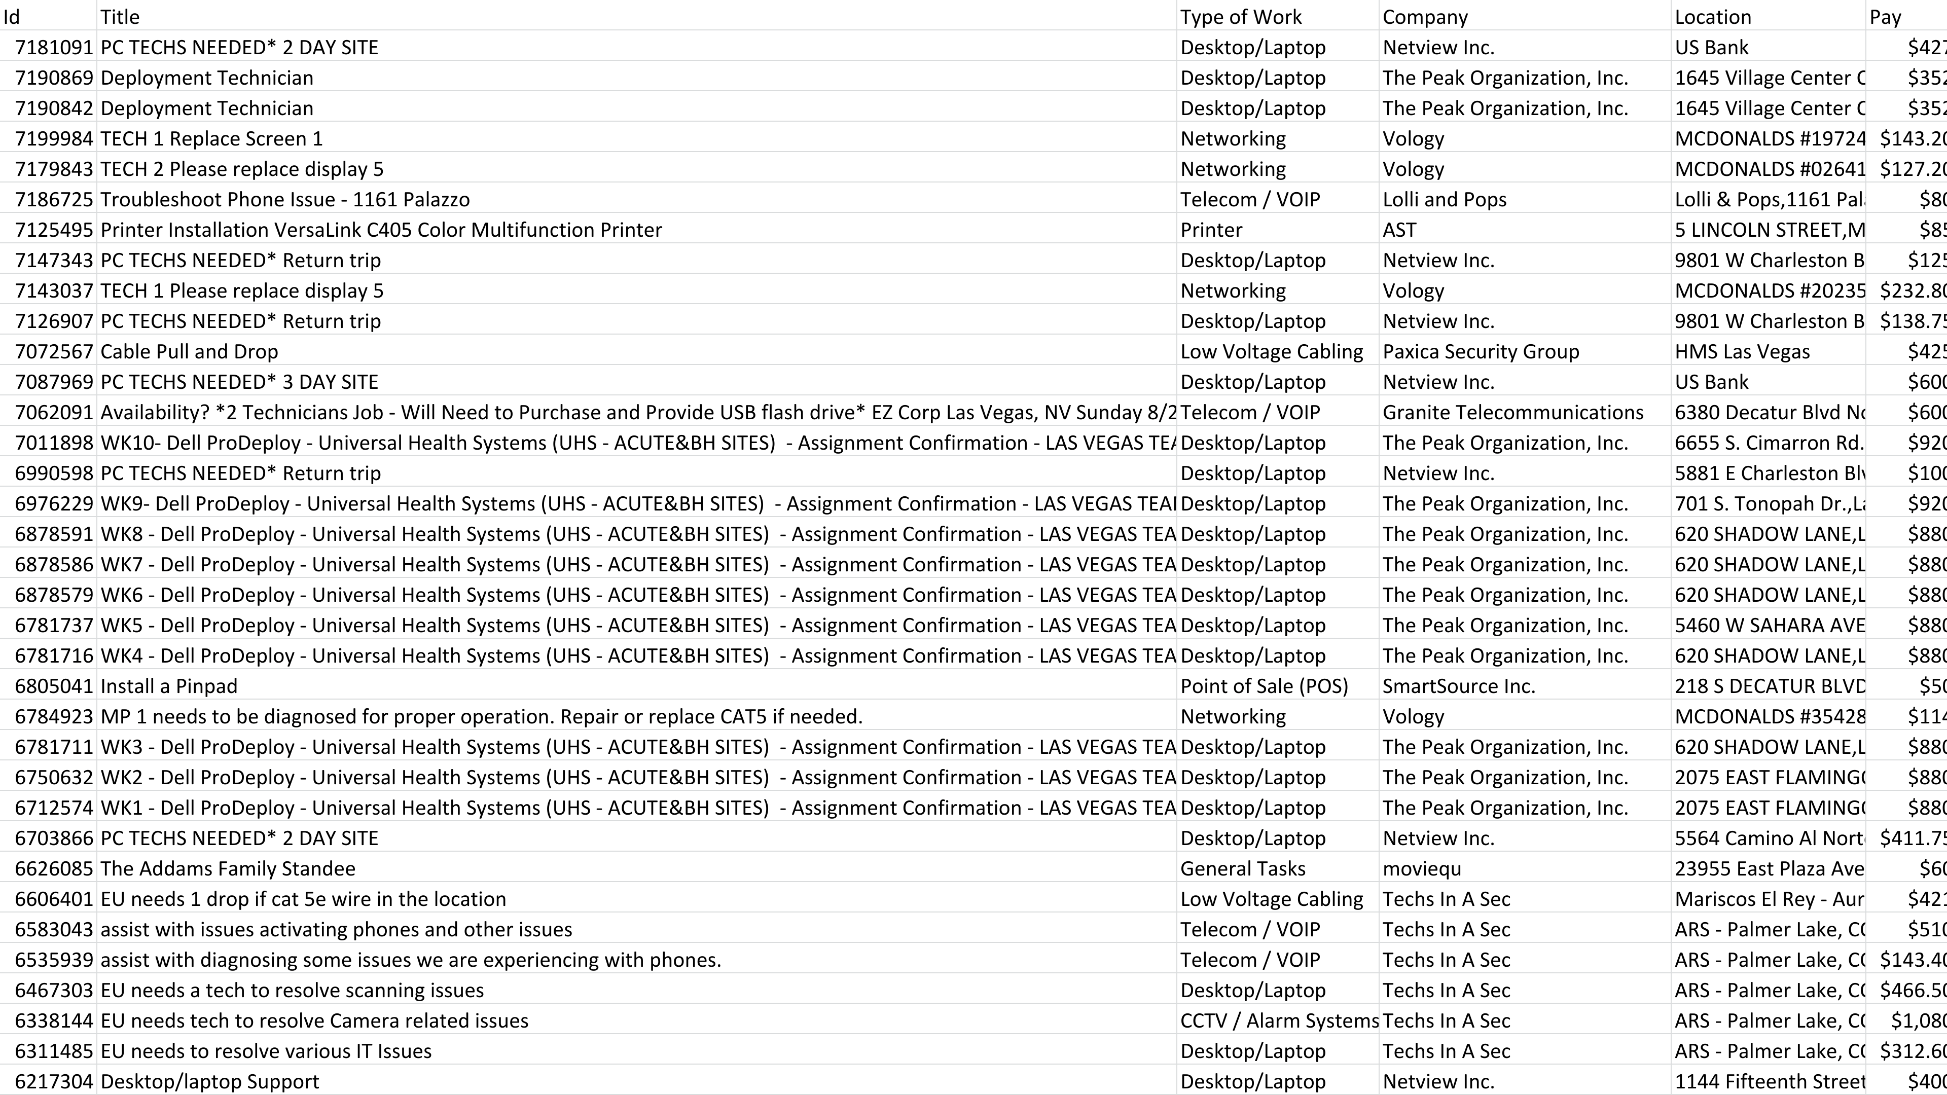Work Completed through FieldNation**