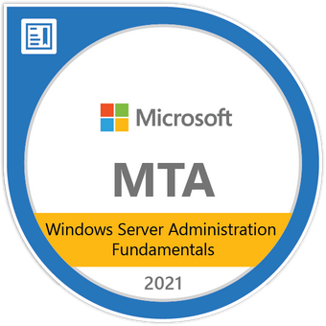**Adrian Banico**

903 N Heliotrope Dr #5, Los Angeles, CA 90029

(323) 384 4386

Banico.adrian@gmail.com

**OBJECTIVE:**

Having recently earned my MTA as Windows Server Administrator, seeking employment as Junior Server Administrator

**WORK EXPERIENCE:**

**SONIC AUTOMOTIVE/BUCHANAN August 2016 to Present**

**Technical Support Representative**

* Supporting Desktop PC at the following Car Dealerships
  + BMW of Beverly Hills
  + WI Simonsons
  + Honda of Santa Monica
  + Mercedes Benz of Calabasas
  + Long Beach BMW
  + Carson Honda
  + BMW of Monrovia
* Window 10/7/XP – Rollouts/Deployment/Migration
* Break/Fix PC issues.
* Supporting Level 1 network troubleshooting issues
* Setup proprietary applications and hardware from BMW.
* Internet site troubleshooting, set up JAVA according to Manufacturer requirements.
* Reimaging PCs as provided by Head office.

**LASERZONE**

**Field Engineering Representative October 2014 to August 2016**

* Repaired client printers onsite.
* Printer include mostly HP printer (42xx, 43xx, 30xx, 9000, 80xx series).
* Set up printers to client PCs. Installed drivers and set up scan to folder access.
* Trained users on accessing folders and printers.

**PMG/CHLA October 2010 to September 2014**

**Technical Support Representative**

* Coordinated with vendor for support on printer maintenance.
* Coordinated with network security to perform anti-virus and malware scans on PCs occasionally.
* IE troubleshooting. Favorite URL updates.
* Perform back up operations, assisting network administrator
* Hardware replacementTechnical support for entire office. Responsible for 110 people.
* Data back up and retrieval of documents for users.
* Download data from internet site, convert format for user.
* Install MAGTEK credit card readers for office conversion to Athena Med system.
* Occasional site maintenance of MAGTEK card readers via remote login.
* Occasionally had to train users how to use applications, perform prints and retrieve files from map drives.
* Responsible for running application updates.
* Migrated PCs from XP to Win7 (32 and 64 bit).

**AMI – Los Angeles, CA February 2004 to October 2010**

**Data Entry and PC/Network Technician**

**2004 to 2009**

Data Entry –

Responsible for scanning client documents using applications such as:

Paperflow, Applications provided by scanner manufacturer.

Extensive scanning experience on Bell and Howell Spectrum, 8000plus and Infinity, Contex wide format scanner.

Responsible for exporting Paperflow data to other format such as: multi/single page image-documents, PDF format, etc

Responsible for prepping documents for scanning.

**2009 to Oct 2010**

PC/Network Technician

* Upgrade applications, from MS Office to task specific application.
* Hardware upgrade from USB peripherals to SCSI specific scanner hardware, hard drive (IDE, SATA), RAM Memory
* Troubleshoot hardware problems: BIOS SCSI Detection, Cable connections, USB Detection, config conflicts
* Setting up Network hard drive, user and network printer coordinating with network admin.
* Basic user access on Active Directory, assisting Network Admin.
* Installation of Applications (MS Office, Hardware specific Applications, Scanning operations application, etc)
* IE troubleshooting. Favorite URL updates.
* Perform back up operations, assisting network administrator
* Hardware replacement
* Wiring CAT5 cables
* Relocating desktop user work stations.
* Occasional laptop troubleshooting.
* Ticket updates and documentation.
* Responsible for hardware inventory for entire office.
* Responsible for whether to reformat PC or not.
* Performed training with users for new applications.
* Responsible for meeting room set up

**TECHNICAL CERTIFICATES:**

A+ Certification

MCP