1. F = x + xyz

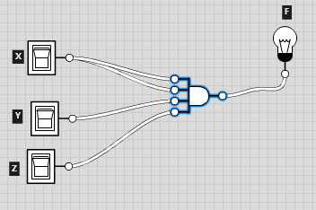

|  |  |  |  |
| --- | --- | --- | --- |
| X | Y | Z | F |
| 0 | 0 | 0 | 0 |
| 0 | 0 | 1 | 0 |
| 0 | 1 | 0 | 0 |
| 1 | 0 | 0 | 1 |
| 0 | 1 | 1 | 0 |
| 1 | 0 | 1 | 1 |
| 1 | 1 | 0 | 1 |
| 1 | 1 | 1 | 2 |

1. F = xyz’

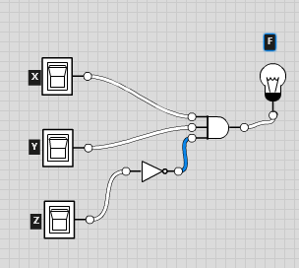

|  |  |  |  |
| --- | --- | --- | --- |
| X | Y | Z | F |
| 0 | 0 | 0 | 0 |
| 0 | 0 | 1 | 0 |
| 0 | 1 | 0 | 0 |
| 1 | 0 | 0 | 0 |
| 0 | 1 | 1 | 0 |
| 1 | 0 | 1 | 0 |
| 1 | 1 | 0 | 1 |
| 1 | 1 | 1 | 0 |

1. F = x + y’z

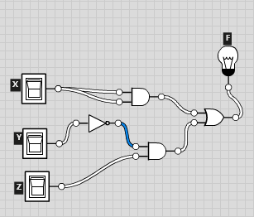

|  |  |  |  |
| --- | --- | --- | --- |
| X | Y | Z | F |
| 0 | 0 | 0 | 0 |
| 0 | 0 | 1 | 1 |
| 0 | 1 | 0 | 0 |
| 1 | 0 | 0 | 1 |
| 0 | 1 | 1 | 0 |
| 1 | 0 | 1 | 2 |
| 1 | 1 | 0 | 1 |
| 1 | 1 | 1 | 1 |

1. F = x’y’z + x’yz + xy’

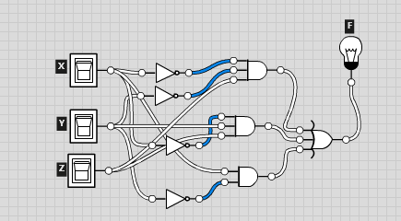

|  |  |  |  |
| --- | --- | --- | --- |
| X | Y | Z | F |
| 0 | 0 | 0 | 0 |
| 0 | 0 | 1 | 1 |
| 0 | 1 | 0 | 0 |
| 1 | 0 | 0 | 1 |
| 0 | 1 | 1 | 1 |
| 1 | 0 | 1 | 1 |
| 1 | 1 | 0 | 0 |
| 1 | 1 | 1 | 0 |

1. F = xy’ + x’z

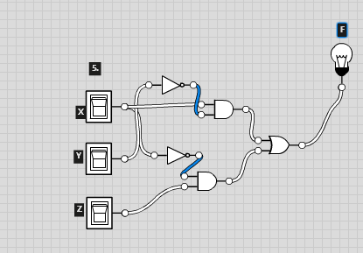

|  |  |  |  |
| --- | --- | --- | --- |
| X | Y | Z | F |
| 0 | 0 | 0 | 0 |
| 0 | 0 | 1 | 1 |
| 0 | 1 | 0 | 0 |
| 1 | 0 | 0 | 1 |
| 0 | 1 | 1 | 2 |
| 1 | 0 | 1 | 1 |
| 1 | 1 | 0 | 0 |
| 1 | 1 | 1 | 0 |