Document Object Model (DOM)
- An application programming interface (API) for valid HTML and well-formed XML documents
- A data structure that is maintained by the browser, you can view the DOM by using the developer tools of your browser
- It defines the logical structure of documents and the way a document is accessed and manipulated
  - Programmers can build documents, navigate their structure, and add, modify, or delete elements and content
  - Anything found in an HTML or XML document can be accessed, changed, deleted, or added using the DOM
Note: you may need app.UseStaticFiles() in the request delegate pipeline.
<!DOCTYPE html>
<html>
<head>
<meta charset="utf-8" />
<title>Introduction to the DOM</title>
</head>
<body>
<header>
<h1>Introduction to the DOM</h1>
</header>
</body>
</html>
DOM Hierarchy
(If I ask you to draw the DOM of an HTML document this is what I expect)
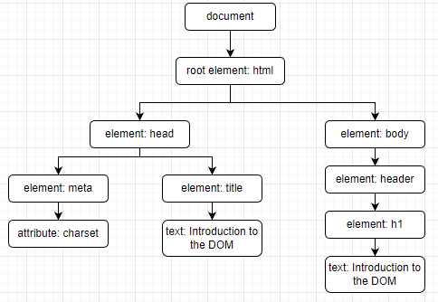
Chart created with https://app.diagrams.net/
DOM Hierarchy using the Developer Tools in Chrome
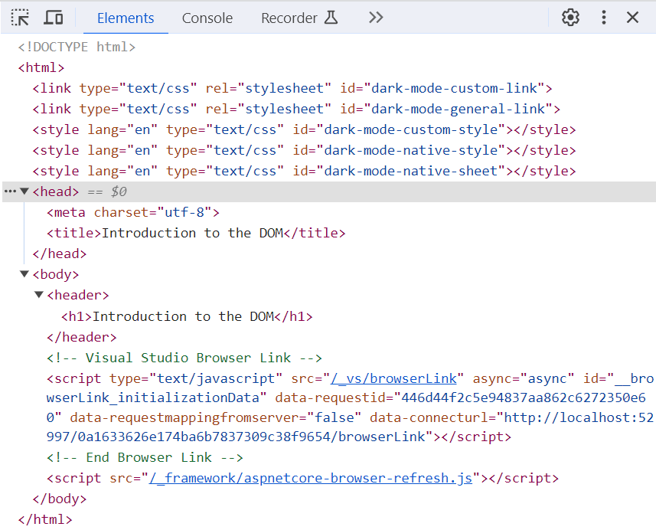

DOM Manipulation
- One of JavaScript’s main purposes is to manipulate the DOM.
- To obtain a DOM element, you must select it (or them) using selectors
- The document and window objects are the objects whose interfaces you generally use most often in DOM programming.
  - The window object represents something like the browser, and the document object is the root of the document itself.

Fundamental DOM Types
Data Type | Description
Document | The root document object itself
Node | Every object found within a document is a node of some kind. In an HTML document, an object can be an element node but also a text node or attribute node.
Element | The element type is based on node. It refers to an element or a node of type element returned by a member of the DOM API.
NodeList | A NodeList is an array of elements.
Attribute | Attributes are nodes in the DOM just like elements are, though you may rarely use them as such.
NamedNodeMap | A NamedNodeMap is like an array, but the items are accessed by name or index, though this latter case is a convenience for enumeration, as they are not ordered in the list.
- Element inherits from the generic Node interface, and together these two interfaces supply many of the methods and properties you use on individual elements.

Common DOM API (There are many more)
- document.querySelector(selector)
- document.querySelectorAll(name)
- document.createElement(name)
- parentNode.appendChild(node)
- element.innerHTML
- element.setAttribute()
- element.getAttribute()
- element.addEventListener()
- window.content
- window.scrollTo()

Selectors
- Selectors are used to get DOM elements

Example HTML
See Appendix: Example View Code
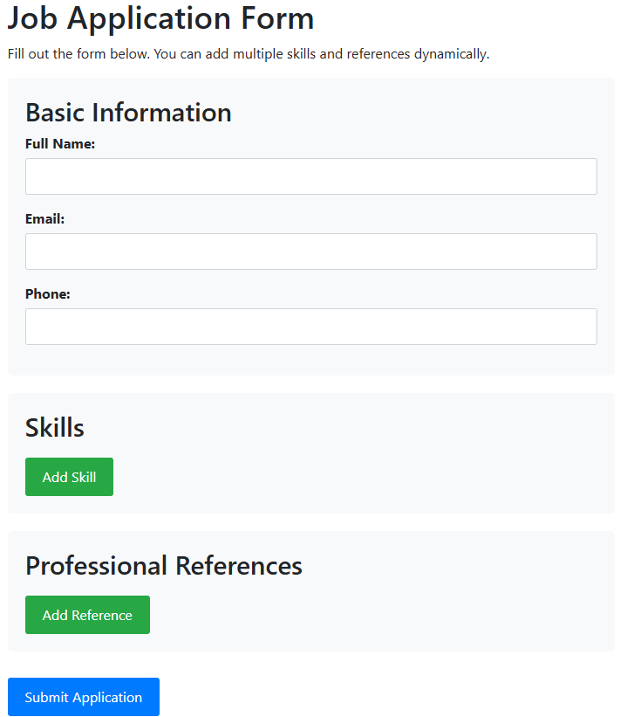

document.querySelector()
- Returns the first element within the document that matches the specified selector, or group of selectors. If no matches are found, null is returned.
- E.g.,
  - const form = document.querySelector('#jobApplicationForm');
    - Selects the first element in the document that has id ‘jobApplication’
export class DOMManipulator {
static demonstrateDOMSelectors() {
console.log('=== DOM SELECTOR EXAMPLES ===');

// Select by ID
const form = document.querySelector('#jobApplicationForm');
console.log('Form element:', form);
}
}
'use strict';

import { DOMManipulator } from "./DOMManipulator.js";

DOMManipulator.demonstrateDOMSelectors();
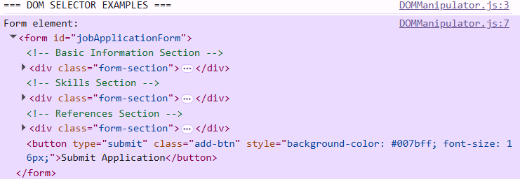

document.querySelectorAll()
- Returns a static list of the document's elements that match the specified group of selectors.
  - Static means that changes to the DOM after the list is created does not affect the list
- E.g.,
  - const allInputs = document.querySelectorAll('input');
    - Gets a list of all inputs in the document
    - If inputs.length = 0 then the list is empty
- The elements are accessed using standard array notations
static demonstrateDOMSelectors() {
console.log('=== DOM SELECTOR EXAMPLES ===');
// Select by ID
const form = document.querySelector('#jobApplicationForm');
console.log('Form element:', form);

// Select by tag name
const allInputs = document.querySelectorAll('input');
console.log('All input elements:', allInputs);

// Select descendant elements
const formSections = document.querySelectorAll('.form-section h2');
console.log('Form section headers:', formSections);
}
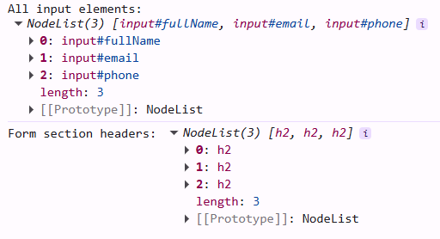

Dynamically Adding Elements to the DOM
<!-- Skills Section -->
<div class="form-section">
<h2>Skills</h2>
<div id="skillsContainer">
<!-- Skills will be added here dynamically -->
</div>
<button type="button" class="add-btn" id="addSkillBtn">Add Skill</button>
</div>
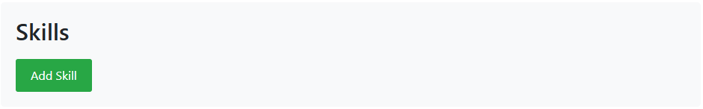

Event Delegation
- An event is a triggered action
  - E.g., clicking a button
- You write an event listener to handle the event
  - The event listener is typically a function
- With event delegation, the listener is attached to a container element. This is effective when working with dynamic DOM elements.

document.createElement(tagName)
- Creates the HTML element specified by tagName
- More secure than innerHTML
- Syntax:
let element = document.createElement(tagName[, options]);
#skillCount = 0;

setUpEventListeners() {
// Using event delegation on the document to handle clicks on dynamically
// added elements
document.addEventListener('click', (e) => {
// Handle "Add Skill" button click
if (e.target.getAttribute('id') === 'addSkillBtn') {
this.addSkillField();
}
});
}

addSkillField() {
this.#skillCount++;

// Select the container where we'll add the new skill field
const skillsContainer = document.querySelector('#skillsContainer');

// METHOD 1: Using createElement (most secure and recommended)
const skillDiv = document.createElement('div');
skillDiv.className = 'skill-item';
skillDiv.setAttribute('data-skill-id', this.#skillCount);

// Create label
const label = document.createElement('label');
label.setAttribute('for', `skill${this.#skillCount}`);
label.textContent = `Skill ${this.#skillCount}:`;

// Create input
const input = document.createElement('input');
input.setAttribute('type', 'text');
input.setAttribute('id', `skill${this.#skillCount}`);
input.setAttribute('name', `skill${this.#skillCount}`);
input.setAttribute('placeholder', 'e.g., JavaScript, Project Management');

// Create remove button
const removeBtn = document.createElement('button');
removeBtn.className = 'remove-btn remove-skill';
removeBtn.textContent = 'Remove';
removeBtn.setAttribute('type', 'button');

// Append elements to the skill div
skillDiv.appendChild(label);
skillDiv.appendChild(input);
skillDiv.appendChild(removeBtn);

// Add the complete skill div to the container
skillsContainer.appendChild(skillDiv);
}
let dom = new DOMManipulator();
dom.setUpEventListeners();

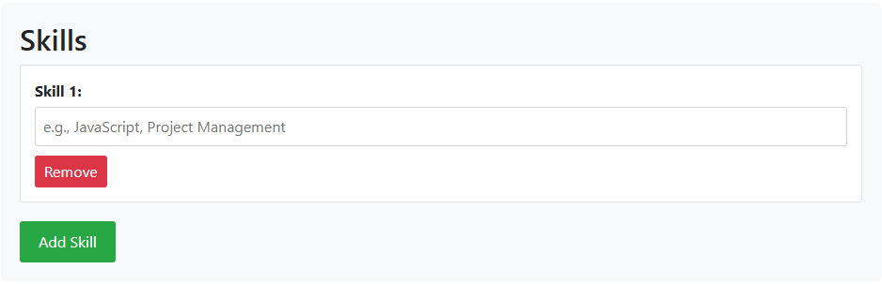

element.innerHTML
- Gets or sets the HTML or XML markup contained within the element
- Note: there are security issues with innerHTML so your code may fail organizational security audits
- Syntax:
Get: const content = element.innerHTML;
Set: element.innerHTML = htmlString;

Example
setUpEventListeners() {
// Using event delegation on the document to handle clicks on dynamically
// added elements
document.addEventListener('click', (e) => {
// Handle "Add Skill" button click
if (e.target.getAttribute('id') === 'addSkillBtn') {
this.addSkillField();
}
});

document.addEventListener('submit', (e) => {
if (e.target.getAttribute('id') === 'jobApplicationForm') {
e.preventDefault();
this.displaySummary();
}
});
}
displaySummary() {
// Select the form and output elements
const form = document.querySelector('#jobApplicationForm');
const output = document.querySelector('#output');
const summaryContent = document.querySelector('#summaryContent');

// Get form data
const formData = new FormData(form);

// Clear previous summary
summaryContent.innerHTML = '';

// Create summary sections using createElement
const basicInfoSection = document.createElement('div');
basicInfoSection.innerHTML = '<h4>Basic Information</h4>';
const nameP = document.createElement('p');
nameP.textContent = `Name: ${formData.get('fullName')}`;
basicInfoSection.appendChild(nameP);
const emailP = document.createElement('p');
emailP.textContent = `Email: ${formData.get('email')}`;
basicInfoSection.appendChild(emailP);
const phoneP = document.createElement('p');
phoneP.textContent = `Phone: ${formData.get('phone')}`;
basicInfoSection.appendChild(phoneP);
summaryContent.appendChild(basicInfoSection);

// Display skills
const skillsSection = document.createElement('div');
skillsSection.innerHTML = '<h4>Skills</h4>';
const skillsList = document.createElement('ul');
let hasSkills = false;
for (const [key, value] of formData.entries()) {
if (key.startsWith('skill') && value.trim() !== '') {
hasSkills = true;
const li = document.createElement('li');
li.textContent = value;
skillsList.appendChild(li);
}
}
if (hasSkills) {
skillsSection.appendChild(skillsList);
} else {
const noSkills = document.createElement('p');
noSkills.textContent = 'No skills added';
skillsSection.appendChild(noSkills);
}
summaryContent.appendChild(skillsSection);

// Display references
const referencesSection = document.createElement('div');
referencesSection.innerHTML = '<h4>References</h4>';
const referencesDiv = document.createElement('div');
let hasReferences = false;

// Group reference data
const references = {};
for (const [key, value] of formData.entries()) {
if (key.startsWith('ref')) {
const match = key.match(/^ref(Name|Email|Relationship)(\d+)$/);
if (match) {
const field = match[1];
const id = match[2];
if (!references[id]) {
references[id] = {};
}
references[id][field] = value;
}
}
}

// Display grouped references
for (const refId in references) {
const ref = references[refId];
if (ref.Name || ref.Email || ref.Relationship) {
hasReferences = true;
const refP = document.createElement('p');
refP.innerHTML = `<strong>${ref.Name || 'N/A'}</strong><br>
Email: ${ref.Email || 'N/A'}<br>
Relationship: ${ref.Relationship || 'N/A'}`;
referencesDiv.appendChild(refP);
}
}
if (hasReferences) {
referencesSection.appendChild(referencesDiv);
} else {
const noRefs = document.createElement('p');
noRefs.textContent = 'No references added';
referencesSection.appendChild(noRefs);
}
summaryContent.appendChild(referencesSection);

// Show the output section
output.style.display = 'block';

// Scroll to the output
output.scrollIntoView({ behavior: 'smooth' });
}
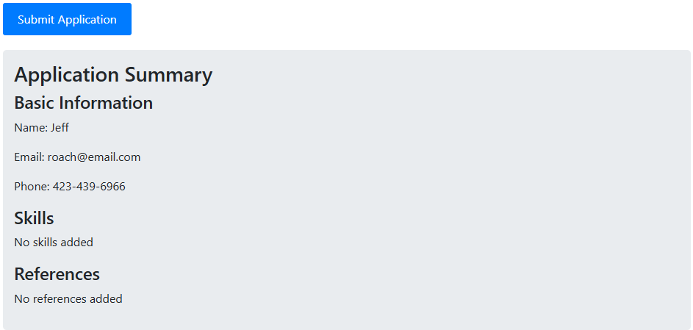

DOMParser
- Allows you to parse HTML or XML from a string into a DOM element
#referenceCount = 0;

setUpEventListeners() {
// Using event delegation on the document to handle clicks on dynamically
// added elements
document.addEventListener('click', (e) => {
// Handle "Add Skill" button click
if (e.target.getAttribute('id') === 'addSkillBtn') {
this.addSkillField();
}

// Handle "Add Reference" button click
if (e.target.getAttribute('id') === 'addReferenceBtn') {
this.addReferenceField();
}
});

document.addEventListener('submit', (e) => {
if (e.target.getAttribute('id') === 'jobApplicationForm') {
e.preventDefault();
this.displaySummary();
}
});
}
addReferenceField() {
this.#referenceCount++;
// Select the container
const referencesContainer = document.querySelector('#referencesContainer');
// METHOD 3: Using DOMParser (useful for more complex HTML structures)
const parser = new DOMParser();
const htmlString = `
<div class="reference-item" data-reference-id="${this.#referenceCount}">
<div class="form-group">
<label for="refName${this.#referenceCount}">Reference ${this.#referenceCount} - Name:</label>
<input type="text" id="refName${this.#referenceCount}" name="refName${this.#referenceCount}"
placeholder="Reference full name">
</div>
<div class="form-group">
<label for="refEmail${this.#referenceCount}">Email:</label>
<input type="email" id="refEmail${this.#referenceCount}" name="refEmail${this.#referenceCount}"
placeholder="reference@email.com">
</div>
<div class="form-group">
<label for="refRelationship${this.#referenceCount}">Relationship:</label>
<select id="refRelationship${this.#referenceCount}" name="refRelationship${this.#referenceCount}">
<option value="">Select relationship</option>
<option value="supervisor">Supervisor</option>
<option value="colleague">Colleague</option>
<option value="mentor">Mentor</option>
<option value="professor">Professor</option>
</select>
</div>
<button type="button" class="remove-btn remove-reference">Remove Reference</button>
</div>`;
const doc = parser.parseFromString(htmlString, 'text/html');
const referenceDiv = doc.querySelector('.reference-item');
referencesContainer.appendChild(referenceDiv);
}
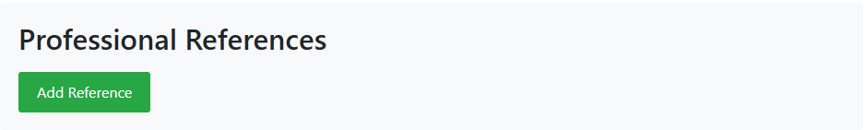
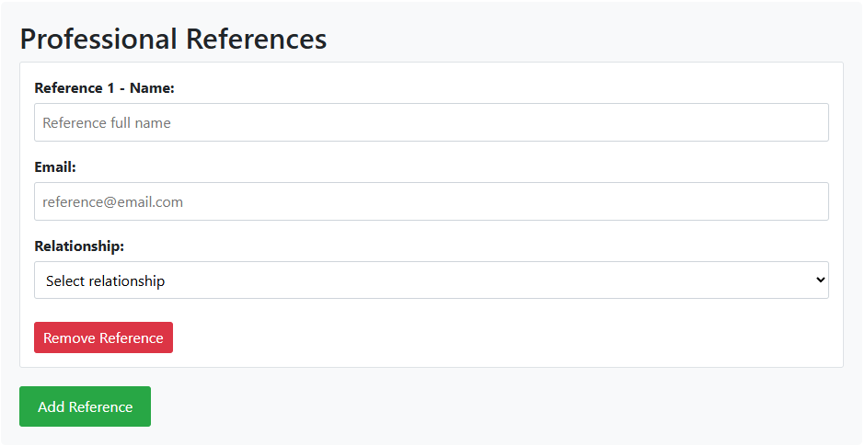

Removing Elements
setUpEventListeners() {
// Using event delegation on the document to handle clicks on dynamically
// added elements
document.addEventListener('click', (e) => {
// Handle "Add Skill" button click
if (e.target.getAttribute('id') === 'addSkillBtn') {
this.addSkillField();
}

// Handle "Add Reference" button click
if (e.target.getAttribute('id') === 'addReferenceBtn') {
this.addReferenceField();
}

// Handle "Remove" button clicks for skills
if (e.target.classList.contains('remove-skill')) {
this.removeSkillField(e.target);
}

// Handle "Remove" button clicks for references
if (e.target.classList.contains('remove-reference')) {
this.removeReferenceField(e.target);
}
});

document.addEventListener('submit', (e) => {
if (e.target.getAttribute('id') === 'jobApplicationForm') {
e.preventDefault();
this.displaySummary();
}
});
}
removeSkillField(button) {
// Traverse the DOM to find the parent skill-item div
const skillItem = button.closest('.skill-item');
if (skillItem) {
skillItem.remove();
}
}

removeReferenceField(button) {
// Find the parent reference-item div
const referenceItem = button.closest('.reference-item');
if (referenceItem) {
referenceItem.remove();
}
}
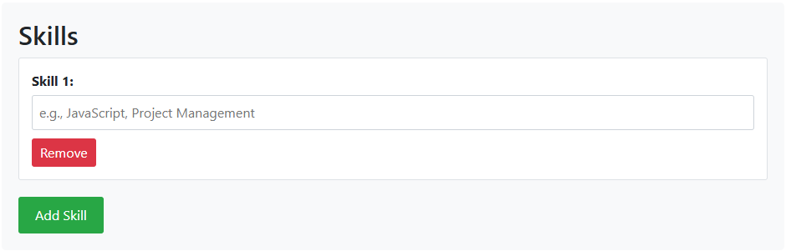
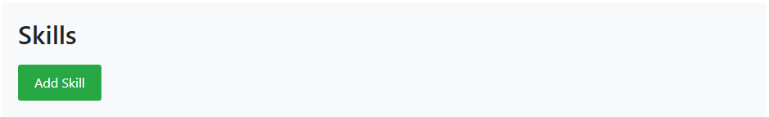
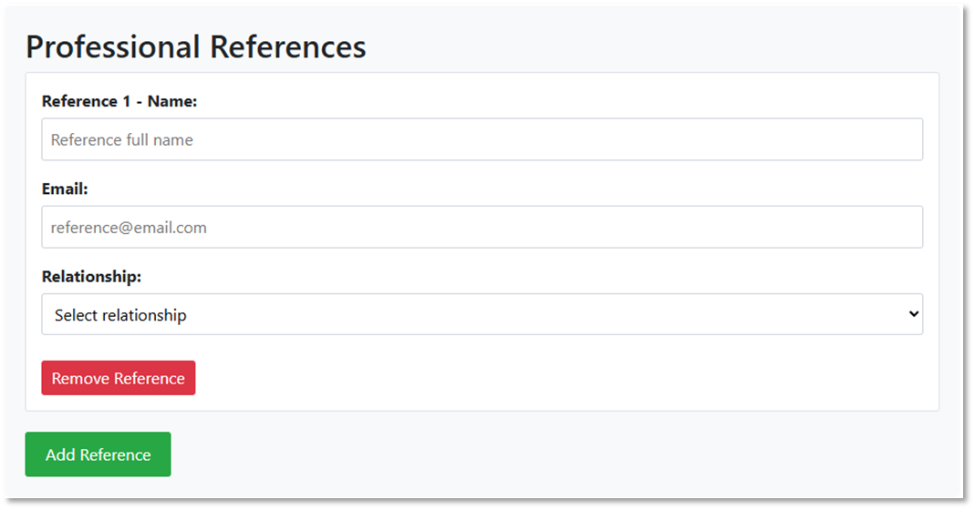


Appendix: Some Common Client-Side Events

Keyboard Events
keydown | When ANY key is pressed
keypress | When ANY key except Shift, Fn, and Caps Lock is in pressed position. (Fired continuously.)
keyup | When ANY key is released

Mouse Events
mouseenter | When a pointing device is moved onto the element that has the listener attached
mouseover | When a pointing device is moved onto the element that has the listener attached or onto one of its children
mousemove | A pointing device is moved over an element (Fired continuously as the mouse moves)
mousedown | When a pointing device button is pressed on an element
mouseup | When a pointing device button is released over an element
auxclick | When a pointing device button (ANY non-primary button) has been pressed and released on an element
click | A pointing device button has been pressed and released on an element
dblclick | A pointing device button is clicked twice on an element
contextmenu | The right button of the mouse is clicked (before the context menu is displayed)
wheel | A wheel button of a pointing device is rotated in any direction
mouseleave | A pointing device is moved off the element that has the listener attached
mouseout | A pointing device is moved off the element that has the listener attached or off one of its children
select | Some text is being selected

Appendix: Example View Code
@{
ViewData["Title"] = "Job Application Form";
}

<style>
.form-section {
background-color: #f8f9fa;
padding: 20px;
margin-bottom: 20px;
border-radius: 5px;
}

.skill-item, .reference-item {
background-color: white;
padding: 15px;
margin-bottom: 10px;
border: 1px solid #dee2e6;
border-radius: 3px;
position: relative;
}

.remove-btn {
background-color: #dc3545;
color: white;
border: none;
padding: 5px 10px;
border-radius: 3px;
cursor: pointer;
margin-top: 10px;
}

.remove-btn:hover {
background-color: #c82333;
}

.add-btn {
background-color: #28a745;
color: white;
border: none;
padding: 10px 20px;
border-radius: 3px;
cursor: pointer;
margin-top: 10px;
}

.add-btn:hover {
background-color: #218838;
}

.form-group {
margin-bottom: 15px;
}

label {
display: block;
font-weight: bold;
margin-bottom: 5px;
}

input[type="text"],
input[type="email"],
input[type="tel"],
select {
width: 100%;
padding: 8px;
border: 1px solid #ced4da;
border-radius: 3px;
box-sizing: border-box;
}

#output {
background-color: #e9ecef;
padding: 15px;
border-radius: 5px;
margin-top: 20px;
display: none;
}
</style>

<h1>@ViewData["Title"]</h1>
<p>Fill out the form below. You can add multiple skills and references dynamically.</p>

<form id="jobApplicationForm">
<!-- Basic Information Section -->
<div class="form-section">
<h2>Basic Information</h2>

<div class="form-group">
<label for="fullName">Full Name:</label>
<input type="text" id="fullName" name="fullName" required>
</div>

<div class="form-group">
<label for="email">Email:</label>
<input type="email" id="email" name="email" required>
</div>

<div class="form-group">
<label for="phone">Phone:</label>
<input type="tel" id="phone" name="phone" required>
</div>
</div>

<!-- Skills Section -->
<div class="form-section">
<h2>Skills</h2>
<div id="skillsContainer">
<!-- Skills will be added here dynamically -->
</div>
<button type="button" class="add-btn" id="addSkillBtn">Add Skill</button>
</div>

<!-- References Section -->
<div class="form-section">
<h2>Professional References</h2>
<div id="referencesContainer">
<!-- References will be added here dynamically -->
</div>
<button type="button" class="add-btn" id="addReferenceBtn">Add Reference</button>
</div>

<button type="submit" class="add-btn" style="background-color: #007bff; font-size: 16px;">Submit Application</button>
</form>

<div id="output">
<h3>Application Summary</h3>
<div id="summaryContent"></div>
</div>

@section Scripts {
<script defer type="module" src="~/js/jobApplicationForm.js"></script>
}

Appendix: CSS Selectors
Source: https://www.w3schools.com/cssref/css_selectors.asp
Selector | Example | Description
.class | .intro | Selects all elements with class="intro"
.class1.class2 | .name1.name2 | Selects all elements with both name1 and name2 set within its class attribute
.class1 .class2 | .name1 .name2 | Selects all elements with name2 that is a descendant of an element with name1
#id | #firstname | Selects the element with id="firstname"
* | * | Selects all elements
element | p | Selects all <p> elements
element.class | p.intro | Selects all <p> elements with class="intro"
element,element | div, p | Selects all <div> elements and all <p> elements
element | div p | Selects all <p> elements inside <div> elements
element>element | div > p | Selects all <p> elements where the parent is a <div> element
element+element | div + p | Selects the first <p> element that is placed immediately after <div> elements
element1~element2 | p ~ ul | Selects every <ul> element that is preceded by a <p> element
[attribute] | [target] | Selects all elements with a target attribute
[attribute=value] | [target=_blank] | Selects all elements with target="_blank"
[attribute~=value] | [title~=flower] | Selects all elements with a title attribute containing the word "flower"
[attribute|=value] | [lang|=en] | Selects all elements with a lang attribute value starting with "en"
[attribute^=value] | a[href^="https"] | Selects every <a> element whose href attribute value begins with "https"
[attribute$=value] | a[href$=".pdf"] | Selects every <a> element whose href attribute value ends with ".pdf"
[attribute*=value] | a[href*="w3schools"] | Selects every <a> element whose href attribute value contains the substring "w3schools"
:active | a:active | Selects the active link
::after | p::after | Insert something after the content of each <p> element
::before | p::before | Insert something before the content of each <p> element
:checked | input:checked | Selects every checked <input> element
:default | input:default | Selects the default <input> element
:disabled | input:disabled | Selects every disabled <input> element
:empty | p:empty | Selects every <p> element that has no children (including text nodes)
:enabled | input:enabled | Selects every enabled <input> element
:first-child | p:first-child | Selects every <p> element that is the first child of its parent
::first-letter | p::first-letter | Selects the first letter of every <p> element
::first-line | p::first-line | Selects the first line of every <p> element
:first-of-type | p:first-of-type | Selects every <p> element that is the first <p> element of its parent
:focus | input:focus | Selects the input element which has focus
:fullscreen | :fullscreen | Selects the element that is in full-screen mode
:hover | a:hover | Selects links on mouse over
:in-range | input:in-range | Selects input elements with a value within a specified range
:indeterminate | input:indeterminate | Selects input elements that are in an indeterminate state
:invalid | input:invalid | Selects all input elements with an invalid value
:lang(language) | p:lang(it) | Selects every <p> element with a lang attribute equal to "it" (Italian)
:last-child | p:last-child | Selects every <p> element that is the last child of its parent
:last-of-type | p:last-of-type | Selects every <p> element that is the last <p> element of its parent
:link | a:link | Selects all unvisited links
::marker | ::marker | Selects the markers of list items
:not(selector) | :not(p) | Selects every element that is not a <p> element
:nth-child(n) | p:nth-child(2) | Selects every <p> element that is the second child of its parent
:nth-last-child(n) | p:nth-last-child(2) | Selects every <p> element that is the second child of its parent, counting from the last child
:nth-last-of-type(n) | p:nth-last-of-type(2) | Selects every <p> element that is the second <p> element of its parent, counting from the last child
:nth-of-type(n) | p:nth-of-type(2) | Selects every <p> element that is the second <p> element of its parent
:only-of-type | p:only-of-type | Selects every <p> element that is the only <p> element of its parent
:only-child | p:only-child | Selects every <p> element that is the only child of its parent
:optional | input:optional | Selects input elements with no "required" attribute
:out-of-range | input:out-of-range | Selects input elements with a value outside a specified range
::placeholder | input::placeholder | Selects input elements with the "placeholder" attribute specified
:read-only | input:read-only | Selects input elements with the "readonly" attribute specified
:read-write | input:read-write | Selects input elements with the "readonly" attribute NOT specified
:required | input:required | Selects input elements with the "required" attribute specified
:root | :root | Selects the document's root element
::selection | ::selection | Selects the portion of an element that is selected by a user
:target | #news:target | Selects the current active #news element (clicked on a URL containing that anchor name)
:valid | input:valid | Selects all input elements with a valid value
:visited | a:visited | Selects all visited links

