Setup
Create a new ASP.NET Core Web Application (Model-View-Controller) project:
- Name the project: CSCI3110Lab01<your initials> e.g., CSCI3110Lab01JR

1: Hello, World!
- Implement the following user story and story flow.
As a C# learner, I want to view my home page.

Trigger:
I send a GET request to /home/index.

Flow:
- The application responds with my home page.
- Here are the UI elements:
Home Page UI Elements
Centered heading: Hello, World! {your name here} is learning C# in the ASP.NET environment.
- Here is an example output:
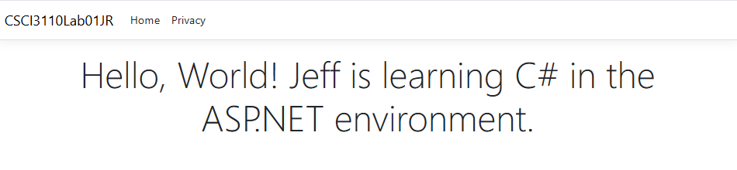
- Checkpoint 1: Show your code and output to the instructor.
Output:
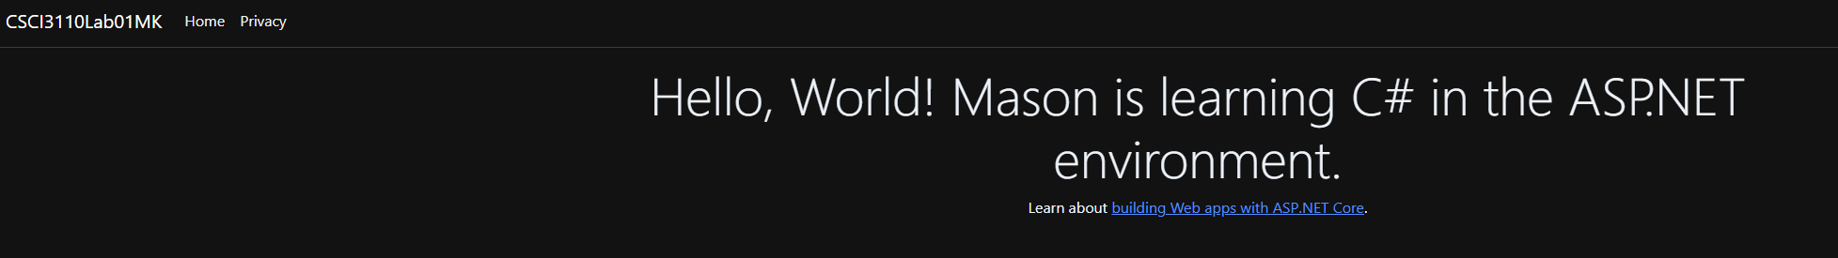
Code:
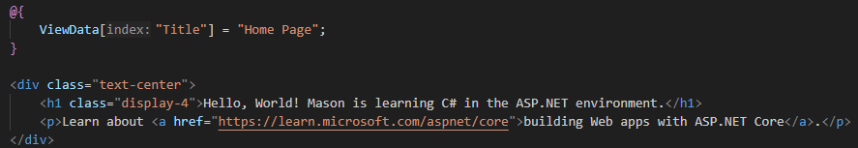

2: Sending a Simple GET Request
- To your home page, add a hyper link to send a GET request to https://www.etsu.edu. The page should open in a different tab.
- Checkpoint 2: Show your code and output the the instructor.
Output:
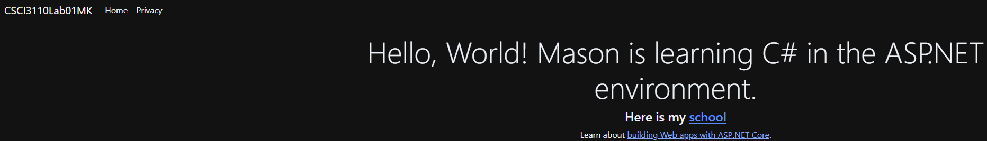
Code:
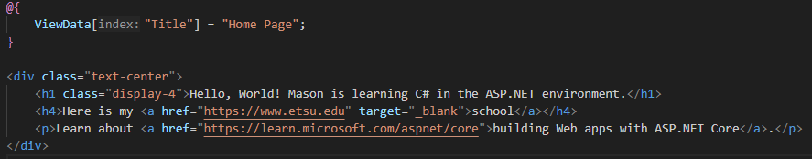

3: Sending a Simple POST Request
- Create an HTML form on your home page:
  - The form should:
    - Use method="post"
    - Set action="/home/data"
    - Include an input element with name="userName" (you'll use this name in your controller)
    - Include a submit button
- Create a Data action method in your HomeController:
  - Add the [HttpPost] attribute above the method to ensure it only handles POST requests.
  - The method signature should accept a parameter that matches your form's input name (e.g., string userName).
  - Store the incoming name in ViewData (e.g., ViewData["UserName"] = userName;)
  - Return a view.
- Create the Data view:
  - Create a new view file for the Data action method.
  - Use ViewData to display the user's name that was submitted from the form.
- Capture the POST request:
  - Open your browser's Developer Tools (F12)
  - Navigate to the Network tab
  - Submit your form
  - Find the POST request to /home/data
  - Copy the raw HTTP request headers and body
  - Paste the complete request message below
POST /home/data HTTP/1.1 Accept: text/html,application/xhtml+xml,application/xml;q=0.9,image/avif,image/webp,image/apng,*/*;q=0.8 Accept-Encoding: gzip, deflate, br, zstd Accept-Language: en-US,en;q=0.9 Cache-Control: max-age=0 Connection: keep-alive Content-Length: 17 Content-Type: application/x-www-form-urlencoded Host: localhost:5002 Origin: http://localhost:5002 Referer: http://localhost:5002/ Sec-Fetch-Dest: document Sec-Fetch-Mode: navigate Sec-Fetch-Site: same-origin Sec-Fetch-User: ?1 Sec-GPC: 1 Upgrade-Insecure-Requests: 1 User-Agent: Mozilla/5.0 (Windows NT 10.0; Win64; x64) AppleWebKit/537.36 (KHTML, like Gecko) Chrome/144.0.0.0 Safari/537.36 sec-ch-ua: "Not(A:Brand";v="8", "Chromium";v="144", "Brave";v="144" sec-ch-ua-mobile: ?0 sec-ch-ua-platform: "Windows"
userName
kelleymt

- Checkpoint 3: Show the instructor:
  - Your HomeController code (Data action method)
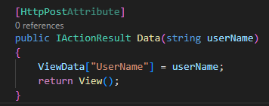
  - Your form HTML code
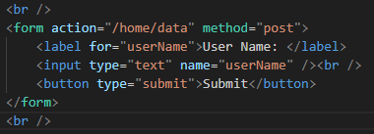
  - Your Data view code
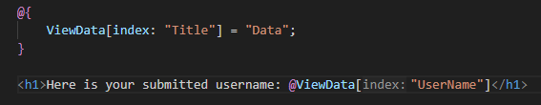
  - The pasted POST request message from step 4

4: Simple Types
- Implement the following user story and story flow:
As a C# learner, I want to view my name and the values of simple data types.

Trigger:
I send a GET request to /home/simpletypes.

Flow:
- The application responds with simple types page.
- In the view code:
  - Use a code block, that is, @{…}.
  - Declare variables and initialize them with values for each of the following types: ‘bool,’ ‘sbyte,’ ‘decimal,’ ‘float,’ ‘uint,’ and ‘short.’
  - Use string interpolation to output your name and all the values as a string.
  - Output the string in a <p>.
- Here are the UI elements:
Simple Types Page UI Elements
Heading: Simple Types
Paragraph: My name is {your name here}. My values: {the values go here}
- Here is an example:
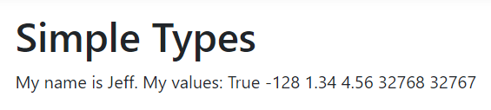
- Checkpoint 4: Show your code and output to the instructor.
Output:
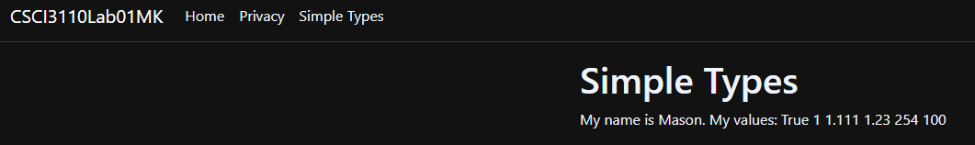
Code:
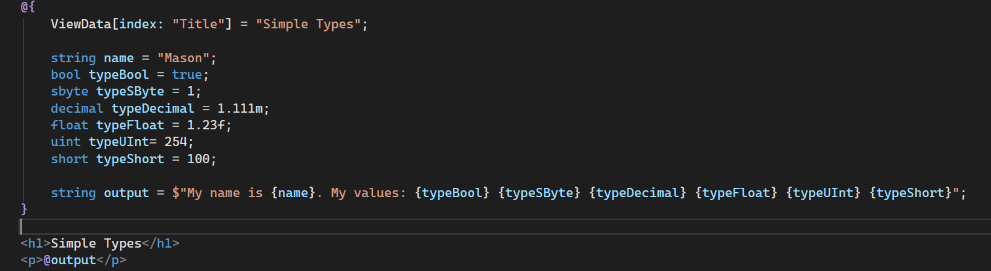
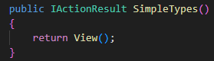

5: Classes
- Implement the following user story and story fllow:
As a C# learner, I want to view the details of my book.

Trigger:
I send a GET request to /home/mybook.

Flow:
- The application responds with the ‘my book’ page.
- Implementation Constraints:
  - Create a class called Book to the Models folder.
  - Add three public properties to the class. You decide what the properties are. Ensure at least two different data types.
  - In the view code
    - Create a code block and then instantiate a Book object. Initialize it with appropriate values for your properties.
  - Output the properties as in the example below.
- Here are the UI elements:
My Book Page UI Elements
Heading: My Book
Paragraph: Each property
- Here is an example:
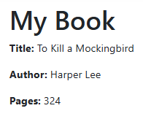
- Checkpoint 5: Show your code and output to the instructor.
Output:
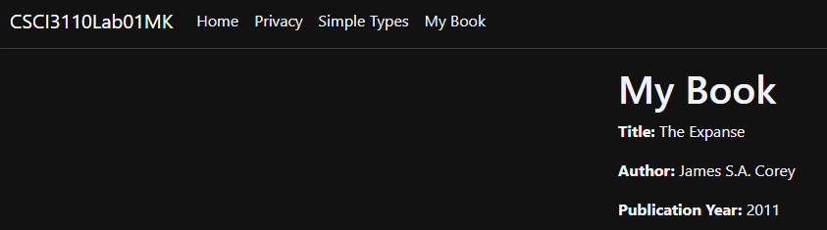
Code:
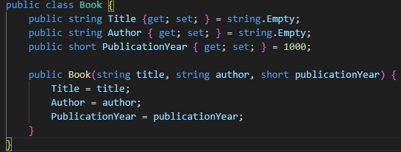
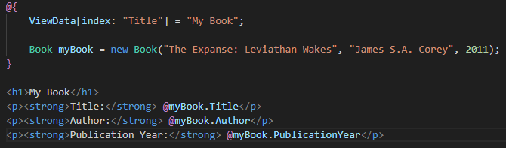
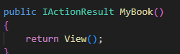

6: Enumeration Types
- Implement the following user story and story flow:
As a C# learner, I want to view my employee details.

Trigger:
I send a GET request to /home/employeedetails.

Flow:
- The application responds with the ‘employee details’ page.
- Implementation Constraints:
  - In the models folder, the department must be implemented as an enumeration: Sales, Marketing, Engineering, HR, Finance, IT.
  - The employee must be implemented as a class with properties: Name, Department.
  - In the view code
    - Instantiate and initialize a Employee object with appropriate property values
  - Output the properties as in the example below.
- Here are the UI elements:
Employee Details UI Elements
Heading: Employee Details
Paragraph: Name and department.
- Here is an example:
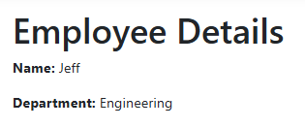
- Checkpoint 6: Show your code and output to the instructor.
Output: 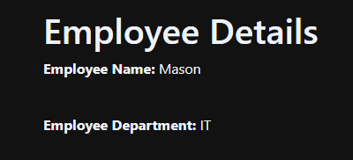
Code:
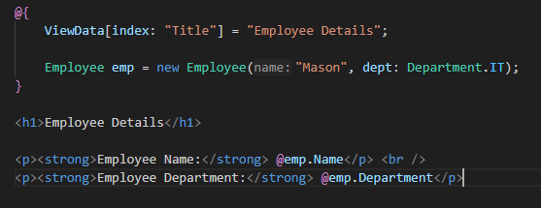
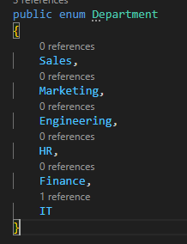
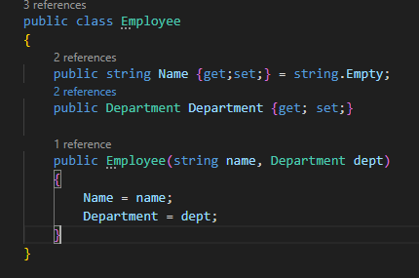

7: Employee Array
- Implement the following user story and story flow:
As a C# learner, I want to view a list of employee departments.

Trigger:
I send a GET request to /home/employeedepartments.

Flow:
- The application responds with the Employee Departments page.
- Implementation constraints:
  - In the view code, create and initialize an array of 5 employees (use the Employee class).
  - Use a @foreach loop to output each employee in the array.
- Here are the UI elements:
Employee Departments UI Elements
Heading: Employee Departments
Paragraphs: The name of each employee and their grade.
- Here is an example:

- Checkpoint 7: Show your code and output to the instructor.
Output:
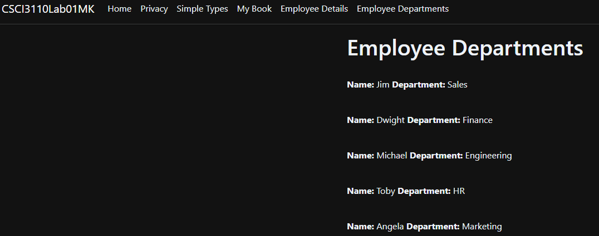
Code:
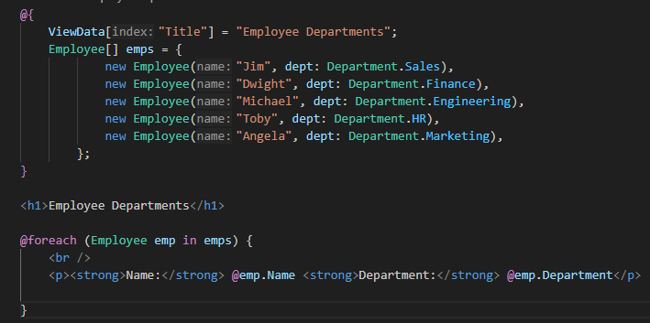

8: 2D Array
- Implement the following user story and story flow:
As a C# learner, I want to view a times table of values.

Trigger:
I send a GET request to /home/timestable.

Flow
- The application responds with the Times Table page.
- Implementation constraints:
  - In the view code, use a 12x12 2D integer array to solve the problem.
  - You must first store the result into the 2D array and then use that array to build the result in a <table> element. You will need a nested for loop.
    - Create the HTML <table> with Bootstrap class “table table-bordered w-25”.
      - Note: w-25 = width 25%
- Here are the UI elements:
Times Table Page
Table of values showing the times table from 1 to 12.
- Here is an example output:
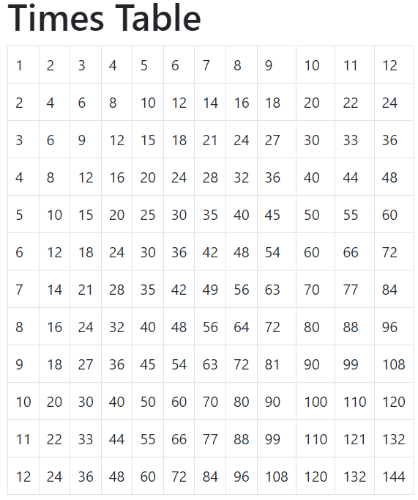
- Checkpoint 8: Show your code and output to the instructor.
Output:
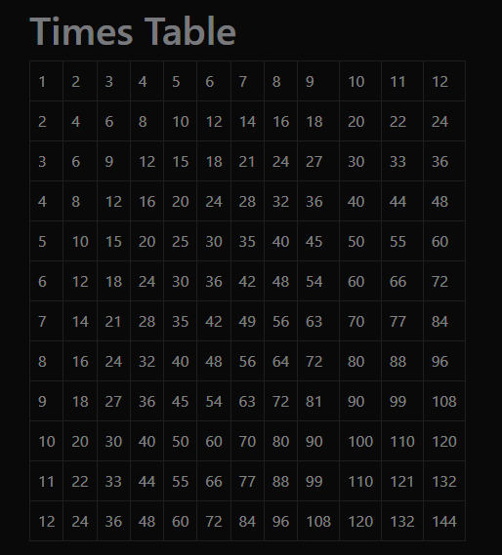
Code:
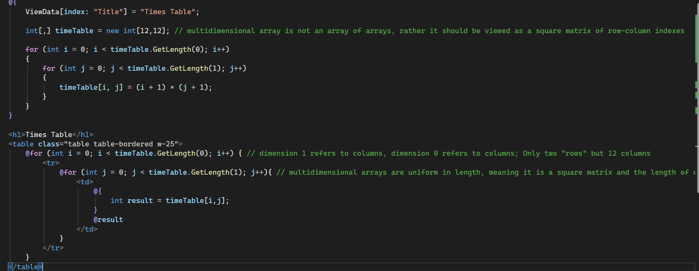
End of Lab

