0: Setup
- Do not use generative AI for this lab.
- Create a new ASP.NET MVC application: CSCI3110<your initials>Lab2CRRUD
- Add the following folders:
  - Services
  - Models/Entites

1: Create the Product Entity
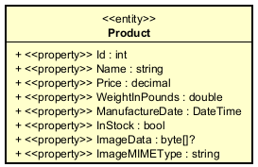
- Code the Product entity. Remember to add the namespace and the data annotation for ManufactureDate.
Checkpoint 1: Show your code to the instructor.

2: Set up Entity Framework and the Database
- Note: For this section you may need to specify the specific package version e.g., --version 9.*
- Globally install the code generator: dotnet tool install -g dotnet-aspnet-codegenerator
- Globally install entity framework tool: dotnet tool install --global dotnet-ef
- Use the CLI to add the following packages:
  - Microsoft.EntityFrameworkCore.Sqlite
  - Microsoft.EntityFrameworkCore.Tools
  - Microsoft.EntityFrameworkCore.Design
- Create the ApplicationDbContext and add Products as a DbSet. Remember to add this class to the Services folder and to include a namespace.
- Add code to the ApplicationDbContext to seed your table with one product. No need to include image information.
- In your project folder, create a Data folder for your database file.
- Add the connection string to appsettings.json to set up the database.
- Configure the DbContext service in Program.cs.
- Ensure that the application builds: dotnet build
- Add your first migration: dotnet ef migrations add Mig1
- Update the database: dotnet ef database update
- Confirm that ProductDb.db was created in the Data folder.
- Go to the Extensions pane, and then search for and install SQLite Viewer by Florian Klampfer.
- View your database using SQLite Viewer:
  - Right-click your database file, choose Open With…
  - Choose SQLite Viewer
- You should see something similar to:
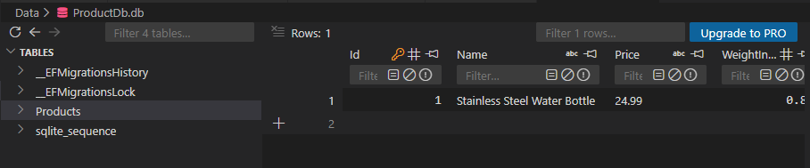
Checkpoint 2: Show your code and database to the instructor.

3: The Product Index Page (ReadAll)
- You’ll now implement the following user story:
As an application user, I want to view a list of all my products.

Trigger:
I send a GET request to /Product/index

Flow:
- The application responds with the list of all my products.
- Code an empty ProductController.
- Code the empty IProductRepository interface.
- Code the empty DbProductRepository class.
- Set up the scoped service for the Product repository.
- Inject the ApplicationDbContext into DbProductRepository.
- Add the Task<ICollection<Product>> ReadAllAsync() method to IProductRepository.
- Implement the ReadAllAsync() method in DbProductRepository.
- Inject the repository into the ProductController.
- Complete the implementation of the Product Index action method:
  - Read all products using the repository.
  - Pass the products to the view and return the view.
- Generate the Product Index view code:
  - dotnet aspnet-codegenerator view Index List --model Product --useDefaultLayout --relativeFolderPath Views/Product
  - You may need to add this package: Microsoft.VisualStudio.Web.CodeGeneration.Design
- Launch the application and navigate to /product/index.
- The output should look like:
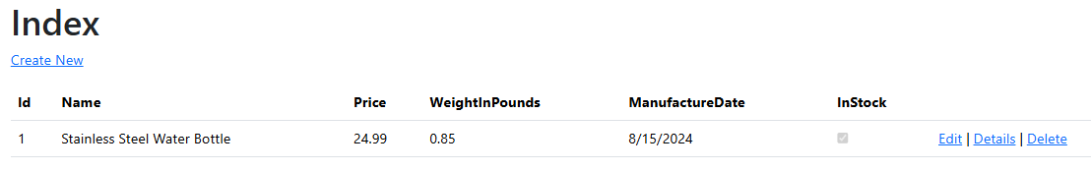
Checkpoint 3: Show your code and output to the instructor.

4: Create Product
- You’ll now implement the following user story and flow:
As an application user, I want to create a new product.

Trigger:
I send a GET request to /Product/create

Flow:
- The application responds with the create product view.
- I enter the new product data.
- I save the new product data.
- The application sends a POST request to /Product/create.
- Guard: [The data is valid]
  - Exception flow: [The data is not valid]
    - The application does not save to the database.
    - The application responds with the populated create Product view.
    - The application shows any error messages.
    - Exit flow
- The application saves the data to the database
- The application redirects to /Product/index
- Code the GET Create action method in the Product controller.
- Generate the create view using the following command: dotnet aspnet-codegenerator view Create Create --model Product --useDefaultLayout --relativeFolderPath Views/Product
  - Add the following to the <form> element: enctype="multipart/form-data"
  - Remove the Id input section.
  - Remove the ImageData and ImageMIMEType input sections. Replace them with the following to upload an image file:
<div class="form-group mb-2">
<label for="imageFiles" class="control-label">Choose an image to upload:</label>
<input id="imageFiles" name="imageFiles" type="file" class="form-control" accept="image/*" />
</div>
- The GET Create view should look like the following:
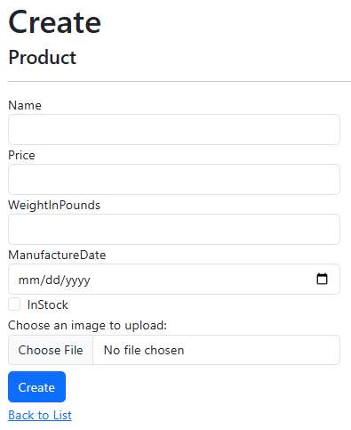
- Add the CreateAsync method to the product repository interface.
- Implement the CreateAsync method in the repository class.
- Here is the code for the async POST Create method in the Product controller. Note how the image file is saved into the database.
[HttpPost]
public async Task<IActionResult> Create(Product newProduct, IList<IFormFile> imageFiles)
{
// Get the first image in the list.
IFormFile? imageFile = imageFiles.FirstOrDefault();
if (imageFile == null || imageFile.Length <= 0)
{
newProduct.ImageData = null;
newProduct.ImageMIMEType = "";
}
else
{
using MemoryStream ms = new();
await imageFile.OpenReadStream().CopyToAsync(ms);
newProduct.ImageData = ms.ToArray();
newProduct.ImageMIMEType = imageFile.ContentType;
}
if (ModelState.IsValid)
{
await _productRepo.CreateAsync(newProduct);
return RedirectToAction("Index");
}
newProduct.ImageData = null;
newProduct.ImageMIMEType = "";
return View(newProduct);
}
- Test creating a Product:
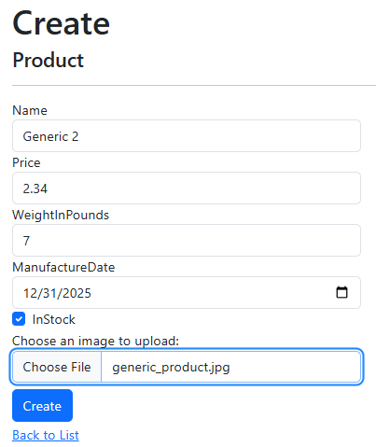
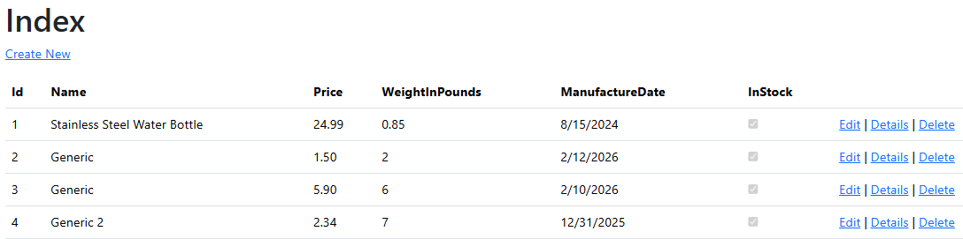
- You can check that the image was uploaded by viewing the database table.
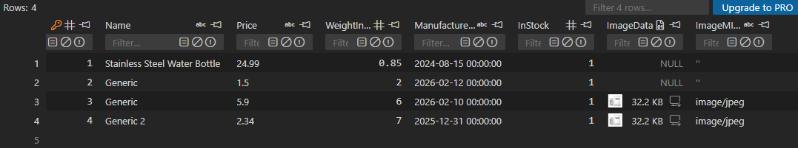
Checkpoint 4: Show your code and that you can create a Product to the instructor.

5: Product Details (Read)
You’ll now implement the following user story and flow:
As an application user, I want to view a product's information.

Trigger:
I send a GET request to /Product/details/{id}

Flow:
- Guard: [id exists]
  - Exception flow:
    - The application redirects to /Product/index
- The application responds with the Product details.
- Add the ReadAsync method to the repository interface.
- Implement the ReadAsync method to the repository class.
- Add the async Details action method to the Product controller.
- Add the following method to the Product controller. This endpoint will return the image to be rendered.
public async Task<IActionResult> Image(int id)
{
var product = await _productRepo.ReadAsync(id);
if (product == null || product.ImageData == null)
{
var svg = @"<svg xmlns='http://www.w3.org/2000/svg' width='200' height='200'>
<rect width='100' height='100' fill='#cccccc'/>
<text x='25%' y='25%' text-anchor='middle' dominant-baseline='middle'
font-family='Arial' font-size='16' fill='#666666'>No Image</text>
</svg>";
return Content(svg, "image/svg+xml");
}
MemoryStream ms = new(product.ImageData);
return new FileStreamResult(ms, product.ImageMIMEType);
}
- Generate the Details view code using the following command: dotnet aspnet-codegenerator view Details Details --model Product --useDefaultLayout --relativeFolderPath Views\Product
- Add the following to site.css:
img.thumbnail {
border: 1px solid #ddd;
border-radius: 4px;
padding: 5px;
width: 150px;
}
- In the Details view code, remove the sections for ImageData and ImageMIMEType. Replace them with the following:
<dt class = "col-sm-2">
Image:
</dt>
<dd class = "col-sm-10">
<img src="/Product/Image/@Model.Id" alt="@Model.Name image" class="thumbnail" />
</dd>
- Update Details action link in the Product index view code.
- Test the details link on the index page.
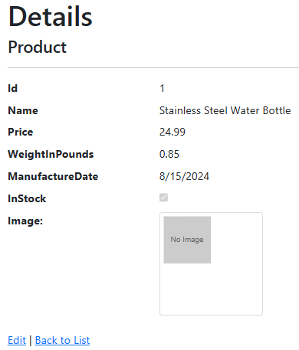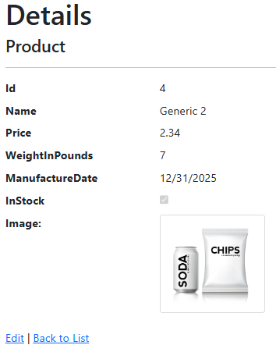
Checkpoint 5: Show your code and output to the instructor.

6: Edit Product (Update)
You’ll now implement the following user story:
As an application user, I want to update a Product's data.

Trigger:
I send a GET request to /Product/update/{id}

Flow:
- Guard:[id exists]
  - Exception flow:
    - The application redirects to /Product/index
- The application responds with the update Product view
- I enter the updated data
- I save the updated data
- The application sends a POST request to /Product/update
- Guard: [The data is valid]
  - Exception flow:
    - The application does not save to the database
    - The application responds with the update Product view
    - The application shows any error messages
    - Exit flow
- The application saves the data to the database
- The application redirects to /Product/index
- Code the async GET Edit action method in the Product controller.
- Generate the Edit view code using the following command : dotnet aspnet-codegenerator view Edit Edit --model Product --useDefaultLayout --relativeFolderPath Views/Product
- Add the enctype attribute to the <form> element:
<form asp-action="Edit" enctype="multipart/form-data">
- Make the Id input read-only: <input asp-for="Id" class="form-control" readonly/>
- Replace the ImageData and the ImageMIMEType sections with the “Choose an image to upload” input from the Create view.
- To the form-group <div> for the image, add the <img> from the Details view code. This will allow the image to be displayed.
- Update the Edit action link in the Product Index view code.
- The Edit view should look like the following:
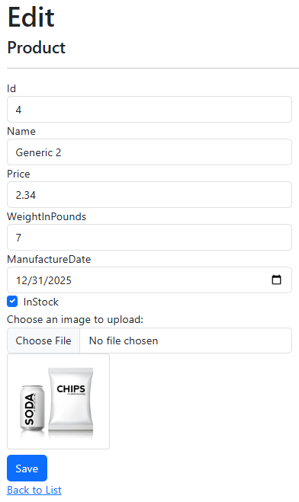
- Add the async update method to the repository interface.
- Implement the async update method in the repository class.
- Code the async POST Edit action method in the controller. The implementation is similar to the that of the POST Create action method. Complete the implementation below:
[HttpPost]
public async Task<IActionResult> Edit(Product productToUpdate, IList<IFormFile> imageFiles)
{
// Get the first image in the list.
IFormFile? imageFile = imageFiles.FirstOrDefault();
if (imageFile != null && imageFile.Length > 0)
{
using MemoryStream ms = new();
await imageFile.OpenReadStream().CopyToAsync(ms);
productToUpdate.ImageData = ms.ToArray();
productToUpdate.ImageMIMEType = imageFile.ContentType;
}
else
{
// Load the previous image information
var product = await _productRepo.ReadAsync(productToUpdate.Id);
productToUpdate.ImageData = product!.ImageData;
productToUpdate.ImageMIMEType = product!.ImageMIMEType;
}
// Complete the implementation here
}
- Test editing a Product
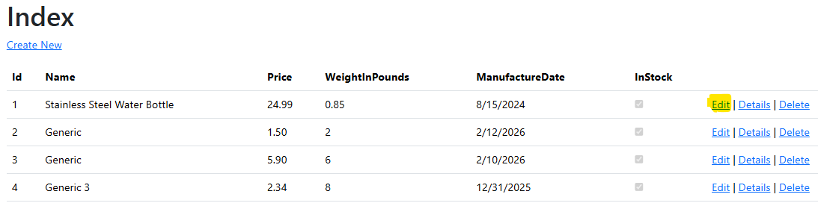
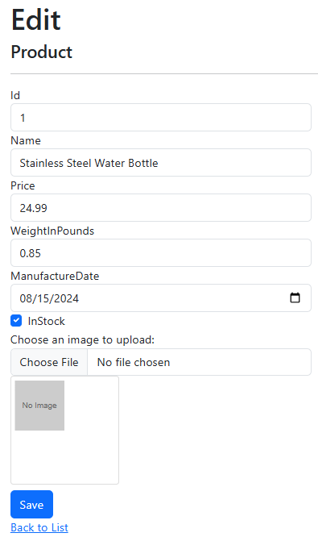 | 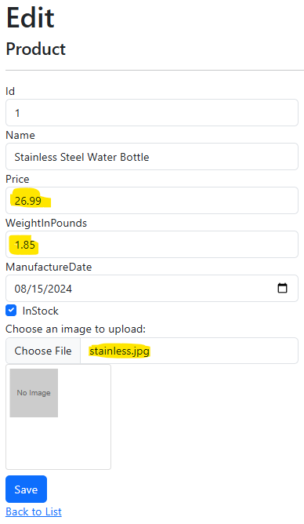
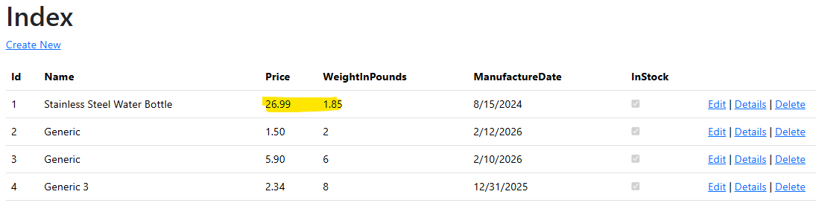
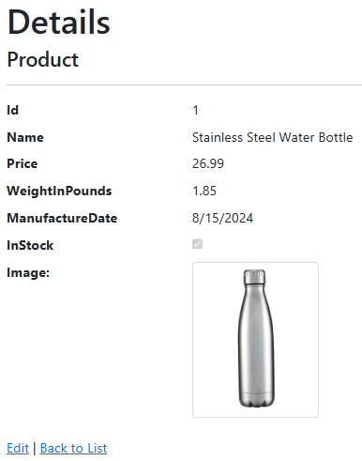
Checkpoint 6: Show your code and working application to the instructor.

7: Delete Product
You’ll now implement the following user story and flow:
As an application user, I want to delete a Product's data.

Trigger:
I send a GET request to /Product/delete/{id}

Flow:
- Guard:[id exists]
  - Exception flow:
    - The application redirects to /Product/index
- The application confirms that I want to delete the Product's data
- Alt:
  - [I answer yes]
    - The application deletes the Product data from the database
  - [I answer no]
    - The application does not delete the Product data from the database
- The application redirects to /Product/index
- Code the GET DeleteAsync action method in the controller.
- Generate the view code: dotnet aspnet-codegenerator view Delete Delete --model Product --useDefaultLayout --relativeFolderPath Views\Product
- Update the Delete action link in the Product index view code.
- Update the Delete view code so that the image is displayed. You can copy the view code from the Details view.
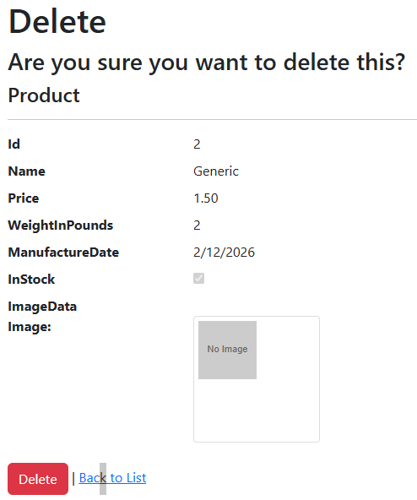
- Update the Delete form view code and add a hidden input for Id.
- Add the DeleteAsync method to the repository interface.
- Implement the DeleteAsync method in the repository class.
- Code the async POST Delete action method.
- Test that you can delete a product. Here is my scenario:
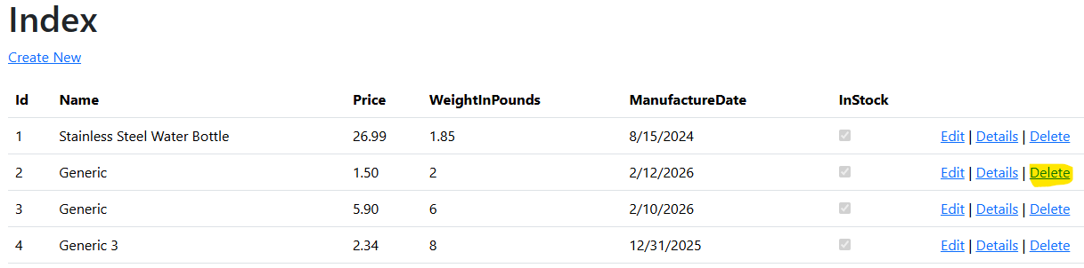
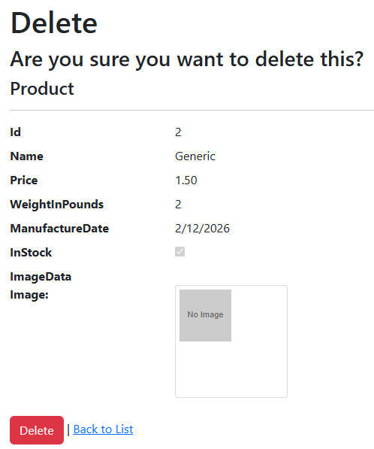
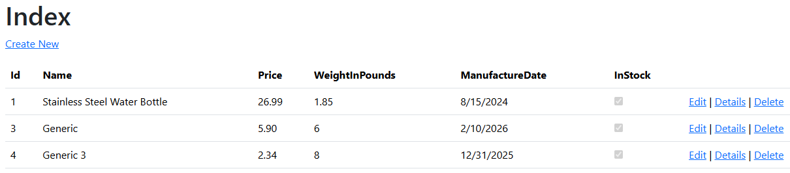
Checkpoint 7: Show your code and that you can delete a product to the instructor.
End of Lab

