Lab 4 – DOM Manipulation

0: Setup
- Create a new ASP.NET MVC application:
dotnet new mvc -n Lab4<your initials>JSDOM

1: Create the Movie Controller
- Create a Movie controller.
- Add the Index action method and create the associated view code.
- Append the following css to site.css (look in wwwroot/css):
.movie-card {
transition: transform 0.2s ease-in-out, box-shadow 0.2s ease-in-out;
border: none;
border-radius: 10px;
overflow: hidden;
}

.movie-card:hover {
transform: translateY(-5px);
box-shadow: 0 8px 16px rgba(0, 0, 0, 0.2) !important;
}

.card-header {
border-bottom: none;
padding: 1rem;
}

.card-body {
padding: 1.25rem;
}

.card-footer {
padding: 1rem;
}

.form-control:focus,
.form-select:focus {
border-color: #0d6efd;
box-shadow: 0 0 0 0.25rem rgba(13, 110, 253, 0.25);
}

.btn {
transition: all 0.2s ease-in-out;
}

.btn:hover {
transform: translateY(-2px);
}

.badge {
font-size: 0.75rem;
padding: 0.35em 0.65em;
}

h1 i {
font-size: 0.9em;
}

.card-title i {
font-size: 1.1em;
}

@media (max-width: 768px) {
.display-5 {
font-size: 2rem;
}

.col-md-3,
.col-md-2 {
margin-bottom: 0.5rem;
}
}
- Create an empty JavaScript file: movieIndex.js
- Copy the following view code into the Movie Index view:
@{
ViewData["Title"] = "Movies";
}

<div class="container-fluid py-4">
<div class="row mb-4">
<div class="col-12">
<h1 class="display-5 fw-bold text-primary mb-3">
<i class="bi bi-film"></i> Movie Collection
</h1>
</div>
</div>

<!-- Add New Movie Card -->
<div class="row mb-4">
<div class="col-12">
<div class="card shadow-sm border-0 bg-light">
<div class="card-body">
<h5 class="card-title mb-3">
<i class="bi bi-plus-circle"></i> Add New Movie
</h5>
<form id="movieForm">
<input type="hidden" id="movieId" value="0" />
<div class="row g-3">
<div class="col-md-3">
<label for="title" class="form-label">Title</label>
<input type="text" class="form-control" id="title" placeholder="Enter movie title"
required>
</div>
<div class="col-md-3">
<label for="director" class="form-label">Director</label>
<input type="text" class="form-control" id="director" placeholder="Enter director name"
required>
</div>
<div class="col-md-2">
<label for="releaseDate" class="form-label">Release Date</label>
<input type="date" class="form-control" id="releaseDate" required>
</div>
<div class="col-md-2">
<label for="isAvailable" class="form-label">Availability</label>
<select class="form-select" id="isAvailable">
<option value="true">Available</option>
<option value="false">Unavailable</option>
</select>
</div>
<div class="col-md-2 d-flex align-items-end">
<button type="submit" class="btn btn-primary w-100" id="submitBtn">
<i class="bi bi-plus-lg"></i> Add Movie
</button>
</div>
</div>
<div class="row mt-2" id="cancelBtnRow" style="display: none;">
<div class="col-12">
<button type="button" class="btn btn-secondary btn-sm" id="cancelBtn">
<i class="bi bi-x-circle"></i> Cancel Edit
</button>
</div>
</div>
</form>
</div>
</div>
</div>
</div>

<!-- Movies Grid -->
<div class="row" id="moviesGrid">
<!-- Sample Movie Cards (These will be dynamically generated with JavaScript) -->

<!-- Sample Card 1 -->
<div class="col-lg-3 col-md-4 col-sm-6 mb-4" style="display: block;">
<div class="card h-100 shadow-sm movie-card">
<div class="card-header bg-primary text-white d-flex justify-content-between align-items-center">
<h6 class="mb-0 text-truncate">Example</h6>
<span class="badge bg-success">Available</span>
</div>
<div class="card-body">
<p class="mb-2">
<strong><i class="bi bi-person-fill"></i> Director:</strong><br>
Frank Director
</p>
<p class="mb-3">
<strong><i class="bi bi-calendar-event"></i> Release Date:</strong><br>
September 23, 1994
</p>
</div>
<div class="card-footer bg-transparent border-top-0">
<div class="d-flex gap-2">
<button class="btn btn-sm btn-outline-primary flex-fill" title="Edit">
<i class="bi bi-pencil-square"></i> Edit
</button>
<button class="btn btn-sm btn-outline-danger flex-fill" title="Delete">
<i class="bi bi-trash"></i> Delete
</button>
</div>
</div>
</div>
</div>

<!-- Empty State (Show when no movies) -->
<div class="col-12 text-center py-5" id="emptyState" style="display: block;">
<i class="bi bi-film display-1 text-muted"></i>
<h4 class="mt-3 text-muted">No Movies Found</h4>
<p class="text-muted">Start by adding your first movie above!</p>
</div>
</div>
</div>

@section Scripts {
<script defer type="module" src="~/js/movieIndex.js"></script>
}
- Launch your application and then navigate to /movie/index, you should see:
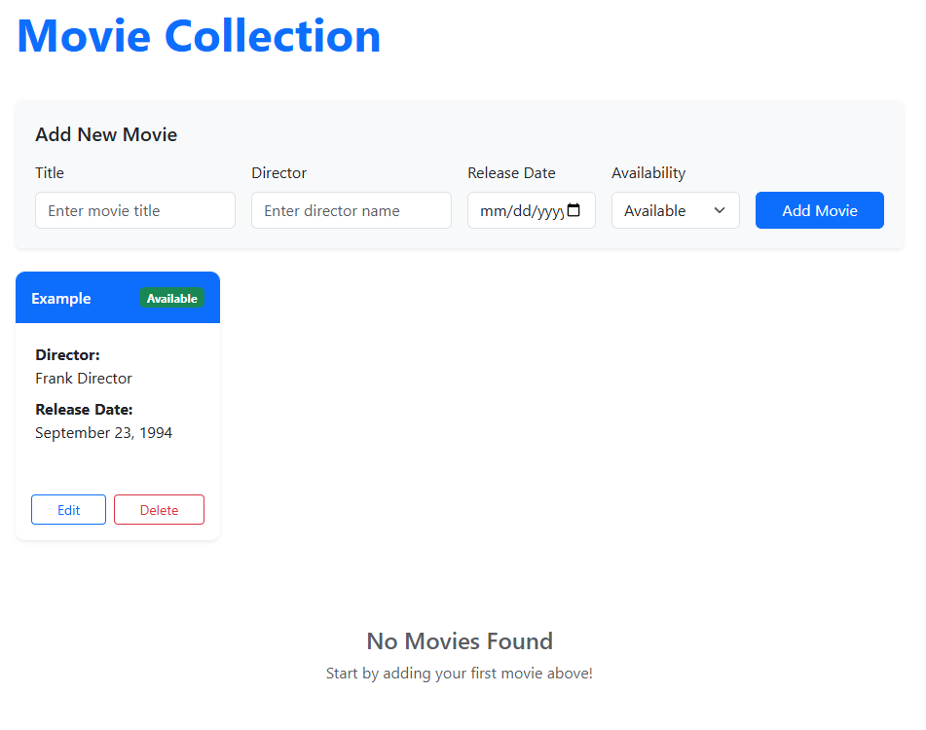
- Checkpoint 1: Show your output to the instructor.

2: Adding jQuery and the MovieDOM class
- From your terminal, install LibMan (it might already be installed):
dotnet tool update -g Microsoft.Web.LibraryManager.Cli
- Initialize LibMan: libman init
  - Keep cdnjs as the default provider.
- In VS Code, note the project path to the jQuery library: /wwwroot/lib/jquery/dist
- Add jQuery to LibMan:
libman install jquery@3.7.1 --provider cdnjs --destination wwwroot/lib/jquery/dist
- Open libman.json to see the libraries:
{
"version": "3.0",
"defaultProvider": "cdnjs",
"libraries": [
{
"library": "jquery@3.7.1",
"destination": "wwwroot/lib/jquery/dist"
}
]
}
- In movieIndex.js, add the following code, this will be your ‘database’:
'use strict';

let movies = [
{
id: 1,
title: "The Shawshank Redemption",
director: "Frank Darabont",
releaseDate: "1994-09-23",
isAvailable: true
},
{
id: 2,
title: "The Godfather",
director: "Francis Ford Coppola",
releaseDate: "1972-03-24",
isAvailable: true
},
{
id: 3,
title: "The Dark Knight",
director: "Christopher Nolan",
releaseDate: "2008-07-18",
isAvailable: false
},
{
id: 4,
title: "Pulp Fiction",
director: "Quentin Tarantino",
releaseDate: "1994-10-14",
isAvailable: true
}
];
// Your code will go here
- Create a separate JavaScript file called MovieDOM.js and then code an exportable class called MovieDOM.
  - Add private attribute: #movies = []
  - Code a method named showMovies that has two parameters: parentElement and movies.
    - Set #movies to movies.
    - For now, the method simply logs parentElement and movies to the console.
- In movieIndex.js:
  - Import MovieDOM.
  - Create an instance of MovieDOM.
  - Use document.querySelector() to select the DOM element with id “moviesGrid”. Reference it with a constant called movieGrid.
  - Call showMovies() with movieGrid and movies.
- You should see the moviesGrid DOM element and the movie collection in the console.
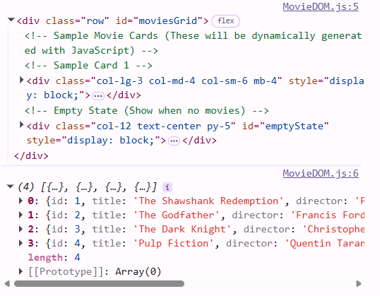
- Checkpoint 2: Show your code and output to the instructor

3: No Movies
- In Movie/index.cshtml, locate the moviesGrid div. There are two divs inside the moviesGrid div: Sample Card 1 and Empty State. Look for the names in the comments. Cut them and paste them temporarily into another editor like Notepad++. You’ll be referencing that code shortly.
- After removing that section, your page should look like:
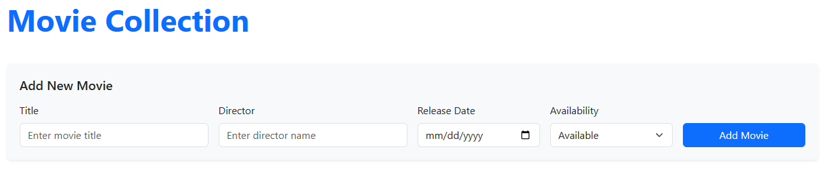
- Reference the Empty State <div> you just pasted:
<!-- Empty State (Show when no movies) -->
<div class="col-12 text-center py-5" id="emptyState" style="display: block;">
<i class="bi bi-film display-1 text-muted"></i>
<h4 class="mt-3 text-muted">No Movies Found</h4>
<p class="text-muted">Start by adding your first movie above!</p>
</div>
- In MovieDOM, code a private method called #createEmptyState(). This method should:
  - Use document.createElement() to create the outer <div> element for the Empty State.
  - Set all the necessary attributes (className, id, style.display) on that div element:
    - className = 'col-12 text-center py-5'
    - id = 'emptyState'
    - style.display = 'block'
  - Use innerHTML to add the inner content (icon, heading, and paragraph).
  - Return the completed DOM element.
- Code the following: In showMovies(), if the movies array is empty (that is, its length is zero) then create the empty state and append it as a child to the parent element.
- Copy the following to _Layout.cshtml in <head> where the stylesheets are:
<link rel="stylesheet" href="https://cdn.jsdelivr.net/npm/bootstrap-icons@1.11.3/font/bootstrap-icons.min.css">
This activates Bootstrap’s icons.
- In movieIndex.js, pass an empty array ([]) to showMovies() to see the No Movies Found message.
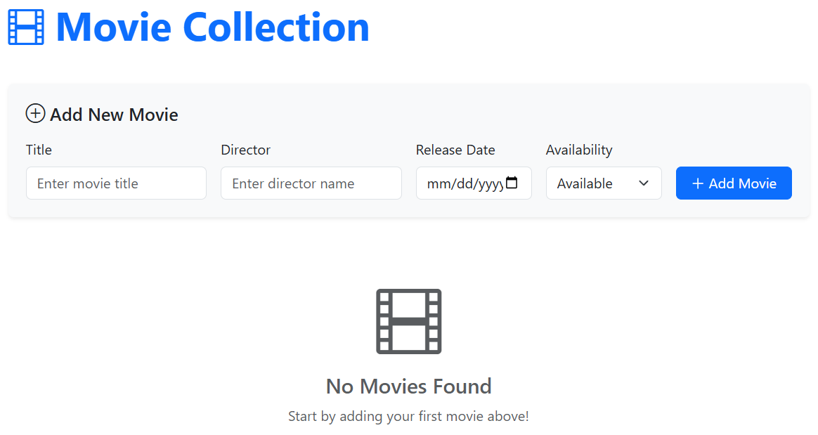
- Checkpoint 3: Show your code and output to the instructor.

4: Create Movie Card
- Reference the pasted Sample Cart 1 <div>:
<!-- Sample Card 1 -->
<div class="col-lg-3 col-md-4 col-sm-6 mb-4" style="display: block;">
<div class="card h-100 shadow-sm movie-card">
<div class="card-header bg-primary text-white d-flex justify-content-between align-items-center">
<h6 class="mb-0 text-truncate">Example</h6>
<span class="badge bg-success">Available</span>
</div>
<div class="card-body">
<p class="mb-2">
<strong><i class="bi bi-person-fill"></i> Director:</strong><br>
Frank Director
</p>
<p class="mb-3">
<strong><i class="bi bi-calendar-event"></i> Release Date:</strong><br>
September 23, 1994
</p>
</div>
<div class="card-footer bg-transparent border-top-0">
<div class="d-flex gap-2">
<button class="btn btn-sm btn-outline-primary flex-fill" title="Edit">
<i class="bi bi-pencil-square"></i> Edit
</button>
<button class="btn btn-sm btn-outline-danger flex-fill" title="Delete">
<i class="bi bi-trash"></i> Delete
</button>
</div>
</div>
</div>
</div>
- To MovieDOM, code #createMovieCard(movie). Here is the algorithm:
  - Use createElement() to create the outer div with the given attributes:
<div class="col-lg-3 col-md-4 col-sm-6 mb-4" style="display: block;">
Give it id ‘movie-{id}’, where {id} is the id of the movie.
  - You can use the following to create a formatted date:
// Format the release date
const releaseDate = new Date(movie.releaseDate + 'T00:00:00');
console.log(releaseDate);
const formattedDate = releaseDate.toLocaleDateString('en-US', {
year: 'numeric',
month: 'long',
day: 'numeric'
});
  - Use innerHTML to set the internals of the element.
    - The <span> for availability changes depending on the movie’s availability.
      - Use css class ‘bg-danger’ when it is not available and update the text to “Unavailable”. Use 'bg-success' otherwise.
  - Return the created element.
- In showMovies(), loop through the movies array and call #createMovieCard() for each movie. Remember to append the movie card to the parent element.
- In movieIndex, pass the movies array to showMovies().
- Your output should look like:
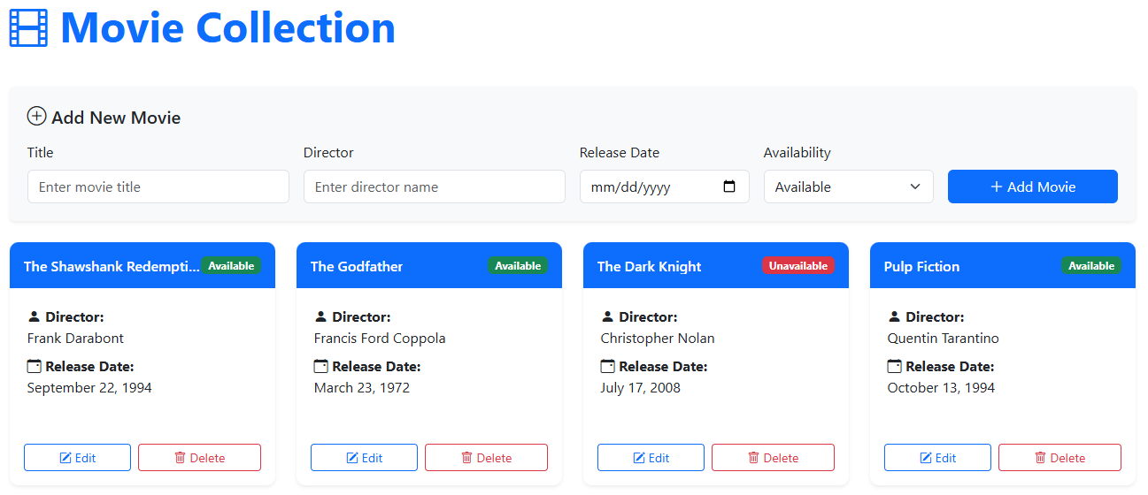
- Checkpoint 4: Show your code and output to the instructor.

5. Add (Create) Movie
- Update the Movie/Index.cshtml code:
  - For each input and select, add a ‘name’ attribute, the ‘name’ should match the ‘id’. For example:
<input type="text" class="form-control" id="title" name="title" placeholder="Enter movie title" required>
- In MovieDOM, code method setUpEventListeners().
  - Use event delegation to set up the listener to listen for ‘submit’ events.
  - The form’s id is ‘movieForm’.
  - Prevent the default behavior and simply log “Form submitted”.
  - Call the method in movieIndex.
  - Test that your code works. Fill out the form and then submit it. You should see ‘Form submitted’ in the console.
- To MovieDOM, code private method: #processForm() (Use the displaySummary() method in the lecture notes as reference). Here is the algorithm:
  - Get the form element. It’s id is ‘movieForm’.
  - Use FormData to get the form data.
  - Create a movie object using the form data. The movie’s id is simply the length of the array plus 1. Use formData.get() to get the relevant data element. For example, formData.get('title') will get the entered title.
  - Log the movie object to the console.
  - Return the movie object.
- In the submit event listener, call #processMovie() and log the returned movie object. If you enter movie data and then submit, you should see the object in the console.
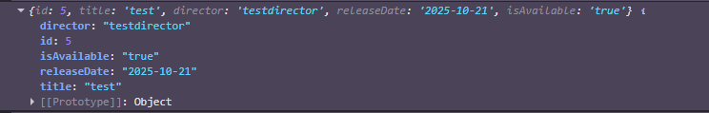
- Ensure that the movie object is created before continuing. Ask for help if you need it.
- Here is some test data:
Title | Director | Release Date | Is Available
Inception | Christopher Nolan | 2010-07-16 | Available
The Matrix | The Wachowskis | 1999-03-31 | Available
Interstellar | Christopher Nolan | 2014-11-07 | Not Available
Parasite | Bong Joon-ho | 2019-05-30 | Available
Forrest Gump | Robert Zemickis | 1994-07-06 | Not Available
- Add the following method to MovieDOM. This method uses jQuery to add the movie to the DOM with a simple fade in animation:
#createAndAppendMovieCard(movie, parentElement) {
// Create the movie card
const cardCol = this.#createMovieCard(movie);

// Hide it initially for animation
$(cardCol).hide();

// Append to parent and animate
$(parentElement).append(cardCol);
$(cardCol).fadeIn(600);
}
- Add the following method to MovieDOM to reset the form:
#resetForm() {
// Reset all form fields to default values
document.getElementById('movieForm').reset();

// Reset the hidden movie ID to 0 (for add mode)
document.getElementById('movieId').value = '0';

// Update form heading back to "Add New Movie"
document.querySelector('.card-title').innerHTML = '<i class="bi bi-plus-circle"></i> Add New Movie';

// Update button text back to "Add Movie"
document.getElementById('submitBtn').innerHTML = '<i class="bi bi-plus-lg"></i> Add Movie';

// Hide the cancel button
document.getElementById('cancelBtnRow').style.display = 'none';
}
- In the submit event listener,
  - Get the movie returned from #processForm.
  - Push the movie to the movies array.
  - Get the movie grid DOM element (the parent element).
  - Call #createAndAppendMovieCard() passing movie and movieGrid.
  - Reset the form.
- Checkpoint 5: Show your code and running program to the instructor. You should be able to add movies to the array and see the UI being updated.
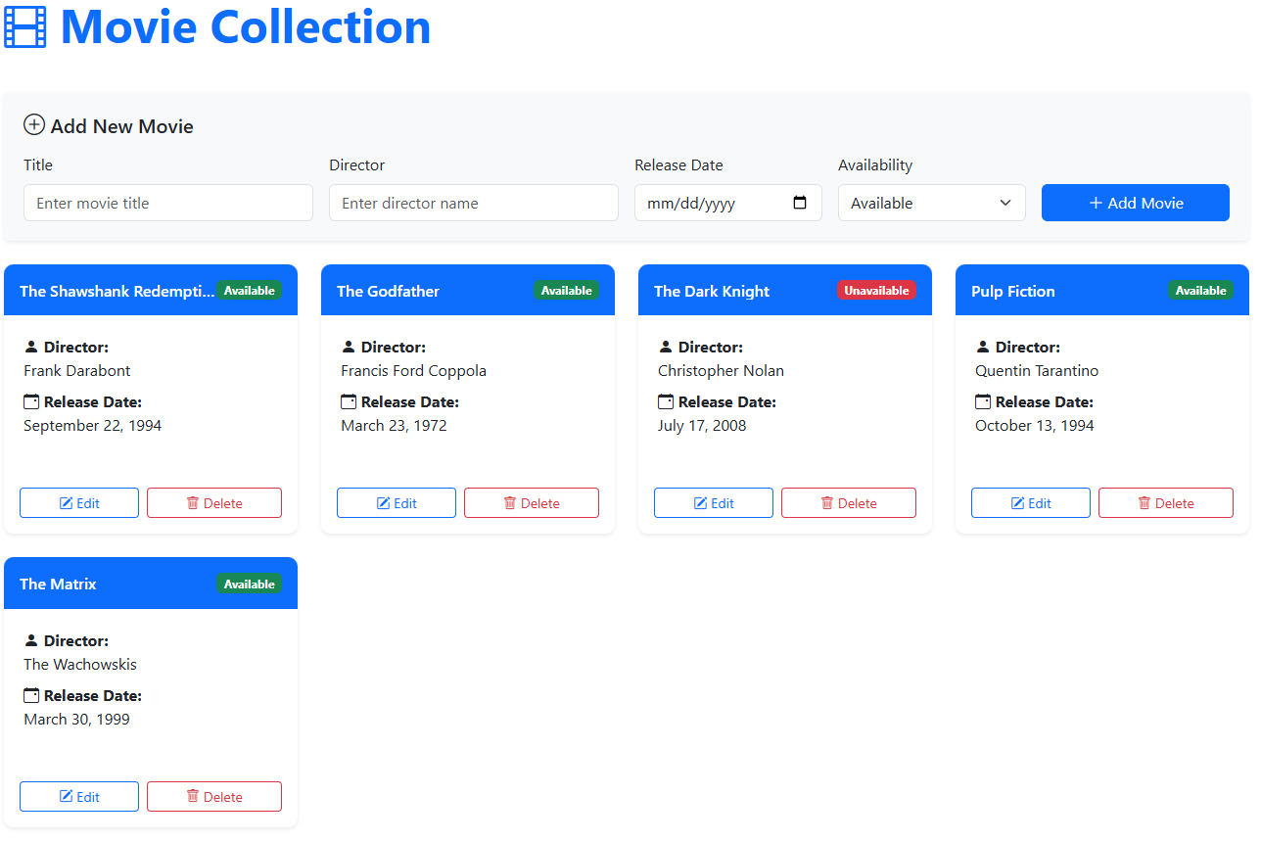

6: Edit (Update) Movie
- In #createMovieCard(), locate the code to create the Edit button:
  - Add class ‘edit-btn’. This will make it easier to select.
  - Add a data- attribute to store the movie id: data-movie-id="${movie.id}". This will make it easier to identify which movie is to be edited.
- In setUpEventListeners(), add the event listener for ‘click’
  - Use event delegation.
  - Select the closest element with class ‘edit-btn’.
  - Get the movie id from the data-movie-id attribute.
  - Log the movie id to the console.
- Test that when the edit button is clicked you can see the movie id in the console. Ask for help if you need it.
- Code private method #populateFormForEdit(movieId). Here is the algorithm (some code is done for your):
  - Find the movie in the movies array. If not found then return.
  - Populate the form fields.
  - Update the form heading to ‘Edit Movie’:
document.querySelector('.card-title').innerHTML = '<i class="bi bi-pencil-square"></i> Edit Movie';
  - Update the button text to “Update Movie”:
document.getElementById('submitBtn').innerHTML = '<i class="bi bi-pencil-square"></i> Update Movie';
  - Show the cancel button:
document.getElementById('cancelBtnRow').style.display = 'block';
  - Scroll to the form:
document.getElementById('movieForm').scrollIntoView({ behavior: 'smooth', block: 'start' });
- Call the method from the ‘click’ event listener to test that it works. Whenever an Edit button is clicked the form should be updated with the movie data.
- Add the event listener for the Cancel Edit button. When the Cancel Edit button is clicked then reset the form. It has id ‘cancelBtn’.
- Update the #processForm() method:
  - Select the submit button. If the button text includes ‘Update’ then the form is in edit mode. Create a state variable (or constant) to track this.
  - Create the form data.
  - Create a movie object.
  - If not editing, set the movie id to movies length plus 1.
  - If editing, read the movie from the array.
  - Set the movie properties to the ones in the form.
  - Return the movie.
- Update the submit event handler:
  - Prevent the default behavior.
  - Call #processForm(). This should return the movie.
  - Determine the state from the submit button text: editing or adding
  - If editing
    - Select the existing movie card (recall that it has id movie-{id}).
    - Create a new card using the updated movie.
    - Replace the existing card with the new card (use replaceWith())
  - If adding
    - Process as before
  - Reset the form
- You should be able to update an existing movie.
- Checkpoint 6: Show your code to the instructor and that you can update a movie.

7: Delete Movie
- In #createMovieCard(), locate the code to create the Delete button:
  - Add class ‘delete-btn’. This will make it easier to select.
  - Add a data- attribute to store the movie id: data-movie-id="${movie.id}". This will make it easier to identify which movie is to be deleted.
- Code the delete button event listener to setUpEventListeners(). The logic should be similar to the ‘Edit’. Log the movie’s id to test.
- Check that you are getting the movie id when the button is clicked.
- The #deleteMovie() method is coded for you. Here are the steps:
  - Find the movie
  - Show confirmation dialog
  - If confirmed:
    - Remove the movie from the array
    - Remove the card with animation
#deleteMovie(movieId) {
// Find the movie
const movie = this.#movies.find(m => m.id === movieId);
if (!movie) return;

// Show confirmation dialog
const confirmed = confirm(`Are you sure you want to delete "${movie.title}"?`);

if (confirmed) {
// Remove from array
const index = this.#movies.findIndex(m => m.id === movieId);
if (index !== -1) {
this.#movies.splice(index, 1);
}

// Remove the card with animation
const card = document.getElementById(`movie-${movieId}`);
$(card).fadeOut(400, function () {
$(this).remove();

// Check if there are no movies left and show empty state
const movieGrid = document.querySelector('#moviesGrid');
if (this.#movies.length === 0) {
const emptyState = this.#createEmptyState();
movieGrid.appendChild(emptyState);
}
}.bind(this));
}
}
- Call the method in the event listener.
- Checkpoint 7: Show that you can delete movies.
End of Lab

