0. Set Up
- Open the CRRUD Related Data lecture notes and have them available for reference.
- Create a new ASP.NET Core Web Application (Model-View-Controller)
  - Lab5{Your Initials}BookAuthorApp
- Set up the following folder structures in the project:
  - /Services
  - /Models/Entities
  - /Models/ViewModels
- Install the Entity Framework Core packages. Remember to use the --version 9.* if you are using .NET9.0.
dotnet add package Microsoft.EntityFrameworkCore.Sqlite
dotnet add package Microsoft.EntityFrameworkCore.Tools
dotnet add package Microsoft.EntityFrameworkCore.Design
dotnet add package Microsoft.VisualStudio.Web.CodeGeneration.Design
- Create the Data folder and add the connection string in appsettings.json and give your database a meaningful name.
{
"ConnectionStrings": {
"DefaultConnection": "Data Source=./Data/JRBookAuthorDB.db"
},
"Logging": {
"LogLevel": {
"Default": "Information",
"Microsoft.AspNetCore": "Warning"
}
},
"AllowedHosts": "*"
}

1. Set Up the Services
- Create the ApplicationDbContext class in the Services folder.
- Configure the DbContext in Program.cs.
- In the Services folder
  - Create an empty public interface named IBookRepository
  - Create class DbBookRepository that implements IBookRepository
    - Inject the ApplicationDbContext into the repository
  - Create an empty public interface named IAuthorRepository
  - Create class DbAuthorRepository that implements IAuthorRepository
    - Inject the ApplicationDbContext into the repository
- In Program.cs
  - Configure the scoped service that maps IBookRepository to DbBookRepository
  - Configure the scoped service that maps IAuthorRepository to DbAuthorRepository
- Checkpoint 1: Show your setup code to the instructor.
  - DbContext
  - Repositories

2: Create the Model
- Create the following classes in the /Models/Entities folder. Set up the given constraints using data annotations.
  - Book
    - Title – Required, string length: 256
  - Author
    - FirstName – Not required, string length: 128
    - LastName – Required, string length: 128
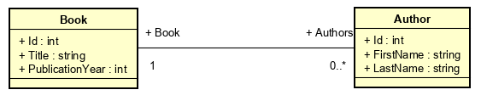
- Set up the DbContext with DbSets:
  - Books
  - Authors
- Save and then build the solution
- Add the first migration: dotnet ef migrations add Mig1
- Update the database: dotnet ef database update
- Open the SQL DDL for Authors and Books (Use the SQLite Viewer)
- Make sure the code matches those below
CREATE TABLE "Books" (
"Id" INTEGER NOT NULL CONSTRAINT "PK_Books" PRIMARY KEY AUTOINCREMENT,
"Title" TEXT NOT NULL,
"PublicationYear" INTEGER NOT NULL
)
CREATE TABLE "Authors" (
"Id" INTEGER NOT NULL CONSTRAINT "PK_Authors" PRIMARY KEY AUTOINCREMENT,
"FirstName" TEXT NULL,
"LastName" TEXT NOT NULL,
"BookId" INTEGER NOT NULL,
CONSTRAINT "FK_Authors_Books_BookId" FOREIGN KEY ("BookId") REFERENCES "Books" ("Id") ON DELETE CASCADE
)
- Checkpoint 2: Show your SQL DDL to the instructor.

Seeding the Database
- Add the following class to your Services folder:
public class Initializer
{
private readonly ApplicationDbContext _db;

public Initializer(ApplicationDbContext db)
{
_db = db;
}

public async Task SeedDatabaseAsync()
{
_db.Database.EnsureCreated();

// If there are any books then assume the database is already
// seeded.
if (_db.Books.Any()) return;

var books = new List<Book>
{
new() { Title = "The Midnight Library", PublicationYear = 2020},
new() { Title = "Project Hail Mary", PublicationYear = 2021},
new() { Title = "Tomorrow, and Tomorrow, and Tomorrow", PublicationYear = 2022},
new() { Title = "The Woman in Me", PublicationYear = 2023},
new() { Title = "The Housemaid ", PublicationYear = 2022}
};

await _db.Books.AddRangeAsync(books);
await _db.SaveChangesAsync();
}
}
- Scope the initializer service in Program.cs:
builder.Services.AddScoped<Initializer>();
- Modify Program.cs to include the following:
… <snipped builder services>
var app = builder.Build();
await SeedDataAsync(app);
… <snipped app services>
app.Run();

static async Task SeedDataAsync(WebApplication app)
{
using var scope = app.Services.CreateScope();
var services = scope.ServiceProvider;
try
{
var initializer = services.GetRequiredService<Initializer>();
await initializer.SeedDatabaseAsync();
}
catch (Exception ex)
{
var logger = services.GetRequiredService<ILogger<Program>>();
logger.LogError("An error occurred while seeding the database: {Message}", ex.Message);
}
}
- Launch your application.
- After your application launches, check your database, you should see the following in your Book table:
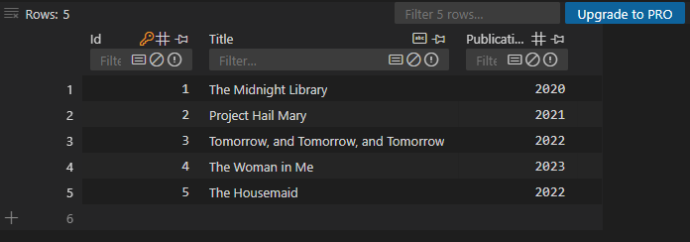
Not a checkpoint

3: The Book Web API
- Have your Web API lectures notes available for easy reference.
- Implement the following API endpoint to get a JSON array of Books: GET /api/book/all
Steps
- Code the ReadAllAsync book repository method.
- Create the BookAPIController
- Inject the book repository into the API controller
- Code the action method to handle the GET all.
- Test that your API endpoint works by navigating to /api/book/all:
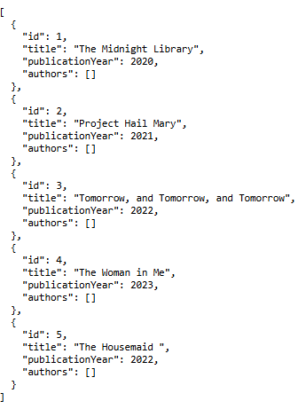
- Checkpoint 3: Show your output to the instructor.

4: Setting up the Book Index Page
- Update _ViewImports.cshtml to include your Entities namespace.
- Initialize LibMain: libman init
- Add (update) Bootstrap in the project:
libman install bootstrap@5.3.8 --provider cdnjs --destination wwwroot/lib/bootstrap/dist
- Add the Bootstrap Icons CDN to your layout file:
<link rel="stylesheet" href="https://cdn.jsdelivr.net/npm/bootstrap-icons@1.11.1/font/bootstrap-icons.css">
- Create the BookController and an Index action method that returns a View.
- Use the following as the code for the view:
@{
ViewData["Title"] = "Books";
}

<div class="container mt-4">
<div class="d-flex justify-content-between align-items-center mb-4">
<h1>Books</h1>
<a asp-action="Create" class="btn btn-primary">
<i class="bi bi-plus-circle"></i> Add New Book
</a>
</div>
<div class="row row-cols-1 row-cols-md-2 row-cols-lg-3 g-4" id="bookContainer">
</div>
</div>

@section Scripts{
<script type="module" src="~/js/bookIndex.js"></script>
}
- Create bookIndex.js and add the following code to it:
class Main {
run() {
const bookContainer = document.getElementById("bookContainer");
console.log(bookContainer);
}
}

const main = new Main();
main.run();
- Launch the application and navigate to /book/index. You should see the book container div printed in the console.
- Checkpoint 4: Show the application to the instructor.
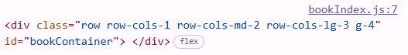

5: Book Card
- Create an exportable JavaScript class called BookDOM.
- Add a static method createBookCard(book) that returns the following as a DOM element. Replace {xxx} with the appropriate code. Add an appropriate data-book-id attribute to each of the buttons.
<div class="col" id="book-{book's id}">
<div class="card h-100 shadow-sm">
<div class="card-body">
<h5 class="card-title">{book's title}</h5>
<p class="card-text text-muted">
<small>Published: {book's publicationYear}</small>
<br/>
<small>Number of Authors: {book's number of authors}</small>
</p>
</div>
<div class="card-footer bg-white border-0 d-flex gap-2 justify-content-end">
{HTML and bootstrap code to create a small outlined information button for Details}
{HTML and bootstrap code to create a small outlined warning button for Edit}
{HTML and bootstrap code to create a small outlined danger button for Delete}
</div>
</div>
</div>
- In run(), create a book with the following:
const book = {
id: 1,
title: "Test title",
publicationYear: 1999,
authors: []
};
- Test your createBookCard(book) method.
- You should see the following as your test output:
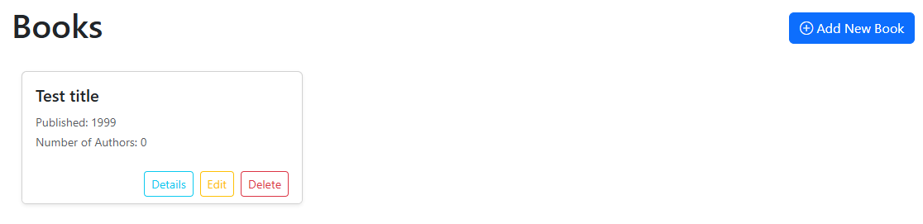
- Checkpoint 5: Show your code and output to the instructor.

6: Showing the Books
- Create JavaScript class BookAJAXRepository and then copy the AJAX repository code from the ‘Consuming a Web API Ajax’ lecture notes. You’ll only need methods readAll() and read().
- In class Main, add private attribute #bookRepo. Use it to initialize the BookAJAXRepository with the base URL of your web API.
- To class Main, add a method to read all books from the database using the AJAX repository and then populate the Book Index page. Call the method from run(). Remember to use async and await appropriately.
- You should see:
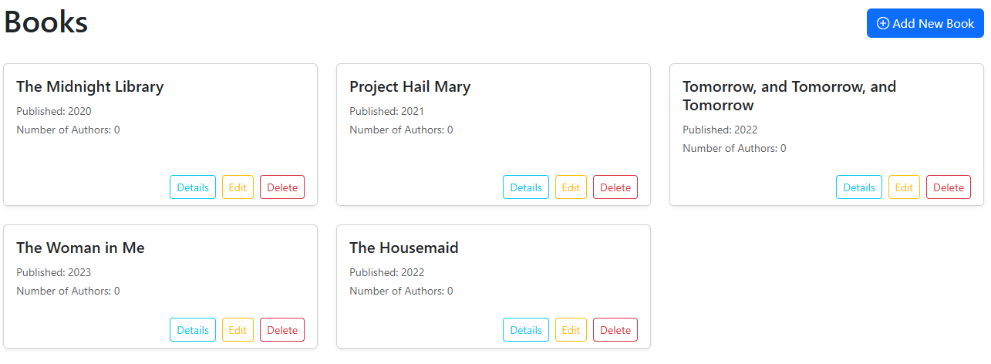
- Checkpoint 6: Show your code and output to the instructor.

7: Book Details Start
- In BookDOM.createBookCard(), give the Details button class ‘details-btn’ so that it is easy to select.
- In class Main, add a method to set up the event listener so that when the Details button is clicked, the book’s id is displayed in the console. Test to ensure this works. Remember to call it in run().
- To the C# book repository, add the method to read a book given the id.
- To the book API controller add the endpoint to read one book: /api/book/one/{id}
- Modify the event listener so that the book is read using the repo and then log the book object to the console.
- Checkpoint 7: Demonstrate to your instructor that the book is visible in the console.

8: Book Details Modal
- Add the following HTML to Book Index.cshtml:
<div id="bookModalContainer">
<partial name="_BookDetailsModal.cshtml" />
</div>
- In /Views/Book, create a partial view called _BookDetailsModal.cshtml and then copy the following code into it:
<div class="modal fade" id="bookDetailsModal" tabindex="-1" aria-labelledby="bookDetailsModalLabel">
<div class="modal-dialog modal-dialog-centered">
<div class="modal-content">
<div class="modal-header">
<h5 class="modal-title" id="bookDetailsModalLabel">Book Details</h5>
<button type="button" class="btn-close" data-bs-dismiss="modal" aria-label="Close"></button>
</div>
<div class="modal-body">
<!-- Book Title -->
<div class="mb-4">
<h4 id="bookTitle" class="text-primary">Book's title</h4>
<p class="text-muted mb-0">
<small>
Published: <span id="bookPublicationYear">Book's publication year</span>
</small>
</p>
</div>

<!-- Number of Authors -->
<div class="mb-3">
<strong>Number of Authors:</strong>
<span id="numberOfAuthors" class="badge bg-secondary">
Number of authors
</span>
</div>

<!-- Authors Table -->
<div class="mb-3">
<strong>Authors:</strong>
<div class="table-responsive mt-2">
<table class="table table-sm table-striped table-hover">
<thead class="table-light">
<tr>
<th>#</th>
<th>Author Name</th>
</tr>
</thead>
<tbody id="bookAuthors">
</tbody>
</table>
</div>
</div>
</div>
<div class="modal-footer">
<button type="button" class="btn btn-secondary" data-bs-dismiss="modal">Close</button>
</div>
</div>
</div>
</div>
- To class Main, add private attribute #bookDetailsModal, initialize it to:
new bootstrap.Modal(document.getElementById('bookDetailsModal'));
- In the book details event handler, after logging the book, show the book details modal.
- You should see:
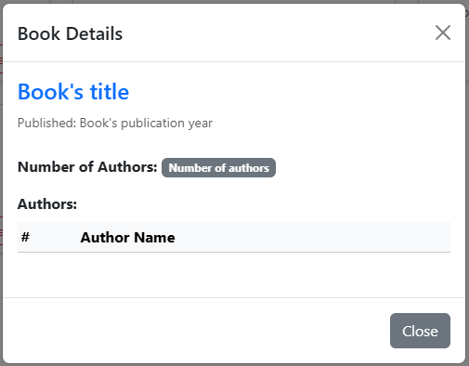
- In BookDOM, add static method populateBookDetailsModal(book). It sets the book’s title, publication year, and number of authors. See the highlighted elements in the modal code above for the ids.
- Call the method to populate the modal before showing it. You should see:
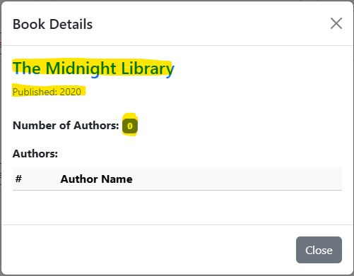
- Checkpoint 8: Show your output and code to the instructor.

9: Add Author Start
- Update your book details modal HTML to add a button to add an author. Remember to add a css class to make it easier to select and the add a data- for book id.
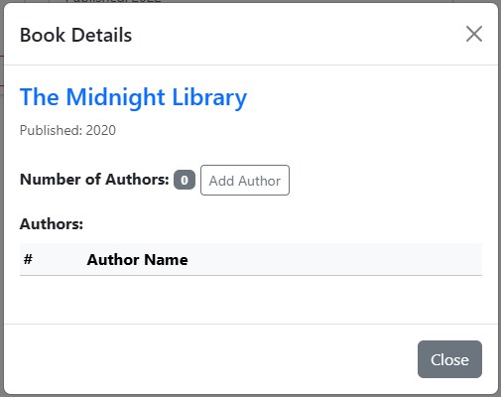
- In BookDOM.populateBookDetailsModal(), set the data-book-id attribute of the add author button to the book’s id.
- Ensure that the book’s id was set.
- In Index.cshml, add another div container for a author modal.
<div id="authorModalContainer">
<partial name="_AuthorModal.cshtml" />
</div>
- To /Views/Book, add partial view _AuthorModal.cshtml and paste the following code in it:
<!-- Author Modal -->
<div class="modal fade" id="authorModal" tabindex="-1" aria-labelledby="authorModalLabel">
<div class="modal-dialog modal-dialog-centered">
<div class="modal-content">
<div class="modal-header">
<h5 class="modal-title" id="authorModalLabel">Add Author</h5>
<button type="button" class="btn-close" data-bs-dismiss="modal" aria-label="Close"></button>
</div>
<form id="addAuthorForm">
<div class="modal-body">
<!-- Hidden Book ID -->
<input type="hidden" id="bookId" name="bookId" value="">

<!-- First Name -->
<div class="mb-3">
<label for="FirstName" class="form-label">First Name <span class="text-danger">*</span></label>
<input type="text" class="form-control" id="FirstName" name="FirstName" required>
</div>

<!-- Last Name -->
<div class="mb-3">
<label for="LastName" class="form-label">Last Name <span class="text-danger">*</span></label>
<input type="text" class="form-control" id="LastName" name="LastName" required>
</div>
</div>
<div class="modal-footer">
<button type="button" class="btn btn-secondary" data-bs-dismiss="modal">Cancel</button>
<button type="submit" class="btn btn-primary">Add Author</button>
</div>
</form>
</div>
</div>
</div>
- To class Main, add private attribute #authorModal and initiaze it similar to the book details modal. Use the id of the author modal.
- Add the event handler for clicking the add author button. When the add author button is clicked:
  - Get bookId from the data-book-id attribute.
  - Hide the book details modal.
  - Show the author modal.
  - Select the book id hidden input and set its value to bookId.
  - Show the author modal.
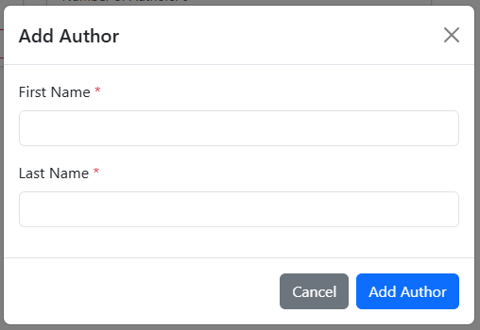
- Checkpoint 9: Show your code and output to the instructor.

10: Add Author API
- To IAuthorRepository, add method interface:
Task<Author> CreateAsync(int bookId, Author author);
- Implement the method in DbAuthorRepository, here is the algorithm:
Method: CreateAsync
Parameters: bookId, author
Returns: author

Read the book using bookId
If the boof is found
Add the book to the author
Add the author to the database
Save the changes
EndIf
Return the author
- Add the following endpoint to the BookAPIController. Inject the author repository. You’ll need to create a data transfer object (DTO) to prevent the potential JSON cycle. The DTO should not include the reference back to Book. Use an anonymous object for this.
Endpoint: POST /api/book/author/add
Form data: bookId, author
Response: AuthorDTO JSON

Store the author
Create an authorDTO (id, firstName, lastName, bookId)
Return the authorDTO as JSON
- Add the addAuthor(formData) to BookAJAXRepository:
Method: async addAuthor
Parameter: formData
Returns: Response as JSON

Build the address url
Send a post ajax request with formData
If there is an error then
throw an error
EndIf
Return the response as JSON
- Add an event listener for when the add author form is submitted:
Event: Submit
Parameter: e

Prevent the default behavior
If the event was triggered from the add author form
Build the formData
Add the author using the repository
Hide the author modal
Repopulate the books
EndIf
- Run the application and try to add an author.
- Check your database that the author was added.
- In your Author C# class, add the following immediately before the Book navigation property:
[JsonIgnore]
- Modify your DbBookRepository to eager or explicitly load the authors when reading a book.
- You should now see the number of authors being updated. We’ll work on populating the authors next.
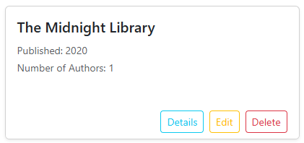
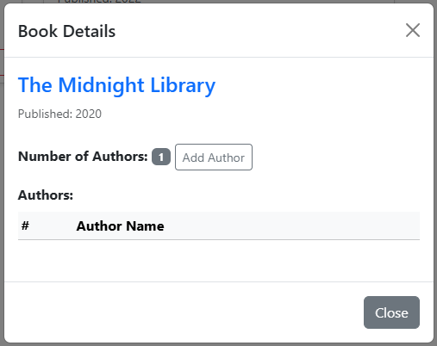
- Checkpoint 10: Show your code and output to the instructor.

11: Populating Authors
- To BookDOM, add static method createAuthorRow(author). This method returns a DOM element that represents the following HTML. The author’s name should be formatted as {firstname lastname}.
<tr>
<td>{Author’s id}</td>
<td>{Author’s name}</td>
</tr>
- In BookDOM.populateBookDetailsModal(), loop through all the authors and add them to the table body. You should first clear the inner elements. The table body has id ‘bookAuthors’.
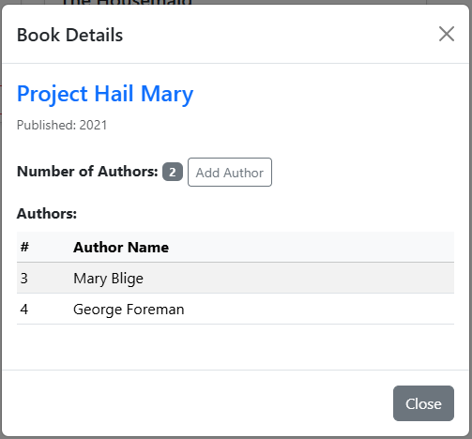
- Checkpoint 11: Show your code and output to the instructor.
End of Lab

