AJAX
- AJAX = Asynchronous JavaScript and XML.
- AJAX allows web pages to be updated asynchronously by exchanging small amounts of data with the server behind the scenes
  - This means that it is possible to update parts of a web page, without reloading the whole page
- AJAX is based on internet standards, and uses a combination of:
  - ‘XMLHttpRequest’ object (to exchange data asynchronously with a server)
  - JavaScript/DOM (to display/interact with the information)
  - CSS (to style the data)
  - XML (often used as the format for transferring data)
  - JSON (also used as the format for transferring data)

Using Fetch
- See https://developer.mozilla.org/en-US/docs/Web/API/fetch
- The Fetch API provides a JavaScript interface for accessing and manipulating parts of the HTTP pipeline, such as requests and responses.
- It also provides a global fetch() method that allows you to fetch resources asynchronously across the network.
- Fetch also provides a single logical place to define other HTTP-related concepts such as CORS and extensions to HTTP.
- The return value is a Promise that resolves to a Response object

Response Object
Property/Method | Description
Some read-only properties
headers | See https://developer.mozilla.org/en-US/docs/Web/API/Headers
ok | A boolean indicating whether the response was successful (status in the range 200–299) or not.
status | The status code of the response. (This will be 200 for a success).
statusText | The status message corresponding to the status code. (e.g., OK for 200).
type | The type of the response (e.g., basic, cors).
url | The URL of the response.
Some common methods
arrayBuffer() | Returns a promise that resolves with an ArrayBuffer representation of the response body.  https://developer.mozilla.org/en-US/docs/Web/JavaScript/Reference/Global_Objects/ArrayBuffer
blob() | Returns a promise that resolves with a Blob representation of the response body.  https://developer.mozilla.org/en-US/docs/Web/API/Blob
formData() | Returns a promise that resolves with a FormData representation of the response body.  https://developer.mozilla.org/en-US/docs/Web/API/FormData
json() | Returns a promise that resolves with the result of parsing the response body text as JSON.  https://developer.mozilla.org/en-US/docs/Web/JavaScript/Reference/Global_Objects/JSON
text() | Returns a promise that resolves with a text representation of the response body.

Basic Syntax
fetch('{URL string}', {options})
.then({callback function}) // Extract the data from the response
.then({callback function}) // Do something with the data
.catch({callback function}); // Handle any errors

Example
fetch('http://example.com/movies.json')
.then(response => response.json()) // Get the json from the response
.then(data => console.log(data)) // Log the data to the console
.catch(error => console.error(error)); // Log the error to the error console

Example Using await
const response = await fetch(address);
if (!response.ok) {
throw new Error("There was an HTTP error.");
}
const data = await response.json();
const response = await fetch(address, {
method: "post",
body: formData
});
if (!response.ok) {
throw new Error("There was an HTTP error.");
}
const data = await response.json();

Building the PetAJAXRepository JavaScript Class
The Web API’s base address will be an attribute of the class. The base address is injected through the constructor.
Example usage:
const petRepo = new PetAJAXRepository('http://localhost:5147/api/pet');
'use strict';

export class PetAJAXRepository{
#baseAddress;

constructor(baseAddress){
this.#baseAddress = baseAddress;
}
}

ReadAll Repository Function
ReadAll
Given: Nothing
Returns: Collection of pets (JSON)
- Send the GET request
- Await response
- Check for errors
- Return the collection
async readAll() {
const address = `${this.#baseAddress}/all`;
const response = await fetch(address);
if (!response.ok) {
throw new Error("There was an HTTP error getting the pet data.");
}
return await response.json();
}

Read Repository Method
Read
Given: pet id
Returns: the pet
- Send the GET request
- Await response
- Check for errors
- Return the pet
async read(id) {
const address = `${this.#baseAddress}/one/${id}`;
const response = await fetch(address);
if (!response.ok) {
throw new Error("There was an HTTP error getting the pet data.");
}
return await response.json();
}

Create Repository Method
Create
Given: the pet form data
Returns: the created pet (JSON)
- Encode the form data
- Send the POST request
- Check for errors
- Return the created pet as JSON
async create(formData) {
const address = `${this.#baseAddress}/create`;
const response = await fetch(address, {
method: "post",
body: formData
});
if (!response.ok) {
throw new Error("There was an HTTP error creating the pet data.");
}
return await response.json();
}

Update Repository Method
Update
Given: the pet form data
Returns: no content
- Encode the form data
- Send the PUT request
- Check for errors
- Return no content (text)
async update(formData) {
const address = `${this.#baseAddress}/update`;
const response = await fetch(address, {
method: "put",
body: formData
});
if (!response.ok) {
throw new Error("There was an HTTP error updating the pet data.");
}
return await response.text();
}

Delete Repository Method
Delete
Given: the pet id
Returns: no content
- Send the DELETE request
- Check for errors
- Return no content (text)
async delete(id) {
const address = `${this.#baseAddress}/delete/${id}`;
const response = await fetch(address, {
method: "delete"
});
if (!response.ok) {
throw new Error("There was an HTTP error deleting the pet data.");
}
return await response.text();
}

Consuming a Web API from an ASP.NET MVC Web App Using AJAX

The Pet Class
public class Pet
{
public int Id { get; set; }
public string? Name { get; set; }
public float Weight { get; set; }
}

View Code
<!-- Bootstrap Icons CDN (for icons in buttons) -->
<link rel="stylesheet" href="https://cdn.jsdelivr.net/npm/bootstrap-icons@1.11.1/font/bootstrap-icons.css">
@{
ViewData["Title"] = "Pet Management - Ajax Demo";
}

<div class="container mt-5">
<div class="row mb-4">
<div class="col">
<h1 class="display-4 text-primary">Pet Management System</h1>
<p class="lead text-muted">Demonstrating CRUD Operations with Ajax</p>
</div>
</div>

<!-- Create/Edit Pet Form -->
<div class="row mb-5">
<div class="col-lg-6 mx-auto">
<div class="card shadow-sm">
<div class="card-header bg-primary text-white">
<h5 class="mb-0" id="form-title">Add New Pet</h5>
</div>
<div class="card-body">
<form id="petForm">
<input type="hidden" id="Id" name="Id" value="0" />

<div class="mb-3">
<label for="Name" class="form-label">Pet Name</label>
<input type="text" class="form-control" id="Name" name="Name"
placeholder="Enter pet name" required>
</div>

<div class="mb-3">
<label for="Weight" class="form-label">Weight (lbs)</label>
<input type="number" step="0.1" class="form-control" id="Weight" name="Weight"
placeholder="Enter weight" required>
</div>

<div class="d-grid gap-2 d-md-flex justify-content-md-end">
<button type="button" class="btn btn-secondary" id="cancelBtn" style="display: none;">Cancel</button>
<button type="submit" class="btn btn-primary" id="submitBtn">Add Pet</button>
</div>
</form>
</div>
</div>
</div>
</div>

<!-- Alert Messages -->
<div class="row">
<div class="col">
<div id="alertContainer"></div>
</div>
</div>

<!-- Pets Display Section -->
<div class="row mb-4">
<div class="col text-center">
<h2 class="mb-3">Current Pets</h2>
</div>
</div>

<!-- Pet Cards Container -->
<div class="row row-cols-1 row-cols-md-2 row-cols-lg-3 g-4" id="petCardsContainer">
<!-- Sample Pet Card (Template/Example) -->
<div class="col">
<div class="card h-100 shadow-sm">
<div class="card-body">
<h5 class="card-title text-primary">Fluffy</h5>
<p class="card-text">
<strong>ID:</strong> 1<br>
<strong>Weight:</strong> 12.5 lbs
</p>
</div>
<div class="card-footer bg-transparent">
<button class="btn btn-sm btn-outline-primary" data-pet-id="1">
<i class="bi bi-pencil"></i> Edit
</button>
<button class="btn btn-sm btn-outline-danger" data-pet-id="1">
<i class="bi bi-trash"></i> Delete
</button>
</div>
</div>
</div>
<!-- Additional pet cards will be dynamically generated here via Ajax -->
</div>

<!-- Empty State -->
<div class="row" id="emptyState" style="display: none;">
<div class="col text-center py-5">
<div class="text-muted">
<i class="bi bi-inbox" style="font-size: 4rem;"></i>
<h4 class="mt-3">No Pets Found</h4>
<p>Add your first pet using the form above!</p>
</div>
</div>
</div>

<!-- Loading Spinner -->
<div class="row" id="loadingSpinner" style="display: none;">
<div class="col text-center py-5">
<div class="spinner-border text-primary" role="status">
<span class="visually-hidden">Loading...</span>
</div>
<p class="mt-2 text-muted">Loading pets...</p>
</div>
</div>
</div>

@section Scripts {
<script defer type="module" src="~/js/petIndex.js"></script>
}

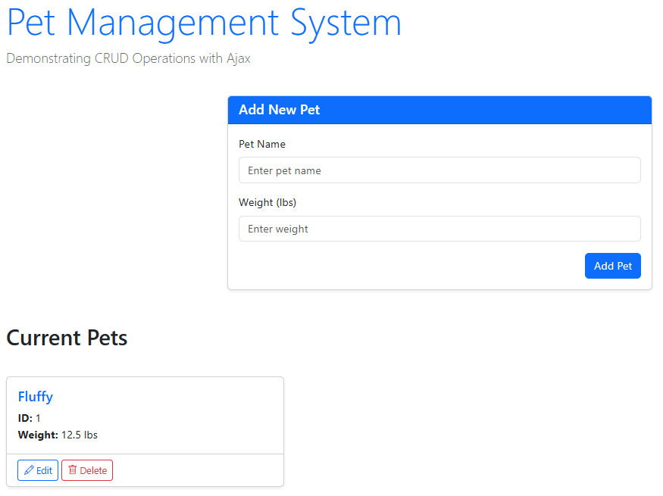
Let’s create the PetDOM class to manipulate the DOM.
'use strict';

export class PetDOM{

}

Showing No Pets
static showNoPetsMessage() {
const emptyState = document.querySelector('#emptyState');
emptyState.style.display = 'block';
}
static hideNoPetsMessage() {
const emptyState = document.querySelector('#emptyState');
emptyState.style.display = 'none';
}
'use strict';
import { PetDOM } from "./PetDOM.js";

main();

function main(){
PetDOM.showNoPetsMessage();
}
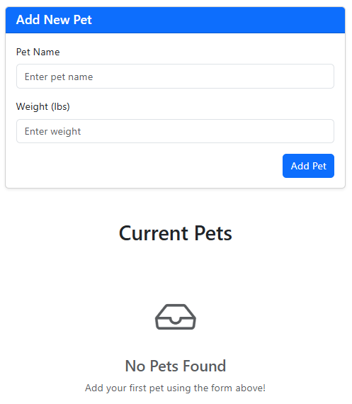

Adding a Pet to the DOM
static createPetCard(pet) {
const outerDiv = document.createElement('div');
outerDiv.className = 'col';
const shadowDiv = document.createElement('div');
shadowDiv.className = 'card h-100 shadow-sm';
outerDiv.appendChild(shadowDiv);
shadowDiv.innerHTML = `
<div class="card-body">
<h5 class="card-title text-primary">${pet.name}</h5>
<p class="card-text">
<strong>ID:</strong>${pet.id}<br>
<strong>Weight:</strong> ${pet.weight} lbs
</p>
</div>
<div class="card-footer bg-transparent">
<button class="btn btn-sm btn-outline-primary edit-btn" data-pet-id="${pet.id}">
<i class="bi bi-pencil"></i> Edit
</button>
<button class="btn btn-sm btn-outline-danger delete-btn" data-pet-id="${pet.id}">
<i class="bi bi-trash"></i> Delete
</button>
</div>
`;
const petCardsContainer = document.querySelector('#petCardsContainer');
petCardsContainer.appendChild(outerDiv);
}
'use strict';
import { PetDOM } from "./PetDOM.js";

main();

function main(){
// PetDOM.showNoPetsMessage();
PetDOM.createPetCard({id:1, name:'Fluffy', weight:2.3});
}
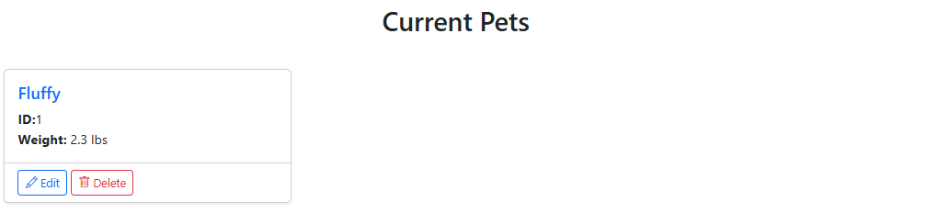

Consume GET Methods

Read All Pets
static showPetCards(pets) {
const petCardsContainer = document.querySelector('#petCardsContainer');
petCardsContainer.innerHTML = "";
if (pets.length === 0) {
PetDOM.showNoPetsMessage();
} else {
PetDOM.hideNoPetsMessage();
pets.forEach(pet => {
PetDOM.createPetCard(pet);
});
}
}
'use strict';
import { PetDOM } from "./PetDOM.js";
import { PetAJAXRepository } from "./PetAJAXRepository.js";

main();

async function main() {
const petRepo = new PetAJAXRepository('http://localhost:5147/api/pet');
let pets = await petRepo.readAll();
PetDOM.showPetCards(pets);
};
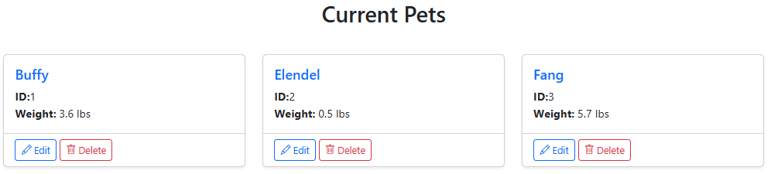

Pet Create
static resetForm() {
// Reset all form fields to default values
document.getElementById('petForm').reset();

// Reset the hidden pet ID to 0 (for add mode)
document.getElementById('Id').value = '0';

// Update form heading back to "Add New Pet"
document.querySelector('#form-title').innerHTML = '<i class="bi bi-plus-circle"></i> Add New Pet';

// Update button text back to "Add Pet"
document.getElementById('submitBtn').innerHTML = '<i class="bi bi-plus-lg"></i> Add Pet';

// Hide the cancel button
document.getElementById('cancelBtn').style.display = 'none';
}
'use strict';
import { PetDOM } from "./PetDOM.js";
import { PetAJAXRepository } from "./PetAJAXRepository.js";

main();

async function main() {
const petRepo = new PetAJAXRepository('http://localhost:5147/api/pet');
await setUpEventHandlers(petRepo);
let pets = await petRepo.readAll();
PetDOM.showPetCards(pets);
};

async function setUpEventHandlers(petRepo) {
petForm.addEventListener('submit', async (e) => {
e.preventDefault();
const petForm = document.getElementById('petForm');
await processFormSubmitted(petForm, petRepo);
let pets = await petRepo.readAll();
PetDOM.showPetCards(pets);
PetDOM.resetForm();
return false
});
}

async function processFormSubmitted(petForm, petRepo) {
try {
const formData = new FormData(petForm);
await petRepo.create(formData);
}
catch (error) {
console.error("An error occurred:", error.message);
}
}

Pet Edit
static populateFormForEdit(pet) {
// Populate form fields
document.getElementById('Id').value = pet.id;
document.getElementById('Name').value = pet.name;
document.getElementById('Weight').value = pet.weight;

// Update form heading
document.querySelector('#form-title').innerHTML =
'<i class="bi bi-pencil-square"></i> Edit Pet';

// Update button text to "Update Pet"
document.getElementById('submitBtn').innerHTML =
'<i class="bi bi-pencil-square"></i> Update Pet';

// Show the cancel button
document.getElementById('cancelBtn').style.display = 'block';

// Scroll to the form
document.getElementById('petForm').scrollIntoView({ behavior: 'smooth', block: 'start' });
}
'use strict';
import { PetDOM } from "./PetDOM.js";
import { PetAJAXRepository } from "./PetAJAXRepository.js";

main();

async function main() {
const petRepo = new PetAJAXRepository('http://localhost:5147/api/pet');
await setUpEventHandlers(petRepo);
let pets = await petRepo.readAll();
PetDOM.showPetCards(pets);
};

async function setUpEventHandlers(petRepo) {
const petForm = document.getElementById('petForm');
petForm.addEventListener('submit', async (e) => {
e.preventDefault();
const submitBtn = document.getElementById('submitBtn');
const isEditMode = submitBtn.textContent.trim().includes('Update');
if (isEditMode === false) {
await processCreatePet(petForm, petRepo);
}else{
await processEditPet(petForm, petRepo);
}

let pets = await petRepo.readAll();
PetDOM.showPetCards(pets);
PetDOM.resetForm();
return false
});

document.addEventListener('click', async (e) => {
const editBtn = e.target.closest('.edit-btn');
if (editBtn) {
const petId = parseInt(editBtn.getAttribute('data-pet-id'));
let pet = await petRepo.read(petId);
PetDOM.populateFormForEdit(pet);
}
});

document.addEventListener('click', (e) => {
if (e.target.getAttribute('id') === 'cancelBtn') {
PetDOM.resetForm();
}
});
}

async function processCreatePet(petForm, petRepo) {
try {
const formData = new FormData(petForm);
await petRepo.create(formData);
}
catch (error) {
console.error("An error occurred:", error.message);
}
}

async function processEditPet(petForm, petRepo) {
try {
const formData = new FormData(petForm);
await petRepo.update(formData);
}
catch (error) {
console.error("An error occurred:", error.message);
}
}

Pet Delete
document.addEventListener('click', async (e) => {
if (e.target.closest('.delete-btn')) {
const deleteBtn = e.target.closest('.delete-btn');
const petId = parseInt(deleteBtn.getAttribute('data-pet-id'));
let pet = await petRepo.read(petId);
await deletePet(pet, petRepo);

let pets = await petRepo.readAll();
PetDOM.showPetCards(pets);
PetDOM.resetForm();
return false
}
});
async function deletePet(pet, petRepo) {
const confirmed = confirm(`Are you sure you want to delete "${pet.name}"?`);

if (confirmed) {
await petRepo.delete(pet.id);
}
}

