Authentication vs. Authorization
- Authentication - The process of restricting access to an application until the user proves who they are by providing their credentials.
  - Typical credentials use a username and password.
- Authorization – The process that determines what a user can do.

Authentication in Web-Based Applications

Cookie-based Authentication
- The client posts the login credentials to the server.
- The server verifies the credentials and creates a session ID which is stored on the server and returned to the client via set-cookie.
- On subsequent requests, the session ID from the cookie is verified in the server and the request gets processed.
- Upon logout, the session ID is cleared from both client cookie and server.
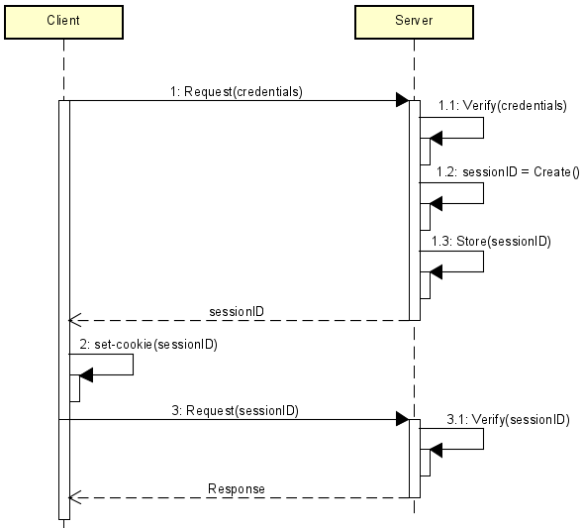

Pros
- Cookies are small
- Requires less code to implement

Cons
- Vulnerable to CSRF
- Less scalable because session data must be stored server-side
- Limited to a single domain; using web APIs will be a challenge
- Client needs to send cookie with every request, even those that do not need authentication

Token-Based Authentication
- Server receives credentials and validates it
- Server generates a token.
  - The token is not stored on the server (stateless)
- On subsequent requests, the token is passed to the server and verified.
- The token is stored on the client in local storage, session storage, or in cookies.
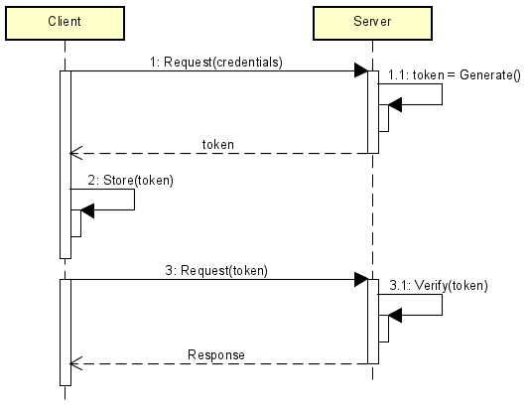

Pros
- Scalable because it is stateless
- Easier to expose APIs to different services and domains
- There is flexibility in the type of data included in the token
- Overall system performance is improved

Cons
- Tokens can be large
- Cannot be used to authenticate the user in the background
- Token storage on the client-side may be problematic
- Vulnerable to cross-site scripting attacks

Third Party Access
- Multiple ways
- OAuth
  - Open Authentication
  - Protocol that allows an application to authenticate against a server as a user.
  - Relies on HTTPS for security
  - Implemented by Google, Facebook, Twitter, and others
  - Token is issued by an identity provider.
  - The client uses the token to access the resource on behalf of the user.

Identity in ASP.NET Core
(Anderson, 2021)
- An API that supports UI login functionality
- Manages users, passwords, profile data, roles, claims, tokens, email confirmation, and more.
- Typically configured using a SQL server database to store usernames, passwords, and profile data
- Users can create an account with the login information stored in Identity.
  - Or they can use an external login provider.
    - E.g., Facebook, Google, Microsoft Account, and Twitter

Identity into a New Project

Individual Accounts
- Individual Accounts store profiles in a SQL Server database.
- The traditional ‘Enter username and password’ use case.
- When this is selected during program creation, Visual Studio adds any needed dependencies and generates quite a bit of boilerplate starting code

Enabling Identity
- Install the following NuGet packages:
  - dotnet add package Microsoft.AspNetCore.Identity.EntityFrameworkCore
  - dotnet add package Microsoft.AspNetCore.Identity.UI
- Update the DbContext:
  - Inherit from IdentityDbContext
  - Ensure that base.OnModelCreating(modelBuilder) is called
using Microsoft.AspNetCore.Identity.EntityFrameworkCore;
using Microsoft.EntityFrameworkCore;

namespace LecAuth.Services;

public class ApplicationDbContext : IdentityDbContext
{
public ApplicationDbContext(DbContextOptions<ApplicationDbContext> options)
: base(options)
{
}

protected override void OnModelCreating(ModelBuilder modelBuilder)
{
base.OnModelCreating(modelBuilder);

…
}
…
}
- Configure the identity service in Program.cs:
using LecAuth.Services;
using Microsoft.AspNetCore.Identity;
using Microsoft.EntityFrameworkCore;

var builder = WebApplication.CreateBuilder(args);

builder.Services.AddDbContext<ApplicationDbContext>(options =>
options.UseSqlite(
builder.Configuration.GetConnectionString("DefaultConnection"))
);

// Add Identity services
builder.Services.AddDefaultIdentity<IdentityUser>(options =>
{
options.SignIn.RequireConfirmedAccount = false;
// Configure other options as needed
})
.AddEntityFrameworkStores<ApplicationDbContext>();

// Add services to the container.
builder.Services.AddControllersWithViews();

var app = builder.Build();
- Identity is enabled by calling UseAuthentication.
  - UseAuthentication adds authentication middleware to the request pipeline.
  - Take note that authentication comes before authorization but after routing.
    - You must authenticate and then authorize.
app.UseHttpsRedirection();
app.UseRouting();

app.UseAuthentication();
app.UseAuthorization();

app.MapStaticAssets();

app.MapControllerRoute(
name: "default",
pattern: "{controller=Home}/{action=Index}/{id?}")
.WithStaticAssets();

// Add Razor Pages for Identity UI
app.MapRazorPages();

app.Run();

Generated Database
dotnet ef migrations add IdentityMig
dotnet ef database update
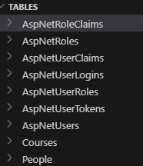

_LoginPartial.cshtml
- Create a Login Partial View: Views/Shared/_LoginPartial.cshtml
@using Microsoft.AspNetCore.Identity
@inject SignInManager<IdentityUser> SignInManager
@inject UserManager<IdentityUser> UserManager

<ul class="navbar-nav">
@if (SignInManager.IsSignedIn(User))
{
<li class="nav-item">
<a class="nav-link text-dark"
asp-area="Identity" asp-page="/Account/Manage/Index"
title="Manage">Hello @User.Identity?.Name!</a>
</li>
<li class="nav-item">
<form class="form-inline"
asp-area="Identity" asp-page="/Account/Logout"
asp-route-returnUrl="@Url.Action("Index", "Home", new { area = "" })">
<button type="submit" class="nav-link btn btn-link text-dark">
Logout
</button>
</form>
</li>
}
else
{
<li class="nav-item">
<a class="nav-link text-dark"
asp-area="Identity" asp-page="/Account/Register">Register</a>
</li>
<li class="nav-item">
<a class="nav-link text-dark"
asp-area="Identity" asp-page="/Account/Login">Login</a>
</li>
}
</ul>
- Modify _Layout.cshtml to include the Login links
<div class="navbar-collapse collapse d-sm-inline-flex justify-content-between">
<ul class="navbar-nav flex-grow-1">
<li class="nav-item">
<a class="nav-link text-dark"
asp-area="" asp-controller="Home" asp-action="Index">Home</a>
</li>
<li class="nav-item">
<a class="nav-link text-dark" asp-area="" asp-controller="Home"
asp-action="Privacy">Privacy</a>
</li>
</ul>
<div class="navbar-nav ms-auto">
<partial name="_LoginPartial" />
</div>
</div>
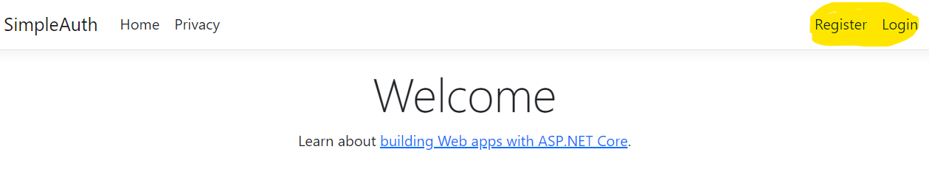

Generate the Identity UI
dotnet aspnet-codegenerator identity -dc ApplicationDbContext --files "Account.Register;Account.Login;Account.Logout"

Register Users
- The framework generates this functionality for “free.”
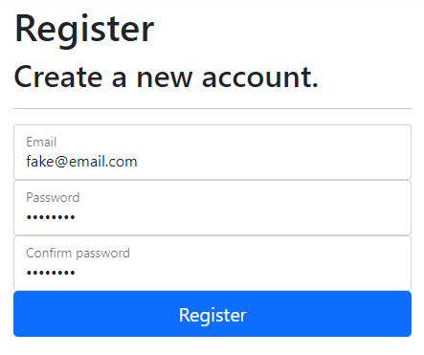


Log In/Out User
- These functionalities are also provided for “free”
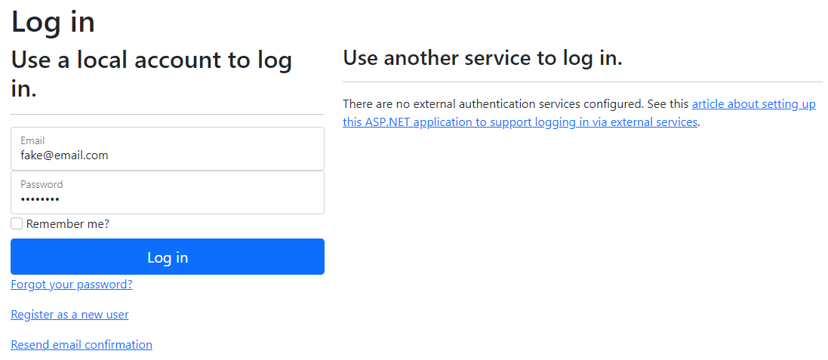


Accessing User Information

User Object
- The framework maintains the currently logged in user using the ‘User’ object
  - It maps to an authentication cookie
User.Identity.Name | Gets the username of the user
- Using the ‘User’ object reference:
public IActionResult GetUserName()
{
if (User.Identity!.IsAuthenticated)
{
string username = User.Identity.Name ?? "";
return Content(username);
}
return Content("No user");
}
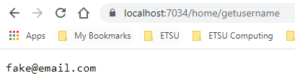

Authentication and Authorization
(Unnamed, 2016)
- Authentication is the process of restricting access to an application until the user proves who they are by providing their credentials.
- Authorization refers to the process that determines what a user can do.
  - E.g.,
    - An administrative user can create a document library, add documents, edit documents, and delete them.
    - A non-administrative user working with the library is only authorized to read the documents.
- Restricting access to web resources is done by using the ‘[Authorize]’ annotation.

[Authorize]
- The user must be logged in to access this resource
- It may be applied to the controller or to the action methods
  - When applied to the controller, all action methods in the controller are restricted
[Authorize]
public class HomeController : Controller
{
…
}

[Authorize]
public IActionResult Restricted()
{
return Content("This is restricted.");
}

Adding Role Checks
- Note that the list can be comma separated.
[Authorize(Roles = "Administrator")]
public class HomeController : Controller
{
…
}

[Authorize(Roles = "HRManager,Finance")]
public IActionResult Restricted()
{
return Content("This is restricted.");
}

[AllowAnonymous]
Allows access to non-authenticated users.
[AllowAnonymous]
public IActionResult About()
{
ViewData["Message"] = "Your application about page.";

return View();
}

A User Repository
- To work with user accounts, you should create an ApplicationUser class
  - It derives from IdentityUser
- You won’t need a DbSet for this class because the generated data context already has it internally
public class ApplicationUser : IdentityUser
{
}
- Modify the _LoginPartial.cshtml (in Views/Shared) to use that class
  - Set up the namespace in _ViewImports.cshtml
_ViewImports.cshtml
@using AuthenticationDemo
@using AuthenticationDemo.Models
@using AuthenticationDemo.Models.Entities
@addTagHelper *, Microsoft.AspNetCore.Mvc.TagHelpers
_LoginPartial.cshtml
@using Microsoft.AspNetCore.Identity
@inject SignInManager<ApplicationUser> SignInManager
@inject UserManager<ApplicationUser> UserManager
- Modify the ApplicationDbContext.cs in the Data folder to assign ApplicationUser and IdentityRole:
public class ApplicationDbContext : IdentityDbContext<ApplicationUser>
{
public ApplicationDbContext(DbContextOptions<ApplicationDbContext> options)
: base(options)
{
}
}
- Modify the Program.cs to enable using the new ApplicationUser:
builder.Services
.AddDefaultIdentity<ApplicationUser>(
options => options.SignIn.RequireConfirmedAccount = false)
.AddEntityFrameworkStores<ApplicationDbContext>();
- There may be other locations to change from IdentityUser to ApplicationUser e.g., the LoginModel
- We’ll then need a repository to manage application users
public interface IUserRepository
{
Task<ApplicationUser?> ReadByUsernameAsync(string username);
}
public class DbUserRepository : IUserRepository
{
private readonly ApplicationDbContext _db;

public DbUserRepository(ApplicationDbContext db)
{
_db = db;
}

public async Task<ApplicationUser?> ReadByUsernameAsync(string username)
{
return await _db.Users.FirstOrDefaultAsync(u => u.UserName == username);
}
}
builder.Services.AddScoped<IUserRepository, DbUserRepository>();
- To access the Id of the logged in user, we must use the username from the user object then read the user from the database
private readonly ILogger<HomeController> _logger;
private readonly IUserRepository _userRepo;

public HomeController(IUserRepository userRepo, ILogger<HomeController> logger)
{
_logger = logger;
_userRepo = userRepo;
}

public async Task<IActionResult> GetUserId()
{
if (User.Identity!.IsAuthenticated)
{
string username = User.Identity.Name ?? "";
var user = await _userRepo.ReadByUsernameAsync(username);
if (user != null)
{
return Content(user.Id);
}
}
return Content("No user");
}

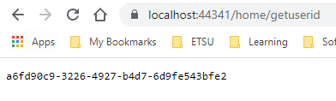

Customizing Users
- Modify the ApplicationUser class and add the properties you need.
- Let’s give the application user a first name and a last name.
public class ApplicationUser : IdentityUser
{
public string FirstName { get; set; } = String.Empty;
public string LastName { get; set; } = String.Empty;
}
- Add a new migration and update the database.
- Let’s modify the register page to include these.
- Expand Areas > Identity > Pages > Account > Register.cshtml
    - Note: you are to expand Register.cshtml so that you can see Register.cshtml.cs
- Open Register.cshtml.cs
  - Locate the InputModel class
  - Add the following to the class
[Required]
[Display(Name = "First Name")]
public string FirstName { get; set; } = String.Empty;
[Required]
[Display(Name = "Last Name")]
public string LastName { get; set; } = String.Empty;
- In public async Task<IActionResult> OnPostAsync(string returnUrl = null)
  - After the user is created, set the first name and the last name
public async Task<IActionResult> OnPostAsync(string returnUrl = null)
{
…
if (ModelState.IsValid)
{
var user = CreateUser();
user.FirstName = Input.FirstName;
user.LastName = Input.LastName;
…
- Open Register.cshtml
  - Add input divs for Input.FirstName and Input.LastName before the div for Input.Email
<div class="form-floating mb-3">
<input asp-for="Input.FirstName" class="form-control" autocomplete="first-name" aria-required="true" placeholder="first name" />
<label asp-for="Input.FirstName">First Name</label>
<span asp-validation-for="Input.FirstName" class="text-danger"></span>
</div>
<div class="form-floating mb-3">
<input asp-for="Input.LastName" class="form-control" autocomplete="last-name" aria-required="true" placeholder="last name" />
<label asp-for="Input.LastName">Last Name</label>
<span asp-validation-for="Input.LastName" class="text-danger"></span>
</div>
<div class="form-floating">
<input asp-for="Input.Email" class="form-control" autocomplete="username" aria-required="true" />
<label asp-for="Input.Email"></label>
<span asp-validation-for="Input.Email" class="text-danger"></span>
</div>
- Build and then run the application
- Register an account and enter your first name and last name
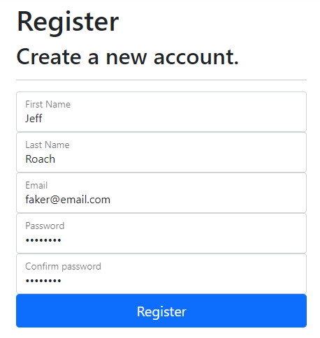
- You can view the data in the AspNetUsers table, scroll across until you see your first name and last name.


Adding the User’s Name to the Message Bar
- Modify _LoginPartial.cshtml and inject the user repository
@using Microsoft.AspNetCore.Identity
@using AuthenticationDemo.Services
@inject SignInManager<ApplicationUser> SignInManager
@inject UserManager<ApplicationUser> UserManager
@inject IUserRepository userRepo
- Then add code to show the user’s name
<ul class="navbar-nav">
@if (SignInManager.IsSignedIn(User))
{
var user = await userRepo.ReadByUsernameAsync(User.Identity?.Name!);
var fullName = $"{user!.FirstName} {user!.LastName}";

<li class="nav-item">
<a id="manage" class="nav-link text-dark"
asp-area="Identity"
asp-page="/Account/Manage/Index" title="Manage">
Hello @fullName!
</a>
</li>
<li class="nav-item">
…
</li>
}
else
{
…
}
</ul>


