Creating Users
- To create a user, you’ll need a UserManager.
- It must be configured as part of the identity service.
- This operation is I/O bound so you’ll need to call an asynchronous method to create a user.
builder.Services
.AddDefaultIdentity<ApplicationUser>(
options => options.SignIn.RequireConfirmedAccount = false)
.AddUserManager<UserManager<ApplicationUser>>()
.AddEntityFrameworkStores<ApplicationDbContext>();
public interface IUserRepository
{
Task<ApplicationUser?> ReadByUsernameAsync(string username);
Task<ApplicationUser> CreateAsync(ApplicationUser user, string password);
}
public class DbUserRepository : IUserRepository
{
private readonly ApplicationDbContext _db;
private readonly UserManager<ApplicationUser> _userManager;

public DbUserRepository(ApplicationDbContext db,
UserManager<ApplicationUser> userManager)
{
_db = db;
_userManager = userManager;
}

public async Task<ApplicationUser?> ReadByUsernameAsync(string username)
{
return await _db.Users.FirstOrDefaultAsync(u => u.UserName == username);
}

public async Task<ApplicationUser> CreateAsync(
ApplicationUser user, string password)
{
await _userManager.CreateAsync(user, password);
return user;
}
}
In HomeController
Don’t create users like this in a real application, this is only for demonstration purposes.
private readonly Random _random = new Random();
public async Task<IActionResult> CreateTestUser()
{
var n = _random.Next(100);
var check = await _userRepo.ReadByUsernameAsync($"test{n}@test.com");
if (check == null)
{
var user = new ApplicationUser
{
Email = $"test{n}@test.com",
UserName = $"test{n}@test.com",
FirstName = $"User{n}",
LastName = $"Userlastname{n}"
};
await _userRepo.CreateAsync(user, "Pass123!");
return Content($"Created test user 'test{n}@test.com' with password 'Pass123!'");
}
return Content("The user was already created.");
}
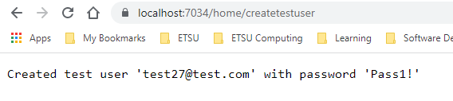
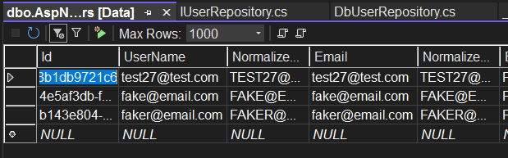

Assigning Roles
- To work with roles, we need to configure the DbContext and the identity service
- To assign a role to a user, the user and the role must exist
- Get the user and then add the role to the user using the UserManager
public class ApplicationDbContext
: IdentityDbContext<ApplicationUser, IdentityRole, string>
{
public ApplicationDbContext(DbContextOptions<ApplicationDbContext> options)
: base(options)
{
}
}
builder.Services
.AddDefaultIdentity<ApplicationUser>(
options => options.SignIn.RequireConfirmedAccount = false)
.AddUserManager<UserManager<ApplicationUser>>()
.AddRoles<IdentityRole>()
.AddEntityFrameworkStores<ApplicationDbContext>();
public interface IUserRepository
{
Task<ApplicationUser?> ReadByUsernameAsync(string username);
Task<ApplicationUser> CreateAsync(ApplicationUser user, string password);
Task AssignUserToRoleAsync(string userName, string rolename);
}
public class DbUserRepository : IUserRepository
{
private readonly ApplicationDbContext _db;
private readonly UserManager<ApplicationUser> _userManager;
private readonly RoleManager<IdentityRole> _roleManager;

public DbUserRepository(ApplicationDbContext db,
UserManager<ApplicationUser> userManager,
RoleManager<IdentityRole> roleManager)
{
_db = db;
_userManager = userManager;
_roleManager = roleManager;
}

…

public async Task AssignUserToRoleAsync(string userName, string rolename)
{
var roleCheck = await _roleManager.RoleExistsAsync(rolename);
if (!roleCheck)
{
await _roleManager.CreateAsync(new IdentityRole(rolename));
}
var user = await ReadByUsernameAsync(userName);
if (user != null)
{
await _userManager.AddToRoleAsync(user, rolename);
}
}
}
public async Task<IActionResult> TestAssignUserToRole()
{
await _userRepo.AssignUserToRoleAsync("fake@email.com", "TestRole");
return Content("Assigned 'fake@email.com' to role 'TestRole'");
}
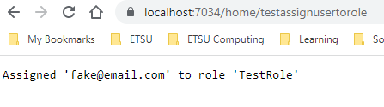
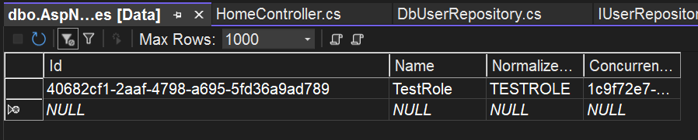
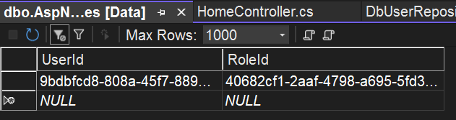

Read a User and its Roles
public class ApplicationUser : IdentityUser
{
public string FirstName { get; set; } = String.Empty;
public string LastName { get; set; } = String.Empty;
[NotMapped]
public ICollection<string> Roles { get; set; }
= new List<string>();
}
public async Task<ApplicationUser?> ReadByUsernameAsync(string username)
{
var user = await _db.Users.FirstOrDefaultAsync(u => u.UserName == username);
if (user != null)
{
user.Roles = await _userManager.GetRolesAsync(user);
}
return user;
}
public async Task<IActionResult> ShowRoles(string userName)
{
ApplicationUser? user = await _userRepo.ReadByUsernameAsync(userName);
StringBuilder builder = new();
foreach (var rolename in user!.Roles)
{
builder.Append(rolename + " ");
}
return Content($"UserName: {user.UserName} Roles: {builder}");
}
Note the URL used below
/home/showroles?userName=fake@email.com
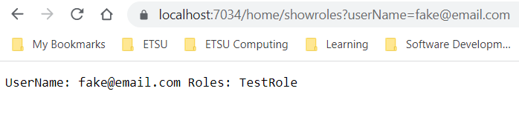

Test If a User is in a Role
public class ApplicationUser : IdentityUser
{
public string FirstName { get; set; } = String.Empty;
public string LastName { get; set; } = String.Empty;
[NotMapped]
public ICollection<string> Roles { get; set; }
= new List<string>();

public bool HasRole(string rolename)
{
return Roles.Any(r => r == rolename);
}
}
Can also be done with the user manager:
_userManager.IsInRole(user.Id, rolename)

public async Task AssignUserToRoleAsync(string userName, string rolename)
{
var roleCheck = await _roleManager.RoleExistsAsync(rolename);
if (!roleCheck)
{
await _roleManager.CreateAsync(new IdentityRole(rolename));
}
var user = await ReadByUsernameAsync(userName);
if (user != null)
{
if (!user.HasRole(rolename))
{
await _userManager.AddToRoleAsync(user, rolename);
}
}
}
public async Task<IActionResult> HasRole(string userName, string rolename)
{
ApplicationUser? user = await _userRepo.ReadByUsernameAsync(userName);
if (user!.HasRole(rolename))
{
return Content($"{userName} has role {rolename}");
}
return Content($"{userName} does not have role {rolename}");
}
Note the URLs used below
/home/hasRole?userName=fake@email.com&rolename=TestRole
/home/hasRole?userName=fake@email.com&rolename=Admin
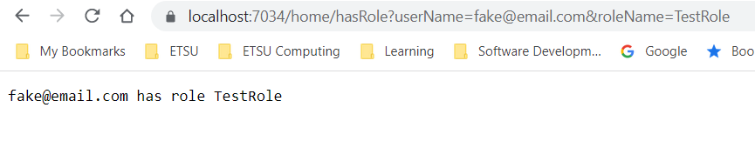
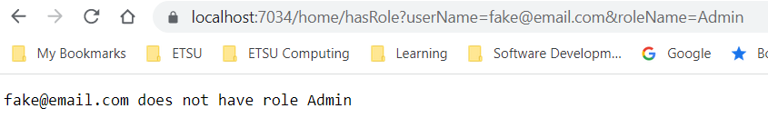

Role-Based Authorization
[Authorize(Roles ="TestRole")]
public IActionResult TestRoleCheck()
{
return Content("Restricted to role TestRole");
}

Logged in as fake@email.com
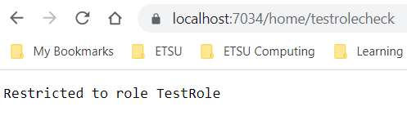

Seeding the Database with Roles and an Admin User
- In the Services folder, create the Initializer class:
public class Initializer
{
private readonly ApplicationDbContext _db;
private readonly UserManager<ApplicationUser> _userManager;
private readonly RoleManager<IdentityRole> _roleManager;

public Initializer(
ApplicationDbContext db,
UserManager<ApplicationUser> userManager,
RoleManager<IdentityRole> roleManager)
{
_db = db;
_userManager = userManager;
_roleManager = roleManager;
}

public async Task SeedUsersAsync()
{
_db.Database.EnsureCreated();

if (!_db.Roles.Any(r => r.Name == "Admin"))
{
await _roleManager.CreateAsync(new IdentityRole { Name = "Admin" });
}

if (!_db.Roles.Any(r => r.Name == "Teacher"))
{
await _roleManager.CreateAsync(new IdentityRole { Name = "Teacher" });
}

if (!_db.Roles.Any(r => r.Name == "Student"))
{
await _roleManager.CreateAsync(new IdentityRole { Name = "Student" });
}

if (!_db.Users.Any(u => u.UserName == "admin@test.com"))
{
var user = new ApplicationUser
{
Email = "admin@test.com",
UserName = "admin@test.com",
};
await _userManager.CreateAsync(user, "Pass123!");
await _userManager.AddToRoleAsync(user, "Admin");
}
}
}
- Configure Initializer in Program.cs:
builder.Services.AddScoped<Initializer>();
- Modify Program.cs to seed the users:
var app = builder.Build();
await SeedDataAsync(app);
…
static async Task SeedDataAsync(WebApplication app)
{
using var scope = app.Services.CreateScope();
var services = scope.ServiceProvider;
try
{
var initializer = services.GetRequiredService<Initializer>();
await initializer.SeedUsersAsync();
}
catch (Exception ex)
{
var logger = services.GetRequiredService<ILogger<Program>>();
logger.LogError("An error occurred while seeding the database: {Message}", ex.Message);
}
}
- After the application rns, use SQL server object explorer to view the data in the AspNetRoles and the AspNetUsers tables
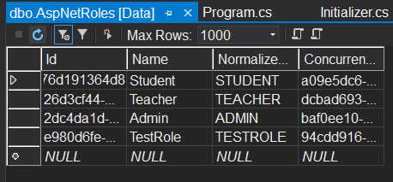
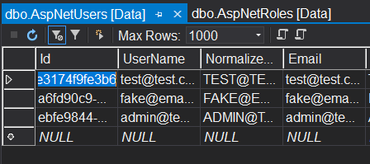

References
Anderson, R. (2021, 9 15). Introduction to Identity on ASP.NET Core. Retrieved 9 30, 2020, from Microsoft Docs: https://docs.microsoft.com/en-us/aspnet/core/security/authentication/identity?view=aspnetcore-5.0&tabs=visual-studio
Unnamed. (2016, October 14). Authorization in ASP.NET Core: Simple, role, claims-based, and custom. Retrieved November 20, 2017, from Microsoft Docs: https://docs.microsoft.com/en-us/aspnet/core/security/authorization/

