Responsive UI
- A responsive UI is one that adapts to the size (height and width) of each device
- This allows for a good user experience

WAI-ARIA
- WAI-ARIA, the Accessible Rich Internet Applications Suite, defines a way to make Web content and Web applications more accessible to people with disabilities
- It especially helps with dynamic content and advanced user interface controls developed with Ajax, HTML, JavaScript, and related technologies. (https://www.w3.org/WAI/intro/aria)

What is Bootstrap?
- Web-development front-end framework
- HTML and CSS-based templates
- Typography and UI components
- Has optional JavaScript extensions
- Helps in creating responsive forms
- Developed by Mark Otto and Jacob Thornton at Twitter

Where to find Bootstrap?
- https://getbootstrap.com/

Updating Bootstrap
- Install LibMan: dotnet tool update -g Microsoft.Web.LibraryManager.Cli
- Initialize LibMan: libman init
- > libman install bootstrap@5.3.8 --provider cdnjs --destination wwwroot/lib/bootstrap/dist
libman.json
{
"version": "3.0",
"defaultProvider": "cdnjs",
"libraries": [
{
"library": "jquery@3.7.1",
"destination": "wwwroot/lib/jquery/dist"
},
{
"library": "bootstrap@5.3.8",
"destination": "wwwroot/lib/bootstrap/dist"
}
]
}
- Use libman restore to update the version of Bootstrap.

Breakpoints
- Customizable widths that determine how responsive layouts behave across viewport sizes.
- A breakpoint is set to accommodate containers with widths that are multiples of 12.
- Six default breakpoints:
Breakpoint | Class infix | Dimensions
X-Small | None | <576px
Small | sm | ≥576px
Medium | md | ≥768px
Large | lg | ≥992px
Extra large | xl | ≥1200px
Extra extra large | xxl | ≥1400px

Containers
- Used to enclose content
- Three different containers;
  - .container, which sets a max-width at each responsive breakpoint
  - .container-fluid, which is width: 100% at all breakpoints
  - .container-{breakpoint}, which is width: 100% until the specified breakpoint
.example {
color: #000000;
}

/* Extra small devices (phones, 600px and down) */
@media only screen and (max-width: 600px) {
.example {
background: red;
}
}

/* Small devices (portrait tablets and large phones, 600px and up) */
@media only screen and (min-width: 600px) {
.example {
background: green;
}
}

/* Medium devices (landscape tablets, 768px and up) */
@media only screen and (min-width: 768px) {
.example {
background: blue;
}
}

/* Large devices (laptops/desktops, 992px and up) */
@media only screen and (min-width: 992px) {
.example {
background: orange;
}
}

/* Extra large devices (large laptops and desktops, 1200px and up) */
@media only screen and (min-width: 1200px) {
.example {
background: pink;
}
}
Default Container
<div class="container border">
<h2>Default container</h2>
</div>
It prevents content from stretching too wide on large screens (which hurts readability) while providing appropriate spacing on smaller devices.
Behavior:
- Centers itself horizontally on the page
- Has built-in left/right padding (gutters) to keep content away from screen edges
- Snaps to predefined max-widths at different breakpoints (small, medium, large, etc.)
- Leaves margins on either side once the viewport exceeds the container's max-width
Responsive containers
<div class="container-sm border example">
100% wide until small breakpoint
<button class="col-sm-1 col-md-2 col-lg-2 btn btn-info">1</button>
<button class="col-sm-1 col-md-2 col-lg-2 btn btn-info">2</button>
<button class="col-sm-1 col-md-2 col-lg-2 btn btn-info">3</button>
</div>
<div class="container-md border example">
<button class="btn btn-info">1</button>
<button class="btn btn-info">2</button>
<button class="btn btn-info">3</button>
</div>
<div class="container-lg border">100% wide until large breakpoint</div>
<div class="container-xl border">100% wide until extra large breakpoint</div>
<div class="container-xxl border">100% wide until extra extra large breakpoint</div>
.container-sm: Full-width on extra-small screens, then becomes fixed-width from small breakpoint and up
.container-md: Full-width until medium breakpoint, then fixed-width
.container-lg: Full-width until large breakpoint, then fixed-width
.container-xl: Full-width until extra-large breakpoint, then fixed-width
.container-xxl: Full-width until extra-extra-large breakpoint, then fixed-width
Fluid containers
<div class="container-fluid border">
<h2>Fluid container</h2>
</div>
The fluid container is the simplest container variant; it always spans 100% of the viewport width at every screen size, with no maximum width constraints.
Behavior:
- Stretches edge-to-edge (minus the standard Bootstrap padding/gutters)
- Never constrains width regardless of how large the screen gets
- Still maintains left/right padding to keep content off the screen edges

Grid System
- See https://getbootstrap.com/docs/5.3/layout/grid/
- Containers, rows, and columns
- The col- classes control column width in Bootstrap's 12-column grid system.
- col-md-4: sets up a column of width 4 for a medium device, for smaller devices, the columns will automatically stack.
- "col-12 col-md-8":
  - col-12: on small (mobile) screens, the element takes up all 12 columns (full width)
  - col-md-8: on medium screens and larger (≥768px), it shrinks to 8 of 12 columns (~66% width)
  - The md part is the breakpoint; it's Bootstrap's responsive prefix that kicks in at that screen size and above. Together, these two classes make the element full-width on mobile and narrower on larger screens.

Grid options
 | xs  <576px | sm  ≥576px | md  ≥768px | lg  ≥992px | xl  ≥1200px | xxl  ≥1400px
Max container width | None (auto) | 540px | 720px | 960px | 1140px | 1320px
Class prefix | .col- | .col-sm- | .col-md- | .col-lg- | .col-xl- | .col-xxl-
# of columns | 12

Example
GridExample.cshtml
<div class="container">
<!-- Stack the columns on mobile by making one full-width and the other half-width -->
<div class="row">
<div class="col-12 col-md-8 border">.col-12 .col-md-8</div>
<div class="col-6 col-md-4 border">.col-6 .col-md-4</div>
</div>

<!-- Columns start at 50% wide on mobile and bump up to 33.3% wide on desktop -->
<div class="row">
<div class="col-6 col-md-4 border">.col-6 .col-md-4</div>
<div class="col-6 col-md-4 border">.col-6 .col-md-4</div>
<div class="col-6 col-md-4 border">.col-6 .col-md-4</div>
</div>

<!-- Columns are always 50% wide, on mobile and desktop -->
<div class="row">
<div class="col-6 border">.col-6</div>
<div class="col-6 border">.col-6</div>
</div>
</div>
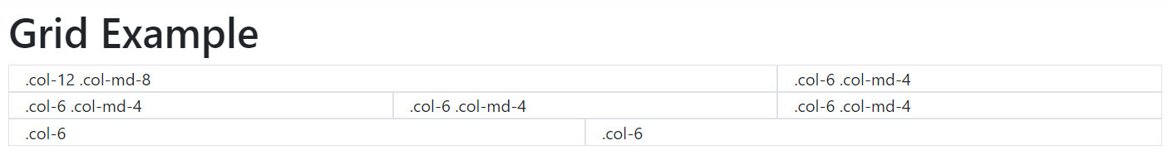
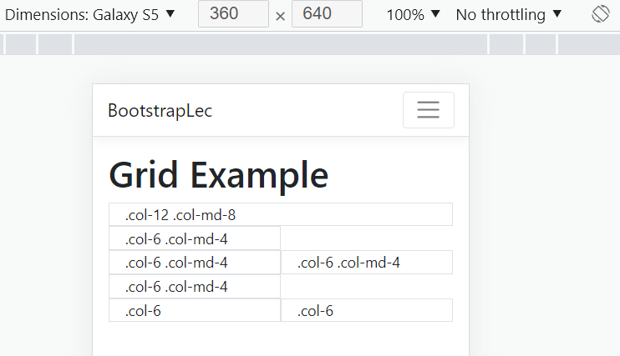
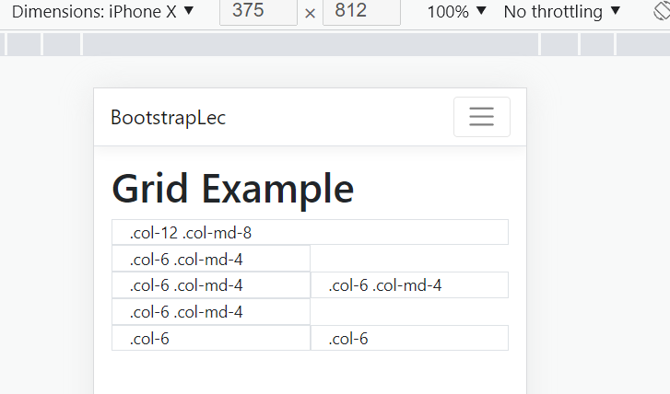

Forms
- Example Model
public enum Gender { Female, Male }
public class Pet
{
public string? Name { get; set; }
public string? Type { get; set; }
public Gender Gender { get; set; }
public bool IsNeutered { get; set; }
}
- Use an appropriate HTML 'type' attribute on all inputs (e.g., email for email address or number for numerical information) to take advantage of newer input controls like email verification, number selection, and more.
  - See: https://www.w3schools.com/html/html_form_input_types.asp
- Use a <label> for accessibility with class “form-label”
- Use class “form-control” for the inputs
  - Use class "form-check" for radios and checkboxes

Stacked Forms
- The default form layout
- Elements are stacked vertically
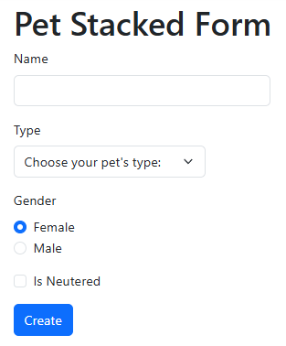

The Code
@model Pet
@{
ViewData["Title"] = "Pet Stacked Form";
}

<h1>@ViewData["Title"]</h1>

<form id="createPetForm" asp-action="Create">
<div class="mb-3 col-4">
<label asp-for="Name" class="form-label"></label>
<input type="text" asp-for="Name" class="form-control" />
<span asp-validation-for="Name" class="text-danger"></span>
</div>
<div class="mb-3 col-3">
<label asp-for="Type" class="form-label"></label>
<select class="form-select" asp-for="Type" aria-label="Pet type">
<option selected>Choose your pet's type:</option>
<option value="Bird">Bird</option>
<option value="Cat">Cat</option>
<option value="Dog">Dog</option>
<option value="Snake">Snake</option>
</select>
</div>
<div class="mb-3">
<label class="form-label">Gender</label>
<div class="form-check">
<input class="form-check-input" type="radio" id="femaleRdo" name="Gender" value="Female" checked />
<label class="form-check-label" for="femaleRdo">
Female
</label>
</div>
<div class="form-check">
<input class="form-check-input" type="radio" id="maleRdo" name="Gender" value="Male" />
<label class="form-check-label" for="maleRdo">
Male
</label>
</div>
</div>
<div class="mb-3">
<div class="form-check">
<input asp-for="IsNeutered" class="form-check-input" type="checkbox" id="isNeuteredChk">
<label class="form-check-label" for="isNeuteredChk">
Is Neutered
</label>
</div>
</div>

<div class="mb-3">
<input type="submit" value="Create" class="btn btn-primary" />
</div>
</form>

Bootstrap Buttons
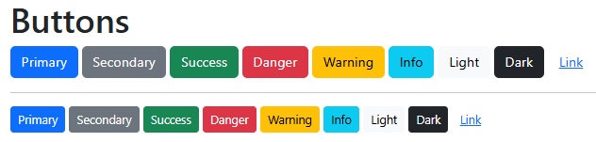
@{
ViewData["Title"] = "Buttons";
}

<h1>Buttons</h1>

<button type="button" class="btn btn-primary">Primary</button>
<button type="button" class="btn btn-secondary">Secondary</button>
<button type="button" class="btn btn-success">Success</button>
<button type="button" class="btn btn-danger">Danger</button>
<button type="button" class="btn btn-warning">Warning</button>
<button type="button" class="btn btn-info">Info</button>
<button type="button" class="btn btn-light">Light</button>
<button type="button" class="btn btn-dark">Dark</button>
<button type="button" class="btn btn-link">Link</button>
<hr />
<button type="button" class="btn btn-primary btn-sm">Primary</button>
<button type="button" class="btn btn-secondary btn-sm">Secondary</button>
<button type="button" class="btn btn-success btn-sm">Success</button>
<button type="button" class="btn btn-danger btn-sm">Danger</button>
<button type="button" class="btn btn-warning btn-sm">Warning</button>
<button type="button" class="btn btn-info btn-sm">Info</button>
<button type="button" class="btn btn-light btn-sm">Light</button>
<button type="button" class="btn btn-dark btn-sm">Dark</button>
<button type="button" class="btn btn-link btn-sm">Link</button>

Horizontal Forms
- See: https://getbootstrap.com/docs/5.3/forms/layout/#horizontal-form
- Create horizontal forms with the grid by adding the .row class to form groups and using the .col-*-* classes to specify the width of your labels and controls
  - Add .col-form-label to your <label>s as well so they’re vertically centered with their associated form controls
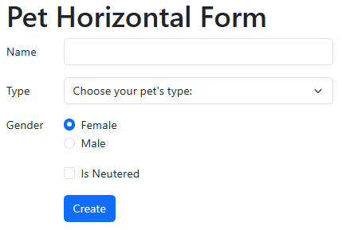

@model Pet
@{
ViewData["Title"] = "Pet Horizontal Form";
}

<h1>@ViewData["Title"]</h1>

<form id="createPetForm" asp-action="Create">
<partial name="_PetFormHorizontal" model="@Model">
<div class="row mb-3">
<div class="col-11 offset-1">
<input type="submit" value="Create" class="btn btn-primary" />
</div>
</div>
</form>
@model Pet
<div class="row mb-3">
<label asp-for="Name" class="col-1 col-form-label"></label>
<div class="col-5">
<input type="text" asp-for="Name" class="form-control" />
<span asp-validation-for="Name" class="text-danger"></span>
</div>
</div>
<div class="row mb-3">
<label asp-for="Type" class="col-1 col-form-label"></label>
<div class="col-5">
<select class="form-select" asp-for="Type" aria-label="Pet type">
<option selected>Choose your pet's type:</option>
<option value="Bird">Bird</option>
<option value="Cat">Cat</option>
<option value="Dog">Dog</option>
<option value="Snake">Snake</option>
</select>
</div>
</div>
<div class="row mb-3">
<label class="col-1 col-form-label pt-0">Gender</label>
<div class="col-11">
<div class="form-check">
<input class="form-check-input" type="radio" id="femaleRdo" name="Gender" value="Female" checked />
<label class="form-check-label" for="femaleRdo">
Female
</label>
</div>
<div class="form-check">
<input class="form-check-input" type="radio" id="maleRdo" name="Gender" value="Male" />
<label class="form-check-label" for="maleRdo">
Male
</label>
</div>
</div>
</div>
<div class="row mb-3">
<div class="col-11 offset-1">
<div class="form-check">
<input asp-for="IsNeutered" class="form-check-input" type="checkbox" id="isNeuteredChk">
<label class="form-check-label" for="isNeuteredChk">
Is Neutered
</label>
</div>
</div>
</div>

Modal Dialog Forms
- Uses the Bootstrap JavaScript modal component
- See https://getbootstrap.com/docs/5.3/components/modal/

Activating Modal Dialogs
- The modal dialog can be activated using a CSS button or using JavaScript
- Take note of the data-toggle and the data-target
<button type="button" class="btn btn-primary"
data-bs-toggle="modal"
data-bs-target="#createModal">
Activate Modal
</button>
// Using JavaScript
let modalDOM = document.querySelector("#modalID");
let modal = new bootstrap.Modal(modalDOM);
modal.show();
modal.hide();
modal.toggle();

Modal Dialog
- First div: class="modal" tabindex="-1" id="someID"
- Second div: class="modal-dialog modal-dialog-centered {size}"
  - modal-dialog-centered – optional, centers the modal vertically on-screen
  - {size} is optional but can be modal-sm, modal-lg, or modal-xl
- Third div: class="modal-content"
- Three other divs: modal-header, modal-body, modal-footer
- Add elements to assist screen-readers e.g., aria-labelledby="modalTitle"
- Add the header section. Note the classes.
- Use the horizontal form code (a partial view would be useful here)
@model Pet
@{
ViewData["Title"] = "Modal Form";
}

<h1>@ViewData["Title"]</h1>

<button type="button" class="btn btn-primary"
data-bs-toggle="modal"
data-bs-target="#createModal">
Activate Modal
</button>

<div class="modal fade" id="createModal" tabindex="-1" role="dialog"
aria-labelledby="createPetModalTitle" aria-hidden="true">
<div class="modal-dialog modal-dialog-centered modal-lg">
<div id="mainContent" class="modal-content">
<form id="createPetForm" asp-action="Create">

<div class="modal-header">
<h5 class="modalTitle" id="createPetModalTitle">Create Pet</h5>
<button type="button" class="btn-close"
data-bs-dismiss="modal" aria-label="Close">
</button>
</div>

<div class="modal-body">
<partial name="_PetFormHorizontal" model="@Model">
</div>

<div class="modal-footer">
<button type="submit" class="btn btn-primary">Save</button>
<button type="reset" class="btn btn-secondary">Clear</button>
</div>
</form>
</div>
</div>
</div>
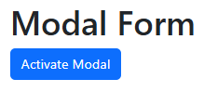
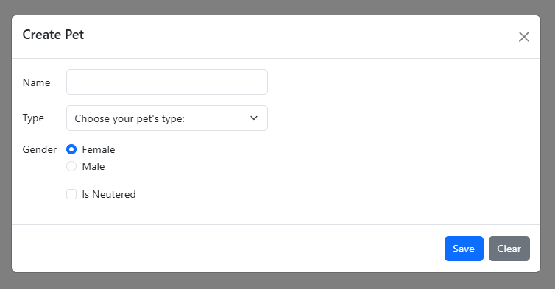

Modal Form JavaScript Activated
@model Pet
@{
ViewData["Title"] = "Modal Form";
}

<h1>@ViewData["Title"]</h1>

<div class="modal fade" id="createModal" tabindex="-1" role="dialog"
aria-labelledby="createPetModalTitle" aria-hidden="true">
<div class="modal-dialog modal-dialog-centered modal-lg">
<div id="mainContent" class="modal-content">
<form id="createPetForm" asp-action="Create">

<div class="modal-header">
<h5 class="modalTitle" id="createPetModalTitle">Create Pet</h5>
<button type="button" class="btn-close"
data-bs-dismiss="modal" aria-label="Close">
</button>
</div>

<div class="modal-body">
<partial name="_PetFormHorizontal" model="@Model">
</div>

<div class="modal-footer">
<button type="submit" class="btn btn-primary">Save</button>
<button type="reset" class="btn btn-secondary">Clear</button>
</div>
</form>
</div>
</div>
</div>

@section Scripts{
<script src="~/js/modalForm.js"></script>
}
"use strict";

main();

function main() {
let modalDOM = document.querySelector("#createModal");
let modal = new bootstrap.Modal(modalDOM);
modal.show();
}


Submit Modal Form
- Set up the view
@model Pet
@{
ViewData["Title"] = "Modal Form Submit";
}

<h1>@ViewData["Title"]</h1>

<button type="button" class="btn btn-primary" id="btnCreatePet">
Create Pet
</button>

<div class="modal fade" id="createModal" tabindex="-1" role="dialog"
aria-labelledby="createPetModalTitle" aria-hidden="true">
<div class="modal-dialog modal-dialog-centered modal-lg">
<div id="mainContent" class="modal-content">
<form id="createPetForm" asp-action="CreatePet">

<div class="modal-header">
<h5 class="modalTitle" id="createPetModalTitle">Create Pet</h5>
<button type="button" class="btn-close"
data-bs-dismiss="modal" aria-label="Close">
</button>
</div>

<div class="modal-body">
<partial name="_PetFormHorizontal" model="@Model">
</div>

<div class="modal-footer">
<button type="submit" class="btn btn-primary">Save</button>
<button type="reset" class="btn btn-secondary">Clear</button>
</div>
</form>
</div>
</div>
</div>

@section Scripts{
@{
await Html.RenderPartialAsync("_ValidationScriptsPartial");
}
<script src="~/js/modalFormSubmit.js"></script>
}
- To demonstrate reporting errors, let’s add an annotation to the model:
public class Pet
{
[Required]
public string Name { get; set; } = String.Empty;
public string? Type { get; set; }
public Gender Gender { get; set; }
public bool IsNeutered { get; set; }
}
- Use JSON, AJAX, and JavaScript
- If the model state is valid, add the pet and return a success message as JSON
- Otherwise return a failure message
[HttpPost]
public IActionResult CreatePet(Pet pet)
{
if (ModelState.IsValid)
{
// Save the pet data here
return Json(new { message = "success", pet });
}
return Json("fail");
}
- Here is the AJAX and JavaScript
"use strict";

main();

function main() {
// Get the create pet modal DOM element and use it to set up the bootstrap
// modal.
const createPetModalDOM = document.querySelector("#createModal");
const createPetModal = new bootstrap.Modal(createPetModalDOM);
// Get the create pet buttom DOM element and use it to set up it's
// click event listener.
const createPetButton = document.querySelector("#btnCreatePet");
createPetButton.addEventListener("click", _ => {
createPetModal.show();
})
// Get the create pet form DOM element and use it to set up it's
// submit event listener
const createPetForm = document.querySelector("#createPetForm");
createPetForm.addEventListener("submit", async (event) => {
event.preventDefault();
// Submit the form data. This form data wil be processed based on
// the action and the method defined in the form.
await submitWithAjax(createPetForm);
// Submit the form data but pretend we are submitting to an API
submitWithAjaxToPretendAPI(createPetForm);
createPetModal.hide();
});
}

async function submitWithAjax(createPetForm) {
const url = createPetForm.getAttribute('action');
const method = createPetForm.getAttribute('method');
const formData = new FormData(createPetForm);

const response = await fetch(url, {
method: method, body: formData
});
if (response.ok == false) {
throw new Error("There was an HTTP error!");
}
const result = await response.json();
if (result === "fail") {
return;
}
console.log(result);
}

function submitWithAjaxToPretendAPI(createPetForm) {
const formData = new FormData(createPetForm);
// Invoke the code to send the data to the API here. In this pretend
// example we convert the form data to a Javascript object.
const result = convertFormDataToObject(formData);
// Convert the JavaScript object to JSON.
const petJson = JSON.stringify(result);
console.log(petJson);
}

function convertFormDataToObject(formData) {
const obj = {};
for (const [key, value] of formData.entries()) {
if (key === "__RequestVerificationToken") continue;
obj[key] = value;
}
return obj;
}

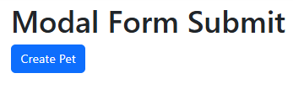
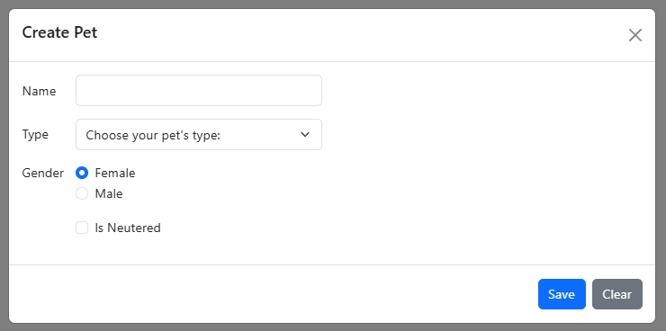
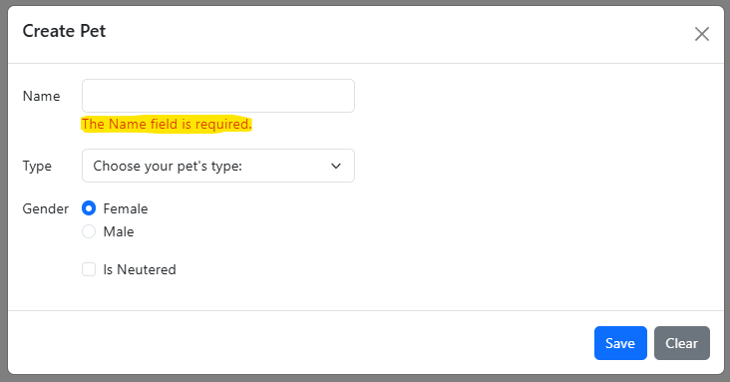
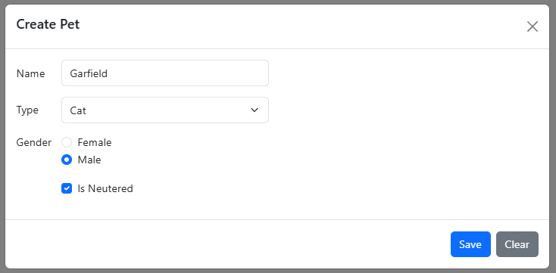
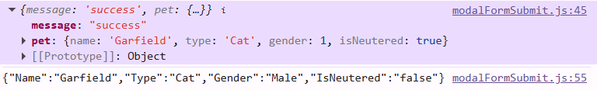

Tooltips
- See: https://getbootstrap.com/docs/5.3/components/tooltips/
- To create a tooltip, add the data-bs-toggle="tooltip" attribute to an element.
- Use the title attribute to specify the text that should be displayed inside the tooltip:
<a href="#" data-bs-toggle="tooltip" title="Hooray!">Hover over me</a>
- Note: Tooltips must be initialized using JavaScript
One element
let tooltipDOMElement = document.querySelector('#tooltipElementID');
let tooltipElement = new bootstrap.Tooltip(tooltipDOMElement);
Initialize all tooltip elements
let allTooltipDOMElementList =
document.querySelectorAll('[data-bs-toggle="tooltip"]');
// Convert the NodeList to an Array
let allTooltipDOMElements = Array.from(allTooltipDOMElementList);
let allTooltipElements = allTooltipDOMElements.map(tt => {
return new bootstrap.Tooltip(tt);
});
- By default, the tooltip will appear on top of the element.
- Use the data-bs-placement attribute to set the position of the tooltip on top, bottom, left or the right side of the element:
@{
ViewData["Title"] = "ToolTips Demo";
}

<h1>@ViewData["Title"]</h1>

<a href="#" data-bs-toggle="tooltip"
data-bs-placement="top" title="Hooray!">Hover</a>
<a href="#" data-bs-toggle="tooltip"
data-bs-placement="bottom" title="Hooray!">Hover</a>
<a href="#" data-bs-toggle="tooltip"
data-bs-placement="left" title="Hooray!">Hover</a>
<a href="#" data-bs-toggle="tooltip"
data-bs-placement="right" title="Hooray!">Hover</a>

@section Scripts{
<script src="~/js/toolTipDemo.js"></script>
}
'use strict';

main();

function main() {
let allTooltipDOMElementList =
document.querySelectorAll('[data-bs-toggle="tooltip"]');
// Convert the NodeList to an Array
let allTooltipDOMElements = Array.from(allTooltipDOMElementList);
let allTooltipElements = allTooltipDOMElements.map(tt => {
return new bootstrap.Tooltip(tt);
});
};
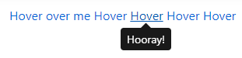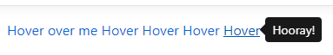

Popovers
See: https://getbootstrap.com/docs/5.3/components/popovers/
- To create a popover, add the data-bs-toggle="popover" attribute to an element along with title="Popover title" and data-bs-content="content"
- The following code will enable all popovers in the document:
let allPopoverDOMElementList =
document.querySelectorAll('[data-bs-toggle="popover"]');
// Convert the NodeList to an Array
let allPopoverDOMElements = Array.from(allPopoverDOMElementList);
let allPopovers = allPopoverDOMElements.map(po => {
return new bootstrap.Popover(po);
});
- Example:
<button type="button" class="btn btn-lg btn-danger"
data-bs-toggle="popover"
title="Popover title"
data-bs-content="And here's some amazing content. It's very engaging. Right?">
Click to toggle popover
</button>
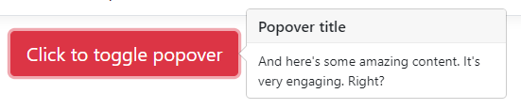

Dismiss on Next Click
<a tabindex="0" class="btn btn-lg btn-danger popover-dismiss" role="button"
data-bs-toggle="popover"
data-bs-trigger="focus" title="Dismissible popover"
data-bs-content="And here's some amazing content. It's very engaging. Right?">
Dismissible popover
</a>
let popoverElement = document.querySelector('.popover-dismiss');
let popover = new bootstrap.Popover(popoverElement, {
trigger: 'focus'
});

Show/Hide with Mouse
<a tabindex="0" class="btn btn-lg btn-danger" role="button" id="popoverHoverBtn"
title="Hover popover"
data-bs-content="And here's some amazing content. It's very engaging. Right?">
Hover popover
</a>
let popoverHoverElement = document.querySelector('#popoverHoverBtn');
let hoverBtnPopover = new bootstrap.Popover(popoverHoverElement);
popoverHoverElement.addEventListener("mouseover", () => {
hoverBtnPopover.show();
});
popoverHoverElement.addEventListener("mouseout", () => {
hoverBtnPopover.hide();
});

@{
ViewData["Title"] = "Popover Demo";
}

<h1>@ViewData["Title"]</h1>

<button type="button" class="btn btn-lg btn-danger"
data-bs-toggle="popover"
title="Popover title"
data-bs-content="And here's some amazing content. It's very engaging. Right?">
Click to toggle popover
</button>

<a tabindex="0" class="btn btn-lg btn-danger popover-dismiss" role="button"
data-bs-toggle="popover"
data-bs-trigger="focus" title="Dismissible popover"
data-bs-content="And here's some amazing content. It's very engaging. Right?">
Dismissible popover
</a>

<a tabindex="0" class="btn btn-lg btn-danger" role="button" id="popoverHoverBtn"
title="Hover popover"
data-bs-content="And here's some amazing content. It's very engaging. Right?">
Hover popover
</a>

@section Scripts{
<script src="~/js/popoverDemo.js"></script>
}

"use strict";

main();

function main() {
let allPopoverDOMElementList =
document.querySelectorAll('[data-bs-toggle="popover"]');
// Convert the NodeList to an Array
let allPopoverDOMElements = Array.from(allPopoverDOMElementList);
let allPopovers = allPopoverDOMElements.map(po => {
return new bootstrap.Popover(po);
});

let popoverElement = document.querySelector('.popover-dismiss');
let popover = new bootstrap.Popover(popoverElement, {
trigger: 'focus'
});

let popoverHoverElement = document.querySelector('#popoverHoverBtn');
let hoverBtnPopover = new bootstrap.Popover(popoverHoverElement);
popoverHoverElement.addEventListener("mouseover", () => {
hoverBtnPopover.show();
});
popoverHoverElement.addEventListener("mouseout", () => {
hoverBtnPopover.hide();
});
}

