This learning lab complements the lecture notes.

Setup
- Create a new ASP.NET Core Web App (Model-View-Controller) project. Call it BootstrapLearningLab.
- Install LibMan: dotnet tool update -g Microsoft.Web.LibraryManager.Cli
- Initialize LibMan: libman init
- Install/update Bootstrap: libman install bootstrap@5.3.8 --provider cdnjs --destination wwwroot/lib/bootstrap/dist
- Examine Libman.json
{
"version": "3.0",
"defaultProvider": "cdnjs",
"libraries": [
{
"library": "bootstrap@5.3.8",
"destination": "wwwroot/lib/bootstrap/dist"
}
]
}

Add the action methods to the HomeController.

Containers
When the application runs, open the developer console then resize the viewing area to see how it affects the containers.

Default Container
- In _Layout.cshtml:
  - Remove the .container class from the <div> after the </header>.
<div class="container">
<main role="main" class="pb-3">
@RenderBody()
</main>
</div>
- Add action method Containers, it returns a View().
- Add the following to site.css to add add some styling:
/* Custom style to visualize the container */
.container {
background-color: #f8f9fa;
border: 1px solid #dee2e6;
padding: 20px;
margin-top: 20px;
}

/* Content box to show container effects */
.content-box {
background-color: #0d6efd;
color: white;
padding: 15px;
border-radius: 5px;
margin-bottom: 10px;
}
- Create the view for Containers, and then add the following code:
<!-- This is the standard container -->
<div class="container">
<h2>Standard Bootstrap Container</h2>
<div class="content-box">
This content is inside a standard container (.container).
Notice how it has a maximum width at each breakpoint and is centered on the page.
</div>
<div class="content-box">
Try resizing your browser window to see how the container width changes at different breakpoints:
<ul>
<li>xs (&lt;576px): 100% width</li>
<li>sm (≥576px): 540px max-width</li>
<li>md (≥768px): 720px max-width</li>
<li>lg (≥992px): 960px max-width</li>
<li>xl (≥1200px): 1140px max-width</li>
<li>xxl (≥1400px): 1320px max-width</li>
</ul>
</div>
</div>

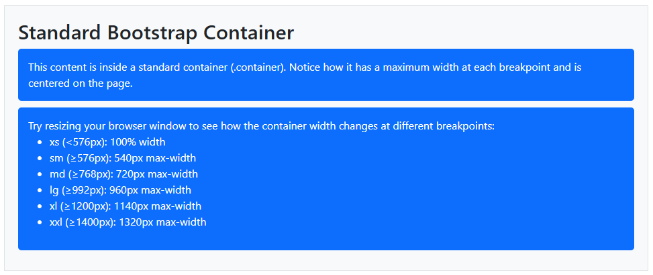

Fluid Container
- Add the following CSS:
/* Custom style to visualize the container */
.container-fluid {
background-color: #f8f9fa;
border: 1px solid #dee2e6;
padding: 20px;
margin-top: 20px;
}
/* Content box to show container effects */
.fluid-content-box {
background-color: #20c997;
color: white;
padding: 15px;
border-radius: 5px;
margin-bottom: 10px;
}
- Then add the following to the view code:
<!-- This is the fluid container -->
<div class="container-fluid">
<h2>Fluid Bootstrap Container</h2>
<div class="content-box">
This content is inside a fluid container (.container-fluid).
Notice how it always takes up the full width of the viewport, regardless of screen size.
</div>
<div class="fluid-content-box">
Unlike the standard container:
<ul>
<li>The container-fluid always spans 100% of the viewport width</li>
<li>It maintains the same padding on the sides</li>
<li>It doesn't have maximum width limits at different breakpoints</li>
<li>It's ideal for full-width layouts or when you want content to use all available space</li>
</ul>
</div>
</div>

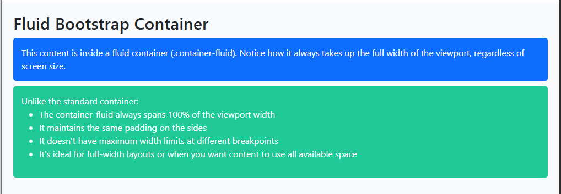

Responsive Containers
- Add the following CSS:
/* Custom styles to visualize the responsive containers */
.container-sm, .container-md, .container-lg {
margin-top: 30px;
padding: 20px;
border-radius: 5px;
}

.container-sm {
background-color: #f8d7da;
border: 1px solid #f5c2c7;
}

.container-md {
background-color: #d1e7dd;
border: 1px solid #badbcc;
}

.container-lg {
background-color: #cfe2ff;
border: 1px solid #b6d4fe;
}
/* Content box to show container effects */
.responsive-content-box {
color: white;
padding: 15px;
border-radius: 5px;
margin-bottom: 10px;
}

.box-sm {
background-color: #dc3545;
}

.box-md {
background-color: #198754;
}

.box-lg {
background-color: #0d6efd;
}
- Then add the following to the view code:
<!-- container-sm example -->
<div class="container-sm">
<h2>container-sm</h2>
<div class="responsive-content-box box-sm">
This is a container-sm.
<ul>
<li>Below 576px: 100% width (fluid)</li>
<li>576px and above: Fixed maximum widths like a standard container</li>
</ul>
</div>
</div>

<!-- container-md example -->
<div class="container-md">
<h2>container-md</h2>
<div class="responsive-content-box box-md">
This is a container-md.
<ul>
<li>Below 768px: 100% width (fluid)</li>
<li>768px and above: Fixed maximum widths like a standard container</li>
</ul>
</div>
</div>

<!-- container-lg example -->
<div class="container-lg">
<h2>container-lg</h2>
<div class="responsive-content-box box-lg">
This is a container-lg.
<ul>
<li>Below 992px: 100% width (fluid)</li>
<li>992px and above: Fixed maximum widths like a standard container</li>
</ul>
</div>
</div>

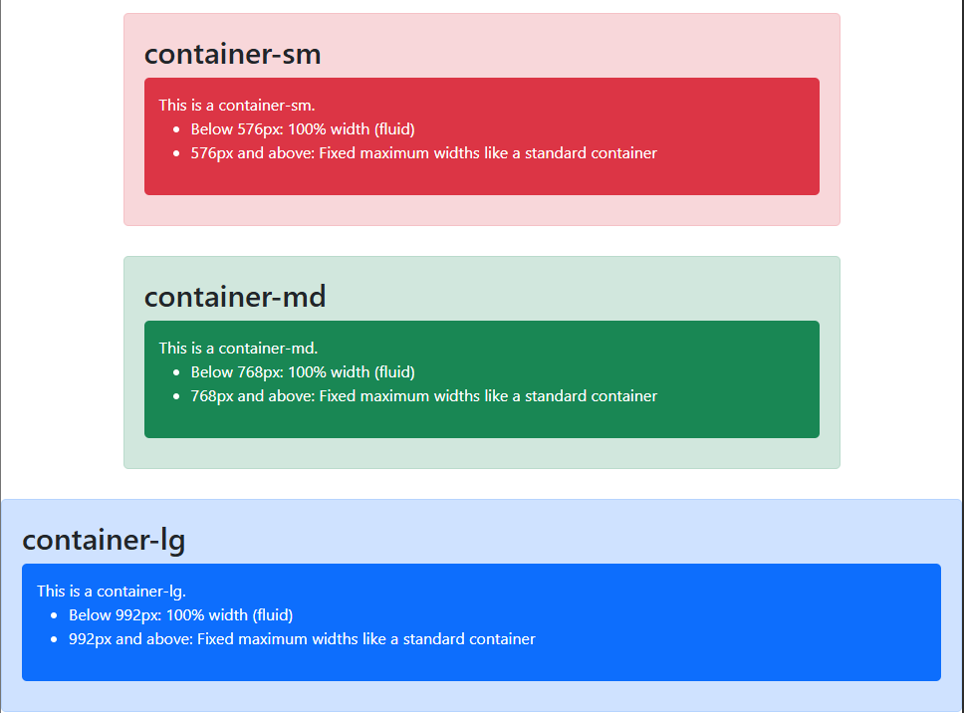

Grid System

Basic
- Add the following CSS:
.grid-example .row {
margin-bottom: 15px;
}
.grid-example [class^="col"] {
padding-top: 10px;
padding-bottom: 10px;
background-color: rgba(86, 61, 124, .15);
border: 1px solid rgba(86, 61, 124, .2);
text-align: center;
}
.section {
margin-bottom: 40px;
padding: 20px;
border-radius: 5px;
background-color: #f8f9fa;
}
.explanation {
margin-top: 10px;
margin-bottom: 20px;
padding: 10px;
background-color: #e9ecef;
border-radius: 5px;
}
header {
background-color: #563d7c;
color: white;
padding: 30px 0;
margin-bottom: 40px;
text-align: center;
}
h1, h2, h3 {
margin-bottom: 20px;
}
.responsive-demo {
margin-top: 30px;
padding: 15px;
background-color: #e2e3e5;
border-radius: 5px;
}
- Add action method GridSystem, return a View, and then create the view code. Add the following HTML to the code:
<div class="container">
<div class="section">
<h2>1. Basic Grid Structure</h2>
<div class="explanation">
<p>
Bootstrap's grid consists of rows (<code>.row</code>) containing columns (<code>.col-*</code>).
Each row divides into 12 columns. You can combine these columns to create different layouts.
</p>
</div>
<div class="grid-example">
<div class="row">
<div class="col">Single column (takes full width)</div>
</div>
<div class="row">
<div class="col">Column 1</div>
<div class="col">Column 2</div>
</div>
<div class="row">
<div class="col">Column 1</div>
<div class="col">Column 2</div>
<div class="col">Column 3</div>
</div>
<div class="row">
<div class="col">Column 1</div>
<div class="col">Column 2</div>
<div class="col">Column 3</div>
<div class="col">Column 4</div>
</div>
</div>
</div>
</div>
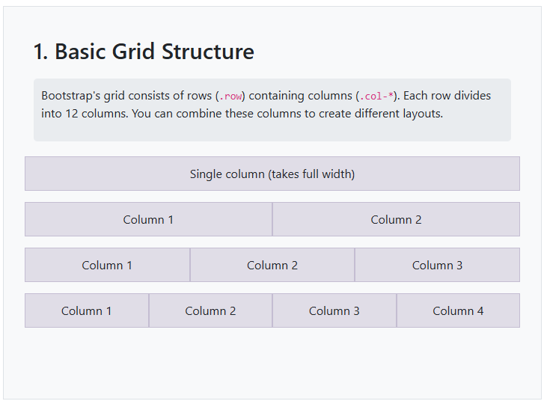

Numbered
- Add the following HTML to the code:
<div class="container">
<div class="section">
<h2>2. Column Sizing with Numbers</h2>
<div class="explanation">
<p>
You can explicitly define column widths using numbers (out of 12).
For example, <code>col-6</code> takes up half of the row's width.
</p>
</div>
<div class="grid-example">
<div class="row">
<div class="col-12">col-12 (Full width)</div>
</div>
<div class="row">
<div class="col-6">col-6 (Half width)</div>
<div class="col-6">col-6 (Half width)</div>
</div>
<div class="row">
<div class="col-4">col-4</div>
<div class="col-4">col-4</div>
<div class="col-4">col-4</div>
</div>
<div class="row">
<div class="col-3">col-3</div>
<div class="col-3">col-3</div>
<div class="col-3">col-3</div>
<div class="col-3">col-3</div>
</div>
<div class="row">
<div class="col-8">col-8</div>
<div class="col-4">col-4</div>
</div>
<div class="row">
<div class="col-3">col-3</div>
<div class="col-9">col-9</div>
</div>
</div>
</div>
</div>
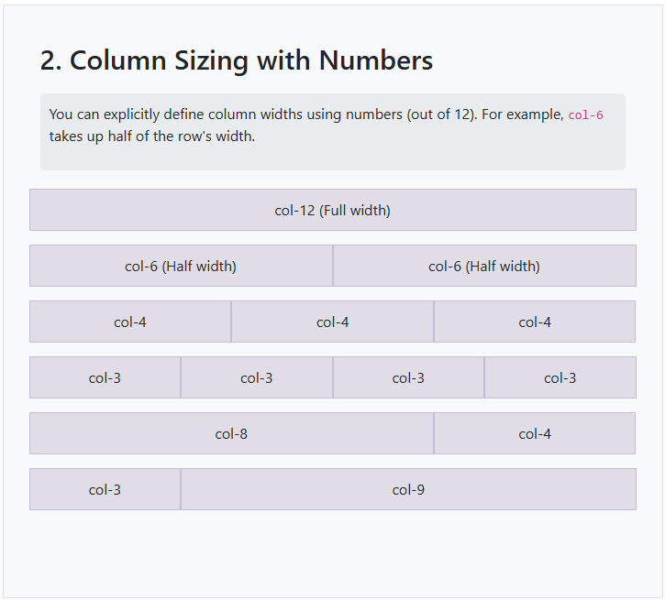

Responsive
- Add the following HTML to the code:
<div class="container">
<div class="section">
<h2>3. Responsive Breakpoints</h2>
<div class="explanation">
<p>
Bootstrap has 6 breakpoints: xs (< 576px), sm (≥ 576px), md (≥ 768px),
lg (≥ 992px), xl (≥ 1200px), and xxl (≥ 1400px). Using these breakpoints,
you can create responsive layouts.
</p>
</div>
<div class="grid-example">
<div class="row">
<div class="col-12 col-md-6 col-lg-4">
<p>Full width on xs, Half width on md, 1/3 width on lg</p>
<p><code>col-12 col-md-6 col-lg-4</code></p>
</div>
<div class="col-12 col-md-6 col-lg-4">
<p>Full width on xs, Half width on md, 1/3 width on lg</p>
<p><code>col-12 col-md-6 col-lg-4</code></p>
</div>
<div class="col-12 col-md-12 col-lg-4">
<p>Full width on xs, Full width on md, 1/3 width on lg</p>
<p><code>col-12 col-md-12 col-lg-4</code></p>
</div>
</div>
</div>
<div class="responsive-demo">
<p><strong>Try it:</strong> Resize your browser window to see how the columns above change at different breakpoints!</p>
</div>
</div>
</div>
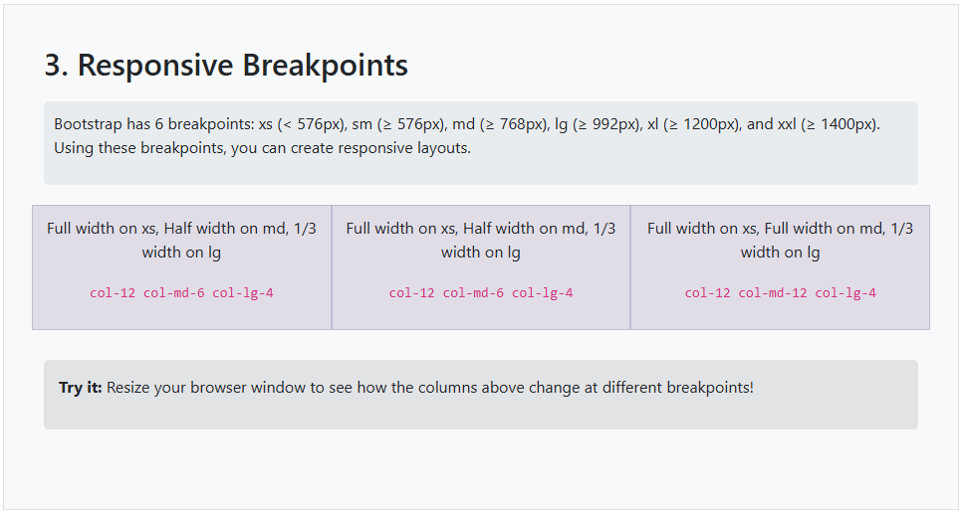

Practical Layout
- Add the following HTML to the code:
<div class="container">
<div class="section">
<h2>4. Practical Layout Example</h2>
<div class="explanation">
<p>Here's a practical example of how you might structure a simple web page layout.</p>
</div>
<div class="grid-example">
<div class="row">
<div class="col-md-3">Sidebar (col-md-3)</div>
<div class="col-md-9">
<div class="row mb-3">
<div class="col-12">Header Section (col-12)</div>
</div>
<div class="row mb-3">
<div class="col-md-6">Content Section 1 (col-md-6)</div>
<div class="col-md-6">Content Section 2 (col-md-6)</div>
</div>
<div class="row">
<div class="col-12">Footer Section (col-12)</div>
</div>
</div>
</div>
</div>
</div>
</div>
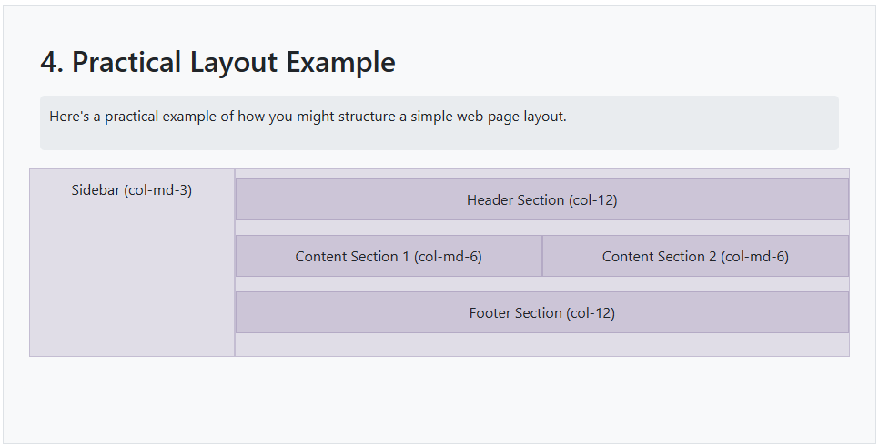

Forms

Stacked
- Add a new action method: Forms and its view.
- Add the following HTML:
<div class="container">
<h2>Stacked</h2>
<form id="createPetForm" asp-action="Create">
<div class="mb-3 col-4">
<label for="Name" class="form-label">Name</label>
<input type="text" id="Name" class="form-control" />
</div>
<div class="mb-3 col-3">
<label for="Type" class="form-label">Pet Type</label>
<select class="form-select" id="Type" aria-label="Pet type">
<option selected>Choose your pet's type:</option>
<option value="Bird">Bird</option>
<option value="Cat">Cat</option>
<option value="Dog">Dog</option>
<option value="Snake">Snake</option>
</select>
</div>
<div class="mb-3">
<label class="form-label">Gender</label>
<div class="form-check">
<input class="form-check-input" type="radio" id="femaleRdo" name="Gender" value="Female" checked />
<label class="form-check-label" for="femaleRdo">
Female
</label>
</div>
<div class="form-check">
<input class="form-check-input" type="radio" id="maleRdo" name="Gender" value="Male" />
<label class="form-check-label" for="maleRdo">
Male
</label>
</div>
</div>
<div class="mb-3">
<div class="form-check">
<input for="IsNeutered" class="form-check-input" type="checkbox" id="isNeuteredChk">
<label class="form-check-label" for="isNeuteredChk">
Is Neutered
</label>
</div>
</div>
<div class="mb-3">
<input type="submit" value="Create" class="btn btn-primary" />
</div>
</form>
</div>
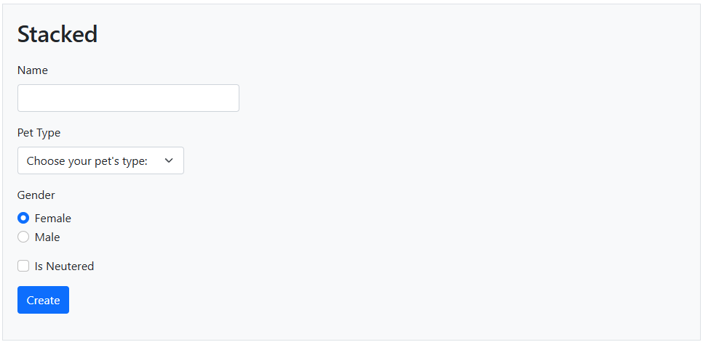

Horizontal
- Add the following HTML:
<div class="container">
<h2>Horizontal</h2>
<form id="createPetForm" asp-action="Create">
<div class="row mb-3">
<label for="Name" class="col-1 col-form-label">Name</label>
<div class="col-5">
<input type="text" id="Name" class="form-control" />
</div>
</div>
<div class="row mb-3">
<label for="Type" class="col-1 col-form-label">Pet Type</label>
<div class="col-5">
<select class="form-select" id="Type" aria-label="Pet type">
<option selected>Choose your pet's type:</option>
<option value="Bird">Bird</option>
<option value="Cat">Cat</option>
<option value="Dog">Dog</option>
<option value="Snake">Snake</option>
</select>
</div>
</div>
<div class="row mb-3">
<label class="col-1 col-form-label pt-0">Gender</label>
<div class="col-11">
<div class="form-check">
<input class="form-check-input" type="radio" id="femaleRdo" name="Gender" value="Female" checked />
<label class="form-check-label" for="femaleRdo">
Female
</label>
</div>
<div class="form-check">
<input class="form-check-input" type="radio" id="maleRdo" name="Gender" value="Male" />
<label class="form-check-label" for="maleRdo">
Male
</label>
</div>
</div>
</div>
<div class="row mb-3">
<div class="col-11 offset-1">
<div class="form-check">
<input for="IsNeutered" class="form-check-input" type="checkbox" id="isNeuteredChk">
<label class="form-check-label" for="isNeuteredChk">
Is Neutered
</label>
</div>
</div>
</div>
<div class="row mb-3">
<div class="col-11 offset-1">
<input type="submit" value="Create" class="btn btn-primary" />
</div>
</div>
</form>
</div>
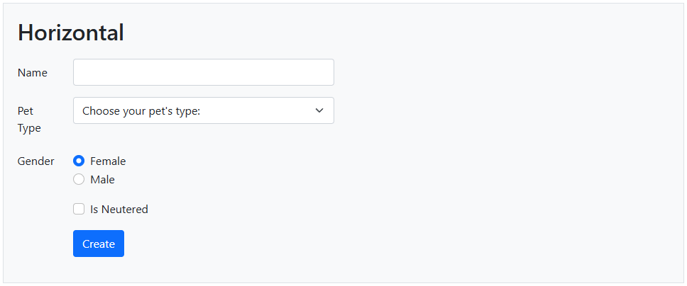

Modals
- Create class Pet in the Models folder:
namespace BootstrapLearningLab.Models;

public enum Gender { Female, Male }

public class Pet
{
public string? Name { get; set; }
public string? Type { get; set; }
public Gender Gender { get; set; }
public bool IsNeutered { get; set; }
}
- Create a partial view called _PetFormHorizontal.cshtml and then add the following code to it:
@model Pet
<div class="row mb-3">
<label asp-for="Name" class="col-1 col-form-label"></label>
<div class="col-5">
<input type="text" asp-for="Name" class="form-control" />
<span asp-validation-for="Name" class="text-danger"></span>
</div>
</div>
<div class="row mb-3">
<label asp-for="Type" class="col-1 col-form-label"></label>
<div class="col-5">
<select class="form-control" asp-for="Type" aria-label="Pet type">
<option selected>Choose your pet's type:</option>
<option value="Bird">Bird</option>
<option value="Cat">Cat</option>
<option value="Dog">Dog</option>
<option value="Snake">Snake</option>
</select>
</div>
</div>
<div class="row mb-3">
<label class="col-1 col-form-label pt-0">Gender</label>
<div class="col-11">
<div class="form-check">
<input class="form-check-input" type="radio" id="femaleRdo" name="Gender" value="Female" checked />
<label class="form-check-label" for="femaleRdo">
Female
</label>
</div>
<div class="form-check">
<input class="form-check-input" type="radio" id="maleRdo" name="Gender" value="Male" />
<label class="form-check-label" for="maleRdo">
Male
</label>
</div>
</div>
</div>
<div class="row mb-3">
<div class="col-11 offset-1">
<div class="form-check">
<input asp-for="IsNeutered" class="form-check-input" type="checkbox" id="isNeuteredChk">
<label class="form-check-label" for="isNeuteredChk">
Is Neutered
</label>
</div>
</div>
</div>
- Create partial view _PetModal.cshtml and then add the following code to it:
<div class="modal fade" id="petModal" tabindex="-1" role="dialog"
aria-labelledby="petModalTitle" aria-hidden="true">
<div class="modal-dialog modal-dialog-centered modal-lg">
<div id="mainContent" class="modal-content">
<form id="createPetForm" asp-action="CreatePet">

<div class="modal-header">
<h5 class="modalTitle" id="petModalTitle">Create Pet</h5>
<button type="button" class="btn-close"
data-bs-dismiss="modal" aria-label="Close">
</button>
</div>

<div class="modal-body">
<partial name="_PetFormHorizontal" model="@Model" />
</div>

<div class="modal-footer">
<button type="submit" class="btn btn-primary">Save</button>
<button type="reset" class="btn btn-secondary">Clear</button>
</div>
</form>
</div>
</div>
</div>
- Create action method Modals and then create its view. Replace its view code with the following:
@{
ViewData["Title"] = "Modals";
}

<div class="container">
<h1>Modals (Trigger with data-bs)</h1>
<button type="button" class="btn btn-primary"
data-bs-toggle="modal"
data-bs-target="#petModal">
Create Pet
</button>
</div>

<partial name="_PetModal" />
- Run the application and then test the modal.
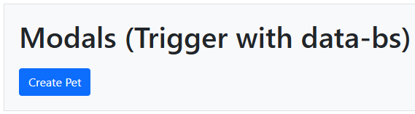
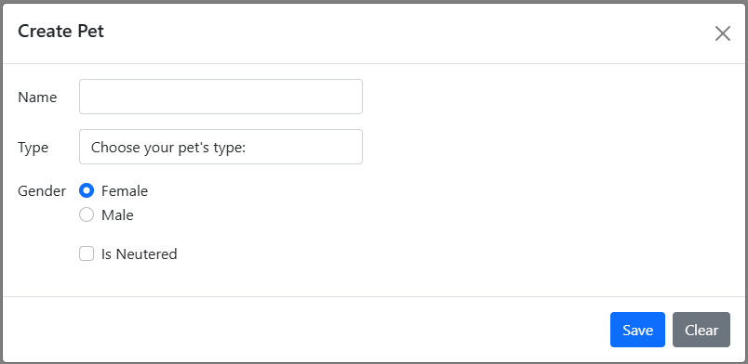
- Read the code to see how they fit together.
- Modify the view code and add the bolded code:
@{
ViewData["Title"] = "Modals";
}

<div class="container">
<h1>Modals (Trigger with data-bs)</h1>
<button type="button" class="btn btn-primary"
data-bs-toggle="modal"
data-bs-target="#petModal">
Create Pet
</button>
</div>

<div class="container">
<h1>Modals (Trigger with JavaScript)</h1>
<button id="createPetBtn" type="button" class="btn btn-primary">
Create Pet (JavaScript)
</button>
</div>

<partial name="_PetModal" />

@section Scripts{
<script type="module" defer src="~/js/homeModals.js"></script>
}
- Create homeModals.js and then add the following code:
'use strict';

const petModalDOM = document.getElementById('petModal');
const createPetBtn = document.getElementById('createPetBtn');
const petModal = new bootstrap.Modal(petModalDOM);

createPetBtn.addEventListener('click', () => {
petModal.show();
});
- Run the application to see the modal in action.
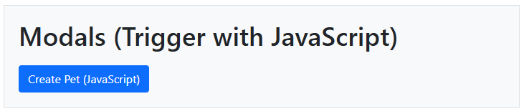
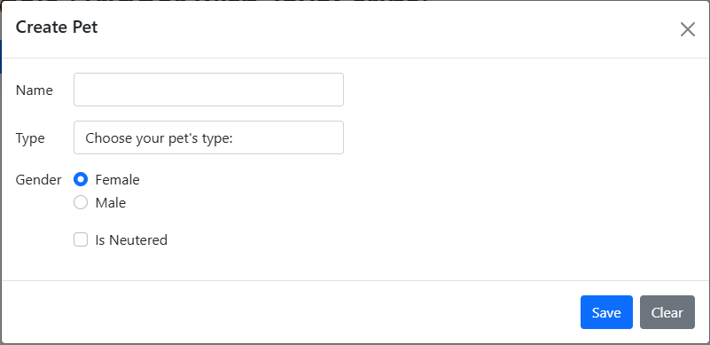

Submit Modal Form
- Note the asp-action of the form: <form id="createPetForm" asp-action="CreatePet">
- Add the following action method to HomeController to process submitting the form:
[HttpPost]
public IActionResult CreatePet(Pet pet)
{
if (ModelState.IsValid)
{
// Save the pet data here
return Json(new { message = "success", pet });
}
return Json("fail");
}
- Add the following code to homeModal.js:
'use strict';

const petModalDOM = document.getElementById('petModal');
const createPetBtn = document.getElementById('createPetBtn');
const petModal = new bootstrap.Modal(petModalDOM);

createPetBtn.addEventListener('click', () => {
petModal.show();
});

const createPetForm = document.querySelector("#createPetForm");
createPetForm.addEventListener("submit", async (event) => {
event.preventDefault();
try {
await submitWithAjax(createPetForm);
}
catch (error) {
console.error(error);
}
});

async function submitWithAjax(createPetForm) {
const url = createPetForm.getAttribute('action');
const method = createPetForm.getAttribute('method');
const formData = new FormData(createPetForm);

const response = await fetch(url, {
method: method, body: formData
});
if (response.ok == false) {
throw new Error("There was an HTTP error!");
}
const result = await response.json();
if (result === "fail") {
throw new Error("Failed to save the pet data!");
}
console.log(result);
petModal.hide();
}

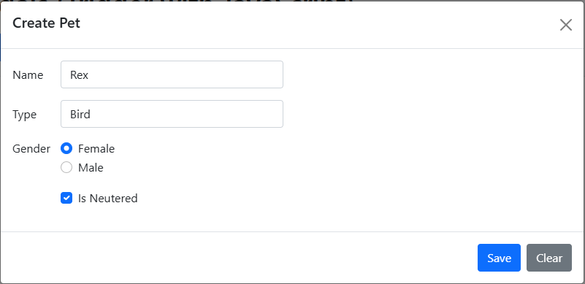
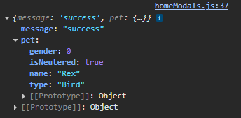

Adding Client-side Validation
- Add the following to Modals.cshtml:
@section Scripts{
@{
await Html.RenderPartialAsync("_ValidationScriptsPartial");
}
<script type="module" defer src="~/js/homeModals.js"></script>
}
- Update the Pet model to make Name required:
public class Pet
{
public string Name { get; set; } = String.Empty;
public string? Type { get; set; }
public Gender Gender { get; set; }
public bool IsNeutered { get; set; }
}
- Rerun the application and try leaving the name blank:
