Introduction to JavaScript

JavaScript
- A high level, dynamic, loosely typed, interpreted, scripting programming language
  - A dynamic language allows the extension of language elements at runtime
  - A loosely typed language does not require a variable to the declared and once defined may then be assigned values of differing types
  - Each statement in an interpreted language is translated and then executed
  - A scripting language is typically designed to manipulate a particular environment
    - JavaScript was designed to manipulate the HTML DOM
- Its official name is ECMAScript, but JavaScript is the common name

Example: Change the background color of first <h1> to red
public IActionResult JavaScript1()
{
return View();
}
@{
ViewData["Title"] = "JavaScript 1";
}

<h1>@ViewData["Title"]</h1>

@section Scripts{

}
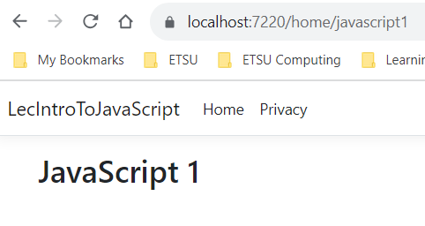
@{
ViewData["Title"] = "JavaScript 1";
}

<h1>@ViewData["Title"]</h1>

@section Scripts{
<script>
let h1s = document.getElementsByTagName('h1');
h1s[0].style.backgroundColor = "red";
</script>
}
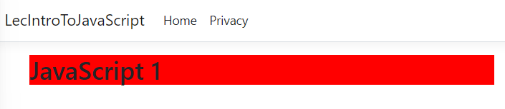

Creating JavaScript File in the IDE
- Create the file in the js folder of wwwroot:
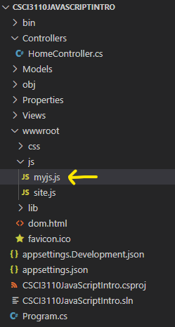
myjs.js
'use strict';
let h1s = document.getElementsByTagName('h1');
h1s[0].style.backgroundColor = "green";

Example: Using a separate file
@{
ViewData["Title"] = "JavaScript 2";
}

<h1>@ViewData["Title"]</h1>

@section Scripts{
<script src="~/js/myjs.js"></script>
}
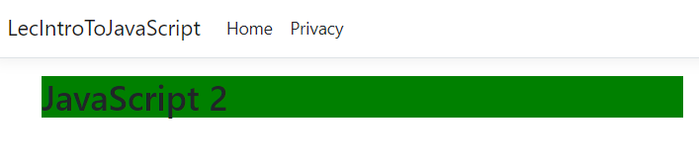

Using the JavaScript Language
- The language allows the processing of numbers, strings, booleans, arrays, objects, functions, regular expressions, and other things
- Tip: When developing JavaScript applications, open the developer tools of the browser to the Console tab then use console.log() to log values to the console.

Strict Mode
- Tip: Always turn on strict mode
- 'use strict';
- Eliminates some JavaScript silent errors by changing them to throw errors.
- Fixes mistakes that make it difficult for JavaScript engines to perform optimizations: strict mode code can sometimes be made to run faster than identical code that's not strict mode.
- Prohibits some syntax unlikely to be defined in future versions of ECMAScript.
public IActionResult UsingJavaScript()
{
return View();
}
@{
ViewData["Title"] = "Using JavaScript";
}

<h1>@ViewData["Title"]</h1>
<p>Please view the console</p>

@section Scripts{
<script src="~/js/usingjs.js"></script>
}
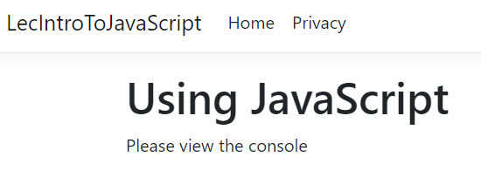

Naming Identifiers
- Use letters, digits, $, and _, cannot start with a digit
console.log("Naming Identifiers");
let tax = 1.4;
let tax2 = 3.4;
let $tax3 = 5.6;
let _tax4 = 7.8;
console.log(`tax=${tax} tax2=${tax2} $tax3=${$tax3} _tax4=${_tax4}`);

Object Initializer
- A comma-delimited list of zero or more pairs of property names and associated values enclosed in curly braces {}
- Examples:
  - {}
  - { name: "Jeff", age: 23, grades: ["A", "B", "C"] }
console.log("\nObject Initializer");
let o1 = {};
let o2 = { name: "Jeff", age: 23, grades: ["A", "B", "C"] };
console.log(o1);
console.log(o2);
console.log(o2.name);
console.log(o2["name"]);
console.log(o2.grades[1]);
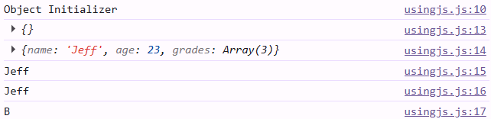
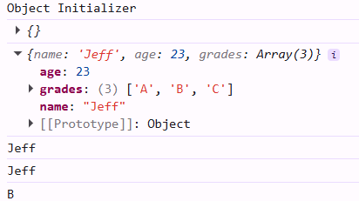

Functions
- Are used to encapsulate actions
- A function definition can appear after the function is called
- A function expression must appear before the function is called
- An arrow function must appear before the function is called
- Examples:
console.log("\nFunctions");

sayHello("Jeff");

// Function definition
function sayHello(name) {
console.log("Hello, " + name + "!");
}

// Function expression
let sayHello2 = function (name) {
console.log("Hello, " + name + "!!");
};

sayHello2("Jeff");

// Arrow function
let sayHello3 = (name) => {
console.log("Hello, " + name + "!!!");
};

sayHello3("Jeff");
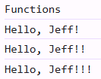

Self-Invoking Function
- A self-invoking function defines a localized scope and then calls itself immediately.
  - The localized scope helps to keep the global namespace uncluttered.
// This is a self-invoking function that creates a localized scope.
(function _justTesting() {
// Code goes here
console.log("\nSelf-invoking function");
})();
- Best practice: Always give your functions a name, the above function could have been written:
(function () {
// Code goes here
console.log("\nSelf-invoking function");
})();
- Giving your functions names make error reporting much easier to read

Arrays
An array is an ordered collection of values stored under a single variable name.

Creating Arrays
The most common way to create an array is using square bracket notation:
let fruits = ["apple", "banana", "cherry"];
Unlike some languages, JavaScript arrays are dynamically typed, meaning a single array can hold values of mixed types:
let mixed = [42, "hello", true, null];
You can also create an empty array and populate it later:
let scores = [];

Accessing Elements
Arrays are zero-indexed, just as in most languages. You access elements using their index in square brackets:
console.log(fruits[0]); // "apple"
console.log(fruits[2]); // "cherry"

To find out how many elements are in an array, use the .length property:
console.log(fruits.length); // 3

Common Array Methods
JavaScript arrays come with a rich set of built-in methods. Some of the most frequently used are:
let fruits2 = ["apple", "banana"];

fruits2.push("cherry"); // Adds to the end: ["apple", "banana", "cherry"]
fruits2.pop(); // Removes from end: ["apple", "banana"]
fruits2.unshift("mango"); // Adds to the front: ["mango", "apple", "banana"]
fruits2.shift(); // Removes from front: ["apple", "banana"]

You can also check whether a value exists in an array:
fruits2.includes("apple"); // true
fruits2.indexOf("banana"); // 1

Looping Over Arrays
There are several ways to iterate over an array. The classic for loop gives you full control:
for (let i = 0; i < fruits.length; i++) {
console.log(fruits[i]);
}

The for...of loop is cleaner when you don't need the index:
for (let fruit of fruits) {
console.log(fruit);
}

For more functional-style iteration, forEach() is widely used in modern JavaScript:
fruits.forEach(function(fruit) {
console.log(fruit);
});

Transforming Arrays: map, filter, and reduce
Three of the most powerful array methods in JavaScript are map(), filter(), and reduce(). These come from functional programming and allow you to transform arrays cleanly and concisely, without manually writing loops.

map()
map() creates a new array by applying a function to every element of the original. The original array is not modified.
let numbers = [1, 2, 3, 4, 5];
let doubled = numbers.map(function(n) {
return n * 2;
});
console.log(doubled); // [2, 4, 6, 8, 10]

A common real-world use is transforming an array of objects to extract a specific field:
let students = [
{ name: "Alice", grade: 88 },
{ name: "Bob", grade: 74 },
{ name: "Carol", grade: 95 }
];
let names = students.map(function(student) {
return student.name;
});
console.log(names); // ["Alice", "Bob", "Carol"]

filter()
filter() creates a new array containing only the elements for which the callback function returns true.
let numbers2 = [1, 2, 3, 4, 5, 6];
let evens = numbers2.filter(function(n) {
return n % 2 === 0;
});
console.log(evens); // [2, 4, 6]

Using the students example from above, you could filter to only those who passed:
let passing = students.filter(function(student) {
return student.grade >= 75;
});
console.log(passing); // [{ name: "Alice", ... }, { name: "Carol", ... }]

reduce()
reduce() is the most flexible of the three. It iterates over an array and accumulates a single result – a sum, a string, an object, or anything else you need.
It takes a callback with two key parameters: an accumulator (the running result) and the current element. You also provide an initial value for the accumulator as a second argument.
let total = numbers.reduce(function(accumulator, n) {
return accumulator + n;
}, 0);
console.log(total); // 15

A slightly more complex exampleuses reduce() to count how many students achieved a distinction (grade >= 90):
let distinctions = students.reduce(function(count, student) {
return student.grade >= 90 ? count + 1 : count;
}, 0);
console.log(distinctions); // 1

Chaining Methods
One of the real strengths of these methods is that they can be chained together, since each one returns a new array (except reduce(), which returns a single value).
let numbers3 = [1, 2, 3, 4, 5, 6, 7, 8, 9, 10];
let result = numbers3
.filter(function(n) { return n % 2 === 0; }) // keep evens: [2, 4, 6, 8, 10]
.map(function(n) { return n * 3; }) // triple each: [6, 12, 18, 24, 30]
.reduce(function(acc, n) { return acc + n; }, 0); // sum: 90
console.log(result); // 90

Note that none of these methods modify the original array, they always return a new one. This is an important principle to keep in mind as your programs grow in complexity.

Modules
JavaScript modules allow you encapsulate JavaScript code so that you can reuse them in other areas of your application. To declare a script as a module, you include type="module" in the <script> element.
public IActionResult ModuleDemo()
{
return View();
}
@{
ViewData["Title"] = "Module Demo";
}

<h1>@ViewData["Title"]</h1>

@section Scripts{
<script type="module" src="~/js/moduleDemo.js"></script>
}

Exporting
- To indicate that code can be reused you use the export statement. You can simply place it in front of items you want to use.
myExports.js
'use strict';
export const SIZE = 10;

export function sayHello(name) {
console.log("Hello, " + name + "!");
}
- You can also put a single export statement at the end of the module file.
export {SIZE, sayHello};

Importing
- To use the exporting item, you must import them:
moduleDemo.js
'use strict';
import { SIZE, sayHello } from './myExports.js';

console.log(SIZE);
sayHello("Jeff");
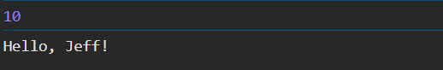

Classes
- Consider class Rectangle:
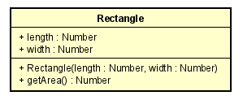

Class Keyword
- JavaScript classes, introduced in ECMAScript 2015, are primarily syntactical sugar over JavaScript's existing prototype-based inheritance
- The class syntax does not introduce a new object-oriented inheritance model to JavaScript
- Take note of function constructor()
- Methods are defined outside of constructor and are added to the prototype
public IActionResult ClassDemo()
{
return View();
}
@{
ViewData["Title"] = "Class Demo";
}

<h1>@ViewData["Title"]</h1>

@section Scripts{
<script type="module" src="~/js/classDemo.js"></script>
}
/js/classes/Rectangle.js
'use strict';
class Rectangle {
constructor(length, width) {
this.length = length;
this.width = width;
}

// Method
getArea() {
return this.length * this.width;
}

// Getter
get area() {
return this.getArea();
}
}

Rectangle.prototype.getPerimeter = function _getPerimeter() {
return 2 * (this.length + this.width);
};

export { Rectangle };
/js/classDemo.js
'use strict';
import { Rectangle } from './classes/Rectangle.js';

let r1 = new Rectangle(2, 3);
let r2 = new Rectangle(6.7, 21.3);
console.log(r1.getArea());
console.log(r2.area);
console.log(r2.getPerimeter());
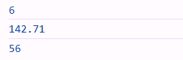

Private and Public Members
- Class elements are public by default so use the hash # symbol to declare them as private:
/js/classes/Rectangle2.js
'use strict';
class Rectangle2 {
// These are the private attributes
#length = 0;
#width = 0;

constructor(length, width) {
this.#length = length;
this.#width = width;
}

// Method
getArea() {
return this.#length * this.#width;
}

// Setters
set length(length) {
this.#length = length;
}

set width(width) {
this.#width = width
}

// Getters
get length() {
return this.#length
}

get width() {
return this.#width;
}

get area() {
return this.getArea();
}
}

// Using the prototype to add a method
Rectangle2.prototype.getPerimeter = function _getPerimeter() {
return 2 * (this.length + this.width);
};

export { Rectangle2 };
/js/classDemo.js
import { Rectangle2 } from './classes/Rectangle2.js';

let r3 = new Rectangle2(2, 3);
let r4 = new Rectangle2(6.7, 21.3);
console.log(r3.getArea());
console.log(r3.area); // Using the getter
//console.log(r3.#length); ERROR!
//console.log(r3.#width); ERROR!
console.log(r4.getArea());
console.log(r4.getPerimeter());

r3.length = 40; // Using the setter
console.log(r3.area);
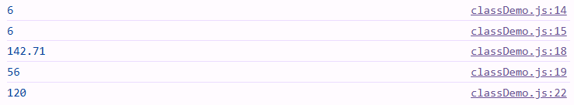

Inheritance
- Consider the following inheritance hierarchy:
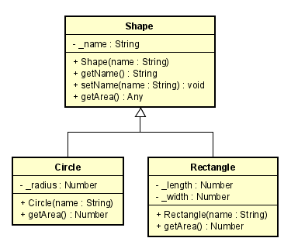

Class Syntax Implementation
/js/classes/Shapes.js
"use strict";
class Shape {
#name;

constructor(name) {
this.setName(name);
}

setName(name) {
this.#name = name;
}

getName() {
return this.#name;
}
}

class Rectangle3 extends Shape {
#length;
#width;

constructor(length, width) {
super("Rectangle");
this.#length = length;
this.#width = width;
}

getArea() {
return this.#length * this.#width;
}

getLength() {
return this.#length;
};

getWidth() {
return this.#width;
};
}

class Circle extends Shape {
#radius;

constructor(radius) {
super("Circle");
this.#radius = radius;
}

getArea() {
return Math.PI * this.#radius * this.#radius;
}

getRadius() {
return this.#radius;
};
}

export { Shape, Rectangle3, Circle };
/js/classDemo.js
import { Shape, Rectangle3, Circle } from './classes/Shapes.js';

var shapes = [
new Shape("Generic"),
new Rectangle3(2, 3),
new Circle(10),
new Rectangle3(6.7, 21.3)
];

for (let i = 0; i < shapes.length; i++) {
console.log(shapes[i].getName());
console.log(shapes[i].getArea?.()); // undefined if getArea is not there
}
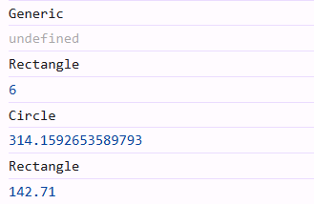

References
Burdette, L. (2010). The JavaScript PocketGuide. Berkley: Peachpit Press.
MDN Contributors. (2019, Oct 5). Classes. Retrieved Nov 4, 2019, from MDN web docs: https://developer.mozilla.org/en-US/docs/Web/JavaScript/Reference/Classes

