WEB API
- An application programming interface (API) is a set of programming constructs that provides a simpler interface to complex functionality. It allows developers to "easily" program complex functionality.
  - Example APIs:
    - X API (https://docs.x.com/x-api/introduction)
    - YouTube API (https://developers.google.com/youtube/)
- A Web API is an API that can be accessed using HTTP.

.NET RESTFUL API Routing
- In .NET, RESTFUL API routes should be defined using attribute routing

Attribute Routing
(Nowak, Larkin, & Anderson, 2021)
- Attributes (e.g., [Route()]) are used to define routes.
[Route("Home/Index/{id?}")]
public IActionResult Index(int? id)
- May be configured with:
app.MapControllers();
- app.MapControllers() is a method that automatically discovers all your controllers in your application and registers their routes based on routing attributes you've applied to them. It's part of ASP.NET Core's attribute routing system.
- The controller and action names play no part in which action is matched, unless token replacement is used
- Do not use the following set of reserved routing names as route parameters: action, area, controller, handler, page
  - E.g., the following will lead to inconsistent and confusing behavior with URL generation
[Route("/articles/{page}")]

HTTP Verb Templates
- [HttpGet]
- [HttpPost]
- [HttpPut]
- [HttpDelete]
- [HttpHead]
- [HttpPatch]

Route Templates
- All the HTTP verb templates
- [Route]

Using the Templates
- The following code sets up explicit route /lec/ demoone
using Microsoft.AspNetCore.Mvc;

namespace LecWebAPI.Controllers;

[Route("lec/demoone")]
public class Demo1Controller : Controller
{
[HttpGet]
public IActionResult Index()
{
return Content("A plain GET endpoint.");
}
}
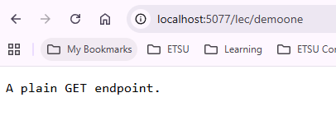
- The following is a GET request to /lec/demoone/{any id}
[HttpGet("{id}")]
public IActionResult InfoWithId(string id)
{
return Content($"A GET request with parameter id {id}");
}
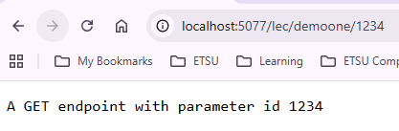
- The following is a GET request to /lec/demoone/intdata/{int id}
  - If the id cannot be converted to an int then there is a 404 error
[HttpGet("intdata/{id:int}")]
public IActionResult InfoWithIntId(int id)
{
return Content($"A GET endpoint with 3 segments and parameter that must be an int id: {id}");
}
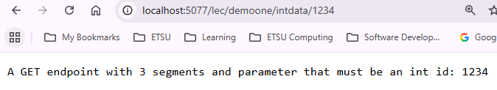
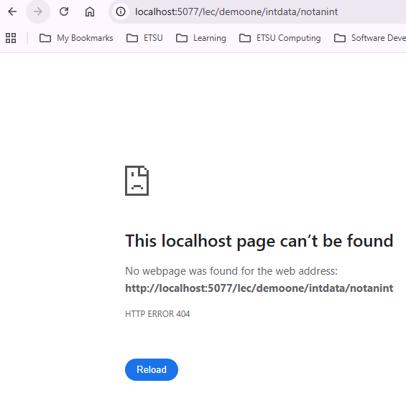

Token Replacement
- Accomplished by enclosing a token in square brackets ([token])
- The tokens [action] and [controller] are replaced with the values of the action name and controller name
using Microsoft.AspNetCore.Mvc;

[Route("[controller]/[action]")]
public class Demo2Controller : Controller
{
[HttpGet]
public IActionResult Index()
{
return Content("Another simple GET endpoint");
}

[HttpGet("{id}")]
public IActionResult Details(int id)
{
return Content($"Details of {id}");
}
}
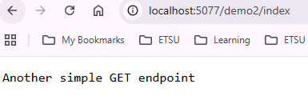
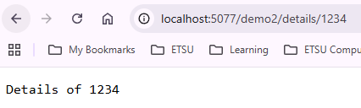

JSON
- JSON stands for JavaScript Object Notation and is a lightweight data-interchange format
- It is language independent in that it uses JavaScript syntax, but the format is text only
- It is "self-describing" and easy to understand
- It is typically used as the media type in web APIs

Syntax Rules
- Data is expressed in key/value pairs
  - "<key>":<value>
  - E.g.
    - "name": "main_window"
    - "size": 36
- <key> must be strings, written with double quotes
- <value> must be
  - A string e.g., "center"
    - Must be in double quotes
  - A number e.g., 42
    - Must be an integer or a floating point
  - An object e.g., {"firstName":"John", "lastName":"Doe"}
  - An array e.g., [1, 2, 3, 7]
    - Each element can be a JSON value
  - A boolean e.g., true
    - true or false
  - null

Examples
{"employees":[
{"firstName":"John", "lastName":"Doe"},
{"firstName":"Anna", "lastName":"Smith"},
{"firstName":"Peter", "lastName":"Jones"}
]}
{"widget": {
"debug": "on",
"window": {
"title": "Sample Konfabulator Widget",
"name": "main_window",
"width": 500,
"height": 500
},
"image": {
"src": "Images/Sun.png",
"name": "sun1",
"hOffset": 250,
"vOffset": 250,
"alignment": "center"
},
"text": {
"data": "Click Here",
"size": 36,
"style": "bold",
"name": "text1",
"hOffset": 250,
"vOffset": 100,
"alignment": "center",
"onMouseUp": "sun1.opacity = (sun1.opacity / 100) * 90;"
}
}}

Creating (RESTFUL) Web APIs
- Controllers are derived from ControllerBase.
- If a controller will be used for both views and web APIs, derive it from Controller.
- We’ll use CURL to test the API.

HTTP Access Control (CORS)
A browser’s same-origin policy prevents a web page from making requests to a different domain than the one that served the web page. Cross Origin Resource Sharing (CORS) is a W3C standard that allows a server to relax the same-origin policy. Note: It is not a security feature, CORS relaxes security. An API is not safer by allowing CORS. It allows a server to explicitly allow some cross-origin requests while rejecting others.

Creating the API
(Anderson, Larkin, & Wasson, 2020)
- Set up the data model (keeping it simple to one table)
namespace WebAPI.Models.Entities;

namespace LecWebAPI.Models.Entities;

public class Pet
{
public int Id { get; set; }
public string Name { get; set; } = String.Empty;
public float Weight { get; set; }
}
- Install Entity Framework
  - dotnet tool install --global dotnet-ef
  - dotnet tool install --global dotnet-aspnet-codegenerator
  - dotnet add package Microsoft.EntityFrameworkCore.Sqlite
  - dotnet add package Microsoft.EntityFrameworkCore.Tools
  - dotnet add package Microsoft.EntityFrameworkCore.Design
- Create the Database Context class
using Microsoft.EntityFrameworkCore;
using LecWebAPI.Models.Entities;

namespace LecWebAPI.Services;

public class ApplicationDbContext : DbContext
{
public ApplicationDbContext(DbContextOptions options) : base(options)
{
}

public DbSet<Pet> Pets => Set<Pet>();
}
- Set up the connection string in appsettings.json:
{
"ConnectionStrings": {
"DefaultConnection": "Data Source=./Data/PetsDb.db"
},
"Logging": {
"LogLevel": {
"Default": "Information",
"Microsoft.AspNetCore": "Warning"
}
},
"AllowedHosts": "*"
}
- Configure the DbContext service in Program.cs:
using LecWebAPI.Services;
using Microsoft.EntityFrameworkCore;

var builder = WebApplication.CreateBuilder(args);

builder.Services.AddDbContext<ApplicationDbContext>(options => {
options.UseSqlite(
builder.Configuration.GetConnectionString("DefaultConnection"));
});

// Add services to the container.
builder.Services.AddControllersWithViews();
- Add the migration and update the database:
> dotnet ef migrations add Mig1
> dotnet ef database update
- Define your API
API | Description | Request body | Response body
GET /api/pet/all | Get all Pets | None | Array of Pets
GET /api/pet/one/{id} | Get a Pet by id | None | Pet object
POST /api/pet/create | Add a new Pet | Pet form-data | Pet object
PUT /api/pet/update | Update an existing Pet | Pet form-data | None
DELETE /api/pet/delete/{id} | Delete a Pet | None | None
- [Optional] Enable CORS so that Postman can send requests
var builder = WebApplication.CreateBuilder(args);

builder.Services.AddDbContext<ApplicationDbContext>(options => {
options.UseSqlServer(
builder.Configuration.GetConnectionString("DefaultConnection"));
});
// Allow postman to send requests
builder.Services.AddCors(options =>
{
options.AddDefaultPolicy(
builder =>
{
builder.WithOrigins("https://web.postman.co")
.AllowAnyHeader()
.AllowAnyMethod();
});
});

// Add services to the container.
builder.Services.AddControllersWithViews();
app.UseRouting();

app.UseCors();

app.UseAuthorization();
- Set up the repository
using LecWebAPI.Models.Entities;

namespace LecWebAPI.Services;

public interface IPetRepository
{
Task<ICollection<Pet>> ReadAllAsync();
}
using LecWebAPI.Models.Entities;
using Microsoft.EntityFrameworkCore;

namespace LecWebAPI.Services;

public class DbPetRepository : IPetRepository
{
private readonly ApplicationDbContext _db;

public DbPetRepository(ApplicationDbContext db)
{
_db = db;
}

public async Task<ICollection<Pet>> ReadAllAsync()
{
return await _db.Pets.ToListAsync();
}
}
// Add services to the container.
builder.Services.AddControllersWithViews();
builder.Services.AddScoped<IPetRepository, DbPetRepository>();
- Create the API controller and enable CORS on it:
using LecWebAPI.Services;
using Microsoft.AspNetCore.Mvc;

namespace LecWebAPI.Controllers;

[Route("api/[controller]")]
[ApiController]
public class PetController : ControllerBase
{
}
- Inject the repository into the API controller
private readonly IPetRepository _petRepo;

public PetController(IPetRepository petRepo)
{
_petRepo = petRepo;
}

Read All
- Code get all pets: GET /api/pet/all
  - OK() returns a JSON formatted object
[HttpGet("all")]
public async Task<IActionResult> Get()
{
return Ok(await _petRepo.ReadAllAsync());
}
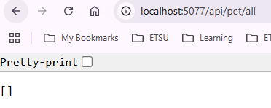

CURL
Open a terminal and then use CURL to send a GET request (I’m using PowerShell):
> curl.exe http://localhost:5077/api/pet/all
[]

Create
- Code creating a new Pet: POST /api/pet/create
  - The [FromForm] indicates the Pet data is coming in key/value pairs (typically from a form)
  - The CreatedAtAction method returns a 201 status if successful and specifies the create object.
public interface IPetRepository
{
Task<ICollection<Pet>> ReadAllAsync();
Task<Pet> CreateAsync(Pet newPet);
}
public async Task<Pet> CreateAsync(Pet newPet)
{
await _db.Pets.AddAsync(newPet);
await _db.SaveChangesAsync();
return newPet;
}
[HttpPost("create")]
public async Task<IActionResult> Post([FromForm] Pet pet)
{
await _petRepo.CreateAsync(pet);
return CreatedAtAction("Get", new { id = pet.Id }, pet);
}

CURL
> curl.exe -X POST http://localhost:5077/api/pet/create -H "Content-Type: application/x-www-form-urlencoded" -d "Name=Buffy&Weight=3.6"
{"id":3,"name":"Buffy","weight":3.6}
> curl.exe http://localhost:5077/api/pet/all
[{"id":1,"name":"Buffy","weight":3.6}]

Read
- Code get pet by id: GET /api/pet/one/{id}
public interface IPetRepository
{
Task<ICollection<Pet>> ReadAllAsync();
Task<Pet> CreateAsync(Pet newPet);
Task<Pet?> ReadAsync(int id);
}
public async Task<Pet?> ReadAsync(int id)
{
return await _db.Pets.FindAsync(id);
}
[HttpGet("one/{id}")]
public async Task<IActionResult> Get(int id)
{
var pet = await _petRepo.ReadAsync(id);
if (pet == null)
{
return NotFound();
}
return Ok(pet);
}
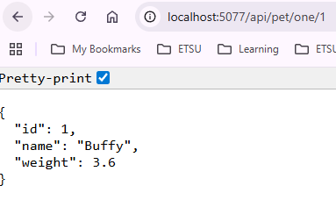
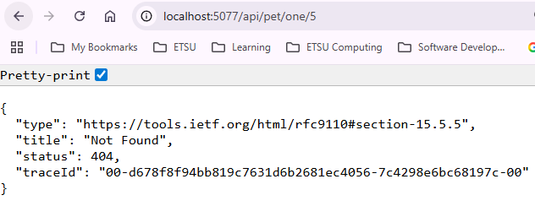

CURL
> curl.exe http://localhost:5077/api/pet/one/1
{"id":1,"name":"Rex","weight":2.4}
> curl.exe http://localhost:5077/api/pet/one/5
{"type":"https://tools.ietf.org/html/rfc9110#section-15.5.5","title":"Not Found","status":404,"traceId":"00-d85cb350124f8e279c51a4ce7440595b-af8faba27989e914-00"}

Update
- Code updating a pet: PUT /api/pet/update
public interface IPetRepository
{
Task<ICollection<Pet>> ReadAllAsync();
Task<Pet> CreateAsync(Pet newPet);
Task<Pet?> ReadAsync(int id);
Task UpdateAsync(int oldId, Pet updatedPet);
}
public async Task UpdateAsync(int oldId, Pet updatedPet)
{
var petToUpdate = await ReadAsync(oldId);
if (petToUpdate != null)
{
petToUpdate.Name = updatedPet.Name;
petToUpdate.Weight = updatedPet.Weight;
await _db.SaveChangesAsync();
}
}
[HttpPut("update")]
public async Task<IActionResult> Put([FromForm] Pet pet)
{
await _petRepo.UpdateAsync(pet.Id, pet);
return NoContent(); // 204 as per HTTP specification
}

CURL
> curl.exe -X PUT http://localhost:5077/api/pet/update -H "Content-Type: application/x-www-form-urlencoded" -d "Id=1&Name=Polly-Anna&Weight=1.3"
> curl.exe http://localhost:5077/api/pet/one/1
{"id":1,"name":"Polly-Anna","weight":1.3}

Delete
- Code deleting a pet: DELETE /api/pet/delete/{id}
public interface IPetRepository
{
Task<ICollection<Pet>> ReadAllAsync();
Task<Pet> CreateAsync(Pet newPet);
Task<Pet?> ReadAsync(int id);
Task UpdateAsync(int oldId, Pet updatedPet);
Task DeleteAsync(int id);
}
public async Task DeleteAsync(int id)
{
var petToDelete = await ReadAsync(id);
if (petToDelete != null)
{
_db.Pets.Remove(petToDelete);
await _db.SaveChangesAsync();
}
}
[HttpDelete("delete/{id}")]
public async Task<IActionResult> Delete(int id)
{
await _petRepo.DeleteAsync(id);
return NoContent(); // 204 as per HTTP specification
}

CURL
> curl.exe -X DELETE http://localhost:5077/api/pet/delete/1
> curl.exe -X GET http://localhost:5077/api/pet/one/1
{"type":"https://tools.ietf.org/html/rfc9110#section-15.5.5","title":"Not Found","status":404,"traceId":"00-5c4a4055606497c4f255874c1ddd1e7c-3f792a07d7ba9d40-00"}

References
Addie, S., & Dykstra, T. (2020, July 20). Create web APIs with ASP.NET Core. Retrieved November 11, 2020, from Microsoft Docs: https://docs.microsoft.com/en-us/aspnet/core/web-api/?view=aspnetcore-3.1
Anderson, R., Larkin, K., & Wasson, M. (2020, August 13). Tutorial: Create a web API with ASP.NET Core. Retrieved November 15, 2020, from Microsoft Docs: https://docs.microsoft.com/en-us/aspnet/core/tutorials/first-web-api?view=aspnetcore-3.1&tabs=visual-studio
Nowak, R., Larkin, K., & Anderson, R. (2021). Routing to controller actions in ASP.NET Core. Retrieved October 16, 2021, from Microsoft Docs: https://docs.microsoft.com/en-us/aspnet/core/mvc/controllers/routing?view=aspnetcore-5.0#attribute-routing-for-rest-apis-1
What is REST. (2020). Retrieved November 11, 2020, from REST API Turorial: https://restfulapi.net/

