Fault-Tolerant Code Switching from the [[4,2,2]] Detection Code to the [[5,1,3]] Perfect Code
Corrina Alcoser, Keeban Villarreal, Michael Pendleton
UTSA / NSCC / The AI Cowboys

Abstract
We study fault-tolerant switching from the [[4,2,2]] error-detecting code to the [[5,1,3]] perfect code and report two negative results and one protocol. First, of the fifteen weight-one errors present on the data block when re-encoding begins, 12 lie in a confusable pair and are correctable by no encoder and no decoder; the initial post-selection is therefore load-bearing and the procedure is a state-preparation factory rather than an in-line switch. Second, flag-protected re-encoding cannot be made fault tolerant at any flag budget: partitioning the single-fault locations by syndrome leaves three or four logically inequivalent residuals in every class, so at least 2 flag bits are necessary regardless of placement, and an exhaustive search over 97,466 valid single-flag designs across all twenty-four stabilizer bijections, together with an exact set-cover analysis of two-bit designs over 2,405 separation constraints, finds no certifying design. We then give a teleportation-based switch that does certify. An end-to-end single-fault enumeration over 824 fault mechanisms finds no undetectable single-fault logical error in either logical basis, and Monte Carlo under circuit-level depolarizing noise measures a logical error rate scaling with exponent 2.17, against 1.13 for a deliberately crippled control. Acceptance under post-selection is 86% at p = 0.001 and 21% at p = 0.01. All circuits, certificates and numbers in this paper are generated by scripts in the accompanying repository.

1. Introduction
Quantum error correction is the foundational technology for large-scale, reliable quantum computation. The central idea, developed by Shor [1], Steane [2] and others, is to encode logical information redundantly so that the effects of noise can be detected and reversed. Within the stabilizer formalism of Gottesman [3] and of Calderbank, Rains, Shor and Sloane [4], a code is specified by its stabilizer group and its error-correcting power is set by the minimum weight of a logical operator.
No single code is optimal for every stage of a computation. During state preparation, where faulty attempts can be discarded, an error-detecting code may suffice, and its lower overhead makes it attractive. During the body of a computation, where post-selection is impractical, a higher-distance code is essential. This motivates code switching: fault-tolerant procedures that convert between codes while preserving the encoded information. Paetznick and Reichardt [5], Anderson, Duclos-Cianci and Poulin [6], Bombin [7], and Vuillot and co-workers [8] developed the general theory; flag-qubit techniques due to Chao and Reichardt [9] and Chamberland and Beverland [10] provide low-overhead fault tolerance for syndrome extraction, and it is natural to ask whether they extend to code switching.
The switch from the [[4,2,2]] code to the [[5,1,3]] code is the minimal instance of trading rate for distance: one of two logical qubits is sacrificed to gain the ability to correct, rather than merely detect, an arbitrary single-qubit error. The obvious construction is to project out the second logical qubit, adjoin a fresh physical qubit and apply a re-encoding Clifford, protecting the cascade with a flag.
We show that this construction cannot work, and we quantify exactly why. We then give a teleportation-based switch that carries a machine-checked certificate. Our methodology is deliberate: every circuit is synthesized from a stabilizer frame specification and verified by two independent methods, every decoder is synthesized from an exhaustive fault enumeration rather than written down and defended, and every number in this paper is produced by a script. Where a bound is the result of a bounded search, the bound is stated.

2. Background and conventions
An [[n,k,d]] stabilizer code encodes k logical qubits into n physical qubits. The code space is the simultaneous +1 eigenspace of an abelian subgroup S of the Pauli group not containing -I, generated by n - k independent operators. Logical operators commute with all of S without lying in it, and d is the minimum weight of such an operator. A code of distance d detects d - 1 errors and corrects the floor of (d - 1)/2.
We adopt the flag fault-tolerance definition of Chamberland and Beverland [10]: a gadget is fault tolerant when, for every single fault location, the pair consisting of the syndrome and the flag outcomes determines a correction returning the block to the code space up to a stabilizer. We do not use the stronger and, as Section 4 shows, unattainable condition that a single fault produce at most a weight-one output error.
Conventions used throughout, and enforced by a test in the repository:
object | value
[[4,2,2]] stabilizers | XXXX, ZZZZ
[[4,2,2]] logical qubit 1 (kept) | X1bar = XXII, Z1bar = ZIZI
[[4,2,2]] logical qubit 2 (discarded) | X2bar = XIXI, Z2bar = ZZII
[[5,1,3]] stabilizers | XZZXI, IXZZX, XIXZZ, ZXIXZ
[[5,1,3]] logicals | Xbar = XXXXX, Zbar = ZZZZZ
CNOT(a to b) | control a, target b; X propagates forward, Z backward

The distinction between Z1bar = ZIZI and Z2bar = ZZII is load-bearing. Measuring ZIZI destroys the logical qubit the switch is meant to preserve, and a parity measurement realising Z2bar must place its controls on q1 and q2.

3. The re-encoding Clifford, derived and verified
After measuring Z2bar and adjoining a fresh qubit q5 in |0>, the input frame on five qubits is generated by XXXXI, ZZIII, IIZZI, IIIIZ with logical operators Xbar = XXIII and Zbar = ZIZII. Because the commutation structure of this frame matches that of the [[5,1,3]] frame, a Clifford carrying one to the other exists and can be synthesized mechanically: complete each frame to a symplectic basis, build the two tableaux, and compose one with the inverse of the other. The output is correct by construction, and we verify it anyway by two independent methods.
The first verification conjugates all six frame generators through the circuit, including signs. The second rebuilds the 32 by 32 unitary from the circuit file in double precision using an independent set of gate matrices, and measures leakage out of the code space and overlap with the target codewords. Leakage is 1.8e-15 and overlap is 1.000000 for both logical states.
The resulting circuit uses exactly 17 CNOT gates before optimization. We note this because the count is an integer read off a file rather than an estimate.

4. Residual input errors are uncorrectable for every encoder
It is tempting to argue that a weight-one error which evades the initial detection round is harmless because the [[5,1,3]] code will correct it after re-encoding. That argument fails, and no choice of re-encoder repairs it.
Lemma 1. Partition the fifteen weight-one Paulis on the Phase 3 input block by their syndrome with respect to the input frame. The classes are:
input syndrome | errors | status
(0, 0, 0, 0) | IIIIZ | correctable
(0, 0, 0, 1) | IIIIX, IIIIY | correctable
(0, 0, 1, 0) | IIXII, IIIXI | confusable
(0, 1, 0, 0) | XIIII, IXIII | confusable
(1, 0, 0, 0) | ZIIII, IZIII, IIZII, IIIZI | confusable
(1, 0, 1, 0) | IIYII, IIIYI | confusable
(1, 1, 0, 0) | YIIII, IYIII | confusable

12 of the fifteen lie in a confusable pair: two errors sharing a syndrome whose product is a logical operator rather than a stabilizer. The pair X1 and X2 is typical; they share a syndrome and differ by X1bar = XXII, which is precisely what distance two means. A Clifford is an isomorphism of the Pauli algebra, so the images of such a pair are syndrome-identical and differ by a logical operator under every valid re-encoding unitary. Only the 3 errors on the fresh ancilla are correctable, and a decoder synthesized for their images achieves all three.
Two consequences follow. The initial post-selection is the only mechanism that removes these errors, so its fault tolerance belongs inside the theorem rather than in a remark. And the protocol is a state-preparation factory unless discard and restart is replaced by frame updates.

5. Flag-protected re-encoding cannot be certified
The natural construction protects the re-encoding cascade with a flag qubit. We show it cannot succeed, first by a counting bound that requires no search, then by exhaustive search confirming the bound is not merely loose.
Partition the single-fault locations of the re-encoding cascade by their [[5,1,3]] syndrome and count the logically inequivalent residuals in each class:
4, 4, 4, 4, 4, 4, 4, 4, 4, 4, 3, 3, 3, 3, 3, 3
A decoder keyed on the syndrome and the flag outcomes splits each class into at most two-to-the-b groups, where b is the number of flag bits. Separating 4 inequivalent residuals therefore requires b of at least 2. This is independent of where the couplings are placed, and it holds for the gate-only and the gate-plus-idle fault models alike. A single flag qubit carries one bit where two are needed.
Exhaustive search confirms it. Across all twenty-four stabilizer bijections, giving cascades of 15 to 25 two-qubit gates, 97,466 valid single-flag designs were enumerated and none certifies; the best leaves 14 of sixteen syndrome classes mixing logically inequivalent residuals. Widening the family to flags with three and four couplings, and to couplings spanning different data qubits, adds nothing.
For two-bit designs we recast the question as exact set cover. Each constraint is a pair of faults in one syndrome class with inequivalent residuals that must receive different labels; each candidate flag covers the constraints on which its bit differs; a certifying pair is two flags whose coverage unions to everything. Over 2,405 constraints and 5,384 distinct coverage patterns, branching on the rarest constraint makes the search exact rather than quadratic, and it returns no covering pair. A greedy cover requires 9 flag bits.
Every constraint is separable by some flag individually, so the obstruction is combinatorial rather than absolute. But the gap between a lower bound of two bits and a greedy cover of nine settles the engineering question.

6. A teleportation-based switch
We instead teleport the logical qubit into a fresh [[5,1,3]] block by joint logical measurement, which requires no cross-code CNOT. Let A denote the [[4,2,2]] block and B a fresh [[5,1,3]] block. The protocol is:
- verify A by measuring XXXX and ZZZZ, flag protected and repeated, and post-select on the trivial syndrome
- prepare B in |0>_L and verify it by measuring g1 through g4, flag protected
- record the frame bit b5 by measuring Zbar on B, flagged and repeated, followed by a second verification round
- measure the joint logical operator M1 = X1bar_A tensor Xbar_B, of weight seven, flag protected and repeated, with A's XXXX check interleaved between rounds
- read A out destructively in the Z basis, which yields M2 = Z1bar and, from the ZZZZ parity, a free check at no two-qubit cost
- apply the Pauli frame update Xbar^(m2 + b5) Zbar^(m1) to B
Three structural features distinguish this from re-encoding, and the third explains why it can be certified when the other cannot.
The second logical qubit is discarded with the block, so no Z2bar measurement is needed and the step that carried the conventions hazard disappears entirely.
Block A is destroyed. Its destructive readout costs no two-qubit gates and returns the ZZZZ stabilizer as a free check, so any odd-weight X-type error on A is detected.
The object requiring protection is a Pauli product measurement rather than an encoding cascade. Every gate in the cascade is a controlled operation sharing the ancilla as control, and a flag gadget is another such gate. Operations sharing a control commute, so the flag pair cancels exactly for any bracketing. In a re-encoding cascade the intervening gates do not commute with the flag pair, which is why most bracketings there are not valid flags at all. This is the structural reason flags are standard for syndrome extraction and fail for re-encoding, and to our knowledge it has not been stated in this form.
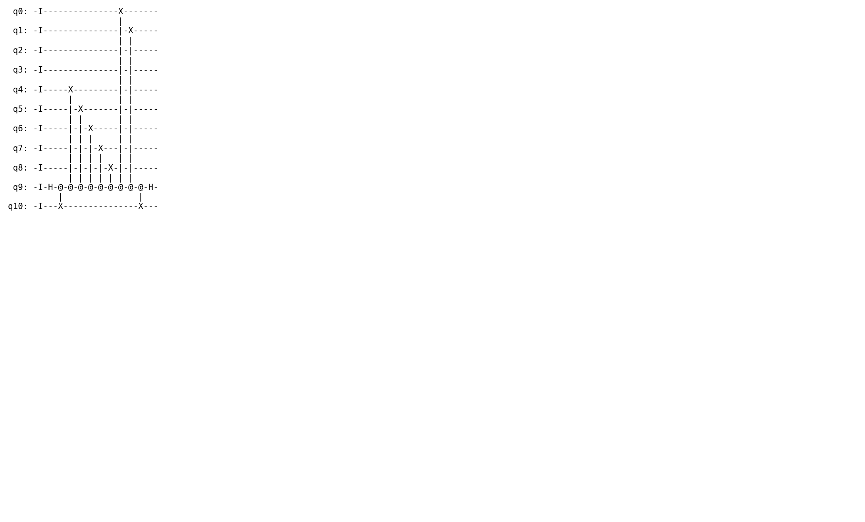
Figure 1. The flag-protected joint logical measurement, rendered directly from the circuit that the fault enumeration analyses.

7. Fault tolerance
We state the fault model once. Every gate of arity k contributes all four-to-the-k minus one non-identity Paulis on its support, so correlated multi-qubit faults are included for any k. Preparation faults act on every fresh ancilla and measurement faults flip every classical outcome. An error lying in the stabilizer group of the state at that point is not a fault, and two errors differing by an ancilla-local stabilizer are the same fault; without these two reductions the count is formal rather than physical.
For the joint measurement in isolation, a single flag bracketing the cascade gives 142 fault locations, of which 83 are discarded by the flag or by the ZZZZ check on A, leaving 59 surviving, and all sixteen syndrome classes are decodable. Without the flag, 9 classes are not. The synthesized decoder coincides exactly with the standard weight-one [[5,1,3]] lookup table, which is the signature of a gadget behaving: the surviving errors really are weight one.
Preparation of B is similarly benign, and for a reason worth stating. B need only be in the code space; which logical state it holds is recorded in b5, not required. Every single prep fault is therefore detected by the syndrome (124 of them), is a stabilizer (3), or is a logical absorbed by the frame bit (3), with none uncorrectable. This absorption imposes an ordering requirement: b5 must be recorded after the verification, since a logical fault arriving later leaves the frame bit stale.
Per-gadget certificates do not compose, and we do not claim they do. We build the whole protocol as a single circuit carrying a detector for every post-selection check and an observable for the teleported logical, so that a single fault is dangerous exactly when it flips the observable while firing no detector.
logical basis | single-fault mechanisms | undetectable logical errors
Xbar | 383 | 0
Zbar | 441 | 0

Composition exposed three gaps that the per-gadget analyses could not see: the Zbar frame measurement sat unprotected between two certified gadgets; errors injected into B by the M1 cascades faced no later check; and a Z error landing on A during an M1 cascade biases every repeated round identically, so round-to-round detectors cannot see it. The protocol in Section 6 includes the fixes. As a control, removing the M1 flag reintroduces 1 dangerous mechanism, so the scan is capable of failing.

8. Numerics
We sample the same circuit that carries the certificate under circuit-level depolarizing noise, four million shots per point. Acceptance is the fraction of shots in which no detector fires; the logical error rate is measured among accepted shots.
p | acceptance | accepted shots | logical errors | p_L
0.0010 | 0.856 | 3,424,271 | 17 | 4.96e-06
0.0020 | 0.733 | 2,930,314 | 76 | 2.59e-05
0.0030 | 0.627 | 2,508,509 | 155 | 6.18e-05
0.0050 | 0.460 | 1,841,082 | 346 | 1.88e-04
0.0070 | 0.337 | 1,348,338 | 477 | 3.54e-04
0.0100 | 0.212 | 847,774 | 639 | 7.54e-04

The fitted slope of log p_L against log p is 2.17. This is an independent check on the enumeration rather than a restatement of it: the enumeration is combinatorial and forces the leading term to be quadratic, and the Monte Carlo measures the exponent statistically. A variant with the M1 flag removed, which has one single-fault mechanism, fits 1.13 as it must. A slope near one for the certified protocol would have indicated that the enumeration had missed something.
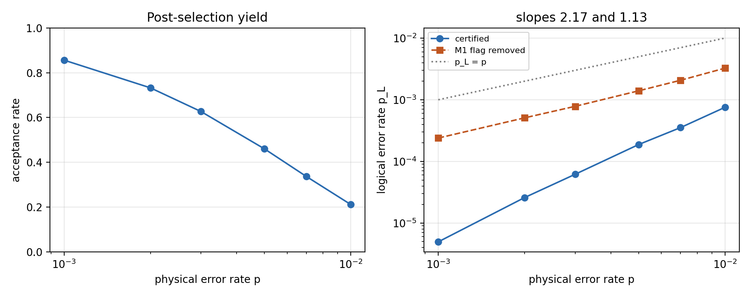
Figure 2. Post-selection yield, and logical error rate against physical error rate for the certified protocol and for a crippled control.
Acceptance is the practical constraint and is reported here for the first time. At p = 0.001 roughly 86% of shots survive; at p = 0.01 roughly 21% do, so the factory yields about one block in nine. Post-selection is load-bearing at four separate stages, and a gate count quoted without an acceptance rate describes half the cost.

9. Resources
The full certified protocol uses 120 two-qubit gates, counted from the circuit and including the hand-off error-correction round that a real switch charges to the receiving computation. Protection is most of that cost, which is the expected result and is stated plainly here rather than buried: the bare joint measurement is seven gates.
A comparison with flag-protected re-encoding is available but is not the reason to prefer this protocol. The two are comparable on gate count. The difference is that this one has a certificate and the other provably cannot obtain one at any flag budget, by Section 5.

10. Discussion
The commutation observation in Section 6 suggests a general design rule: protect measurements, not encoders. Whenever a construction can be expressed so that the object needing fault tolerance is a Pauli product measurement, flag gadgets apply cleanly because the flag pair commutes with the cascade. Where a construction requires a general Clifford cascade, the flag family is both smaller than it appears and, as our counting bound shows, potentially too weak in principle.
The counting bound itself generalizes. For any gadget, partitioning single-fault locations by syndrome and counting inequivalent residuals gives an immediate lower bound on the number of flag bits, before any search. We suggest it as a routine first check when designing flag gadgets, since it is cheap and can rule out an entire design family in seconds.
Limitations. Where a search is bounded we state the bound. The single-flag family is exhaustive at two, three and four couplings, 867,694 candidates in total, so the negative result of Section 5 is not an artifact of sampling. The two-flag stage ran on the default cascade rather than all twenty-four, and the greedy cover of nine is an upper bound rather than the true minimum, so no lower bound above two bits is proved. The end-to-end certificate covers single faults; we make no claim about pairs. The hand-off round is taken noiseless by convention. Optimization of the circuits is left for future work, and re-verification after every optimization pass is mandatory under our methodology.

11. Conclusion
We have shown that residual input errors are uncorrectable for every encoder, that flag-protected re-encoding of the [[4,2,2]] to [[5,1,3]] switch cannot be certified at any flag budget, and that a teleportation-based switch can. The certificate is an end-to-end enumeration over 824 single-fault mechanisms, independently corroborated by a measured error-rate exponent of 2.17. Every circuit, table and number in this paper is generated by the accompanying scripts, and the manuscript is regenerated rather than edited when they change.

References
[1] P. W. Shor, "Scheme for reducing decoherence in quantum computer memory," Phys. Rev. A 52, R2493 (1995).
[2] A. M. Steane, "Error correcting codes in quantum theory," Phys. Rev. Lett. 77, 793 (1996).
[3] D. Gottesman, "Stabilizer codes and quantum error correction," Ph.D. thesis, Caltech (1997). arXiv:quant-ph/9705052.
[4] A. R. Calderbank, E. M. Rains, P. W. Shor, and N. J. A. Sloane, "Quantum error correction via codes over GF(4)," IEEE Trans. Inf. Theory 44, 1369 (1998).
[5] A. Paetznick and B. W. Reichardt, "Universal fault-tolerant quantum computation with only transversal gates and error correction," Phys. Rev. Lett. 111, 090505 (2013).
[6] J. T. Anderson, G. Duclos-Cianci, and D. Poulin, "Fault-tolerant conversion between the Steane and Reed-Muller quantum codes," Phys. Rev. Lett. 113, 080501 (2014).
[7] H. Bombin, "Gauge color codes: Optimal transversal gates and gauge fixing in topological stabilizer codes," New J. Phys. 17, 083002 (2015).
[8] C. Vuillot, H. Lao, B. Criger, C. G. Almudever, K. Bertels, and B. M. Terhal, "Code deformation and lattice surgery are gauge fixing," New J. Phys. 21, 033028 (2019).
[9] R. Chao and B. W. Reichardt, "Quantum error correction with only two extra qubits," Phys. Rev. Lett. 121, 050502 (2018).
[10] C. Chamberland and M. E. Beverland, "Flag fault-tolerant error correction with arbitrary distance codes," Quantum 2, 53 (2018).
[11] C. Chamberland and A. W. Cross, "Fault-tolerant magic state preparation with flag qubits," Quantum 3, 143 (2019).
[12] R. Chao and B. W. Reichardt, "Flag fault-tolerant error correction for any stabilizer code," PRX Quantum 1, 010302 (2020).
[13] T. Tansuwannont, C. Chamberland, and D. Leung, "Flag fault-tolerant error correction, measurement, and quantum computation for cyclic CSS codes," Phys. Rev. A 104, 042410 (2021).
[14] D. Gottesman, "Theory of fault-tolerant quantum computation," Phys. Rev. A 57, 127 (1998).
[15] R. Laflamme, C. Miquel, J. P. Paz, and W. H. Zurek, "Perfect quantum error correcting code," Phys. Rev. Lett. 77, 198 (1996).
[16] C. H. Bennett, D. P. DiVincenzo, J. A. Smolin, and W. K. Wootters, "Mixed-state entanglement and quantum error correction," Phys. Rev. A 54, 3824 (1996).
[17] P. Aliferis, D. Gottesman, and J. Preskill, "Quantum accuracy threshold for concatenated distance-3 codes," Quantum Inf. Comput. 6, 97 (2006).
[18] Google Quantum AI, "Suppressing quantum errors by scaling a surface code logical qubit," Nature 614, 676 (2023).
[19] C. Gidney, "Stim: a fast stabilizer circuit simulator," Quantum 5, 497 (2021).

