Calculation of Audit Person Days for IT Service MS
Standard or certification scheme | ISO/IEC 20000-1:2018
Audit Duration Table – Table 1: | Calculation of M/D for the initial certification audit according to the Information technology service management —Requirements for bodies providing audit and certification of IT service management systems is based on the values shown in the table below  Auditor Time Chart  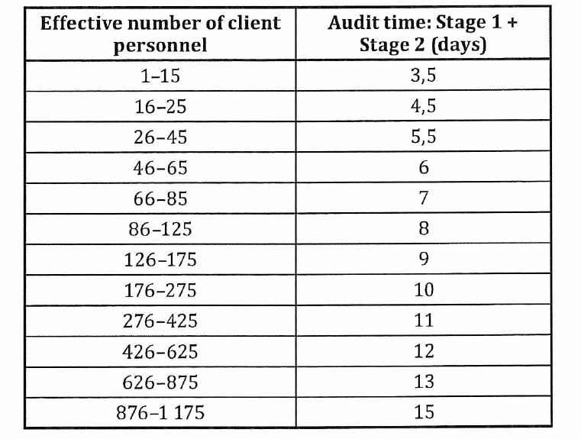
Organization with multiple sites: | In case of multi site organizations, a representative number of sites have been sampled taking into account:  - Operating under the same SMS, which is certainly administrated  - Included within the client’s internal audit programme  - Included within the client’s management review programme
Factors for adjustment of audit time | Potential decrease factors (non exhaustive list)  - A low rate of change to the SMS and the services  - Previously demonstrated effective performance of the SMS, e.g. previously certified with another accredited certification body  - Combined audit of the SMS with one or more other relevant management systems  - Prior knowledge of the organization, e.g. already certified to another standard by the same certification body  - A single, simple service  - Identical activities performed on all shifts, with appropriate evidence of equivalent performance on all shifts, e.g. service desk  - A significant proportion of service management personnel carry out a similar simple function  - Single site with low number of personnel  - A low level of reliance on other parties, such as suppliers, internal groups or customers acting as suppliers, involved in the provision of services  Potential increase factors (non exhaustive list)  - Complicated logistics involving multi-jurisdiction, multi-site working, in the same, or across a number of, time zone(s)  - Complexity of language differences across different locations, e.g. personnel speaking in more than one language (requiring interpreter(s) or preventing individual auditors from working independently)  - Large size or complexity of the SMS scope, e.g. high number of services, personnel or locations, specialized services which are difficult to understand and maintain  - High degree of legal and regulatory requirements affecting the client’s SMS, e.g. intellectual property rights, privacy, food, drug, aerospace, nuclear  - Different activities done in different shifts  - Temporary sites within the scope of the SMS for a specific audit  - Complex business processes performed within the scope of the SMS  - A high level of reliance on other parties, such as suppliers, internal groups or customers acting as suppliers, involved in the provision of services  - Frequent addition of new services, removal of services, transfer of services or significant changes to services

