Calculation of Audit Person Days for Quality MS
Standard or certification scheme | ISO 9001:2015
Audit Duration Table:
  TABLE 1 : AUDIT MANDAYS CALCULATION
  Effective Number of Personnel | Certification Audit | Effective Number of Personnel | Certification Audit
  Effective Number of Personnel | Audit Duration Stage 1 + Stage 2 (days) | Effective Number of Personnel | Audit Duration Stage 1 + Stage 2 (days)
  1-5 | 1.5 | 626 - 875 | 12
  6 -10 | 2 | 876 - 1175 | 13
  11 - 15 | 2.5 | 1176-1550 | 14
  16 - 25 | 3 | 1551 - 2025 | 15
  26 - 45 | 4 | 2026 - 2675 | 16
  46 - 65 | 5 | 2676 - 3450 | 17
  66 - 85 | 6 | 3541 - 4350 | 18
  86 - 125 | 7 | 4351 - 5450 | 19
  126 - 175 | 8 | 5451 - 6800 | 20
  176 - 275 | 9 | 6801 - 8500 | 21
  276 - 425 | 10 | 8501 - 10700 | 22
  426 - 625 | 11 | >10700 | Follow progression above
Risk Category Classification | Risk categories for a QMS audit are based on the nature of activities of the organization. These categories affect the audit duration and are shown below.  It is expected that business activities defined as low risk may require less audit time than the time calculated using Table 1, activities defined as medium risk will take the time calculated using Table 1, and activities defined as high risk will take more time. The reduction of audit time of management systems shall not exceed 30% of the times established from Table 1.  These risk categories are not definitive, they are examples only that could be used when determining the risk category of an audit  - High risk : Where failure of the product or service causes economic catastrophe or puts life at risk.  - Medium risk : Where failure of the product or service could cause injury or illness.  - Low risk : Where failure of the product or service is unlikely to cause injury or illness.  For organizations with activities that fall into more than one risk categories, the calculation of mandays is the sum of the required mandays for each activity based on the number of employees in each category.
  RISK CATEGORY | EA SECTOR / SUBSECTOR | NACE CODES | BUSINESS SECTOR
  High | 1.5 | 3 | Fishing and Aquaculture
  High | 3 (except 3.5) | 10, 11 | Processing of food
  High | 11 | 24.46, 20.13 | Nuclear Fuel
  High | 12 | 20 | Manufacture of Chemicals and Synthetic fibers
  High | 13 | 21 | Manufacture of Pharmaceutical products
  High | 18 | 28, 30.4, 33.12,  33.2, 25.4 | Manufacture of construction machinery and equipment
  High | 19.2 | 27.3 | Wiring and wiring equipment manufacture
  High | 19.3 | 26.6, 26.7 | Manufacture of irradiation and electronic equipment for medical and therapeutic use. Manufacture of optical and photographic equipment.
  High | 20 | 30.1, 33.15 | Shipbuilding
  High | 21 | 30.3, 33.16 | Aerospace
  High | 22.1 | 29, 30.2, 30.91 | Manufacturing of motor vehicles, trailers, semi-trailers. Manufacturing of railway locomotives and rolling stock. Manufacturing of motorcycles.
  High | 25 | 35.1 | Electricity production (coal, lignite)
  High | 26 | 35.2 | Gas supply
  High | 27 | 35.3, 36 | Drilling, water treatment and distribution
  High | 28.1 | 41, 42, 43  except 43.2 and  43.3 | Building construction, Civil engineering, specialized construction work (except from electrical, plumbing and other simple construction work)
  High | 32 | 64, 65, 66, 68,  77 | Financial institutions, Estate management
  High | 38 | 86, 87, 88, 75 | Health and social care
  Medium | 1 (except 1.5) | 1,2 | Agriculture
  Medium | 3.5 | 12 | Processing of tobacco
  Medium | 2 | 05, 06, 07, 08, 09 | Mining and quarrying
  Medium | 6 | 16 | Production of boards, processing of wood and wood products
  Medium | 10 | 19 | Refineries
  Medium | 14 | 22 | Rubber and plastic injection moulding, forming and assembly
  Medium | 15 | 23, except 23.5 and 23.6 | Processing of non – metallic minerals and ceramic
  Medium | 16 | 23.5, 23.6 | Production of concrete, cement, lime, plaster e.t.c
  Medium | 17 | 24 except 24.46, 25 except 25.4, 33.11 | Basic metal and metallic products manufacturing
  Medium | 19.1 | 26 except 26.6  and 26.7, 27  except 27.3,  33.13, 33.14,  95.1 | P/C manufacturing, electronic and optical equipment
  Medium | 22.2 | 30.92, 30.99,  33.17 | Bicycle, wheel chair and other transportation equipment manufacturing, repair and maintenance of other transportation equipment.
  Medium | 23 | 31, 32, 33.19 | Other manufacturing non classified elsewhere
  Medium | 24 | 38.3 | Recycling
  Medium | 28.2 | 43.2, 43.3 | Electrical, plumbing and other simple construction work.
  Medium | 31 | 49, 50, 51, 52, 53, 61 | Transportation, Storage and Communication
  Medium | 33 | 58.2, 62, 63.1 | Information technology
  Medium | 34 | 71, 72, 74  except 74.3 | Architectural and engineering activities. Technical consultancy. Research and development.
  Medium | 39 | 37, 38.1, 38.2, 39, 59.1, 60, 63.9, 79, 90,  91, 92, 93, 94, 96 | Other services except education, health and social work
  Low | 4 | 13, 14 | Textile industry
  Low | 5 | 15 | Leather and leather products industry
  Low | 7 | 17 | Pulp, Paper and paper products
  Low | 8 | 58.1, 59.2 | Wood and wood products
  Low | 9 | 18 | Printing
  Low | 29 | 45, 46, 47, 95.2 | Wholesale/retail sale, Repair of motor vehicles and motorcycles. Personal and household goods
  Low | 30 | 55, 56 | Hotels and restaurants
  Low | 35 | 69, 70, 73, 74.2, 74.3, 78, 80, 81, 82 | Other services, except trade, hotels, restaurants, transport, financial intermediation, real estate, information technology, education, health and social work
  Low | 36 | 84 | Public administration
  Low | 37 | 85 | Education
Factors for increase or decrease in audit duration : | All the following factors shall be considered, in order to calculate the real man days of audits, in relation to the man days calculated from the Tables. In all cases, the maximum reduction of man days of audit shall not exceed 30% of the time established in Table 1.  Indicative factors for increase of M/D  - Complicated logistics involving more than one building or location where work is carried out. e.g., a separate Design Centre must be audited;  - Staff speaking in more than one language (requiring interpreter(s) or preventing individual auditors from working independently);  - Very large site for the number of personnel (e.g., a forest);  - High degree of regulation (e.g. food, drugs, aerospace, nuclear power, etc);  - System covers highly complex processes or relatively high number of unique activities;  - Activities that require visiting temporary sites to confirm the activities of the permanent site(s) whose management system is subject to certification.  - Outsourced functions or processes  - Activities considered to be of high risk  Indicative factors for decrease of M/D  - Client is not "design responsible" or other standard elements are not covered in the scope  - Very small site for number of personnel (e.g. office complex only),  - Maturity of management system  - Prior knowledge of the client management system (e.g., already certified to another standard by the same CAB);  - Client preparedness for certification (e.g., already certified or recognized by another 3rd party scheme);  - High level of automation  - Where staff include a number of people who work “off location” e.g. salespersons, drivers, service personnel, etc. and it is possible to substantially audit compliance of their activities with the system through review of records  - Activities considered to be of low risk  - Processes involving similar and repetitive activities  - Identical activities of low complexity performed on all shifts with appropriate evidence of equivalent performance on all shifts  - Where significant proportion of the staff carry out a similar simple function. Repetitive processes within the scope.
Use of remote auditing techniques | The use of such techniques shall be described in to the audit plan. Remote auditing activities shall not represent more than 30% of the planned on site duration of the management system audit.
Relationship between Complexity and Audit Duration: | 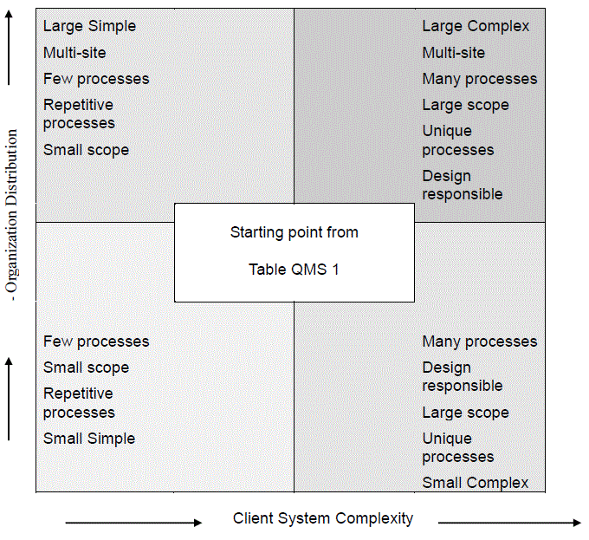  Figure 1 : Relationship between Complexity and Audit Duration (Source: IAF MD5)

