**Gomoku Implementation with Min-Max and Alpha-Beta algorithm**

**Author SheepCore**

**SID 20164586**

**I. Question Description**

AlphaGo now is on fire due to the issue of beating world-class go champion winner – Ke Jie. It was absolutely amazing for people to think about what AI can do and what AI can not do. And we perceive that the algorithm behind AlphaGo is a mix of neural network and with self-play mechanics. Everybody knows the story of AlphaGo:

AlphaGo is the first computer program to defeat a professional human Go player, the first program to defeat a Go world champion, and arguably the strongest Go player in history.

AlphaGo’s first formal match was against the reigning 3-times European Champion, Mr Fan Hui, in October 2015. Its 5-0 win was the first ever against a Go professional, and the results were published in full technical detail in the international journal, Nature. AlphaGo then went on to compete against legendary player Mr Lee Sedol, winner of 18 world titles and widely considered to be the greatest player of the past decade.

AlphaGo's 4-1 victory in Seoul, South Korea, in March 2016 was watched by over 200 million people worldwide. It was a landmark achievement that experts agreed was a decade ahead of its time, and earned AlphaGo a 9 dan professional ranking (the highest certification) - the first time a computer Go player had ever received the accolade.

**Alpha–beta pruning** is a search algorithm that seeks to decrease the number of nodes that are evaluated by the min-max algorithm in its [search tree](https://en.wikipedia.org/wiki/Game_tree). It is an adversarial search algorithm used commonly for machine playing of two-player games ([Tic-tac-toe](https://en.wikipedia.org/wiki/Tic-tac-toe), [Chess](https://en.wikipedia.org/wiki/Chess), [Go](https://en.wikipedia.org/wiki/Go_(board_game)), etc.). It stops evaluating a move when at least one possibility has been found that proves the move to be worse than a previously examined move. Such moves need not be evaluated further. When applied to a standard minimax tree, it returns the same move as minimax would, but prunes away branches that cannot possibly influence the final decision.

So why do we use alpha-beta pruning algorithm, the main goal is to elevate the efficiency of three search, otherwise we have to deeply search on some unnecessary branches which costs a lot. Normally speaking, The algorithm maintains two values, alpha and beta, which represent the minimum score that the maximizing player is assured of and the maximum score that the minimizing player is assured of respectively. Initially, alpha is negative infinity and beta is positive infinity, i.e. both players start with their worst possible score. Whenever the maximum score that the minimizing player (i.e. the "beta" player) is assured of becomes less than the minimum score that the maximizing player (i.e., the "alpha" player) is assured of (i.e. beta ≤ alpha), the maximizing player need not consider further descendants of this node, as they will never be reached in the actual play.

This is what alpha-beta looks like:

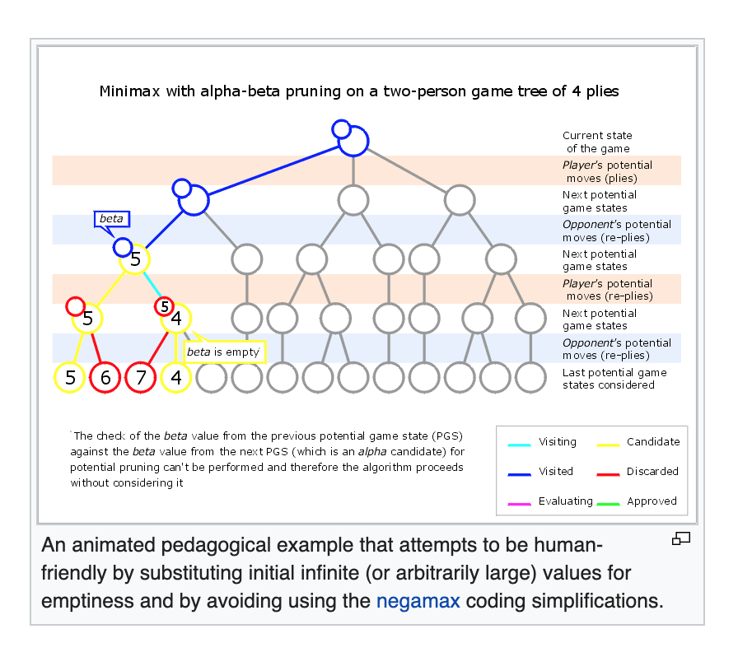

Here is my Pseudocode for minimax algorithm with alpha-beta pruning:

function minimax(node, depth, isMaximizingPlayer, alpha, beta):

if node is a leaf node :

return value of the node

if isMaximizingPlayer :

bestVal = -INFINITY

for each child node :

value = minimax(node, depth+1, false, alpha, beta)

bestVal = max( bestVal, value)

alpha = max( alpha, bestVal)

if beta <= alpha:

break

return bestVal

else :

bestVal = +INFINITY

for each child node :

value = minimax(node, depth+1, true, alpha, beta)

bestVal = min( bestVal, value)

beta = min( beta, bestVal)

if beta <= alpha:

break

return bestVal

// Calling the function for the first time.

minimax(0, 0, true, -INFINITY, +INFINITY)

**II. Implementation Process**

1. Evaluation for board state

Here is the score matrix for each board layout.

shape_score = [(50, (0, 1, 1, 0, 0)),  
 (50, (0, 0, 1, 1, 0)),  
 (200, (1, 1, 0, 1, 0)),  
 (500, (0, 0, 1, 1, 1)),  
 (500, (1, 1, 1, 0, 0)),  
 (5000, (0, 1, 1, 1, 0)),  
 (5000, (0, 1, 0, 1, 1, 0)),  
 (5000, (0, 1, 1, 0, 1, 0)),  
 (5000, (1, 1, 1, 0, 1)),  
 (5000, (1, 1, 0, 1, 1)),  
 (5000, (1, 0, 1, 1, 1)),  
 (5000, (1, 1, 1, 1, 0)),  
 (5000, (0, 1, 1, 1, 1)),  
 (50000, (0, 1, 1, 1, 1, 0)),  
 (99999999, (1, 1, 1, 1, 1))]

1. Calculate evaluation value

Determine final evaluation value with heuristic algorithm.

def evaluation(is_ai):  
 total_score = 0  
 if is_ai:  
 my_list = list1  
 enemy_list = list2  
 else:  
 my_list = list2  
 enemy_list = list1  
  
 # calculate evaluation value  
 score_all_arr = []   
 my_score = 0  
 for pt in my_list:  
 m = pt[0]  
 n = pt[1]  
 my_score += cal_score(m, n, 0, 1, enemy_list, my_list, score_all_arr)  
 my_score += cal_score(m, n, 1, 0, enemy_list, my_list, score_all_arr)  
 my_score += cal_score(m, n, 1, 1, enemy_list, my_list, score_all_arr)  
 my_score += cal_score(m, n, -1, 1, enemy_list, my_list, score_all_arr)  
  
 # calculate evaluation value of opponent  
 score_all_arr_enemy = []  
 enemy_score = 0  
 for pt in enemy_list:  
 m = pt[0]  
 n = pt[1]  
 enemy_score += cal_score(m, n, 0, 1, my_list, enemy_list,  
 score_all_arr_enemy)  
 enemy_score += cal_score(m, n, 1, 0, my_list, enemy_list,  
 score_all_arr_enemy)  
 enemy_score += cal_score(m, n, 1, 1, my_list, enemy_list,  
 score_all_arr_enemy)  
 enemy_score += cal_score(m, n, -1, 1, my_list, enemy_list,  
 score_all_arr_enemy)  
  
 # determine final score  
 total_score = my_score - enemy_score * ratio * 0.1  
 return total_score

1. Gomoku Game Board Definition

# define Gomoku Window  
def gomokuWin():  
 win = GraphWin("Tiny Gomoku Game: ", GRID_WIDTH * COLUMN,  
 GRID_WIDTH * ROW)  
 win.setBackground("deeppink")  
  
 # horizontalLine verticalLine 分别绘制棋盘纵横线  
 horizontalLine = 0  
 while horizontalLine <= GRID_WIDTH * COLUMN:  
 l = Line(Point(horizontalLine, 0), Point(horizontalLine, GRID_WIDTH * COLUMN))  
 l.draw(win)  
 horizontalLine = horizontalLine + GRID_WIDTH  
 verticalLine = 0  
 while verticalLine <= GRID_WIDTH * ROW:  
 l = Line(Point(0, verticalLine), Point(GRID_WIDTH * ROW, verticalLine))  
 l.draw(win)  
 verticalLine = verticalLine + GRID_WIDTH  
 return win

1. Alpha-Beta Algorithm

def negamax(is_ai, depth, alpha, beta):  
 # return evaluation value when the game reaches the end  
 if game_win(list1) or game_win(list2) or depth == 0:  
 return evaluation(is_ai)  
  
 # list_all - list3 = {blank_list}  
 blank_list = list(set(list_all).difference(set(list3)))  
  
 order(blank_list)   
  
 # traverse all blank space   
 for next_step in blank_list:  
  
 global search_count  
 search_count += 1  
  
 # no action if no neighbor around  
 if not has_neighbor(next_step):  
 continue  
 # check which is gonna go...  
 if is_ai:  
 list1.append(next_step)  
 else:  
 list2.append(next_step)  
 list3.append(next_step)  
  
 # switch to the opponent mode  
 value = -negamax(not is_ai, depth - 1, -beta, -alpha)  
  
   
 if is_ai:  
 list1.remove(next_step)  
 else:  
 list2.remove(next_step)  
 list3.remove(next_step)  
  
 if value > alpha:  
 print(str(value) + " [alpha: " + str(alpha) + "beta:" + str(  
 beta) + ']')  
 print(list3)  
 # check if not step over max search depth  
 if depth == DEPTH:  
 next_point[0] = next_step[0]  
 next_point[1] = next_step[1]  
 # alpha-beta pruning   
 if value >= beta:  
 global cut_count  
 cut_count += 1  
 return beta  
 alpha = value  
  
 return alpha

**III. Parameter Adjusting**

Here are several super-parameters we need to adjust to satisfy our algorithm better:

1. **MAX_SEARCH_DEPTH**
2. **Ratio**
3. **Who is the first run**
4. **Winning Board States**

Here is a simple analyzation based on those super-parameters I mentioned before.

**Adjusting MAX_SEARCH_DEPTH:**

☞Set **MAX_SEARCH_DEPTH = 2:**

✔︎Performance:

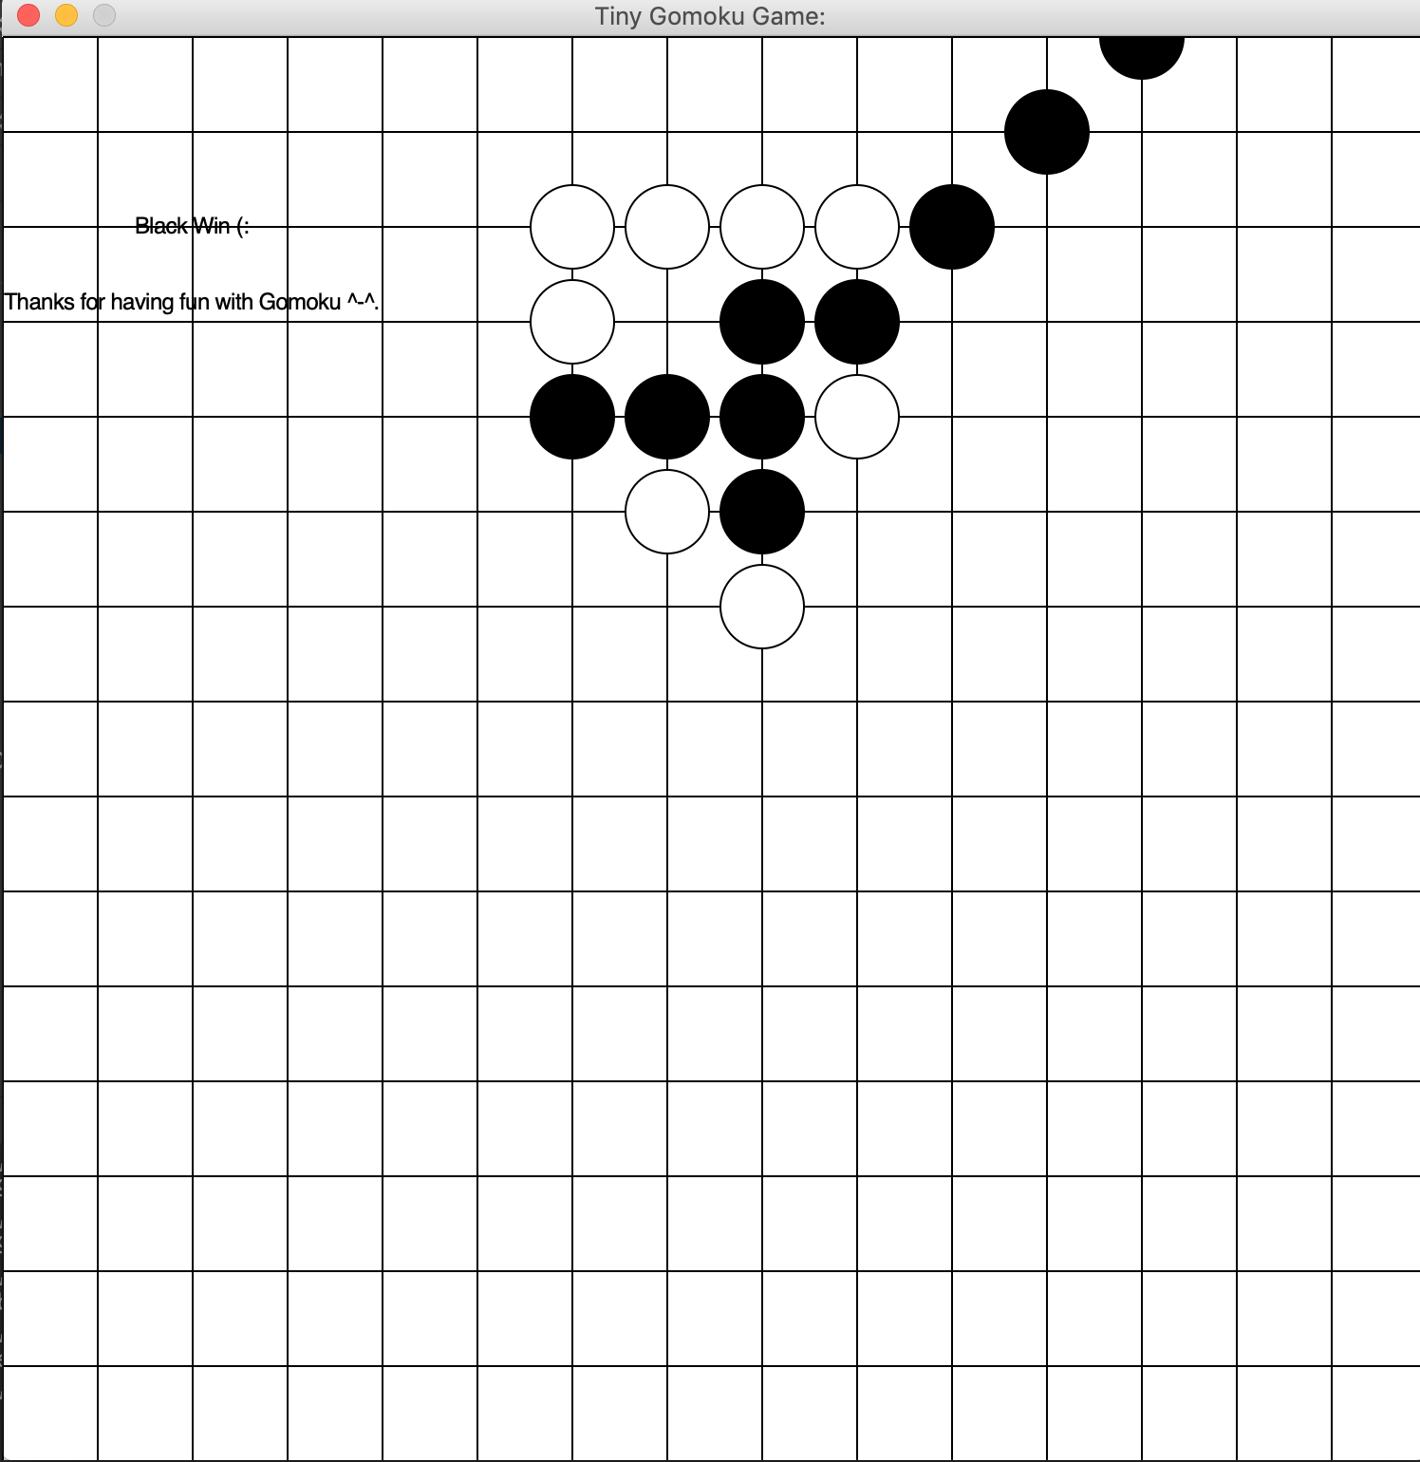

Statistical analysis:

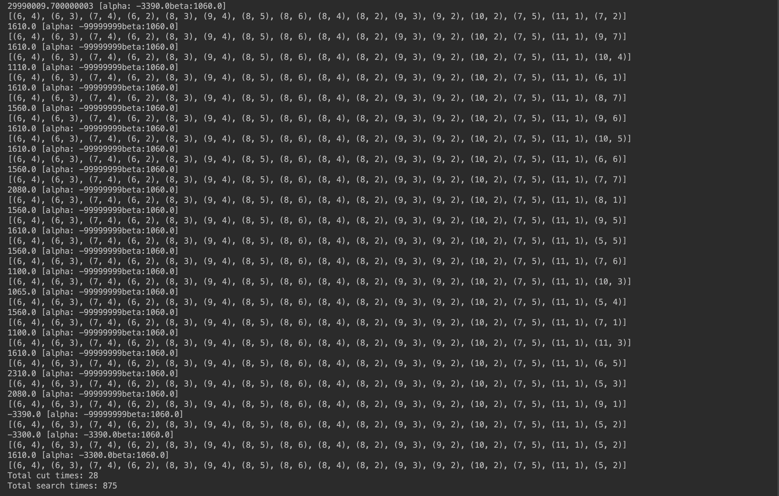

☞Set **MAX_SEARCH_DEPTH = 3:**

✔︎Performance:

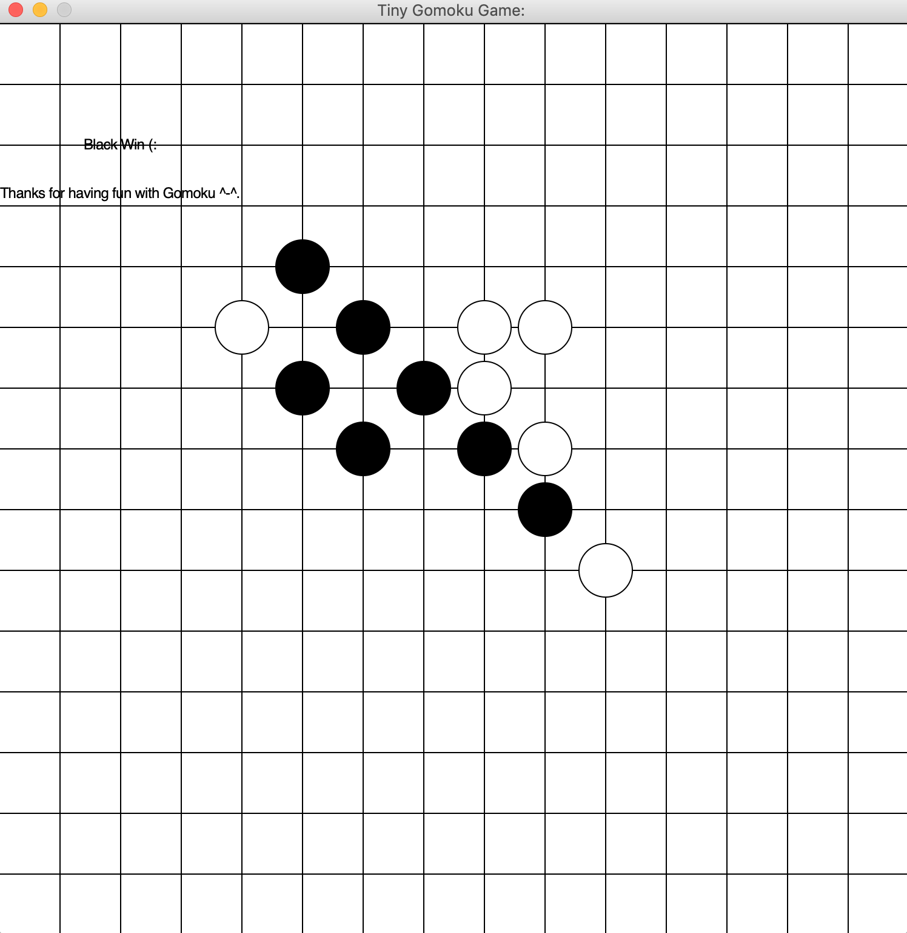

Statistical analysis:

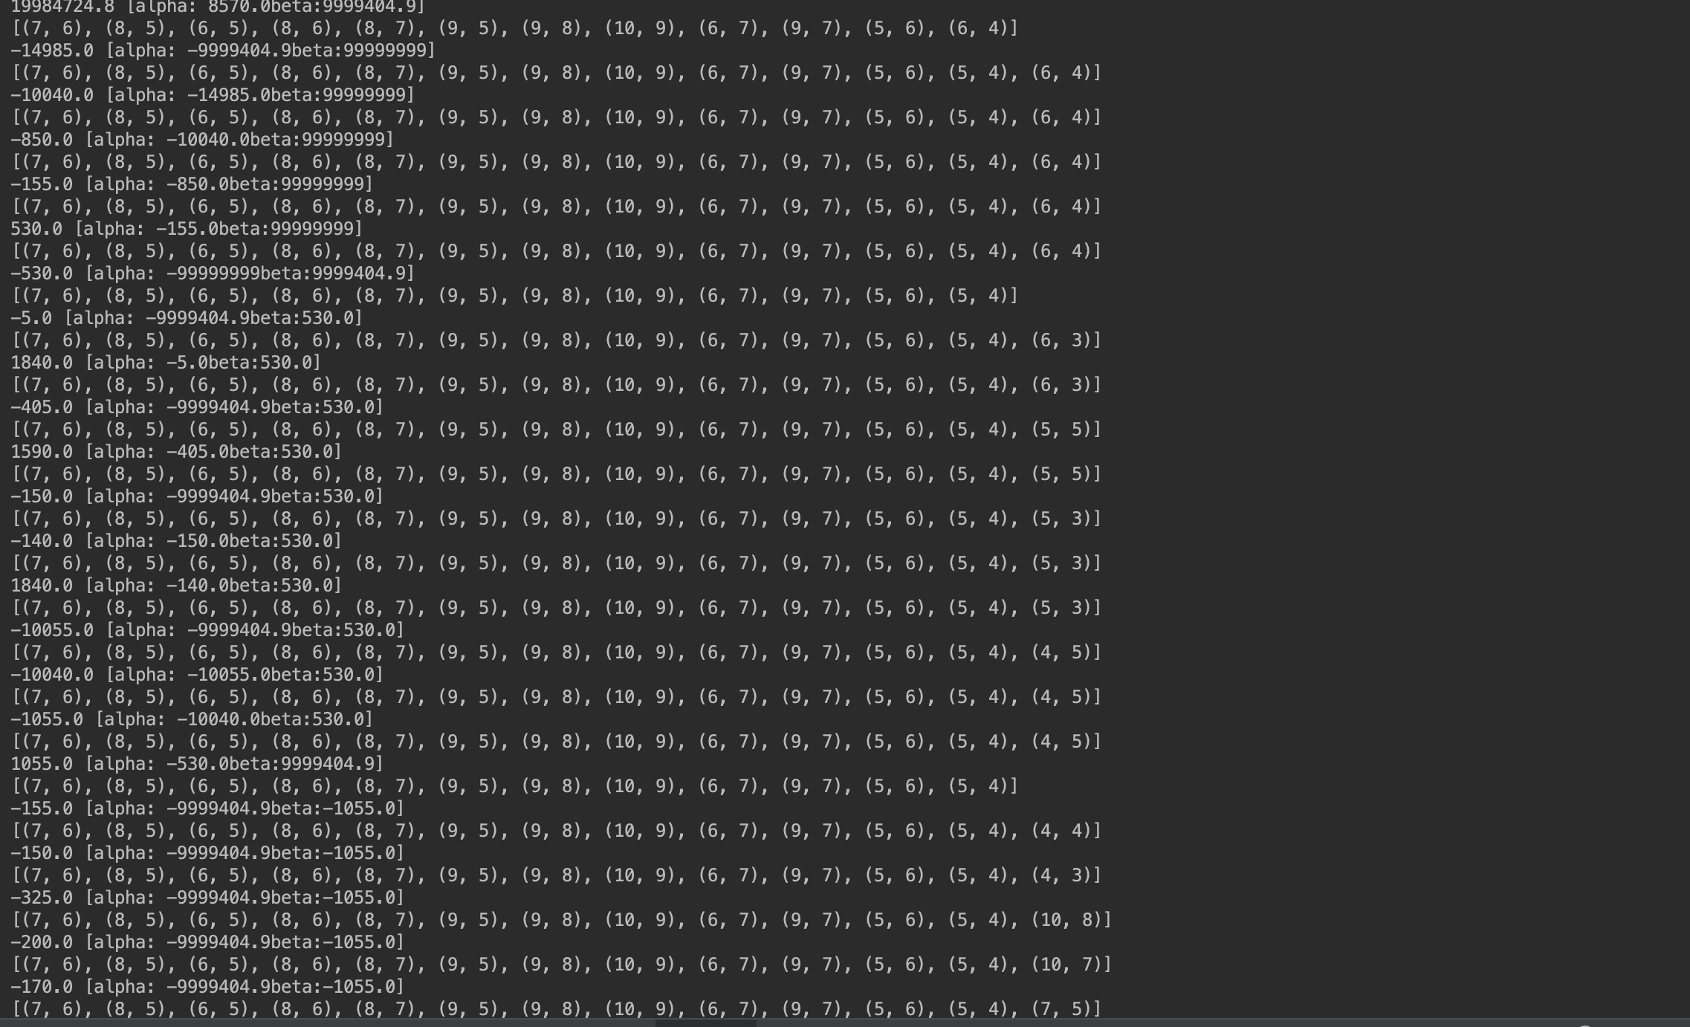

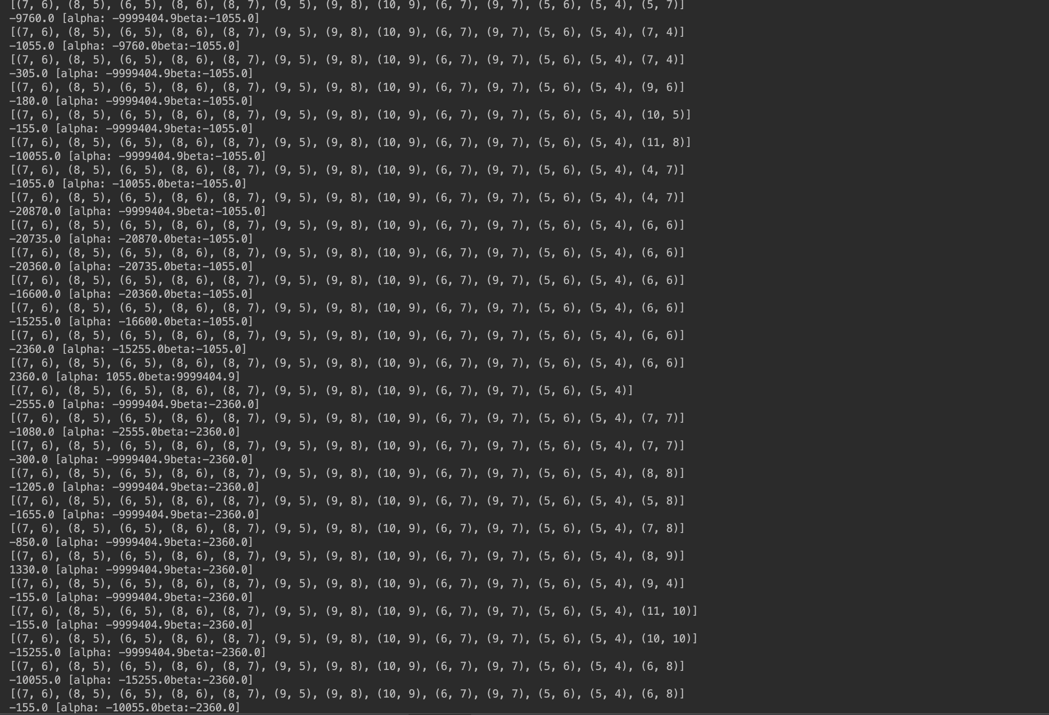

☞Set **MAX_SEARCH_DEPTH = 4:**

✔︎Performance:

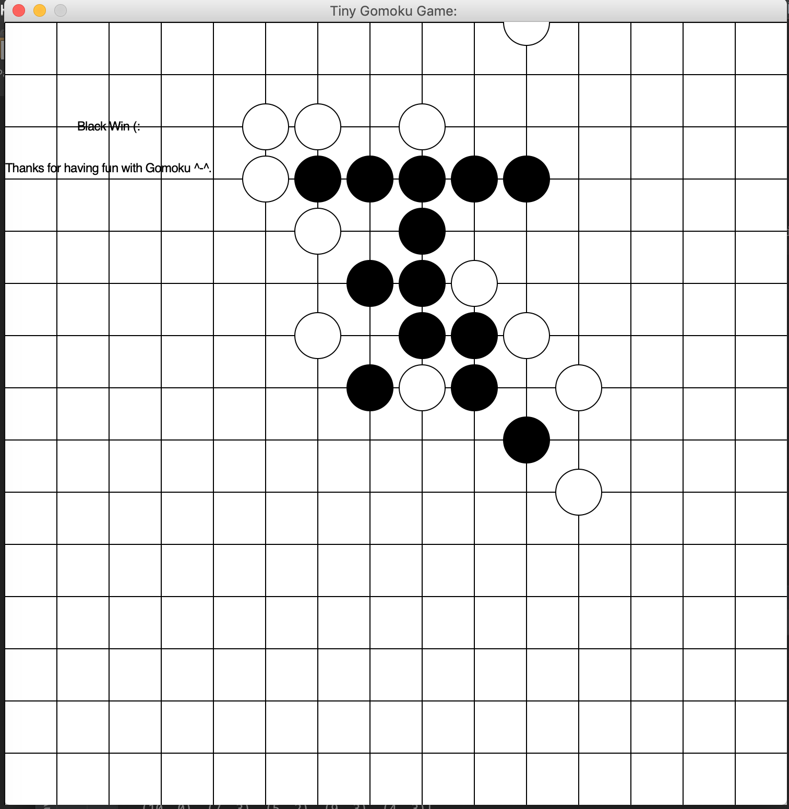

Cut times lasting for too long…

…

…

…

Statistical analysis:

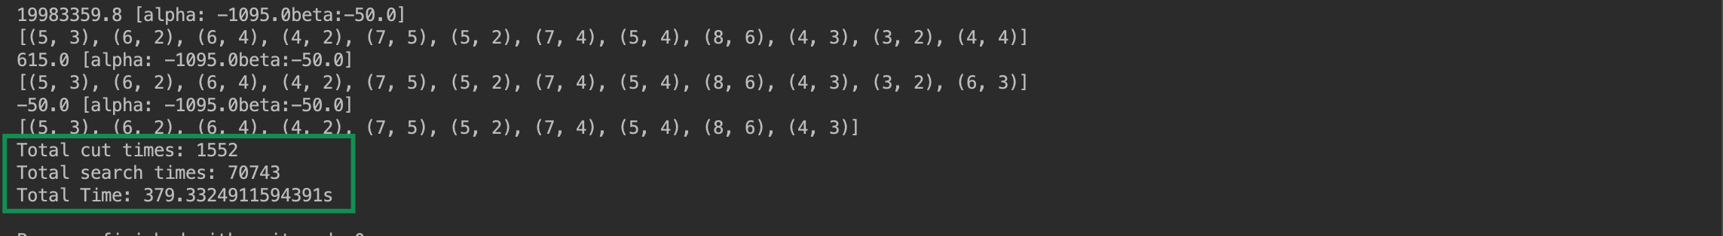

**Conclusion for adjusting MAX_SEARCH_DEPTH:**

Let’s take a look what happen when adjust MAX_SEARCH_DEPTH, Here is the comparison on those performances:

|  |  |  |  |
| --- | --- | --- | --- |
| Performance/  Max_Search_Depth | 2 | 3 | 4 |
| Total Cut Times | 28 | 266 | 1552 |
| Total Search Times | 785 | 2300 | 70743 |
| Total Time | 18.44s | 76.33s | 379.88s |

**Adjusting ratio:**

☞Set ratio = 1:

✔︎Performance:

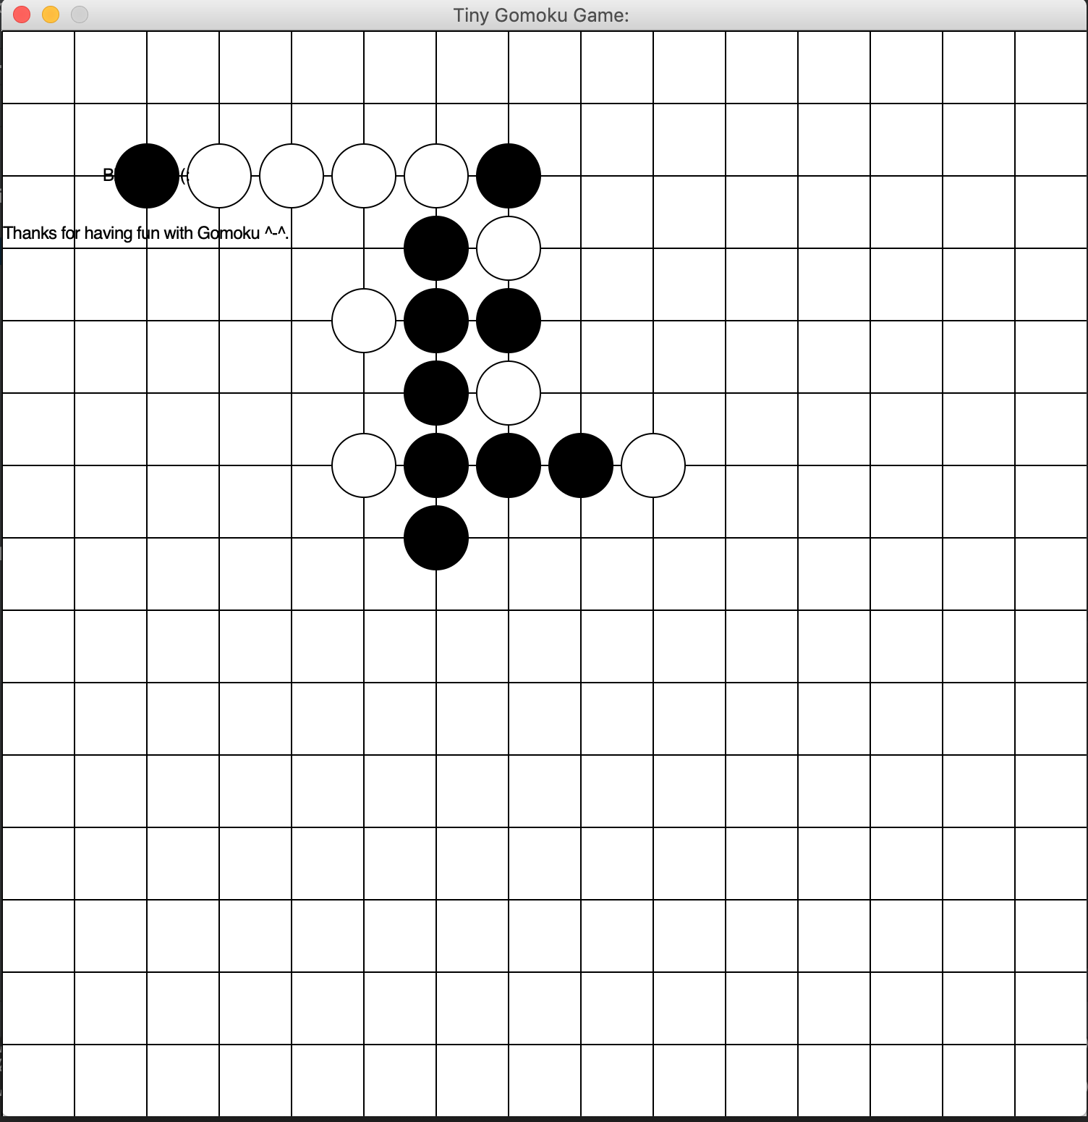

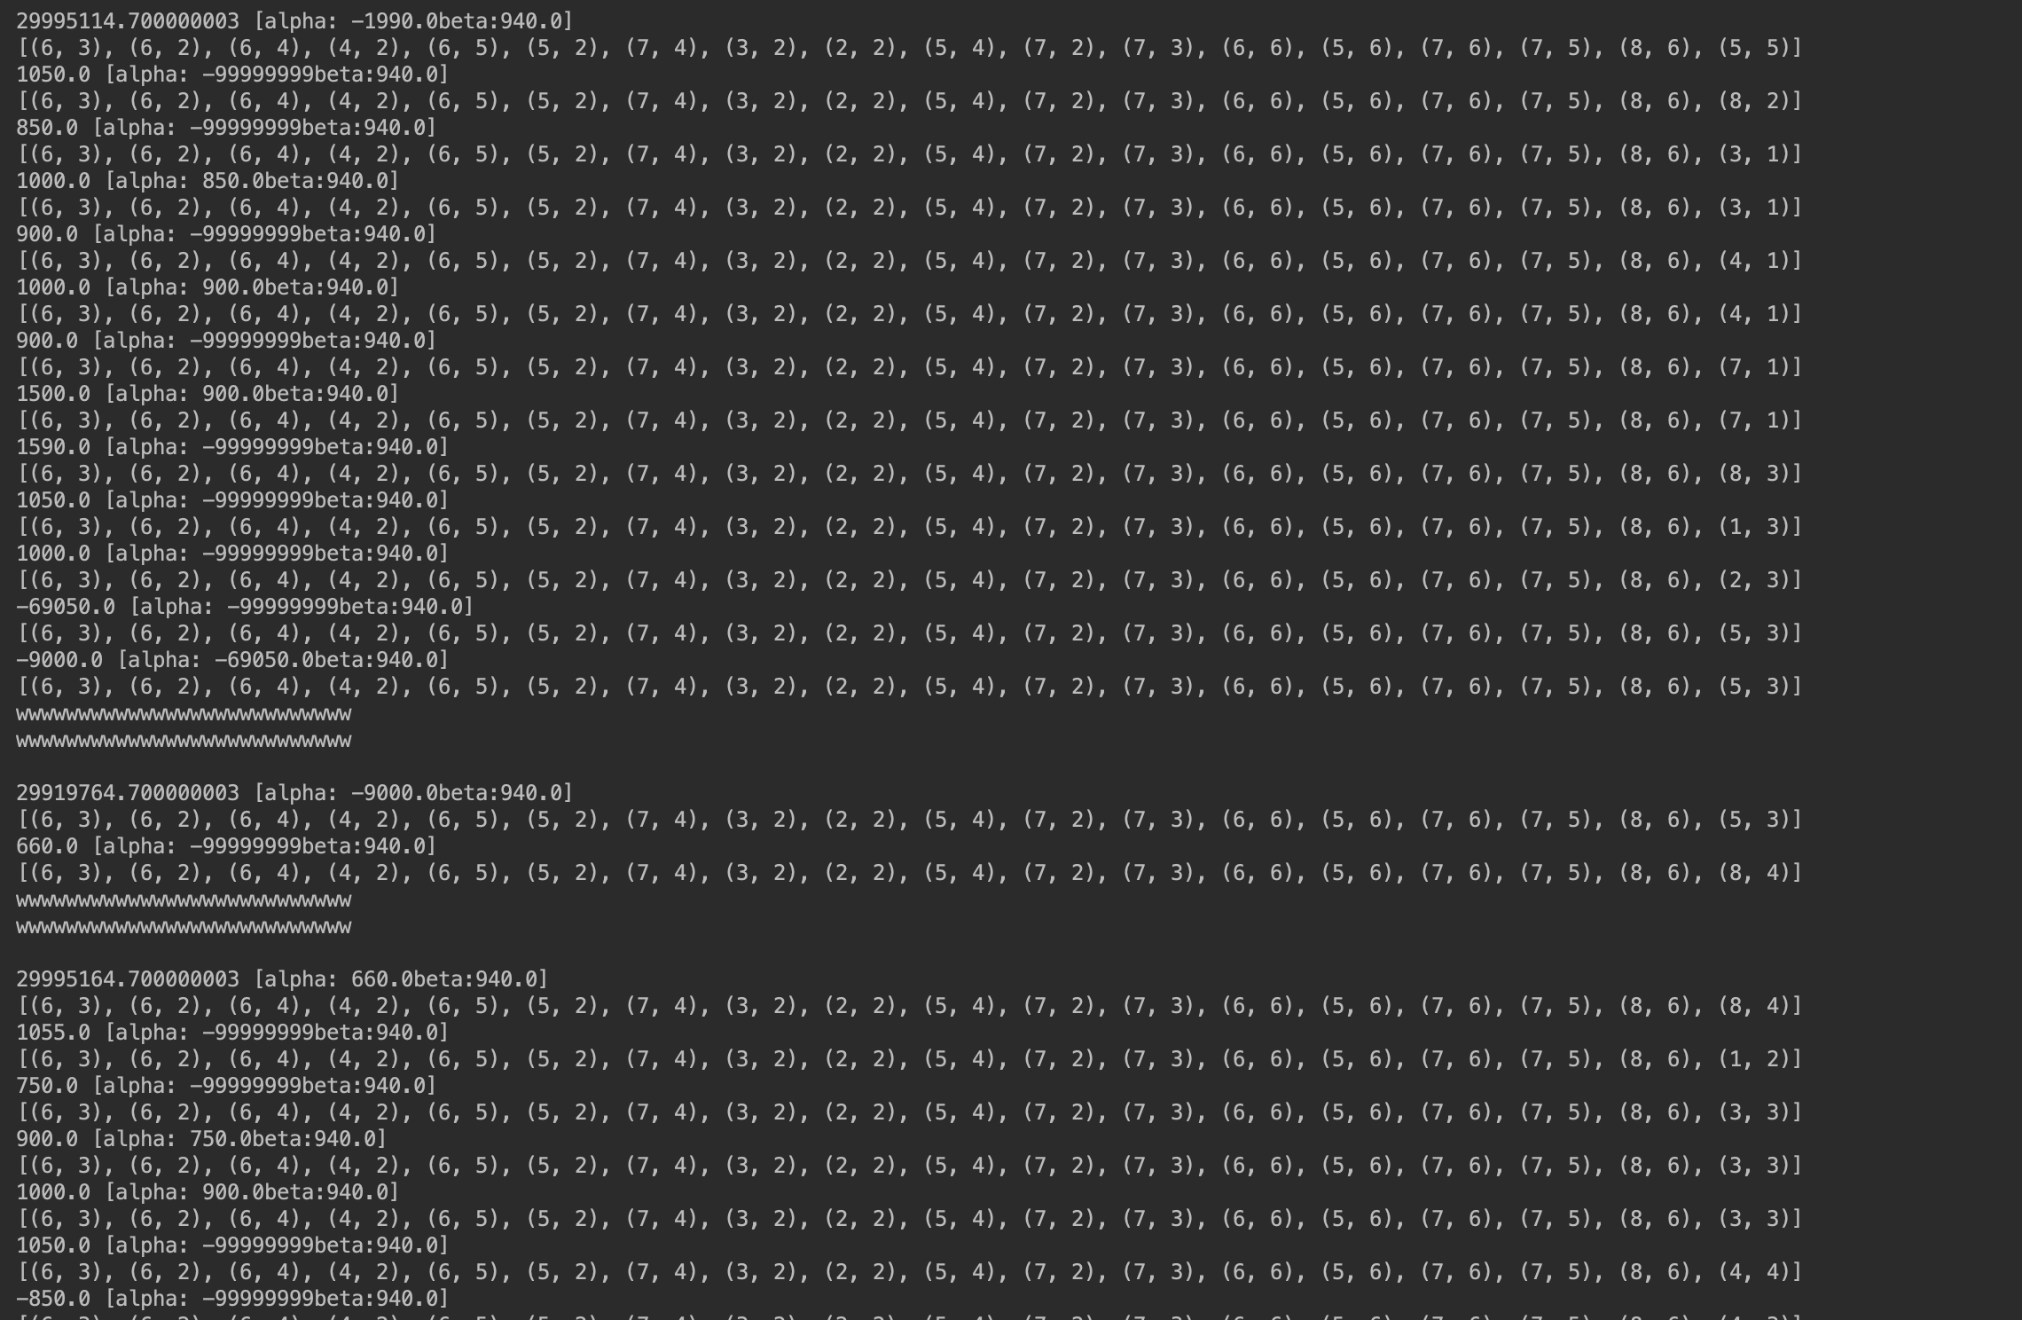

Statistical analysis:



☞Set ratio = 5:

✔︎Performance:

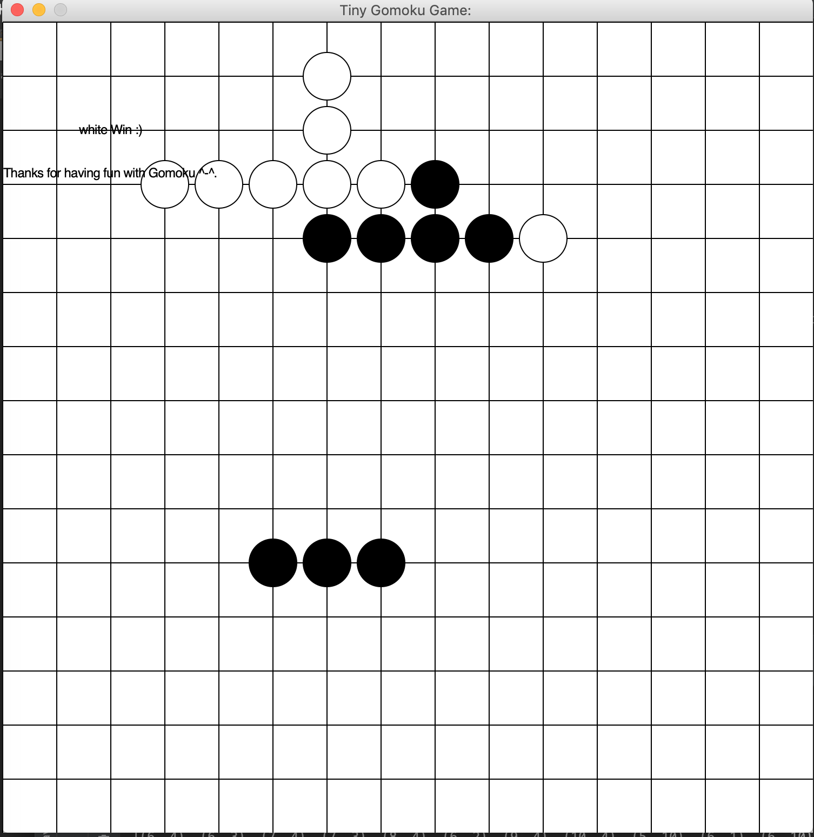

Statistical analysis:

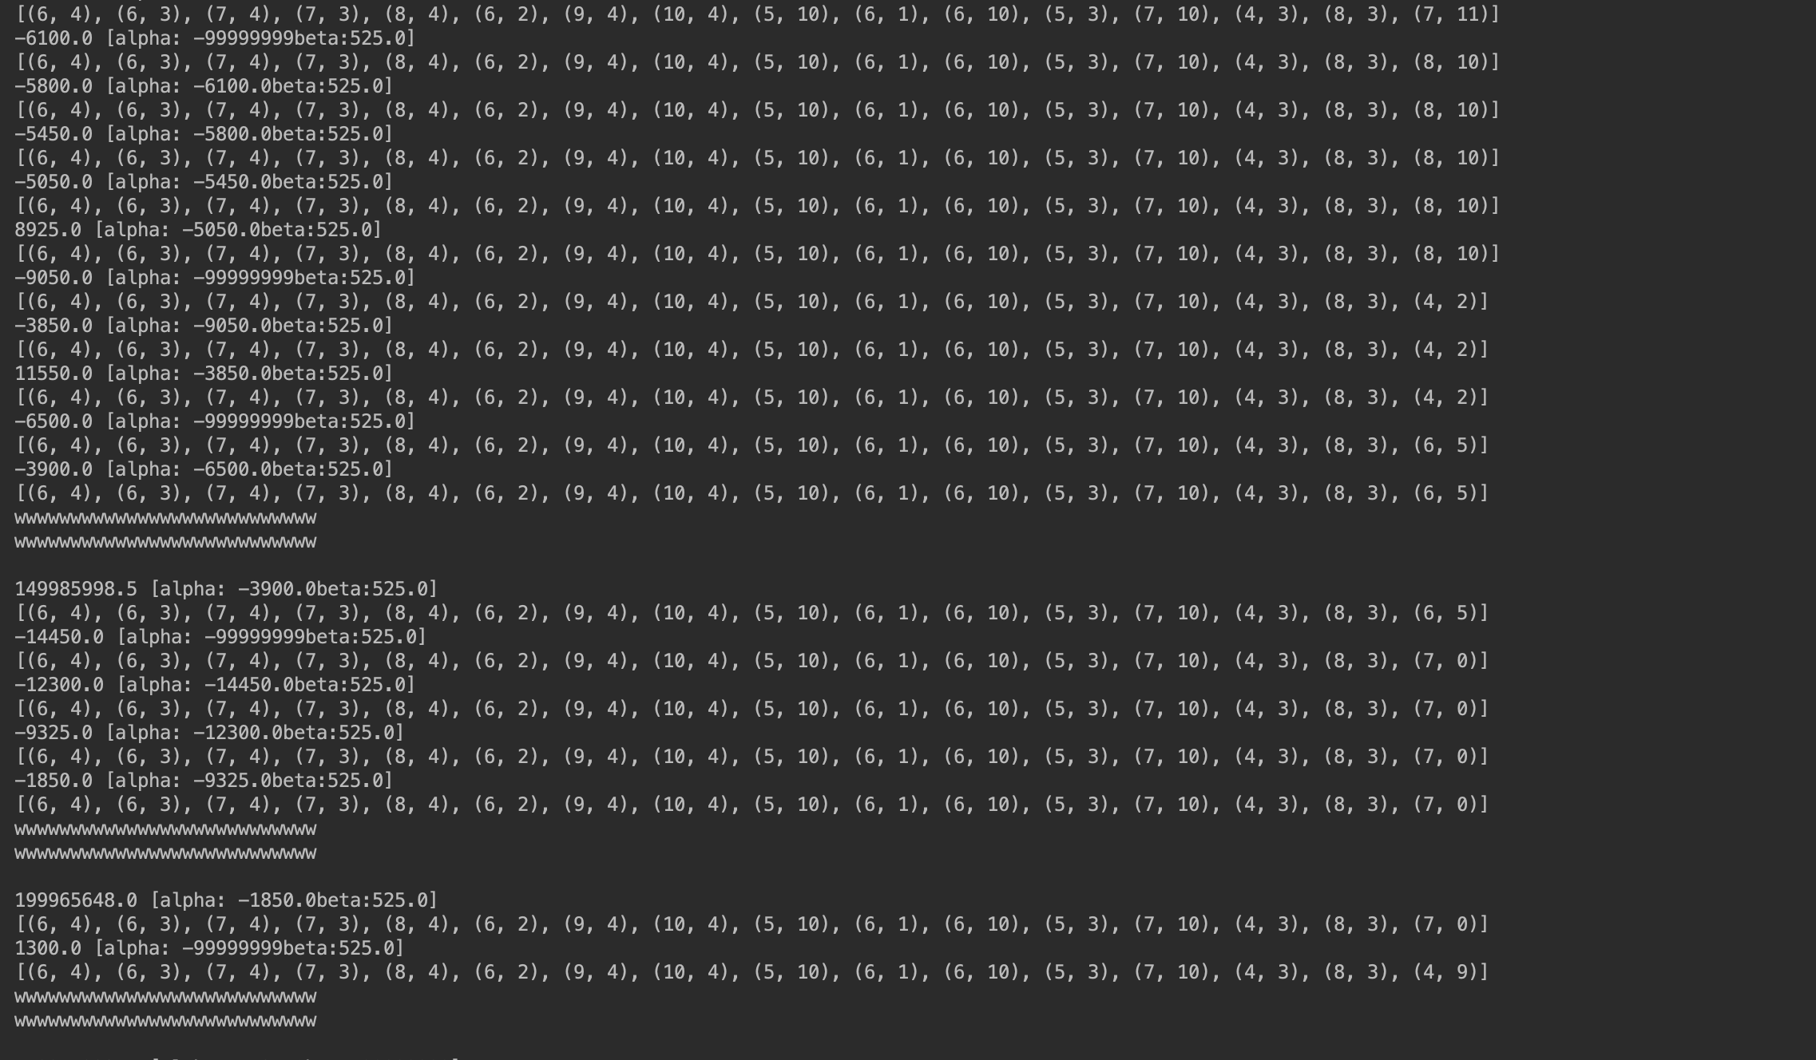



☞Set ratio = 25:

✔︎Performance:

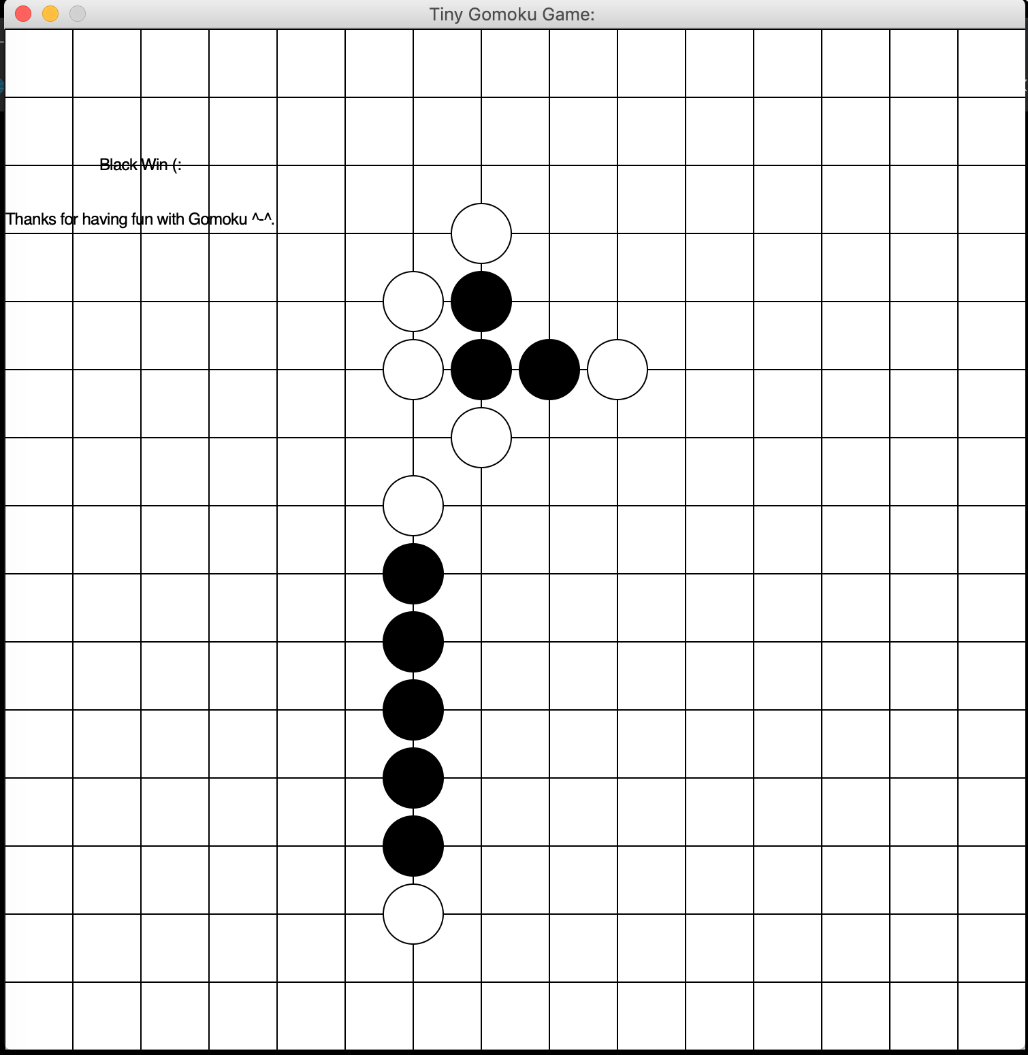

Statistical analysis:

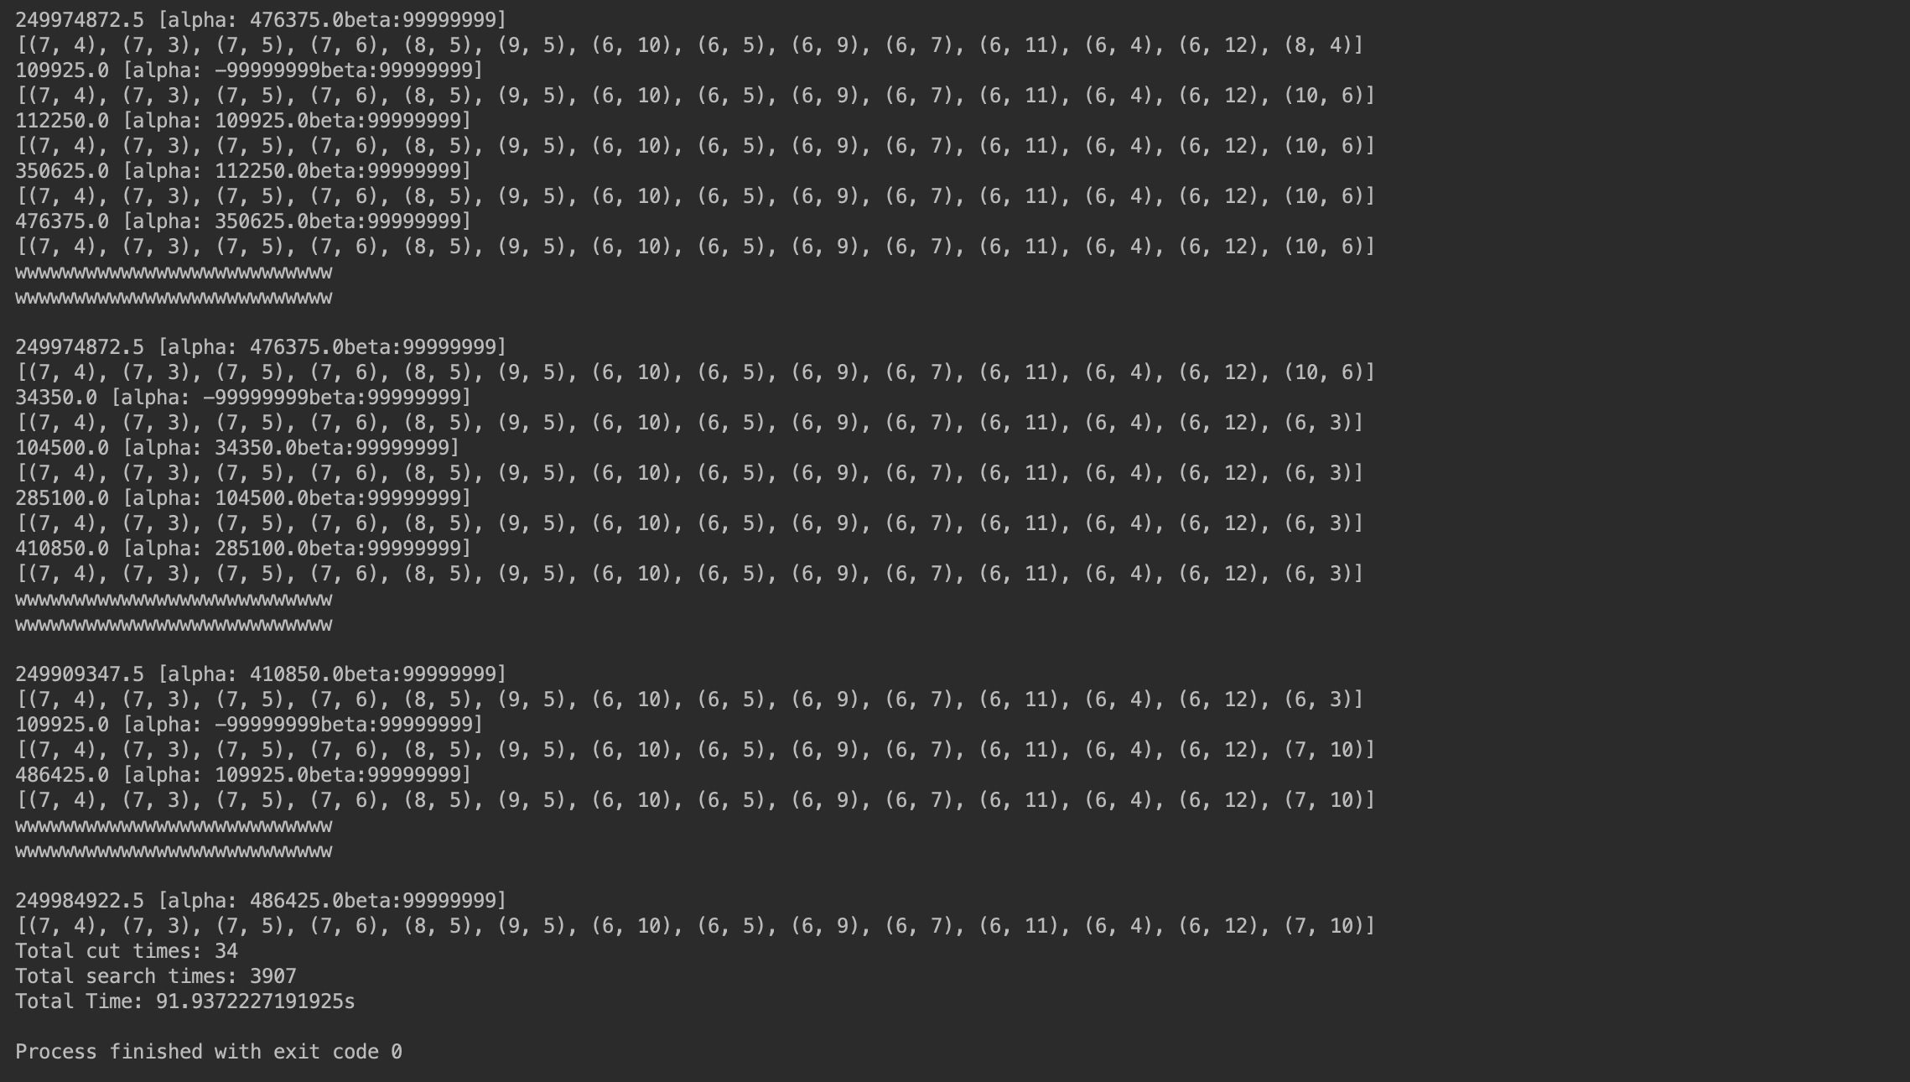

**Conclusion for adjusting Ratio:**

Let’s take a look what happen when adjust Ratio, Here is the comparison on those performances:

|  |  |  |  |
| --- | --- | --- | --- |
| Performance/  Ratio | 1 | 5 | 25 |
| Total Cut Times | 27 | 34 | 34 |
| Total Search Times | 2861 | 4699 | 3907 |
| Total Time | 125.16s | 123.44s | 91.93s |

**IV. Debug Guidance**

Here is what I have done in this paper and all the work is based on the Ai-Studio Platform and I’ve already reformat the structure of the code style. Even though I was hoping to implement Gomoku-Game with Coevolutionary Neural Network (CNN), but you know time is limited, I have to spent more time on Graduate Unified Examination at the end of the year 2019.

Here is the class hierarchy:

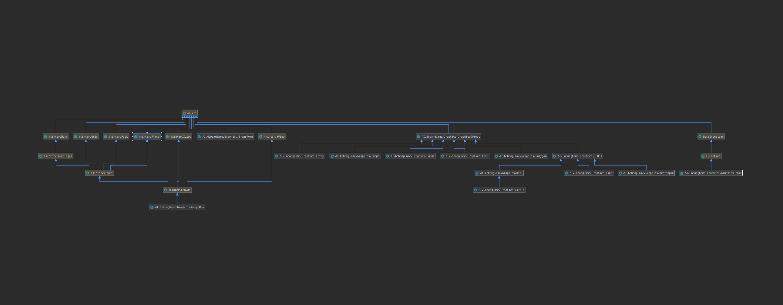

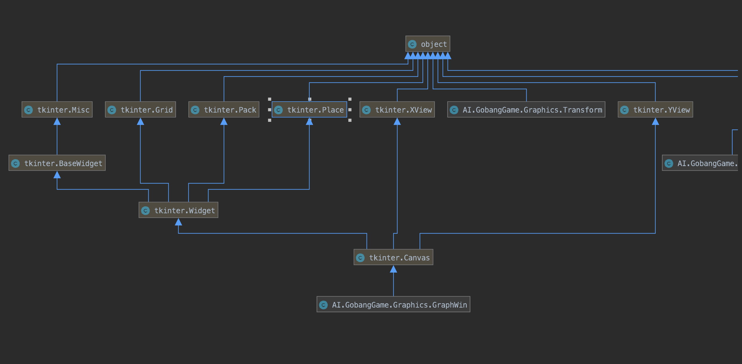

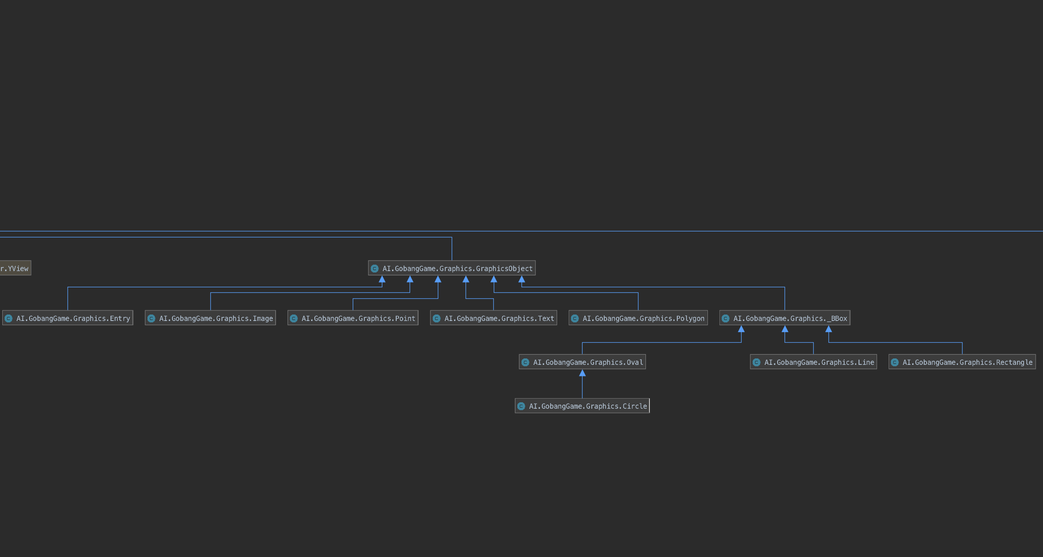

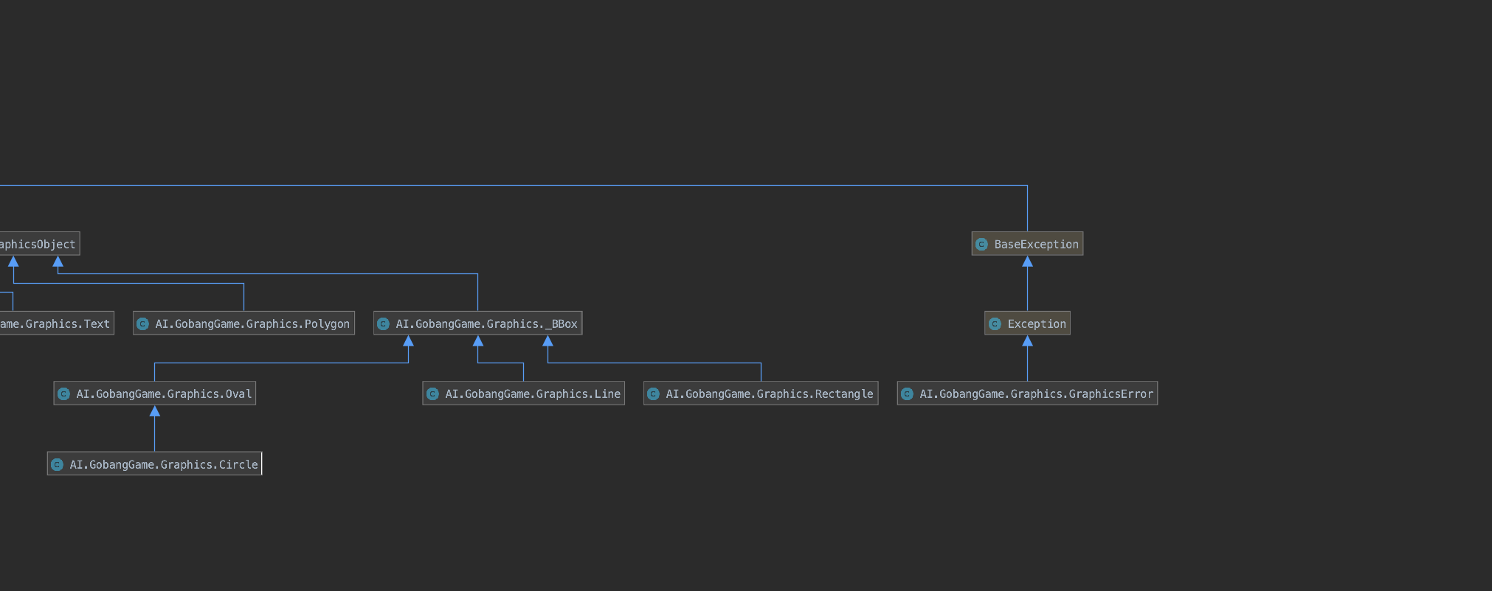

**V. Summary**

**Learning AI is great opportunity for us recognize the new model and digital world, which got me feeling like it’s the crazy thing in the world. In the early period of last AI Course, I’ve learned “Dive into deep learning” written by Mu Li, that was a great book which brought me into the Artificial Intelligence World. And I feel grateful to re-implement some model by myself.**

**由于自己考研原因，其实很想用MXnet 深度学习框架再实现一个 AI 五子棋版本，时间确实比较紧张，而且由于我的macbook-pro 没有 Nvidia GPU，所以如果训练15 * 15，通过self-play 至少要4000 局才能达到80%胜率。训练时间耗时挺长的。所以只做了Minimax Algorithm with alpha-beta-pruning 版本。**

**Reference:**

<https://github.com/junxiaosong/AlphaZero_Gomoku>

<https://aistudio.baidu.com/user/56655/65661/notebooks/65661.ipynb?redirects=1>

**VI. Source Code**

**Alpha-Beta-Algorithm:**

Gomoku.py

from math import *

import numpy as np

from AI.GobangGame.Graphics import *

# global variables here

GRID_WIDTH = 50

COLUMN = 15

ROW = 15

BeanSize = 22

# Gomoku board states

list1 = [] # AI

list2 = [] # human

list3 = [] # all

list_all = [] # all board states

next_point = [0, 0] # next step for AI

ratio = 25 # offense-defense-ratio: offense if ratio > 0 else defense < 0

MAX_SEARCH_DEPTH = 2 # MAX_SEARCH_DEPTH of search

# give scores according to board layout

shape_score = [(50, (0, 1, 1, 0, 0)),

(50, (0, 0, 1, 1, 0)),

(200, (1, 1, 0, 1, 0)),

(500, (0, 0, 1, 1, 1)),

(500, (1, 1, 1, 0, 0)),

(5000, (0, 1, 1, 1, 0)),

(5000, (0, 1, 0, 1, 1, 0)),

(5000, (0, 1, 1, 0, 1, 0)),

(5000, (1, 1, 1, 0, 1)),

(5000, (1, 1, 0, 1, 1)),

(5000, (1, 0, 1, 1, 1)),

(5000, (1, 1, 1, 1, 0)),

(5000, (0, 1, 1, 1, 1)),

(50000, (0, 1, 1, 1, 1, 0)),

(99999999, (1, 1, 1, 1, 1))]

def ai():

global cut_count # total cut num for ai

cut_count = 0

global search_count # total search times for ai

search_count = 0

# negative-max algorithm

negamax(True, MAX_SEARCH_DEPTH, -99999999, 99999999)

print("Total cut times: " + str(cut_count))

print("Total search times: " + str(search_count))

return next_point[0], next_point[1]

def negamax(is_ai, MAX_SEARCH_DEPTH, alpha, beta):

# return evaluation value when the game reaches the end

if game_win(list1) or game_win(list2) or MAX_SEARCH_DEPTH == 0:

return evaluation(is_ai)

# list_all - list3 = {blank_list}

blank_list = list(set(list_all).difference(set(list3)))

order(blank_list)

# traverse all blank space

for next_step in blank_list:

global search_count

search_count += 1

# no action if no neighbor around

if not has_neighbor(next_step):

continue

# check which is gonna go...

if is_ai:

list1.append(next_step)

else:

list2.append(next_step)

list3.append(next_step)

# switch to the opponent mode

value = -negamax(not is_ai, MAX_SEARCH_DEPTH - 1, -beta, -alpha)

if is_ai:

list1.remove(next_step)

else:

list2.remove(next_step)

list3.remove(next_step)

if value > alpha:

print(str(value) + " [alpha: " + str(alpha) + "beta:" + str(

beta) + ']')

print(list3)

# check if not step over max search MAX_SEARCH_DEPTH

if MAX_SEARCH_DEPTH == MAX_SEARCH_DEPTH:

next_point[0] = next_step[0]

next_point[1] = next_step[1]

# alpha-beta pruning

if value >= beta:

global cut_count

cut_count += 1

return beta

alpha = value

return alpha

# order and make a priority for all blank_list to speed-up search efficiency

def order(blank_list):

last_pt = list3[-1]

for item in blank_list:

for i in range(-1, 2):

for j in range(-1, 2):

if i == 0 and j == 0:

continue

if (last_pt[0] + i, last_pt[1] + j) in blank_list:

blank_list.remove((last_pt[0] + i, last_pt[1] + j))

blank_list.insert(0, (last_pt[0] + i, last_pt[1] + j))

def has_neighbor(pt):

for i in range(-1, 2):

for j in range(-1, 2):

if i == 0 and j == 0:

continue

if (pt[0] + i, pt[1] + j) in list3:

return True

return False

def evaluation(is_ai):

total_score = 0

if is_ai:

my_list = list1

enemy_list = list2

else:

my_list = list2

enemy_list = list1

# calculate evaluation value

score_all_arr = []

my_score = 0

for pt in my_list:

m = pt[0]

n = pt[1]

my_score += cal_score(m, n, 0, 1, enemy_list, my_list, score_all_arr)

my_score += cal_score(m, n, 1, 0, enemy_list, my_list, score_all_arr)

my_score += cal_score(m, n, 1, 1, enemy_list, my_list, score_all_arr)

my_score += cal_score(m, n, -1, 1, enemy_list, my_list, score_all_arr)

# calculate evaluation value of opponent

score_all_arr_enemy = []

enemy_score = 0

for pt in enemy_list:

m = pt[0]

n = pt[1]

enemy_score += cal_score(m, n, 0, 1, my_list, enemy_list,

score_all_arr_enemy)

enemy_score += cal_score(m, n, 1, 0, my_list, enemy_list,

score_all_arr_enemy)

enemy_score += cal_score(m, n, 1, 1, my_list, enemy_list,

score_all_arr_enemy)

enemy_score += cal_score(m, n, -1, 1, my_list, enemy_list,

score_all_arr_enemy)

# determine final score

total_score = my_score - enemy_score * ratio * 0.1

return total_score

#

def cal_score(m, n, x_direction, y_direction, enemy_list, my_list, score_all_arr):

add_score = 0

max_score_shape = (0, None)

for item in score_all_arr:

for pt in item[1]:

if m == pt[0] and n == pt[1] and x_direction == item[2][0] \

and y_direction == item[2][1]:

return 0

# check scores around last move

for offset in range(-5, 1):

# offset = -2

pos = []

for i in range(0, 6):

if (m + (i + offset) * x_direction, n + (i + offset) * y_direction) in\

enemy_list:

pos.append(2)

elif (m + (i + offset) * x_direction,

n + (i + offset) * y_direction) in my_list:

pos.append(1)

else:

pos.append(0)

tmp_shap5 = (pos[0], pos[1], pos[2], pos[3], pos[4])

tmp_shap6 = (pos[0], pos[1], pos[2], pos[3], pos[4], pos[5])

for (score, shape) in shape_score:

if tmp_shap5 == shape or tmp_shap6 == shape:

if tmp_shap5 == (1, 1, 1, 1, 1):

print('wwwwwwwwwwwwwwwwwwwwwwwwwww')

print('wwwwwwwwwwwwwwwwwwwwwwwwwww')

print()

if score > max_score_shape[0]:

max_score_shape = (score, (

(m + (0 + offset) * x_direction, n + (0 + offset) * y_direction),

(m + (1 + offset) * x_direction, n + (1 + offset) * y_direction),

(m + (2 + offset) * x_direction, n + (2 + offset) * y_direction),

(m + (3 + offset) * x_direction, n + (3 + offset) * y_direction),

(m + (4 + offset) * x_direction, n + (4 + offset) * y_direction)),

(x_direction, y_direction))

# combine two kind of scores in horizontal and vertical direction

if max_score_shape[1] is not None:

for item in score_all_arr:

for pt1 in item[1]:

for pt2 in max_score_shape[1]:

if pt1 == pt2 and max_score_shape[0] > 10 and item[0] > 10:

add_score += item[0] + max_score_shape[0]

score_all_arr.append(max_score_shape)

return add_score + max_score_shape[0]

# winning board states

def game_win(list):

for m in range(COLUMN):

for n in range(ROW):

if n < ROW - 4 and (m, n) in list and (m, n + 1) in list and (

m, n + 2) in list and (

m, n + 3) in list and (m, n + 4) in list:

return True

elif m < ROW - 4 and (m, n) in list and (m + 1, n) in list and (

m + 2, n) in list and (

m + 3, n) in list and (m + 4, n) in list:

return True

elif m < ROW - 4 and n < ROW - 4 and (m, n) in list and (

m + 1, n + 1) in list and (

m + 2, n + 2) in list and (m + 3, n + 3) in list and (

m + 4, n + 4) in list:

return True

elif m < ROW - 4 and n > 3 and (m, n) in list and (

m + 1, n - 1) in list and (

m + 2, n - 2) in list and (m + 3, n - 3) in list and (

m + 4, n - 4) in list:

return True

return False

# define Gomoku Window

def gomokuWin():

win = GraphWin("Tiny Gomoku Game: ", GRID_WIDTH * COLUMN,

GRID_WIDTH * ROW)

win.setBackground("white")

# horizontalLine verticalLine

horizontalLine = 0

while horizontalLine <= GRID_WIDTH * COLUMN:

l = Line(Point(horizontalLine, 0), Point(horizontalLine, GRID_WIDTH * COLUMN))

l.draw(win)

horizontalLine = horizontalLine + GRID_WIDTH

verticalLine = 0

while verticalLine <= GRID_WIDTH * ROW:

l = Line(Point(0, verticalLine), Point(GRID_WIDTH * ROW, verticalLine))

l.draw(win)

verticalLine = verticalLine + GRID_WIDTH

return win

def main():

startTime = time.time()

try:

win = gomokuWin()

for i in range(COLUMN + 1):

for j in range(ROW + 1):

list_all.append((i, j))

change = 0

GAMEOVER = 0

m = 0

n = 0

# GAMEOVER == 1 game over

while GAMEOVER == 0:

# step alternatively

if change % 2 == 1:

# ai turn

pos = ai()

# duplicate position

if pos in list3:

message = Text(Point(200, 200),

"dessert position" + str(pos[0]) + "," + str(

pos[1]))

message.draw(win)

GAMEOVER = 1

list1.append(pos)

list3.append(pos)

''''

draw white node

'''

piece = Circle(Point(GRID_WIDTH * pos[0], GRID_WIDTH * pos[1]), BeanSize)

piece.setFill('white')

piece.draw(win)

if game_win(list1):

message = Text(Point(100, 100), "white Win :)")

message.draw(win)

GAMEOVER = 1

change = change + 1

else:

# get the position of current user

p2 = win.getMouse()

if not ((round((p2.getX()) / GRID_WIDTH),

round((p2.getY()) / GRID_WIDTH)) in list3):

# get user move pos

a2 = round((p2.getX()) / GRID_WIDTH)

b2 = round((p2.getY()) / GRID_WIDTH)

list2.append((a2, b2))

list3.append((a2, b2))

piece = Circle(Point(GRID_WIDTH * a2, GRID_WIDTH * b2), BeanSize)

piece.setFill('black')

piece.draw(win)

if game_win(list2):

message = Text(Point(100, 100), "Black Win (:")

message.draw(win)

GAMEOVER = 1

change = change + 1

message = Text(Point(100, 140), "Thanks for having fun with Gomoku ^-^.")

message.draw(win)

win.getMouse()

win.close()

except KeyboardInterrupt:

print("Bye")

endTime = time.time()

print("Total Time: {}s".format(endTime - startTime))

main()

**Graphics.py:**

# graphics.py

__version__ = "5.0"

import time

import os

import sys

try: # import as appropriate for 2.x vs. 3.x

import tkinter as tk

except:

import Tkinter as tk

##########################################################################

# Module Exceptions

class GraphicsError(Exception):

"""Generic error class for graphics module exceptions."""

pass

OBJ_ALREADY_DRAWN = "Object currently drawn"

UNSUPPORTED_METHOD = "Object doesn't support operation"

BAD_OPTION = "Illegal option value"

##########################################################################

# global variables and functions

_root = tk.Tk()

_root.withdraw()

_update_lasttime = time.time()

def update(rate=None):

global _update_lasttime

if rate:

now = time.time()

pauseLength = 1 / rate - (now - _update_lasttime)

if pauseLength > 0:

time.sleep(pauseLength)

_update_lasttime = now + pauseLength

else:

_update_lasttime = now

_root.update()

############################################################################

# Graphics classes start here

class GraphWin(tk.Canvas):

"""A GraphWin is a toplevel window for displaying graphics."""

def __init__(self, title="Graphics Window",

width=200, height=200, autoflush=True):

assert type(title) == type(""), "Title must be a string"

master = tk.Toplevel(_root)

master.protocol("WM_DELETE_WINDOW", self.close)

tk.Canvas.__init__(self, master, width=width, height=height,

highlightthickness=0, bd=0)

self.master.title(title)

self.pack()

master.resizable(0, 0)

self.foreground = "black"

self.items = []

self.mouseX = None

self.mouseY = None

self.bind("<Button-1>", self._onClick)

self.bind_all("<Key>", self._onKey)

self.height = int(height)

self.width = int(width)

self.autoflush = autoflush

self._mouseCallback = None

self.trans = None

self.closed = False

master.lift()

self.lastKey = ""

if autoflush: _root.update()

def __repr__(self):

if self.isClosed():

return "<Closed GraphWin>"

else:

return "GraphWin('{}', {}, {})".format(self.master.title(),

self.getWidth(),

self.getHeight())

def __str__(self):

return repr(self)

def __checkOpen(self):

if self.closed:

raise GraphicsError("window is closed")

def _onKey(self, evnt):

self.lastKey = evnt.keysym

def setBackground(self, color):

"""Set background color of the window"""

self.__checkOpen()

self.config(bg=color)

self.__autoflush()

def setCoords(self, x1, y1, x2, y2):

"""Set coordinates of window to run from (x1,y1) in the

lower-left corner to (x2,y2) in the upper-right corner."""

self.trans = Transform(self.width, self.height, x1, y1, x2, y2)

self.redraw()

def close(self):

"""Close the window"""

if self.closed: return

self.closed = True

self.master.destroy()

self.__autoflush()

def isClosed(self):

return self.closed

def isOpen(self):

return not self.closed

def __autoflush(self):

if self.autoflush:

_root.update()

def plot(self, x, y, color="black"):

"""Set pixel (x,y) to the given color"""

self.__checkOpen()

xs, ys = self.toScreen(x, y)

self.create_line(xs, ys, xs + 1, ys, fill=color)

self.__autoflush()

def plotPixel(self, x, y, color="black"):

"""Set pixel raw (independent of window coordinates) pixel

(x,y) to color"""

self.__checkOpen()

self.create_line(x, y, x + 1, y, fill=color)

self.__autoflush()

def flush(self):

"""Update drawing to the window"""

self.__checkOpen()

self.update_idletasks()

def getMouse(self):

"""Wait for mouse click and return Point object representing

the click"""

self.update() # flush any prior clicks

self.mouseX = None

self.mouseY = None

while self.mouseX == None or self.mouseY == None:

self.update()

if self.isClosed(): raise GraphicsError("getMouse in closed window")

time.sleep(.1) # give up thread

x, y = self.toWorld(self.mouseX, self.mouseY)

self.mouseX = None

self.mouseY = None

return Point(x, y)

def checkMouse(self):

"""Return last mouse click or None if mouse has

not been clicked since last call"""

if self.isClosed():

raise GraphicsError("checkMouse in closed window")

self.update()

if self.mouseX != None and self.mouseY != None:

x, y = self.toWorld(self.mouseX, self.mouseY)

self.mouseX = None

self.mouseY = None

return Point(x, y)

else:

return None

def getKey(self):

"""Wait for user to press a key and return it as a string."""

self.lastKey = ""

while self.lastKey == "":

self.update()

if self.isClosed(): raise GraphicsError("getKey in closed window")

time.sleep(.1) # give up thread

key = self.lastKey

self.lastKey = ""

return key

def checkKey(self):

"""Return last key pressed or None if no key pressed since last call"""

if self.isClosed():

raise GraphicsError("checkKey in closed window")

self.update()

key = self.lastKey

self.lastKey = ""

return key

def getHeight(self):

"""Return the height of the window"""

return self.height

def getWidth(self):

"""Return the width of the window"""

return self.width

def toScreen(self, x, y):

trans = self.trans

if trans:

return self.trans.screen(x, y)

else:

return x, y

def toWorld(self, x, y):

trans = self.trans

if trans:

return self.trans.world(x, y)

else:

return x, y

def setMouseHandler(self, func):

self._mouseCallback = func

def _onClick(self, e):

self.mouseX = e.x

self.mouseY = e.y

if self._mouseCallback:

self._mouseCallback(Point(e.x, e.y))

def addItem(self, item):

self.items.append(item)

def delItem(self, item):

self.items.remove(item)

def redraw(self):

for item in self.items[:]:

item.undraw()

item.draw(self)

self.update()

class Transform:

"""Internal class for 2-D coordinate transformations"""

def __init__(self, w, h, xlow, ylow, xhigh, yhigh):

# w, h are width and height of window

# (xlow,ylow) coordinates of lower-left [raw (0,h-1)]

# (xhigh,yhigh) coordinates of upper-right [raw (w-1,0)]

xspan = (xhigh - xlow)

yspan = (yhigh - ylow)

self.xbase = xlow

self.ybase = yhigh

self.xscale = xspan / float(w - 1)

self.yscale = yspan / float(h - 1)

def screen(self, x, y):

# Returns x,y in screen (actually window) coordinates

xs = (x - self.xbase) / self.xscale

ys = (self.ybase - y) / self.yscale

return int(xs + 0.5), int(ys + 0.5)

def world(self, xs, ys):

# Returns xs,ys in world coordinates

x = xs * self.xscale + self.xbase

y = self.ybase - ys * self.yscale

return x, y

# Default values for various item configuration options. Only a subset of

# keys may be present in the configuration dictionary for a given item

DEFAULT_CONFIG = {"fill": "",

"outline": "black",

"width": "1",

"arrow": "none",

"text": "",

"justify": "center",

"font": ("helvetica", 12, "normal")}

class GraphicsObject:

"""Generic base class for all of the drawable objects"""

# A subclass of GraphicsObject should override _draw and

# and _move methods.

def __init__(self, options):

# options is a list of strings indicating which options are

# legal for this object.

# When an object is drawn, canvas is set to the GraphWin(canvas)

# object where it is drawn and id is the TK identifier of the

# drawn shape.

self.canvas = None

self.id = None

# config is the dictionary of configuration options for the widget.

config = {}

for option in options:

config[option] = DEFAULT_CONFIG[option]

self.config = config

def setFill(self, color):

"""Set interior color to color"""

self._reconfig("fill", color)

def setOutline(self, color):

"""Set outline color to color"""

self._reconfig("outline", color)

def setWidth(self, width):

"""Set line weight to width"""

self._reconfig("width", width)

def draw(self, graphwin):

"""Draw the object in graphwin, which should be a GraphWin

object. A GraphicsObject may only be drawn into one

window. Raises an error if attempt made to draw an object that

is already visible."""

if self.canvas and not self.canvas.isClosed(): raise GraphicsError(

OBJ_ALREADY_DRAWN)

if graphwin.isClosed(): raise GraphicsError(

"Can't draw to closed window")

self.canvas = graphwin

self.id = self._draw(graphwin, self.config)

graphwin.addItem(self)

if graphwin.autoflush:

_root.update()

return self

def undraw(self):

"""Undraw the object (i.e. hide it). Returns silently if the

object is not currently drawn."""

if not self.canvas: return

if not self.canvas.isClosed():

self.canvas.delete(self.id)

self.canvas.delItem(self)

if self.canvas.autoflush:

_root.update()

self.canvas = None

self.id = None

def move(self, dx, dy):

"""move object dx units in x direction and dy units in y

direction"""

self._move(dx, dy)

canvas = self.canvas

if canvas and not canvas.isClosed():

trans = canvas.trans

if trans:

x = dx / trans.xscale

y = -dy / trans.yscale

else:

x = dx

y = dy

self.canvas.move(self.id, x, y)

if canvas.autoflush:

_root.update()

def _reconfig(self, option, setting):

# Internal method for changing configuration of the object

# Raises an error if the option does not exist in the config

# dictionary for this object

if option not in self.config:

raise GraphicsError(UNSUPPORTED_METHOD)

options = self.config

options[option] = setting

if self.canvas and not self.canvas.isClosed():

self.canvas.itemconfig(self.id, options)

if self.canvas.autoflush:

_root.update()

def _draw(self, canvas, options):

"""draws appropriate figure on canvas with options provided

Returns Tk id of item drawn"""

pass # must override in subclass

def _move(self, dx, dy):

"""updates internal state of object to move it dx,dy units"""

pass # must override in subclass

class Point(GraphicsObject):

def __init__(self, x, y):

GraphicsObject.__init__(self, ["outline", "fill"])

self.setFill = self.setOutline

self.x = float(x)

self.y = float(y)

def __repr__(self):

return "Point({}, {})".format(self.x, self.y)

def _draw(self, canvas, options):

x, y = canvas.toScreen(self.x, self.y)

return canvas.create_rectangle(x, y, x + 1, y + 1, options)

def _move(self, dx, dy):

self.x = self.x + dx

self.y = self.y + dy

def clone(self):

other = Point(self.x, self.y)

other.config = self.config.copy()

return other

def getX(self): return self.x

def getY(self): return self.y

class _BBox(GraphicsObject):

# Internal base class for objects represented by bounding box

# (opposite corners) Line segment is a degenerate case.

def __init__(self, p1, p2, options=["outline", "width", "fill"]):

GraphicsObject.__init__(self, options)

self.p1 = p1.clone()

self.p2 = p2.clone()

def _move(self, dx, dy):

self.p1.x = self.p1.x + dx

self.p1.y = self.p1.y + dy

self.p2.x = self.p2.x + dx

self.p2.y = self.p2.y + dy

def getP1(self): return self.p1.clone()

def getP2(self): return self.p2.clone()

def getCenter(self):

p1 = self.p1

p2 = self.p2

return Point((p1.x + p2.x) / 2.0, (p1.y + p2.y) / 2.0)

class Rectangle(_BBox):

def __init__(self, p1, p2):

_BBox.__init__(self, p1, p2)

def __repr__(self):

return "Rectangle({}, {})".format(str(self.p1), str(self.p2))

def _draw(self, canvas, options):

p1 = self.p1

p2 = self.p2

x1, y1 = canvas.toScreen(p1.x, p1.y)

x2, y2 = canvas.toScreen(p2.x, p2.y)

return canvas.create_rectangle(x1, y1, x2, y2, options)

def clone(self):

other = Rectangle(self.p1, self.p2)

other.config = self.config.copy()

return other

class Oval(_BBox):

def __init__(self, p1, p2):

_BBox.__init__(self, p1, p2)

def __repr__(self):

return "Oval({}, {})".format(str(self.p1), str(self.p2))

def clone(self):

other = Oval(self.p1, self.p2)

other.config = self.config.copy()

return other

def _draw(self, canvas, options):

p1 = self.p1

p2 = self.p2

x1, y1 = canvas.toScreen(p1.x, p1.y)

x2, y2 = canvas.toScreen(p2.x, p2.y)

return canvas.create_oval(x1, y1, x2, y2, options)

class Circle(Oval):

def __init__(self, center, radius):

p1 = Point(center.x - radius, center.y - radius)

p2 = Point(center.x + radius, center.y + radius)

Oval.__init__(self, p1, p2)

self.radius = radius

def __repr__(self):

return "Circle({}, {})".format(str(self.getCenter()), str(self.radius))

def clone(self):

other = Circle(self.getCenter(), self.radius)

other.config = self.config.copy()

return other

def getRadius(self):

return self.radius

class Line(_BBox):

def __init__(self, p1, p2):

_BBox.__init__(self, p1, p2, ["arrow", "fill", "width"])

self.setFill(DEFAULT_CONFIG['outline'])

self.setOutline = self.setFill

def __repr__(self):

return "Line({}, {})".format(str(self.p1), str(self.p2))

def clone(self):

other = Line(self.p1, self.p2)

other.config = self.config.copy()

return other

def _draw(self, canvas, options):

p1 = self.p1

p2 = self.p2

x1, y1 = canvas.toScreen(p1.x, p1.y)

x2, y2 = canvas.toScreen(p2.x, p2.y)

return canvas.create_line(x1, y1, x2, y2, options)

def setArrow(self, option):

if not option in ["first", "last", "both", "none"]:

raise GraphicsError(BAD_OPTION)

self._reconfig("arrow", option)

class Polygon(GraphicsObject):

def __init__(self, *points):

# if points passed as a list, extract it

if len(points) == 1 and type(points[0]) == type([]):

points = points[0]

self.points = list(map(Point.clone, points))

GraphicsObject.__init__(self, ["outline", "width", "fill"])

def __repr__(self):

return "Polygon" + str(tuple(p for p in self.points))

def clone(self):

other = Polygon(*self.points)

other.config = self.config.copy()

return other

def getPoints(self):

return list(map(Point.clone, self.points))

def _move(self, dx, dy):

for p in self.points:

p.move(dx, dy)

def _draw(self, canvas, options):

args = [canvas]

for p in self.points:

x, y = canvas.toScreen(p.x, p.y)

args.append(x)

args.append(y)

args.append(options)

return GraphWin.create_polygon(*args)

class Text(GraphicsObject):

def __init__(self, p, text):

GraphicsObject.__init__(self, ["justify", "fill", "text", "font"])

self.setText(text)

self.anchor = p.clone()

self.setFill(DEFAULT_CONFIG['outline'])

self.setOutline = self.setFill

def __repr__(self):

return "Text({}, '{}')".format(self.anchor, self.getText())

def _draw(self, canvas, options):

p = self.anchor

x, y = canvas.toScreen(p.x, p.y)

return canvas.create_text(x, y, options)

def _move(self, dx, dy):

self.anchor.move(dx, dy)

def clone(self):

other = Text(self.anchor, self.config['text'])

other.config = self.config.copy()

return other

def setText(self, text):

self._reconfig("text", text)

def getText(self):

return self.config["text"]

def getAnchor(self):

return self.anchor.clone()

def setFace(self, face):

if face in ['helvetica', 'arial', 'courier', 'times roman']:

f, s, b = self.config['font']

self._reconfig("font", (face, s, b))

else:

raise GraphicsError(BAD_OPTION)

def setSize(self, size):

if 5 <= size <= 36:

f, s, b = self.config['font']

self._reconfig("font", (f, size, b))

else:

raise GraphicsError(BAD_OPTION)

def setStyle(self, style):

if style in ['bold', 'normal', 'italic', 'bold italic']:

f, s, b = self.config['font']

self._reconfig("font", (f, s, style))

else:

raise GraphicsError(BAD_OPTION)

def setTextColor(self, color):

self.setFill(color)

class Entry(GraphicsObject):

def __init__(self, p, width):

GraphicsObject.__init__(self, [])

self.anchor = p.clone()

# print self.anchor

self.width = width

self.text = tk.StringVar(_root)

self.text.set("")

self.fill = "gray"

self.color = "black"

self.font = DEFAULT_CONFIG['font']

self.entry = None

def __repr__(self):

return "Entry({}, {})".format(self.anchor, self.width)

def _draw(self, canvas, options):

p = self.anchor

x, y = canvas.toScreen(p.x, p.y)

frm = tk.Frame(canvas.master)

self.entry = tk.Entry(frm,

width=self.width,

textvariable=self.text,

bg=self.fill,

fg=self.color,

font=self.font)

self.entry.pack()

# self.setFill(self.fill)

self.entry.focus_set()

return canvas.create_window(x, y, window=frm)

def getText(self):

return self.text.get()

def _move(self, dx, dy):

self.anchor.move(dx, dy)

def getAnchor(self):

return self.anchor.clone()

def clone(self):

other = Entry(self.anchor, self.width)

other.config = self.config.copy()

other.text = tk.StringVar()

other.text.set(self.text.get())

other.fill = self.fill

return other

def setText(self, t):

self.text.set(t)

def setFill(self, color):

self.fill = color

if self.entry:

self.entry.config(bg=color)

def _setFontComponent(self, which, value):

font = list(self.font)

font[which] = value

self.font = tuple(font)

if self.entry:

self.entry.config(font=self.font)

def setFace(self, face):

if face in ['helvetica', 'arial', 'courier', 'times roman']:

self._setFontComponent(0, face)

else:

raise GraphicsError(BAD_OPTION)

def setSize(self, size):

if 5 <= size <= 36:

self._setFontComponent(1, size)

else:

raise GraphicsError(BAD_OPTION)

def setStyle(self, style):

if style in ['bold', 'normal', 'italic', 'bold italic']:

self._setFontComponent(2, style)

else:

raise GraphicsError(BAD_OPTION)

def setTextColor(self, color):

self.color = color

if self.entry:

self.entry.config(fg=color)

class Image(GraphicsObject):

idCount = 0

imageCache = {} # tk photoimages go here to avoid GC while drawn

def __init__(self, p, *pixmap):

GraphicsObject.__init__(self, [])

self.anchor = p.clone()

self.imageId = Image.idCount

Image.idCount = Image.idCount + 1

if len(pixmap) == 1: # file name provided

self.img = tk.PhotoImage(file=pixmap[0], master=_root)

else: # width and height provided

width, height = pixmap

self.img = tk.PhotoImage(master=_root, width=width, height=height)

def __repr__(self):

return "Image({}, {}, {})".format(self.anchor, self.getWidth(),

self.getHeight())

def _draw(self, canvas, options):

p = self.anchor

x, y = canvas.toScreen(p.x, p.y)

self.imageCache[self.imageId] = self.img # save a reference

return canvas.create_image(x, y, image=self.img)

def _move(self, dx, dy):

self.anchor.move(dx, dy)

def undraw(self):

try:

del self.imageCache[self.imageId] # allow gc of tk photoimage

except KeyError:

pass

GraphicsObject.undraw(self)

def getAnchor(self):

return self.anchor.clone()

def clone(self):

other = Image(Point(0, 0), 0, 0)

other.img = self.img.copy()

other.anchor = self.anchor.clone()

other.config = self.config.copy()

return other

def getWidth(self):

"""Returns the width of the image in pixels"""

return self.img.width()

def getHeight(self):

"""Returns the height of the image in pixels"""

return self.img.height()

def getPixel(self, x, y):

"""Returns a list [r,g,b] with the RGB color values for pixel (x,y)

r,g,b are in range(256)

"""

value = self.img.get(x, y)

if type(value) == type(0):

return [value, value, value]

elif type(value) == type((0, 0, 0)):

return list(value)

else:

return list(map(int, value.split()))

def setPixel(self, x, y, color):

"""Sets pixel (x,y) to the given color

"""

self.img.put("{" + color + "}", (x, y))

def save(self, filename):

"""Saves the pixmap image to filename.

The format for the save image is determined from the filname extension.

"""

path, name = os.path.split(filename)

ext = name.split(".")[-1]

self.img.write(filename, format=ext)

def color_rgb(r, g, b):

"""r,g,b are intensities of red, green, and blue in range(256)

Returns color specifier string for the resulting color"""

return "#%02x%02x%02x" % (r, g, b)

# MacOS fix 2

# tk.Toplevel(_root).destroy()

# MacOS fix 1

update()