Cross-fitted selective recovery for fault-tolerant multi-sensor fusion under sensor corruption
Riyang Luo*
School of Mechanical and Power Engineering, Nanjing Tech University, 30 South Puzhu Road, Nanjing 211816, Jiangsu Province, China
*Corresponding author: lry@njtech.edu.cn

Abstract
An available sensor can remain numerically plausible while corrupted, and unconditional recovery can overturn a correct decision. We combine paired clean–faulted training with a cross-fitted fallback that chooses between a bounded base model and its recovery-supervised counterpart without test labels or fault types. The strict primary set contains 1,436 held-out observations with controlled faults on available sensor groups. Under Gaussian corruption, unconditional recovery improved the macro-averaged receiver-operating-characteristic area by 0.0143 over the base model in all 10 matched fits (P = 0.00195); the selective fallback retained a 0.0066 gain. Across four controlled mechanisms, a crossed fault-by-model-seed bootstrap estimated that the fallback prevented 90.3% of negative transfers (95% interval 82.3–95.2%) while retaining 14.4% of available corrections (5.6–26.2%). Its corresponding gain over the base model was 0.00483 (0.00166–0.00780), whereas its difference from unconditional recovery crossed zero. In complete streams at 40% fault prevalence, it prevented 185.6 harmful decisions, retained 20.9 corrections and produced 3.4 net additional correct decisions per 10,000 observations. On a no-fault stream with matched group missingness, the harmful-switch rate was 0.14%. This protection requires six forward passes for four sensor groups and approximately twice the stored parameters. The evidence supports a conservative recovery decision under controlled corruption, not device-independent natural-failure generalization.
Keywords: multi-sensor fusion; sensor corruption; fault-tolerant classification; selective recovery; negative transfer; cross-fitting

1 Introduction
Scientific and industrial systems increasingly combine several channels whose availability and fidelity can change after deployment. Missing inputs, delayed diagnostics and distribution shifts can invalidate a model even when its architecture performs well on a static benchmark [1–4]. This problem is distinct from ordinary random missingness because a faulty sensor can remain present and produce plausible but biased, clipped, noisy or unresponsive measurements. A robust fusion rule must therefore decide not only whether a channel exists, but how strongly it should influence the prediction.
Several training strategies improve tolerance to absent or inconsistent sources. Modality dropout, masking and self-distillation expose models to missing inputs [5–7]. Representation refinement, gradient decoupling and expert routing address source imbalance or train–test mismatch [8–11]. Reliability-aware fusion additionally uses predictive uncertainty, learned credibility or rejection [12–17]. Quality-aware multimodal fusion (QMF) provides a published failure-aware comparator by deriving modality confidence from predictive energy and aligning confidence with historical loss trajectories [18]. These approaches establish useful design patterns, but they do not make an arbitrary weighting response physically calibrated or comparable across sensors.
Sensor-fault diagnosis has a complementary engineering literature. Redundant sensor networks can localize offset, drift, noise, peaks and stuck responses, and can distinguish local sensor faults from global system changes [19–21]. Hydraulic condition-monitoring studies further show the value of heterogeneous pressure, flow, temperature, power and vibration measurements for component-state classification [22–25]. These studies motivate physically defined sensor groups and independent condition-monitoring validation rather than arbitrary computational groupings alone.
Most open benchmarks nevertheless encode sensor failure through simulation, laboratory intervention or post hoc feature corruption. A recent public AHU resource instead provides one year of building-management-system records from an office, an auditorium and a hospital, with return- and supply-air temperature sensor faults annotated by experienced HVAC engineers [26, 27]. These labels create a useful external field test, although they are rule- and expert-adjudicated operational annotations rather than maintenance-confirmed hardware replacement events.
Recent AHU studies show that the direct diagnosis problem differs from fault-tolerant recovery. Transformer models can exploit long temporal dependencies within a continuously operating hospital, while attention-based transfer and temporal–contextual learning explicitly address building shift and limited labels [28–30]. These architectures preserve fault signatures to identify the failure itself. In contrast, fault-tolerant classification seeks to suppress corrupted evidence while retaining another target, so superiority in one task need not transfer to the other.
We study paired-degradation responsive fusion (PDRF). “Responsive” denotes an operational change in fusion weight after a controlled sensor degradation; it does not imply physical health, calibrated risk or sensor variance. Each training observation is paired with a view in which one available sensor group is degraded. The model learns a bounded response, and directional losses encourage the affected sensor’s response to rise and its fusion weight to fall. The formulation does not invoke an identifiable causal counterfactual. Predictive calibration is evaluated separately because discrimination, uncertainty and calibration are different properties [31–37].
The study makes four contributions. First, it defines the available-but-corrupted recovery problem and reports a strict estimand containing only observations for which a controlled fault was applied to an available group. Second, it introduces a selective recovery layer whose preference scores are cross-fitted before threshold selection, separating coefficient estimation from threshold tuning. Third, it evaluates that layer on clean and mixed deployment streams, leave-one-fault-family-out transfer, three unseen corruption mechanisms and simple confidence, entropy, disagreement and random-selection baselines. Fourth, it separates the recovery objective from architecture through gated, attention and multi-expert controls, while retaining the bounded implementation’s explicit monotonicity and finite equal-quality weight ratio. Optimization seeds, fault realizations, acquisition batches and guarded hydraulic blocks are reported at their actual evidence levels. Expert-annotated air-handling-unit diagnosis remains a negative task boundary because it lacks an independent downstream recovery target.

2 Related work

2.1 Missing and unreliable sensor inputs
Missing-data mechanisms affect the interpretation of any robustness experiment [38]. Random sensor dropout tests tolerance to absent channels, whereas the present study targets channels that remain available but become corrupted. Corruption augmentation and consistency distillation can improve this setting, but they can also make an apparently novel fusion rule indistinguishable from robust training. Our comparator design therefore gives the main gates identical paired degradations, labels, minibatches and additional forward passes, and separately evaluates early and uniform fusion with clean distillation and modality-dropout self-distillation.

2.2 Bounded operational responses and probability calibration
Input-dependent losses can represent aleatoric variation when their probabilistic assumptions are valid [31, 32]. PDRF instead uses a bounded operational response solely for weighting. We assess response–noise ordering, sensor localization, monotonicity and a post-hoc isotonic mapping to known synthetic noise. These audits do not convert the response into a physical variance. Likewise, expected calibration error depends on binning and can conceal multiclass structure [37]. Multiclass Dirichlet calibration can alter all class probabilities jointly, while calibrated classifier sets can be viewed through convex combinations of their members [39, 40]. We therefore report NLL, Brier score, several ECE definitions and both raw and temperature-scaled probabilities, and we evaluate calibration-set stacking separately from the prespecified single-model comparison.
We additionally distinguish learned gating from predictive-uncertainty weighting. The ENT-PD comparator assigns each available group a positive weight that decreases with its normalized predictive entropy and receives the same paired degradation, consistency and normalized-weight monotonicity supervision as the other corruption-trained models. Deep ensembles quantify variation across independently fitted members [33]; split-conformal prediction sets provide a separate coverage-oriented deployment diagnostic, whose exchangeability assumptions may fail under building shift [41]. Neither construction is interpreted as physical sensor health.
Cross-building deployment introduces a different problem: domain shift. CORAL aligns second-order source and target statistics without target labels [42]; GroupDRO minimizes the worst empirical loss across prespecified source groups [43]; and target-statistic normalization can adapt a frozen prediction pipeline to an unlabeled target stream [44]. These approaches answer different questions. GroupDRO is source-only robustness, whereas CORAL and target normalization consume unlabeled target-building features and are therefore unsupervised adaptation, not zero-shot evaluation.

2.3 Selective prediction and model fallback
Selective classification and reject-option learning trade coverage for lower predictive risk [45–47]; recent work additionally studies selection under distribution shift [48]. Learning-to-defer methods route difficult cases to a human or another expert whose error pattern may differ from that of the primary predictor [49, 50]. Classifier cascades explicitly trade predictive accuracy against evaluation cost, while dynamic classifier and ensemble selection estimate which member is locally competent [51, 52]. Mixture-of-experts routing provides a related differentiable allocation mechanism [14]. The present fallback problem is narrower: both endpoints are fixed models of the same sensor-fusion task, no observation is rejected, and the selector specifically controls recovery-induced negative transfer while retaining corrections. Its operating curve is therefore prevention versus retained recovery, rather than conventional risk versus coverage, human deferral utility or average cascade cost.

2.4 Evidence and statistical estimands
Classifier comparisons can change with the resampling unit and evaluation estimand [53, 54]. Optimization seeds describe repeated fitting, whereas sample bootstrap intervals describe a fixed set of fitted predictors [55]. McNemar’s paired test evaluates discordant hard decisions on the same observations [56]. We report these levels separately and do not treat observations from one instrument as independent devices. Precision–recall metrics are included because class imbalance can make ROC summaries incomplete [57].

3 Methods

3.1 Problem definition
For observation i and sensor group m, let x_{im} ∈ℝ^{d} be the feature vector, a_{im} ∈{0,1} the availability indicator, q_{im} ∈ (0,1] an optional diagnostic-quality covariate and y_{i} ∈{1,…,C} the target. PDRF estimates
(1)
When no quality metadata are available, all q_{im} equal one. Every evaluated observation contains at least one available group. If all groups are unavailable, the implementation abstains before inference because normalized fusion is undefined.

3.2 Architecture and bounded weighting
Each sensor group is encoded by two fully connected layers, d → 64 → 32, with ReLU activations and no normalization or dropout. A 32 →C head produces group-specific logits μ_{im}. A 32 → 16 → 1 ReLU head produces the raw response u_{im}. The bounded operational response is
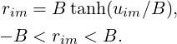 | (2)
where the prespecified main setting uses B = 3. Unnormalized and normalized weights are
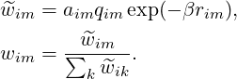 | (3)
with β = 0.25. Fused logits are ℓ_{i} = ∑ _{m}w_{im}μ_{im}. The implementation applies a 10⁻⁶ lower guard to the normalization denominator, but the guard is inactive under the stated input constraints because every observation has at least one available group and q_{im} ≥ 0.01 after clipping.
This construction differs from an unconstrained softmax gate in three testable ways. First, the weight is factorized into availability, an optional externally measured quality term and one bounded operational response; it is not an unrestricted function of the concatenated sensor representation. Second, the perturbed group is known during paired degradation, so its response and normalized weight receive directional supervision rather than only a task-gradient signal. Third, the same response that controls fusion is regularized by a group-specific predictive loss. Thus the response is operationally coupled to group evidence, although it is not asserted to be a physical health variable.
The factorization also gives two elementary stability properties. For an available group, fixed q and any k≠m,
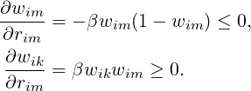 | (4)
For two available groups with equal quality, bounded responses imply
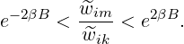 | (5)
At B = 3 and β = 0.25, one response alone can therefore create at most a 4.48-fold unnormalized-weight ratio between equal-quality groups. These properties do not guarantee that the learned ordering is correct; the experiments separately test that question.
The response regularizer, retained as ℒ_{score} in the implementation for reproducibility, combines a bounded heteroscedastic-style term and a boundary penalty. For a minibatch ℬ, write s_{im} = ω_{yi}[−log softmax(μ_{im})_{yi}], where ω_{c} = n∕(Cn_{c}) is the training-set class weight, and let h_{im} = e^{−r}_{im}s_{im} + r_{im}. Then
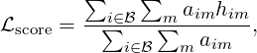 | (6)

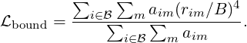 | (7)
Because cross-entropy is non-negative and r_{im} > −B, ℒ_{score} > −B. The complete objective therefore has a finite lower bound. This statement concerns optimization stability, not calibration of the bounded operational response.

3.3 Paired degradation and directional losses
For each minibatch observation, one available group m∗ is drawn from a fixed training prior. A retention factor ρ_{i} ∼ Uniform(0.15,0.50) controls additive Gaussian degradation with scale 2.5(1 −ρ_{i}). In half of the pairs, q_{im}∗ is multiplied by ρ_{i}; otherwise it is unchanged. Let primed symbols denote the degraded view and d_{i} = 1 −ρ_{i}.
The clean and degraded task losses use the class-weighted mean implemented by PyTorch. With e_{i}(ℓ) = −log softmax(ℓ)_{yi},
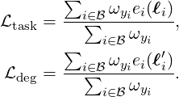 | (8)
Let 𝒱_{ℬ} = {i ∈ℬ : ∑ _{m}a_{im} > 1} denote observations for which the selected group can be removed while another group remains. For i ∈𝒱_{ℬ}, the removal prediction p_{i}^{(−m∗)} defines a severity-interpolated target t_{i}; write _{i} = stopgrad(t_{i}):
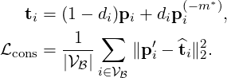 | (9)
If 𝒱_{ℬ} is empty, ℒ_{cons} and the removal-dependent directional terms are omitted, equivalently set to zero. Directional terms operate on the affected normalized weight and raw response and are averaged over eligible observations. With [z]₊ = max(0,z) and Δw_{i} = w′_{im}∗−w_{im}∗,
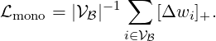 | (10)
With γ_{i} = 0.5d_{i}∕0.85 and Δr_{i} = stopgrad(r_{im}∗) −r′_{im}∗, the response-ranking term is
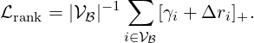 | (11)
The final loss is
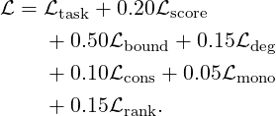 | (12)
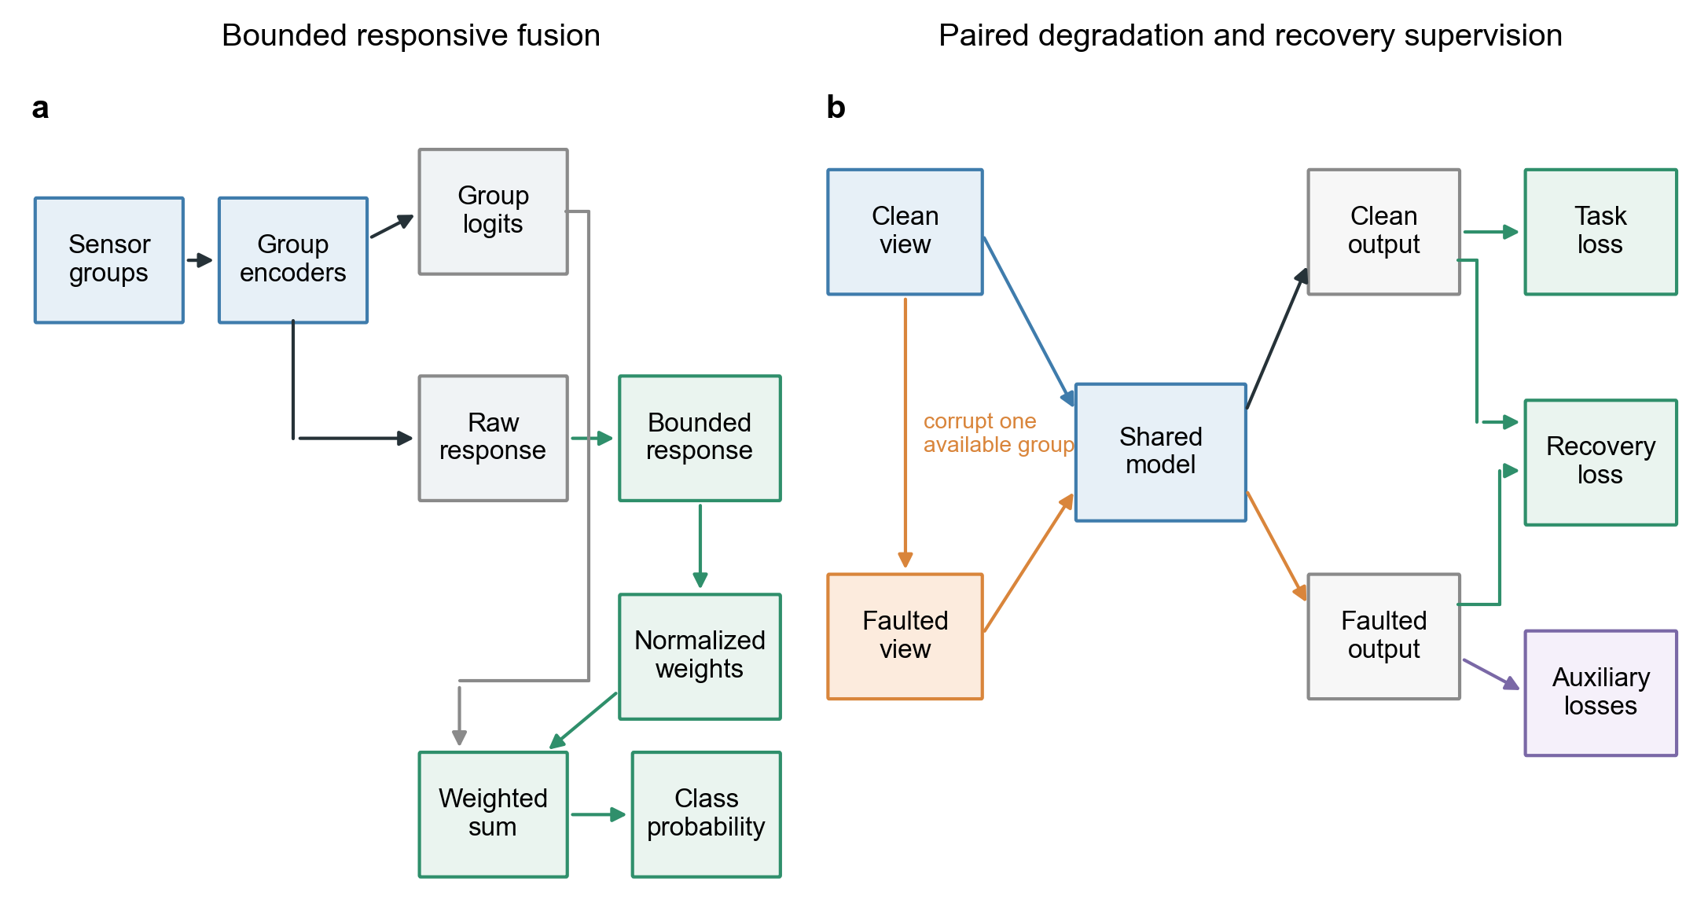
Figure 1: Bounded responsive fusion and recovery supervision. a, Each sensor group produces class logits and a bounded operational response. Availability, optional diagnostic quality and the response determine normalized fusion weights. Distinct connector ports separate the logit and weight contributions to the fused prediction. b, Clean and faulted views share model parameters. The detached clean prediction supervises recovery of the faulted prediction; proper-scoring and ranking terms are auxiliary controls.

3.4 Comparators and mechanism ablations
Early fusion concatenates zero-filled group features, masks and quality values before a 128 → 64 →C multilayer perceptron. Uniform fusion averages group logits. EF-PD and UF-PD receive the same paired degradations and degraded-task loss as PDRF. The corruption-aware gated fusion model (CAGF) concatenates the four 32-dimensional group representations, masks and quality values, then applies a 64 →M softmax gate. It is the matched mixture-of-experts-style comparator: group classifiers act as experts and a sample-dependent unrestricted gate supplies their mixing coefficients. CAGF receives the same paired degradation, consistency and normalized-weight monotonicity losses. Direct weight ranking (DWR) adds a margin directly to the gate weight. The quality-only model uses a_{im}q_{im} without a learned gate or bounded operational response.
To test whether a stronger interaction model alters the architecture comparison, RO-AT-GATE maps each physical sensor group to a 32-dimensional token, adds a learned group-identity embedding, and applies one four-head self-attention layer with a 64-unit feed-forward block. Unavailable groups are masked before attention. A shared 32 + 2 → 16 → 1 head converts each contextualized token, availability flag and quality value into an unrestricted softmax gate. This compact attention baseline has 26,809 parameters, close to CAGF’s 26,588, and receives exactly the same paired views and complete recovery objective as RO-CAGF. It is a sensor-group adaptation of modern cross-modal attention practice rather than a claim to reproduce a task-specific vision or language system [6, 12, 13].
The recovery-oriented multi-expert router (RO-MER) is a stronger sample-dependent control motivated by recent failure-resilient expert routing [14]. Its candidate set contains one classifier from each physical group and one joint expert that maps all group representations, availability indicators and quality values through a 64-unit hidden layer. A separate 64-unit router produces probabilities α_{i1},…,α_{iM},α_{iJ} over the available group experts and the joint expert. The prediction uses this unmodified (M + 1)-expert distribution. For losses that require physical-group weights, the differentiable effective allocation is
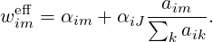 | (13)
The joint probability is therefore distributed uniformly only for the shared monotonicity and gate-regularization terms. This allocation is not detached, but it does not alter the routed prediction. RO-MER has 35,811 trainable parameters and receives the same faults, batches, seeds and checkpoint rule as RO-CAGF and RO-PDRF-Full.
The complete RO-MER objective is
(14)
where ℒ_{router} is the mean clean-plus-degraded Kullback–Leibler divergence from w_{i}^{eff} to the uniform distribution over available physical groups. RO-CAGF uses the same coefficients and terms, with its native M-group softmax weights replacing Eq. (13). RO-PDRF-Full replaces ℒ_{router} with the response-interior penalty because its bounded responses have a different geometry. Thus recovery supervision, proper scoring, pairwise ranking, paired views and task losses are matched, whereas only the architecture-specific regularizer differs. RO-MER tests whether the conclusion survives explicit cross-group interaction rather than merely widening the original gate.
We additionally adapt Quality-aware Multimodal Fusion (QMF), originally evaluated for text–image classification and RGB–D scene recognition, to the same four sensor groups [18]. For group logits μ_{im}, the signed energy-derived quantity is c_{im} = log ∑ _{c} exp(μ_{imc})∕10. Because c_{im} can be negative, the implementation uses the positive confidence c_{im} = max(10⁻⁶,c_{im}) before fusing available-group logits as the unnormalized sum ∑ _{m}a_{im} stopgrad(c_{im})μ_{im}. The ranking loss uses cumulative per-sample cross-entropy histories to form normalized pairwise margins and enters at unit weight, matching the published implementation rule. Group encoders, paired corruption, optimizer, split and checkpoint criterion remain those of the present chemical experiment. We call this primary control QMF-PD. It aligns the decision, confidence-detachment and trajectory-ranking rules with the published code, but remains a sensor-group adaptation rather than an exact reproduction of the original backbones or tasks. Confidence scales, normalized versus unnormalized fusion, ranking weights and the previous adaptation are reported as sensitivity variants.
PDRF contains 19,740 trainable parameters on the chemical array, compared with 26,588 for CAGF and DWR, 35,811 for RO-MER, 26,182 for early fusion and 17,560 for uniform fusion. Ablations comprise paired degradation only (PD-ONLY), paired degradation plus normalized-weight monotonicity (PD-MONO), paired degradation plus response ranking (PD-RANK), the complete objective without ℒ_{score} (NO-LSCORE), and ℒ_{score} without ℒ_{rank} (LSCORE-NO-LRANK). A PDRF-NOQ model is trained and tested with all quality values fixed to one.

3.5 Recovery-oriented extension
The mechanism audit showed that reducing an affected group’s weight was often necessary but not sufficient for prediction recovery. We therefore define recovery-oriented PDRF (RO-PDRF), which retains the PDRF architecture and adds recovery supervision. First, the degraded prediction is distilled from the detached clean-view prediction. Write _{i} = stopgrad(p_{i}); then
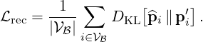 | (15)
As with the removal consistency term, ℒ_{rec} is defined only for observations with at least two available groups, because removing the degraded group from a single-group observation leaves no valid recovery view; it is omitted when 𝒱_{ℬ} is empty. In the frozen chemical run, this eligibility rule excluded 0.386% ± 0.052% of 5,933 training rows across seeds. The exclusion rate and counts are reported in the Supplementary Information. This label-free teacher targets recovery of the clean class distribution instead of assuming that downweighting alone repairs the decision. We denote the base PDRF objective plus 0.30ℒ_{rec} as RO-PDRF-Lite. Label-assisted best-view, affected-group-removal and confidence-selected teachers are evaluated only as sensitivity variants. Three additional teacher controls use the same principal split and fault: a hard 0.70 confidence threshold, continuous weighting and an exponential-moving-average (EMA) teacher [58]. For continuous weighting, let c_{i} = max_{c}p_{ic} and k_{i} = D_{KL}[stopgrad(p_{i})∥p′_{i}]. Then
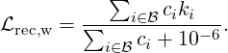 | (16)
The EMA model is updated after every optimization step and only the student is used at inference. Decays 0.95, 0.99 and 0.995 are tested. To attenuate a single teacher’s mistakes, clean/removal agreement (CRA) uses the mean of clean and affected-group-removal probabilities only when their predicted classes agree; student/EMA agreement (ECA) analogously averages the student-clean and EMA-clean probabilities only when their classes agree. The CE-conflict training audit retains recovery distillation when the clean-view cross-entropy does not exceed degraded-view cross-entropy. It uses training labels already present in the task losses, but the analogous conflict state is unavailable at test time; it is therefore a mechanistic diagnostic, not a deployable safeguard or fault selector. These controls were specified for the revision and do not redefine the principal comparison.
Second, multiclass Brier losses on clean and degraded predictions provide proper-scoring supervision,
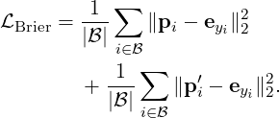 | (17)
The Brier term is the unweighted multiclass score averaged over observations; class weights are used for cross-entropy but are not inserted into the proper score. This preserves its standard probabilistic interpretation while classwise calibration is reported separately. Third, a weak log barrier discourages boundary occupancy without removing the original finite quartic penalty. With 𝜖 = 10⁻⁴, define b_{𝜖}(r) = −log{max[𝜖,1 − (r∕B)²]}, b_{im} = b_{𝜖}(r_{im}) + b_{𝜖}(r′_{im}) and Z_{ℬ} = ∑ _{i∈ℬ}∑ _{m}a_{im}. Its exact clean-plus-degraded implementation is
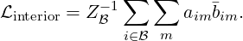 | (18)
Unavailable groups are excluded by a_{im}; the clamp is solely a numerical safeguard near the open boundary. Fourth, a smooth one-versus-rest pairwise ranking loss directly supervises degraded-view class ordering. For class c, let P_{c} and N_{c} denote positive and negative observations in a minibatch, let 𝒞_{ℬ} = {c : |P_{c}|> 0,|N_{c}|> 0} be the eligible class set, and let ϕ_{ijc} = softplus[−(ℓ′_{ic} −ℓ′_{jc})]:
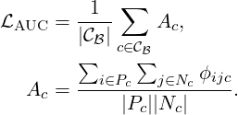 | (19)
Pairwise losses target class ordering directly rather than using cross-entropy as an indirect surrogate [59]. A class contributes only when the current minibatch contains at least one positive and one negative example; absent classes are skipped, and the pairwise term is omitted if no class is eligible. RO-PDRF-Full adds 0.30ℒ_{rec} + 0.05ℒ_{Brier} + 0.005ℒ_{interior} + 0.10ℒ_{AUC} to Eq. (12). The formal hierarchy is fixed throughout: RO-PDRF-Lite is the primary practical model and software default; RO-PDRF-Full is the mechanistic full model used for complete-objective architecture comparisons; and RO-PDRF-EMA is a calibration-oriented sensitivity based on Full. The clean-view teacher is the formal specification because it removes label-assisted teacher selection without reducing affected-subset discrimination in the teacher audit. The test set is not used to fit model or ensemble parameters.
To separate recovery supervision from architecture, we also train recovery-oriented CAGF (RO-CAGF). It receives the same clean-view recovery distillation, Brier and degraded-view AUC losses as RO-PDRF-Full. Because an unrestricted softmax gate has no bounded operational response, its architecture-specific regularizer is a weak KL penalty from clean and degraded gates to the uniform distribution over available groups (weight 0.005), rather than the response-interior barrier used by RO-PDRF-Full. CAGF, RO-CAGF, PDRF and RO-PDRF-Full use identical data, fixed faults, seeds, minibatches, checkpoint rules and three training forward paths; each requires one inference path. We therefore call the design recovery-objective matched with architecture-specific regularization, rather than fully objective-symmetric. KL weights 0, 0.001, 0.005 and 0.020 and interior weights 0, 0.001, 0.005 and 0.020 are evaluated in a factorial sensitivity analysis. Additional controls apply clean-view distillation alone to early fusion, uniform fusion, CAGF and PDRF. A modality-dropout self-distillation baseline removes one available group per training pair, and a confidence-thresholded control applies distillation only when teacher confidence is at least 0.70. These controls test established consistency-training mechanisms rather than claiming a new divergence or distillation principle [5, 6].

3.6 Cross-fitted selective recovery
Unconditional recovery can repair a wrong base prediction but can also overturn a correct one. We therefore evaluate two selective-recovery variants that choose between PDRF and RO-PDRF-Full for each observation. Batch 7 is divided chronologically into two disjoint halves. The first half fits one temperature for each model. The second half contains two calibration-only realizations of Gaussian, offset, drift and stuck-at corruption. Only rows on which the intervention reaches an available affected group enter selector development.
The selector receives neither the class label nor fault type at inference. Its 12 inputs are base and recovery confidence, normalized entropy and their differences; Jensen–Shannon disagreement between the two predictions; disagreement of each prediction with the mean obtained by removing every legally removable group; class agreement with that leave-one-group-out consensus; and the fraction of legal removals. Let z_{ij} denote standardized selector feature j. A logistic model produces the conditional preference score
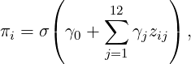 | (20)
using only calibration rows for which PDRF and RO-PDRF-Full differ in correctness. The target equals one when recovery is correct and the base model is wrong. The score is a discriminative routing quantity conditional on a correctness disagreement; it is not presented as a generally calibrated probability of reliability. All fits use an L₂ penalty, C = 0.5, the lbfgs solver, balanced class weights, tolerance 10⁻⁴, 2,000 maximum iterations and random state 0.
Coefficient fitting is separated from threshold selection by five-fold stratified group cross-fitting. All realizations and fault types originating from the same calibration observation are assigned to one fold. Each held-out fold receives scores from coefficients fitted without that observation. Candidate thresholds from 0.50 to 0.90 are selected only from pooled out-of-fold scores. The final coefficients are then refitted on all informative calibration rows while the selected thresholds remain frozen. Safe-CF first minimizes calibration negative transfer and then maximizes accuracy and retained recovery. Balanced-CF first maximizes accuracy and then minimizes negative transfer. This procedure prevents threshold optimization on in-sample selector scores. Every formal fold contained both preference classes and all 10 final fits converged; fold counts and iteration totals are archived.
The deployment audit uses the same fitted PDRF/RO-PDRF-Full pair, temperatures, selector and fault realization for every reported stream. It includes a no-fault stream with the same fixed 20% group-missingness process but no sensor corruption, complete mixed streams at fault prevalences 0.10, 0.40 and 0.70, the strict fault-applied-and-available subset, assigned-but-masked rows and unaffected rows. A false switch is any selection of RO-PDRF-Full on the no-fault stream; a harmful switch additionally requires PDRF to be correct and RO-PDRF-Full to be wrong. Leave-one-fault-family-out experiments fit the selector on three calibration mechanisms and test the fourth. Gain loss, clipping and correlated dual-group corruption are absent from selector calibration and form a separate unseen-mechanism audit.
Simple comparators comprise always-PDRF, always-RO-PDRF-Full, higher confidence, lower entropy, lower leave-one-group-out disagreement, a Jensen–Shannon threshold, a random selector with matched recovery-model usage and a correctness-disagreement oracle. The oracle identifies whether the endpoint hard decisions differ in correctness and therefore marks an opportunity boundary in prevention–retention space; it is not an AUROC upper bound. Scalar-rule thresholds are fitted on out-of-fold calibration scores at either matched negative-transfer prevention or matched recovery retention, then frozen before testing. Selector discrimination, conditional-score reliability bins, per-seed thresholds, logistic coefficients and standardization parameters are reported in the Supplementary Information.
The inference path contains one PDRF pass, one ordinary RO-PDRF-Full pass and one RO-PDRF-Full pass for each of the M leave-one-group-out views. It therefore requires M + 2 forward passes. CPU latency is measured both on the complete 4,364-observation held-out batch and at batch size one after three warm-up calls and seven repeated calls. Measurements use an Intel Core i5-13500H, PyTorch 2.12.1+cpu, 12 intra-op threads and 12 inter-op threads; data loading is excluded. Parameter-state memory assumes 32-bit floating point storage. FLOPs are counted from linear-layer multiply–add operations. Scaling is reported for M = 4,8,16. These quantities are computational boundaries, not accuracy-normalized efficiency claims.

3.7 Chemical-sensor dataset and fixed faults
The UCI Gas Sensor Array Drift Dataset contains 13,910 observations from 16 metal-oxide sensors, six gas classes and 10 acquisition batches over 36 months [60, 61]. Each sensor contributes eight extracted response features. The principal grouping uses four consecutive sensors per group. All models receive the same grouping. Sensitivity analyses additionally use interleaved and five fixed random partitions; no partition is called a physical modality.
Batches 1–6 train the models. The first 60% of batch 7 selects checkpoints, and the remaining 40% is reserved for calibration; the selective-recovery experiment further divides that calibration partition into temperature and selector halves. Batches 8–10 are held out for testing. The primary controlled fault assigns 40% of test observations a standardized Gaussian intervention of scale 3 on group 1 and leaves q = 1. We call an intervention silent when the corrupted group is available without a quality alert, that is, a_{im}∗ = 1 and q_{im}∗ = 1. Fault assignment and missingness are sampled independently. Of 4,364 test observations, 1,765 are assigned the principal fault; group 1 remains available and receives a nonzero intervention in 1,436, whereas it is masked in the remaining 329. The strict recovery estimand is the former fault-applied-and-available subset. The full assignment subset is reported only as a sensitivity analysis because an assigned but masked group cannot transmit the intervention. Twenty percent random group missingness is applied to controlled-fault test views. Fault indices, missingness masks and intervention values are fixed across methods and optimization seeds.
Checkpoint selection and temperature calibration use separate fault-free views with independently generated 10% group missingness; no controlled Gaussian, offset, drift or stuck-at intervention is added to either subset. The checkpoint criterion is unweighted cross-entropy on the complete selection subset. For the cross-fitted deployment run, temperature is fitted on the first chronological half of the calibration partition, not an affected subset, by minimizing unweighted multiclass negative log-likelihood. The resulting scalar is specific to each fitted seed and method and is applied unchanged to every deployment stream. Controlled-fault and no-fault deployment streams use the same fixed 20% group-missingness process so that fault prevalence is the changing factor. Earlier natural-view analyses without imposed test missingness remain supplementary sensitivity evidence.
The expanded fault study crosses four prespecified mechanisms with realizations 70001–70008 and fitted seeds 101–105. Model fitting always uses the Gaussian paired degradation defined above; offset, drift and stuck-at are test-time interventions only. Gaussian faults add independent standardized noise. Offset faults add a scale-3 featurewise signed displacement. Drift uses the same signed displacement multiplied by a monotone 0.25–1.00 trajectory over held-out acquisition order. Stuck-at faults replace the affected group’s standardized features by a signed scale-3 vector. Within each realization, all four mechanisms share affected rows and group-missingness masks, while intervention-specific values remain fixed across methods. These are controlled repeats on the same instrument. Additional exploratory interventions vary prevalence (0.10, 0.40, 0.70), scale (1, 3, 5), sensor group, gain, clipping and dual-group corruption.
Quality controls include reported q, row-shuffled q, misleading q, absent q, training without q and a quality-only comparator. Leave-one-group-out training assigns zero degradation probability to each group in turn before testing that group’s fault. Hyperparameter sensitivity varies B ∈{1,2,3,4,5}, β ∈{0.10,0.25,0.50,0.75} and ranking weight ∈{0.05,0.15,0.30}. The recovery-objective-matched stress grid contains 17 conditions spanning fault type, affected group, severity and prevalence; these conditions share observations and fitted models and are not treated as 17 independent replications. These sensitivity analyses are exploratory and are not used to replace the prespecified main setting.

3.8 Independent hydraulic test-rig validation
The UCI Condition Monitoring of Hydraulic Systems dataset contains 2,205 raw 60-s cycles from an experimental hydraulic rig and native condition labels for cooler, valve, pump and accumulator states (DOI: 10.24432/C5CW21) [22, 62]. We retain 1,449 cycles marked as stable. Fourteen physical sensors form five groups by measured quantity: six pressure sensors, two flow sensors, four temperature sensors, motor power and vibration. This grouping is defined before model fitting and follows the measurement system rather than a random partition.
For each sensor, we calculate mean, standard deviation, minimum, maximum, quartiles, root-mean-square value and linear slope. Physical groups contain different numbers of sensors and therefore different summary-vector lengths. The principal representation linearly resamples each flattened group vector to 48 positions so all groups can use the same encoder architecture and parameter budget. This operation is a dimensional alignment convention, not temporal interpolation; it may nevertheless smooth adjacent summary coordinates or alter their relative spacing. A no-interpolation audit therefore places each native summary vector at the start of a 48-position vector and zero-pads only the unused tail. Each component task first uses a fixed stratified 60/15/10/15% split. A stricter audit preserves acquisition order within every native condition class, assigns contiguous 60/15/10/15% blocks and discards five guard cycles at each split boundary. A single global chronological split is invalid because cooler and accumulator states occupy non-overlapping acquisition ranges and would leave unseen classes in training or test. PDRF-NOQ, RO-PDRF-Full-NOQ and CAGF are fitted with five matched seeds for both representations; recovery-objective-matched RO-PDRF-Full and RO-CAGF are refitted under the guarded blocked split. Pressure-group and vibration-group faults affect the same 40% of test cycles across methods. Component-condition labels are native to the test-rig experiment; sensor faults remain controlled interventions. Related hydraulic work is used only for context, not as a directly reproduced architecture [23–25].

3.9 Real-operational AHU sensor-fault validation
We additionally use the open real-operational AHU dataset from an auditorium, a hospital and a large office (Figshare DOI: 10.6084/m9.figshare.27147678.v3) [26, 27]. It contains hourly building-management-system records collected for one year per building. Four HVAC specialists with at least 20 years of experience annotated operating conditions, and two additional experts cross-checked a random subset. The present binary task retains normal operation and the native return- or supply-air temperature sensor-fault labels. No artificial corruption is applied to any AHU test record. Crucially, the public labels identify the sensor fault itself; they do not provide an independent component-condition, energy or control target to be recovered after suppressing that sensor. AHU direct diagnosis is therefore intentionally designated a negative task-boundary experiment, not a third validation of downstream recovery.
Seven harmonized measurements form five physically interpretable groups. Each building uses a chronological 60%/15%/10%/15% split, untouched future-time testing and five matched seeds. A leave-one-building-out audit trains on two buildings and holds out the third; the main text retains only the task boundary, within-building comparison and hospital transfer collapse. Full grouping, temporal controls, feature-shift, reversal, GroupDRO, unlabeled-target adaptation, risk–coverage and conformal specifications are reported in the Supplementary Information [41–44].

3.10 Training, metrics and statistical analysis
AdamW uses learning rate 2 × 10⁻³, weight decay 10⁻⁴, batch size 256 and gradient clipping at 5. Chemical-array training uses at most 60 epochs, hydraulic training uses at most 80 and AHU training uses at most 12. Checkpoints minimize unweighted selection cross-entropy and stop after nine epochs without an improvement greater than 10⁻⁴. RO-PDRF-Lite, RO-PDRF-Full, RO-PDRF-EMA and all teacher controls use this identical criterion; no test metric selects a checkpoint or variant. Class weights are n∕(Cn_{c}). No dropout or batch normalization is used.
Parameter counts and wall-clock costs are audited on the same CPU-only PyTorch runtime. Timings exclude data download and preprocessing, use identical test observations and are descriptive rather than hardware-independent complexity guarantees. Linear-layer multiply–accumulate operations, corresponding floating-point operations, model-state bytes and forward-activation bytes are counted for 2, 4, 8 and 16 sensor groups. Training loss, checkpoint cross-entropy and pre-clipping gradient norms are recorded by epoch for the consistency controls.
We report accuracy, macro-F1, macro-AUROC, macro/micro-AUPRC, NLL, multiclass Brier score, per-class precision, recall, F1, AUROC and AUPRC, confusion matrices and ECE with 10, 15, 20 fixed-width bins and 15 equal-frequency bins. Temperature scaling is fitted separately for every seed. The revised headline endpoint is macro-AUROC on the strict fault-applied-and-available subset under the fixed silent-Gaussian fault (seed 70001). The four-method comparison uses 10 matched optimization seeds; the assignment-only subset is a protocol sensitivity. Exact two-sided Wilcoxon signed-rank tests and seed intervals describe fitting stability, not population-level or device-level replication. Because the strict estimand, selector and multi-expert baseline were added after reviewer-driven audit of earlier results, their P values are not labelled preregistered confirmatory evidence. Fault-realization, fault-type, hydraulic, AHU, calibration, ensemble, teacher and sensitivity analyses are likewise interpreted at their stated exploratory evidence levels. An earlier recovery/calibration run and a superseded factorial rerun used a label-assisted teacher or a different fixed fault instance; both are confined to protocol sensitivity in the Supplementary Information. A post-hoc non-inferiority margin appears only as a descriptive supplementary analysis.
Paired seed differences quantify repeated fitting and are not interpreted as external replication. The C&EE deployment analysis is identified as frozen run CEE-CF10-R2. Within each seed, one PDRF/RO-PDRF-Full pair is reused across all four primary faults, deployment prevalences, selector baselines and transfer audits. The test realization is 70001, and the temperature protocol is fixed to the first chronological half of Batch 7. Main-table values from this run are therefore directly comparable; earlier assignment-defined and alternative-temperature runs are confined to the Supplementary Information. Clean/no-fault summaries contain exactly one value per fitted seed. For full, assigned-but-masked and unaffected streams, mechanism-specific values are first averaged within seed before the 10 seed units are summarized, preventing repeated identical predictions from being treated as independent evidence.
Selector uncertainty uses 1,000 crossed-cluster bootstrap replicates because fault mechanism and fitted model-pair seed are crossed factors. Each replicate independently samples four mechanisms and 10 seed identities with replacement, retains the same sampled seed identities across all sampled mechanisms, and then resamples observations within every sampled fault-by-seed cell. The procedure reports negative-transfer prevention, recovery retention, recovery-model usage and Safe-CF macro-AUROC differences. This contrasts with incorrectly nesting seed under fault and preserves the dependence induced by reuse of one model pair across mechanisms. The four mechanisms and 10 fitted pairs are not interpreted as independent devices. Other legacy ensemble and fault-realization intervals use their stated resampling designs and remain supplementary. Hydraulic summaries report condition effect sizes, median and range, leave-one-task-out means and a task–fault–seed hierarchical bootstrap; no condition-level value is interpreted as device-level replication. AHU results remain building-specific. Formal and exploratory analyses are identified in the source metadata.
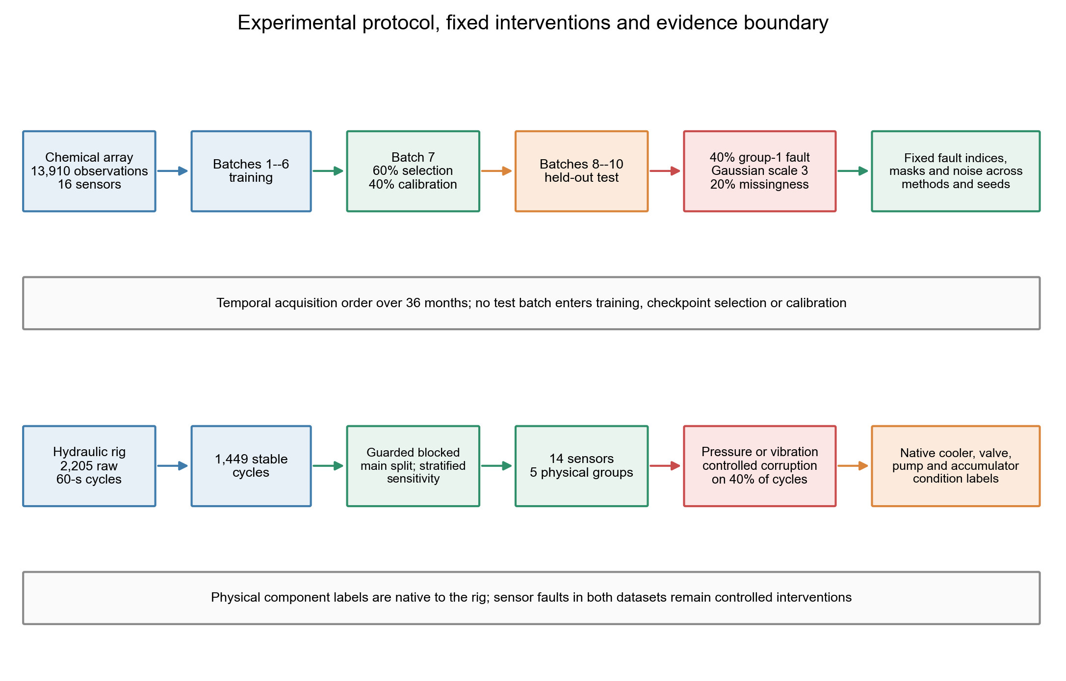
Figure 2: Integrated experimental protocol and controlled fault design. The upper lane follows the chemical-array acquisition order from batches 1–6 training through Batch 7 checkpoint selection/calibration to held-out batches 8–10; fault indices, masks and intervention values are fixed across methods and seeds. The lower lane follows the independent hydraulic rig from stable 60-s cycles to the guarded within-condition blocked main analysis; the earlier stratified split is retained only as a sensitivity analysis. Component-condition labels are native to the rig, whereas chemical, pressure and vibration sensor corruptions remain controlled interventions.

4 Results

4.1 Recovery improved the strict applied-fault estimand
The formal C&EE run reused one fitted PDRF/RO-PDRF-Full pair per seed across every primary analysis. The strict subset contains 1,436 observations per fault mechanism for which the assigned intervention reached an available group. Under the prespecified Gaussian corruption, mean macro-AUROC was 0.7842 for PDRF and 0.7986 for unconditional recovery (Table 1). The paired difference was +0.0143, was positive in all 10 optimization runs and had an exact two-sided Wilcoxon P = 0.00195. Safe-CF retained a +0.0066 difference over PDRF. Across Gaussian, offset, drift and stuck-at faults, the descriptive mean Full–PDRF and Safe-CF–PDRF differences were +0.0047 and +0.0031, respectively. The near-zero unconditional differences under offset and drift show that the Gaussian result does not generalize uniformly across mechanisms.

Table 1: Strict fault-applied-and-available estimand. Macro-AUROC values are means ± standard deviations across 10 matched optimization seeds in frozen run CEE-CF10-R2. Each fault contains 1,436 held-out observations per seed; fault mechanisms are not independent devices.
Fault mechanism | PDRF | RO-PDRF-Full | Safe-CF | Full–PDRF | Safe–PDRF
Gaussian noise | 0.7842 ± 0.0113 | 0.7986 ± 0.0104 | 0.7909 ± 0.0107 | +0.0143 | +0.0066
Offset | 0.8207 ± 0.0144 | 0.8216 ± 0.0131 | 0.8229 ± 0.0114 | +0.0009 | +0.0022
Drift | 0.8292 ± 0.0141 | 0.8293 ± 0.0135 | 0.8307 ± 0.0123 | +0.0001 | +0.0015
Stuck-at | 0.8118 ± 0.0108 | 0.8153 ± 0.0107 | 0.8139 ± 0.0089 | +0.0035 | +0.0021

Full-stream evaluation preserved the ordering without filtering observations by fault status (Table 2). At 10%, 40% and 70% imposed-fault prevalence, Safe-CF exceeded PDRF by 0.0004, 0.0013 and 0.0024 macro-AUROC, respectively, while remaining between PDRF and unconditional recovery. Safe-CF accuracy/macro-F1 was 0.584/0.562, 0.561/0.544 and 0.535/0.520 at the same prevalences. The three methods were nearly indistinguishable on the no-fault stream and on unaffected rows. Assigned-but-masked rows also showed no material unconditional recovery advantage, confirming why they are excluded from the strict recovery estimand rather than mixed into the headline effect.

Table 2: Complete deployment-stream estimands. Macro-AUROC values are means ± standard deviations; accuracy and macro-F1 are shown as paired means. Mechanism values are first averaged within each fitted seed, leaving 10 independent fitting units. Clean/no-fault predictions occur once per seed. Mixed streams contain all 4,364 held-out observations per seed–mechanism cell and use the same 20% group-missingness masks.
Evaluation stream | PDRF AUROC | PDRF Acc. / F1 | Full AUROC | Full Acc. / F1 | Safe-CF AUROC | Safe-CF Acc. / F1
Clean / no imposed fault | 0.8631 ± 0.0038 | 0.591/0.567 | 0.8634 ± 0.0053 | 0.591/0.563 | 0.8632 ± 0.0044 | 0.590/0.567
Mixed stream, 10% prevalence | 0.8587 ± 0.0043 | 0.584/0.562 | 0.8597 ± 0.0057 | 0.584/0.559 | 0.8591 ± 0.0049 | 0.584/0.562
Mixed stream, 40% prevalence | 0.8426 ± 0.0070 | 0.561/0.543 | 0.8450 ± 0.0077 | 0.562/0.541 | 0.8439 ± 0.0068 | 0.561/0.544
Mixed stream, 70% prevalence | 0.8288 ± 0.0093 | 0.534/0.519 | 0.8328 ± 0.0095 | 0.537/0.518 | 0.8312 ± 0.0082 | 0.535/0.520
Assigned but masked, 40% | 0.8446 ± 0.0126 | 0.570/0.543 | 0.8448 ± 0.0112 | 0.566/0.540 | 0.8453 ± 0.0120 | 0.569/0.542
Unaffected rows, 40% | 0.8667 ± 0.0039 | 0.600/0.574 | 0.8669 ± 0.0055 | 0.600/0.570 | 0.8668 ± 0.0047 | 0.600/0.573

Expressed as operational event counts, the 40% full stream contained a mean 185.6 ± 157.6 prevented harmful decisions, 20.9 ± 13.4 retained corrections and 17.4 ± 15.3 residual harmful decisions per 10,000 observations (Table 3). The resulting net correct-decision change relative to PDRF was +3.4 ± 16.4 per 10,000; this seed-level descriptive interval is wide and does not imply a guaranteed accuracy gain. Relative to one PDRF pass, Safe-CF used approximately 404 additional forward passes per prevented negative transfer at 40% prevalence because all observations incur five extra passes.

Table 3: Operational utility of Safe-CF on complete streams. Event counts are scaled to 10,000 observations after averaging the four mechanisms within each seed; values are means ± standard deviations across 10 fitted seeds. Net correct decisions equal retained corrections minus residual harmful transfers.
Fault prevalence | Harm prevented / 10,000 | Corrections retained / 10,000 | Residual harm / 10,000 | Net correct vs PDRF / 10,000
10% | 171.5 ± 124.8 | 11.5 ± 8.9 | 15.1 ± 12.5 | -3.6 ± 15.2
40% | 185.6 ± 157.6 | 20.9 ± 13.4 | 17.4 ± 15.3 | 3.4 ± 16.4
70% | 192.7 ± 186.5 | 29.3 ± 13.8 | 21.5 ± 19.1 | 7.8 ± 18.5

4.2 Cross-fitting exposed a conservative safety–recovery trade-off
Five-fold sample-group cross-fitting yielded mean out-of-fold selector AUROC 0.872, AUPRC 0.886 and Brier score 0.133 (Table 4). A mean of 1,861 calibration rows per seed was available, of which 130 were informative disagreements: 75.1 recovery-positive and 54.7 negative-transfer events. The mean minority-class count was only 4.15 events per fitted variable, so coefficient-level interpretation is weak despite regularization. Nevertheless, every fold contained both classes, all 10 final fits converged without warnings and the median final iteration count was 14. The Safe-CF threshold had median 0.85 and ranged from 0.55 to 0.90 across fitted pairs, so a universal threshold is not supported. Coefficients, sign agreement, fold counts and reliability bins are reported in the Supplementary Information.
Crossed-cluster resampling over fault mechanism, fitted pair and observation estimated 90.3% negative-transfer prevention (95% interval 82.3–95.2%) and 14.4% recovery retention (5.6–26.2%). Safe-CF used the recovery model for 44.3% of predictions (27.1–60.5%) and improved macro-AUROC over PDRF by 0.00483 (0.00166–0.00780). Its difference from unconditional recovery was −0.00233 (−0.00777 to +0.00349). The selector is therefore a risk-control layer, not a uniformly more accurate replacement. On the no-fault stream, it selected recovery on 41.4% of observations, but only 0.14% were harmful switches in which PDRF was correct and recovery was wrong. The large gap between switch and harmful-switch rates also shows why recovery usage alone is not a safety metric.

Table 4: Cross-fitted selector estimands. Out-of-fold discrimination and Brier values are means ± standard deviations across 10 fitted pairs. Prevention and retention are crossed-cluster bootstrap means with 95% equal-tailed intervals from 1,000 resamples. Fault and model-pair seed are independently resampled crossed factors, with sampled seed identities retained across faults before observation-level resampling. Clean switching uses exactly one complete no-fault stream per seed.
Quantity | Estimate
OOF selector AUROC | 0.872 ± 0.056
OOF selector AUPRC | 0.886 ± 0.084
OOF selector Brier score | 0.133 ± 0.039
Preference events: recovery / negative transfer | 75.1 / 54.7 per seed
Minority events per variable | 4.15 ± 2.27
Converged final selector fits | 10/10; no one-class fold
Safe threshold, median (range) | 0.850 (0.550–0.900)
Negative-transfer prevention | 0.903 [0.823, 0.952]
Recovery retention | 0.144 [0.056, 0.262]
Clean false-switch rate | 0.414 ± 0.270
Clean harmful-switch rate | 0.001 ± 0.001

Feature-set ablation confirmed that the routing signal was not reducible to one feature family. Confidence and entropy alone were most conservative (94.2% mean prevention) but retained only 6.1% of recoveries; disagreement features retained 10.1%; all 12 features retained 13.1% and achieved the highest out-of-fold selector AUROC, 0.872 (Table 5). Test macro-AUROC did not rank identically across feature sets, so the ablation supports complementary routing information rather than universal superiority of the largest selector. Balanced-CF increased recovery retention to 26.8% while reducing prevention to 75.8%; it is retained as a sensitivity operating point in the Supplementary Information.

Table 5: Selector feature-set ablation. Out-of-fold discrimination is measured on calibration disagreements. Strict-test safety and AUROC first average the four fault mechanisms within seed; values are means ± standard deviations across 10 fitted pairs.
Feature set | OOF AUROC | Prevention | Retention | Test AUROC
Confidence and entropy (6) | 0.782 ± 0.094 | 0.942 ± 0.064 | 0.061 ± 0.063 | 0.8156 ± 0.0096
Disagreement only (5) | 0.841 ± 0.087 | 0.875 ± 0.132 | 0.101 ± 0.100 | 0.8119 ± 0.0116
All features (12) | 0.872 ± 0.056 | 0.900 ± 0.113 | 0.131 ± 0.084 | 0.8146 ± 0.0094

4.3 Held-out mechanisms and simple rules bounded transport claims
When each calibrated fault family was omitted in turn, Safe-CF averaged +0.0032 macro-AUROC over PDRF, prevented 86.2% of negative transfers and retained 15.4% of recoveries (Table 6). On three mechanisms absent from selector calibration, corresponding means were +0.0019, 86.8% and 11.5%. The gain was not uniform: clipping gave −0.0002 relative to PDRF, whereas correlated dual-group corruption gave +0.0060. Safe-CF remained below unconditional recovery on average in both audits. These tests reduce same-family calibration leakage but do not establish natural-failure or device transfer.

Table 6: Selector transport estimands. Values are means across 10 fitted pairs on the strict applied-and-available subset. Leave-one-family-out selectors are developed on the other three families; unseen mechanisms are absent from all selector calibration.
Audit | Held-out mechanism | Safe–PDRF | Safe–Full | Prevention | Retention
Leave-one-family-out | Drift | +0.0016 | +0.0014 | 0.912 | 0.115
Leave-one-family-out | Gaussian noise | +0.0068 | -0.0075 | 0.788 | 0.324
Leave-one-family-out | Offset | +0.0019 | +0.0010 | 0.825 | 0.118
Leave-one-family-out | Stuck-at | +0.0024 | -0.0011 | 0.923 | 0.060
Unseen mechanism | Clipping | -0.0002 | -0.0052 | 0.897 | 0.049
Unseen mechanism | Correlated Dual | +0.0060 | -0.0075 | 0.744 | 0.270
Unseen mechanism | Gain Loss | +0.0001 | -0.0002 | 0.963 | 0.026

At approximately matched prevention, Safe-CF retained 13.1% of recoveries, compared with 5.7–8.8% for the four deterministic confidence, entropy and disagreement rules (Table 7). Random selection retained 49.1% but prevented only 47.3% of negative transfers. Always using PDRF or Full defines the zero-recovery and zero-prevention endpoints. The correctness-disagreement oracle defines the opportunity corner using held-out hard-decision correctness; it is neither deployable nor an AUROC upper bound. The 90.0% prevention and 13.1% retention in Table 7 are equal-weight descriptive averages over seed–fault cells, whereas Table 4 reports ratios recomputed in each crossed bootstrap replicate; the different estimands explain their small numerical difference. Thus the multivariable selector adds value over one-dimensional rules, while the large distance from the opportunity boundary quantifies unresolved error transfer.

Table 7: Matched selector-baseline estimands. Prevention, retention and recovery-model use are equal-weight descriptive means across four fault mechanisms and 10 fitted pairs; macro-AUROC is mean ± standard deviation across the same 40 cells. Scalar thresholds are fitted on out-of-fold calibration scores and frozen before testing. The correctness-disagreement oracle is an opportunity boundary, not an AUROC upper bound.
Selection rule | Matching | Prevention | Retention | Full use | Macro-AUROC
Safe CF | proposed | 0.900 | 0.131 | 0.440 | 0.8146 ± 0.0184
Higher confidence | prevention matched | 0.941 | 0.088 | 0.034 | 0.8116 ± 0.0206
Lower entropy | prevention matched | 0.933 | 0.070 | 0.057 | 0.8118 ± 0.0205
Lower LOO disagreement | prevention matched | 0.919 | 0.057 | 0.022 | 0.8117 ± 0.0205
Higher JS disagreement | prevention matched | 0.927 | 0.076 | 0.010 | 0.8116 ± 0.0206
Random matched selection | selection rate matched | 0.473 | 0.491 | 0.509 | 0.8123 ± 0.0173
Always PDRF | endpoint | 1.000 | 0.000 | 0.000 | 0.8115 ± 0.0210
Always RO PDRF Full | endpoint | 0.000 | 1.000 | 1.000 | 0.8162 ± 0.0163
Correctness disagreement oracle | opportunity boundary | 1.000 | 1.000 | 0.029 | 0.8141 ± 0.0210

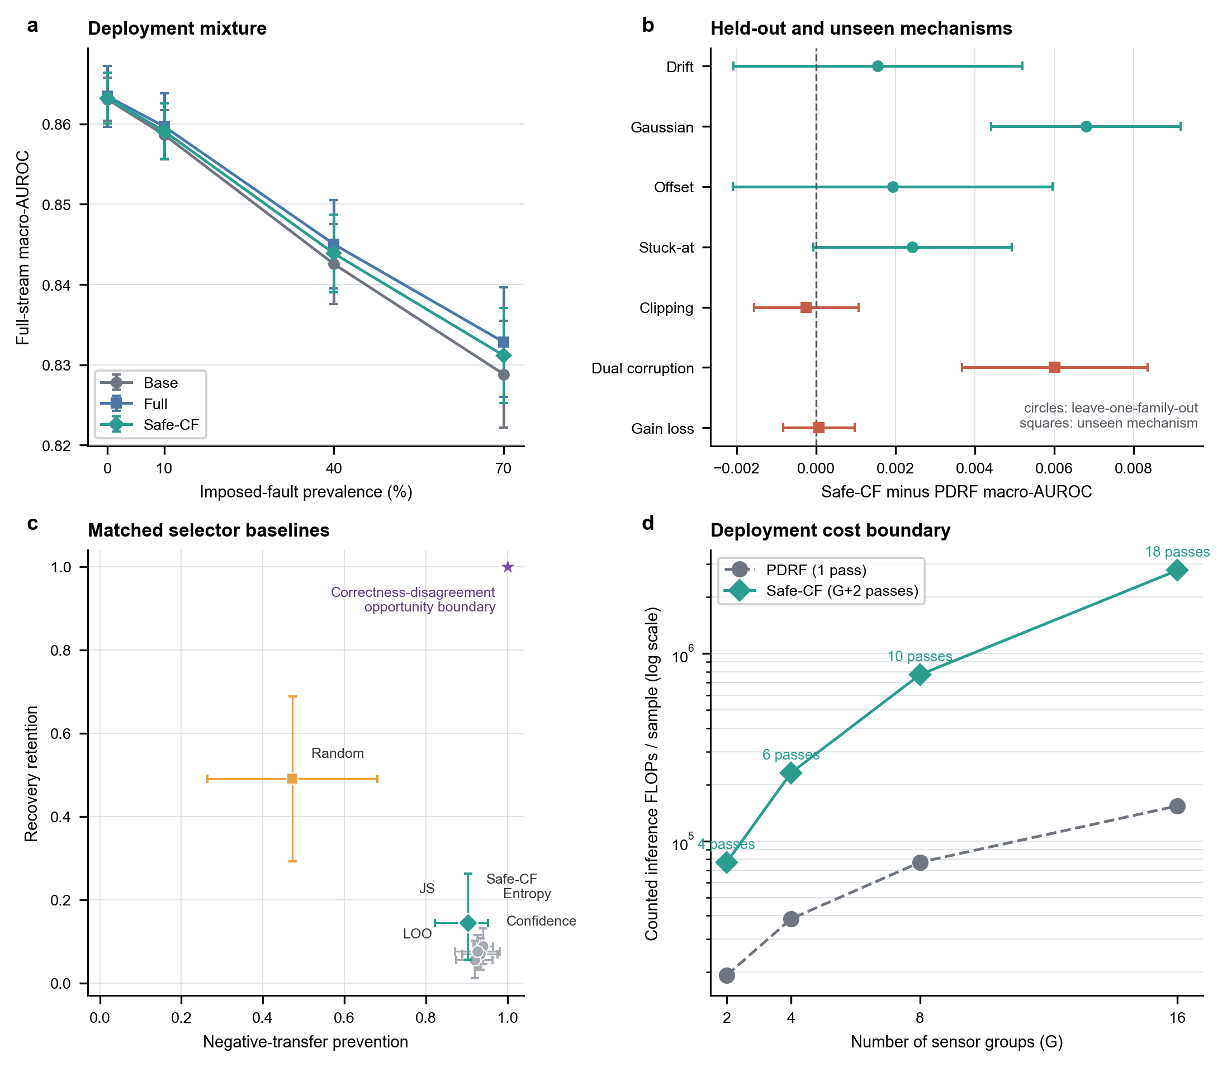
Figure 3: Cross-fitted selective recovery under deployment and transfer audits. a, complete held-out streams as imposed-fault prevalence increases; the 0% point contains exactly one clean value per seed, nonzero points first average mechanisms within seed, and bars are seed-level 95% Student-t intervals. b, Safe-CF minus PDRF macro-AUROC under leave-one-family-out and unseen-mechanism audits; bars are paired seed-level 95% Student-t intervals. c, negative-transfer prevention versus recovery retention for cross-fitted, simple and random selectors; Safe-CF bars are crossed-cluster 95% bootstrap intervals and other bars are seed-level 95% Student-t intervals. The star marks the correctness-disagreement opportunity boundary. d, counted linear-layer FLOPs for PDRF and Safe-CF as the number of sensor groups increases; Safe-CF requires G + 2 forward passes.

4.4 A stronger router narrowed the architecture claim
A separate objective-matched architecture-control run tested whether the result was an artifact of the original unrestricted gate. RO-MER routes among four group experts and one joint expert using the complete objective in Eq. (14). It exceeded RO-CAGF for offset, drift and stuck-at corruption, but not Gaussian noise. RO-PDRF-Full exceeded RO-MER for all four controlled mechanisms and by +0.0154 on average (descriptive crossed-factor interval +0.0106 to +0.0206; Table 8). This run addresses comparator strength, but it is not merged numerically with CEE-CF10-R2 and does not establish universal architectural superiority.

Table 8: Separate architecture-control estimand. Strict fault-applied-and-available macro-AUROC means ± standard deviations across 10 matched optimization seeds. RO-MER includes group experts and a joint expert; the four mechanisms remain controlled interventions on one instrument.
Fault | RO-CAGF | RO-MER | RO-PDRF-Full
gaussian | 0.795 ± 0.023 | 0.787 ± 0.012 | 0.799 ± 0.010
offset | 0.792 ± 0.029 | 0.807 ± 0.011 | 0.822 ± 0.013
drift | 0.799 ± 0.025 | 0.813 ± 0.014 | 0.829 ± 0.013
stuck-at | 0.780 ± 0.038 | 0.797 ± 0.016 | 0.815 ± 0.011

4.5 Downweighting remained distinct from prediction recovery
In the separate objective-ablation run, the affected group’s normalized weight decreased in 80.2% of affected predictions, yet 41.9% of all affected predictions still failed despite that decrease. Recovery distillation was the largest leave-one-loss-out contribution (+0.0105 affected AUROC; 10/10 seeds, P = 0.0020). Brier supervision contributed +0.0018 (P = 0.0098), degraded-AUC supervision +0.0023 (P = 0.0645), and the response-interior term +0.0008 (P = 0.2754). The clean, label-assisted best-view, removal and confidence-selected teachers produced near-identical sensitivity results. These archived values are mechanistic evidence rather than additional CEE-CF10-R2 headline endpoints; they localize the main gain to recovery supervision rather than teacher selection or response-interior regularization.
The clean teacher also created an identifiable failure boundary. Across five RO-PDRF-Full models and eight fault realizations, 45.5% of affected predictions were correct on both clean and faulted views, 12.6% changed from correct to incorrect, 4.6% recovered despite an incorrect clean teacher and 37.3% were incorrect on both views. When the actual RO-PDRF-Full clean teacher was correct but ordinary PDRF was wrong under fault, RO-PDRF-Full repaired 2,293 of 10,558 eligible predictions (21.7%). Conversely, when that teacher was wrong but ordinary PDRF remained correct under fault, RO-PDRF-Full lost 1,177 of 4,001 corrections (29.4%). These are paired conditional associations rather than causal attribution to one loss term, but they expose both recovery and error-transfer routes.
The separate principal-fault heuristic audit used five fitted seeds and is reported independently from the preceding eight-realization analysis. Ordinary clean teaching recovered 21.3% of eligible cases and transferred 32.2%. CRA retained 65.3% active coverage, raised conditional recovery to 24.6% and left transfer at 32.9%. ECA retained 72.4% coverage and raised recovery to 28.1%, but transfer increased to 40.3%. The CE-conflict training audit yielded 24.7% recovery and 35.7% transfer; the conflict state requires the held-out label and is therefore not a test-time selector. Recovery benefit was also negative in the lowest teacher-confidence quintile. These one-dimensional or agreement heuristics did not isolate negative transfer. The cross-fitted multivariable selector reduced it substantially, but at the explicit cost of rejecting most recovery opportunities. EMA smoothing improved probability quality without eliminating this mechanism.
The bounded operational response nevertheless remained switch-like: 63.6% of affected responses occupied the outer 5% of the allowed range. Raw cross-sensor ordering and generator-specific isotonic calibration remain in the Supplementary Information. The response is therefore suitable for constrained weighting and directional intervention audits, not interval-scale device health or calibrated risk.

4.6 Guarded hydraulic blocks reduced the apparent architecture advantage
The main hydraulic analysis uses guarded within-condition blocks across four native component-condition tasks and controlled pressure- and vibration-group faults (Table 9). RO-PDRF-Full exceeded recovery-objective-matched RO-CAGF in six of eight task–fault conditions. The mean difference was +0.015, the median was +0.011, the range was −0.033 to +0.053, and the task–fault–seed hierarchical interval (−0.006 to +0.036) included zero. Leave-one-task-out means ranged from +0.003 to +0.028.
Absolute blocked performance was heterogeneous. RO-PDRF-Full was near ceiling for cooler (task-averaged affected macro-AUROC 0.996) and moderate for valve (0.756), but pump (0.528) and accumulator (0.487) were near the 0.5 chance level; corresponding RO-CAGF means were 0.945, 0.735, 0.551 and 0.476. Architecture differences on the latter two tasks should therefore be interpreted cautiously even when their signed condition effects are reported.
For sensitivity only, the earlier random-stratified split produced seven of eight positive conditions and mean difference +0.044. Recovery training in that split improved CAGF in all eight conditions (mean +0.027), whereas the bounded recovery increment averaged +0.008 and varied in direction. The fall from +0.044 to +0.015 shows that random cycle allocation inflated the apparent architecture advantage; the stratified table is therefore moved to the Supplementary Information rather than retained as the main hydraulic result.
The no-interpolation representation retained positive task-averaged differences for accumulator (+0.135), cooler (+0.081) and pump (+0.124), with a valve reversal (−0.025). In the blocked split, median train–test nearest-neighbour cosine similarity remained 0.988 for cooler and approximately 0.83 for the other tasks, showing that the guard bands reduced direct adjacency without making the single-rig states independent. PDRF required 29,300 versus 37,844 parameters on the hydraulic task, but the evidence now supports constrained efficiency and platform-internal robustness rather than a general architecture ranking.

Table 9: Guarded-block hydraulic affected-subset macro-AUROC. Values are means ± standard deviations across five matched seeds. The eight task–fault rows are conditions from one rig, not independent devices; the earlier random-stratified results are supplementary sensitivity evidence.
Task | Fault | RO-CAGF | RO-PDRF-Full | Difference
Cooler | Pressure | 0.942 ± 0.023 | 0.992 ± 0.004 | +0.050
Cooler | Vibration | 0.947 ± 0.029 | 1.000 ± 0.000 | +0.053
Valve | Pressure | 0.730 ± 0.026 | 0.762 ± 0.023 | +0.032
Valve | Vibration | 0.739 ± 0.029 | 0.749 ± 0.032 | +0.010
Pump | Pressure | 0.569 ± 0.035 | 0.536 ± 0.018 | -0.033
Pump | Vibration | 0.533 ± 0.061 | 0.521 ± 0.022 | -0.012
Accumulator | Pressure | 0.478 ± 0.022 | 0.491 ± 0.023 | +0.013
Accumulator | Vibration | 0.474 ± 0.047 | 0.483 ± 0.044 | +0.009

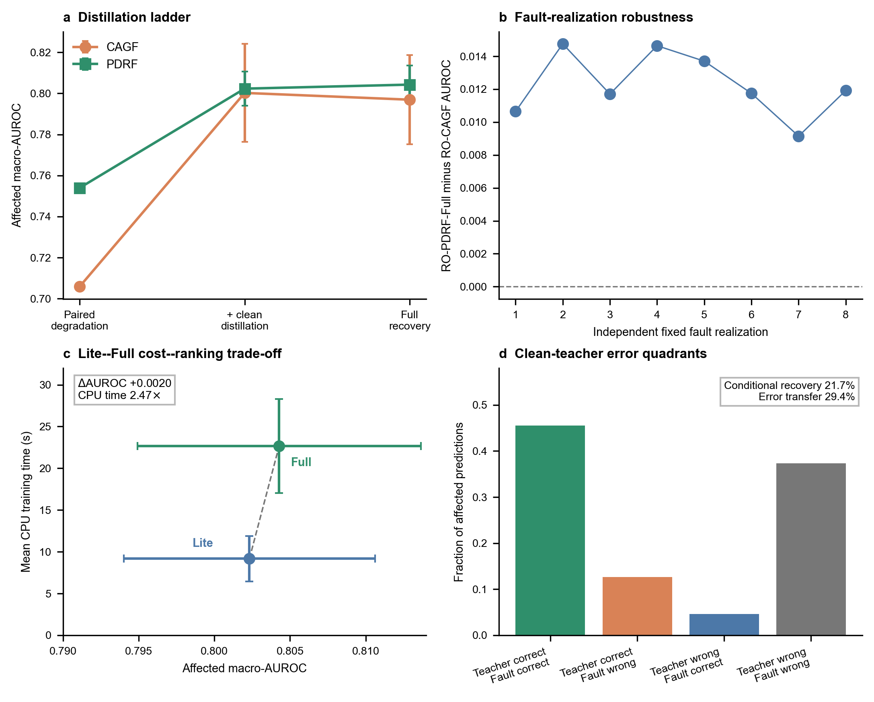
Figure 4: Controls for recovery mechanism, robustness and cost. a, Paired degradation, clean-view distillation and the complete recovery objective for bounded and gated fusion; error bars are standard deviations across 10 optimization seeds. b, RO-PDRF-Full–RO-CAGF affected-AUROC differences across eight method-shared Gaussian fault realizations on one instrument. c, affected macro-AUROC versus measured CPU training time for RO-PDRF-Lite and RO-PDRF-Full; horizontal and vertical bars are seed standard deviations. The +0.0020 ranking difference required 2.47-fold mean training time. d, direct conditional audit: 21.7% recovery when the clean teacher is correct and baseline is wrong, versus 29.4% error transfer when the clean teacher is wrong and baseline is correct.

4.7 AHU direct diagnosis exposed a negative task boundary
The chronological air-handling-unit tests contained 37,831 untouched future-time records, including 2,069 expert-annotated temperature-sensor faults. Because the target is the fault itself and no independent downstream state is available, this experiment cannot test whether suppressing that sensor recovers another prediction. Early fusion exceeded bounded recovery in all 15 building–seed pairs (mean AUROC difference −0.0341 for bounded recovery, P < 0.001), and leave-one-building-out bounded recovery collapsed to 0.298 ± 0.005 in the hospital. The operational data therefore establish a direct-diagnosis and transfer boundary, not downstream recovery validation; complete subtype, shift, adaptation and risk analyses remain in the Supplementary Information.

4.8 Probability quality and aggregation remained deployment limitations
Recovery improved bounded-model probability quality without matching the recovery gate. All values in this comparison use temperatures fitted on the calibration split. On affected observations, RO-PDRF-Full NLL and ECE were 2.650 and 0.342, compared with 3.085 and 0.369 for PDRF but 2.071 and 0.275 for RO-CAGF. RO-PDRF-EMA reduced the bounded model’s values to 2.413 and 0.321, whereas increasing the Brier coefficient fourfold gave 2.681 and 0.342. RO-AT-GATE achieved lower NLL and ECE (1.826 and 0.210) but lower affected AUROC (0.784). Thus no tested model dominated both class ranking and probability quality. Classwise diagrams confirmed larger average one-versus-rest calibration error for the original bounded ensemble (0.100 versus 0.072). Calibration diagrams, Brier scores, temperature sensitivity and the optional-quality-metadata failure audit remain in the Supplementary Information.
Equal-probability aggregation gave overall AUROC 0.8512 for RO-PDRF-Full and 0.8510 for RO-CAGF; their difference was 0.0002 with a 5,000-resample interval from −0.0039 to 0.0044. On affected rows, however, RO-PDRF-Full ensemble AUROC was 0.8186 versus 0.8368 for RO-CAGF, a difference of −0.0181 (−0.0260 to −0.0101). Affected NLL was also worse (2.019 versus 1.411), and RO-PDRF-Full members were less diverse (pairwise disagreement 0.181 versus 0.335). Logit averaging further reduced affected AUROC to 0.813 for RO-PDRF-Full and 0.832 for RO-CAGF and increased both NLL values. Confidence-based abstention did not reverse the ordering: at 20% coverage, affected-row classification risk was 0.125 for RO-PDRF-Full and 0.093 for RO-CAGF, and Full remained worse at every evaluated coverage. Recovery of the complete bounded model therefore does not solve affected-row probability aggregation, calibration or selective prediction.
The discrimination–calibration audit (Fig. 5) makes this trade-off explicit. RO-AT-GATE had the lowest ECE but lower AUROC; QMF-PD improved substantially within the official-rule-aligned sensor-group adaptation but was dominated by RO-CAGF on these two mean metrics; and the explicitly named Lite, Full and EMA variants occupied a higher-ranking, higher-ECE region. Teacher-error controls changed recovery and transfer rates without producing a rule that isolated negative transfer. Model choice therefore depends on whether ranking, probability quality or conservative recovery supervision is operationally primary.
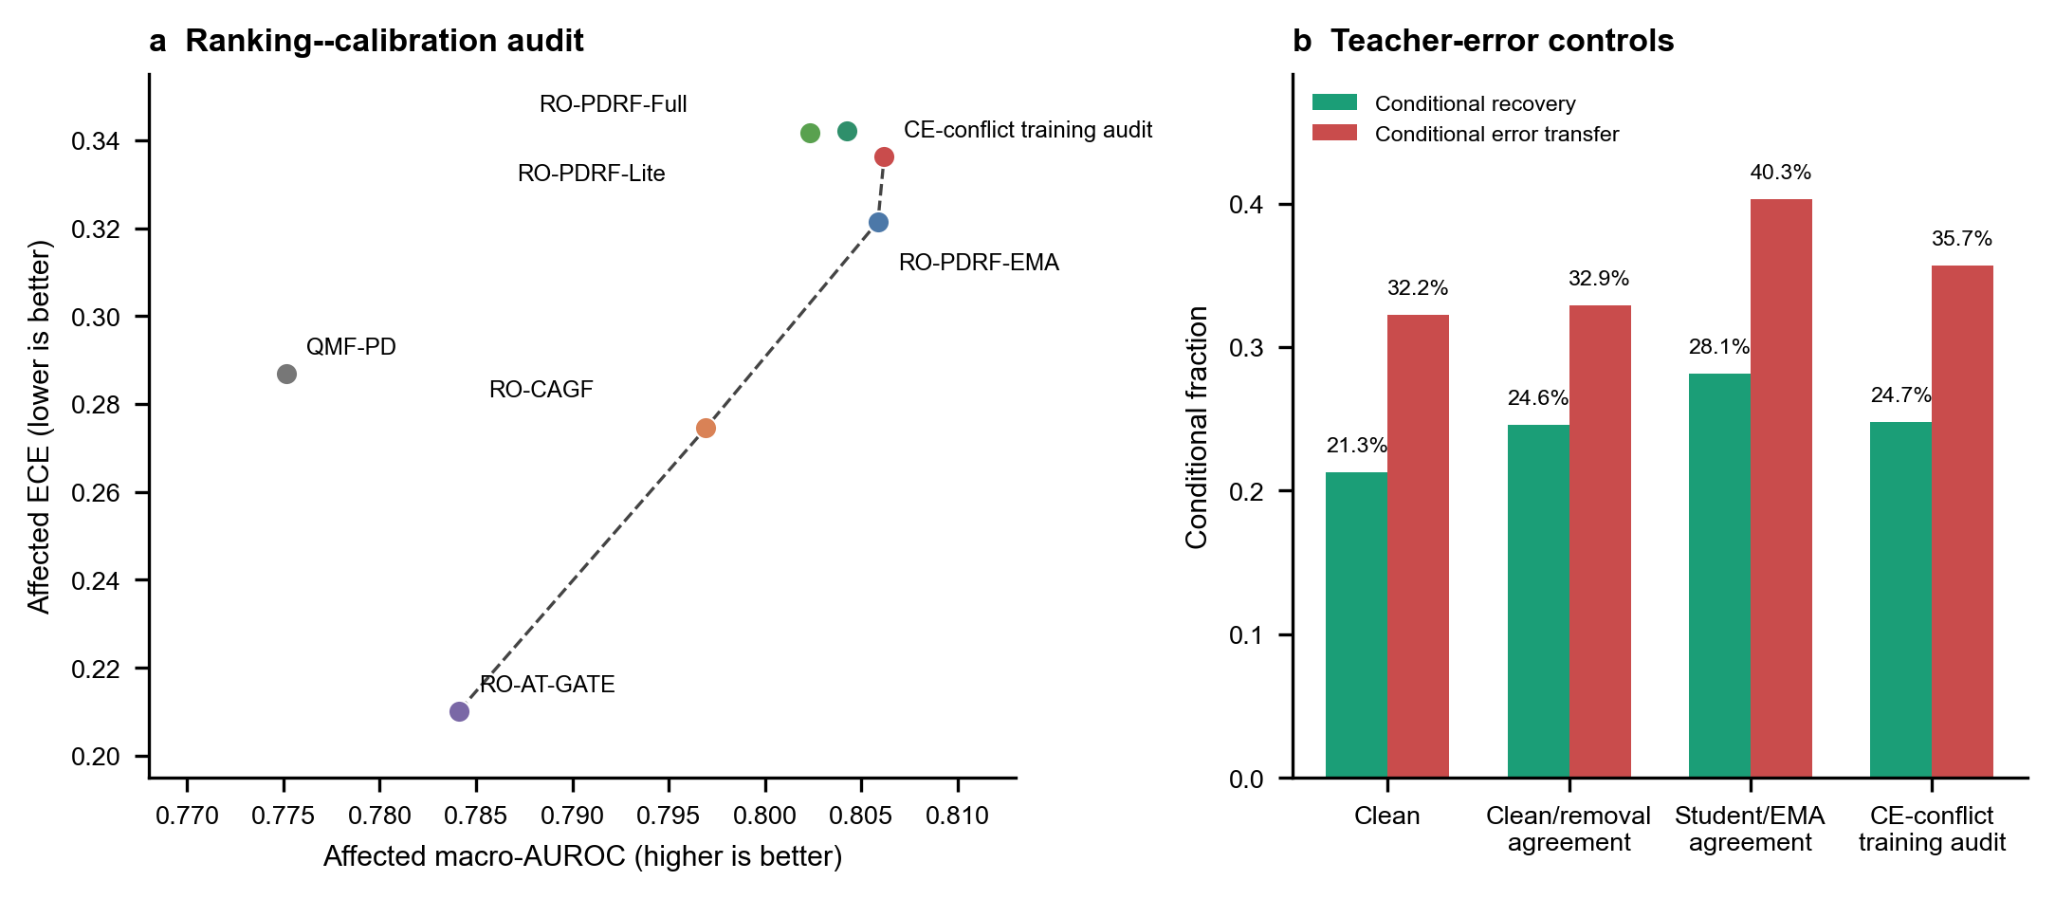
Figure 5: Ranking–calibration and teacher-error audit. a, affected-subset macro-AUROC versus 15-bin expected calibration error after per-seed temperature scaling. A mean is non-dominated when no other tested mean has AUROC at least as high and ECE at most as low, with at least one strict inequality; the dashed line joins such means. b, conditional recovery and error transfer for ordinary clean teaching, CRA, ECA and the CE-conflict training audit. The last control is label-assisted and training-only; it is not observable at test time. Fractions are paired prediction-level audit quantities, not independent-device rates.

4.9 Selective protection imposed a measurable deployment cost
PDRF and RO-PDRF-Full each require one forward pass, 19,740 stored parameters and 38,528 counted linear-layer FLOPs per four-group observation (Table 10). Safe-CF stores both endpoints and a 13-parameter logistic selector, requires six forward passes and uses 231,168 FLOPs. On the stated CPU, median complete-batch throughput was approximately 677,000 observations/s for either endpoint and 84,300 observations/s for Safe-CF. Batch-size-one median latency was 0.875, 0.880 and 6.810 ms, respectively; these values are descriptive hardware-specific measurements rather than real-time guarantees. At 8 and 16 groups, Safe-CF required 10 and 18 passes and 770,560 and 2,774,016 counted FLOPs, respectively (Fig. 3d). The protection is therefore plausible for offline monitoring but not computationally free. Separately, the bounded PDRF endpoint remained smaller than CAGF at four groups (19,740 versus 26,588 parameters); full activation and training-cost audits are supplementary.

Table 10: Four-group inference cost. Parameter state assumes 32-bit floating point storage. Throughput uses the complete 4,364-observation batch and online latency uses batch size one; both are medians of seven calls after three warm-ups on an Intel Core i5-13500H with PyTorch 2.12.1+cpu and 12 intra-/inter-op threads. Data loading is excluded. FLOPs count linear-layer multiply and add operations.
Method | Parameters | State (KiB) | Passes | FLOPs / sample | Batch throughput / s | Batch-1 latency (ms)
PDRF | 19,740 | 77.1 | 1 | 38,528 | 676997 | 0.875
RO-PDRF-Full | 19,740 | 77.1 | 1 | 38,528 | 678381 | 0.880
SR-PDRF-Safe-CF | 39,493 | 154.3 | 6 | 231,168 | 84288 | 6.810

5 Discussion
The strict estimand and frozen-run discipline change the central interpretation. Clean-to-faulted prediction distillation, an established consistency mechanism, produced a stable gain under Gaussian corruption, but the unconditional gain was small under offset and drift. The contribution is therefore not a new divergence or a universal architecture ranking. It is an operational design that (i) distinguishes an intervention that actually reaches an available group from fault assignment, (ii) measures both recovery and negative transfer, and (iii) cross-fits the deployment decision before choosing its threshold. The separate multi-expert audit reduces concern that the result follows from an intentionally weak gate, yet remains evidence from one chemical instrument.
Cross-fitting addresses a specific leakage route. Each conditional preference score used for threshold selection came from coefficients fitted without the originating calibration observation, and the final threshold was frozen before test evaluation. This does not make the score externally calibrated. Only about 130 informative disagreement rows were available per fitted pair, corresponding to 4.15 minority events per variable on average; thresholds varied from 0.55 to 0.90 and calibration still used controlled faults from the same instrument. The feature ablation and complete convergence audit reduce, but do not remove, this small-sample concern. The crossed-cluster interval consequently describes the audited mechanisms, fitted pairs and observations rather than a population of devices.
The safety–recovery trade-off is substantial. Safe-CF prevented 90.3% of negative transfers but retained 14.4% of recoveries, and its difference from unconditional recovery crossed zero. Its benefit over one-dimensional selectors came from retaining more recovery at roughly matched prevention, not from approaching the correctness-disagreement opportunity boundary. The 41.4% clean false-switch rate initially appears high, but only 0.14% of clean observations underwent a harmful switch. Reporting both quantities prevents recovery-model usage from being mistaken for error risk. Balanced-CF shows that the same conditional score can retain more corrections only by accepting more transfer. A system with a tighter latency or energy budget may reasonably prefer unconditional PDRF or a scalar rule, because Safe-CF needs six passes at four groups and its cost grows as G + 2.
The transfer audits support a narrower but stronger claim than same-family testing alone. Mean prevention remained above 86% after holding out each calibrated family and on three unseen synthetic mechanisms. However, recovery retention remained low, clipping produced no macro-AUROC gain and all mechanisms reused the same sensor array and downstream gas label. These results demonstrate robustness to specified corruption transformations, not to naturally occurring hardware failure, maintenance events or new devices. The public AHU dataset cannot close that gap because its target is the sensor fault itself; suppressing the anomalous signal may directly oppose the diagnosis objective.
The hydraulic rig supplies native component-condition targets that remain meaningful after pressure or vibration sensors are corrupted, but the stricter split changes its evidential role. The mean bounded-gate difference fell from +0.044 under random stratification to +0.015 under guarded blocks, and the hierarchical interval crossed zero. This sensitivity is consistent with adjacent-cycle similarity and prevents the original condition-level result from serving as independent architecture confirmation. The chemical multi-realization audit provides stronger robustness evidence for repeated corruption, but it too remains within one instrument.
The AHU data answer a different question. Their native label is the sensor fault itself, and no independent downstream state is available. Direct diagnosis rewards preservation of the anomalous signature that recovery may suppress. Stronger EF-PD and histogram gradient boosting (HGB) results are therefore a substantive negative boundary, not an inconvenient failed validation. Creating a downstream target from the same fault label would be circular; resolving this boundary requires a dataset that jointly records sensor faults and an independent control, energy, comfort or component outcome.
Cross-building AHU results further separate task mismatch from domain shift. The bounded recovery model’s hospital ordering reversed, while EF-PD transferred almost perfectly. Hospital feature, class-prior and subtype shifts are large, but simple target normalization and CORAL did not repair the bounded model, and GroupDRO did not improve an already strong EF-PD. This architecture-specific contrast argues against attributing every failure to a single scalar distance. A useful next step is a pre-registered multi-building study with target-free model selection, representation-level invariance and sufficient examples of each fault subtype.
Four deployment boundaries remain. First, 63.6% saturation of the bounded operational response prevents interval-scale interpretation. Second, wrong clean teachers can propagate errors; selective recovery reduces this route only when calibration disagreements resemble deployment disagreements. Third, equal-probability and logit-averaged RO-PDRF-Full ensembles remained inferior on affected-row probability quality, classwise calibration and selective risk. Fourth, optional quality metadata help only when trustworthy and create a new failure route when systematically misleading. The model should therefore expose the bounded response as an operational control signal, validate any external quality channel and retain abstention or explicit selection logic rather than presenting a calibrated device-health estimate.
The study is limited by controlled feature corruptions, one chemical instrument, one hydraulic rig, residual within-condition similarity after blocked splitting, rare AHU supply-air faults and expert/rule-based rather than maintenance-confirmed AHU labels. The four top-level chemical faults and eight hydraulic task–fault conditions are not independent device replicates. The unseen mechanisms are algorithmically novel to the selector but not naturally annotated failures. The final CEE protocol was frozen before run CEE-CF10-R2, yet the overall method was developed through repeated inspection of related outcomes; optimization-seed and bootstrap intervals cannot remove that researcher-level adaptive-development risk. Prospective multi-device data with adjudicated sensor failures and an independent downstream target are required for a field-recovery claim.

6 Conclusion
Cross-fitted selective recovery converted a useful but fallible recovery model into an explicit deployment trade-off. Under Gaussian corruption, unconditional recovery improved strict-subset macro-AUROC by 0.0143 across all 10 matched fits, while Safe-CF retained a 0.0066 gain. Across four mechanisms, crossed-cluster inference estimated 90.3% negative-transfer prevention and 14.4% retained corrections; the AUROC gain over PDRF remained positive, whereas the difference from unconditional recovery crossed zero. The selector retained more corrections than scalar rules at roughly matched prevention, but required G + 2 forward passes. The supported contribution is therefore a reproducible, cross-fitted risk-control protocol for controlled available-but-corrupted sensors. It is not evidence for calibrated device health, maintenance-confirmed natural faults or device-independent field recovery.

Data and code availability
The Gas Sensor Array Drift Dataset (DOI: https://doi.org/10.24432/C5RP6W) and Condition Monitoring of Hydraulic Systems dataset (DOI: https://doi.org/10.24432/C5CW21) are available from the UCI Machine Learning Repository under CC BY 4.0. The operational AHU data are available from Figshare under CC BY 4.0 (DOI: https://doi.org/10.6084/m9.figshare.27147678.v3). Code, fixed seeds, environment information, source data for CEE-CF10-R2 and figure/table scripts are publicly available in the cee_revision directory at https://github.com/Corey9999/recovery-supervision-calibrated-fallback. The submitted computational snapshot is commit 78f8226776853c64da01a70bd0ffbd912ba2ad2a. A permanent software DOI has not been assigned.

Ethics statement
The study used public engineering datasets and controlled computer-generated sensor corruptions. It involved no human participants, personal data, animals or biological specimens; institutional ethics review was not applicable.

Author contributions
Riyang Luo: Conceptualization, Methodology, Software, Validation, Formal analysis, Investigation, Data curation, Visualization, Writing–original draft, Writing–review and editing, and Project administration.

Acknowledgements and funding
The author received no specific funding for this work and has no acknowledgements to declare.

Declaration of interests
The author declares that there are no known competing financial interests or personal relationships that could have appeared to influence the work reported in this paper.

Declaration of generative AI and AI-assisted technologies in the writing process
During the preparation of this work, the author used OpenAI Codex to assist with language editing, code development, plotting-code preparation and document preparation. The author reviewed and edited all assisted material, reran deterministic scripts, and verified the reported outputs against the archived source data. No experimental image was synthesized or altered. The author takes full responsibility for the content of the publication.

References
[1]
X. Liu, J. Zhang, S. Zhou, et al. Towards deployment-centric multimodal ai beyond vision and language. Nature Machine Intelligence, 7:1612–1624, 2025. doi: 10.1038/ s42256-025-01116-5.
[2]
Tapabrata Chakraborti, Christopher R. S. Banerji, Ariane Marandon, et al. Personalized uncertainty quantification in artificial intelligence. Nature Machine Intelligence, 7:522–530, 2025. doi: 10.1038/s42256-025-01024-8.
[3]
Robin Mitra, Sarah F. McGough, Tapabrata Chakraborti, et al. Learning from data with structured missingness. Nature Machine Intelligence, 5:13–23, 2023. doi: 10.1038/ s42256-022-00596-z.
[4]
Renjie Wu, Hu Wang, Hsiang-Ting Chen, and Gustavo Carneiro. Deep multimodal learning with missing modality: A survey. Transactions on Machine Learning Research, February 2026. URL https://openreview.net/forum?id=tc7RFcx4hT.
[5]
Natalia Neverova, Christian Wolf, Graham Taylor, and Florian Nebout. ModDrop: Adaptive multi-modal gesture recognition. IEEE Transactions on Pattern Analysis and Machine Intelligence, 38(8):1692–1706, 2016. doi: 10.1109/TPAMI.2015.2461544.
[6]
Mingcheng Li, Dingkang Yang, Yuxuan Lei, Shunli Wang, Shuaibing Wang, Liuzhen Su, Kun Yang, Yuzheng Wang, Mingyang Sun, and Lihua Zhang. A unified self-distillation framework for multimodal sentiment analysis with uncertain missing modalities. In Proceedings of the AAAI Conference on Artificial Intelligence, volume 38, pages 10074–10082, 2024. doi: 10.1609/aaai.v38i9.28871.
[7]
Sangmin Woo, Sumin Lee, Yeonju Park, Muhammad Adi Nugroho, and Changick Kim. Towards good practices for missing modality robust action recognition. In Proceedings of the AAAI Conference on Artificial Intelligence, volume 37, pages 2776–2784, 2023. doi: 10.1609/aaai.v37i3.25378.
[8]
Hao Wang, Shengda Luo, Guosheng Hu, and Jianguo Zhang. Gradient-guided modality decoupling for missing-modality robustness. In Proceedings of the AAAI Conference on Artificial Intelligence, volume 38, pages 15483–15491, 2024. doi: 10.1609/aaai.v38i14.29474.
[9]
Brandon Mckinzie, Vaishaal Shankar, Joseph Yitan Cheng, Yinfei Yang, Jonathon Shlens, and Alexander T. Toshev. Robustness in multimodal learning under train–test modality mismatch. In Proceedings of the 40th International Conference on Machine Learning, volume 202 of Proceedings of Machine Learning Research, pages 24291–24303. PMLR, 2023. URL https://proceedings.mlr.press/v202/mckinzie23a.html.
[10]
Wenfang Yao, Kejing Yin, William K. Cheung, Jia Liu, and Jing Qin. DrFuse: Learning disentangled representation for clinical multi-modal fusion with missing modality and modal inconsistency. In Proceedings of the AAAI Conference on Artificial Intelligence, volume 38, pages 16416–16424, 2024. doi: 10.1609/aaai.v38i15.29578.
[11]
Wuliang Huang, Yiqiang Chen, Xinlong Jiang, Chenlong Gao, Teng Zhang, Qian Chen, and Yifan Wang. Mitigating pervasive modality absence through multimodal generalization and refinement. In Proceedings of the AAAI Conference on Artificial Intelligence, volume 39, pages 26796–26804, 2025. doi: 10.1609/aaai.v39i25.34883.
[12]
Zixian Gao, Xun Jiang, Xing Xu, Fumin Shen, Yujie Li, and Heng Tao Shen. Embracing unimodal aleatoric uncertainty for robust multimodal fusion. In Proceedings of the IEEE/CVF Conference on Computer Vision and Pattern Recognition, pages 26876–26885, 2024. doi: 10.1109/CVPR52733.2024.02538.
[13]
Minkyoung Cho, Yulong Cao, Jiachen Sun, Qingzhao Zhang, Marco Pavone, Jeong Joon Park, Heng Yang, and Zhuoqing Mao. Cocoon: Robust multi-modal perception with uncertainty-aware sensor fusion. In The Thirteenth International Conference on Learning Representations, 2025. URL https://proceedings.iclr.cc/paper_files/paper/2025/hash/6580845ce91a748a9bb09cec079aac1d-Abstract-Conference.html.
[14]
Konyul Park, Yecheol Kim, Daehun Kim, and Jun Won Choi. Resilient sensor fusion under adverse sensor failures via multi-modal expert fusion. In Proceedings of the IEEE/CVF Conference on Computer Vision and Pattern Recognition, pages 6720–6729, 2025. doi: 10.1109/CVPR52734.2025.00630.
[15]
Sahil Sidheekh, Pranuthi Tenali, Saurabh Mathur, Erik Blasch, Kristian Kersting, and Sriraam Natarajan. Credibility-aware multimodal fusion using probabilistic circuits. In Proceedings of the 28th International Conference on Artificial Intelligence and Statistics, volume 258 of Proceedings of Machine Learning Research, pages 2305–2313. PMLR, 2025. URL https://proceedings.mlr.press/v258/sidheekh25a.html.
[16]
Wei Liu, Yufei Chen, and Xiaodong Yue. Enhancing multi-view classification reliability with adaptive rejection. In Proceedings of the AAAI Conference on Artificial Intelligence, volume 39, pages 18969–18977, 2025. doi: 10.1609/aaai.v39i18.34088.
[17]
Stephan Rabanser, Anvith Thudi, Kimia Hamidieh, Adam Dziedzic, Israfil Bahceci, Akram Bin Sediq, Hamza Sokun, and Nicolas Papernot. Selective prediction via training dynamics. Transactions on Machine Learning Research, 2025. URL https://openreview.net/forum?id=2wgnepQjyF.
[18]
Qingyang Zhang, Haitao Wu, Changqing Zhang, Qinghua Hu, Huazhu Fu, Joey Tianyi Zhou, and Xi Peng. Provable dynamic fusion for low-quality multimodal data. In Proceedings of the 40th International Conference on Machine Learning, volume 202 of Proceedings of Machine Learning Research, pages 41753–41769. PMLR, 2023. URL https://proceedings.mlr.press/v202/zhang23ar.html.
[19]
Jyrki Kullaa. Distinguishing between sensor fault, structural damage, and environmental or operational effects in structural health monitoring. Mechanical Systems and Signal Processing, 25(8):2976–2989, 2011. doi: 10.1016/j.ymssp.2011.05.017.
[20]
Jyrki Kullaa. Detection, identification, and quantification of sensor fault in a sensor network. Mechanical Systems and Signal Processing, 40(1):208–221, 2013. doi: 10.1016/j.ymssp.2013. 05.007.
[21]
Nikolai Helwig, Eliseo Pignanelli, and Andreas Schütze. Detecting and compensating sensor faults in a hydraulic condition monitoring system. In Proceedings SENSOR 2015, pages 641–646, 2015. doi: 10.5162/sensor2015/D8.1.
[22]
Nikolai Helwig, Eliseo Pignanelli, and Andreas Schütze. Condition monitoring of a complex hydraulic system using multivariate statistics. In 2015 IEEE International Instrumentation and Measurement Technology Conference Proceedings, pages 210–215, 2015. doi: 10.1109/ I2MTC.2015.7151267.
[23]
Xiangkai Ma, Pei Wang, Bozhou Zhang, and Ming Sun. A multirate sensor information fusion strategy for multitask fault diagnosis based on convolutional neural network. Journal of Sensors, 2021:9952450, 2021. doi: 10.1155/2021/9952450.
[24]
Aurelien Teguede Keleko, Bernard Kamsu-Foguem, Raymond Houe Ngouna, and Amèvi Tongne. Health condition monitoring of a complex hydraulic system using deep neural network and DeepSHAP explainable XAI. Advances in Engineering Software, 175:103339, 2023. doi: 10.1016/j.advengsoft.2022.103339.
[25]
Cevahir Yildirim, Alba M. Franco-Pereira, and Rosa E. Lillo. Condition monitoring and multi-fault classification of hydraulic systems using multivariate functional data analysis. Heliyon, 11(1):e41251, 2025. doi: 10.1016/j.heliyon.2024.e41251.
[26]
Seunghyeon Wang. Real operational labeled data of air handling units from office, auditorium, and hospital buildings. Scientific Data, 12:1481, 2025. doi: 10.1038/s41597-025-05825-9.
[27]
Seunghyeon Wang. Labelled dataset for fdd in different building types: auditorium, hospital, and large-scale office. Dataset, version 3, 2024.
[28]
Seunghyeon Wang. Automated fault diagnosis detection of air handling units using real operational labelled data and transformer-based methods at 24-hour operation hospital. Building and Environment, 282:113257, 2025. doi: 10.1016/j.buildenv.2025.113257.
[29]
Bowei Feng, Qizhen Zhou, Jianchun Xing, Qiliang Yang, Yin Chen, and Zhongkai Deng. Attention-empowered transfer learning method for hvac sensor fault diagnosis in dynamic building environments. Building and Environment, 250:111148, 2024. doi: 10.1016/j. buildenv.2023.111148.
[30]
Seunghyeon Wang. Temporal–contextual self-supervised time-series learning for automated fault detection and diagnosis of air handling units in buildings. Building and Environment, 292:114300, 2026. doi: 10.1016/j.buildenv.2026.114300.
[31]
Alex Kendall and Yarin Gal. What uncertainties do we need in bayesian deep learning for computer vision? In Advances in Neural Information Processing Systems, volume 30, 2017. URL https://proceedings.neurips.cc/paper/2017/hash/2650d6089a6d640c5e85b2b88265dc2b-Abstract.html.
[32]
Eyke Hüllermeier and Willem Waegeman. Aleatoric and epistemic uncertainty in machine learning: An introduction to concepts and methods. Machine Learning, 110:457–506, 2021. doi: 10.1007/s10994-021-05946-3.
[33]
Balaji Lakshminarayanan, Alexander Pritzel, and Charles Blundell. Simple and scalable predictive uncertainty estimation using deep ensembles. In Advances in Neural Information Processing Systems, volume 30, 2017. URL https://proceedings.neurips.cc/paper/2017/hash/9ef2ed4b7fd2c810847ffa5fa85bce38-Abstract.html.
[34]
Chuan Guo, Geoff Pleiss, Yu Sun, and Kilian Q. Weinberger. On calibration of modern neural networks. In Proceedings of the 34th International Conference on Machine Learning, volume 70 of Proceedings of Machine Learning Research, pages 1321–1330. PMLR, 2017. URL https://proceedings.mlr.press/v70/guo17a.html.
[35]
Yaniv Ovadia, Emily Fertig, Jie Ren, Zachary Nado, D. Sculley, Sebastian Nowozin, Joshua V. Dillon, Balaji Lakshminarayanan, and Jasper Snoek. Can you trust your model’s uncertainty? evaluating predictive uncertainty under dataset shift. In Advances in Neural Information Processing Systems, volume 32, 2019. URL https://proceedings.neurips.cc/paper/2019/hash/8558cb408c1d76621371888657d2eb1d-Abstract.html.
[36]
Matthias Minderer, Josip Djolonga, Rob Romijnders, Frances Hubis, Xiaohua Zhai, Neil Houlsby, Dustin Tran, and Mario Lucic. Revisiting the calibration of modern neural networks. In Advances in Neural Information Processing Systems, volume 34, pages 15682–15694, 2021. URL https://proceedings.neurips.cc/paper/2021/hash/8420d359404024567b5aefda1231af24-Abstract.html.
[37]
Juozas Vaicenavicius, David Widmann, Carl Andersson, Fredrik Lindsten, Jacob Roll, and Thomas B. Schön. Evaluating model calibration in classification. In Proceedings of the Twenty-Second International Conference on Artificial Intelligence and Statistics, volume 89 of Proceedings of Machine Learning Research, pages 3459–3467, 2019. URL https://proceedings.mlr.press/v89/vaicenavicius19a.html.
[38]
Roderick J. A. Little and Donald B. Rubin. Statistical Analysis with Missing Data. Wiley, 3 edition, 2019. doi: 10.1002/9781119482260.
[39]
Meelis Kull, Miquel Perello-Nieto, Markus Kängsepp, Telmo Silva Filho, Hao Song, and Peter Flach. Beyond temperature scaling: Obtaining well-calibrated multi-class probabilities with dirichlet calibration. In Advances in Neural Information Processing Systems, volume 32, 2019. URL https://proceedings.neurips.cc/paper/2019/hash/8ca01ea920679a0fe3728441494041b9-Abstract.html.
[40]
Thomas Mortier, Viktor Bengs, Eyke Hullermeier, Stijn Luca, and Willem Waegeman. On the calibration of probabilistic classifier sets. In Proceedings of the 26th International Conference on Artificial Intelligence and Statistics, volume 206 of Proceedings of Machine Learning Research, pages 8857–8870, 2023. URL https://proceedings.mlr.press/v206/mortier23a.html.
[41]
Aleksandr Podkopaev and Aaditya Ramdas. Distribution-free uncertainty quantification for classification under label shift. In Proceedings of the Thirty-Seventh Conference on Uncertainty in Artificial Intelligence, volume 161 of Proceedings of Machine Learning Research, pages 844–853, 2021. URL https://proceedings.mlr.press/v161/podkopaev21a.html.
[42]
Baochen Sun, Jiashi Feng, and Kate Saenko. Return of frustratingly easy domain adaptation. In Proceedings of the AAAI Conference on Artificial Intelligence, volume 30, pages 2058–2065, 2016. doi: 10.1609/aaai.v30i1.10306.
[43]
Shiori Sagawa, Pang Wei Koh, Tatsunori B. Hashimoto, and Percy Liang. Distributionally robust neural networks for group shifts: On the importance of regularization for worst-case generalization. In International Conference on Learning Representations, 2020. URL https://openreview.net/forum?id=ryxGuJrFvS.
[44]
M. Jehanzeb Mirza, Jakub Micorek, Horst Possegger, and Horst Bischof. The norm must go on: Dynamic unsupervised domain adaptation by normalization. In Proceedings of the IEEE/CVF Conference on Computer Vision and Pattern Recognition, pages 14765–14775, 2022. URL https://openaccess.thecvf.com/content/CVPR2022/html/Mirza_The_Norm_Must_Go_On_Dynamic_Unsupervised_Domain_Adaptation_by_CVPR_2022_paper.html.
[45]
Ran El-Yaniv and Yair Wiener. On the foundations of noise-free selective classification. Journal of Machine Learning Research, 11(53):1605–1641, 2010. URL https://jmlr.org/papers/v11/el-yaniv10a.html.
[46]
Yonatan Geifman and Ran El-Yaniv. SelectiveNet: A deep neural network with an integrated reject option. In Proceedings of the 36th International Conference on Machine Learning, volume 97 of Proceedings of Machine Learning Research, pages 2151–2159. PMLR, 2019. URL https://proceedings.mlr.press/v97/geifman19a.html.
[47]
Vojtech Franc, Daniel Prusa, and Vaclav Voracek. Optimal strategies for reject option classifiers. Journal of Machine Learning Research, 24(11):1–49, 2023. URL https://www.jmlr.org/papers/v24/21-0048.html.
[48]
Hengyue Liang, Le Peng, and Ju Sun. Selective classification under distribution shifts. Transactions on Machine Learning Research, 2024. URL https://openreview.net/forum?id=dmxMGW6J7N.
[49]
Hussein Mozannar and David Sontag. Consistent estimators for learning to defer to an expert. In Proceedings of the 37th International Conference on Machine Learning, volume 119 of Proceedings of Machine Learning Research, pages 7076–7087. PMLR, 2020. URL https://proceedings.mlr.press/v119/mozannar20b.html.
[50]
Dharmesh Tailor, Aditya Patra, Rajeev Verma, Putra Manggala, and Eric Nalisnick. Learning to defer to a population: A meta-learning approach. In Proceedings of the 27th International Conference on Artificial Intelligence and Statistics, volume 238 of Proceedings of Machine Learning Research, pages 3475–3483. PMLR, 2024. URL https://proceedings.mlr.press/v238/tailor24a.html.
[51]
Minmin Chen, Zhixiang Xu, Kilian Weinberger, Olivier Chapelle, and Dor Kedem. Classifier cascade for minimizing feature evaluation cost. In Proceedings of the Fifteenth International Conference on Artificial Intelligence and Statistics, volume 22 of Proceedings of Machine Learning Research, pages 218–226. PMLR, 2012. URL https://proceedings.mlr.press/v22/chen12c.html.
[52]
Rafael M. O. Cruz, Robert Sabourin, and George D. C. Cavalcanti. Dynamic classifier selection: Recent advances and perspectives. Information Fusion, 41:195–216, 2018. doi: 10.1016/j.inffus.2017.09.010.
[53]
Thomas G. Dietterich. Approximate statistical tests for comparing supervised classification learning algorithms. Neural Computation, 10(7):1895–1923, 1998. doi: 10.1162/ 089976698300017197.
[54]
Janez Demšar. Statistical comparisons of classifiers over multiple data sets. Journal of Machine Learning Research, 7:1–30, 2006. URL https://www.jmlr.org/papers/v7/demsar06a.html.
[55]
Bradley Efron and Robert J. Tibshirani. An Introduction to the Bootstrap. Chapman and Hall/CRC, 1994. doi: 10.1201/9780429246593.
[56]
Quinn McNemar. Note on the sampling error of the difference between correlated proportions or percentages. Psychometrika, 12(2):153–157, 1947. doi: 10.1007/BF02295996.
[57]
Takaya Saito and Marc Rehmsmeier. The precision–recall plot is more informative than the ROC plot when evaluating binary classifiers on imbalanced datasets. PLOS ONE, 10(3): e0118432, 2015. doi: 10.1371/journal.pone.0118432.
[58]
Antti Tarvainen and Harri Valpola. Mean teachers are better role models: Weight-averaged consistency targets improve semi-supervised deep learning results. In Advances in Neural Information Processing Systems, volume 30, pages 1195–1204, 2017. URL https://proceedings.neurips.cc/paper_files/paper/2017/hash/68053af2923e00204c3ca7c6a3150cf7-Abstract.html.
[59]
Zhenhuan Yang, Yunwen Lei, Siwei Lyu, and Yiming Ying. Stability and differential privacy of stochastic gradient descent for pairwise learning with non-smooth loss. In Proceedings of the 24th International Conference on Artificial Intelligence and Statistics, volume 130 of Proceedings of Machine Learning Research, pages 2026–2034, 2021. URL https://proceedings.mlr.press/v130/yang21c.html.
[60]
Alexander Vergara. Gas sensor array drift dataset, 2012. Licensed under CC BY 4.0.
[61]
Alexander Vergara, Shankar Vembu, Tuba Ayhan, Margaret A. Ryan, Margie L. Homer, and Ramon Huerta. Chemical gas sensor drift compensation using classifier ensembles. Sensors and Actuators B: Chemical, 166–167:320–329, 2012. doi: 10.1016/j.snb.2012.01.074.
[62]
Nikolai Helwig, Eliseo Pignanelli, and Andreas Schütze. Condition monitoring of hydraulic systems, 2018. Licensed under CC BY 4.0.

