CLIENT IMAGE.gy

**PROCESS DEFINITION DOCUMENT**

**BUSINESS HISTORY**

|  |  |  |  |  |
| --- | --- | --- | --- | --- |
| DATE | **VERSION** | **NAME** | **ORG.** | **COMMENTS** |
| 20/07/2023 | **1.0** | *K.A.C* | **ABP INC.** | Final draft. |

**DOCUMENT APPROVAL FLOW**

|  |  |  |  |  |  |
| --- | --- | --- | --- | --- | --- |
| **VERSION** | **FLOW** | **ROLE** | **NAME** | **ORG.** | **DATE** |
| **1.0** | **PREPARED BY** | **BUSINESS ANALYST** | *K.A.C* | **ABP INC.** | **17/04/2024** |

**TABLE OF CONTENTS**

1. **Introduction**

**1.1** Purpose of the document

**1.2** Objectives

**1.3** NECESSARY PRE-REQUISITES FOR AUTOMATION

1. **AS IS PROCESS DESCRIPTION**

**2.1** High-Level Description

**2.2** Low-Level Description

**3. TO BE PROCESS DESCRIPTION**

**3.1** TO BE DETAILED PROCESS MAP

**3.1.1** GRASP

**3.1.2** YIELD

**3.1.3** GRASP 2

**3.1.4** YIELD 2

**3.2** LOW-LEVEL PROCESS OVERVIEW

**4. ERROR HANDLING & TOS**

**4.1.1** In Scope for RPA

**4.1.2** Out of Scope for RPA

**4.1.3** Business Exceptions Handling

**4.2 UNKNOWN EXCEPTIONS**

**4.2.1** Application Error and Exception Handling

**4.3 UNKNOWN ERRORS AND EXCEPTIONS**

**5. OTHER**

**5.1** ACRONYMS

1. **INTRODUCTION**

**1.1 PURPOUSE OF THE DOCUMENT**

The Process Design Document outlines the Process of finding and categorizing the items that have been chosen for automation.

The document describes the sequence of steps to be performed as a part of the business process, the specific conditions and rules that must be obeyed. This document serves as a base for the developers, providing them with the necessary details to develop a robotic automation process for the selected business process.

**1.2 OBJECTIVES**

The business objectives for LEV & ULEV emissions expected by the Business Process Owner after automation of the selected business process are:

|  |  |
| --- | --- |
| **OBJECTIVES** | **BENEFITS** |
| **Reduce the repetitive tasks** | Reduce workload. |
| **Speed up process** | Faster process. |
| **Standardize Automation** | Removes human error. |

**1.3 NECESSARY PRE-REQUISITES FOR AUTOMATION**

* Complete Process Definition Document with As-is and To-Be solution signed by relevant parties.
* Test Data to support development
* Acquire the necessary user access and accounts (licenses, permissions, user accounts)
* Necessary credentials required to logon the machines and applications

1. **AS IS PROCESS DESCRIPTION**

**AS IS PROCESS STEPS**

|  |  |  |
| --- | --- | --- |
| Step | Description | Details (Screenshot) |
| 1 | check for new invoice email |  |
| 2 | move to appropriate subfolder |  |
| 3 | Open invoice and verify details match the PO details in the Procedural System |  |
| 4 | Create an invoice in Procedural System |  |
| 5 | Wait for Accounts Payable Team to approve the invoice |  |

**AS IS DETAILED PROCESS MAP**

**HIGH-LEVEL PROCESS OVERVIEW:**

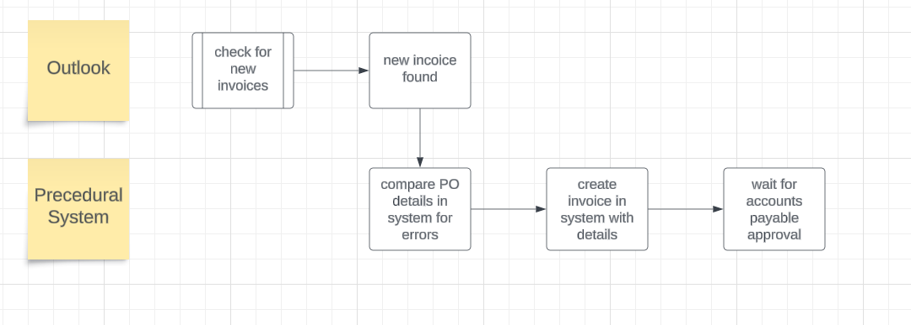

Broken down by component

GRASP:

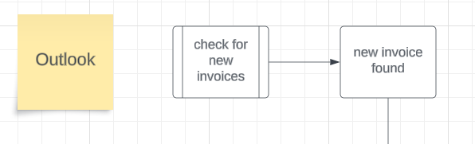

Yield:

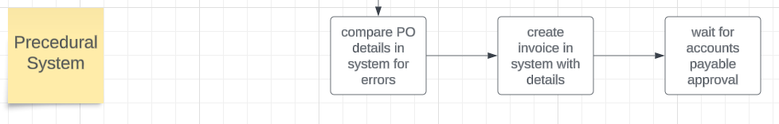

**LOW-LEVEL PROCESS OVERVIEW:**

**Grab Invoice Email From Outlook**

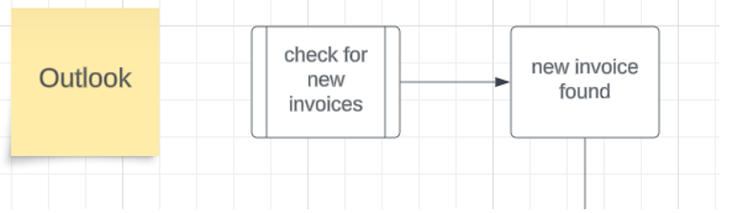

**Compare details in Procedural System:**

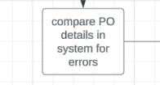

**Create invoice in system with all details:**

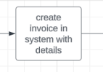

**3. TO BE PROCESS DESCRIPTION**

This chapter highlights the expected design of the business process after automation.

This process is divided into 2 stages: **GRASP** and **YIELD**

**GRASP:** The Grasp will access the desired website and find the necessary data. It will open the Vehicle Certification Agency, car fuel and navigate to Low and Ultra-Low emissions cars. After which it will click Ultra Low emissions and update. It will repeat the process for Low emission cars.

**YIELD:** The Yield will output the data onto the excel sheet accordingly. It will start scraping the assigned data from each column accordingly. It will store each input and check for duplicates after which it will discard the duplicate and repeat the process until the necessary amount of data is harvested. Once it's done with emissions below 75g CO2 it will move to create an excel sheet with CO2 emissions between 75g and 100g. After successfully displaying the desired amount of data it will halt operation.

**3.1 TO BE DETAILED PROCESS MAP**

**HIGH-LEVEL PROCESS OVERVIEW**

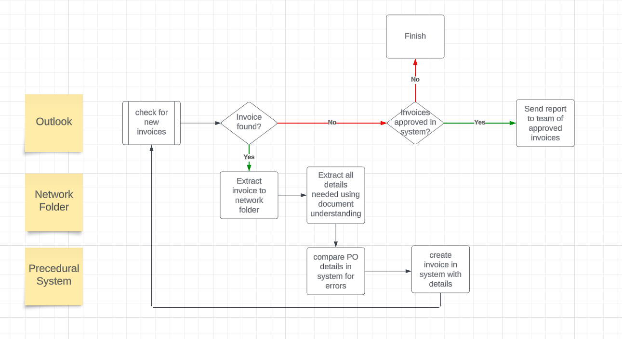

Broken down by component

**3.1.1** GRASP

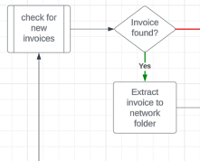

**3.1.2** YIELD

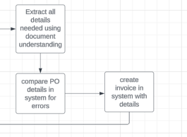

**3.1.3** GRASP 2

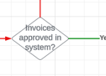

**3.1.4** YIELD 2

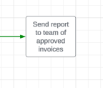

**3.2 LOW-LEVEL PROCESS OVERVIEW:**

**Grab Invoice Email from Outlook:**

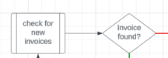

**Extract to Share Folder & all details using Document Undestanding:**

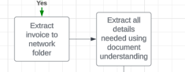

**Compare PO to details in procedural System:**

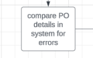

**Create Invoice in System:**

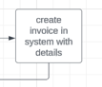

**Check for approvals and send email report If so:**

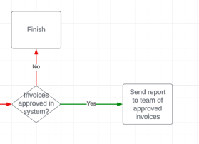

**4. Error Handling & TOS**

**4.1.1 In Scope for RPA**

The automated process will be developed as described in this document.

**4.1.2 Out of Scope for RPA**

The following will be considered out of scope for this automated process:

· N/a

**4.1.3 Business Exceptions Handling**

**Known Exceptions**

Currently there are no known exceptions.

**4.2 Unknown Exceptions**

**For all the other unanticipated or unknown business (process) exceptions, the robot should:**

· Take a screenshot and save locally.

· Send an error log message

· Recover & retry for maximum 3 times

· Close the applications and run the sequence again

**4.2.1 Application Error and Exception Handling**

**Known Errors or Exceptions**

The table below reflects all the errors identifiable in the process evaluation and documentation.

For each of these errors or exceptions, define a corresponding expected action that the robot should complete if it is encountered.

|  |  |  |  |
| --- | --- | --- | --- |
| Error Name | **Step** | **Parameters** | **Action** to be taken |
| Application crash/Internal error | Any | Error message | Recover & retry for maximum 3 times.  Take Screenshot.  Close the applications and run the sequence again. |
| Timeouts | Any | Error message | Recover & retry for maximum 3 times.    Take Screenshot.  Close the applications and run the sequence again. |

**4.3 Unknown Errors and Exceptions**

**For all the other unanticipated or unknown business (process) exceptions, the robot should:**

· Take a screenshot and save locally.

· Send an error log message

· Recover & retry for maximum 3 times

· Close the applications and run the sequence again

**5. OTHER**

**5.1** Acronyms

|  |  |
| --- | --- |
| **Abbreviation** | **Full-length** |
| **ABP INC.** | **Agile Business Processing Incorporated** |
| **K.A.C** |  |
| **LEV** | **Low Emissions Vehicle** |
| **ULEV** | **Ultra-Low Emissions Vehicle** |