**Introduction to Dopex**

Dopex -- A decentralized options protocol aiming to expand option liquidity throughout DeFi by minimizing option losses via rebates and maximizing reward through delegated controlled incentives.

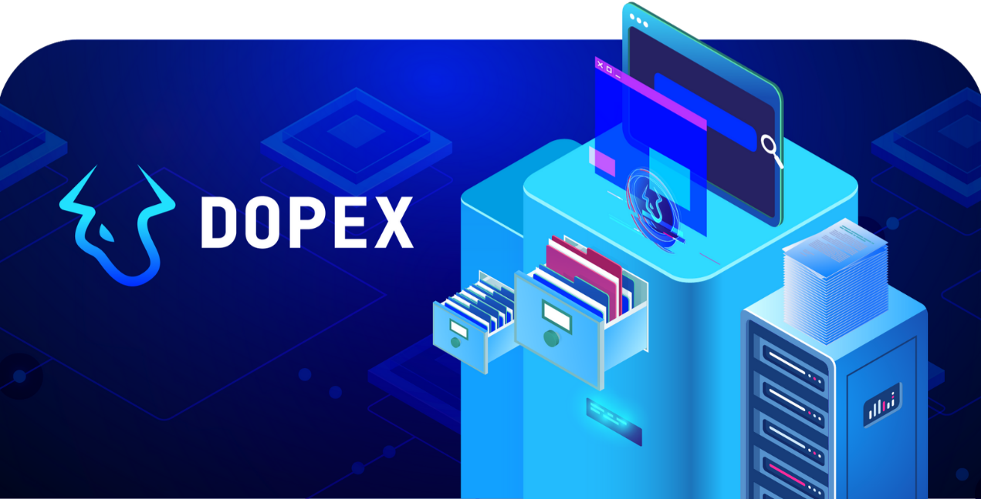

Incentives with minimized losses translate into a deep liquidity option market. Dopex leverages this liquidity to maximize option buyer's demands on strategies that are designed to:

* Hedge
* Give insurance
* Make speculative bets
* Or form an income basis

On diverse assets such as (Cryptos, derivatives, fungibles, non-fungibles, and more)

**Explore the incredible ecosystem that Dopex pursues #OpFi**

Dopex leverages options (the most composable financial tool) as a primary infrastructure base to construct prominent DeFi primitives in a securer format. These unique by-products give fruition to capital-efficient mechanics, which is only possible with modern blockchain SC technology.

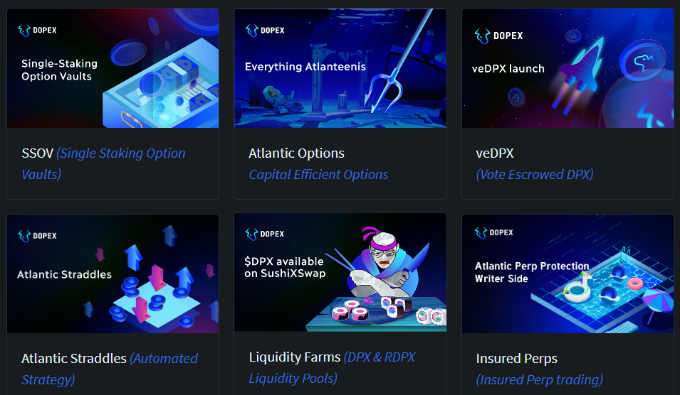

An incredible component of Dopex is that it can be used as a base layer for partnered protocols to build structured products on top of existing building blocks. Fortunately, multiple protocols have already built around us and joined our ecosystem, most of them committed community members.

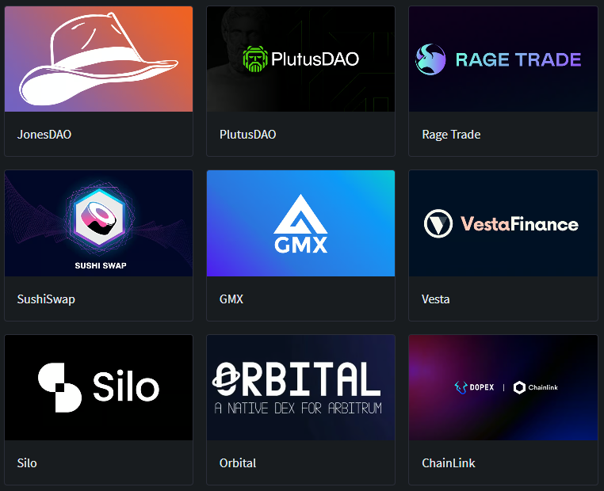

# Protocol Overview

Get to know your way around Dopex's ecosystem.

## What is Dopex?

Dopex, a decentralized options exchange, is a venue where users can provide option liquidity, buy vanilla options, or use structured option-based by-products to fulfill their financial inquiries.

Options

Dopex options are fully-transparent and embedded on-chain through “smart contracts.” They are identical in structure to traditional European options but with a few noteworthy differences. These include:

* Transparent and visible on-chain with zero downtime.
* Option Collateral can be moved across platforms and chains to conceivably benefit from valuable opportunities.
* Option positions come with an ERC-20 receipt that enables Users and protocols to use as a primary building bloc (OTC, Leverage, etc)

Atlantic Options

Unlike existing vanilla option configurations - Atlantic options strive to innovate in terms of collateral composability and efficiency in a safe and usable manner. As a new DeFi primitive, they improve collateral efficiency with a simple mechanism and with various practical use cases such as:

* CDP & Perp Protocols Liquidation Protection
* Atlantic Straddles & Atlantic Spreads
* Leveraged Bonding Insurance
* Positioning protocol-wide price floors via treasury
* Setting up “buy the dip” strategies
* And much more.

Liquidity Model

* Dopex uses its own state-of-the-art option pricing model that uses the traditional Black-Scholes model with a proxy that replicates volatility smiles. The model ensures fair and optimized option prices across all strike prices and expiries by coordinating implied volatility oscillations to major CEXes where the majority of Crypto option volume occurs.
* Non-Bluechip tokens use rolled-over RV (Realized Volatility) over XXXXX amount of time to create an authentic and accurate market price for these assets.

To learn more about Options: ["What are options?"](https://blog.dopex.io/articles/dopex-essentials/dopex-essentials-what-are-options)​

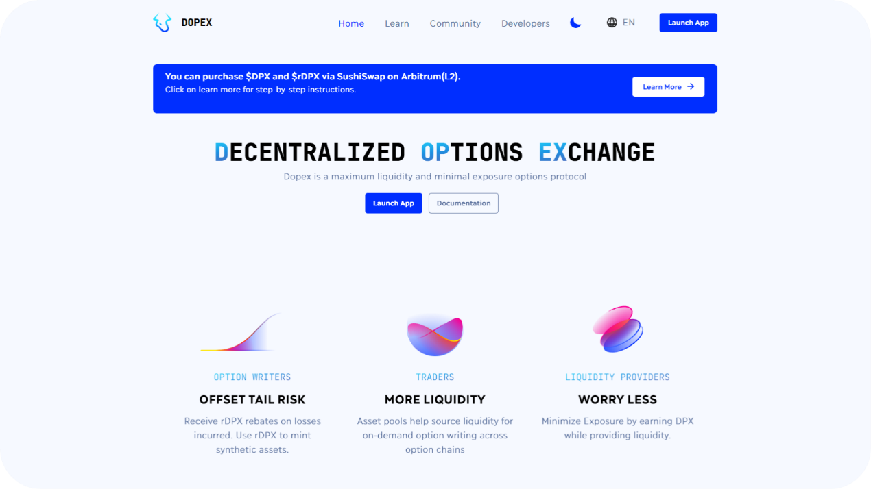

Dopex.io Landing Page

### Single Staking Option Vaults (SSOVs) 🔒

SSOVs allow users to lock up tokens for a specified period of time and earn yield on their staked assets. Users will be able to deposit assets into a contract which then sells your deposits as **call or put options** to buyers at fixed strikes that they select for different expiries.

​[Read More Here](https://docs.dopex.io/products/ssov-single-staking-options-vault)​

### Option Liquidity Pools (Secondary Market) 🧊

OLP is a configuration (A Secondary Option Market) built on top of our well-known SSOV product. As the name indicates, they are simply pools that allow the purchasing of SSOV option tokens at an implied volatility discount in exchange for providing anytime exit liquidity to option buyers. In simpler terms, it allows buyers of SSOV options to exit their position into option liquidity pools at any time in exchange for a discounted rate.

​[Read More Here](https://docs.dopex.io/products/option-liquidity-pools)​

### Atlantic Straddles ⚓

Straddles are a popular options strategy that allows traders to profit from significant price movements in an underlying asset. To execute a straddle, the trader simultaneously purchases both a call option and a put option for the same asset with the same strike price and expiration date, enabling the trader to benefit from any price movement (up or down).

​[Read More Here](https://docs.dopex.io/products/atlantic-options/atlantic-straddles)​

### Insured Perps 🩺

Atlantic Perp Protection is a product that provides liquidation protection to leveraged traders on GMX. This product allows them to keep their trading position open even if the mark price of their target asset falls below their liquidation price, the point where a trader’s margin is zero and their position should be automatically closed.

# Options 101

Learn the basic fundamentals of Options

## What are Options?

Options are financial instruments that derive their value from an underlying asset. An options “contract” offers the buyer the opportunity to buy or sell the underlying asset at a predetermined price and date There are two types of Option contracts: -Call Options (or “Call”) -Put Options (or “Put”)

* Calls are contracts that give the owner the right, but not the obligation, to BUY a specified amount of an underlying asset at a pre-determined price and date/time.
* Puts are contracts that give the owner the right, but not the obligation, to SELL a specified amount of an underlying asset at a pre-determined price and date/time.

Holders are not required to buy or sell the asset if they decide against it. Each contract has a specified expiration date by which the holder has the right to exercise their option. The strike price is the price at which the underlying asset can be bought or sold when exercised.

For calls, the strike price is the price at which the asset can be bought by the option holder For puts, the strike price is the price at which the asset can be sold by the option holder.

Calls and puts form the basis for option strategies designed for hedging, income, or speculation.

Dopex.io "What are options"

All options on Dopex are [European](https://docs.dopex.io/getting-started/protocol-overview/tokenomics/european-vs-american-options) in type, which signifies that they can only be exercised at expiry (Dopex automates this process), unlike American-style options which can be exercised any time before expiry.

#### Options Terminology to know

* ​[At-the-money](https://www.investopedia.com/terms/a/atthemoney.asp) (ATM) - an option whose strike price is exactly that of where the underlying is trading. ATM options have a delta of 0.50.
* ​[In-the-money](https://www.investopedia.com/terms/i/inthemoney.asp) (ITM) - an option with intrinsic value, and a delta greater than 0.50. For a call, the strike price of an ITM option will be below the current price of the underlying; for a put, above the current price.
* ​[Out-of-the-money](https://www.investopedia.com/terms/o/outofthemoney.asp) (OTM) - an option with only extrinsic (time) value and a delta a less than 0.50. For a call, the strike price of an OTM option will be above the current price of the underlying; for a put, below the current price.
* ​[Premium](https://www.investopedia.com/terms/o/option-premium.asp) - the price paid for an option in the market
* ​[Strike price](https://www.investopedia.com/terms/s/strikeprice.asp) - the price at which you can buy or sell the underlying, also known as the exercise price.
* ​[Underlying](https://www.investopedia.com/terms/u/underlying-security.asp) - the security upon which the option is based
* ​[Implied volatility](https://www.investopedia.com/terms/i/iv.asp) (IV) - the volatility of the underlying (how quickly and severely it moves), as revealed by market prices
* ​[Exercise](https://www.investopedia.com/terms/e/exercise.asp) - when an options contract owner exercises the right to buy or sell at the strike price.
* ​[Expiration](https://www.investopedia.com/terms/e/expirationdate.asp) - the date at which the options contract expires, or ceases to exist. OTM options expire worthless.

## Call Option

#### Buyer Of Call Option

Illustrated is the payoff graph of a "call" option. As defined in the image, the maximum loss for the option buyer is the premium paid for the option. As the underlying price passes the strike price and moves further ITM (Up), the user's profit increases with an unlimited profit potential.

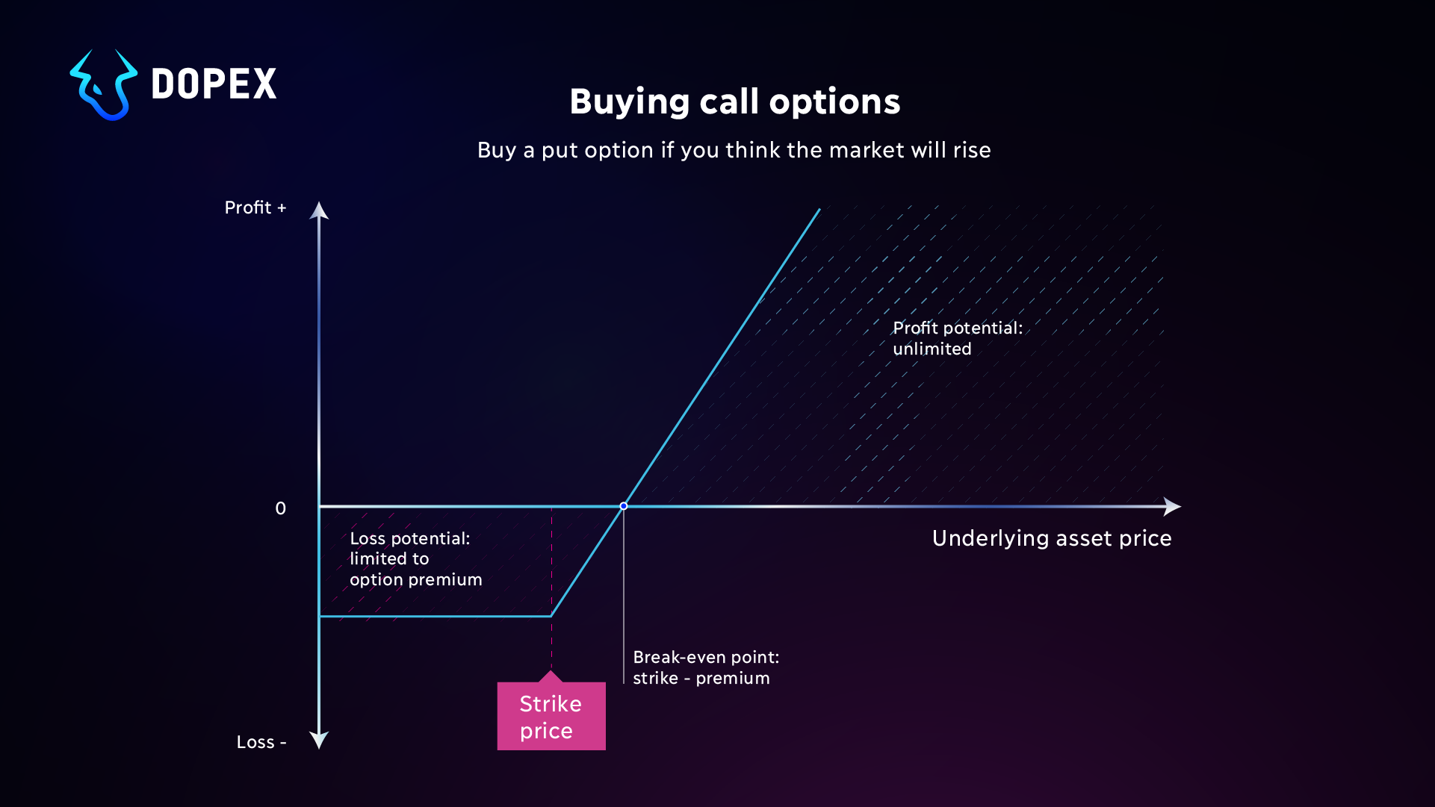

#### Seller Of Call Option

The payoff graph for the seller of the same option (Call Option) looks very similar to the buyers except that it is inversed. The seller instead receives the buyer's premium, and as the price increases, he loses capital which is paid to the buyer whenever the option is exercised.

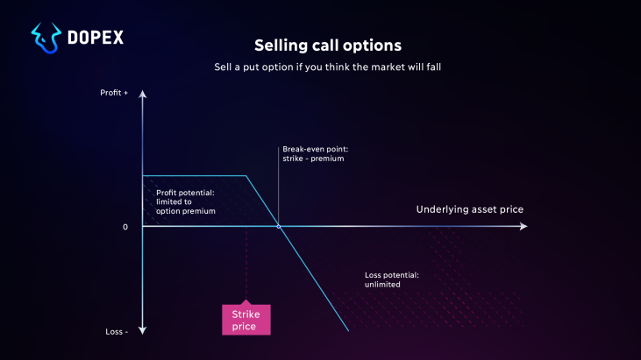

## Put Option

#### Buyer Of Put Option

Illustrated is the payoff graph of a "Put" option. As defined in the image, the maximum loss for the option buyer is the premium paid for the option. As the underlying price passes the strike price and moves further ITM (Down), the user's profit increases with substantial profit potential. (Until price hits 0)

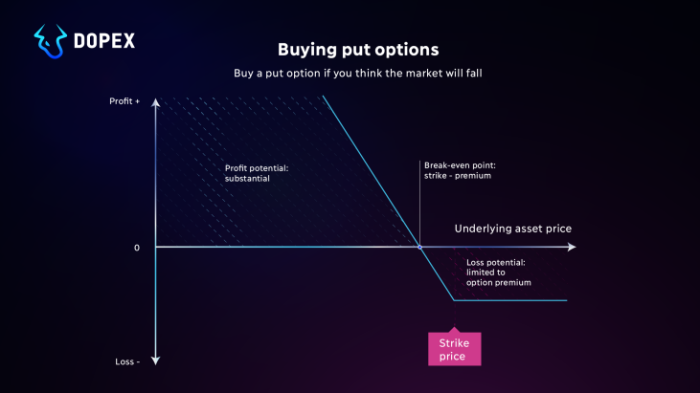

#### Seller Of Put Option

The payoff graph for the seller of the same option looks very similar to the buyer except that it is inversed. The seller instead receives the buyer's premium, and as the price decreases, he loses capital which is paid to the buyer whenever the option is exercised.

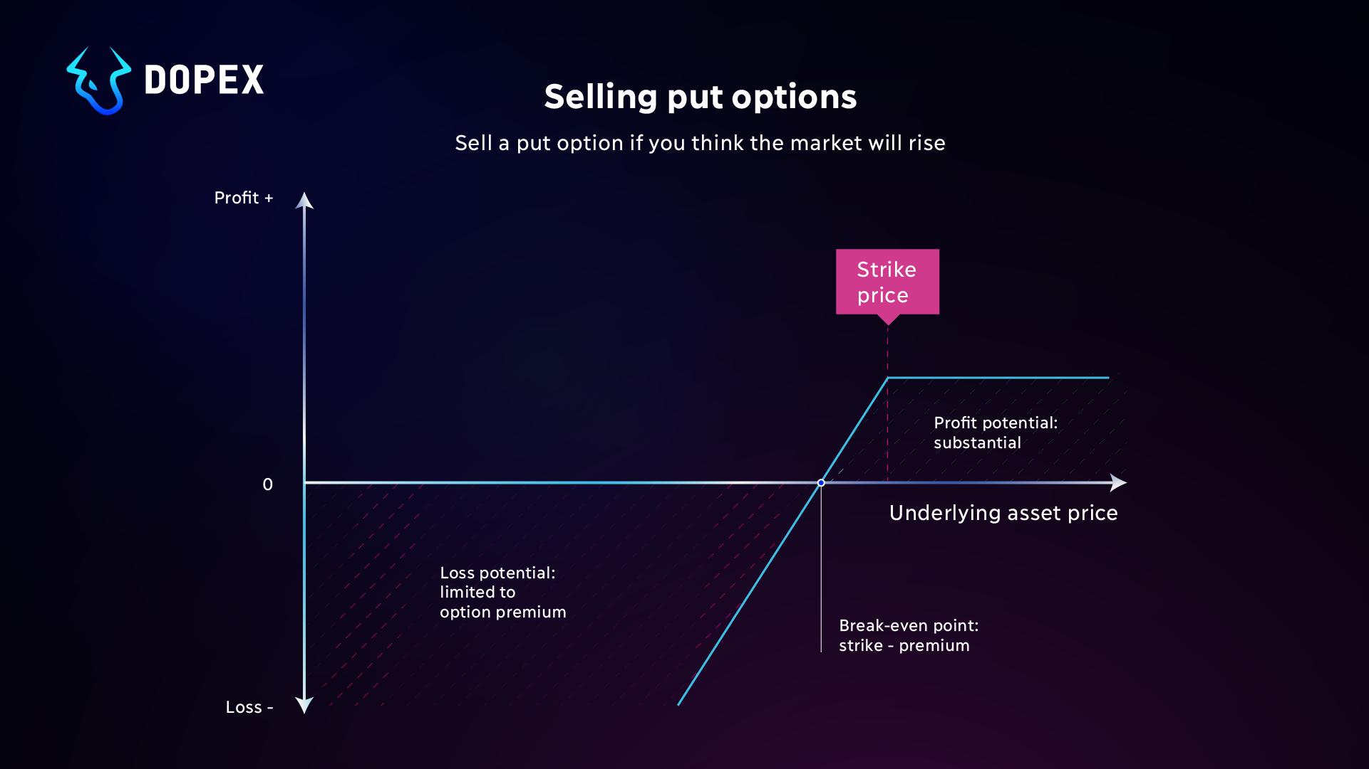

## Dopex Type Options

Dopex options are fully-transparent and embedded on-chain through “smart contracts.” Our options are most similar in design to European Options rather than their American counterparts. Read more ["here"](https://docs.dopex.io/getting-started/protocol-overview/tokenomics/european-vs-american-options) Dopex Options features include:

1. 1.

Transparent and visible on-chain

1. 2.

Only exercisable at expiration

1. 3.

Option Collateral can be moved across platforms since it is only needed at expiration

1. 4.

Options come with an ERC-20 receipt that Users can use to OTC, Leverage, etc

Using these metrics, Dopex develops numerous option-based products, for example, “SSOV” (Single Staking Option Vault), a product that automates the whole procedure while delivering ongoing yields and incentivizing deep liquidity. To learn more about Options or SSOVs:

# European vs American Options

### What Are European Or American Options?

The terms European and American options refer to the two different styles of options contracts, each of which offers advantages and disadvantages depending on the trader’s unique situation and goals. Before getting into the differences between these two types of options contracts, it is important to note that they both refer to derivatives, which are financial instruments with values that depend on the values of underlying assets in the market, such as stocks, bonds, commodities, tokens, coins, etc. If you haven’t already, we suggest reading more on options [“here.”](https://docs.dopex.io/getting-started/protocol-overview/tokenomics)​

### The Difference Between Both Types

The main difference between European and American options has to do with when the option can be exercised. European options can only be exercised on the expiration date, whereas American options can be exercised at any time before the expiration date. This can be beneficial to the option holder because it gives them greater flexibility when deciding when or if to exercise their option. In contrast, European option holders would have had to wait until the expiration date to exercise their option.

Another major difference between these two types of options is the way their premiums are determined. The premium of an option is the price the buyer pays to the seller (the writer) for the right to buy or sell an asset at the predetermined price and before the expiration date. In the case of European options, the premium is determined by finding the theoretical value of the option at the expiration date. This is calculated based on the [Black-Scholes](https://docs.dopex.io/getting-started/protocol-overview/dopex-option-pricing-model/tokenomics) pricing model, which estimates the expected return on the option given certain market conditions. American options, on the other hand, will have a higher premium due to the flexibility that the option holder has (Exercise anytime).

It is important to note that European options have certain advantages compared to American options. For example, European options are often less expensive because of the difference in how their price is determined. Also, since they can only be exercised on the expiration date, they don’t come with as much risk for the seller as American options.

| European | American |
| --- | --- |
| Inflexible (Exercises only at expiry) | Flexible (Can be exercised anytime) |
| Less expensive | More Expensive |
| Less risky for the seller | Useful flexibility for the buyer |

### Conclusion

Regardless of whether you are buying or selling an option, it is important to understand the differences between the two types of options contracts. European options offer a less risky way to invest in the potential of underlying assets but may not offer the same potential for profits as American options do. On the other hand, American options give traders the added flexibility to exercise the contract at any time before the expiration date, but the cost of these options will usually be significantly higher.

Learn how Dopex manages to offer Users the European Option model, all the while offering a tool that enables the flexibility of American options "here"

# ATM, ITM, OTM

### The Three Primary Terms

When investing in options, there are three primary terms — ATM, ITM, and OTM — used to describe a relative relationship between the strike price and the current market price of the underlying security. An investor’s choice of option depends upon its position in relation to the underlying market value, known as its “moneyness.” Knowing the difference between these terms is the first step towards deciding when to buy or sell an option.

|  |  |
| --- | --- |
| At-the-Money (ATM): | An ATM option is an option whose underlying asset’s current market price is equal to the option’s strike price. For both call and put options, buying an ATM option means that the underlying asset’s market price is currently equal to the option’s strike price. ATM options have no intrinsic value. |
| In-the-Money (ITM): | An ITM option is an option whose underlying asset’s current market price is higher than the option’s strike price. For call options, buying an ITM option means that the underlying asset’s market price is currently greater than the option’s strike price. Buying an ITM put option means that the underlying asset’s market price is currently less than the option’s strike price. ITM options generally cost more than other options because they have intrinsic value. |
| Out-of-the-Money (OTM): | An OTM option is an option whose underlying asset’s current market price is lower than the option’s strike price. For call options, buying an OTM option means that the underlying asset’s market price is currently less than the option’s strike price. Buying an OTM put option means that the underlying asset’s current market price is currently greater than the option’s strike price. OTM options have no intrinsic value and generally cost less than other options. |

When investing in options, it is important to understand the difference between the three types. An ITM call option will give you greater potential for price appreciation than an ATM or OTM option, as it leverages the intrinsic value from the start. OTM options are typically less expensive as they lack intrinsic value, but there is less of an upside potential for price appreciation. And an ATM option will be somewhere in the middle. Knowing the difference between these options can help investors make more informed decisions.