**Option Greeks**

Option Greeks: 4 Factors for Measuring Risk

**Overview**

The Greeks are a valuable tool for options traders to help them evaluate the risk of different options. Investors use them to make new investment decisions and analyze their current portfolio's risk. Ultimately, the Greeks provide information that allows investors to make informed decisions.

Ultimately, the Greeks are there to help take some of the guesswork out of options trading. It can be a complicated realm of investing for those who don’t have experience with options. It is important to know that the Greeks do not work in isolation and are constantly changing — A change in one Greek can affect all of the other Greeks. The Greeks are one tool that can be used to help you determine the risk you’re getting yourself into before you make significant investing decisions.

Notably, Option Greeks indicate how sensitive an option is to time-value decay, changes in implied volatility, and movements in the price of its underlying security, among numerous other values.

The four primary Greek risk measures are known as an option's

* ​[THETA](https://docs.dopex.io/getting-started/protocol-overview/tokenomics/option-greeks/theta)​
* ​[VEGA](https://docs.dopex.io/getting-started/protocol-overview/tokenomics/option-greeks/vega)​
* ​[DELTA](https://docs.dopex.io/getting-started/protocol-overview/tokenomics/option-greeks/delta)​
* ​[GAMMA](https://docs.dopex.io/getting-started/protocol-overview/tokenomics/option-greeks/gamma)​

In the next section, we explore each in greater detail.

# DELTA

### What is Delta?

Delta is a measure of the change in an option's price (that is, the premium of an option) resulting from a change in the underlying asset.

The value of Delta ranges from -1.00 to 0 for puts and 0 to 1.00 for calls. Puts generate a negative delta because they have an inversely proportional (negative) relationship with the underlying asset In other words, put premiums fall when the underlying asset rises, and vice versa.

On the other hand, call options have a directly proportional (positive) relationship with the underlying asset's price. Provided that other variables, such as implied volatility or time to expiry remain constant, the call premium should rise as the price of the underlying asset increases. Correspondingly, if the underlying asset price lowers, the call premium will also decrease.

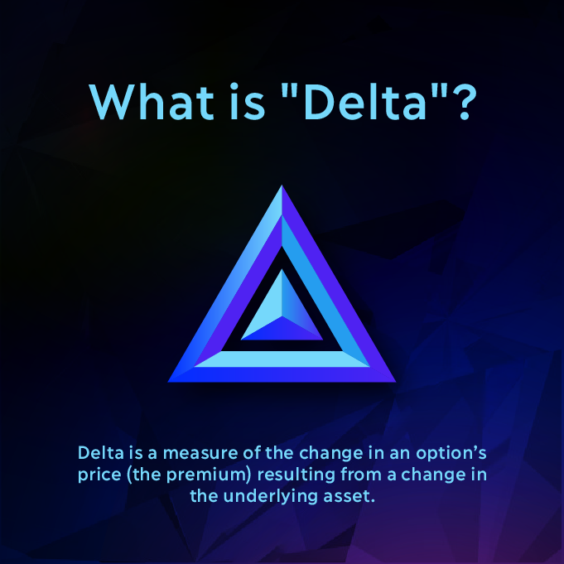

### Analogy

Think of Delta like a race track: The tires = the delta. The gas pedal = the price of the underlying asset.

Options with low delta are like race cars with stock tires. When you rapidly accelerate, they won’t get a lot of traction. On the flip side, options with high delta are like drag racing tires. When you rapidly accelerate, they provide a lot of traction. Delta values closer to 1.00 or -1.00 provide the highest levels of traction.

### Example of Delta

Let’s suppose that there are Option X and Option Y, both have the same underlying asset.

Option X is an out-of-the-money option with a delta of 0.25

Option Y is an in-the-money option with a delta of 0.80

A $1 increase in the underlying asset price will lead to a $0.25 increase in Option X and a $0.80 increase in Option Y.

Options with high deltas are likely to provide grander traction. Due to this, these options tend to be more expensive in terms of their cost basis since their probability to expire in the money.

The Delta changes as options become more profitable or in the money. As the option gets further in the money, Delta approaches closer to 1.00 on a call option and -1.00 on a put option, with the extremes provoking a one-for-one link between changes in the option price and changes in the price of the underlying asset.

Basically, this means that, at delta values of -1.00 and 1.00, the option acts like the underlying asset in terms of price changes. This behavior occurs with little or no time value as most of the value of the option is intrinsic.

### Probability of profitability

Delta is commonly used when determining the probability of an option being in the money at expiration. For instance, an out-of-the-money call option with a 0.30 delta approximately has a 30% chance of being in the money at expiration, whereas a deep-in-the-money call option with a 0.90 delta approximately has a 90% chance of being in the money at expiration.

The assumption made here is that the prices follow a lognormal distribution, like amounts of rainfall for example.

### Delta and directional risk

Delta is also used when determining directional risk. Positive deltas are long (buy) market assumptions, negative deltas are short (sell) market assumptions, and neutral deltas are neutral market assumptions.

Higher deltas may be ideal for more speculative, higher-risk, higher-reward strategies, whereas lower deltas may be more suitable for lower-risk strategies with higher success rates.

When you buy a call option, ideally, you want it to have a positive delta since the price will increase along with the underlying asset’s price. Conversely, when you buy a put option, ideally, you want it to have a negative delta since the price will decrease if the underlying asset’s price increases.

### Key points:

* Delta is inclined to increase closer to expiration for near or at-the-money options.
* Delta is further evaluated by gamma, which is a measure of Delta’s rate of change.
* Delta can also change in reaction to implied volatility changes.

For a more in-depth explainer:

# GAMMA

### ****What is Gamma?****

**Gamma measures the rate of change in delta over time. You could think of Gamma as the acceleration/retardation of delta**

Due to delta values being dynamic and constantly changing with the price of the underlying asset, gamma is used to measure the rate of change and provide traders with insight on what to anticipate in the future.

Gamma values are highest for at-the-money options and lowest for deep in-the-money or out-of-the-money options.

As we covered, delta changes based on the price of the underlying asset; however, gamma is a constant that represents the rate of change of delta. This makes gamma very useful for determining the stability of delta, which can then be used to determine the probability of an option reaching the strike price at expiration.

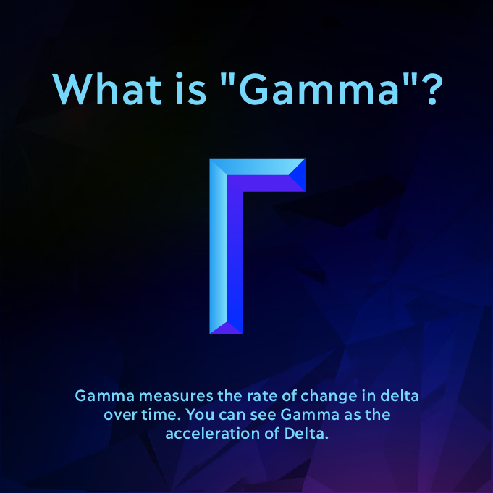

## Example of Gamma

Let’s suppose there are two options — Option A and Option B — with the same delta value. However, Option A has a high gamma, whereas, Option B has a low gamma.

The option with the higher gamma (Option A) will have a higher risk factor since an unfavorable move in the underlying asset will have a greater impact. High gamma means that the option is likely to experience volatile swings, which is not ideal for traders looking for predictable opportunities.

We could describe gamma as the measure of the stability of an option’s probability.

Delta and gamma work hand in hand. Delta represents the probability of the option being in the money at expiration. Gamma represents the stability of that probability over time.

An option with a high gamma and a 0.60 delta is less likely to expire in-the-money than a low gamma option with the same delta.

## Key points

* The value of gamma is lower for deep out-of-the-money and deep-in-the-money options.
* The value of gamma is highest when the option gets near the money.
* The value of gamma is positive for long options and negative for short options.

For a more in-depth explainer:

**THETA**

What is Theta?

Theta measures the rate of time decay in the value of an option or its premium

Time decay represents the decrease of an option’s value or price due to the passage of time. As time passes, the likelihood of an option being profitable or in the money at expiry decreases. As the expiration date of an option draws closer, time decay tends to accelerate as there is less time remaining to earn a profit from the trade.

Theta is always negative for a single option because time moves in the same direction (forward, just in case you didn’t know). The moment a trader purchases an option, the clock starts ticking, and the value of the option immediately begins to erode until it expires, worthless, at the expiration date.

In short, theta is to the advantage of option sellers/writers and the disadvantage of option buyers.

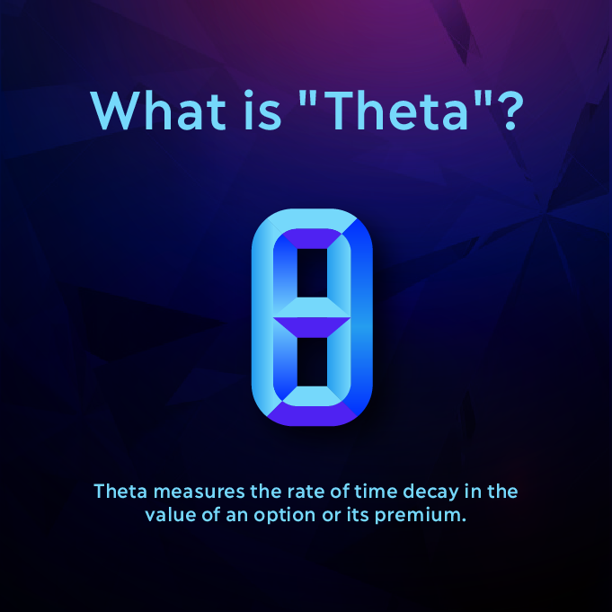

**ANALOGY**

Picture an hourglass, the top side is the option buyer, and the bottom side is the option seller. The buyer must decide whether to exercise the option before time runs out. Meanwhile, as the buyer is deciding what to do, the value is flowing from the buyer’s side to the seller’s side of the hourglass. Although the movement is not rapid, it is a continuous loss of value for the buyer.

Theta values appear smooth and linear over the long term, but as the date of expiry draws nearer, the gradient becomes much steeper for at-the-money options. The extrinsic value/time value of the ITM and OTM options is very low near expiration because the probability of the price reaching the strike price is also low. In layman’s terms, as time runs out, there is less probability of earning a profit.

**KEY POINTS:**

* OTM options with a lot of implied volatility tend to have high values of Theta.
* Theta is typically highest for at-the-money options since less time is needed to earn a profit with a price move in the underlying asset.
* Theta will increase sharply as time decay accelerates in the last few weeks before expiration and can severely undermine a long option holder’s position, especially if implied volatility decreases at the same time.

For a more in-depth explainer:

**VEGA**

What is Vega?

Vega measures the risk of changes in implied volatility or the forward-looking expected volatility of the underlying asset price

Unlike delta, which measures actual price changes, vega measures changes in expectations for future volatility. Greater volatility makes options more expensive because they have a greater likelihood of hitting the strike price at expiry.

Vega tells us approximately how much an option price will increase or decrease given an increase or decrease in the level of implied volatility.

While option sellers benefit from a decrease in implied volatility, option buyers do not.

It’s key to note that implied volatility reflects price action in the market. When option prices are bid up because there are more buyers, we can expect an increase in implied volatility.

Long option traders benefit from prices being bid up, and short option traders benefit from prices being bid down. Due to this, long options have a positive vega value, and short options have a negative vega value.

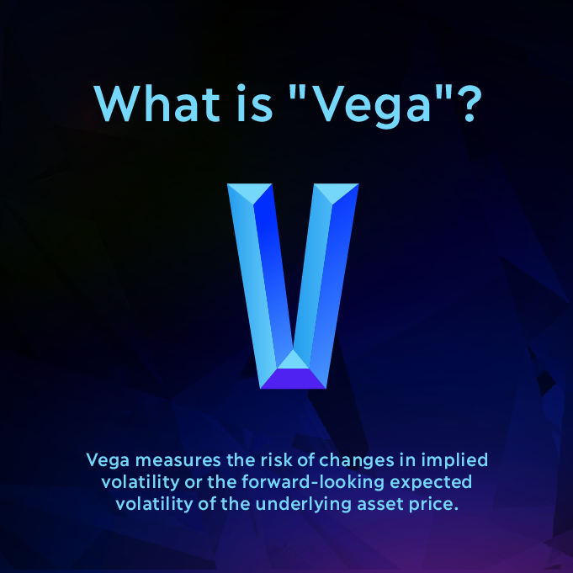

**KEY POINTS:**

* Due to changes in implied volatility, the value of vega can fluctuate even without price changes to the underlying asset.
* Vega can increase in reaction to sudden changes in the price of the underlying asset.
* As the option gets closer to the expiration date, the value of vega decreases.

**CONCLUSION**

This was a brief overview to help you understand the basics of the Greeks and how they are used within the options market. The Greeks help to provide important measurements of an option position’s risks and potential rewards and are good tools to consider when planning risk management for options trading. Due to market volatility, the Greeks provide traders with a means of determining how sensitive a specific trade is to fluctuations in price and volatility as well as time.

If you have any further questions, do not hesitate to reach out to us on the Dopex Discord server or via Twitter.

For a more in-depth explainer: