**Dopex Option Pricing Model**

Market-Making and pricing options in DeFi come with challenges, primarily due to the inconsistency of options demand and data sets (SD, Variance), which are customarily employed as a discovery mechanism for evaluating the IV [(Implied Volatility)](https://www.investopedia.com/terms/i/iv.asp) component of the Black-Scholes formula (A formula widely used to price options contracts.) Dopex does not require a price discovery mechanism as it prices its options accurately by coordinating implied volatility oscillations to major CEXes where the majority of the options volume transpires. This feature ensures proper option pricing so that both parties (buyer and seller) are kept from holding the short end of the stick. In contrast, AMM models, under certain circumstances, disadvantage users by underpricing or overpricing options in periods of low/high volatility.

# The Black-Scholes Model

## The Black-Scholes Model

The Black-Scholes model is a mathematical equation that estimates the theoretical value of derivatives based on other investment instruments, taking into account the impact of time and other risk factors. The model, created in 1973, is one of the most important concepts to have been established in modern financial theory and is widely used to this day to price European options.

Black-Scholes posits that instruments, such as derivatives or futures contracts, have a lognormal distribution of prices following a "random walk" (random and unpredictable path) with constant drift and volatility. Using this assumption and factoring in other important variables, the equation derives the price of a European-style call option.

The Black-Scholes equation requires five variables to derive its estimates.

1. 1.

​[volatility](https://www.investopedia.com/terms/v/volatility.asp)​

1. 2.

the price of the [underlying asset](https://www.investopedia.com/terms/u/underlying-asset.asp)​

1. 3.

the [strike price](https://www.investopedia.com/terms/s/strikeprice.asp) of the option

1. 4.

the time until the expiration of the option

1. 5.

and the risk-free [interest rate](https://www.investopedia.com/terms/i/interestrate.asp)​

With these variables, it is possible for options sellers and Dopex to set institutional-grade pricing for the options sold within the platform.

The assumption of lognormal underlying asset prices should indicate that **the implied volatilities, according to the Black-Scholes model, are identical for each strike price. However, this is inaccurate**. Markets have adapted to consider severe past events where assets declined to significantly inferior levels. To adjust, industry-wide implied volatility of at-the-money options has been positioned lower than those further OTM or deeply ITM. The reason for this phenomenon is the market now prices in a greater likelihood of a high volatility move to the downside in the markets.

This led to the presence of the volatility skew or smile. (Named this way because when the implied volatilities for options with the same [expiration date](https://www.investopedia.com/terms/e/expiration-date.asp) are mapped out on a graph, a smile or skewed shape can be seen)

Read more about Volatility Surfaces in our next section.

​[**Volatility Surfaces**](https://docs.dopex.io/getting-started/protocol-overview/dopex-option-pricing-model/volatility-surfaces)​

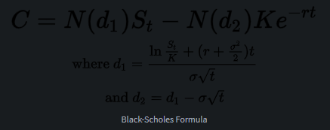

Black-Scholes Formula

where:

C=Call option price

S=Current stock (or other underlying) price

K=Strike price

r=Risk-free interest rate

t=Time to maturity

N=A normal distribution

# Volatility Surfaces

### What is a Volatility Surface?

Of all the variables used in the Black-Scholes model, volatility is the only one that is not known with certainty. At the time of pricing, all of the other variables are clear and known, but volatility remains an estimate. The volatility surface is a three-dimensional plot where the x-axis is the time to maturity, the z-axis is the strike price, and the y-axis is the implied volatility. If the Black-Scholes model were completely correct, then the implied volatility surface across strike prices and time to maturity would be flat. In practice, this is not the case, as many factors affect its activity. Consequently, Dopex designed its own revolutionary version of the renowned volatility smile design.

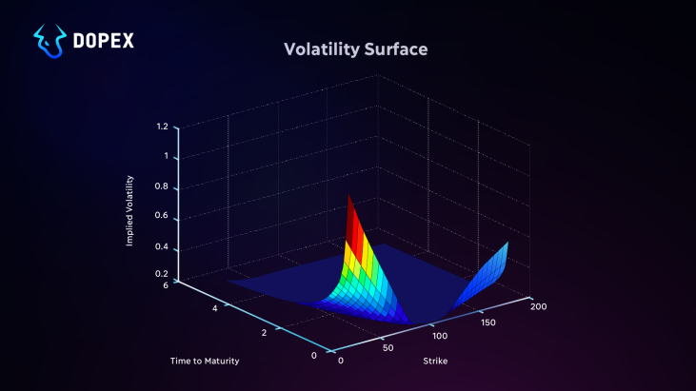

### The Dopex Volatility Smile Replica

A volatility smile is a common graph shape that results from plotting the strike price and implied volatility of a group of options with the same underlying asset and expiration date. Volatility smiles are the result of factoring the possibility of extreme events occurring into the pricing of options by setting further OTM IV to higher levels than ATM options. Accordingly, Dopex replicated an enriched version of the traditional Volatility Smiles approach that uses Implied Volatility and price feed fetched from Chainlink Adapters to employ within a function that retrieves a Volatility Smile graph that's based on Realized Volatility of past data.

When the implied volatilities for options with the same expiration date are mapped out on a graph, a form emerges in the form of a "Smile," hence its name.

