**SSOV (Single Staking Options Vault)**

**What are SSOVs?**

SSOVs, enable users to temporarily lock up tokens in order to provide option liquidity and earn a yield on their assets. This is accomplished by depositing assets into a contract, which are then used as collateral to sell covered calls or cash-secured put options at pre-determined strikes and expiries (e.g. monthly or weekly) to buyers.

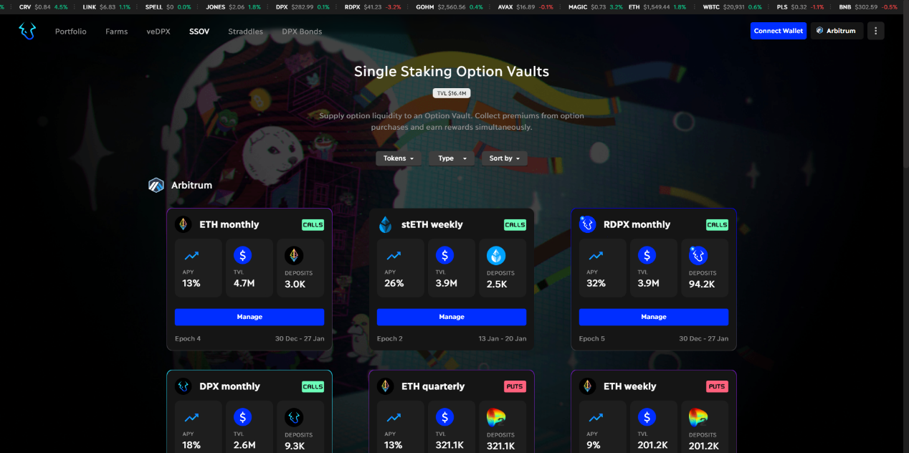

​<https://app.dopex.io/ssov>​

**How do they work?**

1. 1.

Pre-set terms: User chooses which vault they'd like to provide option liquidity for, as well as at which strike and expiry (weekly/monthly).

1. 2.

Deposit assets: The user deposits and locks the underlying asset into the vault, which serves as collateral.

1. 3.

Earning a yield: Users passively earn numerous sources of yield on locked assets including DPX emissions, yield-bearing assets, and premiums.

1. 4.

Provision of option liquidity: The deposited assets are then used to sell covered calls or cash-secured put options to buyers.

1. 5.

Option buyers: Buyers can now purchase the available options offered by the sellers by paying a premium.

1. 6.

Expiry and settlement: At the end of the options' expiry period, they are settled, and the assets are returned to the users, who can then withdraw them.

**In summary, SSOVs allow users to temporarily lock up their assets, sell options to buyers, and earn a yield in the process, all while providing option liquidity to the market.**

**Supported Tokens**

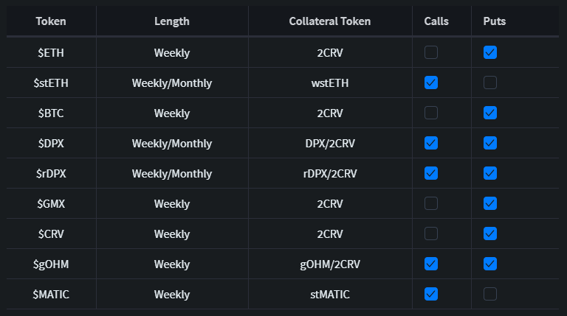

*2CRV tokens utilized as collateral for put vaults. Learn how to obtain 2CRV tokens "[here](https://blog.dopex.io/articles/ssov/how-to-get-2crv-tokens)"

**Purchasing Calls**

The platform provides a simple and convenient way for buyers to purchase calls from the vaults using the base asset. This is done through the platform dapp, which allows users to purchase using the vault underlying asset. The four-strike vaults are straightforward and easy to follow, making them accessible to all users regardless of their level of experience. Once the purchase is made, the premium is securely stored in the vault, and an NFT receipt representing the position is given back to the purchaser. This system provides a reliable and efficient solution for option buyers looking to open a specific option position.

**Yield**

As an SSOV depositor, you'll receive not only premiums calculated through our option pricing model but in some instances, also DPX emissions and yield from receipt tokens (yield-bearing assets). However, it's important to note that while USD notional value remains intact, there is a possibility of losing a percentage of the locked assets.

**Option Specs**

|  |  |
| --- | --- |
| Attribute | Value(s) |
| Style | European |
| Expiries | Weekly, Monthly |
| Expiry Time | 8:00 AM UTC |
| Settlement | CALLS: Base Token PUTS: Quote Token |
| Margin requirements (writing) | Fully backed by collateral  CALLS - Base Token PUTS - Quote Token |

**Exercise & Settlements**

By default, all options are automatically exercised upon expiry, allowing for flexible settlement at the user's convenience. The process is a net settlement, meaning it occurs without the need for the underlying asset. The profit and loss of the option are calculated, and if positive, the option token is burned, transferring the computed profits to the user's wallet. PnL is calculated in the following manner:

For calls:

*PnL*=((*Price*−*Strike*)∗*Amount*)/underlying*Price*

For puts:

*PnL*=((*Strike-Price*)∗*Amount*)/quote*Price*

In the above formula, price is the spot price of the asset and Amount is the number of options being exercised.

​

**Fees**

**Fee Multiplier**

We have introduced an updated fee structure for SSOVs calling it the Fee Multiplier for all our current and upcoming Single Staking Options Vaults (SSOVs). The Fee multiplier is a simple % based multiplier that multiplies fees for Out of the Money (OTM) strikes for call options to account for higher volatilities.

Example:

* Strike - 2000 Current Price of Asset - 1000
* Fee Multiplier = 1 + ((2000/1000) - 1)
* Final Fee = Base Fee * Fee Multiplier

The current fee specifications can be found here: [Link](https://app.dopex.io/protocol-fee-specification)​

​

***For more information on SSOVs check out our blog posts:***

[Dopex Single Staking Option Vaults (SSOV)](https://blog.dopex.io/dpx-single-staking-option-vaults-2b2dbda540f9)

[Dopex Single Staking Option Vaults (SSOV)](https://blog.dopex.io/dpx-single-staking-option-vaults-2b2dbda540f9)

Introduction to SSOV

[Dopex SSOV Strategies](https://blog.dopex.io/dopex-ssov-strategies-7da338cba511)

[Dopex SSOV Strategies](https://blog.dopex.io/dopex-ssov-strategies-7da338cba511)

Strategies for SSOV

**Single Staking Options Vault (SSOV)**

Walkthrough

1.

Head over to the Dopex application: <https://app.dopex.io/>​

2.

Make sure you are connected to the correct network. Connect by selecting your preferred network from the Change Network option next to your wallet button.

​

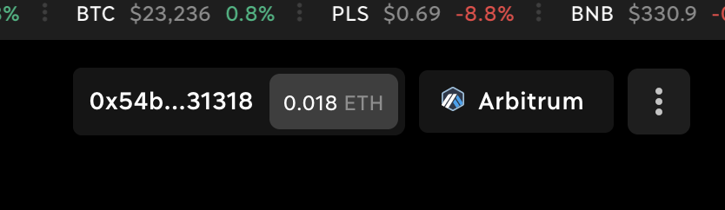

​

then

​

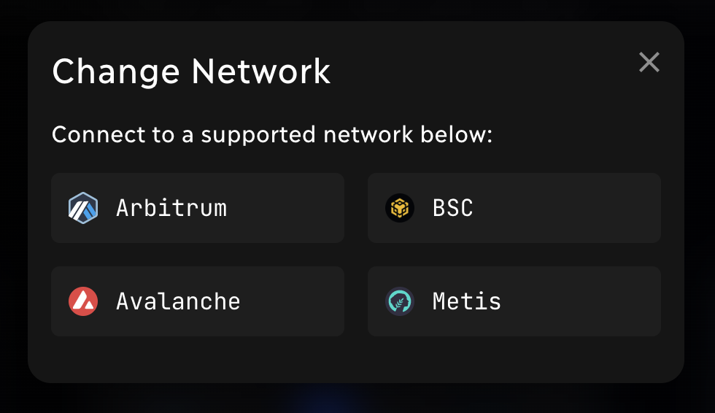

​

3.

Once connected, you can see all Dopex offerings in the top Menu.

4.

Head over to SSOV page by selecting “SSOV” under the “Options” menu.

​

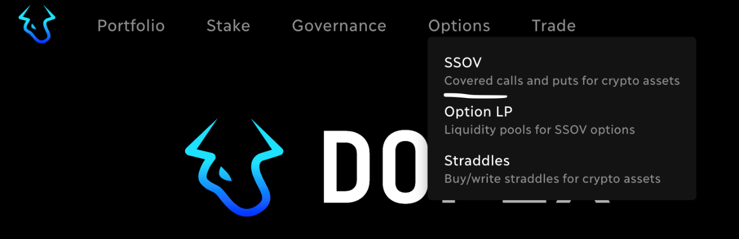

​

5.

You are now on the SSOV page.

6.

Here you will find all Dopex Single Staking Option Vaults with both weekly and monthly expiry

7.

Each vault has its respective details:

* Vault type: CALL/PUT
* APY: Rewards for depositors on a yearly basis
* TVL: Current available liquidity in USD
* Deposits: Amount of tokens deposited
* Epoch: Number of epochs the vault is currently in
* Duration: Start date and end date of the epoch

​

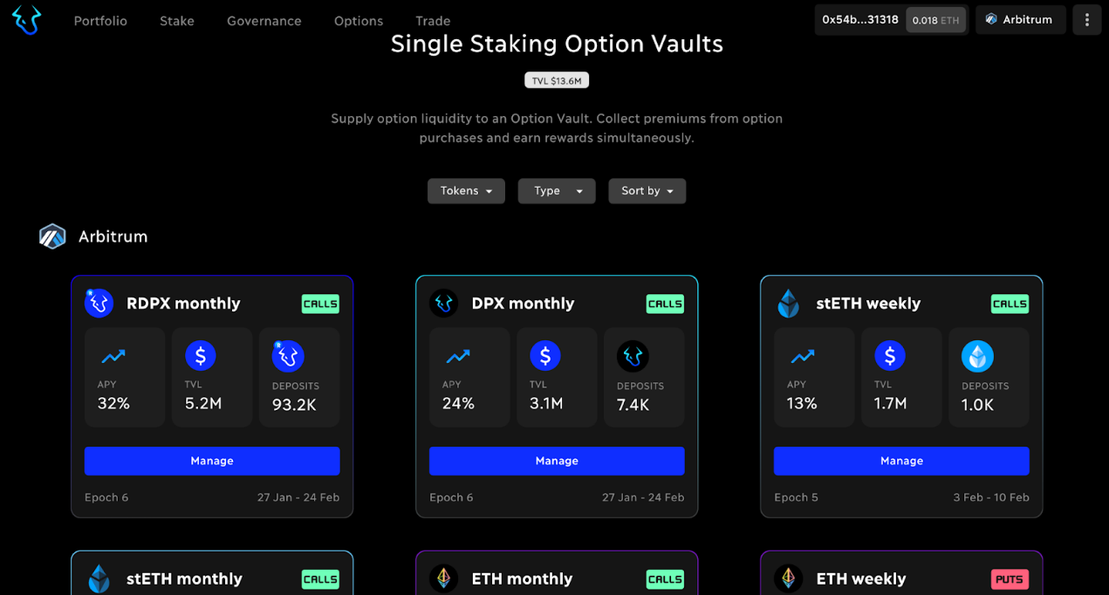

​

8.

Scroll to the token for which you want to deposit (write options) or buy options and Click on the Manage button.

9.

Let’s take a look at the sections displayed.

* Stats: Gives an overview of the vault of selected tokens like how many options were purchased and what was the total premium

​

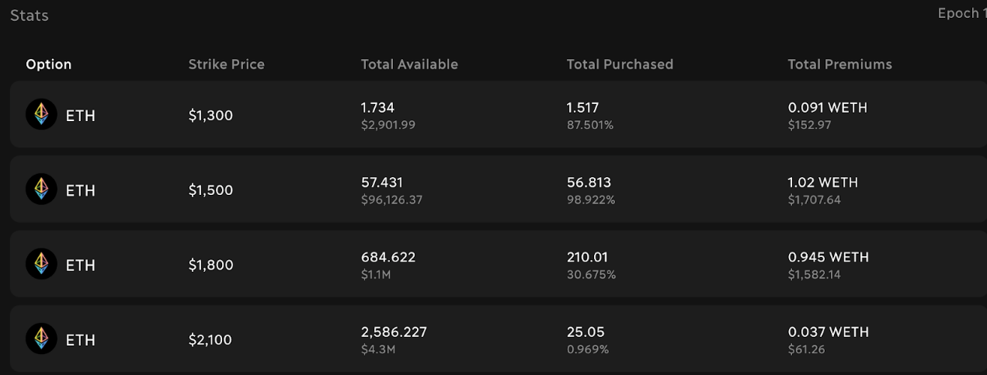

​

* Write Positions: List all your deposits with various information. It displays the amount you deposited for which epoch and how much rewards it has accumulated.

​

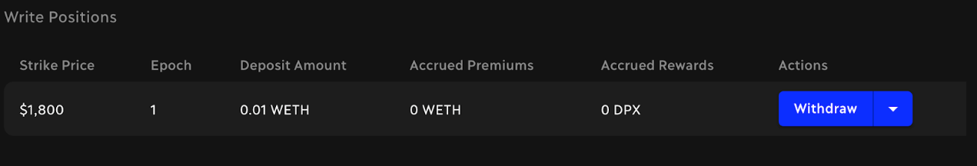

​

* Your Options: If you purchase an option, it will be displayed in this section with information like what was the strike for which it was purchased and what is the profit or loss

​

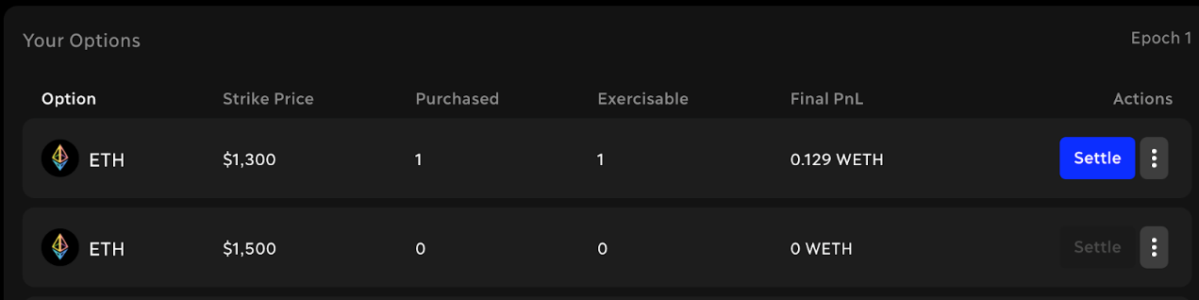

​

**Deposit in SSOV (Write options)**

1.

Ensure your wallet is connected and the network for your token is selected.

2.

Go to the SSOV page

3.

Scroll to the token you want to deposit (write options) and click the Manage button.

4.

On the right side of the SSOV page, you will see a section for performing Deposits.

​

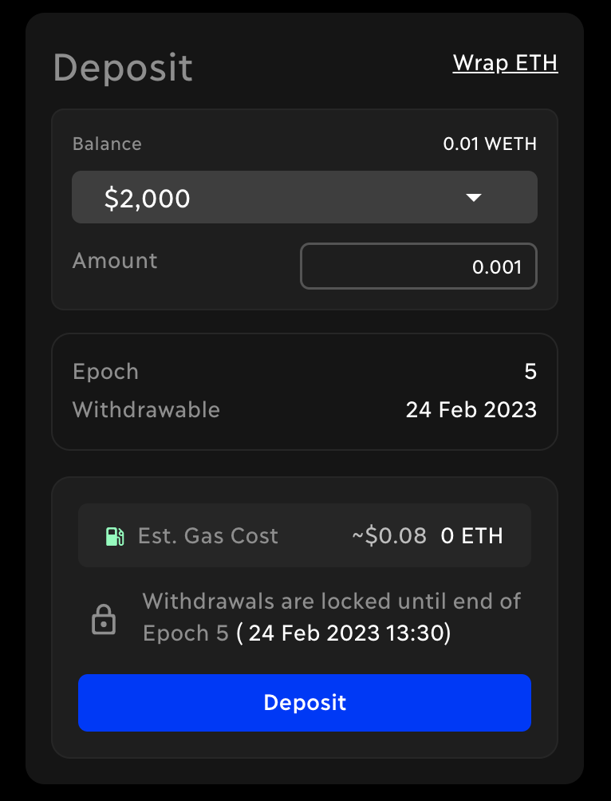

​

5.

Select the Strike for which you want to deposit

6.

Enter the amount of ETH you want to deposit

7.

Hit the Deposit button and Accept the transaction in your wallet. If you are depositing for the first time - you will be asked to approve the token before you can make the deposit. Both Approve and Deposit actions need gas for the transaction.

8.

After the transaction completes, you can see your deposits in the Write Positions section

**Buy options from SSOV**

1.

Make sure your wallet is connected, and the network for your token is selected

2.

Go to the SSOV page from the top menu

3.

Scroll to the token for which you want to buy options and Click on the Manage button

4.

On the left side of the SSOV page, you will see a button to Buy Options

5.

Clicking it will open a pop-up with information and options to buy Options

​

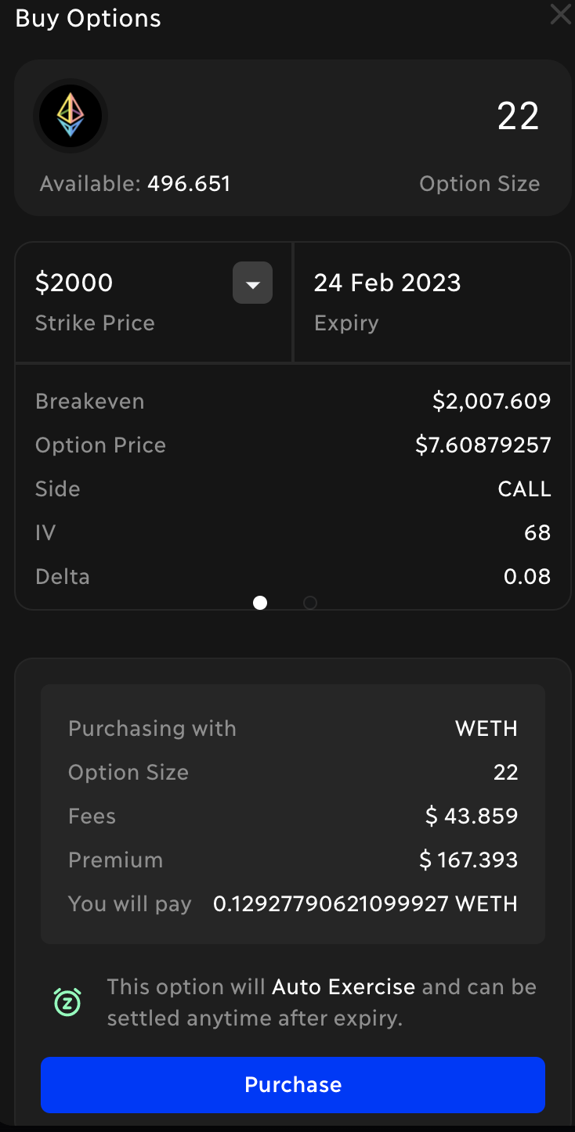

​

6.

Enter the option size you want to buy

7.

Select the strike price of your choice

8.

Have a look at the breakeven price and calculator to be sure about the strike price

9.

Hit purchase and Accept the transaction in your wallet. If you are making the purchase for the first time - you will be asked to approve the token before you can make the purchase. Both Approve and Purchase actions need gas for the transaction.

10.

After the transaction completes, you can see your deposits in the Your Options section

**Withdraw deposits or your Write Position from SSOV**

1.

Make sure your wallet is connected, and the correct network is selected

2.

Go to the SSOV page from the top menu

3.

Scroll to the token for which you want to withdraw your deposits (exit write options) and Click on the Manage button

4.

Select the epoch in which you made the deposit

​

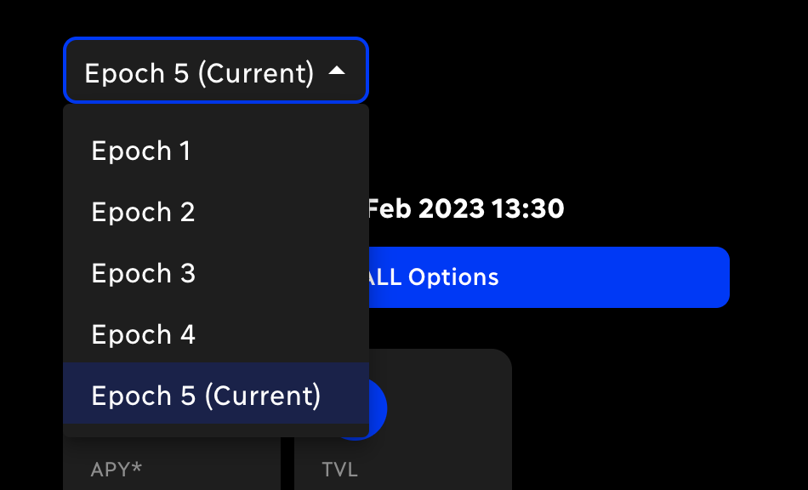

​

5.

Scroll down to the “Write Positions” section

6.

For each of your deposits in the Write Positions section, you can see Withdraw button under the Actions title

​

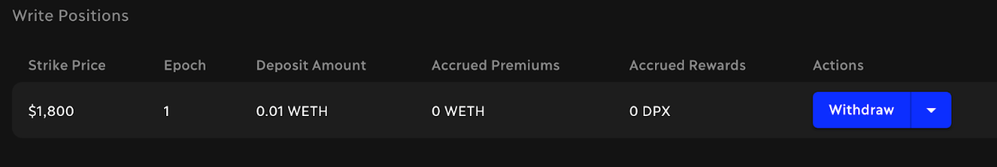

​

7.

Clicking on Withdraw button will give you a summary of your withdrawal

8.

Hit the Withdraw button on the summary and Accept the transaction in your wallet.

**Settle option on SSOV**

1.

Make sure your wallet is connected, and the correct network is selected

2.

Go to the SSOV page from the top menu

3.

Scroll to the token for which you want to settle options and Click on the Manage button

4.

Select the epoch in which you made the purchase

​



​

5.

Scroll down to the “Your Options” section

6.

For each of your brought options in Your Options section, you can see the Settle button under the Actions title

​

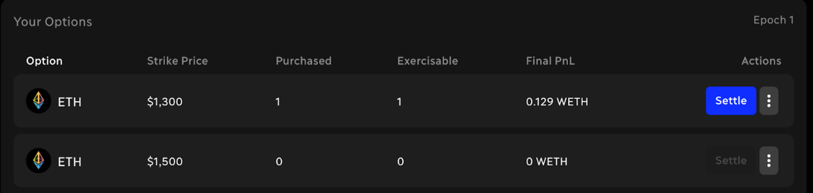

​

7.

Clicking on the Settle button will give you a summary of your settlement

8.

Hit the Approve button on the summary and Accept the transaction in your wallet.