**Overview**

Generalized Leverage Protocol ⚙ Built with composability in mind <3

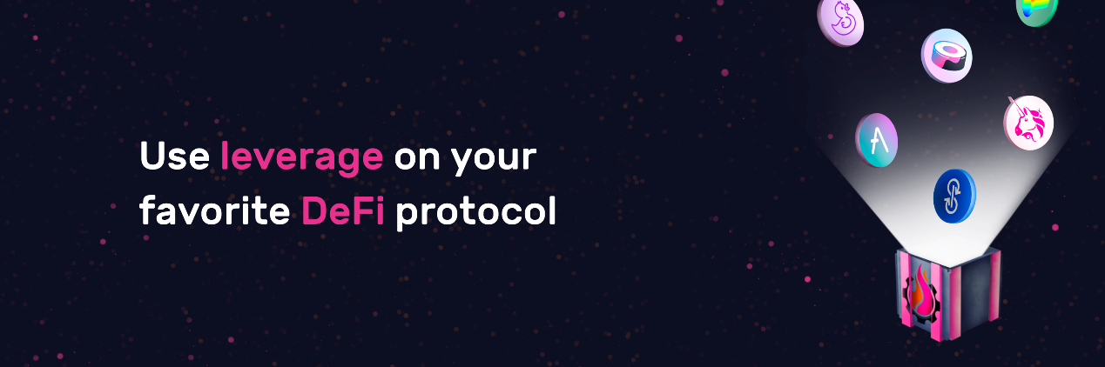

Gearbox is a generalized leverage protocol. It has two sides to it: passive lenders who earn low-risk APY by lending [single-asset](https://docs.gearbox.finance/lending-market/manage-liquidity)s; and active farmers, firms, or even other protocols who borrow those assets to [trade or farm with even x10 leverage](https://docs.gearbox.finance/overview/credit-account). See [**How it works**](https://docs.gearbox.finance/overview/how-it-works).

Gearbox Protocol allows anyone to take DeFi-native leverage and then use it across various (DeFi & more) protocols. This enables you to compose your position as you want. **You take leverage with Gearbox and then use it on other protocols you already love: Uniswap, Curve, Convex, Lido**, etc. For example, you can leverage trade on Uniswap, leverage farm on Yearn, make delta-neutral strategies, hedge your exposure, get Leverage-as-a-Service for your structured product, and more... Thanks to the [Credit Accounts](https://docs.gearbox.finance/overview/credit-account) primitive!

Some compare composable leverage as a primitive to DeFi-native prime brokerage.

The core vision is to become a **leverage middle layer**. You can envision building your own DeFi protocol and just making a “take leverage with Gearbox” as a button. And *bam* - your users are now more capital efficient. Or integrate Gearbox into a platform like Zerion or Zapper. Check this page to understand why [composable leverage 2.0 is cool](https://docs.gearbox.finance/leverage-2.0-is-composable)!

**Developer docs can be found here:**

[Hello from Gearbox Protocol Developer Docs | Gearbox Protocol Developer Docs](https://dev.gearbox.fi/)

**Where is the DAO, how can I contribute?**

Gearbox is a DAO, run by various contributors and initiatives. The protocol and assets are never in custody of any one single person. You can be in a DAO but not be 24/7 active, which is totally okay. There are different ways to get involved and get rewarded for your time and skills. See more:

[Notion – The all-in-one workspace for your notes, tasks, wikis, and databases.](https://gearboxprotocol.notion.site/gearboxprotocol/Gearbox-DAO-Working-Sheet-23966f122ae4421492819242b30a0e7a)

[Notion](https://gearboxprotocol.notion.site/gearboxprotocol/Gearbox-DAO-Working-Sheet-23966f122ae4421492819242b30a0e7a)

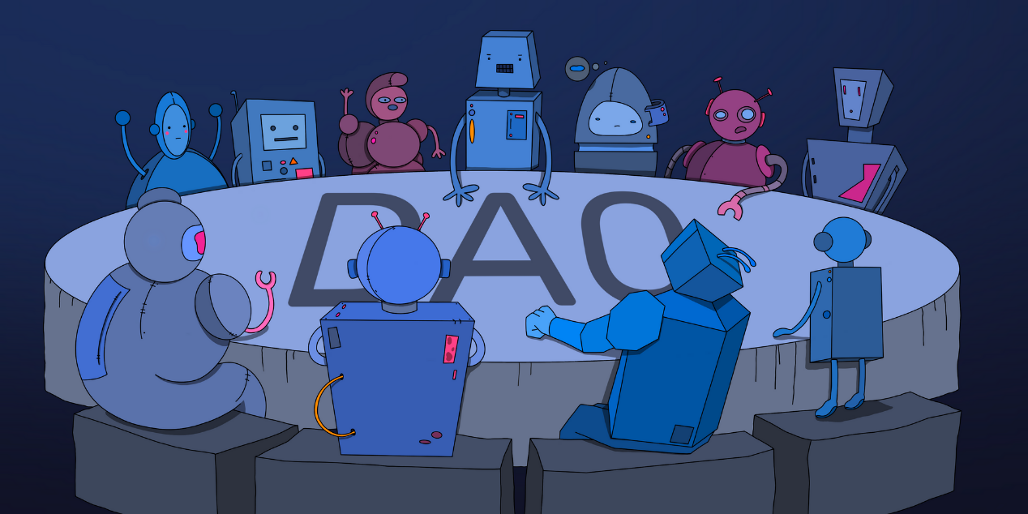

**​**[**https://gearboxprotocol.notion.site/Gearbox-DAO-23966f122ae4421492819242b30a0e7a**](https://gearboxprotocol.notion.site/Gearbox-DAO-23966f122ae4421492819242b30a0e7a)**​**

**Cool Features**

With V2, Gearbox Protocol has become cooler & faster! It now has its own **new multicall** for complex transactions, **smart router** for the best automated routing of trades & deposits, **new integrations** with Curve + Yearn + Convex + Lido, and more:

[Product Evolution V2. Gearbox Protocol from 1 to 2: Going Further!](https://medium.com/gearbox-protocol/product-evolution-v2-gearbox-protocol-from-1-to-2-going-further-dcedf3b5d959)

[Medium](https://medium.com/gearbox-protocol/product-evolution-v2-gearbox-protocol-from-1-to-2-going-further-dcedf3b5d959)

* **Composable.** Gearbox does not have its own order book or trading environment. The leverage you get - is used across multiple DeFi protocols and assets, fully composable! For example, a yield aggregator can be on the liquidity provider side of Gearbox Protocol, as well as be an avenue for Gearbox users to deploy their leverage into. Learn [**How it works**](https://docs.gearbox.finance/overview/how-it-works).
* **0% Funding Rates**. The leverage offered is not based on derivative positions but is instead executed with real assets on third-party protocols. Because Gearbox does not create its own trading pairs, there is no short/long ratio that needs to be maintained with funding rates.
* **Leverage as a Service.** Other protocols can offer leverage to their users with the help of Gearbox Protocol, without modifying anything in their own architecture. As such, they also get exposure to the user base of Gearbox. [Make a proposal to Gearbox DAO](https://gov.gearbox.fi/t/template-proposal-for-managing-gearbox-protocol-parameters/100)!
* **Permissionless Strategies.** Positions and trades within Credit Accounts can be extended to include complex strategies, for example, making a short position farm in Yearn; or having LP tokens as collateral for more composable actions. In fact, you can make all of these complex things easier to ape into, by using Gearbox's unique multicall features.

**DAO-First Approach to Building**

* **Decentralized.** CEXes subjectively define leverage parameters and also keep custody of your funds. With Gearbox, you are always in control of your funds. It's all transparent. There is no one EOA or team signature, it's all in the hands of [**Governance Model**](https://docs.gearbox.finance/governance/setup).
* **Community-driven.** Gearbox Protocol does not have a company responsible for the protocol or on-chain actions. The goal is to make the protocol work based on how the community wants it.
* You can check how from *day -1* the focus has been on community-first [**DAO-First Launch**](https://docs.gearbox.finance/overview/launch-phases).

*MarketMake ETHGlobal 2021 hackathon finalist* 🎆

**Link Tree**

Useful links about many things in the Gearbox ecosystem.

* Discord 👾 <https://discord.com/invite/gearbox>​
* Main website: <https://gearbox.fi/>​
* Mainnet dApp: <https://app.gearbox.fi/>​
* General Docs: <https://docs.gearbox.finance/>​
* Developer Docs: <https://dev.gearbox.fi/>​
* Governance Forum: <https://gov.gearbox.fi/t/start-here-forum-rules/>​
* Snapshot Voting: <https://snapshot.org/#/gearbox.eth>​
* Medium Blog: <https://medium.com/gearbox-protocol>​
* GitHub: <https://github.com/Gearbox-protocol>​
* Twitter: <https://twitter.com/GearboxProtocol>​
* Dune: <https://dune.com/apeir99n/gearbox-protocol-dashboard>**​**
* **Notion** where DAO initiatives and expenditures are reported: <https://gearboxprotocol.notion.site/gearboxprotocol/Gearbox-DAO-23966f122ae4421492819242b30a0e7a>

**Leverage 2.0 is composable!**

Quick overview of what is possible with Gearbox Protocol's Credit Accounts.

The way we are used to leverage is having a *"short BTC" button* on an exchange, where you put your assets as collateral and get a liquidation price which you can adjust by adding funds or closing the position. That's cool and easy, everyone knows it, but then... that's it? Feels too restricted. Your short is just sitting there and you can't utilize the position further.

***...what if you could do more with leverage?***

Gearbox Protocol doesn't give you 2 slick buttons "long" or "short". It gives you more capital to work with, which then YOU DECIDE where to deploy into. For example:

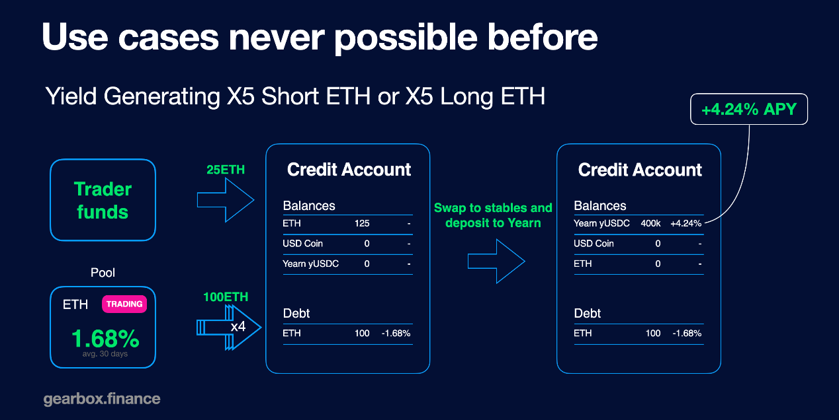

You basically get a short which then makes you money yield farming, and the yield farming LP tokens you can potentially utilize for something else. The lego building blocks can all happen within Credit Accounts!

[Farming Long/Short or "Free Leverage Position"](https://docs.gearbox.finance/traders-and-farmers/strategies/long)

Gearbox only limits you within the boundaries of security according to [AllowedList policy](https://docs.gearbox.finance/overview/credit-account#allowed-list-policy), to make sure funds are not syphoned out by [known](https://docs.gearbox.finance/risk-and-security/risks-terms) attacks. Apart from that, you as a user decide what complex strategies and trades you want to execute thanks to Gearbox leverage.

**Gearbox is your** **leveraged DeFi wallet. Continue doing what you love, but with more capital ❤**

Here is one more:

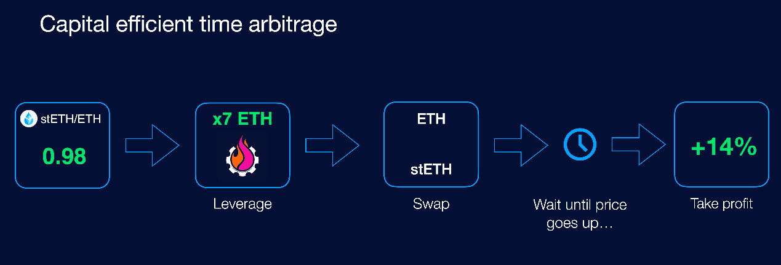

Flash loans make it possible to arbitrage a peg within one block. Gearbox allows you to do so even if it takes more time. However, with stablecoins it's generally easier as there are other avenues to borrow from. But not for all pegged assets!

[Arbitrage of correlated assets](https://docs.gearbox.finance/traders-and-farmers/strategies/arb-correlated-assets)

This is why we call it leverage 2.0 and value composability so highly!

This also **reimagines how undercollateralized loans can work**, because such a system can potentially calculate on-chain values of many things, be it: tokens you trade, LP positions, your reputation score if it's liquid, your vested investments, and so on. If the value of social interactions also becomes liquid and tradeable, like some try to do with social tokens, then undercollateralized loans don't even need to exist per se: Gearbox would potentially be able to calculate the price of any such interaction. It's potentially a new way of how credit can be managed.

Check out what more is possible: