**How it works**

High-level technical overview of Gearbox Protocol.

Gearbox protocol has two sides to it:

* **Passive lenders** - **asset** **lenders** who seek passive yield and prefer lower risks. This can be seen similar to providing liquidity to Compound and getting cTokens back. Lenders' assets are utilized by others, for which they get APY. Any one can be a liquidity provider on Gearbox.
* **Borrowers** - **active** **traders, farmers, and even protocols** who wish to increase their position by borrowing liquidity from the protocol at multiples of their collateral. The liquidity they borrow can be 10x of what their notional size is. This is the leverage power!

[Lending Market](https://docs.gearbox.finance/lending-market)

[Traders & farmers](https://docs.gearbox.finance/traders-and-farmers)

**Core parts of Gearbox Protocol**

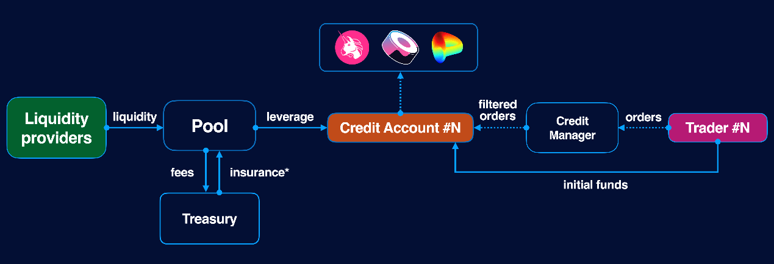

One of the key aspects which actually makes this DeFi primitive possible are [Credit Accounts](https://docs.gearbox.finance/overview/credit-account) (and Credit Managers), which “bind” together lenders and borrowers in this equation. More specifically, a Credit Account is an isolated smart contract that holds user + borrowed funds, has liquidation thresholds, and **has a list of** [**allowed tokens and protocols**](https://docs.gearbox.finance/overview/credit-account#allowed-list-policy) (in order to avoid attack vectors from malicious actors, like borrowing leverage and buying a self-created ERC20 token; or sending an amount to a malicious smart contract).

[Credit Account](https://docs.gearbox.finance/overview/credit-account)

**Gearbox does not silo the assets within its protocol.**

All trades and operations happen on third-party protocols: Uniswap, Curve, Yearn, etc. **Your assets never end up in custody of any one person or company**. As such, Gearbox Protocol is not a trading platform / protocol. The protocol does not have its own order books, or control the secondary market liquidity. Therefore, there are no funding rates.

Integrations possibilities are very broad, as Gearbox is built with composability at its core:

[Integrations](https://docs.gearbox.finance/overview/integrations)

The positions which traders and farmers take should be liquidated by third-party [liquidators](https://docs.gearbox.finance/overview/liquidations) before the assets of liquidity providers would start being exposed to the downside. As such, the protocol returns the liquidity providers’ assets to the pools if all functions correctly and liquidators do their job. This is how Gearbox is able to provide composable leverage.

The liquidations are based on the **health factor and the threshold weighted value**:

[Liquidations](https://docs.gearbox.finance/overview/liquidations)

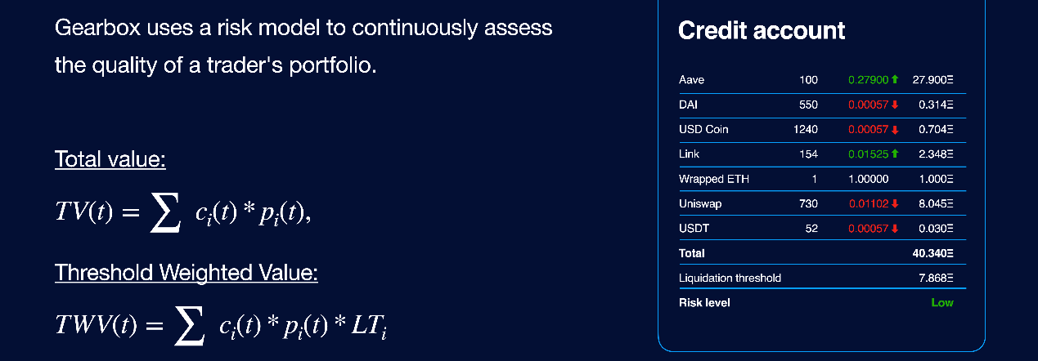

The protocol [takes fees](https://docs.gearbox.finance/overview/protocol-fees) for different operations, where a part goes to [Reserve Fund](https://docs.gearbox.finance/overview/liquidations/insurance-fund) and part to different protocol operations. All parameters and spending depend on the [governance](https://docs.gearbox.finance/governance/setup). Learn more:

**Credit Account**

DeFi Primitive for composable leverage 2.0

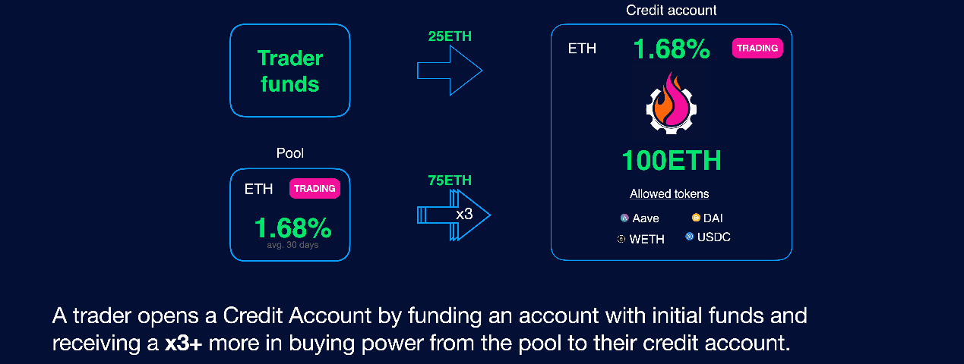

A Credit Account is an isolated smart contract which contains both the user funds and the borrowed funds. This is where your leverage is. After you open an account, all the operations go through this account and the assets stay on it as well. You can see a Credit Account as your automated DeFi wallet where you not only keep positions, but can also potentially program it the way you want. *You can at all times see transactions and assets on Etherscan, obviously.*

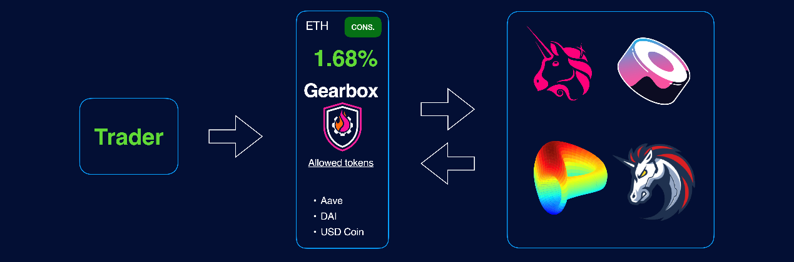

Funds on Credit Accounts are used as collateral for debt, and users can operate these funds by sending financial orders to their Credit Accounts. That could be: margin trading on Uniswap or Sushiswap; leverage farming on Yearn; arbitraging pegged assets on Curve, and more!

See the list of [integrations](https://docs.gearbox.finance/overview/integrations).

**Allowed List policy**

Operations available to users are restricted by two policies:

* **Allowed contracts list**. Users can interact through Credit Accounts only with contracts from this list to mitigate risks that funds will be sent to vulnerable smart contracts.
* **Allowed tokens list**. This allows managing risks of swapping funds to highly-volatile assets whose price could drastically fall after a swap and before a liquidation would take place. Another attack vector is a user creating some dummy ERC20 and then buying it on, let's say' Uniswap - and essentially draining capital from Gearbox Protocol.

Both policies are managed by [governance](https://docs.gearbox.finance/governance/setup) and can grow to enable more assets and protocol.

[AllowedList Policy](https://docs.gearbox.finance/overview/credit-account/allowedlist-policy)

Gearbox architecture is very modular, so it's not just that there is an allowed asset for the entire protocol - there are different pools and **can even be multiple pools for the same asset**. There can be **different Credit Managers with different AllowedList policies**, etc. The information below is just an easy-to-grasp understanding for product users. Developers should dive into the tech section in Gearbox Dev docs and understand the intricacies. Namely, the tree goes as follows:

* Pool
  + Credit Manager
    - allowed assets
    - allowed contracts
* Credit Accounts

[Gearbox Protocol](https://dev.gearbox.fi/)

[Gearbox Dev](https://dev.gearbox.fi/)

**Low Overhead on Gas**

Due to the architecture and design of Gearbox Protocol being modular, users each have their own Credit Account(s) instead of executing trades via a giant joint pool of liquidity with virtual balances of each user (how protocols usually do). Therefore, the gas costs overhead is minimized.

Next to that, Credit Accounts are not deployed by users every time as separate smart contracts, but are "borrowed" from the protocol by users like if you were to get an Uber: you use a car and then give it back once finished. This way, the deployment costs are kept to zero for new users.

With V2, Gearbox Protocol also got Multicall, making it all even more gas efficient! See more:

# AllowedList Policy

Constantly updated list of Allowed Tokens and Contracts.

Composability of Gearbox Protocol is possible via forever-increasing list of Allowed Tokens and Allowed Contracts. By allowing users to access more trade routes, deposits, farms, interactions - the [composability](https://docs.gearbox.finance/leverage-2.0-is-composable) of Gearbox Protocol can really shine! This page is dedicated to keeping an up-to-date list of Allowed Tokens and Allowed Contracts.

Gearbox architecture is very modular, so it's not just that there is an allowed asset for the entire protocol - there are different pools and **can even be multiple pools for the same asset**. There can be **different Credit Managers with different Allowed List policies**, etc. The information below is just an easy-to-grasp understanding for product users. Developers should dive into the tech section in Gearbox Dev docs and understand the intricacies. Namely, the tree goes as follows:

* Pool
  + Credit Manager
    - allowed assets
    - allowed contracts
* Credit Accounts

If you want to check and see the list of deployed contracts, go here:

[Hello from Gearbox Protocol Developer Docs | Gearbox Protocol Developer Docs](https://dev.gearbox.fi/)

Decision on the assets and contracts as per [GIP-19](https://gov.gearbox.fi/t/gip-19-v2-discussion-pools-assets-and-allowedlist-policy-for-v2/1438). And further GIPs.

### Allowed Contracts List

| Pool | LP Token Address |
| --- | --- |
| Curve ETH+stETH | ​[0x06325440D014e39736583c165C2963BA99fAf14E](https://etherscan.io/address/0x06325440D014e39736583c165C2963BA99fAf14E)​ |
| Convex Curve ETH+stETH | ​[0x9518c9063eB0262D791f38d8d6Eb0aca33c63ed0](https://etherscan.io/address/0x9518c9063eB0262D791f38d8d6Eb0aca33c63ed0)​ |
| Curve FRAX+3Crv | ​[0xd632f22692FaC7611d2AA1C0D552930D43CAEd3B](https://etherscan.io/address/0xd632f22692FaC7611d2AA1C0D552930D43CAEd3B)​ |
| Convex Curve FRAX+3Crv | ​[0xbE0F6478E0E4894CFb14f32855603A083A57c7dA](https://etherscan.io/address/0xbE0F6478E0E4894CFb14f32855603A083A57c7dA)​ |
| Curve 3pool (DAI+USDC+USDT) | ​[0x6c3F90f043a72FA612cbac8115EE7e52BDe6E490](https://etherscan.io/address/0x6c3F90f043a72FA612cbac8115EE7e52BDe6E490)​ |
| Convex 3pool (DAI+USDC+USDT) | ​[0x30D9410ED1D5DA1F6C8391af5338C93ab8d4035C](https://etherscan.io/address/0x30D9410ED1D5DA1F6C8391af5338C93ab8d4035C)​ |
| Curve LUSD+3Crv | ​[0xEd279fDD11cA84bEef15AF5D39BB4d4bEE23F0cA](https://etherscan.io/address/0xEd279fDD11cA84bEef15AF5D39BB4d4bEE23F0cA)​ |
| Convex Curve LUSD+3Crv | ​[0xFB9B2f06FDb404Fd3E2278E9A9edc8f252F273d0](https://etherscan.io/address/0xFB9B2f06FDb404Fd3E2278E9A9edc8f252F273d0)​ |
| Curve DAI+USDC+USDT+sUSD | ​[0xC25a3A3b969415c80451098fa907EC722572917F](https://etherscan.io/address/0xC25a3A3b969415c80451098fa907EC722572917F)​ |
| Convex Curve DAI+USDC+USDT+sUSD | ​[0x11D200ef1409cecA8D6d23e6496550f707772F11](https://etherscan.io/address/0x11D200ef1409cecA8D6d23e6496550f707772F11)​ |
| Curve GUSD+3Crv | ​[0xD2967f45c4f384DEEa880F807Be904762a3DeA07](https://etherscan.io/address/0xD2967f45c4f384DEEa880F807Be904762a3DeA07)​ |
| Convex Curve GUSD+3Crv | ​[0x15c2471ef46Fa721990730cfa526BcFb45574576](https://etherscan.io/address/0x15c2471ef46Fa721990730cfa526BcFb45574576)​ |
| USDC yVault | ​[0xa354F35829Ae975e850e23e9615b11Da1B3dC4DE](https://etherscan.io/address/0xa354F35829Ae975e850e23e9615b11Da1B3dC4DE)​ |
| DAI yVault | ​[0xdA816459F1AB5631232FE5e97a05BBBb94970c95](https://etherscan.io/address/0xdA816459F1AB5631232FE5e97a05BBBb94970c95)​ |
| WETH yVault | ​[0xa258C4606Ca8206D8aA700cE2143D7db854D168c](https://etherscan.io/address/0xa258C4606Ca8206D8aA700cE2143D7db854D168c)​ |
| WBTC yVault | ​[0xA696a63cc78DfFa1a63E9E50587C197387FF6C7E](https://etherscan.io/address/0xA696a63cc78DfFa1a63E9E50587C197387FF6C7E)​ |
| Curve stETH Pool yVault | ​[0xdCD90C7f6324cfa40d7169ef80b12031770B4325](https://etherscan.io/address/0xdCD90C7f6324cfa40d7169ef80b12031770B4325)​ |
| Curve FRAX Pool yVault | ​[0xB4AdA607B9d6b2c9Ee07A275e9616B84AC560139](https://etherscan.io/address/0xB4AdA607B9d6b2c9Ee07A275e9616B84AC560139)​ |

### Allowed Assets List

Each column is the pool denomination asset, so the % LTV values per different asset are specific to each pool. As such, leverage factor on correlated assets [stable to stable] can be higher! Links to all the ERC20 contracts can be found [here](https://gov.gearbox.fi/t/gip-19-v2-discussion-pools-assets-and-allowedlist-policy-for-v2/1438), they do not fit into gitbook table format.

If working with the raw numbers, [LT](https://docs.gearbox.finance/overview/liquidations" \l "liquidation-threshold) for stables would work as follows: a swap from a stablecoin to a stablecoin would cause your [Health Factor](https://docs.gearbox.finance/traders-and-farmers/credit-account-dashboard-overview/kak-ne-byt-rekt#what-i-can-do-if-my-health-factor-is-close-to-1-to-keep-my-credit-account-alive) to decrease, that is because stables are not always stable from the price feed and risks perspective. It's not safe to assume a stable is 1:1 to another one, so there are more [complex calculations being done](https://docs.gearbox.finance/overview/liquidations#threshold-weighted-value) which account for possible slippage, chainlink price tick, and other factors.

​

| Token | USDC | DAI | WETH | wstETH | WBTC | FRAX |
| --- | --- | --- | --- | --- | --- | --- |
| WETH | 85 | 85 | 94.5 | 90 | 85 | 85 |
| stETH | 82.5 | 82.5 | 90 | 94.5 | 82.5 | 82.5 |
| WBTC | 85 | 85 | 85 | 85 | 94.5 | 85 |
| USDC | 94.5 | 92 | 82.5 | 82.5 | 82.5 | 92 |
| DAI | 92 | 94.5 | 82.5 | 82.5 | 82.5 | 92 |
| USDT | 90 | 90 | 82.5 | 82.5 | 82.5 | 94.5 |
| sUSD | 90 | 90 | 82.5 | 82.5 | 82.5 | 90 |
| FRAX | 90 | 90 | 82.5 | 82.5 | 82.5 | 90 |
| gUSD | 90 | 90 | 82.5 | 82.5 | 82.5 | 90 |
| LUSD | 90 | 90 | 82.5 | 82.5 | 82.5 | 90 |
| steCRV | 82.5 | 82.5 | 90 | 90 | 82.5 | 82.5 |
| cvxsteCRV | 82.5 | 82.5 | 90 | 90 | 82.5 | 82.5 |
| stkcvxsteCRV | 82.5 | 82.5 | 90 | 90 | 82.5 | 90 |
| FRAX3CRV-f | 90 | 90 | 80 | 80 | 80 | 90 |
| cvxFRAX3CRV-f | 90 | 90 | 80 | 80 | 80 | 90 |
| stkcvxFRAX3CRV | 90 | 90 | 80 | 80 | 80 | 90 |
| 3Crv | 90 | 90 | 80 | 80 | 80 | 90 |
| cvx3Crv | 90 | 90 | 80 | 80 | 80 | 90 |
| stkcvx3Crv | 90 | 90 | 80 | 80 | 80 | 90 |
| LUSD3CRV-f | 90 | 90 | 80 | 80 | 80 | 90 |
| cvxLUSD3CRV-f | 90 | 90 | 80 | 80 | 80 | 90 |
| stkcvxLUSD3CRV | 90 | 90 | 80 | 80 | 80 | 90 |
| crvPlain3andSUSD | 90 | 90 | 80 | 80 | 80 | 90 |
| cvxcrvPlain3andSUSD | 90 | 90 | 80 | 80 | 80 | 90 |
| stkcvxcrvPlain3andSUSD | 90 | 90 | 80 | 80 | 80 | 90 |
| gusd3CRV | 90 | 90 | 80 | 80 | 80 | 90 |
| cvxgusd3CRV | 90 | 90 | 80 | 80 | 80 | 90 |
| stkcvxgusd3CRV | 90 | 90 | 80 | 80 | 80 | 90 |
| FraxUsdc | 90 | 90 | 80 | 80 | 80 | 90 |
| yvDAI | 90 | 90 | 80 | 80 | 80 | 90 |
| yvUSDC | 90 | 90 | 80 | 80 | 80 | 90 |
| yvWETH | 82.5 | 82.5 | 90 | 90 | 80 | 82.5 |
| yvWBTC | 82.5 | 82.5 | 80 | 80 | 90 | 82.5 |
| yvCurve-stETH | 82.5 | 82.5 | 90 | 90 | 82.5 | 82.5 |
| yvCurve-FRAX | 90 | 90 | 80 | 80 | 80 | 90 |
| CVX | 25 | 25 | 25 | 25 | 25 | 25 |
| FXS | 25 | 25 | 25 | 25 | 25 | 25 |
| LQTY | 0 | 0 | 0 | 0 | 0 | 0 |
| CRV | 25 | 25 | 25 | 25 | 25 | 25 |
| LDO | 0 | 0 | 0 | 0 | 0 | 0 |
| SNX | 25 | 25 | 25 | 25 | 25 | 25 |

The information about V1 Credit Managers [Allowed List of contracts & assets] was scraped out from the docs to not confuse new users. Those CMs are still on-chain and exist, but only with the option to trade out of CA positions and close, not borrow or open new ones. If you are looking for old numbers, [check on forum](https://gov.gearbox.fi/t/pre-gip-2-3-start-gearbox-allowed-tokens-and-protocols/152/37).

# How to add new Contracts & Assets to AllowedList

Want to see your favorite protocol or asset be added to Gearbox Protocol? Here is what you need to know.

Composability is at the heart of Gearbox Protocol's ethos as well as its modular architecture. It's imperative to grow the Allowed List Policy to allow traders & farmers to create composable positions across DeFi and other sectors. While the protocol is growing, there are some technical boundaries in place with regard to things like oracles when it comes to assets as well as contracts - to understand those better, please see some wishlist for Gearbox DAO below. If it checks out, go ahead and ask DAO to add it!

* Template for proposals is [here](https://gov.gearbox.fi/t/template-proposal-for-managing-gearbox-protocol-parameters/100#proposal-type-allowed-contracts-2).
* Discord chat to ask tech questions is [here](https://discord.gg/JZgvmaenwn).

If you would like to have an adapter and believe you don't have enough resources to build it yourself, please just ping on Discord & let's collab together on a grant to have an external or internal developer help with such a task! Cooperation is welcome :-)

This article can give you an insight on how you can potentially access a collateral / protocol:

[Risk Committee: DAO’s framework for accessing assets & contracts](https://medium.com/gearbox-protocol/risk-committee-daos-framework-for-accessing-assets-contracts-3d4deea83537)

[Medium](https://medium.com/gearbox-protocol/risk-committee-daos-framework-for-accessing-assets-contracts-3d4deea83537)

## Add new Contracts / Protocols

#### Technical Requirements

* (preferably) The Protocol should have at least two external audit reports.
* (preferably) Adapter for the Protocol should have at least one external audit report.
* (preferably) The Protocol should be at least 2 months from the launch and 2 months without security incidents.
* (preferably) The protocol should be non-custodial.
* Integrations should be made using ERC-20 token in the middle. It could be LP token of Protocol (or in the case of absence LP tokens, should be created separate ERC-20 token that represents user’s position in Protocol). Later on, more standards can be added to expand. Please propose.
* It’s good if methods how LP token can be priced (via using internal/external oracle / using smart contract interface like pricePerShare for Yearn Vaults) are described in the application.
* It is also necessary to show why the price cannot be manipulated and/or describe how to mitigate such risks. It is good to describe how the withdrawal of funds from the protocol works: is it instantaneous, whether funds are locked there, for what period.

#### Step by step process

1. 1.

Create Discussion on [Governance Forum](http://gov.gearbox.fi/). Template is [here](https://gov.gearbox.fi/t/template-proposal-for-managing-gearbox-protocol-parameters/100#proposal-type-allowed-contracts-2).

* (preferably) include links to the code of the Adapter to integrate with external protocol. If there are none, the discussion can be continued, but any other actions can be made after someone (community, post author etc) provide link to Adapter implementation.
* (preferably) include links to external audit of Adapters. If there are none, the discussion can be continued, but the vote can be submitted only after receiving the audit report.

2. After initial discussions it is possible to go through the [standard governance process](https://docs.gearbox.finance/governance/setup).

Prior to the forum posts, feel free to ping on [Discord](https://discord.gg/JssNVvxscK) to ask for help!

## Add new Assets / Tokens

#### Technical Requirements

* It should be an ERC20 token.
* (required) Must have a [chainlink price feed oracle](https://docs.chain.link/docs/ethereum-addresses/) for the token. As you might have guessed, this is the oracle system Gearbox Protocol uses on Ethereum and in its current version.
* (preferably) not possible to pause tokens fully or freeze individually.
* (preferably) fee-on-transfer and rebase tokens to be avoided.
* (preferably) the token must be liquid and have big depth on the secondary markets, specifically DEXes. This is one of the protections against the domino effect.

Risk requirements:

* Volatility should be low enough to get leverage. Current approach is the following:

1. 1.

Check 5 Min max price drop for the last 12 months. Health value is less than 20%.

1. 2.

See parameters of this token on notable DeFi money markets / lending services and whether liquidators manage to eliminate positions in this token with such parameters (if applicable).

* Liquidity should be enough to be able to liquidate positions.
* Optimal distribution of tokens (number of holders, distribution of tokens, unlocking schedule).

#### Step by step process

1. 1.

Create Discussion on [Governance Forum](http://gov.gearbox.fi/). Template is [here](https://gov.gearbox.fi/t/template-proposal-for-managing-gearbox-protocol-parameters/100#proposal-type-allowed-tokens-3). Preferably, the first post should include data of token volatility for the last 1 year and of token liquidity.

1. 2.

After initial discussions it is possible to go through the [standard governance process](https://docs.gearbox.finance/governance/setup).