**Liquidations**

Defining liquidations, health factor, and weighted thresholds.

A new liquidator code for V2 written in typescript: <https://github.com/Gearbox-protocol/liquidator-v2>. Also here is a sample liquidation bot in RUST for V1: <https://github.com/Gearbox-protocol/liquidation-bot>. Some tips and tricks [here](https://twitter.com/0xmikko_eth/status/1580963422317203457).

**How does the protocol ensure over-collateralization while allowing users leveraged operations?**

When trading with Gearbox, your [Credit Account](https://docs.gearbox.finance/overview/credit-account) becomes the collateral for external protocols/actions: both your initial funds and the borrowed amount you got from the protocol. Gearbox Protocol sees which tokens your portfolio consists of and can determine its value at all times, which are always calculated in the underlying borrowed asset which you opened that Credit Account in.

Gearbox uses a risk model to continuously assess the quality-value of a Credit Account. For each Credit Account, it computes its health factor**.**

Anyone can check the health factor and liquidate positions with a health factor less than 1.

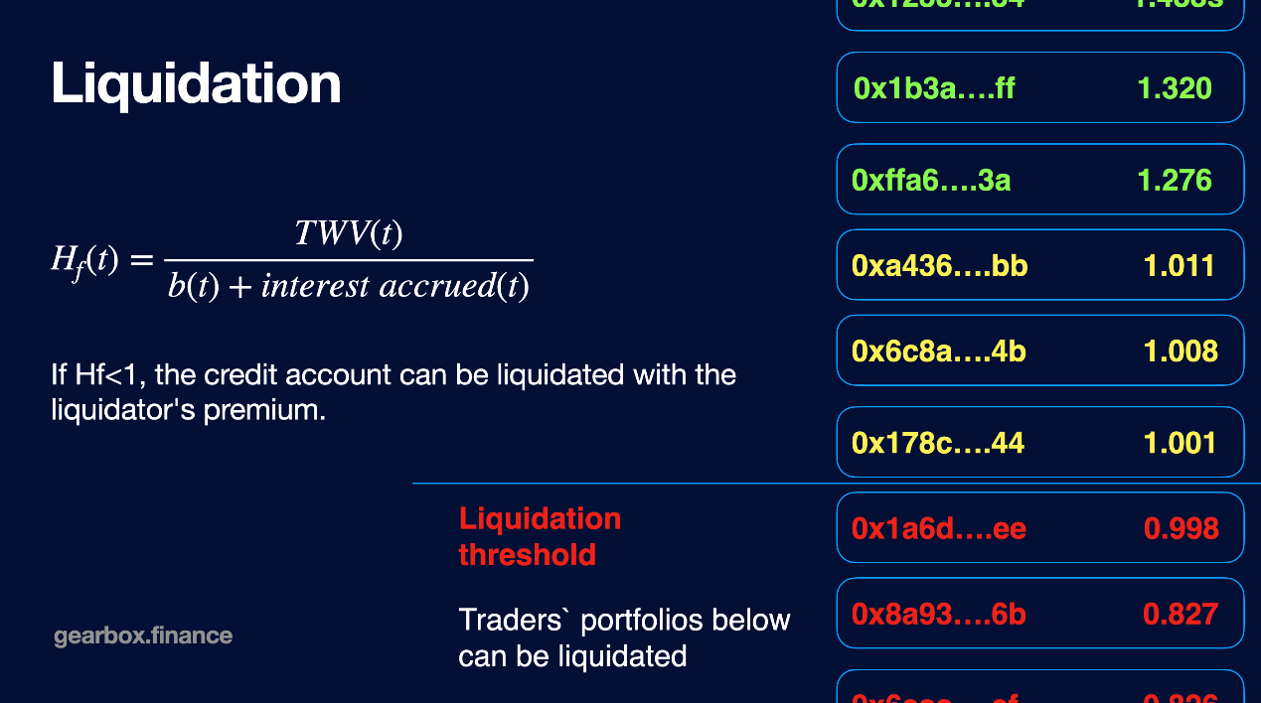

As a user with a leverage position, you need to watch out for your health factor. Having it just above 1 puts you in risk of getting liquidated. Learn how to avoid liquidations.

[How to avoid liquidations](https://docs.gearbox.finance/traders-and-farmers/credit-account-dashboard-overview/kak-ne-byt-rekt)

Learn about the current fee model a user pays in case of a liquidation:

[Protocol Fees](https://docs.gearbox.finance/overview/protocol-fees)

**What is a Health Factor?**

Health Factor is a numeric representation of your account health. If your health factor drops below 1 or close to it, you might be liquidated. The higher the number is, the safer you are. There are some tips on how you can avoid liquidations, [check them here](https://docs.gearbox.finance/traders-and-farmers/credit-account-dashboard-overview/kak-ne-byt-rekt).



where *b(t)* is borrowed amount.

Let's dive into some math formulas to clarify how computation of the health factor works.

**Total Value**

Represents the Credit Account's balance in the underlying asset.



where c_i - balance of i-th asset in credit account, p_i - price of i-th asset calculated in underlying asset(from ChainLink oracle).

**Threshold Weighted Value**



where: c_i - balance of i-th asset in credit account, p_i - price of i-th asset calculated in underlying asset(from ChainLink oracle), LT_i - liquidation threshold, the credit account manager constant showing the maximum allowable ratio of [Loan-To-Value](https://www.investopedia.com/terms/l/loantovalue.asp) for the i-th asset**.**

**Liquidation Threshold**

Liquidation thresholds represents maximum allowable ratio of Loan-To-Value for the i-th asset (LTV is reciprocal of over-collaterization ratio of i-th asset). LT_i for underlying asset is constant and equals:



**How is Liquidation Threshold defined?**

Gearbox Protocol uses statistics of 5-min, 15-min, 1h change of i-th asset's price (price is in the underlying asset) for the last 180 days.

Anybody can run a liquidator bot and secure the protocol. You can chat about setting up your bot and other liquidator-things in [Discord](https://discord.gg/wmydr8JfcP). Help users minimize the [risks](https://docs.gearbox.finance/risk-and-security/risks-terms)!

**Reserve Fund**

Protocol-owned reserve fund. The model can be expanded if DAO decides to.

Even if the math is right on paper, it doesn't always end up so crisp when things come to on-chain execution: high gas fees, bad liquidator work, etc. - can result in the protocol having bad debt and becoming undercollateralized. To prevent it or to retroactively restore capital in such situations, different mechanisms can be put in place. Those include liquidity backstop using governance tokens either by selling them or having LPs do that, having a separate Reserve Fund to pay out liquidity providers (like every CEX has), and so on. Sometimes, these strategies can be combined for extra safety.

Gearbox treasury fees accrue in form in LP tokens, instead of idle assets like in most other protocols. As a result, Treasury itself becomes a liquidity provider to the pool. This is like re-supplying liquidity to keep growing - by default - while other protocols usually need to make a separate transaction to turn their idle assets into productive working LP positions.

This part of the treasury in form of LP tokens is used to cover losses of the pools in case a the Credit Account is closed with a loss for the pool (bad or untimely liquidation). In such cases, Gearbox Protocol automatically burns their part of the Treasury’s LP tokens - restoring the rate of [Diesel Tokens](https://docs.gearbox.finance/lending-market/pools-and-apy#what-is-a-diesel-token). This way, DAO Treasury acts as Reserve Fund that automatically compensates liquidity providers’ losses up to the level it is physically able to.

Of course, such a design has limitations: the maximum amount of losses compensated by the Reserve Fund is limited by the valuation of LP tokens owned by the DAO Treasury. By default, all payments that DAO Treasury receives from the protocol are made in LP tokens. However, DAO can manage it by withdrawing part of the funds from the pool (thus, instead of LP tokens, Treasury will receive the usual underlying asset of the pool aka idle assets). This way, the DAO can limit itself depending on how much it wants its earnings to be exposed to the Reserve Fund.

This Reserve Fund model doesn't relate to actual software hacks. It specifically covers cases of under-collateralization due to incorrect liquidations. See what [risks](https://docs.gearbox.finance/risk-and-security/risks-terms#protocol-technical-disclosure) there are.

The concept is described in the [old] Tech Paper:

[Tech Paper](https://docs.gearbox.finance/overview/whitepaper)

**Protocol Fees**

To stay self-sustainable, the protocol takes fees for different operations.

The fees explained below can also be improed or increased. For example, introducing fees in the other parts of the user lifecycle: on opening, closing, or some other action. Any of that is conceptually possible if decided by the DAO and implemented.

**Liquidation Fee**

If a Credit Account is liquidated, some percentage goes to a third-party liquidator who liquidated the account - and some percentage goes to Gearbox Protocol.

* Current liquidation fee going to the liquidator: 4%
* Current liquidation fee going to the protocol: 1.5%

**APY Spread Fee: 50%**

The protocol takes spread as a fee between the APY which lenders recieve and the fee & farmers pay for borrowing their assets. The exact value of this fee is calculated as following:

* Each pool has it’s interest rate curve. This interest rate curve represents borrow APY that lenders receive as a function of pool’s utilization r(u). See details and formulas at [dev docs](https://dev.gearbox.fi/docs/documentation/pools/intro/#rt---borrow-apy).
* Borrowers pay borrow APY to liquidity providers and pay spread fee to DAO spreadFee. That means effective borrow rate for borrowers is calculated as r(u)*(1+spreadFee). DAO receives r(u)*spreadFee.

[Pools & APY](https://docs.gearbox.finance/lending-market/pools-and-apy)

All protocol fees go to [governance](https://docs.gearbox.finance/governance/setup/guards-multisigs#financial-treasury-multisig-or-5-7) and nothing is assumed for the core contributors or the foundation. The protocol is fully operated by a DAO community.

**Tech Paper**

Math and architecture in one technical document.

This paper was written in summer 2021. However, the protocol has undergone quite a few changes after the initial version. Those changes are not reflected in the paper below. Why? Because there are now user docs, [medium articles](https://medium.com/gearbox-protocol/product-evolution-v2-gearbox-protocol-from-1-to-2-going-further-dcedf3b5d959), there is open-source code, there is dev documentation... As such, it makes no sense to waste time on improving a "paper". Those are mostly used for initial pre-launch stages. However, in case you really want to see a *whitepaper*, this one is OK. Ask more in [Discord](https://discord.gg/JssNVvxscK)!