traders & farmers

**How to open a Credit Account**

A quick guide to your first Credit Account.

Learn what a [Credit Account](https://docs.gearbox.finance/overview/credit-account) is and how it works.

**NOTE:** At the moment, Credit Accounts are in "Leverage Ninja" Mode as we initially test in prod: a list of addresses having access to V2 leverage. You can post your address on the [**gov forum**](https://gov.gearbox.fi/t/gip-21-leverage-ninja-mode-limits-for-v2/1572/11)with a few links. If you don't want your twitter and address to be connected publicly, you can drop a message to any of the contributors on [**Discord**](https://discord.com/invite/gearbox)**:**

[Leverage Ninja Mode: Gearbox V2 is Open for Business in a few hours**!](https://medium.com/gearbox-protocol/leverage-ninja-mode-gearbox-v2-is-open-for-business-in-a-few-hours-bf471e588033)

[Medium](https://medium.com/gearbox-protocol/leverage-ninja-mode-gearbox-v2-is-open-for-business-in-a-few-hours-bf471e588033)

**Two paths to opening a Credit Account**

Being able to leverage trade & farm starts with opening a Credit Account. However, there are different approaches in the interface that vary based on what you are looking for:

1. 1.

"I just want to leverage farm" - then you should go to [**Strategies**](https://docs.gearbox.finance/traders-and-farmers/strategies) and simply open a leveraged farming position with multicall in one click. That page lets you ape into Curve/Convex/Lido/Yearn with a single transaction, and saves you gas costs as well! It's more applicable to farmers who don't want to have a bunch of complexities and steps, and who know what end strategies they want to sit and farm in. It creates a Credit Account for you and apes into a strategy right after, removing manual complexity from you as a user.

1. 2.

"I want to have different strategies and figure out step by step" - in this case, you might be better off following the steps by yourself: from selecting the debt asset to choosing leverage, to swapping some assets and LPing into Curve, to staking on Yearn and so on. In terms of *what* you are doing, it's the same as option 1 above, but with more steps in-between.

Before you begin, maybe check out [**PRO: Leverage Bible**](https://docs.gearbox.finance/traders-and-farmers/pro-leverage-bible) section to understand some of the intricacies on how max leverage works.

**Step 1.** Go to [Credit Accounts](https://app.gearbox.fi/accounts) page. Click on the asset you want to borrow. This underlying debt asset is the asset you trade against, meaning all your positions are denominated in it. Once opened, the underlying asset in that particular account can't be changed. But you can open a new Credit Account with a different debt [borrowed] asset.

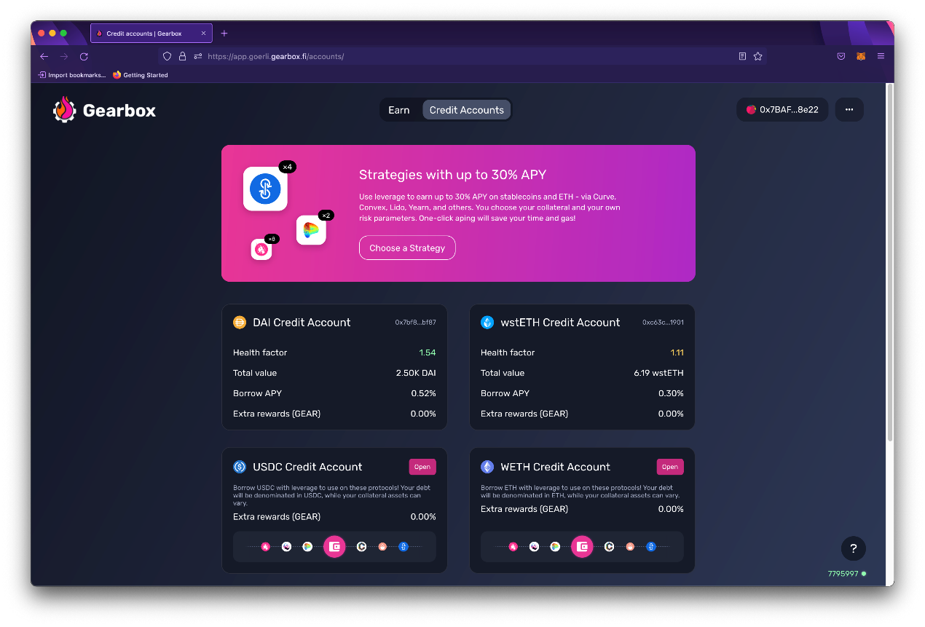

​<https://app.gearbox.fi/accounts>​

**Step 2.** Specify the amount you want to put as collateral. This will be the notional amount from which the leverage X will be calculated. As such, 1 ETH you "deposit" as notional capital can be x6 more leverage, so a 6 ETH position total. You can also have multiple collateral assets!

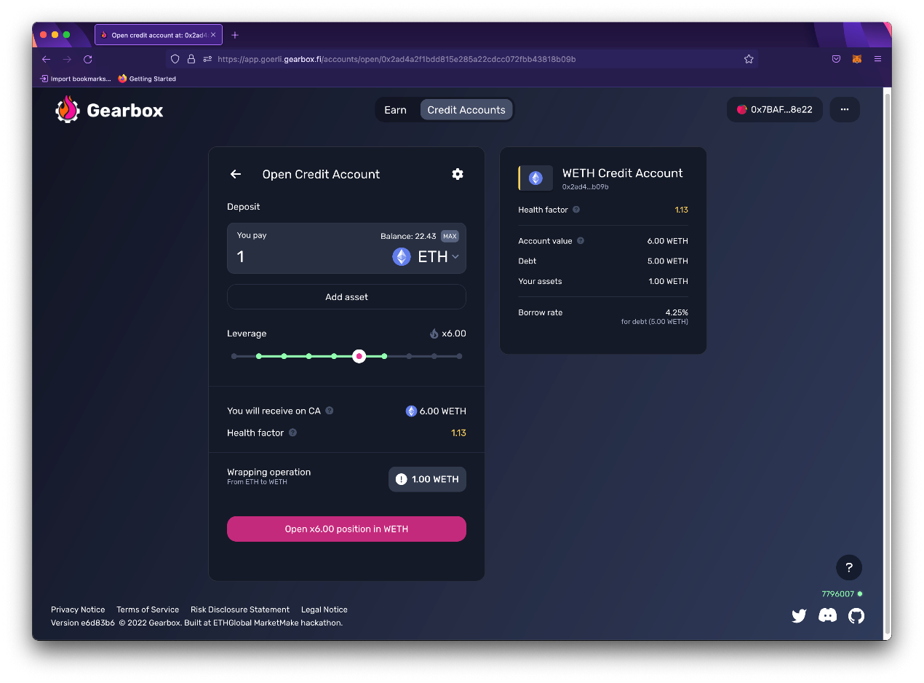

**Step 3.** Select the leverage you want to get and click "Open X position" button. Execute the approval and opening transaction as required, and that's it.

Your Credit Account is now open!

* You can see how much borrow fees you are paying on the amount you borrowed.
* You can top up your Credit Account or borrow more... see further sections.

**Credit Account min/max borrow limits**

The limits on Credit Accounts are enforced on the contract level by minimum borrow and maximum borrow limits, as per the DAO governance process - those can change. Check the latest here:

[Pools & APY](https://docs.gearbox.finance/lending-market/pools-and-apy)

Did you find a bug with the interface, something didn't work as you think it should have, or you have a suggestion on how to improve the user experience? [Suggest](https://discord.gg/hF3QvX2vgt) on Discord!

Now, time to understand the dashboard:

# Inside a Credit Account

A walk-through the main functions on Gearbox app interface.

Learn [how to open a Credit Account](https://docs.gearbox.finance/traders-and-farmers/how-to-open-account) if you have not done it yet.

### Operating a Credit Account

Post opening a Credit Account and taking a leverage position, you'll be able to see an interface that looks like the one below:

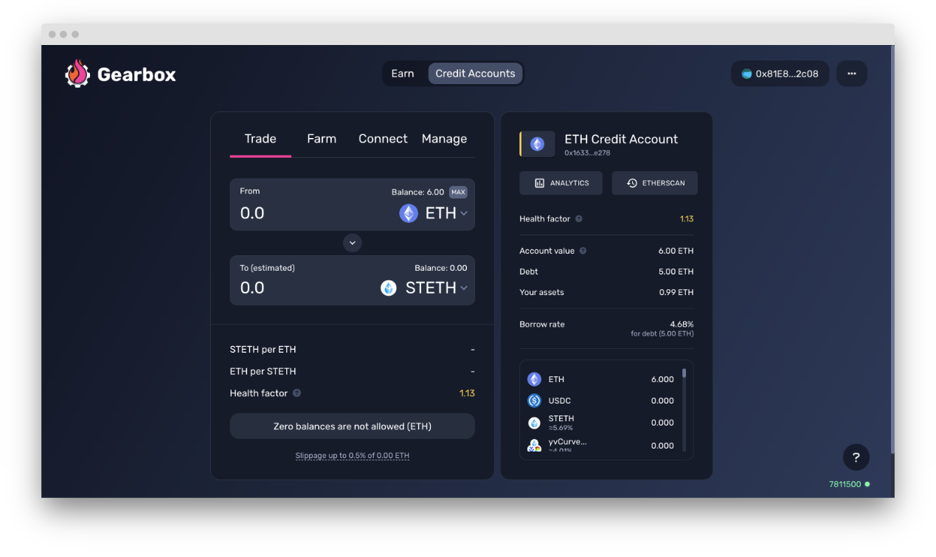

There are 4 tabs inside a Credit Account that let you operate and utilise it to the max potential.

1. 1.

**Trade:** This is where you can see the leveraged funds you have as well as swap them for a different assets. Swapping can affect your HF so take note of the same by monitoring the right side of the screen. Usually, the interface would give a preview of your HF change.

[Trade: swapping assets](https://docs.gearbox.finance/traders-and-farmers/credit-account-dashboard-overview/trade-swapping-assets)

2. **Farm:** Farm is where the real alpha lies. All the strategies for the biggest vaults and pools in DeFi that you want to ape into are available in farm without you having to hop protocol from protocol. You just need to select which pool/vault you want to go deploy in, and done.

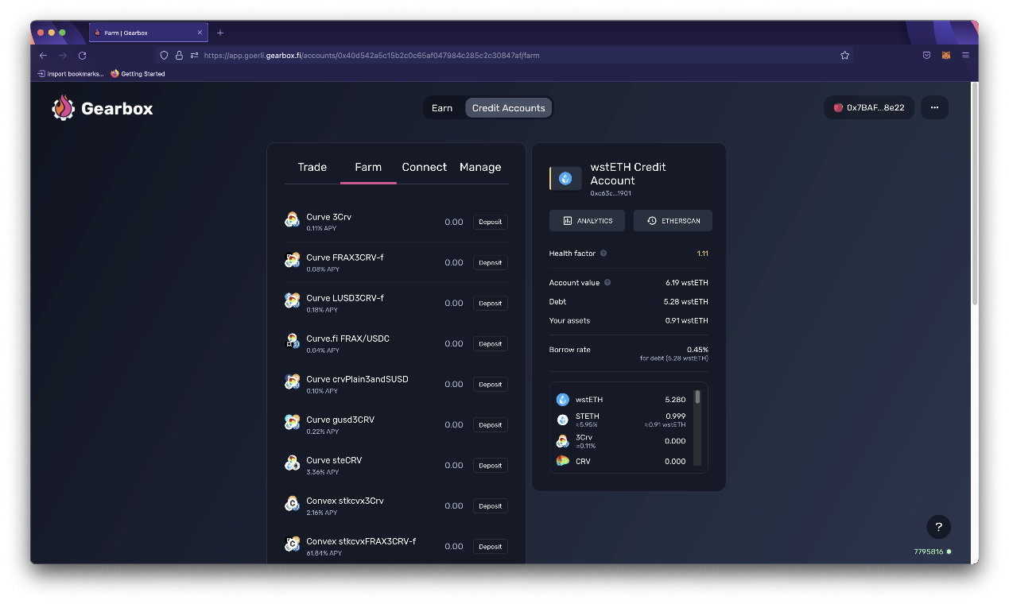

3. **Connect:** Connect is what enables you to use native interfaces of the integrated protocols, thanks to Wallet Connect. You can use them if you like the familiarity but Single Click Strategies and the Farm option already have them available with way more convenience.

[Connect: Wallet Connect](https://docs.gearbox.finance/traders-and-farmers/credit-account-dashboard-overview/connect-wallet-connect)

4. **Manage:** Manage tab lets you take multiple position management actions in order to help you take care of risk as well as to close your position. The options are listed below:

* **Borrow more:** If you have good Health Factor and feel like borrowing more and upping the leverage is worth the play - you can use this feature.
* **Decrease Debt:** You can repay part of your debt to reduce your risk or to reduce the borrow fee you pay on the capital you borrow.
* **Add collateral:** The easiest way to to improve your Health Factor if your Health Factor is getting close to liquidations level, which is < 1.
* **Close Credit Account:** The below page will help you manage the same.

[How to close a Credit Account](https://docs.gearbox.finance/traders-and-farmers/credit-account-dashboard-overview/how-to-close-account)

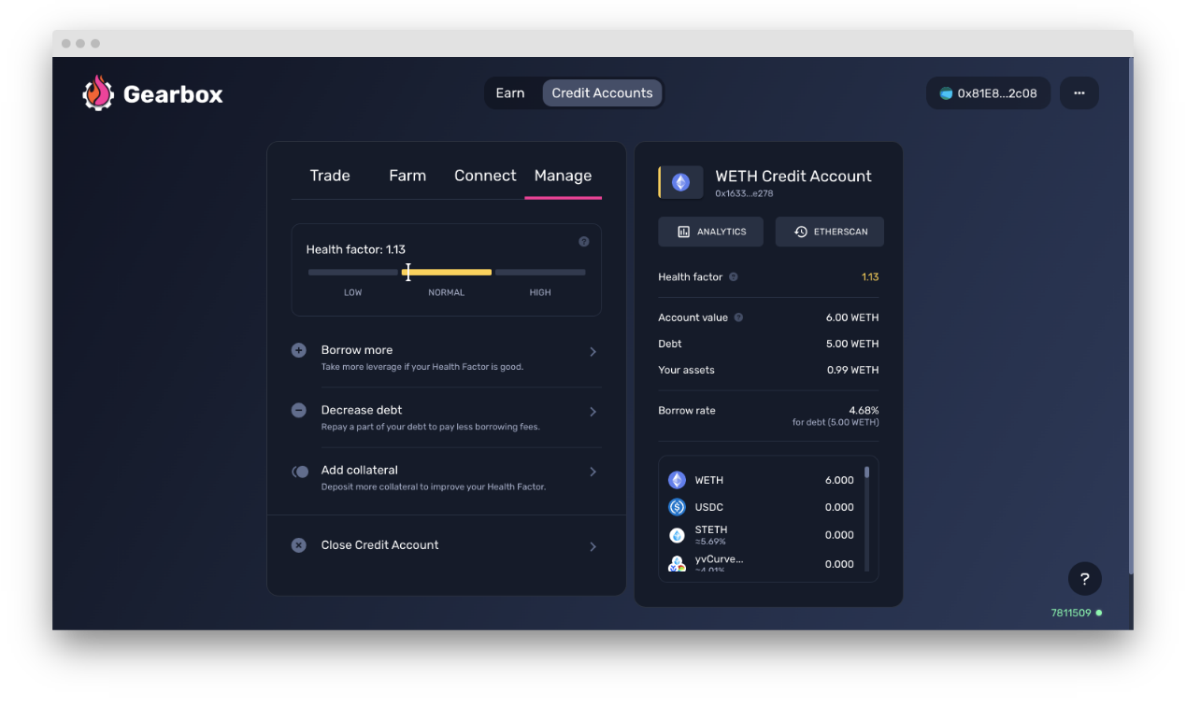

While these are about the tabs for a credit account, there are certain parameters and values you need to take care of too. They are listed below.

### Account Parameters

At the top, you can see the balance of your Credit Account denominated in the underlying asset you opened your account in (it uses ChainLink oracle prices to calculate these values).

* **Health Factor** - your Credit Account can be liquidated if it falls below 1;
* **Account Value** - current value of Credit Account, denominated in the underlying asset;
* **Debt** - total value of the underlying asset you have borrowed from the protocol;
* **Your assets** - total value in the underlying asset that is your collateral;
* **Analytics** - check the stats of the pool and other charts in Gearbox-native analytics;
* **Etherscan** - see your Credit Account's address, and the transactions on-chain.
* **Tokens** - the list of allowed tokens as per the policy which you can trade among.

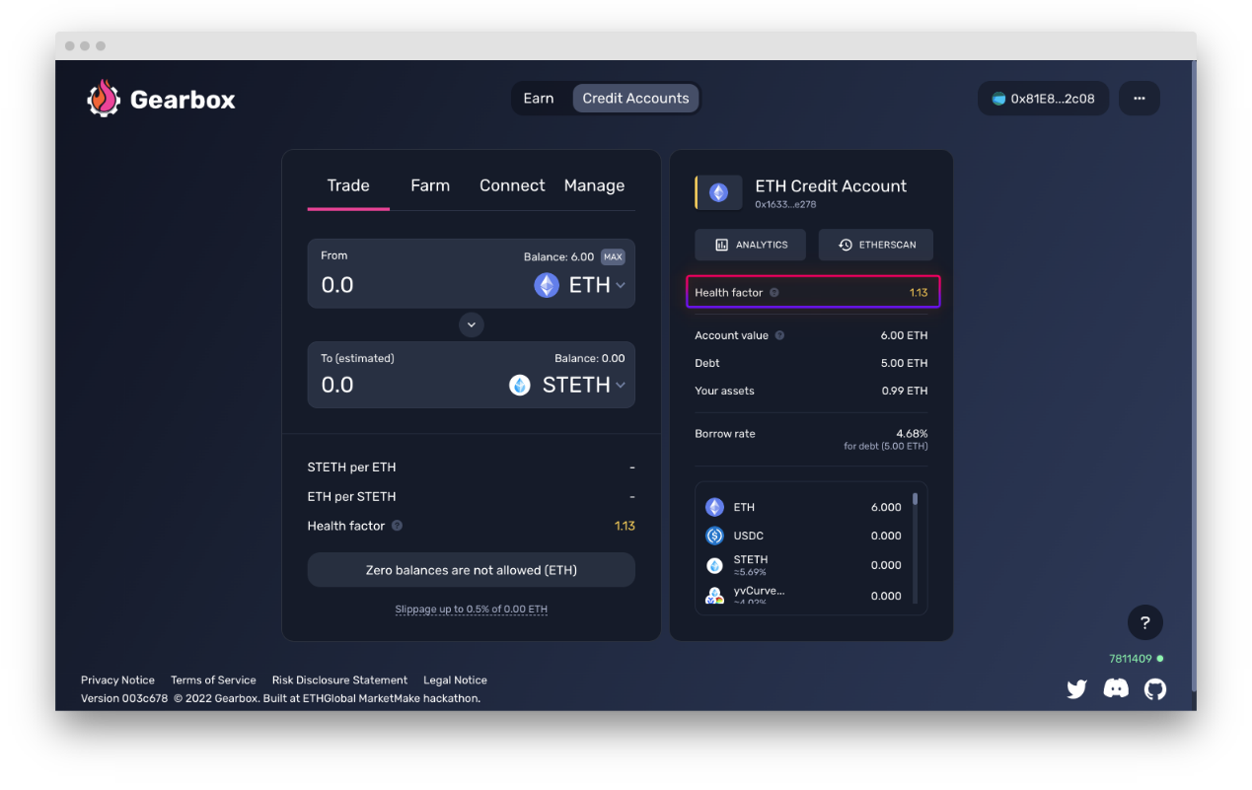

Did you find a bug with the interface, something didn't work as you think it should have, or you have a suggestion on how to improve the user experience? [Suggest](https://discord.gg/hF3QvX2vgt) on Discord!

**Trade: swapping assets**

How you can trade non-farm assets from the Allowed List.

The trade tab lets you trade (swap) any asset from one to another, as long as it is on the [**AllowedList Policy**](https://docs.gearbox.finance/overview/credit-account/allowedlist-policy). You can see that list by scrolling on the right tab of the dashboard.

[AllowedList Policy](https://docs.gearbox.finance/overview/credit-account/allowedlist-policy)

Swapping your asset to another has direct impact on your Health Factor, so please do keep a check on it in order to make sure you don't run into a risk of a liquidation. In most cases, the interface would give you a preview of your approximate Health Factor change prior to a swap.



You can also use native interfaces of Uniswap/Curve/Sushiswap with the this cool feature:

# Farm: depositing into protocols

How you can farm in Convex, Yearn, Lido, and more.

This tab is a selection of farms (protocols where you can deposit capital). Since LP tokens of protocols usually do not have secondary market liquidity, depositing-withdrawing actions are better for a user to avoid slippage. That is why these actions are not on the [**Trade: swapping assets**](https://docs.gearbox.finance/traders-and-farmers/credit-account-dashboard-overview/trade-swapping-assets) tab.

Once you deposit in a farm, you can top up or partly / fully exit.

From A to Yearn deposit [swap->deposit->deposit LP tokens] in one click!

* You can ape into farm with any asset you have. Smart Router will choose the best trade-swap-deposit route for you, so you don't have to think twice before going in.
* Once you get some rewards like CVX, LDO, CRV, or other emissions which require a claim action - the button will appear at the top of the Farm tab. You can claim whenever.
* You can choose to exit into an absolutely different asset too, thanks to Smart Router!

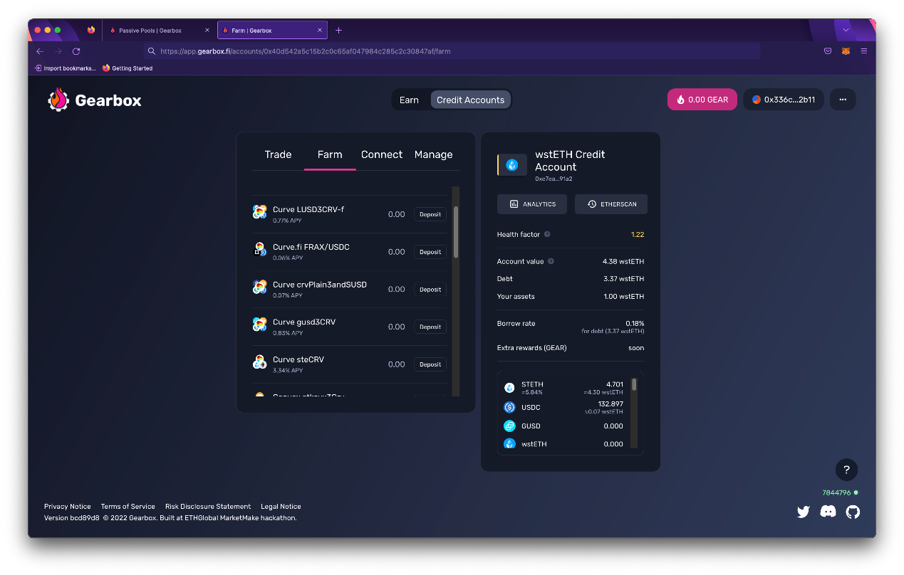

​<https://app.gearbox.fi/accounts>​

​

### Claiming farming rewards

This is also where you claim your LDO, CVX, CRV, and other rewards from farms:

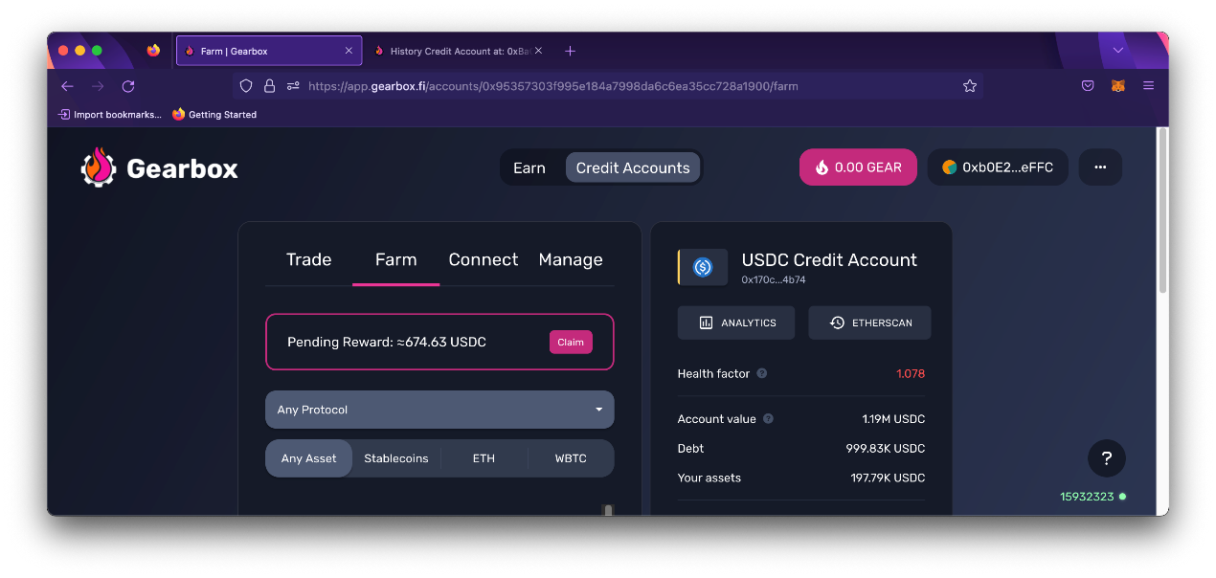

Go to the Farm tab inside your Credit Account view

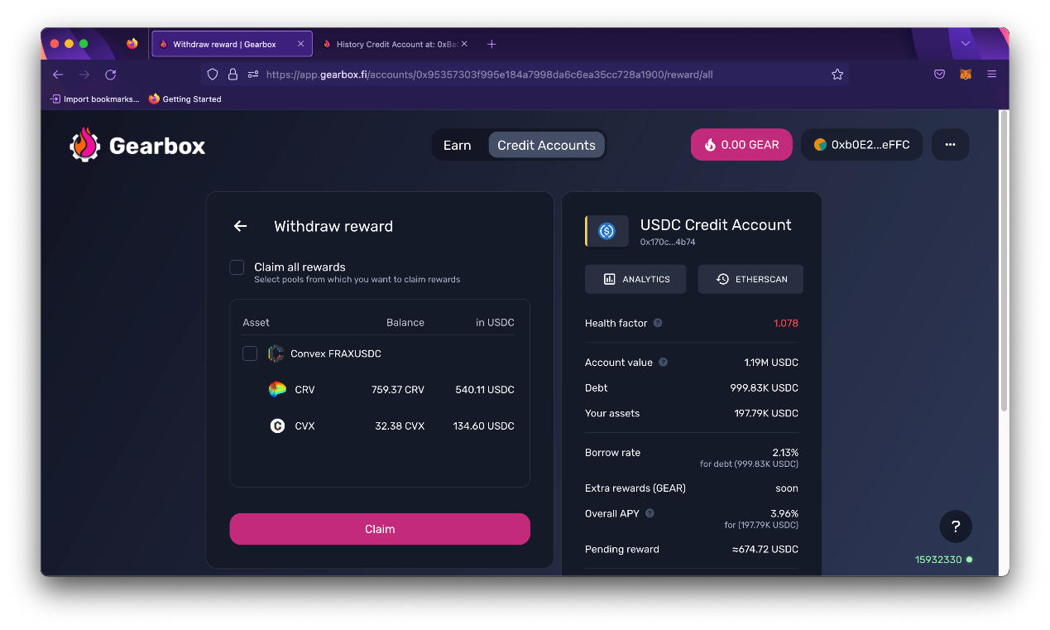

Claim the rewards, done. See their LTVs in [Allowed List](https://docs.gearbox.finance/overview/credit-account/allowedlist-policy#allowed-assets-list)

**Connect: Wallet Connect**

Use leverage on native interfaces of allowed protocols - thanks to Wallet Connect.

Using the Wallet Connect integration, you can use leverage on native interfaces of your favorite DeFi protocols. That's right, interfaces of other protocols don't even have to integrate Gearbox Protocol - you simply connect your Credit Account wallet instead of your regular Metamask obe... and there you go - now you can trade with larger positions thanks to Gearbox leverage!

1. 1.

Open *Connect* page.

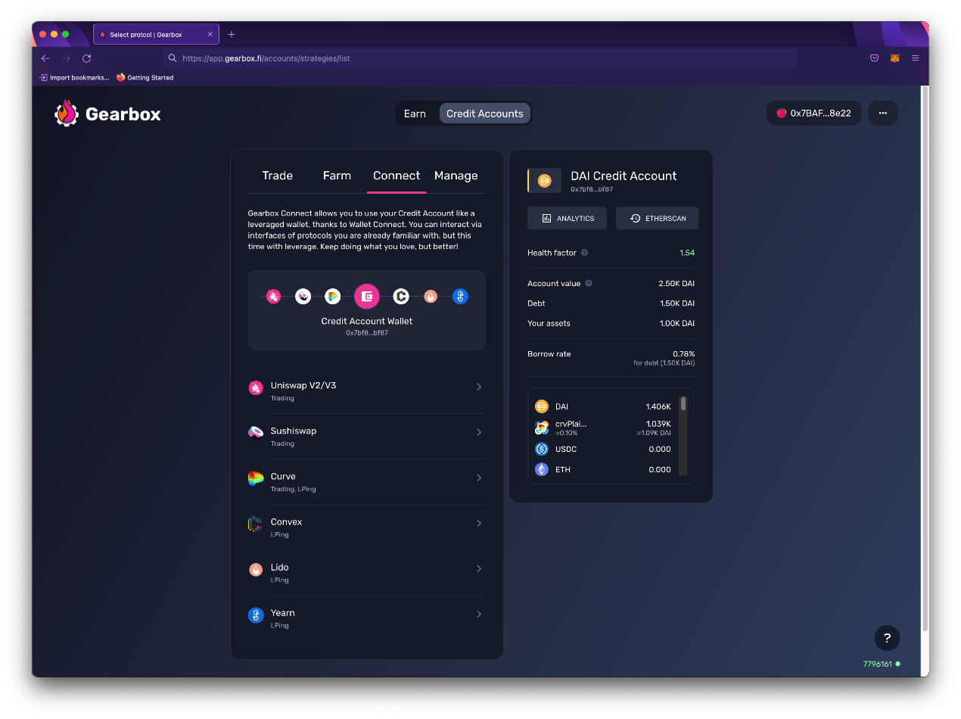

2. Open another page in your browser and go to dApp you want to use with leverage.

You can only interact with the allowed protocol list as per Gearbox governance. You can see their list on the main Credit Accounts page, and also on the [Allowed List policy page](https://docs.gearbox.finance/overview/credit-account/allowedlist-policy). Didn’t find a protocol? Propose to Gearbox DAO to add your favorite protocol!

3. Connect on that interface using WalletConnect.

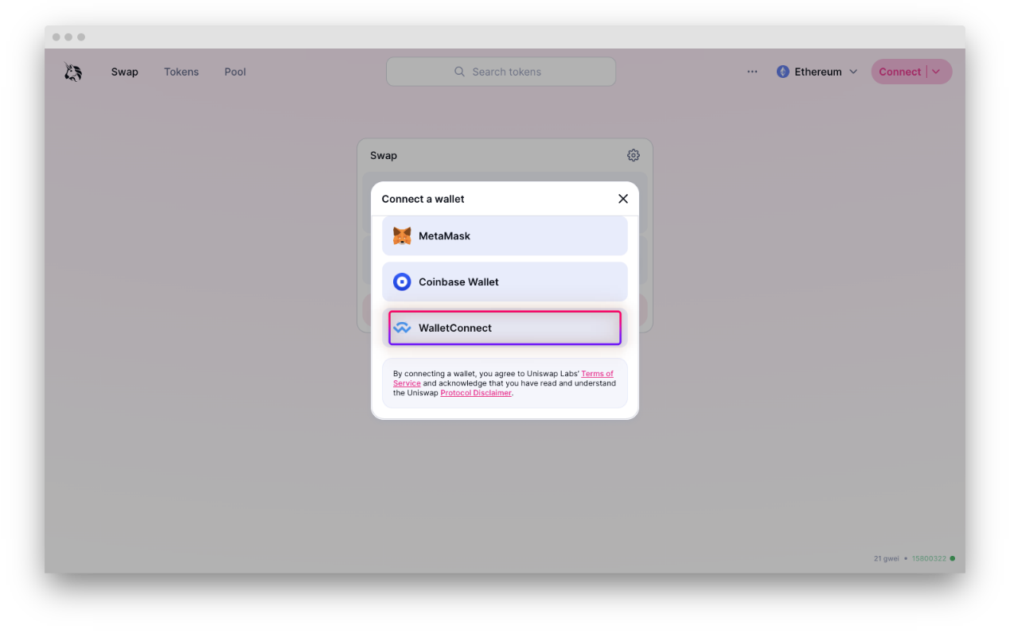

4. Click *Copy to clipboard* in the opened WalletConnect integration interface.

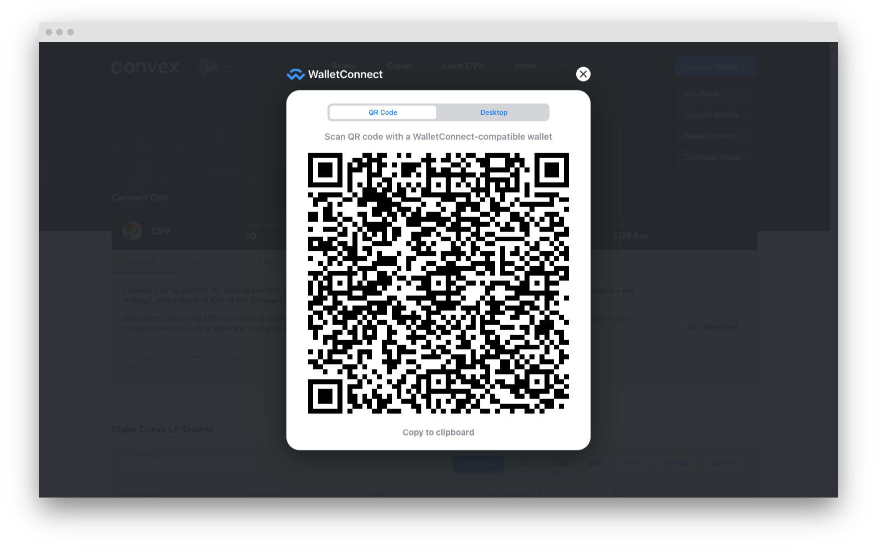

5. Now return to the Gearbox Application page (as you can remember it is still opened on another page in your browser), paste copied into the input field, and click *Connect*.

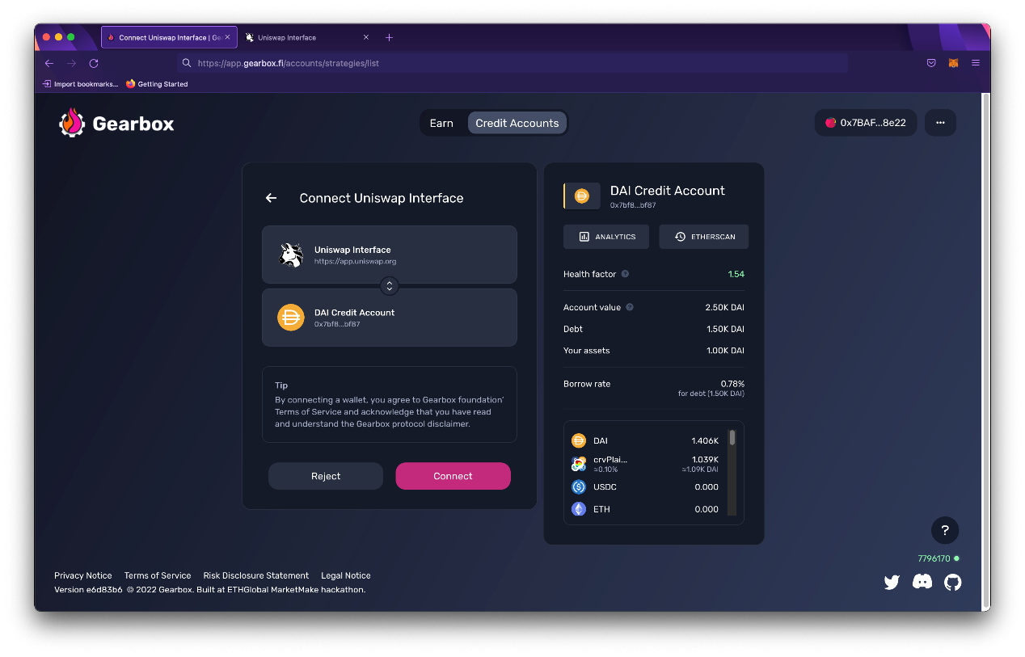

6. Voila! Now you can return to native dApp interface of the protocol you were using, and use it as you are already familiar with. You can sign transactions with Metamask as you are used to. You don't have to cross-check Gearbox interface every time anymore. Just keep the tab open.

Did you find a bug with the interface, something didn't work as you think it should have, or you have a suggestion on how to improve the user experience? [Suggest](https://discord.gg/hF3QvX2vgt) on Discord!