**How to avoid liquidations**

Don't fall prey to the liquidation bots - protect your funds!

Liquidations are there to protect liquidity providers' capital which by default shouldn't be exposed to directional market risk which traders & farmers take. As a leverage user - you can avoid liquidations, which also saves you from the [fees](https://docs.gearbox.finance/overview/protocol-fees) paid to liquidators & the protocol.

[Liquidations](https://docs.gearbox.finance/overview/liquidations)

​[Health Factor](https://docs.gearbox.finance/overview/liquidations#what-is-a-health-factor) is the representation of your Credit Account's performance. Keep it high enough, and it should generally be fine - unless a major market event comes where your positions could go down 25% or more in a matter of minutes. Make sure to keep it high and watch out!

Keep your health factor as high as possible. **Make sure it doesn't drop below 1.**

**What I can do if my Health Factor is close to 1?**

In case you are in position which has correlated collateral to debt [like stablecoin debt to a stablecoin farm [**Leveraged stablecoin farming**](https://docs.gearbox.finance/traders-and-farmers/strategies/leveraged-stablecoin-farming), or an ETH debt to leveraged liquid staking position [**Leveraged liquid staking**](https://docs.gearbox.finance/traders-and-farmers/strategies/leveraged-liquid-staking) - you can take higher leverage as the LTVs of your position <> debt are essentially correlated and are high. As such, it allows you to take 10x leverage in some extreme cases. Then it's normal to have low HF.

Read about that in [**PRO: Leverage Bible**](https://docs.gearbox.finance/traders-and-farmers/pro-leverage-bible).

1. 1.

**Add collateral**: the easiest method to improve your Health Factor is simply by adding more collateral in the form of the base asset that you opened your credit account in. If this isn't a possibility you can follow the below options.

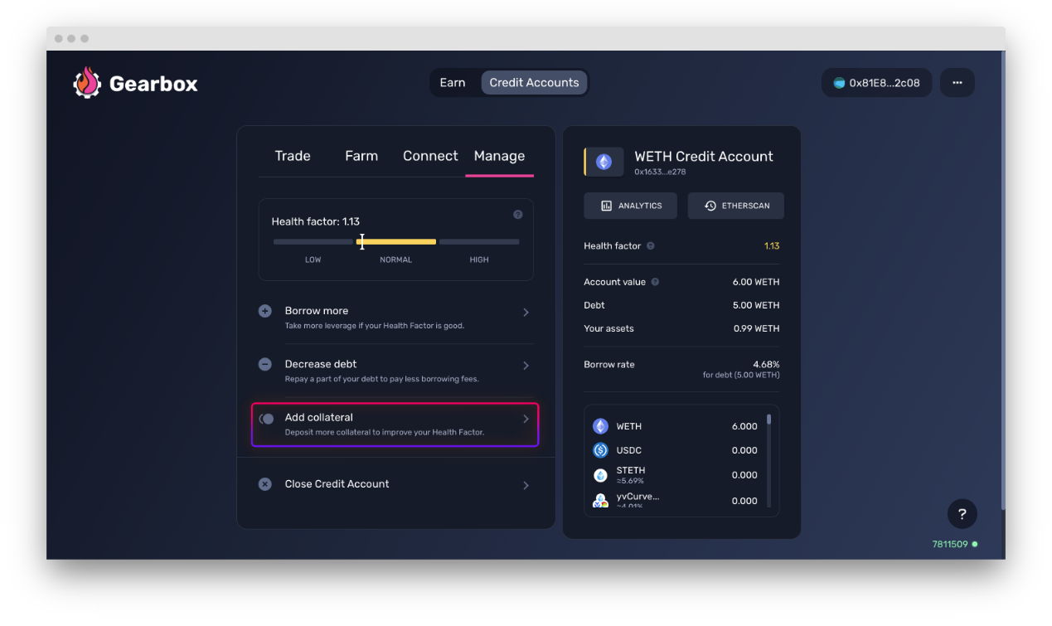

2. **Change your strategy:** If you are in a strategy that has a directional trade that's leading to the HF dropping, a possible better idea could be to change to a strategy with stables or lesser volatile/base asset to preserve your Credit Account. That is, if your debt is stables. If your debt is ETH and you are short ETH in a bull market... *maybe join the ultrasound side, anon-kun.*

3. **Decrease debt:** Add some of the collateral back to the CA in the form of the base asset you borrowed, this will help you lower your leverage and thus improve your health factor

[How to close a Credit Account](https://docs.gearbox.finance/traders-and-farmers/credit-account-dashboard-overview/how-to-close-account)

**Checking Health Factor of your Credit Account**

In the [Credit Account's page](https://app.beta.gearbox.fi/accounts) you can check health factors of all your Credit Accounts:

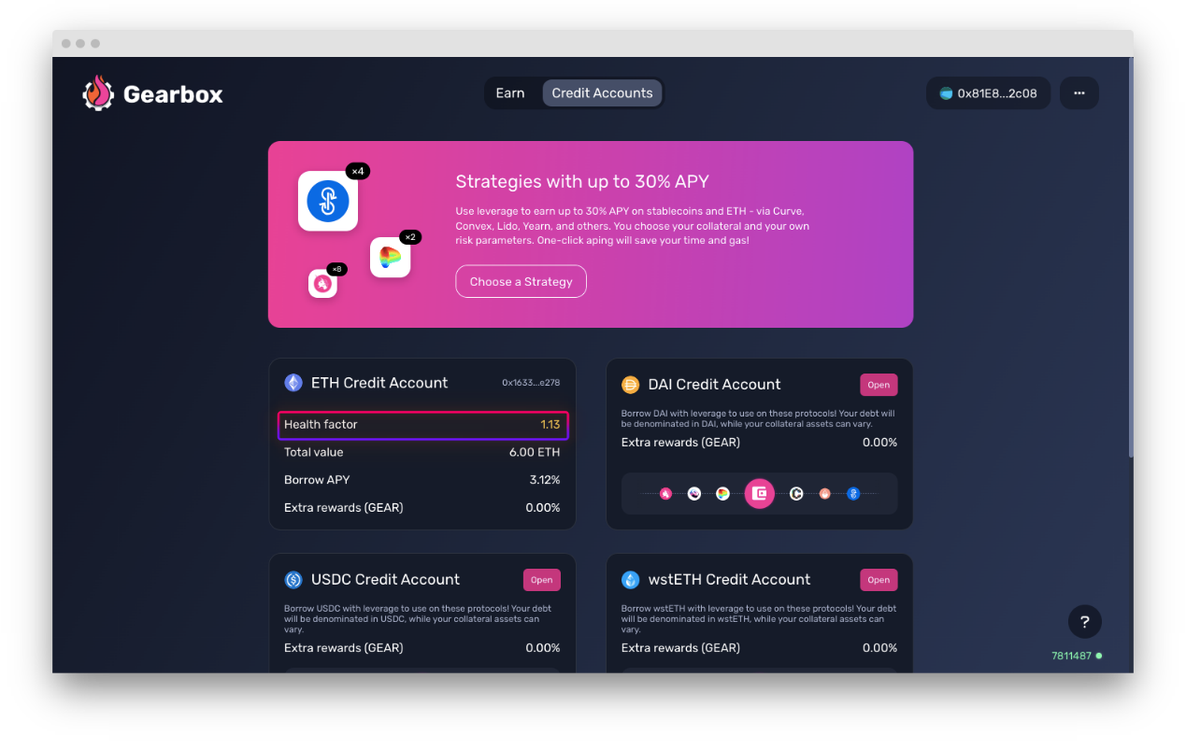

Also you can check health factor inside the Credit Account. *All of these stats are of course also fully on-chain and do not require any interfaces, just so you know*.

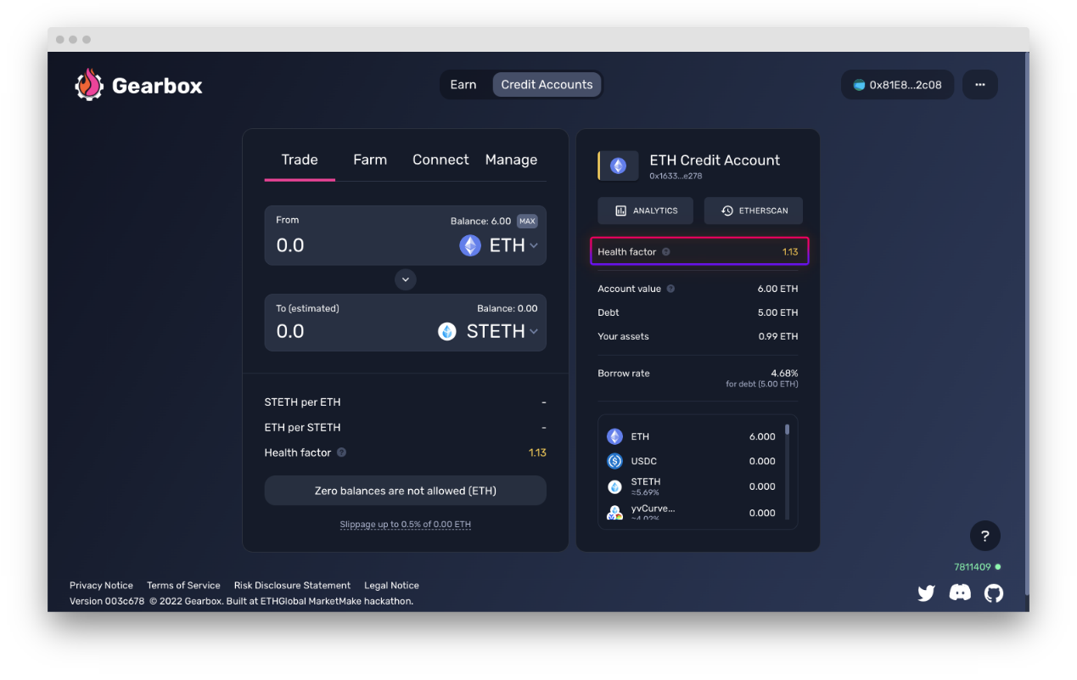

Anybody can run a liquidator bot and secure the protocol. You can chat about setting up your bot and other liquidator-things in [Discord](https://discord.gg/wmydr8JfcP). Help users minimize the [risks](https://docs.gearbox.finance/risk-and-security/risks-terms)!

# How to close a Credit Account

Closing your account and avoiding liquidations.

Before you close a Credit Account, the protocol would want you to pay back what you owe. That is the loan you took and the interest accrued to it over the time you used the Credit Account. You can see this amount in the [Credit Account Dashboard](https://docs.gearbox.finance/traders-and-farmers/credit-account-dashboard-overview) section. There are two options to pay back:

* Use the Credit Account's funds to repay the debt by automatically swapping all positions inside it to the underlying asset, from which the debt (notional loan + interest accrued) are subtracted and then the difference is given back to you. The better you traded, the more you will get.
* Use your own funds to repay the debt in the underlying asset - and get all the assets from the Credit Account back to your wallet. You essentially prepay the debt, and then the Credit Account releases all the funds on its balance to your personal wallet. This shall become available shortly after V2 launch, but not at the start. On contract level this is of course available, but interface didn't catch up to this functionality yet.

**Option number two is preferred in case you really like the assets** you have on your Credit Account and don't want to trade there-and-back and just want to keep the assets. Remember that keeping passive positions on a Credit Account still accrues the interest.

Another reason why **option number two is preferred is because you as a user can slowly trade out of the positions instead of market-selling them**. In case your positions are large, some of the assets on your Credit Account could incur high slippage which the protocol will not allow you to perform such an action and will require you to input larger slippage tolerance.

## Option 1: ****Swap all assets to the underlying and repay the debt****

The protocol will exchange all the non-underlying asset funds to the underlying asset on DEXes and repay your debt. You will receive the remaining funds to your personal wallet.

**Step I-1.** Click Close button

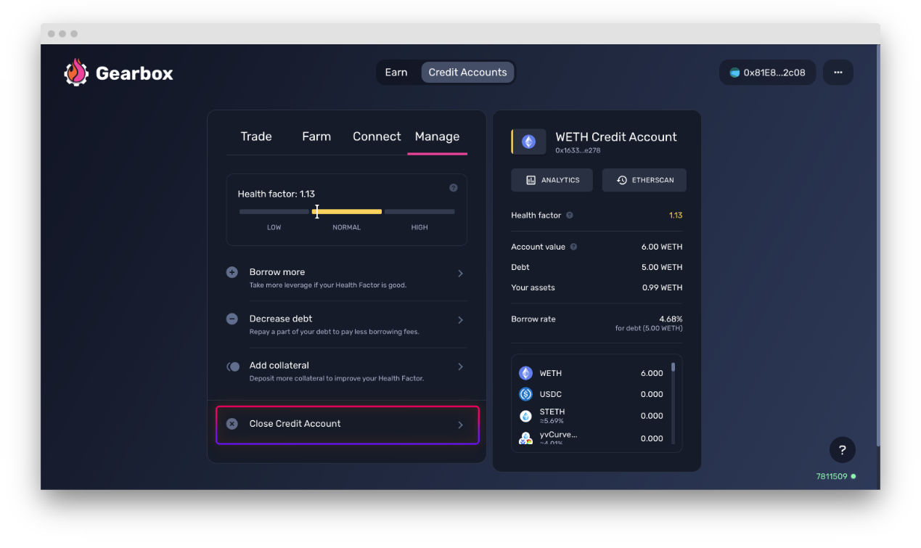

**Step I-2.** Choose the maximum size of the slippage that you will tolerate in the options page in the top right corner, and click Swap and get tokens button. If the price falls by more than the slippage while your trade is being confirmed, the trade will be reverted.

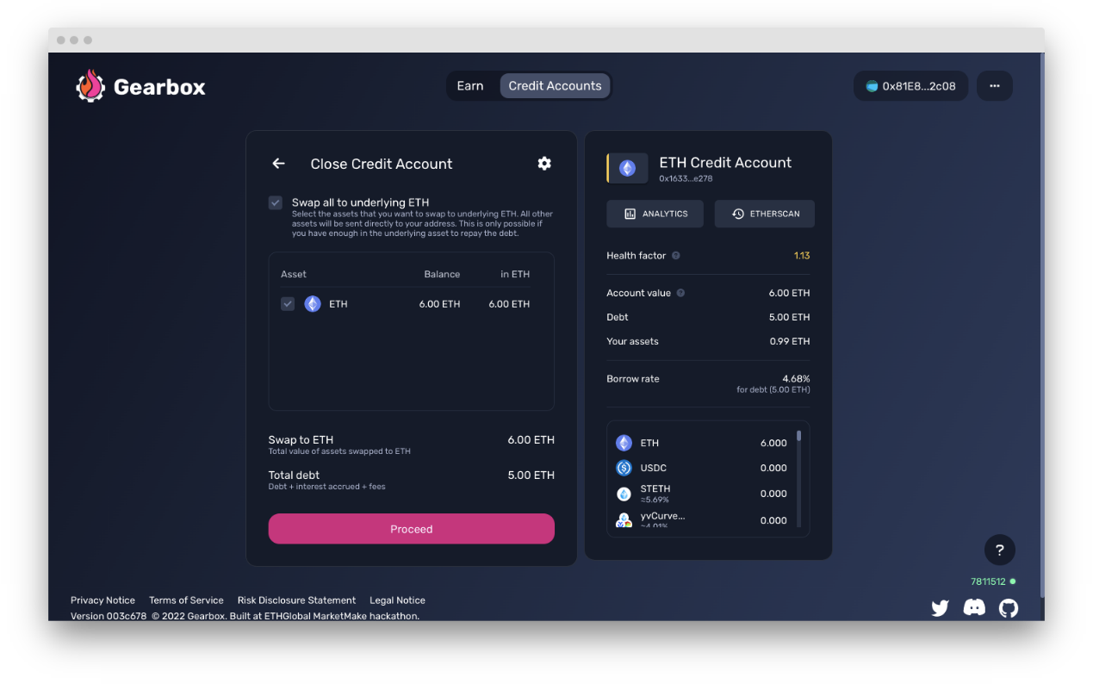

## Option 2: ****C****lose a Credit Account by repaying the debt and keeping some assets

You repay the loan with your own funds. This means you have more funds on your personal wallet. After repayment is done, the assets which were on your Credit Account will be sent to your wallet.

This option is possible only if your personal wallet balance in the denominated asset is at least of the amount required for repaying the debt. Will become possible soon!

Did you find a bug with the interface, something didn't work as you think it should have, or you have a suggestion on how to improve the user experience? [Report](https://discord.gg/5YuHH9tvms) on Discord!