**Strategies**

Some ideas on how leverage could be used across DeFi with the help of Gearbox.

Gearbox Protocol allows for multiple collateral types and interactions within a Credit Account. These collaterals can then deployed across protocols in order to turn DeFi strategies leveraged. Effectively, **every integration on Gearbox enables you to access multiple new strategies** basis the pools and vaults that are allowed.

Before you go any further, just know: <https://app.gearbox.fi/accounts/strategies/list> has the list of strategies that ape for you in one click! That's right: you configure your collateral asset(s), debt asset, leverage factor... and it does all of it for you in one click. So if you just wanna do some vanilla farming - this could be the recipe for you. But keep reading to learn about other hot stuff possible with composable leverage.

While a developer can run all of the complex interactions on-chain, executing these by going protocol to protocol is a tough task. The devs have worked this out though and the interface helps non-technical users to **ape into strategies with one click thanks to "One-Click Strategies"**.

What it enables in 1 go:

* Open a Credit Account based on your preferred collateral, leverage, etc. selected;
* Swap some assets if needed to the ones needed for a specific farm you chose;
* LP, stake, etc. to end up in that destination as you have chosen.

Done! From assets X Y Z -> to taking leverage with gearbox -> to swaps into other assets -> to LP and then staking in the protocols you chose. **All in one click thanks to Multicall + Smart Router!**

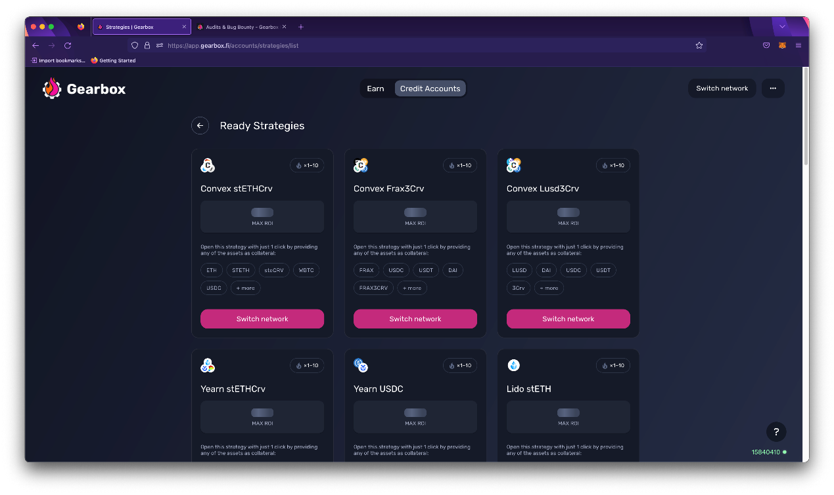

​<https://app.gearbox.fi/accounts/strategies/list>​

**Concrete Strategy Examples**

**Leveraged Liquid Staking**: Stake ETH on LIDO to get stETH. The stETH can then further enable multiple further avenues of incremental APY. You can read the complete details below

[Leveraged liquid staking](https://docs.gearbox.finance/traders-and-farmers/strategies/leveraged-liquid-staking)

**Leveraged Stablecoin Farming:** With V2, we'll be adding a few different stablecoins to help you access more stablecoin strategies as well as gain control over what all stablecoins you have and want exposure to, you can see the exact details below:

[Leveraged stablecoin farming](https://docs.gearbox.finance/traders-and-farmers/strategies/leveraged-stablecoin-farming)

**Leveraged Vanilla yVaults:** This is a great way to avoid any funding fee while leveraging BTC and ETH and earning a small APY through yVaults

[Leveraged vanilla yVaults](https://docs.gearbox.finance/traders-and-farmers/strategies/leveraged-vanilla-yvaults)

Do you have a strategy or idea which you would like to build on top of Gearbox or find community members who could help you out get un-rekt? Jump into [Discord](https://discord.gg/dtqqwDuawE)!

Some older V1 primitive examples [that still work though of course]:

[Farming Long/Short or "Free Leverage Position"](https://docs.gearbox.finance/traders-and-farmers/strategies/long)

[Arbitrage of correlated assets](https://docs.gearbox.finance/traders-and-farmers/strategies/arb-correlated-assets)

​

**One-Click Strategies**

Save gas and time by deploying your favourite DeFi strategies with leverage in one click.

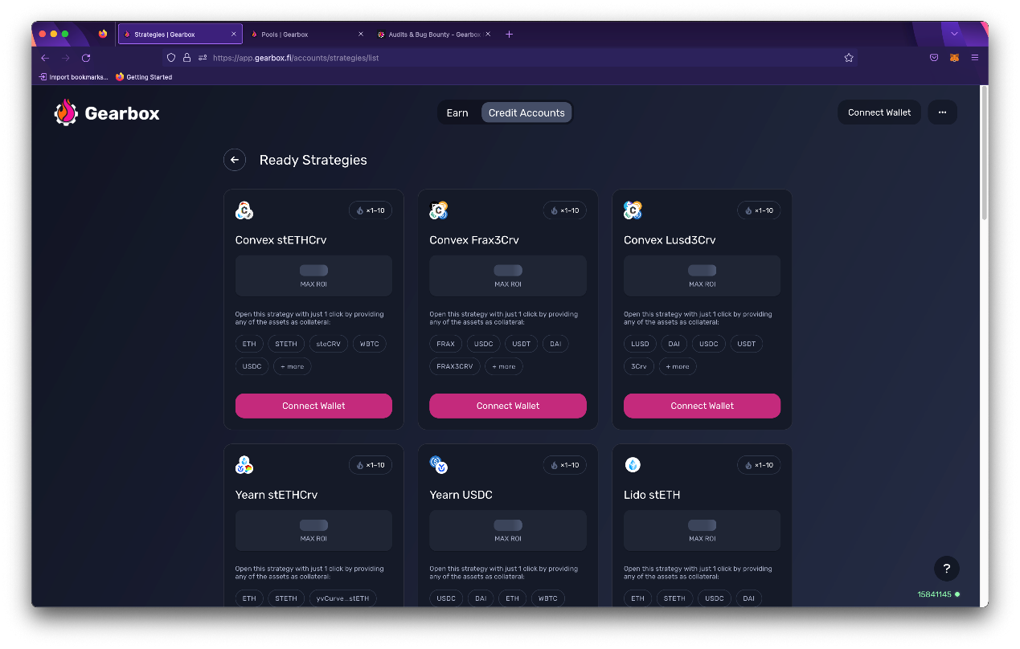

​<https://app.gearbox.fi/accounts/strategies/list>​

One-click strategiesdo what the name suggests: open leveraged positions in your preferred pool/vault/protocol in just one transaction. Multicall feature of Gearbox essentially bundles all the complex [swap->LP->deposit] operations into just 1 transaction, also saving you a bunch of gas.

But not just that, One Click Strategies let you **go from having no Credit Account -> to having a Credit Account open and already aping into a strategy you choose**. You choose the leverage, the debt asset, the risk… And you can always ape out as easily!

1. 1.

Choose your debt [borrow] asset

1. 2.

Choose your collateral(s) which can be multiple

1. 3.

Choose your leverage factor x

1. 4.

Choose where you want to ape in

Single click strategies use a **Smart Router** [our pathfinder] to find the most efficient manner to get the assets for a strategy while **Multicall** ensures that efficiency turns into execution in one click. It saves you the time & gas from doing all of the steps by yourself.

**See for yourself and ape in:**

# Leveraged liquid staking

How leveraged liquid staking strategies can work with LIDO and our new adapter.

With the Gearbox integration, you are able to lever up staking as per your risk and debt [borrowed] asset preference to get access to true leveraged staking… But that’s just the tip of the iceberg. **Beyond the leveraged ETH, it’s the stETH you receive that enables composability across multiple more DeFi protocols**. And each protocol enables you to earn even more APY. Here are the possible strategies, **all available through One Click.**

### Pure leveraged staking yields in stETH

The stETH is what you receive when you stake ETH, with the ability to deploy directly on the [LIDO protocol](https://stake.lido.fi/). stETH ideally is supposed to maintain a peg against ETH but market conditions can make it lose peg which can lead to your health factor dropping, this has previously happened and you should manage your risk accordingly. Depends on your debt asset too!

The yield here is the rebasing stETH rewards you receive. If they are more than the borrow rates you receive, this fully makes sense. This also makes sense if you went ETH-long relative to stablecoin debt: [**Farming Long/Short or "Free Leverage Position"**](https://docs.gearbox.finance/traders-and-farmers/strategies/long)​

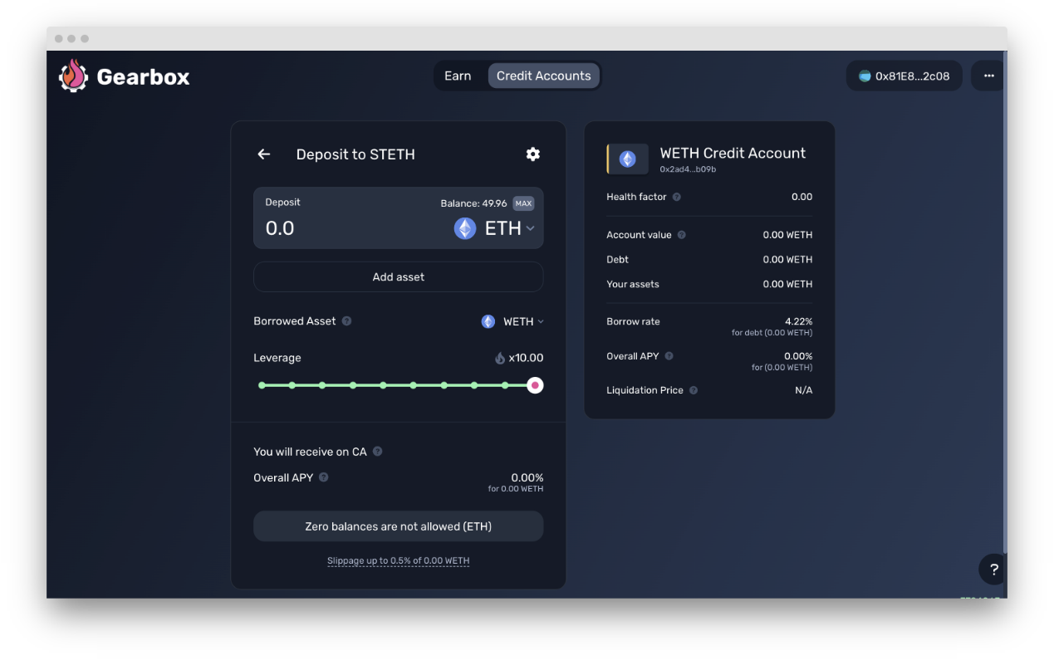

​<https://app.gearbox.fi/accounts>​

### Convex stETHcrv

Convex Finance allows users to stake steCRV LP tokens into their vault, to farm LDO, CVX, trading fees, as well as boosted CRV rewards — without the need for users to lock-up CRV themselves. This is on top of the staking APY of stETH (the portion that remains as stETH inside Curve pool).

Yield: a mix of CVX, LDO, boosted CRV, staking yields, and trading fees of Curve pool.

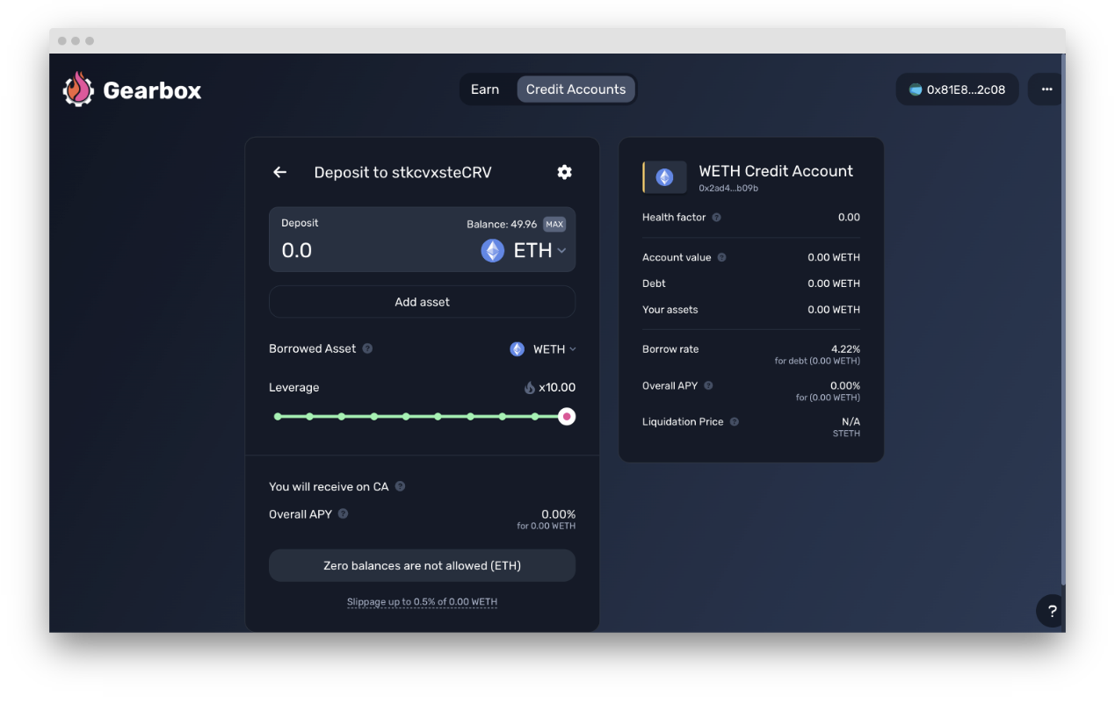

​<https://app.gearbox.fi/accounts>​

### Yearn stETHCrv

Yearn has very similar sources of yield to Convex but unlike convex it sells off some of the rewards earned to then redeposit ETH/stETH into the vault. Without fees, usually has higher performance.

Yield: a mix of CVX, LDO, boosted CRV, staking yields, and trading fees of Curve pool.

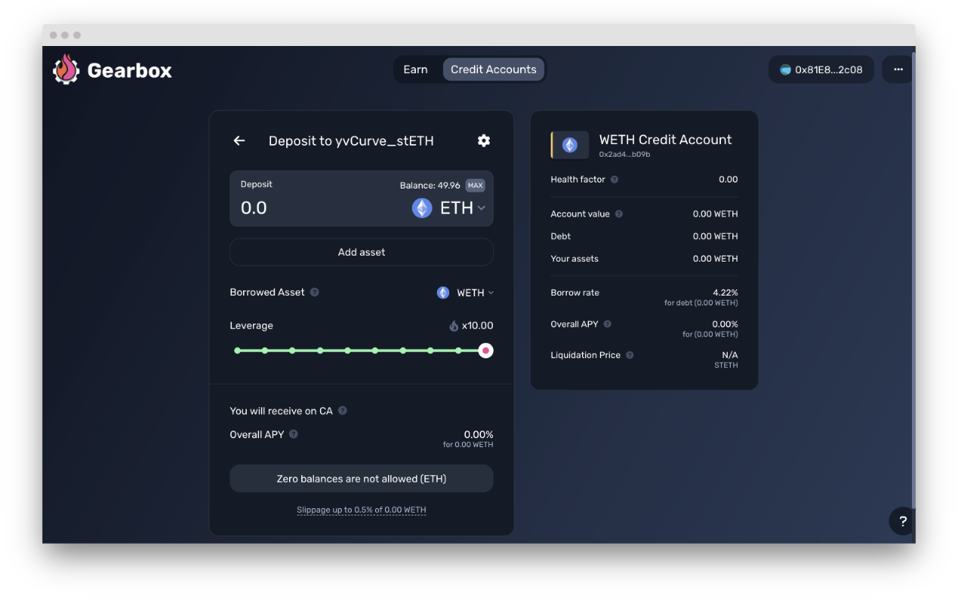

​<https://app.gearbox.fi/accounts>​

### Curve stETH

The Curve stETH Pool takes Lido stETH (liquid staked ETH), puts it in a curve pool with vanilla ETH.

Yield: a mix of LDO, CRV, staking yields, and trading fees of Curve pool.

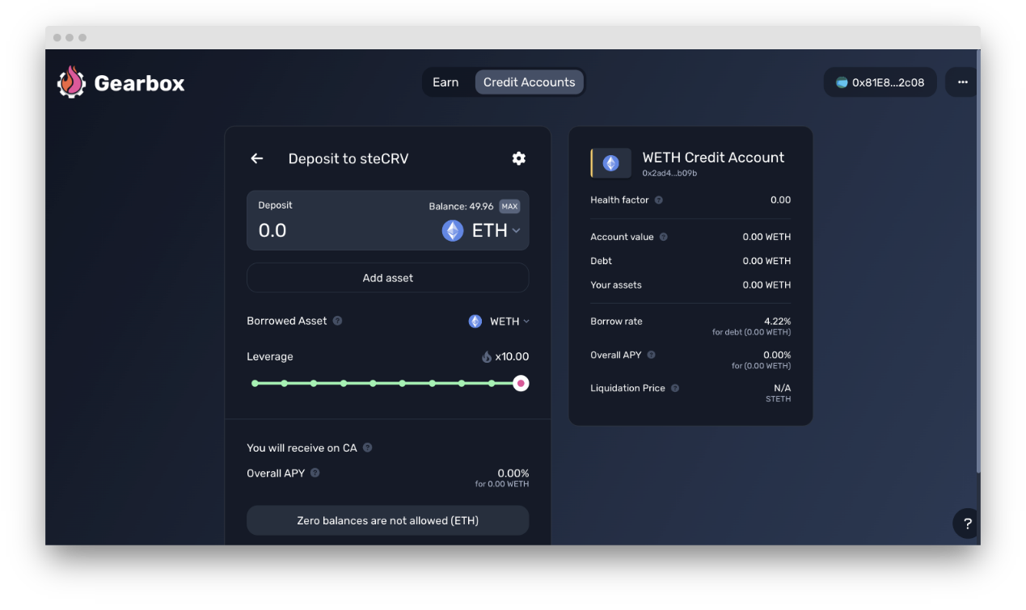

​<https://app.gearbox.fi/accounts>

# Leveraged stablecoin farming

Learn about the multiple stablecoin strategies we have coming up

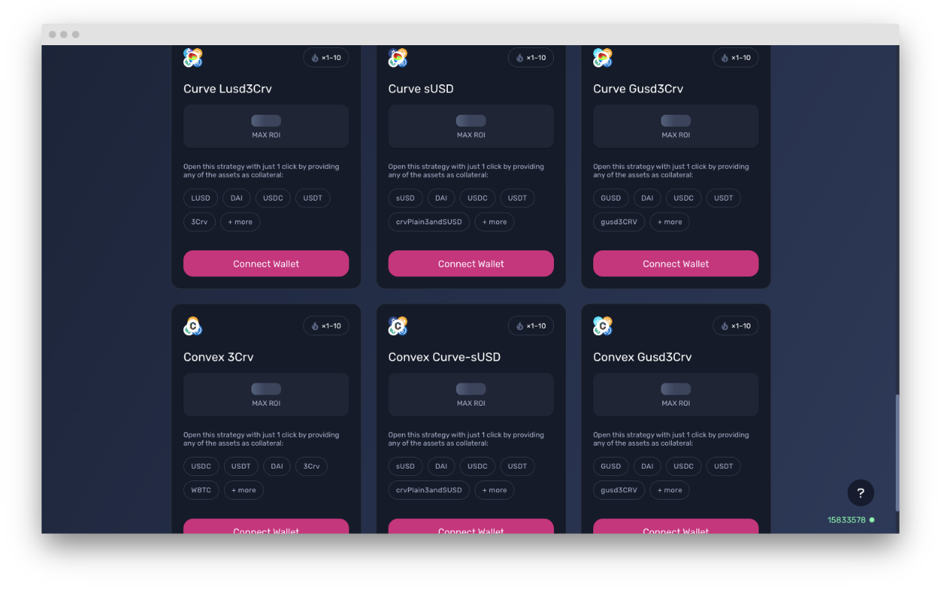

​<https://app.gearbox.fi/accounts/strategies/list>​

### Curve 3Pool (USDC+USDT+DAI)

The Curve 3Pool is one of the most important stablecoin pools in all of DeFi — it underpins much of the Curve ecosystem because many of their other pools are made up for the 3pool + 1 additional asset (known as Curve metapools).

It also holds almost $1b in assets at the moment. While this pool doesn’t have very high APY, this pool is broadly seen as very safe as long as you are happy to hold the underlying stables (USDC, USDT, DAI). Basically, the risks you are taking are Curve protocol risks + one of the 3 assets depegging. That’s a pretty low low risk compared to whatever else you can face in DeFi.

You can then put those Curve LP tokens either in Convex or Yearn. This will give you some [boosted] CRV rewards as well as CVX rewards, next to trading fees of the pool.

### FRAX flavour

#### a. Curve FRAX3CRV

The **FRAX3crv pool** is the type where a pool pairs 1 asset with the 3CRV Pool token. So by participating in this pool, you’re (very approximately) holding 50% FRAX and 50% 3CRV, which is made up of DAI, USDC, and USDT. If FRAX is your stablecoin of choice, then this Vault is a decent option for you to earn yield on FRAX as a stablecoin.

b. **Curve** **FRAXUSDC**

This pool is approximately 50%-50% in FRAX and USDC.

You can then put those Curve LP tokens either in Convex or Yearn. This will give you some [boosted] CRV rewards as well as CVX rewards, next to trading fees of the pool.

### LUSD flavour

#### Curve LUSD3CRV

The **LUSD3crv pool** is another one of these pools with 1 asset + 3CRV. In this case, the 1 asset is LUSD, which again means that you’re holding 50% LUSD and 50% a mixture of DAI, USDC, and USDT. LUSD is generally viewed as one of the most decentralized and censorship resistant stablecoins (the design is similar to original design of DAI, where the only collateral used for LUSD is ETH). So if you’re a decentralization maxi but you still want to earn yield on stables, this LUSD pool might be a reasonably good solution for you.

Just keep in mind that recently LUSD has been >$1 peg, so entering the pool (but so is exiting) yields slippage if you are using another stablecoin other than LUSD itself.

You can then put those Curve LP tokens either in Convex or Yearn. This will give you some [boosted] CRV rewards as well as CVX rewards, next to trading fees of the pool.

### GUSD flavour

#### Curve GUSD3CRV

Similar to the above 2, **GUSD3crv pool** on Curve also functions with 1 asset being clubbed with the 3CRV. GUSD is a 1:1 USD-backed stablecoin issued by Gemini.

You can then put those Curve LP tokens either in Convex or Yearn. This will give you some [boosted] CRV rewards as well as CVX rewards, next to trading fees of the pool.

### ****sUSD**** flavour

**Curve sUSD**

The Curve sUSD pool which this vault is built on predates the metapool design and is instead made up for (approximately, in an ideal world) 25% each of SUSD, USDC, USDT, and DAI.

sUSD is an overcollateralized stablecoin by Synthetix protocol. You can learn more about Synthetix here. sUSD is considered by most to be pretty decentralized, as sUSD is entirely backed by staked SNX as a part of the broader Synthetix ecosystem of synthetic assets and derivatives.

If you’re a believer in the Synthetix ecosystem then this Curve sUSD Pool might make sense as a place for you to park your stablecoins to earn yield.

You can then put those Curve LP tokens either in Convex or Yearn. This will give you some [boosted] CRV rewards as well as CVX rewards, next to trading fees of the pool.

Try these vaults out here: