Corey Mills, Greater Manchester

Mobile: 07388047323

Email: [C.M.Mills@outlook.com](mailto:C.M.Mills@outlook.com)

LinkedIn: <https://www.linkedin.com/in/corey-mills-a68775150/>

Portfolio: <https://coreymills.github.io/index.html>

About me

A Staffordshire University graduate, who has experience with multiple technologies. Experience in creating computer games through several projects throughout University, Game jams and college; using C++, C#, Unity and Unreal. I have a great desire to thrive within the gaming industry as a programmer and to create outstanding and engaging video games people find hard to put down.

I play a wide range of games, from strategy to MMO, RPG, board games, and DnD. I am passionate about making and playing entertaining and exciting games.

I am looking for an opportunity to apply and develop my skills while working in the industry with other professionals.

Skills

|  |  |
| --- | --- |
| Coding Languages:   * C# * C++ * Java * HTML * CSS * JavaScript   Software:   * Unity * Unreal * Visual Studios | API:   * SDL * DirectX * OpenGL   Soft Skills:   * Teamwork * Leadership * Problem Solving * Organisational Skills |

Education

**Staffordshire University** 2017-2021

BSc (Hons) Computer Games Programming - **First Class with Honours**

Check my portfolio to see the projects I worked on.

**UTC@MediaCityUK**

Level 3 BTEC Extended Diploma, Creative Media Production (Games Development) (QCF) – **D*D*D\***

Level 3 Extended Project & A-Level Computer Science.

Relevant Experience

* Participated in Global Games Jam 2021. In a team of 6, we created “X Marks the Spot” in Unity.

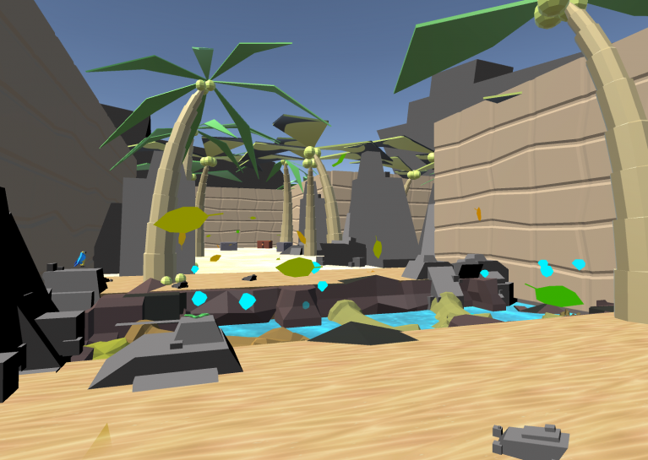

* Participated in Search for a star 2020-2021, Grads in Games. Created an arena-style survival game while following the themes in the brief.
* Self-employed placement year 2019-2020. Created 2 mobile video games in Unity, “Launch” and “Bounce”. Both include a variety of systems needed for a video game to run and create an enjoyable experience.
* Participated in the Global Games Jam 2020 event. In a team of 10, we created “Bermuda” in UE4. I was one of two programmers in the group.
* Participated in a week-long game jam with industry professionals and 9 other students. We created a small multiplayer game called “SoulCats” in Unity. I programmed the AI and Physics behind the characters and items in the game, using C#. I also 3D modelled game objects.
* Participated in Jamchester as a team from UTC@MediaCityUK, using the Unity Engine.

References

**Phi Dinh**- College Lecturer and creator of Phi Games

Email: [phidinh6@gmail.com](mailto:phidinh6@gmail.com)

Web: <http://phidinh.com>

**Davin Ward**- Lecturer at Staffordshire University.

Email: [Davin.Ward@staffs.ac.uk](mailto:Davin.Ward@staffs.ac.uk)

**David White**- Lecturer at Staffordshire University.

Email: [David.White1@staffs.ac.uk](mailto:David.White1@staffs.ac.uk)