**Factors Affecting Salary in US Tech Hubs**

Corey Rowell, Jelani Latimore, Neelesh Reddi, Michael Forshay

College of Data Science, University of North Carolina Charlotte

DTSC 1302: Data and Society

Dr. Jason Grandinetti

December 8th, 2024

**Factors Affecting Salary in US Tech Hubs**

As our society continually advances, the technology we use everyday is forever growing and changing. Technology in this context encompasses the computers, programs, coding languages, and all the AI models we use in certain jobs. As an industry, jobs working with these technologies are some of the most in-demand and rapidly growing in the country. Over the last 20-30 years, there has been a rapid increase in demand for people who specialize in working with computers and “tech.” The common view on these jobs is that they pay a lot for the work that is required. When you ask someone what they do for work, and they respond with something like “I’m a senior software developer for X,” Your first thought will probably be wondering how many digits are on their pay stub every week. The influx of jobs in the tech industry and sudden demand for computer programming specialists caused these salaries to spike, and the popularity of the industry right now is at an all-time high.

The purpose of this paper is to outline the factors that contribute to the salaries of certain jobs in the tech industry. Because there are so many factors that can make or break the income received at these jobs, conceptualizing them can help to identify which jobs and which factors such as the companies, the location of the companies, and experience in the industry. Cities all over the US have an abundance of jobs, but their pay will vary depending on the type of job, and where it is in the U.S. a job in Los Angeles, CA might pay double what the same job will pay in Atlanta, GA because of multiple reasons. We will reveal that in this paper. How do company, location, and experience, race, gender, and education level influence salaries in the tech industry in the US?

**Context & Implications**

This project is about defining and measuring the variables that influence salaries in tech. We are taking into consideration employers, years of experience in the field, and location. We aim to correlate how these variables determine or influence the level of financial compensation that employees are paid. Ethical considerations of potential bias include exclusion, measurement, selection, sampling, availability, and outlier biases. Due to the limitations of available data because of missing variables in our dataset such as bonuses, and stock grants, we are considering total compensation in our analysis. This missing data may end up affecting the results, and we must be mindful of that to ensure the most objective measurement possible.

Upon further research on previous studies done, we discovered key factors such as inflation, reduced consumer demand, and workforce reductions have played an important role in compensatory trends. One study illustrated how different salaries for the same role and responsibility differ among companies and location, backing up the need for an answer to our research question. Another helped explain why certain cities might have higher tech salaries due to localized economic benefits or challenges. In a study done like this one the conductors acknowledged that “There are many work opportunities in the field of data science. However, a variety of jobs, around 43 different kinds of employments are in the industry. The variations further depend on the skills or software that are increasing their values in the field.” (Kaur et al., 2022). They acknowledge that those factors have a very large influence on the salary that a worker gets. In terms of Geographic location, a study conducted on salaries of information technology managers concluded that “Three regions, the Northeast, Southeast, and the West Coast, have average indices that are higher than the computed average for the whole country. In other words, salaries in these three regions lead the nation in their speed of growth. The Southwest region had the slowest average index.” (Koong & Liu, 2003). That study also showed a steady increase of salary for the same positions over the course of the entire 1990’s, that also shows how fast the industry is growing. Knowing factors like this we needed to take everything into account from multiple similar studies and bring them all into one to make a definitive conclusion on which factors are affecting salaries greatly and which are not.

**Stakeholders**

We must acknowledge that there are consequences to discovering and holding information that we are uncovering in this paper. Several entities are capable of receiving either positive or negative ramifications from our findings. As stated above some stakeholders might be job recruiters within the geographic locations that we studied, or employees working for the companies that we collect the data from. These entities could be affected because revealing the salaries that come from the jobs that they have, or jobs that recruiters are advertising may drive people towards or away from them. Employees might see where their own salary falls on the spectrum and might make a decision to be content, or take action based on that information. Students might take this information to help choose what specific industry or job that they will aim for out of school. This might slightly affect educational institutions because students might switch majors based on how the job market looks. The goal for the students is they want to get out of school and make the most money possible, so they will switch their scopes depending on that.

**Potential Bias**

This research is also subject to certain biases because of the nature of us as the researchers and what we study. In this study we chose to limit our research to large cities in the US, because That would make the data easier to compare with different regions. Having just the large cities keeps it simple, and keeps the data concise so that our group of 4 people could manage and analyze it. The only problem with this is that it leaves out such a large geographic area where other tech industries could reside. This might affect the salaries that we work with, because generally salaries for jobs within large cities will be paying more than jobs located in smaller cities farther away from the large tech hubs. Another potential bias that could present itself is with us, the authors. Since we are all students that could potentially be looking for similar jobs in the future, in our minds we would want the salaries that we find to be high. That might result in confirmation bias, because we might subconsciously tune out research that doesn’t support our ideas, or doesn’t support the notion that jobs in the tech industry generally have above average salaries. Another type of bias that could affect this paper would be availability bias. Availability bias occurs when searching for information, and how we are often inclined to believe the first series of information that catches our attention, and overlooking information that you might have to dig a little bit deeper for. There could still be information that we have missed just because it is harder to come by, or requires bridges that we can’t cross to get a hold of, like the wealthiness of the families of the employees at tech companies.

**Measurement & Data**

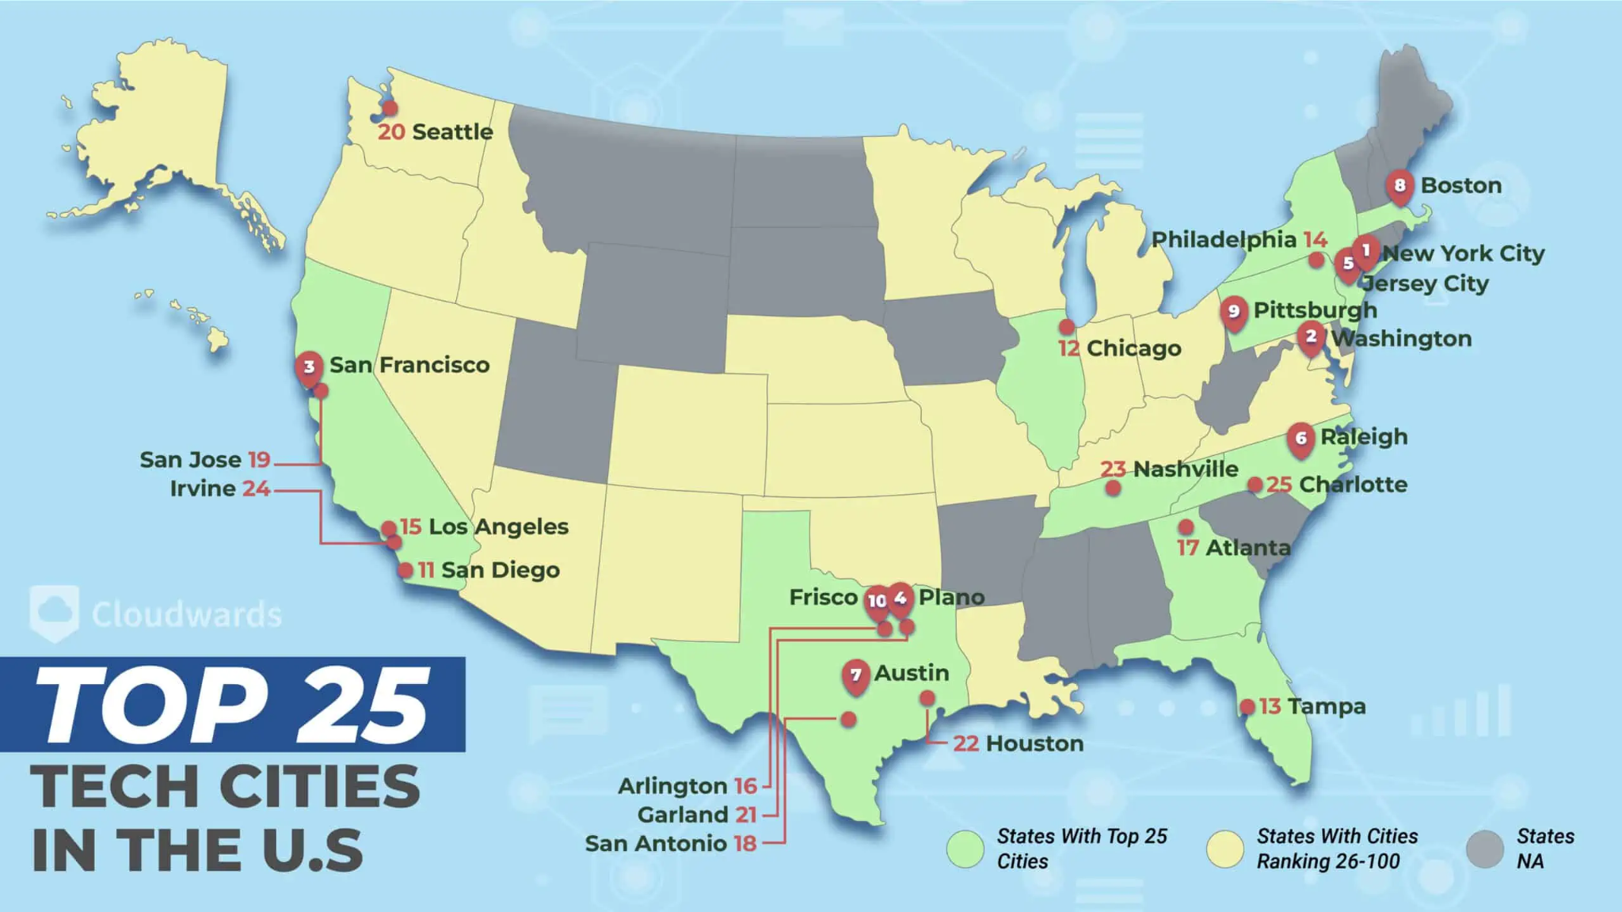

[The Top Tech Cities in the US: Ranking 100 Cities in 2024](https://www.cloudwards.net/top-tech-cities-us/)

Location is an important factor and we will measure these using consensus rankings of the best tech cities in the US from a few sources. Location can affect salary based off of that cities’ score which is determined by; livability, coverage & quality, career & education, innovation & entrepreneurship and lastly the tech community.

General rankings for the top tech locations include:

1. New York, NY
2. Washington City D.C.
3. San Francisco, CA
4. Plano, TX
5. Jersey City, NJ
6. Raleigh, NC
7. Austin, TX
8. Boston, MA
9. Pittsburgh, PA
10. Frisco, TX

According to this list, the East coast, Texas, and California offer the best total compensation for tech industry employment.

To assess this dataset, we took all the factors that we wanted to look at and sorted them into groups with the job titles and their total yearly compensation. We had to sort through all the rows of missing data to get complete information. To measure how the factors are actually affecting salary, we can compare the average total yearly compensation of different factors sorted out. For example, We can compare the average total yearly compensation between White, Asian, Hispanic, Black and mixed individuals. Through comparing them, We can see which race typically makes more money on average.

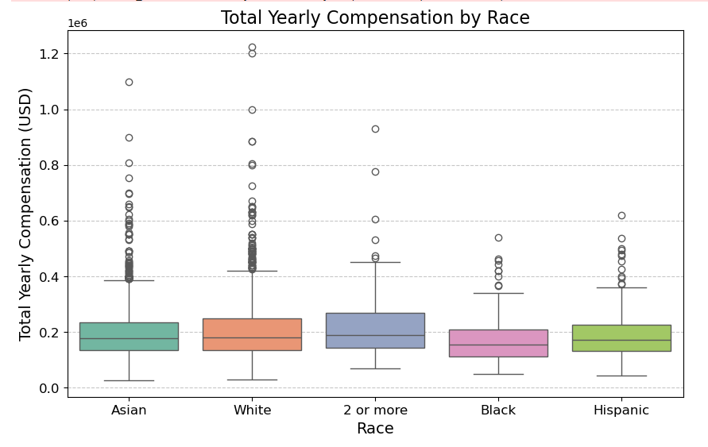

This Box and Whisker plot shows how much the total yearly compensation is affected by the different races. One thing to note is that there is a lot more data representing the white and asian population, because they occupy the majority of jobs in the industry. There is a possibility that the data could be slightly skewed because of that reason, but we still believe that the data in the sample represents the whole population well. We can see from these plots that the median salary for all of the races are very similar. White and Asian individuals seem to have more outliers with extremely high salaries. This could be because they are more likely to hold the higher positions at tech companies and be at the top of the company. Overall, our data shows that race isn’t a very large factor in how much money you make.

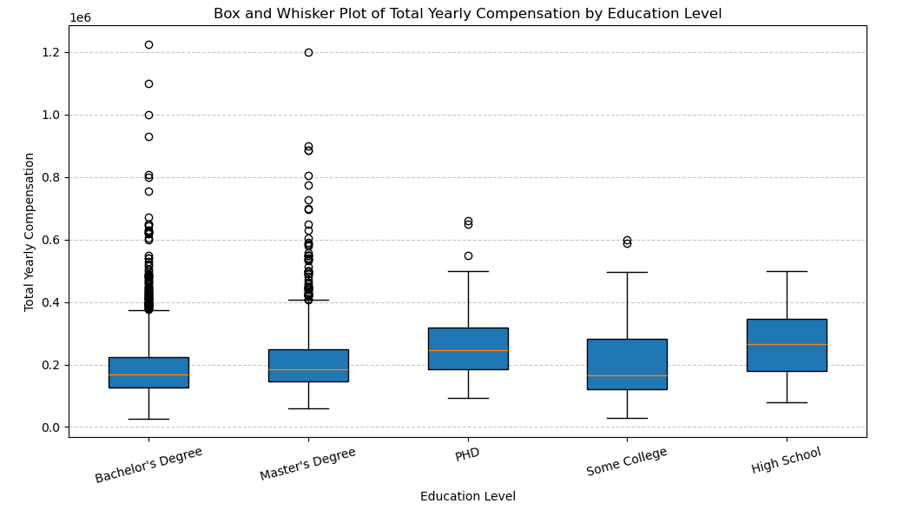

This plot shows the different levels of education that the individuals in the sample have. The first thing that pops out at you when looking at this graph is that High School graduates actually have the highest median salary out of everyone. Realistically, there was not enough data of high school graduates to represent them as a whole. The industry alone has a severe lack of high school graduates with jobs just because the barrier of entry to these jobs are so high. Companies are less likely to hire someone for a role in which they have no higher level education.

Aside from that, this graph proves the initial assumption that individuals with more higher education are more likely to make more money than those with less. Typically someone with a PhD in a subject will be better skilled and more knowledgeable than one with just a bachelor’s degree. The workers with PhDs are the only ones to have a median total yearly compensation of more than $200k. Something to note is that There are less outlier data points with the PhDs, so their maximum TYC is actually less than the master’s and bachelor’s degrees.

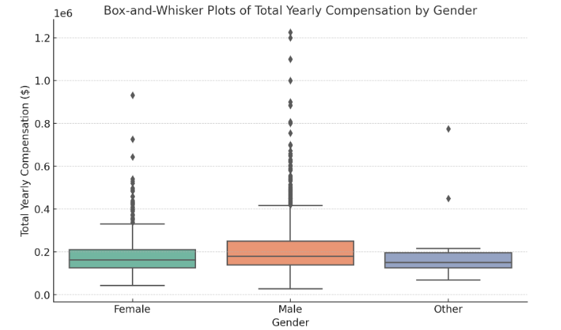

This plot shows the median total yearly compensation based on gender. These graphs are all extremely similar which is ideal, because a large difference between any genders would indicate some sort of gender-based inequality or discrimination. There were not enough data points for individuals that fall under the “other” category to draw a conclusion, and there were more than double the amount of male than females in the data.

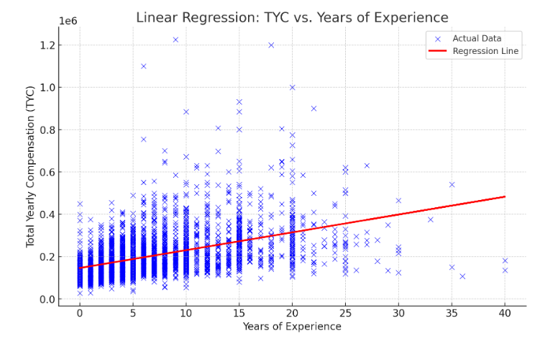

Here we see that Years of experience is also one of the biggest factors when it comes to salary. Through bonuses, promotions, and other rewards, the typical total yearly compensation goes up as the workers years of experience goes up. This happens because the longer you have worked in an industry or at a company, the more skills you possess, and generally the better worker you are. Companies are willing to pay higher salaries to those with more experience because they are more likely to be highly skilled in that job. Despite all of this, there are always outliers. Like how in this graph we can see an x at just under 10 years of experience that has a TYC of over 1.2 million. A possibility that this was someone who got started at a small company and is now one of the higher ups at that company after it had grown very large. This data point is too far from the regression line to mean anything notable. Typically someone with 10 years of experience will make around $200,000 a year. Another thing to note is that someone with 15-20 years of experience will be making around 50% more than someone without any experience in the industry.

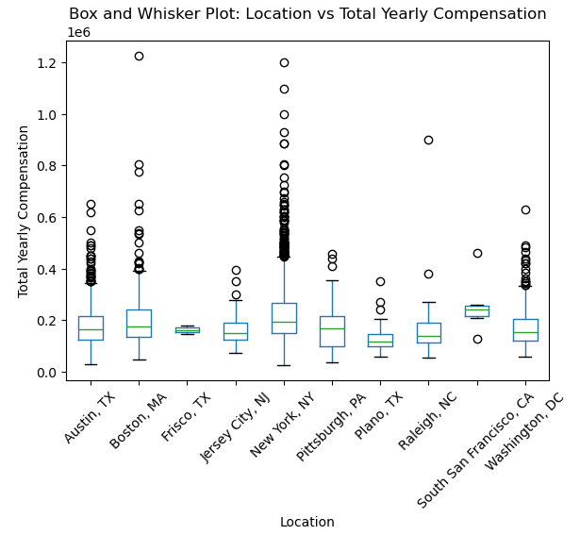

Location of the US tech hubs according to this plot has just some slight variability. Going into the study and research, We though that location would be one of the biggest factors that affect total yearly compensation, because a lot of the places where tech companies are headquartered would be LA and NYC. But our data proved us wrong. We expected New York City to have some of the highest paying jobs, and they did. But the median TYC is only slightly higher than other large cities like Boston, or Pittsburgh. There are lots of companies headquartered in NYC, which could be the main reason for its very large variability, with lots of jobs paying in the high six, low seven-figure range being higher-up positions at tech companies.

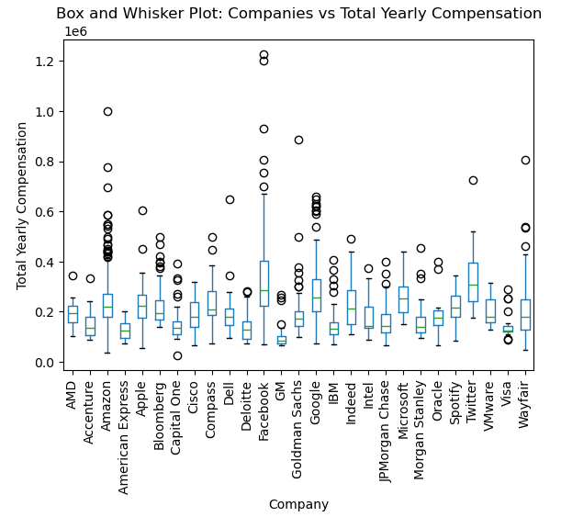

Looking at this graph, the company that you work at is going to be one of the biggest factors that affect TYC. There is a very large variability in the salaries between the companies, which tells us that the company is an extremely important factor. When looking at which companies are the ones with the largest TYC we can draw slight conclusions as to why. The highest payers, Twitter, Microsoft, Google, and Facebook are all companies that require large teams of very skilled computer scientists to keep running. Social media sites like twitter and facebook use very complicated algorithms that are constantly changing and updating, which requires highly skilled workers.

**Conclusion**

Throughout this research project, we have been proven right, and also proven wrong a number of times. But overall we have answered our initial question. Our goal was to be able to identify what properties of workers lead to a high yearly salary.

We found that No one race is very far above others in TYC. All have a very similar median with some outliers. We did find, however, that the median TYC of black individuals was slightly less compared to others, just enough to notice a difference. We couldn’t find a reason for this, except for maybe some lack of data, or a general lack of black individuals in the tech industry. There is also a possibility of racial discrimination that leads to TYC being less.

One of the larger factors we found to be education level. The difference between the 3 collegiate degrees is significant enough to note that it matters how many years of schooling you do. We found that those with PhDs made more than those with master’s and bachelor’s degrees. Though people with higher degrees generally make more, they also generally have to pay a lot more for the years of schooling they do. Because of how expensive it is to attend colleges in this era, choosing which degree to pursue could be a bigger factor than originally thought.

Researching gender we found no significant difference between male, female, and those that fell into the other category. We found there was not enough data to draw a conclusion for the “other” category, so it is hard to speak on. But there are a lot of external factors that could explain the very slight differences between TYC of the three categories.

Years of Experience also proved to be one of the biggest factors as well. This was to be expected, because it is typically common knowledge that is well-known. Generally the more experience you have, the more likely a company is to hire you. The more success you will have getting higher up jobs that have good pay.

Location was a factor that we originally thought to be one of the bigger factors, but proved to not matter as much as originally thought. While there is variability with the data, there is no discernable difference that tells us one or a couple of cities will pay dramatically more.

The company you work for also proves to be a big factor, because different companies demand higher or lower skilled workers. Some companies need the best of the best programmers to create intricate and detailed websites.

In conclusion, the biggest factors that affect the total yearly compensation for jobs are education level, years of experience, and Company. These are the biggest factors because we found the highest variability between their different sub-categories. There were easily identifiable differences between the lowest, and the highest TYC for all categories. For that reason, it is clear that these are the biggest factors.

Works Cited

Deloitte. (n.d.). *2024 technology industry outlook*. Deloitte. Retrieved from<https://www2.deloitte.com/us/en/pages/technology-media-and-telecommunications/articles/technology-industry-outlook.html>

ProQuest. (n.d.). Tech recruiting: How to attract and retain employees in today’s full employment economy. Retrieved from [ProQuest database link].

Gale Academic OneFile. (2008). Tech salaries up, but jobs down. Retrieved from [Gale Academic OneFile database link].

Lee, N., & Rodríguez-Pose, A. (n.d.). Is there trickle-down from tech? Poverty, employment, and the high-technology multiplier in U.S. cities. *JSTOR*. Retrieved from [JSTOR database link].

ScholarWorks. (n.d.). Retrieved from<https://scholarworks.lib.csusb.edu/jiim/vol12/iss1/7/>

IEEE. (2023). *Title of the document*. Retrieved from<https://ieeexplore.ieee.org/abstract/document/10046491>

INFORMS. (2000). *Title of the document*. Retrieved from<https://pubsonline.informs.org/doi/epdf/10.1287/mnsc.46.4.530.12055>

Total Rewards: Good fit for tech workers. (n.d.). *Publication details*. Retrieved from [source link].

ScienceDirect. (n.d.). Displacement in new economy labor markets: Post-displacement wage loss in high tech versus low tech cities. Retrieved from [ScienceDirect database link].