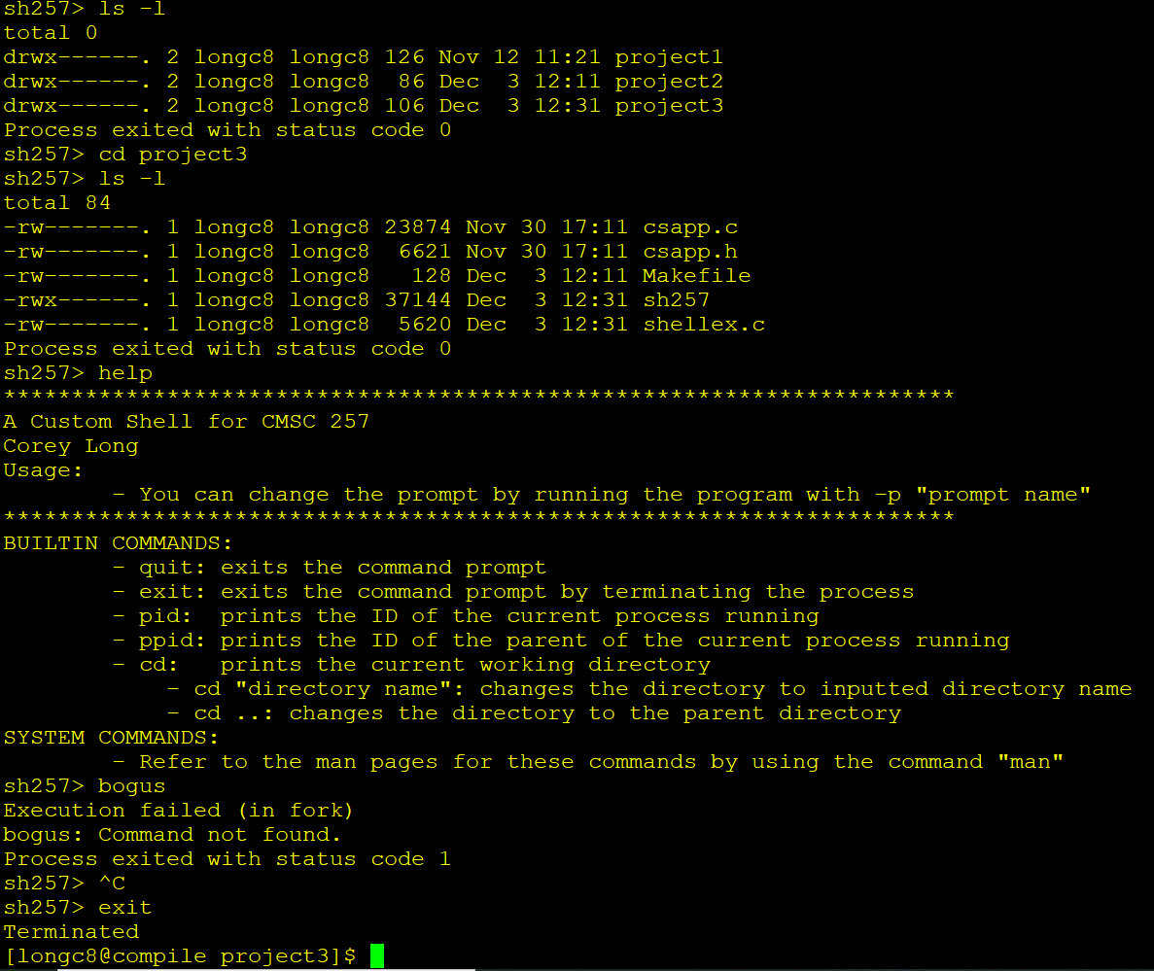

Changing Command Prompt

