4

RMSE:0.0220

MAE:0.0146

MAPE:3.3779

R2:0.9846

5

RMSE:0.0217

MAE:0.0148

MAPE:3.3962

R2:0.9849

6

RMSE:0.0212

MAE:0.0142

MAPE:3.2894

R2:0.9857

7

RMSE:0.0211

MAE:0.0144

MAPE:3.3878

R2:0.9859

8

RMSE:0.0211

MAE:0.0143

MAPE:3.3231

R2:0.9859

9

RMSE:0.0211

MAE:0.0144

MAPE:3.3701

R2:0.9859

10

RMSE:0.0213

MAE:0.0147

MAPE:3.4924

R2:0.9857

11

RMSE:0.0214

MAE:0.0144

MAPE:3.3539

R2:0.9856

12

RMSE:0.0212

MAE:0.0145

MAPE:3.3896

R2:0.9858

13

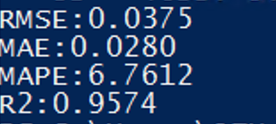

14

RMSE:0.0213

MAE:0.0146

MAPE:3.4115

R2:0.9857

15

RMSE:0.0217

MAE:0.0146

MAPE:3.3910

R2:0.9853