**Отчет по лабораторной работе 1, вариант 7.**

Выполнил: Золотухин Андрей Александрович КС-36

Преподаватель: Семёнов Геннадий Николаевич

**ЗАДАНИЕ**

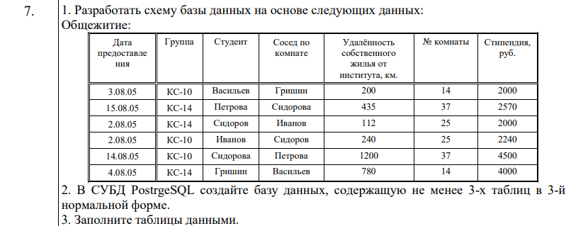

**Создание базы данных**

Пароль к серверу и базе данных: 123

CREATE DATABASE “Var7”

WITH

OWNER = postgres

ENCODING = ‘UTF8’

TABLESPACE = pg_default

CONNECTION LIMIT = -1

IS_TEMPLATE = False;

**Создание таблиц**

1. **Группы**

CREATE TABLE IF NOT EXISTS groups

(

group_id integer NOT NULL GENERATED ALWAYS AS IDENTITY (INCREMENT 1 START 1 MINVALUE 1 MAXVALUE 2147483647),

group_name character varying(5) NOT NULL,

CONSTRAINT groups_pkey PRIMARY KEY (group_id)

);

1. **Комнаты**

CREATE TABLE IF NOT EXISTS rooms

(

room_id integer NOT NULL GENERATED ALWAYS AS IDENTITY (INCREMENT 1 START 1 MINVALUE 1 MAXVALUE 2147483647),

room_number integer NOT NULL,

CONSTRAINT rooms_pkey PRIMARY KEY (room_id)

);

1. **Студенты**

CREATE TABLE IF NOT EXISTS students

(

student_id integer NOT NULL GENERATED ALWAYS AS IDENTITY (INCREMENT 1 START 1 MINVALUE 1 MAXVALUE 2147483647),

student_name character varying(15) NOT NULL,

scholarship integer NOT NULL,

group_name integer REFERENCES groups(group_id) NOT NULL,

CONSTRAINT students_pkey PRIMARY KEY (student_id)

);

1. **Размещения**

CREATE TABLE IF NOT EXISTS accommodations

(

accommodation_id integer NOT NULL GENERATED ALWAYS AS IDENTITY (INCREMENT 1 START 1 MINVALUE 1 MAXVALUE 2147483547)

accommodation_date date NOT NULL,

distance integer NOT NULL,

room_number integer REFERENCES rooms(room_id) NOT NULL,

student_name integer REFERENCES students(student_id) NOT NULL,

neighbour_name integer REFERENCES students(student_id) NOT NULL,

);

**Схема базы данных**

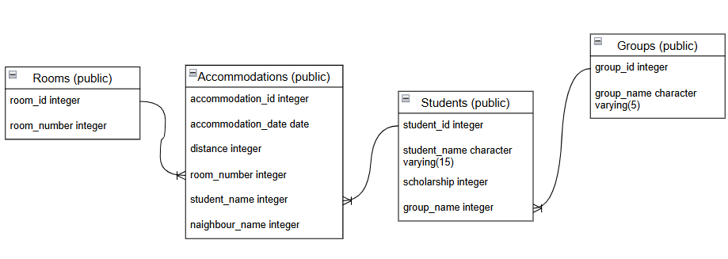

**Полный код создания таблиц**

**ГРУППЫ**

CREATE TABLE IF NOT EXISTS public.groups

(

group_id SERIAL,

group_name character varying(5) NOT NULL,

CONSTRAINT groups_pkey PRIMARY KEY (group_id)

);

**КОМНАТЫ**

CREATE TABLE IF NOT EXISTS public.rooms

(

room_id SERIAL,

room_number integer NOT NULL,

CONSTRAINT room_number_pkey PRIMARY KEY (room_id)

);

**СТУДЕНТЫ**

CREATE TABLE IF NOT EXISTS public.students

(

student_id SERIAL,

student_name character varying(15) NOT NULL,

scholarship integer NOT NULL,

group_name integer NOT NULL,

CONSTRAINT students_pkey PRIMARY KEY (student_id),

CONSTRAINT group_group_name_fkey FOREIGN KEY (group_name)

REFERENCES public.groups(group_id) MATCH SIMPLE

ON UPDATE NO ACTION

ON DELETE NO ACTION

);

**РАЗМЕЩЕНИЯ**

CREATE TABLE IF NOT EXISTS public.accommodations

(

accommodation_id SERIAL,

accommodation_date date NOT NULL,

distance integer NOT NULL,

room_number integer NOT NULL,

student_name integer NOT NULL,

neighbour_name integer NOT NULL,

CONSTRAINT room_room_number_fkey FOREIGN KEY (room_number)

REFERENCES public.rooms(room_id) MATCH SIMPLE

ON UPDATE NO ACTION

ON DELETE NO ACTION,

CONSTRAINT student_student_name_fkey FOREIGN KEY (student_name)

REFERENCES public.students(student_id) MATCH SIMPLE

ON UPDATE NO ACTION

ON DELETE NO ACTION,

CONSTRAINT neighbour_neighbour_name_fkey FOREIGN KEY (neighbour_name)

REFERENCES public.students(student_id) MATCH SIMPLE

ON UPDATE NO ACTION

ON DELETE NO ACTION

);

**Заполнение таблиц**

1. **Группы**

INSERT INTO groups (group_name) VALUES

(‘CS-10’),

(‘CS-14’);

1. **Комнаты**

INSERT INTO rooms (room_number) VALUES

(14),

(37),

(25);

1. **Студенты**

INSERT INTO students (student_name, scholarship, group_name) VALUES

(‘Vasilyev’, 2000, 1),

(‘Petrova’, 2570, 2),

(‘Sidorov’, 2000, 2),

(‘Ivanov’, 2240, 1),

(‘Sidorova’, 4500, 1),

(‘Grishin’, 4000, 2);

1. **Размещения**

INSERT INTO accommodations (accommodation_date, distance, room_number, student_name, neighbour_name) VALUES

(‘2005-08-03’, 200, 1, 1, 6),

(‘2005-08-15’, 435, 2, 2, 5),

(‘2005-08-02’, 112, 3, 3, 4),

(‘2005-08-02’, 240, 3, 4, 3),

(‘2005-08-14’, 1200, 2, 5, 2),

(‘2005-08-04’, 780, 1, 6, 1);

**Результат заполнения таблиц**

